**8,949**

**5,435**

**Measure Names**

**S No.**

**4000K**

**3500K**

**11,719**

**3000K**

**14,810**

**2500K**

**2000K**

**1500K**

**1000K**

**500K**

**0K**

**2015**

**505**

**2016**

**2017**

**2018**

**Year**

**2019**

**2020**

**2021**

**S No.**

|  |  |  |  |  |
| --- | --- | --- | --- | --- |
| REVENUE GROWTH IN INDUISTRIES | TOP 10 INDUSTRIES IN INDIA | GROWTH OF AGRICULTURE IN STATES | DOMAINS | PRODUCTIONS |

5,397

3,60,050

2,60,265

3,23,839

8,71,764

25,111

17,335

8,59,648

10,54,981

5,76,096

4,13,998 79,143

9,43,662

8,29,785

7,69,204

1,35,662

24,298

5,56,732

62,011 7,43,500

9,96,025

9,78,247

3,68,433

5,97,114

49,665

2,900

1,84,773

8,10,941

© 2023 Mapbox © OpenStreetMap

S No.

2,900

10,54,981

|  |  |  |  |  |
| --- | --- | --- | --- | --- |
| REVENUE GROWTH IN INDUISTRIES | TOP 10 INDUSTRIES IN INDIA | GROWTH OF AGRICULTURE IN STATES | DOMAINS | PRODUCTIONS |

REVENUE GROWTH IN INDUISTRIES

TOP 10 INDUSTRIES IN INDIA

Industry State

Agriculture Andaman a..

Andhra Pra.. Arunachal P.. Assam

Bihar Chandigarh Chhattisgarh Dadra and ..

2022

2022

2021

2021

2021

2019

2020

2019

2018

2017

2021

2021

2019

|  |  |  |
| --- | --- | --- |
| GROWTH OF AGRICULTURE IN STATES | DOMAINS | PRODUCTIONS |

2020

2021

2021

2019

2018

8

Delhi Goa Gujarat Haryana

Himachal P..

2022

2021

2020

2019

2018

2017

2020

2019

201

1

Jammu and .. 2022

2021

2019

2018

2019

2018

Jharkhand Karnataka Kerala Madhya Pra.. Maharashtra

2022

2021

2020

2019

2018

2017

2020

2019 2

2

2

|  |  |  |  |  |  |  |  |  |  |  |  |  |  |  |
| --- | --- | --- | --- | --- | --- | --- | --- | --- | --- | --- | --- | --- | --- | --- |
| Manipur |  |  |  |  |  |  |  |  |  |  |  |  |  |  |
|  |  |  |  |  |  |  |  |  |  |  |  |  |  |  |
| Mizoram | 2022 | 2021 |  |  |  |  |  |  |  |  |  |  |  | 2021 |
|  |  |  |  |  |  |  |  |  |  |  |  |  |  |  |
| Nagaland | 2021 |  |  |  |  |  |  |  | 2021 |  |  |  |  | 2021 |
|  |  |  |  |  |  |  |  |  |  |  |  |  |  |  |
| Odisha |  |  |  |  |  |  |  |  |  |  |  |  |  |  |
|  |  |  |  |  |  |  |  |  |  |  |  |  |  |  |
| Puducherry |  |  |  |  |  |  |  |  |  |  |  |  |  |  |
|  |  |  |  |  |  |  |  |  |  |  |  |  |  |  |
| Punjab |  |  |  |  |  |  |  |  |  |  |  |  |  |  |
|  |  |  |  |  |  |  |  |  |  |  |  |  |  |  |
| Rajasthan |  |  |  |  |  |  |  |  |  |  |  |  |  |  |

Tamil Nadu Telangana Tripura Uttar Prade.. Uttarakhand West Bengal

2022

2022

2021

2021

2020

2020

2019

2019

2018

2018

2017

2017

2022

2021

2020

2020

2019

2019

0 100 200 300 400 500 600 700 800 0K 5K 10K

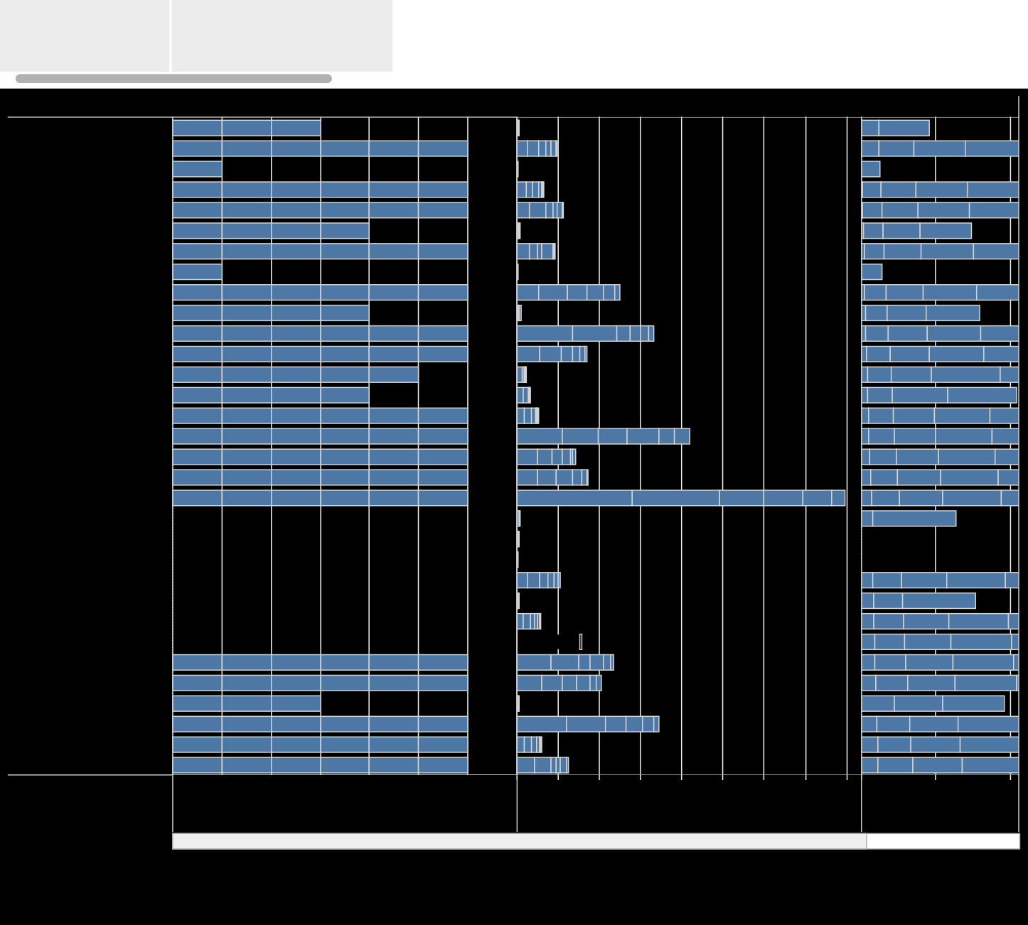Count of Sheet1

Count

S No.

TOP 10 INDUSTRIES IN INDIA

GROWTH OF AGRICULTURE IN STATES

DOMAINS

PRODUCTIONS

DIMENSIONS OF DOMAIN

Textiles & Apparel

IT Services

Education

Human Resources

Marketing

Design Construction

Media &

Enterprise Software

AI

Automotive

Fashion

Non- Renewable

NOT SPECIFIED

Travel & Tourism

Healthcare & Lifesciences

Green Technology

Agriculture

Finance Technology

Internet of Things

Technology Hardware

Retail

Renewable Energy

Food & Beverages

Others



Professional & Commercial Services

0M 1M

2M

3M

4M

5M

6M

S No.

7M 8M

9M

10M 11M 12M 13M 14M 15M

450

Measure Names

Count of Count

S No.

400

350

300

250

200

150

100

50

0

5,000

2,000

1,000

500

200

100

Production

50

20

10

5

2

1

Count (bin)

GROWTH OF AGRICULTURE IN STATES

|  |  |  |  |  |
| --- | --- | --- | --- | --- |
|  | DOMAINS | PRODUCTIONS | DIMENSIONS OF DOMAIN | YEARLY GROWTH OF INDUSTRIAL DEPARTMENTS |

Count

28K

26K

24K

22K

20K

18K

16K

14K

12K

10K

8K

6K

4K

2K

0K

0

20

40

60

80

100

120

140

160

180

200

220

240

260

280

300

320

681

Count

64,583

45,425

45,417

21,571

27,121

10,158

15,673

15,671

9,972

1,36,382

2,59,020

5,39,115

15,10,868

1,48,16,391

STARTUP ANALYSIS

DOMAINS

PRODUCTIONS

DIMENSIONS OF DOMAIN

YEARLY GROWTH OF INDUSTRIAL DEPARTMENTS

COUNT VS COUNT1

Count (bin)

To Null

|  |  |  |
| --- | --- | --- |
| 340 |  | 4,836 |
| 360 |  | 2,574 |
| 380 |  |  |
| 400 |  | 702 |

**Industry**

**2K**

**Advertising**

**1K**

**0K**

**2K**

**2017**

**2018**

**2019**

**2020**

**2021**

**2022**

**Aeronautics Aerospace & Defence**

**1K**

**0K**

**2K**

**2017**

**2018**

**2019**

**2020**

**2021**

**2022**

**Agriculture**

**2021**

**2022**

**1K**

**0K**

**2K**

**2017**

**2018**

**2019**

**2020**

**AI**

**1K**

**2019**

**0K**

**2K**

**2017**

**2018**

**2020**

**2021**

**2022**

**Airport Operations**

**1K**

**0K**

**2K**

**2020**

**2021**

**2022**

**Analytics**

**1K**

**0K**

**2K**

**2017**

**2018**

**2019**

**2020**

**2021**

**2022**

**Animation**

**1K**

**2017**

**2018**

**2019**

**2020**

**2021**

**AR VR**

**0K**

**2K**

**2022**

**2015 2016 2017 2018**

**2019**

**Year**

**2020**

**2021**

**2022**

**2023**

**ount**

**Count**

**Count**

**Count**

**Count**

**Count**

**Count**

PRODUCTIONS DIMENSIONS OF DO

**Count**

|  |  |  |  |
| --- | --- | --- | --- |
| MAIN | YEARLY GROWTH OF INDUSTRIAL DEPARTMENTS | COUNT VS COUNT1 | INDUSTRIAL MEASUREMENT IN INDIAN STATE |

DIMENSIONS OF DOMAIN

YEARLY GROWTH OF INDUSTRIAL DEPARTMENTS

COUNT VS COUNT1

INDUSTRIAL MEASUREMENT IN INDIAN STATE

DEPARTMENTS OF STARTUP COMPANY

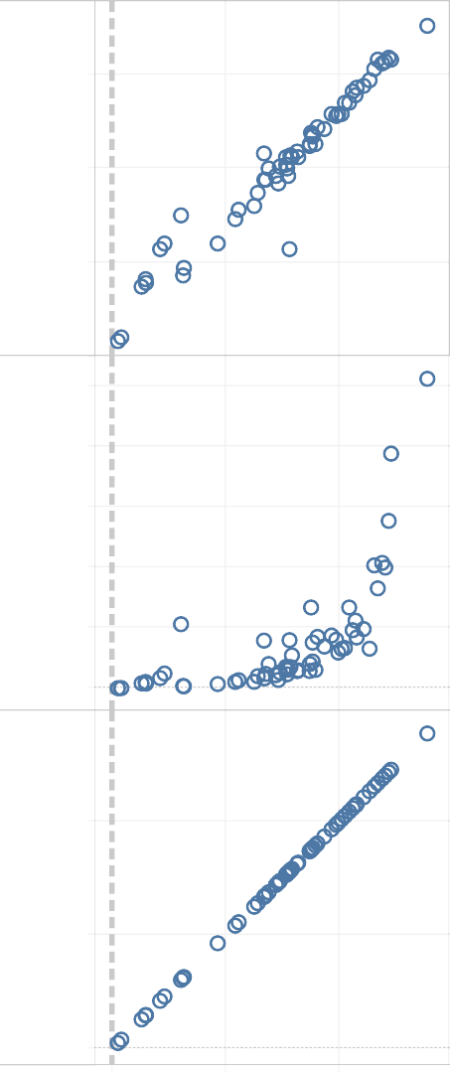

150

100

Count of Sheet1

50

0

10K

8K

6K

Count

4K

2K

0K

400K

200K

S No.

0K

0K 200K 400K

S No.

YEARLY GROWTH OF INDUSTRIAL DEPARTMENTS

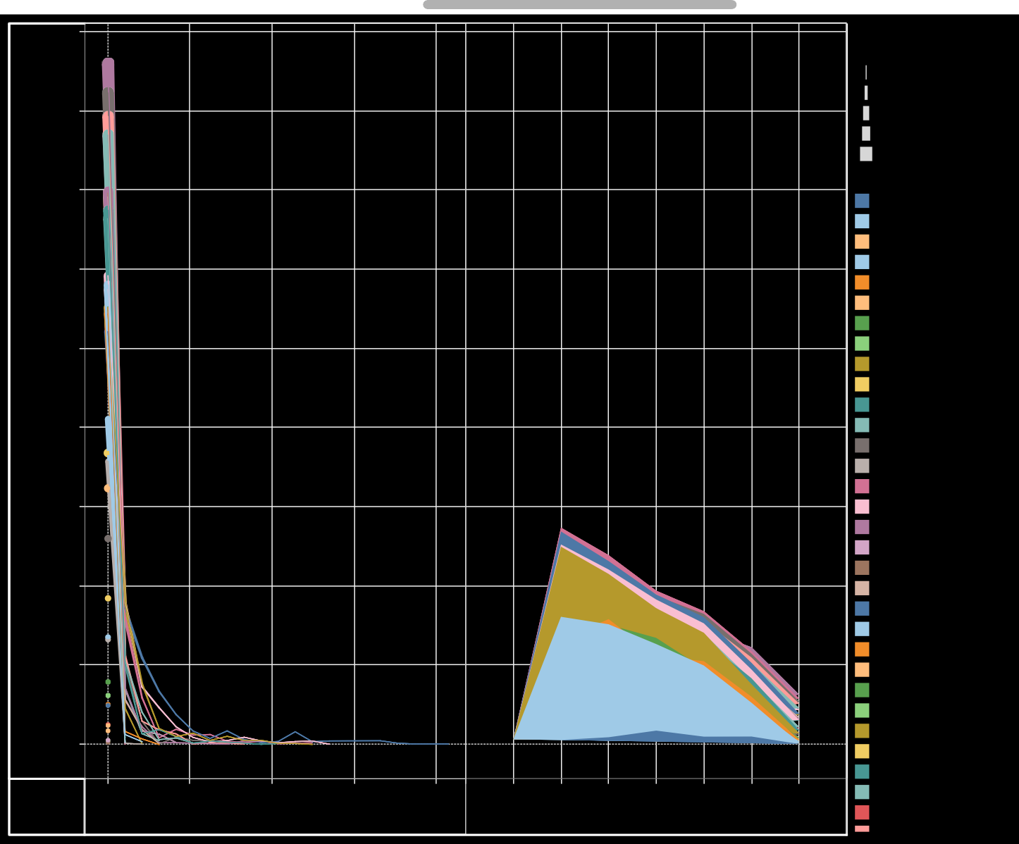

900K

800K

measure values

1

200,000

400,000

600,000

860,029

700K

600K

500K

400K

300K

200K

100K

0K

Odisha West Bengal

Gujarat KarnatakaMaharashtra

0

100

200

Count (bin)

300

400

2016 2017 2018 2019 2020 2021 2022

Year

State Andaman and Nicoba.. Andhra Pradesh Arunachal Pradesh Assam

Bihar Chandigarh Chhattisgarh

Dadra and Nagar Hav.. Delhi

Goa Gujarat Haryana

Himachal Pradesh Jammu and Kashmir Jharkhand Karnataka

Kerala Ladakh Lakshadweep

Madhya Pradesh Maharashtra Manipur Meghalaya Mizoram Nagaland

NOT SPECIFIED

Odisha Puducherry Punjab Rajasthan Sikkim

S No.

|  |  |  |
| --- | --- | --- |
| INDUSTRIAL MEASUREMENT IN INDIAN STATE | DEPARTMENTS OF STARTUP COMPANY | LAUNCH OF INDUSTRIES AT DIFFERENT STATES |

COUNT VS COUNT1

COUNT VS COUNT1

INDUSTRIAL MEASUREMENT IN INDIAN STATE



**State Andaman and Nico.. Andhra Pradesh Arunachal Pradesh**

**Assam Bihar Chandigarh Chhattisgarh**

**Dadra and Nagar H..**

**Delhi Goa Gujarat Haryana**

**Himachal Pradesh Jammu and Kashmir**

**Jharkhand Karnataka**

**Kerala Ladakh Lakshadweep Madhya Pradesh Maharashtra**

**Manipur Meghalaya Mizoram Nagaland**

**NOT SPECIFIED**

**Odisha Puducherry**

**Punjab Rajasthan**

**Sikkim**

**Tamil Nadu Telangana Tripura**

**Uttar Pradesh Uttarakhand**

**West Bengal**

**Design Design 2017 2018**

**Design 2018**

**Design 2019**

**Design 2019**

**Others 2020**

**Design Events 2018 2019**

**Design Design 2018 2019**

**Others 2021**

**Others 2021**

**Others 2021**

**Others 2021**

**Others 2021**

**Others 2021**

**Others 2021**

**Others 2021**

**Others 2022**

**IT Services 2022**

**Design Others**

**2017 2020**

**Retail Design Design Others 2017 2018 2019 2020**

**Design Design Design Others 2017 2018 2019 2020**

**Design Design Design Others 2017 2018 2019 2020**

**AI Others**

**2017 2020**

**Design Design**

**2017 2020**

**Design Others**

**2017 2020**

**Others 2022**

**Others 2022**

**Others 2022**

**Others 2022**

**Others 2022**

**Others 2022**

**Others 2022**

**Construction 2022**

**Agriculture 2019**

**Healthcare & Lifesciences 2022**

**Healthcare & Lifesciences 2021**

**Construction 2022**

**IT Services 2022**

**Design 2017**

**Design 2018**

**Design Others 2019 2020**

**Events 2017**

**Design 2017**

**Design 2017**

**Design 2018**

**Design 2018**

**Design 2018**

**Design 2019**

**Design 2019**

**Retail 2020**

**Others 2020**

**Others 2021**

**Others 2021**

**Retail 2021**

**Others 2022**

**Others 2022**

**Others 2020**

**Others 2021**

**Others 2021**

**Professional & Commercial Services 2021**

**Architecture Interior Design 2020**

**IT Services 2022**

**Design 2019**

**Others 2020**

**Others 2021**

**Design Design**

**Design**

**Others 2022**

**Others 2022**

**Others 2022**

**Others 2022**

**IT Services 2022**

**IT Services 2022**

**2017 2018 2019**

**IT Services 2021**

**Others Others Others Healthcare & Lifesciences 2020 2021 2022 2022**

**2015 2016**

**2017**

**2018**

**2019**

**2020**

**2021**

**2022 2023 0**

**50**

**100**

**150**

**200**

**250**

**300**

**350**

**400**

|  |  |  |
| --- | --- | --- |
| DEPARTMENTS OF STARTUP COMPANY | LAUNCH OF INDUSTRIES AT DIFFERENT STATES | COUNT OF INDUSTRIES IN INDIA |

INDUSTRIAL MEASUREMENT IN INDIAN STATE

DEPARTMENTS OF STARTUP COMPANY

|  |  |  |
| --- | --- | --- |
| LAUNCH OF INDUSTRIES AT DIFFERENT STATES | COUNT OF INDUSTRIES IN INDIA | FINANCIAL PERRFORMANCES |

|  |  |  |  |  |  |  |  |  |  |  |  |  |  |  |  |  |  |  |  |  |  |  |  |  |
| --- | --- | --- | --- | --- | --- | --- | --- | --- | --- | --- | --- | --- | --- | --- | --- | --- | --- | --- | --- | --- | --- | --- | --- | --- |
| **State** | **Industry** |  | | | | | | | | | | | | | | | | | | | | | |  |
| **Andaman and Nicobar Islands** | **Agriculture** |  | |  | |  | |  | |  | |  |  | |  | |  | |  | |  | |  |  |
| **AR VR (Augmented + Virt..** | **2022** | |  | |  | |  | |  | |  |  | |  | |  | |  | |  | |  |  |
| **Construction** |  | |  | |  | |  | |  | |  |  | |  | |  | |  | |  | |  |
| **Education** | **2021** | |  | |  | |  | |  | |  |  | |  | |  | |  | |  | |  |
| **Green Technology** | **2020** | |  | |  | |  | |  | |  |  | |  | |  | |  | |  | |  |
| **Internet of Things** | **2022** | |  | |  | |  | |  | |  |  | |  | |  | |  | |  | |  |
| **IT Services** |  | |  | |  | |  | |  | |  |  | |  | |  | |  | |  | |  |
| **Logistics** | **2021** | |  | |  | |  | |  | |  |  | |  | |  | |  | |  | |  |
| **Marketing** |  | |  | |  | |  | |  | |  |  | |  | |  | |  | |  | |  |
| **Non- Renewable Energy** | **2021** | |  | |  | |  | |  | |  |  | |  | |  | |  | |  | |  |
| **Other Specialty Retailers** |  | |  | |  | |  | |  | |  |  | |  | |  | |  | |  | |  |
| **Professional & Commercia..** | **2019** | |  | |  | |  | |  | |  |  | |  | |  | |  | |  | |  |
| **Textiles & Apparel** | **2018** | |  | |  | |  | |  | |  |  | |  | |  | |  | |  | |  |
| **Transportation & Storage** |  | |  | |  | |  | |  | |  |  | |  | |  | |  | |  | |  |
| **Travel & Tourism** |  | |  | |  | |  | |  | |  |  | |  | |  | |  | |  | |  |
| **Andhra Pradesh** | **Advertising** |  | |  | |  | |  | |  | |  |  | |  | |  | |  | |  | |  |
| **Aeronautics Aerospace & ..** |  | |  | |  | |  | |  | |  |  | |  | |  | |  | |  | |  |
| **Agriculture** |  | |  | |  | |  | |  | |  |  | |  | |  | |  | |  | |  |
| **AI** |  | |  | |  | |  | |  | |  |  | |  | |  | |  | |  | |  |
| **Analytics** |  | |  | |  | |  | |  | |  |  | |  | |  | |  | |  | |  |
| **Animation** |  | |  | |  | |  | |  | |  |  | |  | |  | |  | |  | |  |
| **AR VR (Augmented + Virt..** |  | |  | |  | |  | |  | |  |  | |  | |  | |  | |  | |  |
| **Architecture Interior Desi..** |  | |  | |  | |  | |  | |  |  | |  | |  | |  | |  | |  |
| **Art & Photography** |  | |  | |  | |  | |  | |  |  | |  | |  | |  | |  | |  |
| **Automotive** |  | |  | |  | |  | |  | |  |  | |  | |  | |  | |  | |  |
| **Biotechnology** |  | |  | |  | |  | |  | |  |  | |  | |  | |  | |  | |  |
| **Chemicals** |  | |  | |  | |  | |  | |  |  | |  | |  | |  | |  | |  |
| **Computer Vision** | **2021** | |  | |  | |  | |  | |  |  | |  | |  | |  | |  | |  |
| **Construction** |  | |  | |  | |  | |  | |  |  | |  | |  | |  | |  | |  |
| **Dating Matrimonial** | **2018** | |  | |  | |  | |  | |  |  | |  | |  | |  | |  | |  |
| **Design** |  | |  | |  | |  | |  | |  |  | |  | |  | |  | |  | |  |
| **Education** |  | |  | |  | |  | |  | |  |  | |  | |  | |  | |  | |  |
| **Enterprise Software** |  | |  | |  | |  | |  | |  |  | |  | |  | |  | |  | |  |
| **Events** |  | |  | |  | |  | |  | |  |  | |  | |  | |  | |  | |  |
| **Fashion** |  | |  | |  | |  | |  | |  |  | |  | |  | |  | |  | |  |
| **Finance Technology** |  | |  | |  | |  | |  | |  |  | |  | |  | |  | |  | |  |
|  | | **0K** | **2K** | | **4K** | | **6K** | | **8K** | | **10K 12K**  **Count of Sheet1** | | | **14K** | | **16K** | | **18K** | | **20K** | | **22K** | |  |

DEPARTMENTS OF STARTUP COMPANY

LAUNCH OF INDUSTRIES AT DIFFERENT STATES

**Industry**

**Aeronauti**

**Advertis.. cs Aeros.. Agricult..**

**Airport O**

**AR VR (Au Architect Art & Pho**

**AI**

**perations Analytics Animati.. gmented.. ure Inter.. tography Automot.. Biotechn.. Chemi**

**550K**

**500K**

**Measure Names**

**Count**

**Count of Sheet1 S No.**

**Year**

**2016**

**2018**

**2020**

**2022**

**450K**

**400K**

**2017**

**350K**

**300K**

**2017**

**2017**

**2017**

**2018**

**2017**

**2**

**250K**

**2017**

**2017**

**2017**

**2017**

**2018**

**2018**

**2018**

**2**

**200K**

**2018**

**2019**

**2018**

**2018**

**2018**

**2018**

**150K**

**2019**

**2019**

**2019**

**2**

**2019**

**2019**

**2019 2019**

**100K**

**2020**

**2017**

**2019**

**2020**

**2020**

**2020**

**2018**

**2020**

**2020**

**2020**

**2020**

**2**

**50K**

**2021**

**2021**

**2021**

**2021**

**2021**

**2019**

**2020**

**2020**

**2021**

**2021**

**2021**

**2021**

**2020**

**2021**

**2**

**0K**

**C.. Co S C.. Co S C.. Co S C.. Co S C.. Co S C.. Co S C.. Co S C.. Co S C.. Co S C.. Co S C.. Co S C.. Co S C.. Co**

**u.. No. u.. No. u.. No. u.. No. u.. No. u.. No. u.. No. u.. No. u.. No. u.. No. u.. No. u.. No. u.**

**Value**

|  |  |  |
| --- | --- | --- |
| COUNT OF INDUSTRIES IN INDIA | FINANCIAL PERRFORMANCES | NAME OF STATES |

LAUNCH OF INDUSTRIES AT COUNT OF INDUSTRIES IN INDIA DIFFERENT STATES



**State**

**Anda Andhr Aruna**

**Dadra**

**man .. a Pra.. chal .. Assam Bihar Chan.. Chha.. and .. Delhi**

**Himac Jamm**

**Goa Gujar.. Hary.. hal P.. u and.. Jhark.. Karn.. Kerala Lada.. Laks**

**Measure Names**

**Count of Sheet1**

**S No.**

**1100K**

**1000K**

**900K**

**800K**

**700K**

**600K**

**500K**

**400K**

**300K**

**200K**

**100K**

**0K**

**Value**

**Cou.. S No.**

**Cou.. S No.**

**Cou.. S No.**

**Cou.. S No.**

**Cou.. S No.**

**Cou.. S No.**

**Cou.. S No.**

**Cou.. S No.**

**Cou.. S No.**

**Cou.. S No.**

**Cou.. S No.**

**Cou.. S No.**

**Cou.. S No.**

**Cou.. S No.**

**Cou.. S No.**

**Cou.. S No.**

**Cou.. S No.**

**Cou.. S No.**

**Cou..**

|  |  |  |
| --- | --- | --- |
| FINANCIAL PERRFORMANCES | NAME OF STATES | INDUSTRY |

LAUNCH OF INDUSTRIES AT DIFFERENT STATES

COUNT OF INDUSTRIES IN INDIA

FINANCIAL PERRFORMANCES

NAME OF STATES

INDUSTRY

Andaman

Andhra

Jammu

Tamil

Uttar

West

State

Andaman and Nicoba..

and Nico.. Assam Pradesh Bihar and Kash.. Kerala Manipur Nagaland Nadu Telangana Pradesh Uttarakh.. Bengal

Assam

Andhra Pradesh Bihar

Jammu and Kashmir Kerala

Manipur Nagaland Tamil Nadu Telangana Uttar Pradesh Uttarakhand West Bengal

LAUNCH OF INDUSTRIES AT DIFFERENT STATES

INDUSTRY

COUNT OF INDUSTRIES IN INDIA

FINANCIAL PERRFORMANCES

NAME OF STATES

Industry

|  |  |  |
| --- | --- | --- |
| Advertising | 613 |  |
| Aeronautics Aerospace & .. | 807 |
| Agriculture | 4,071 |
| AI | 1,516 |
| Airport Operations | 11 |
| Analytics | 617 |
| Animation | 81 |
| AR VR (Augmented + Virt.. | 439 |
| Architecture Interior Desi.. | 479 |
| Art & Photography | 280 |
| Automotive | 1,705 |
| Biotechnology | 213 |
| Chemicals | 714 |
| Computer Vision | 218 |
| Construction | 3,311 |
| Dating Matrimonial | 70 |
| Design | 597 |
| Education | 5,543 |
| Enterprise Software | 1,609 |
| Events | 333 |
| Fashion | 1,094 |
| Finance Technology | 2,678 |
| Food & Beverages | 3,998 |
| Green Technology | 1,926 |
| Healthcare & Lifesciences | 7,766 |
| House-Hold Services | 577 |
| Human Resources | 1,748 |
|  |
| Indic Language Startups | 159 |
| Internet of Things | 1,385 |
| IT Services | 10,243 |
| Logistics | 342 |
| Marketing | 1,685 |
| Media & Entertainment | 1,309 |
| Nanotechnology | 145 |
| Non- Renewable Energy | 1,582 |
| NOT SPECIFIED | 1,597 |
| Other Specialty Retailers | 573 |
| Others | 2,125 |
| Passenger Experience | 8 |

Count

8 10,243