STARTUP ANALYSIS

NAME OF STATES

State

Andaman and Nicoba.. Assam

Andhra Pradesh Bihar

Jammu and Kashmir Kerala

# INDUSTRIAL MEASUREMENT IN INDIAN STATES

REVENUE GROWTH OF INDUSTRIES 2016-2020

Manipur Nagaland Tamil Nadu Telangana Uttar Pradesh Uttarakhand West Bengal

Karnata

2016 2018 2020 2022

Year

ka

800K

600K

400K

200K

0K

0

200

Count (bin)

400

# STATE WISE CONSTRUCTION AND AGRICULTURE

## State Andaman nd Nico.. Arunachal PrAasdseasmh

**ChandBigiharahr**

**Andhra Pradesh**

**Dadra aCnhdhNatatgisagraHr.h.**

**DGelohai**

## HGaurjyaarnaat JKhaarrnkahtankda MaLdahkysahPardawdeesph

**LKaedraaklha**

**MeMgihzaolraayma**

**JaHmimuacahnadl KParasdhemsihr**

**Mahar shtra**

**Manipur**

## NOT SNPaEgCaIFlaIEnDd Puducherry

**RajaPsutnhjabn**

**Odisha**

**TamiSl iNkakdimu UUtttatrarParkahdaensdh**

**TelTanrigpaunra**

**West Bengal**

# DIMENSIONS OF DOMAIN

|  |  |  |  |  |  |  |  |  |  |  |
| --- | --- | --- | --- | --- | --- | --- | --- | --- | --- | --- |
| **4M** |  | **5,435** | |  | |  | |  | |  |
|  |  | | **8,949** | |  | |  | |  |
| **3M** |  | | **11,719** | | **14,810** |
|  |  | |  | |  | |  | |  |
| **2M** |
|  |  | |  | |  | |  | |  |
| **1M** |
|  |  | |  | |  | |  | |  |
| **0M** | **505** |
|  | **2015 2016** | | **2017** | | **2018**  **Year** | | **2019** | | **2020 2021** | |

Count

30K

20K

10K

0K

TOP 10

# INDUSTRIES IN INDIA

Count

1,48,16,391

measure values

1

S No.

**S No.**

200,000

400,000

600,000

860,029

S No.

2,900 10,54,981

## 2020 0 200

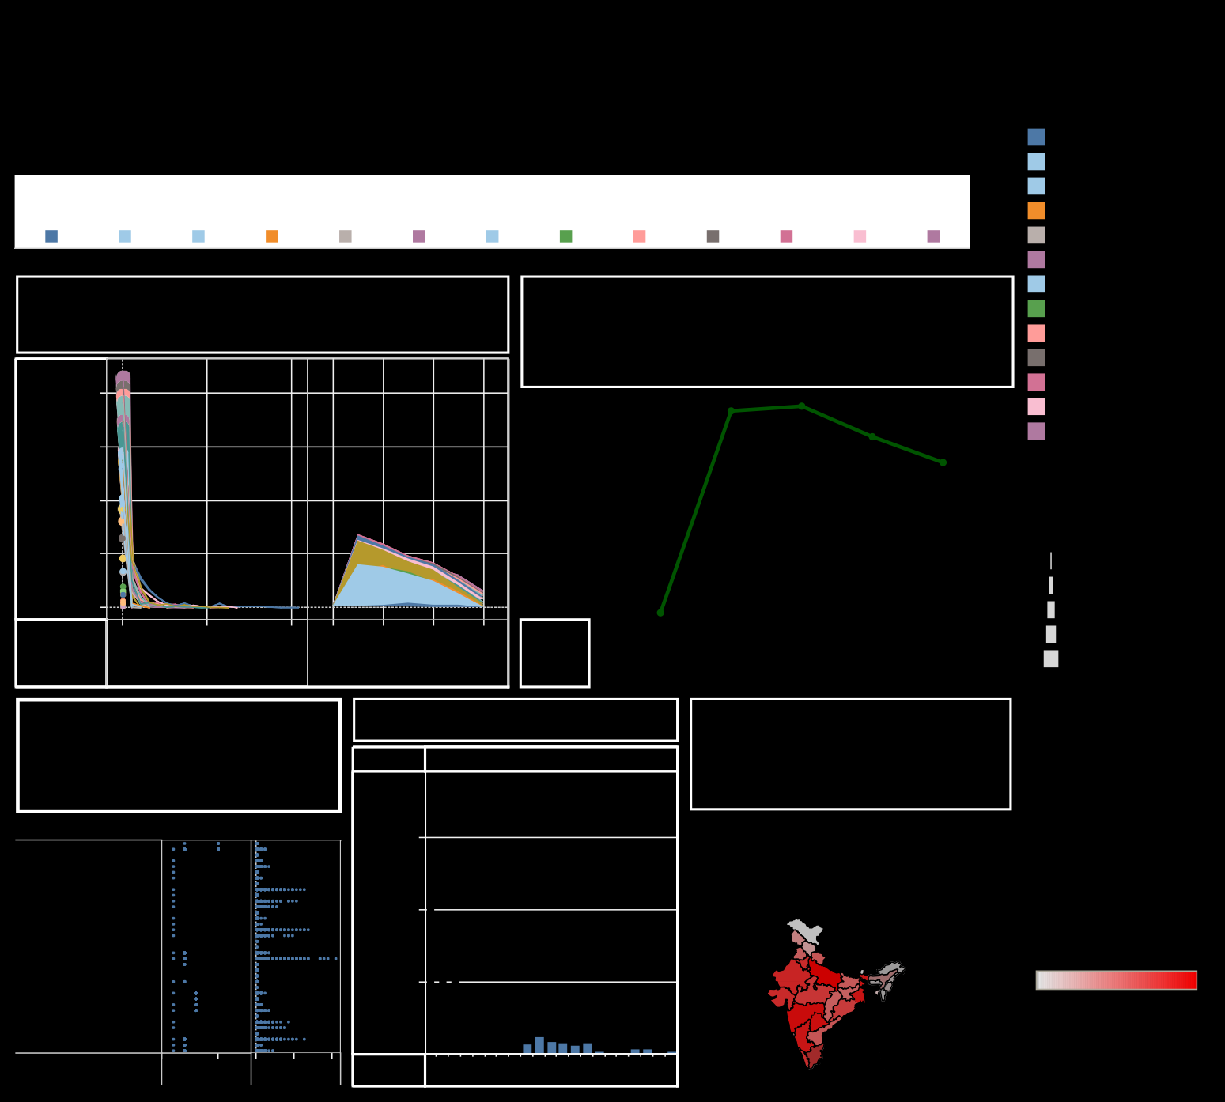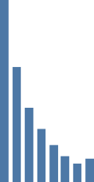

Andaman

Andhra

Jammu

Tamil

Uttar

West

and Nico.. Assam Pradesh Bihar and Kash.. Kerala Manipur Nagaland Nadu Telangana Pradesh Uttarakh.. Bengal

2,60,265

10,54,981 79,143

5,56,7~~3~~2

5,97,114 49,665

© Mapbox © OSM

20

60

100

140

180

220

260

300

340

380

45,417

27,121

15,673

9,972

4,836

702