$hadoop version

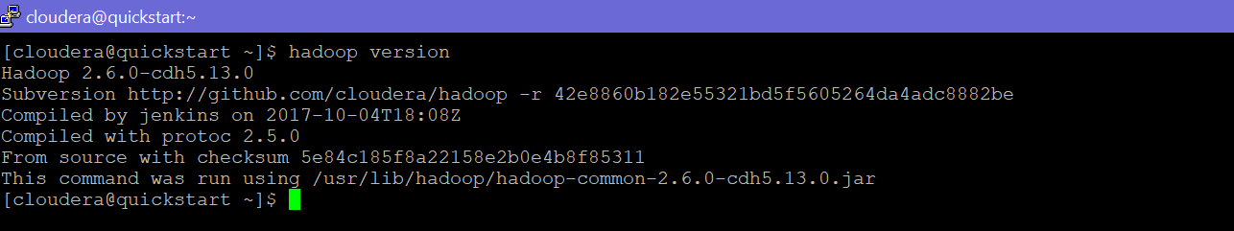

$hadoop fs -ls

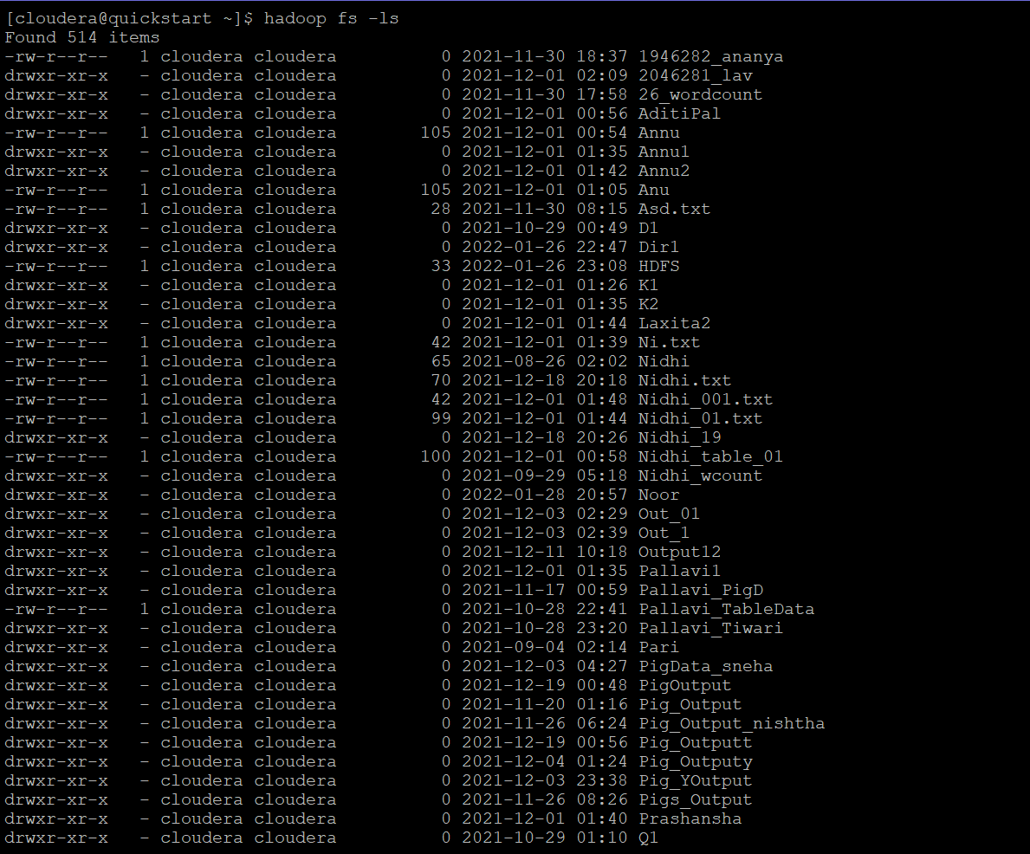

$hadoop fs -mkdir



$hadoop fs -put and $hadoop fs -cat

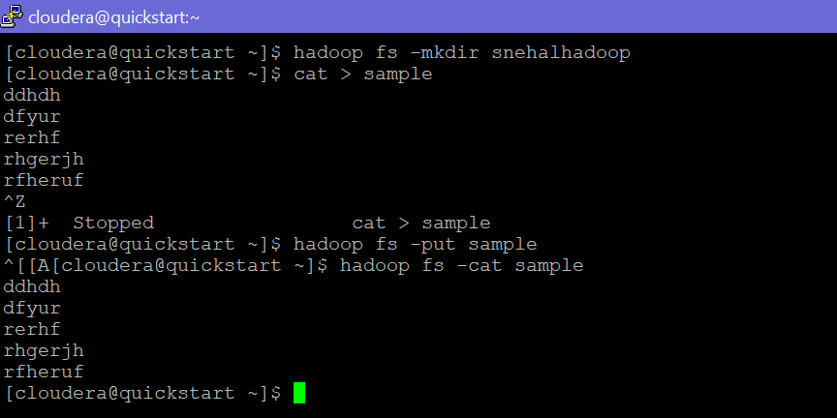

$hadoop fs -cp

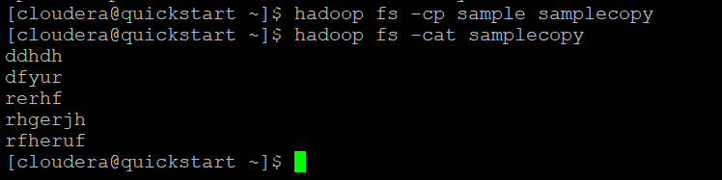

$hadoop fs -mv



$hadoop fs -test

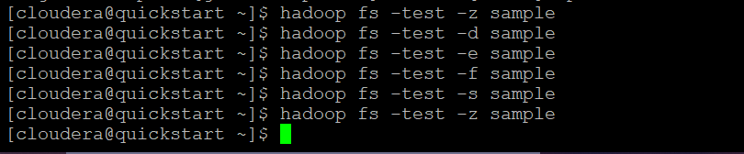

$hadoop fs -stat

