PROJECT 1: AI-POWERED BUSINESS INTELLIGENCE
Retail sales and profitability dashboard
Student Name: Sneha Das
Internship Organization: CODTECH IT SOLUTIONS PRIVATE LIMITED
Internship Track: Data Science
Duration: 8 Weeks
Internship Period: 18 September 2026 – 13 November 2026
Intern ID: CITS9200
Tools: Microsoft Excel / Google Sheets and Microsoft Word

1. Introduction
This project presents a compact business-intelligence view of the SuperStore retail data. Pivot tables summarize sales and profit by product category, sales by customer segment, and sales by region. Charts make the comparisons easier to understand and provide a starting point for business recommendations.

2. Objectives
- Summarize total sales and profit using spreadsheet calculations and pivot tables.
- Compare category, segment, and regional performance.
- Present KPI values and charts in a readable dashboard.
- Use AI only as an optional aid for explaining findings, not as proof of spreadsheet calculations.

3. Tools and Method
The spreadsheet workbook contains category sales/profit, segment sales and regional sales summaries. The charts below are visual exports based on the available spreadsheet summaries.

4. KPI Snapshot
Total Sales shown in the supplied pivot screenshot: 12,642,905. Total Profit shown in the supplied pivot screenshot: 1,469,034.821. Verify these totals against the complete transaction-level source file before final submission.

5. Charts
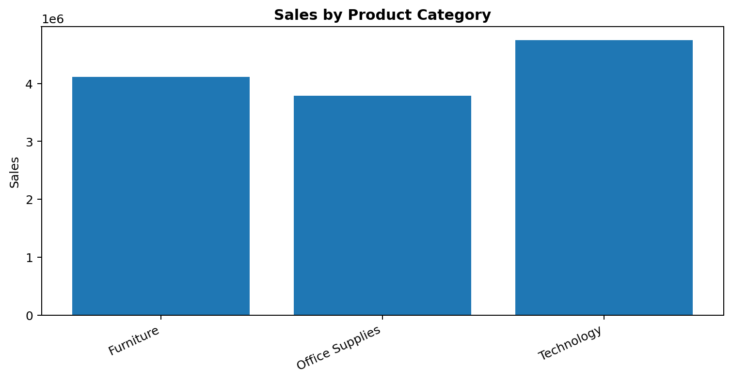
Figure 1. Sales by product category.
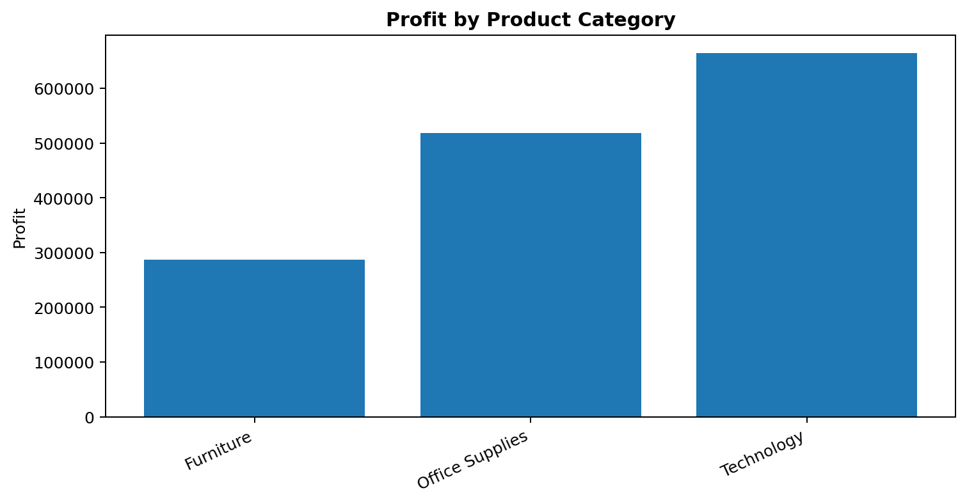
Figure 2. Profit by product category.
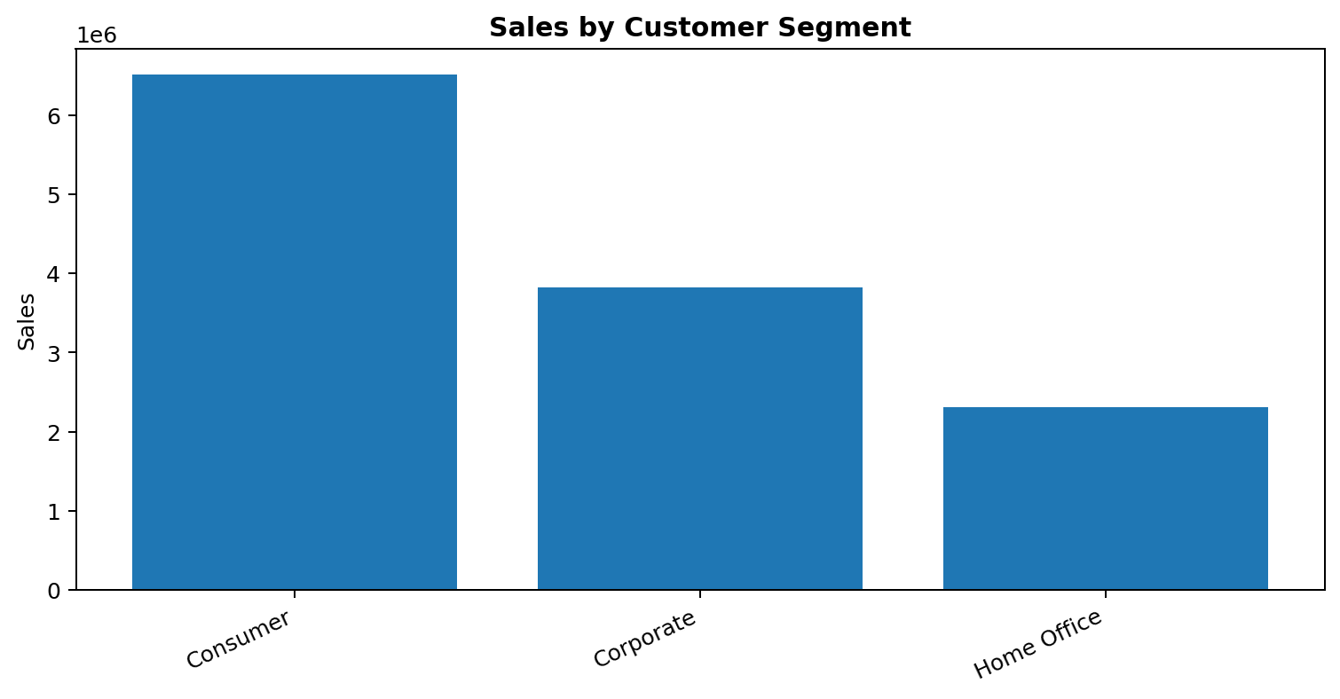
Figure 3. Sales by customer segment.

6. Findings and Recommendations
- Technology has the highest sales among the three categories, followed by Furniture and Office Supplies.
- Technology also has the highest profit in the available category summary. Office Supplies contributes more profit than Furniture despite lower sales.
- The Consumer segment has the largest sales total among the three customer segments.
- Regional totals vary widely. Confirm region definitions before making business decisions.

7. Limitations
Some values were transcribed from the pivot screenshot and should be verified against the original source data. No unsupported claim about AI-generated analysis is made.

8. Conclusion
Pivot tables, KPI totals and charts turn transaction data into a concise business summary. The next improvement is to validate every total directly against the complete dataset.

SPREADSHEET CHART SCREENSHOTS
The following images are screenshots of charts rendered from the accompanying Excel workbooks.
Figure A. Sales by product category — Excel dashboard
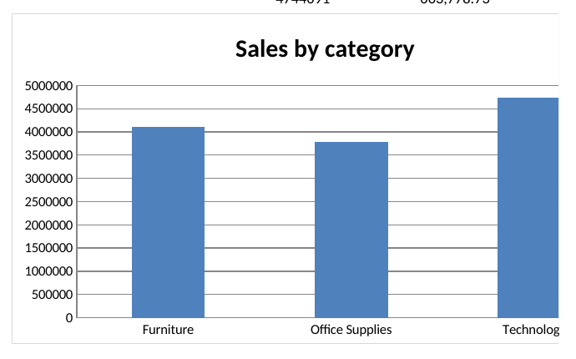
Figure B. Profit by product category — Excel dashboard
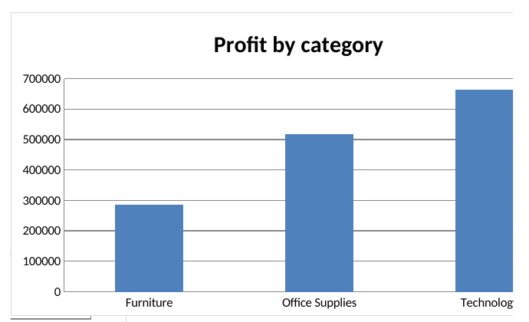
Figure C. Sales by customer segment — Excel dashboard


