PROJECT 2: SALES TREND VISUALIZATION
Time-based retail sales analysis
Student Name: Sneha Das
Internship Organization: CODTECH IT SOLUTIONS PRIVATE LIMITED
Internship Track: Data Science
Duration: 8 Weeks
Internship Period: 18 September 2026 – 13 November 2026
Intern ID: CITS9200
Tools: Microsoft Excel / Google Sheets and Microsoft Word

1. Introduction
Sales trend analysis studies how sales change across days, months, quarters or years. A line chart is suitable for monthly data, while a column chart can compare annual totals. The supplied workbook's monthly sales and profit cells are not populated, so this report does not invent a time trend.

2. Objectives
- Prepare monthly sales and profit summaries from order dates.
- Build a line chart after the monthly pivot table is populated.
- Compare annual totals and identify seasonal patterns only when supported by the data.
- Document the remaining step required to complete a true time-series chart.

3. Step-by-Step Method
- Select the full raw dataset including headers and choose Insert → Pivot table → New sheet.
- Add order_date to Rows and group dates by year and month, if available.
- Add sales to Values summarized by SUM; add profit summarized by SUM.
- If necessary, create a month label using =TEXT(date_cell,"yyyy-mm").
- Select the populated Month and Sales columns, choose Insert → Chart and select Line chart.
- Create a second pivot with Year in Rows and SUM of sales in Values, then insert a column chart.
- Verify grand totals against the source data before interpreting trends.

4. Available Visual Baseline
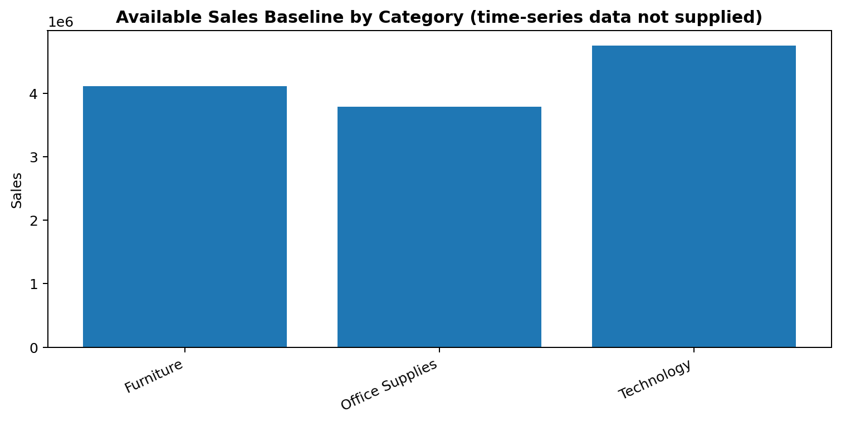
Figure 1. Sales by category is the currently available baseline; it is not a monthly trend chart.
The provided workbook has a monthly template but no month-level sales/profit values. Seasonal peaks, growth rates and annual trends cannot responsibly be reported until the original transaction-level dataset is connected.

5. Interpretation Framework
- Compare each month with the previous month after the pivot is populated.
- Month-over-month change = (current month sales − previous month sales) ÷ previous month sales.
- Compare the same month across years to investigate seasonality.
- Investigate unusual changes against promotions, stock, pricing and order volume.

6. Conclusion
This report documents the workflow for a defensible sales-trend analysis. A true monthly chart must be created after the original date and sales columns are available.

SPREADSHEET CHART SCREENSHOTS
The following images are screenshots of charts rendered from the accompanying Excel workbooks.
Figure A. Monthly sales trend chart — Excel workbook
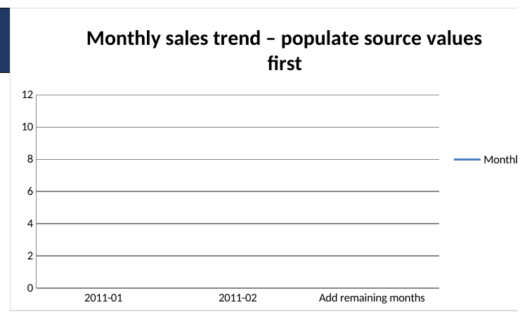
The screenshot shows the current chart template. It is not yet a valid sales trend because monthly sales values have not been populated from the original transaction data.

