PROJECT 3: DATA CLEANING AUTOMATION
Retail data-quality workflow
Student Name: Sneha Das
Internship Organization: CODTECH IT SOLUTIONS PRIVATE LIMITED
Internship Track: Data Science
Duration: 8 Weeks
Internship Period: 18 September 2026 – 13 November 2026
Intern ID: CITS9200
Tools: Microsoft Excel / Google Sheets and Microsoft Word

1. Executive Summary
This project demonstrates a repeatable method for detecting and documenting data-quality issues. The accompanying workbook contains a simulated 30-row retail dataset with deliberately introduced issues, a raw-data tab, cleaned-data tab, quality log, summary and chart. It is explicitly a demonstration and not real company data.

2. Objectives
- Detect missing values, inconsistent text, malformed dates and suspicious date sequences.
- Standardize labels and convert numeric fields consistently.
- Derive values only when required inputs are available.
- Preserve original data and maintain a traceable quality log.
- Compare row counts and key totals before and after cleaning.

3. Workbook Structure
- Raw_Dirty_Data: source-like demonstration records.
- Cleaned_Data: standardized values and review flags.
- Quality_Log: checks, results and actions.
- Cleaning_Summary: quality measures and totals.
- P3_Monthly_Trend: chart-ready summary.

4. Step-by-Step Cleaning Process
- Keep an untouched copy of the original data.
- Inspect headers and expected column types.
- Trim whitespace and standardize category/product labels.
- Parse dates; mark invalid dates for review instead of guessing replacements.
- Convert numeric fields carefully; do not treat missing values as zero without a business rule.
- Derive sales as quantity × unit price only if this matches the source definition.
- Derive profit as sales − cost only if the source definitions are confirmed.
- Flag ship dates earlier than order dates for review.
- Investigate repeated IDs before deletion because multiple line items may share an order ID.
- Compare row counts and totals, documenting each transformation.

5. Useful Google Sheets Formulas
- Count blanks: =COUNTBLANK(A2:A)
- Count numeric cells: =COUNT(B2:B)
- Count non-empty cells: =COUNTA(A2:A)
- Flag date-order issues: =IF(OR(B2="",C2=""),"REVIEW: missing date",IF(C2<B2,"REVIEW: ship before order","OK"))
- Create month label: =IF(B2="","",TEXT(B2,"yyyy-mm"))

6. Chart
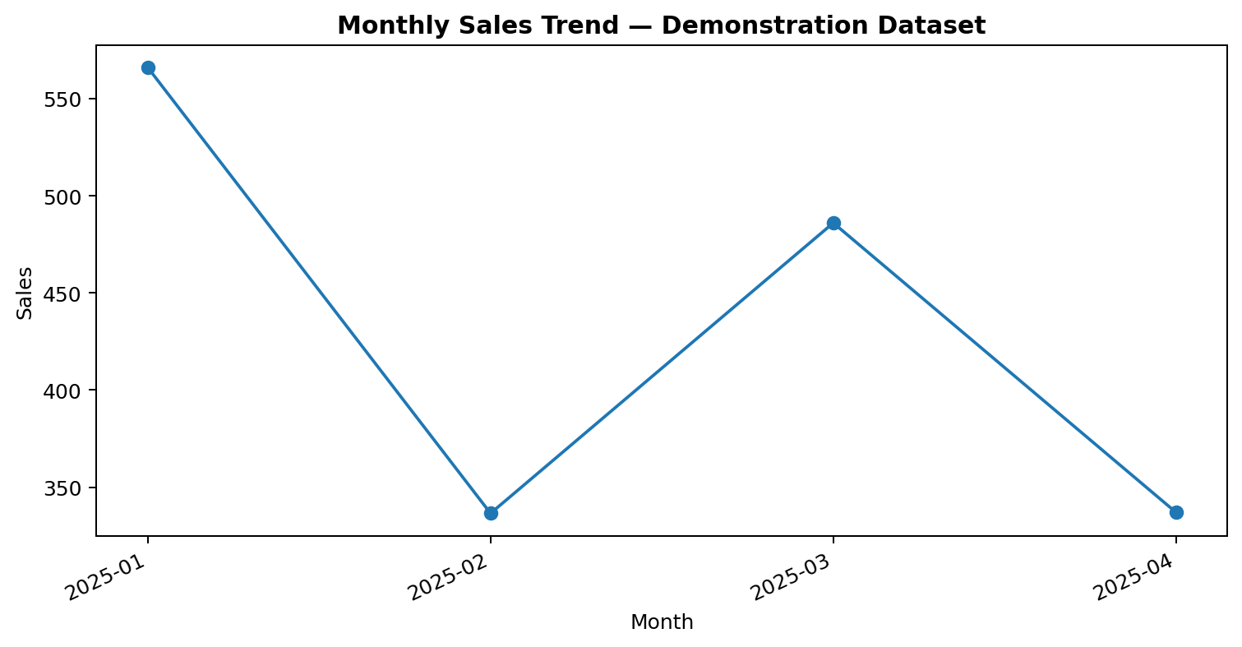
Figure 1. Monthly sales visualization for the simulated cleaning demonstration dataset.

7. Interpretation and Limitations
The dataset is simulated and illustrates a workflow rather than estimating real data quality. Uncertain records remain flagged for review. Negative profit can be valid, and repeated order identifiers may represent multiple order lines.

8. Conclusion
Reliable analytics begins with preserving source data, documenting quality problems, applying defensible rules, validating totals and retaining an audit trail.

SPREADSHEET CHART SCREENSHOTS
The following images are screenshots of charts rendered from the accompanying Excel workbooks.
Figure A. Sales by region — cleaning summary workbook
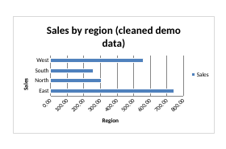
This chart uses the simulated demonstration dataset included in the workbook.
Figure B. Monthly sales after cleaning — cleaning workbook


