PROJECT 4: FUTURE OF DATA – QUANTUM ANALYTICS
Retail shipment optimization case study
Student Name: Sneha Das
Internship Organization: CODTECH IT SOLUTIONS PRIVATE LIMITED
Internship Track: Data Science
Duration: 8 Weeks
Internship Period: 18 September 2026 – 13 November 2026
Intern ID: CITS9200
Tools: Microsoft Excel / Google Sheets and Microsoft Word

1. Executive Summary
This project explores how a retail shipment-allocation problem could be represented as an optimization task and how a future quantum approach might be evaluated. The workbook includes a small illustrative problem and a classical baseline. Route costs, capacities and demands are teaching values, not actual company data. No quantum computer or simulator was run, and no quantum speedup is claimed.

2. Research Question
Could quantum optimization methods eventually help choose low-cost shipment quantities while meeting regional demand and warehouse capacity constraints?

3. Business Problem and Model
A retailer has two warehouses and two regions. Decision variables represent units shipped from each warehouse to each region. The objective is to minimize total shipping cost while satisfying regional demand and respecting warehouse capacity.
- Objective: minimize total shipping cost across all routes.
- Demand constraints: units sent to each region must meet its demand.
- Capacity constraints: units shipped from each warehouse cannot exceed stock.
- Decision variables are non-negative integers.

4. Illustrative Inputs
- Warehouse A capacity: 70 units; Warehouse B capacity: 50 units.
- North demand: 60 units; South demand: 60 units.
- Illustrative unit costs: A→North = 4, A→South = 6, B→North = 5, B→South = 3.
- These are invented teaching values, not actual company costs.

5. Classical Baseline Chart
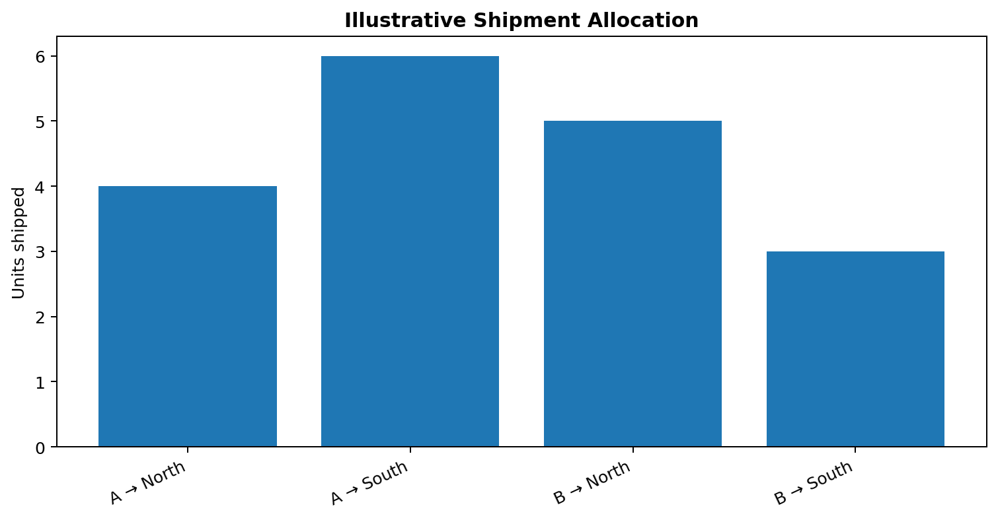
Figure 1. Illustrative shipment allocation from the spreadsheet model.

6. How Quantum Analytics Could Be Studied
Methods such as the Quantum Approximate Optimization Algorithm (QAOA) and quantum annealing are research approaches for selected optimization problems. A future experiment would encode the decisions and constraints, run a documented implementation, and compare results against a strong classical baseline.

7. Evaluation Plan
- Use identical costs, demand and capacity in both approaches.
- Check feasibility of all demand and capacity constraints.
- Compare total cost and solution feasibility.
- Measure runtime consistently, including preparation and encoding overhead.
- Record software, hardware/simulator, parameters, repetitions and variability.
- Claim quantum advantage only if reproducible results beat a strong classical method on a meaningful problem.

8. Limitations
Quantum hardware may be noisy and limited in scale; encoding constraints can increase problem size; classical optimization is often more practical for small examples. This is a conceptual case study with a classical worked example, not an executed quantum experiment.

9. Conclusion
The project demonstrates how to translate a business question into an optimization model and design a fair future comparison. Any claim about quantum advantage requires an actual experiment and transparent evidence.

SPREADSHEET CHART SCREENSHOTS
The following images are screenshots of charts rendered from the accompanying Excel workbooks.
Figure A. Illustrative shipment allocation — Excel worked example
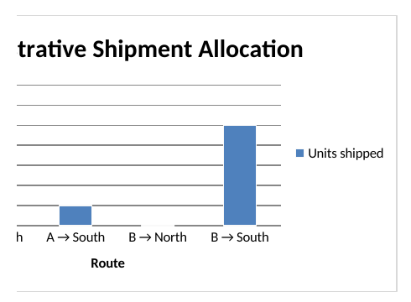
The chart uses illustrative teaching values, not actual company shipping records or a quantum-computer result.

