Progress 1

UI and Business Rules Document

Module: IT3040 – ITPM | Semester 1
Programme: BSc (Hons) in Information Technology — Year 3
Date: March 2026

1. Student Details
Field | Value
Student Name | Akshayan
Registration Number | IT23587106
Responsible Component(s) | Idea & Guidance Module (Member 2)
Description | A web module that lets students submit project ideas with validation, receive recursive threaded feedback from mentors and peers, and view guidance threads per project.

2. Component Summary
# | UI Screen | Route | Key Screenshot
UI 1 | Project Idea Submission Form | /posts/new | 01-post-form-empty.png
UI 2 | Form Validation Error View | /posts/new (invalid) | 02-post-form-validation-errors.png
UI 3 | Feedback Thread (Comment Tree) | /feedback | 05-feedback-thread-full.png
UI 4 | Guidance Thread | /guidance/[projectId] | 09-guidance-thread.png

3. UI 1: Project Idea Submission Form (/posts/new)
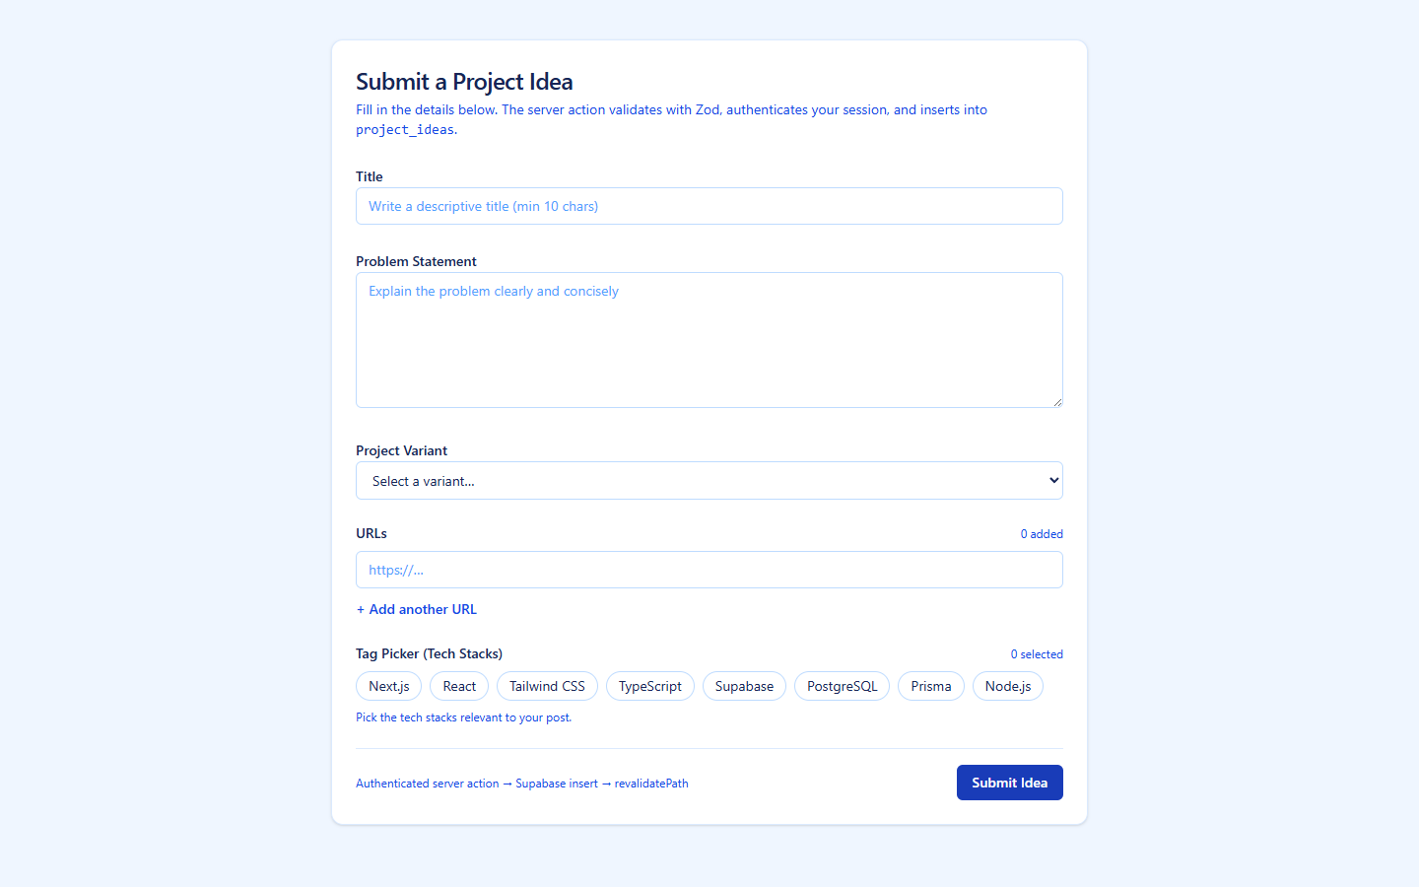
Figure 1 — PostForm empty state
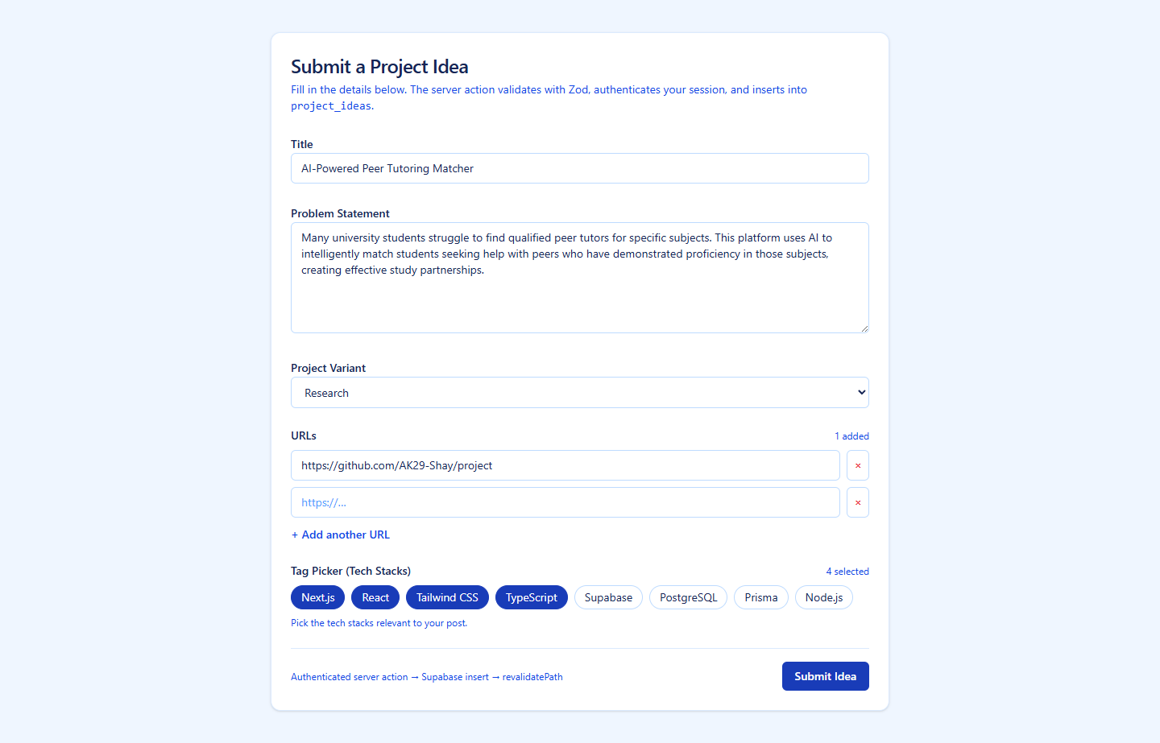
Figure 2 — PostForm filled with ITPM test data

A) Access Control Rules
# | Rule
AC-1 | Only authenticated (logged-in) students can submit a project idea. Unauthenticated users receive an error on submission.
AC-2 | The form page itself is publicly viewable, but the submit action requires a valid Supabase session.

B) Validation Rules (Input Constraints)
# | Field | Rule
VR-1 | Title | Mandatory. Minimum 10 characters. Must be a non-empty string.
VR-2 | Problem Statement | Mandatory. Must be a non-empty string.
VR-3 | Project Variant | Mandatory. Must be one of: research, prototype, capstone, mini-project.
VR-4 | Tech Stacks | Mandatory. At least one tag must be selected. Allowed values: Next.js, React, TypeScript, Tailwind CSS, Node.js, Python, Supabase, PostgreSQL, Prisma, Docker.
VR-5 | URLs | Optional. Each entry must be a valid URL format.
VR-6 | All fields | Validation is performed server-side using Zod schema. Client-side feedback is displayed inline under each invalid field.

C) Process / Workflow Rules
# | Rule
WF-1 | User fills in form fields → clicks "Submit Idea" → server action validates with Zod → if valid, inserts row into project_ideas table in Supabase.
WF-2 | On successful submission, the home page (/) is revalidated and the user sees a success confirmation.
WF-3 | On validation failure, the form re-renders with inline error messages below each invalid field. Data already entered is preserved.
WF-4 | The submit button shows "Submitting…" and is disabled while the server action is in progress, preventing double submissions.

D) Data Consistency Rules
# | Rule
DC-1 | Each submitted idea is stored with the authenticated user's ID (user_id from Supabase auth).
DC-2 | The tech_stack field is stored as a JSON array in the database.
DC-3 | The variant field is stored as one of the four allowed enum values.

E) Notification / System Response Rules
# | Rule
NR-1 | On successful insert, a success message is returned and the page is revalidated.
NR-2 | On validation failure, individual field errors are displayed in red text beneath the respective input.
NR-3 | On server/database error, a generic error message is displayed to the user.

4. UI 2: Form Validation Error View (/posts/new — invalid submit)
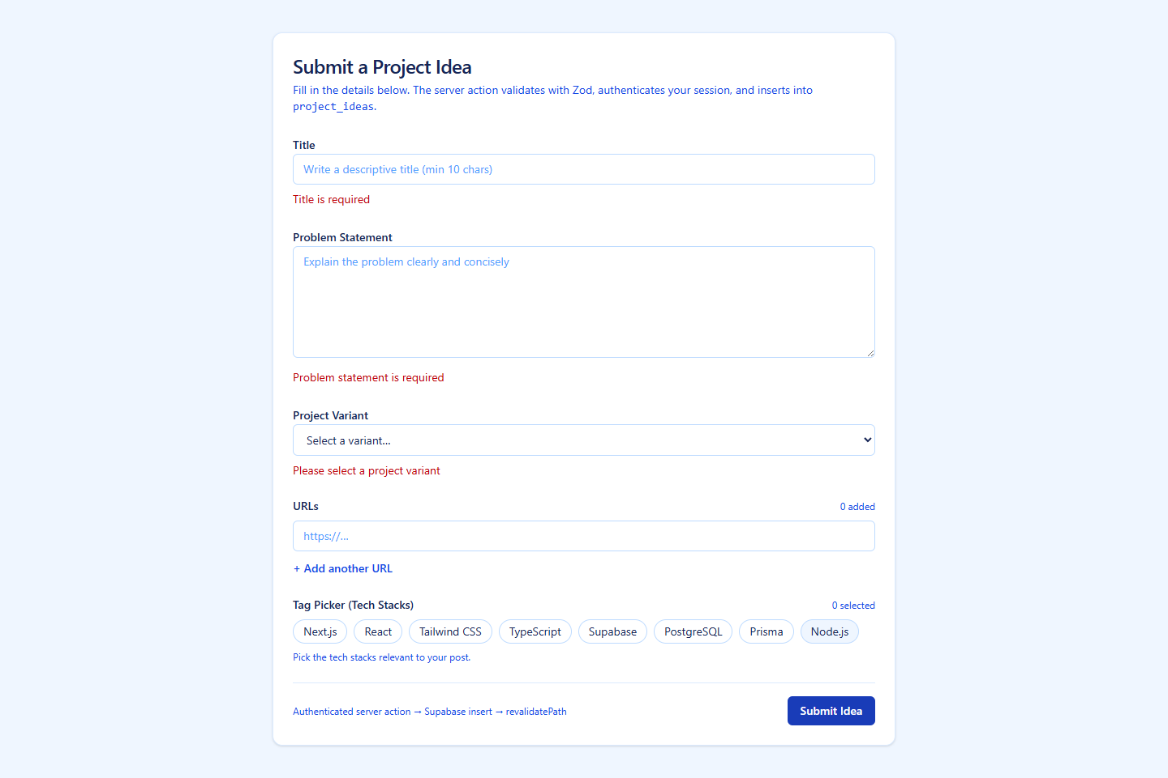
Figure 3 — All validation errors displayed
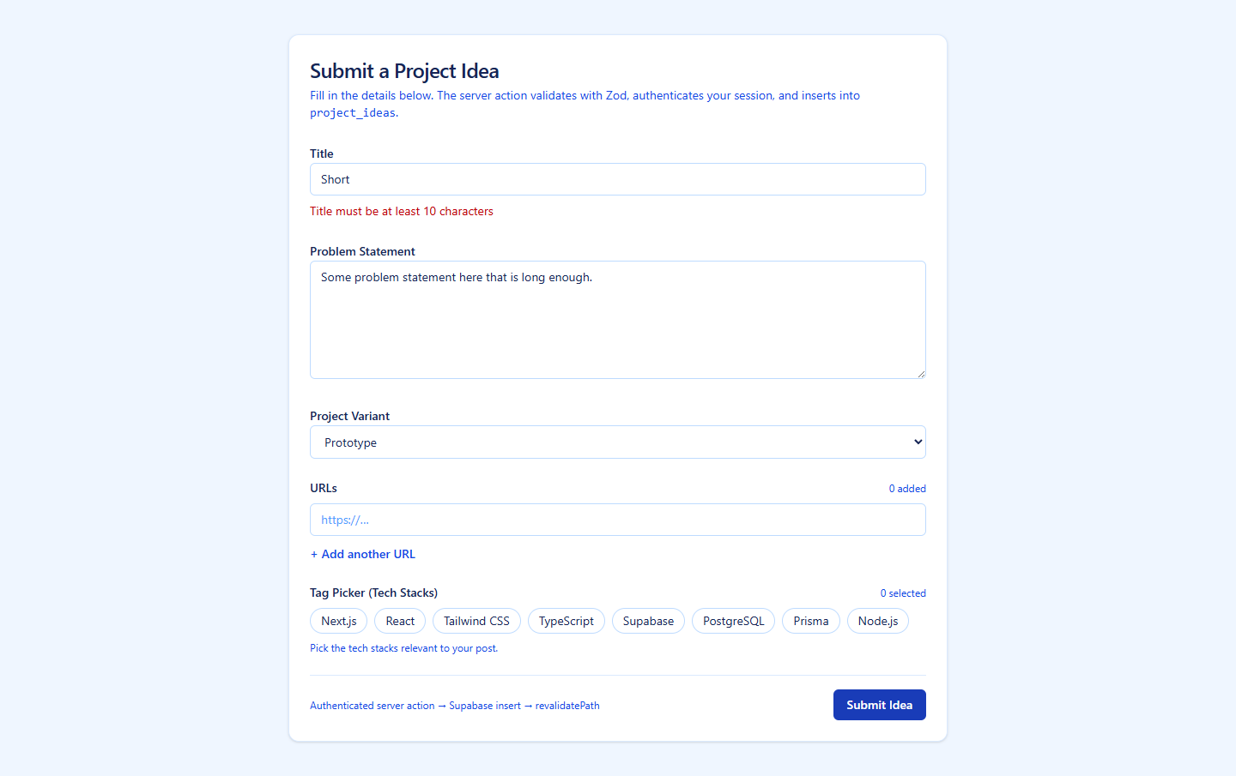
Figure 4 — Title minimum-length error

B) Validation Rules (Input Constraints)
# | Scenario | Expected Behavior
VE-1 | All fields empty → Submit | Errors shown for: Title ("at least 10 characters"), Problem Statement ("Required"), Tech Stacks ("Select at least one").
VE-2 | Title fewer than 10 characters | "Title must be at least 10 characters."
VE-3 | No variant selected | "Please select a project variant."
VE-4 | No tech stacks selected | "Select at least one technology."
VE-5 | Invalid URL format entered | URL-specific validation message.

F) System Response Rules
# | Rule
SR-1 | Error messages appear inline in red (text-red-600) directly below each invalid field.
SR-2 | The form is not submitted when validation fails — no database write occurs.
SR-3 | Previously entered valid data is preserved when the form re-renders with errors.

5. UI 3: Feedback Thread — Comment Tree (/feedback)
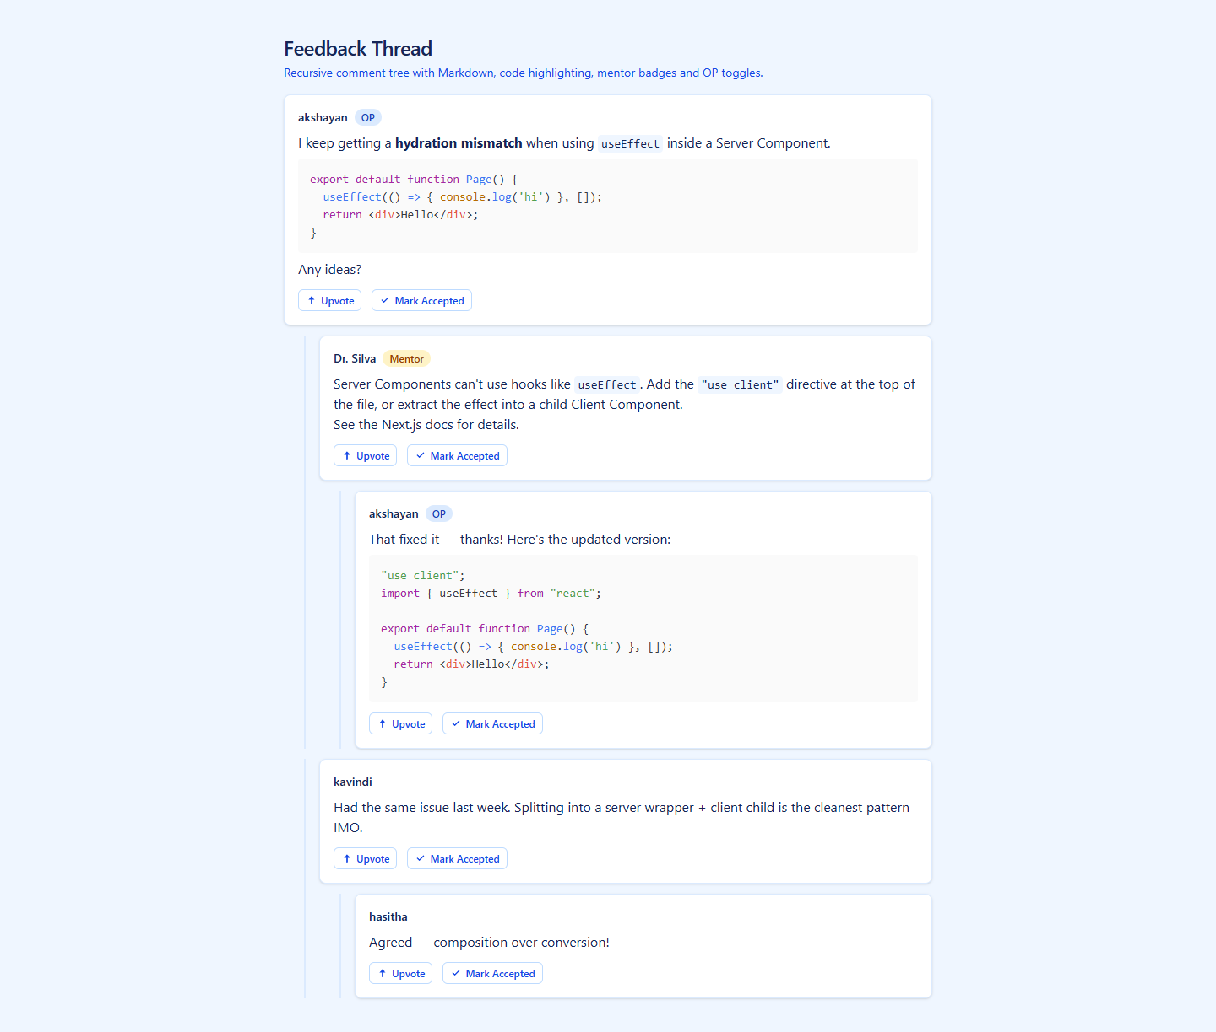
Figure 5 — Full feedback thread with nested comments
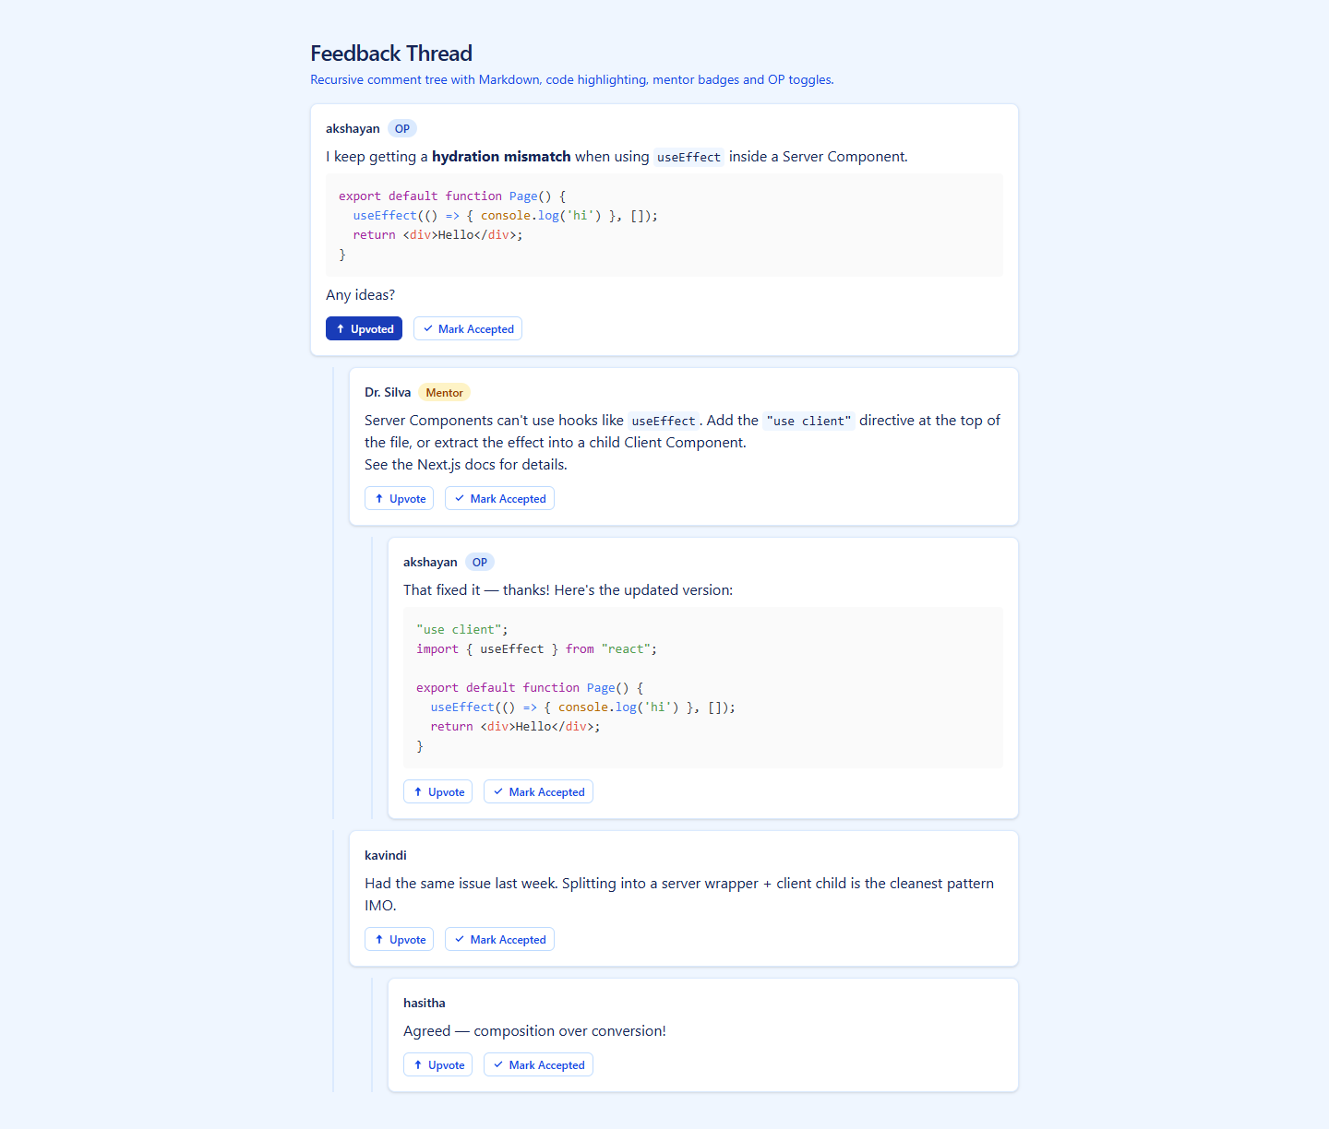
Figure 6 — Upvoted comment state

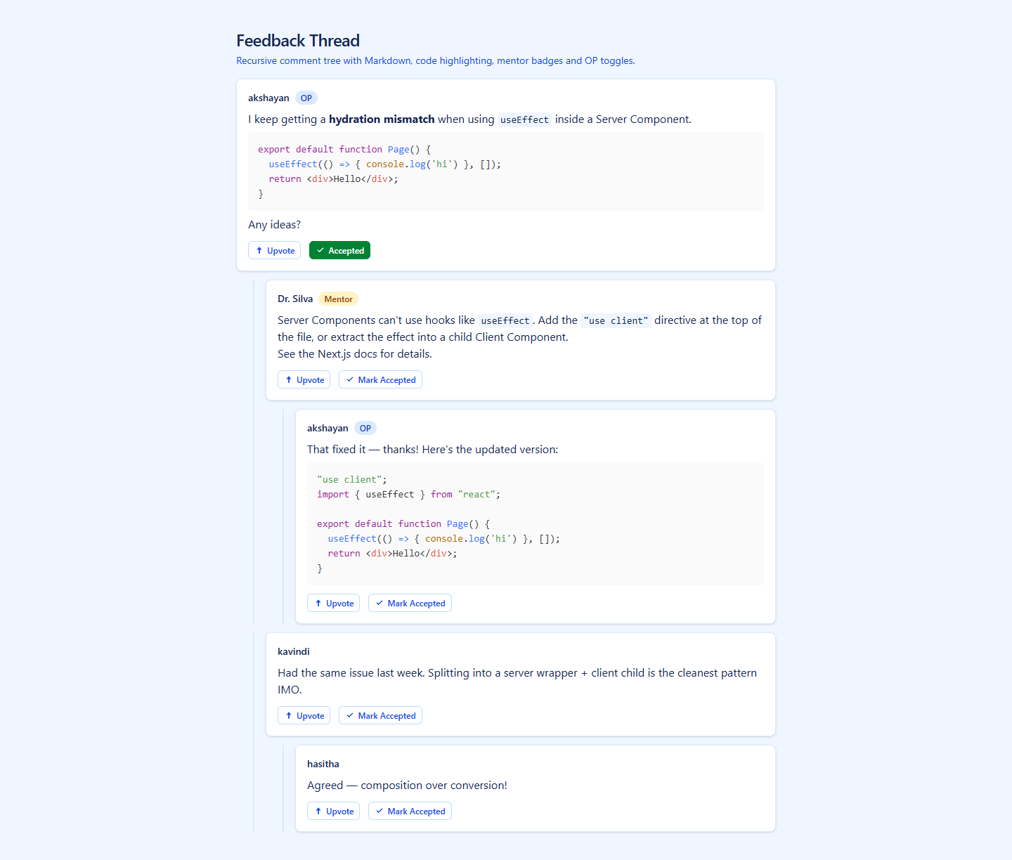
Figure 7 — Accepted comment state (OP view)
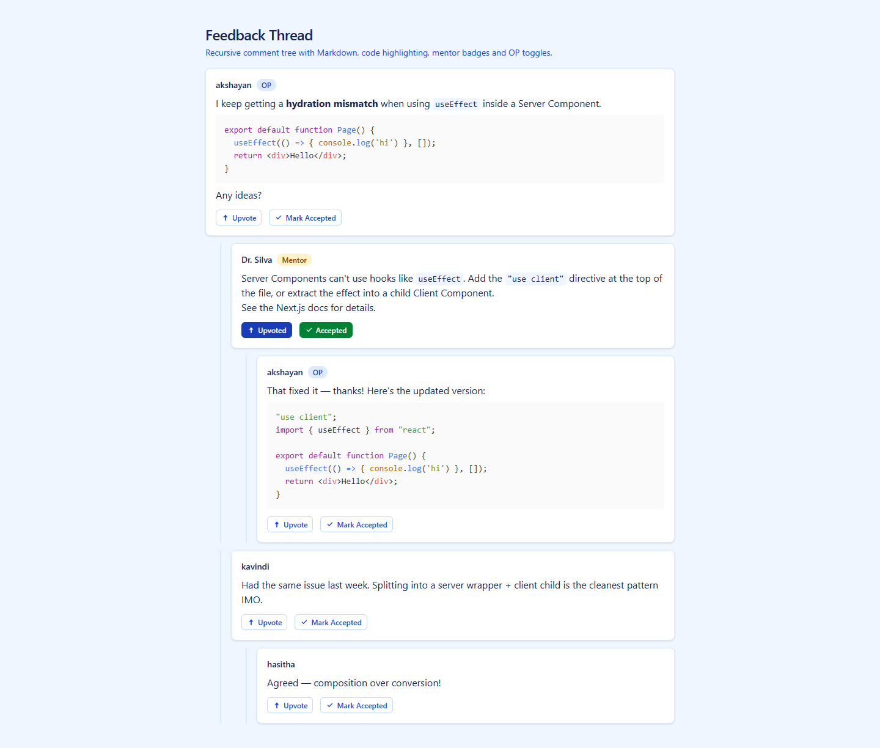
Figure 8 — Upvote + Accept active simultaneously

A) Access Control Rules
# | Rule
AC-3 | The feedback thread page is viewable by all users (public).
AC-4 | The "Mark Accepted" button is visible only to the Original Poster (OP). Other users cannot see or interact with it.
AC-5 | The "Upvote" button is available to all users viewing the thread.

B) Display Rules
# | Rule
DR-1 | Comments are rendered as a recursive tree. Root comments appear at the top level; replies are indented with a left blue border.
DR-2 | Nesting depth is unlimited — replies to replies render at increasing indentation.
DR-3 | Mentor comments display an amber badge (text "Mentor") next to the author name.
DR-4 | OP (Original Poster) comments display a blue badge (text "OP") next to the author name.
DR-5 | Student comments have no special badge.
DR-6 | Comment body supports full Markdown: bold, links, inline code, and fenced code blocks with syntax highlighting.

C) Interaction Rules — Upvote Toggle
# | Rule
UV-1 | Each comment has an "Upvote" button. Clicking it toggles the state to "Upvoted".
UV-2 | When upvoted, the button text changes to "Upvoted", aria-pressed changes from false to true, and the button background changes to blue.
UV-3 | Clicking "Upvoted" toggles back to the initial "Upvote" state (aria-pressed="false", default styling).
UV-4 | Upvote state is maintained per-comment and is independent of other comments.

D) Interaction Rules — Accept Solution Toggle (OP Only)
# | Rule
AS-1 | The "Mark Accepted" button appears only when isOP is true. It is rendered on every comment in the thread.
AS-2 | Clicking "Mark Accepted" toggles the state to "Accepted" with aria-pressed="true" and a green background.
AS-3 | Clicking "Accepted" toggles back to "Mark Accepted" (aria-pressed="false", default styling).
AS-4 | Both Upvote and Accept can be active simultaneously on the same comment. They are independent toggles.

E) Data Consistency Rules
# | Rule
DC-4 | Upvote and accept states are currently client-side only (React useState). They reset on page reload.
DC-5 | Comment data (author, role, content, parent_id) is passed as props from the server component.

6. UI 4: Guidance Thread (/guidance/[projectId])
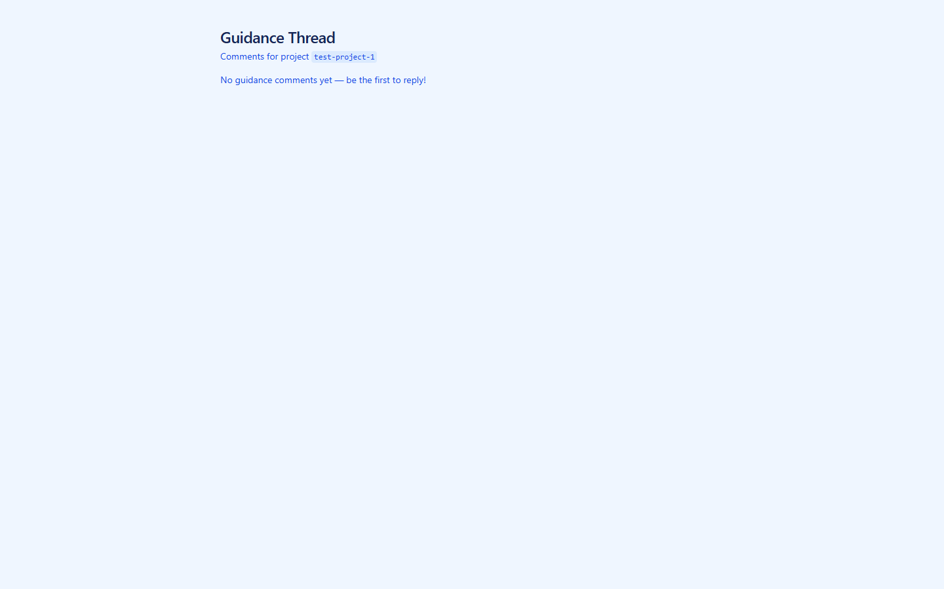
Figure 9 — Guidance Thread page (empty state)

A) Access Control Rules
# | Rule
AC-6 | The guidance thread page is accessible via dynamic route /guidance/[projectId]. Any user with the URL can view it.
AC-7 | Comments are fetched from the Supabase comments table filtered by project_id.

B) Display Rules
# | Rule
DR-7 | The page heading reads "Guidance Thread" with the projectId displayed in a code tag in the subtitle.
DR-8 | If no comments exist for the given projectId, an empty state message is shown: "No guidance comments yet — be the first to reply!"
DR-9 | If comments exist, they are rendered as a recursive tree identical to the Feedback Thread structure (nested, indented, with role badges).
DR-10 | Each comment shows a created_at timestamp in addition to author and content.

C) Data Fetch Rules
# | Rule
DF-1 | Comments are fetched server-side (async Server Component) using fetchCommentsByProjectId().
DF-2 | Comments are ordered by created_at ascending to ensure parent nodes are processed before children.
DF-3 | If Supabase environment variables are not configured, the function returns an empty array gracefully (no crash).
DF-4 | If the Supabase query fails, the error is logged to the server console and an empty array is returned.

D) Tree Building Rules
# | Rule
TB-1 | The buildCommentTree() function converts a flat array of comments into a nested tree using an O(n) single-pass algorithm.
TB-2 | Comments with parent_id: null become root nodes. Comments with a valid parent_id are nested under their parent's children array.
TB-3 | Orphan comments (with a parent_id that doesn't match any existing comment) are promoted to root level.

7. Testing Evidence

Unit Tests (Vitest)
7 tests covering the createProjectIdea server action: validation of all fields, Zod schema enforcement, Supabase integration error handling.

E2E Tests (Playwright)
25 tests across 8 describe blocks covering all 4 UIs:
- PostForm field validation (3 tests)
- PostForm submission with ITPM test data (2 tests)
- FeedbackThread comment tree rendering (4 tests)
- FeedbackThread Markdown rendering (4 tests)
- FeedbackThread role badges (3 tests)
- FeedbackThread upvote interaction (2 tests)
- FeedbackThread accept solution toggle (4 tests)
- GuidanceThread page rendering (3 tests)

Version Control (Git)
- Repository: https://github.com/AK29-Shay/project
- Branch: feature/member2-idea-guidance
- Meaningful commits tracking each feature addition

8. Technology Stack
Technology | Purpose
Next.js 14 (App Router) | Full-stack React framework
React 18 | UI component library
TypeScript 5 | Type-safe development
Tailwind CSS 4 | Utility-first styling
Zod 4 | Schema validation (server-side)
Supabase (SSR) | Database + Authentication
Playwright | E2E automated testing
Vitest | Unit testing
Vercel | Cloud deployment

9. Deployment
Platform: Vercel
GitHub Integration: Auto-deploys from feature/member2-idea-guidance branch
Live URL: https://project-fawn-six-84.vercel.app

