Impact of 6G Network Performance on Manufacturing Efficiency in Smart Factories
A connectivity-first analysis of 100,000 machine records — Thales Group / Unified Mentor project

Abstract
Smart factories rely on 6G network slicing for ultra-low-latency machine communication, yet it is unclear how much network degradation actually harms production. We analyse 100,000 one-minute machine records (50 machines, 1 Jan – 10 Mar 2025) and build a Network Stability Index (NSI), network-quality segments, latency/packet-loss bands and four KPIs. Across every test — chi-square, Spearman, Kruskal–Wallis, OLS, change-point scan and random-forest importance — network latency and packet loss show no practically meaningful relationship with efficiency class, production speed, error rate or defect rate (all |ρ| < 0.01; Cramér's V < 0.01; a model using only network features achieves 33.3% balanced accuracy, equal to random guessing at 33.3%). Efficiency status is, in practice, a deterministic function of Error_Rate and Production_Speed. We conclude that, within the studied operating envelope (latency ≤ 50 ms, loss ≤ 5 %), the data provide no evidence that network performance is an independent driver of efficiency, and we recommend richer telemetry before network-investment decisions are made.

1. Introduction and problem statement
In Industry 4.0/5.0, machines depend on real-time data exchange and AI-driven decisions. Network degradation can silently reduce efficiency without any mechanical failure. Manufacturers therefore lack clarity on (i) whether efficiency drops come from delay or from packet loss, (ii) how much latency variation is tolerable before quality degrades, and (iii) which efficiency levels are most sensitive to instability. Without answers, network investment may be misallocated and network issues misdiagnosed as machine faults.

2. Data
The dataset has 100,000 rows and 14 columns (Date, Timestamp, Machine_ID, Operation_Mode, Temperature_C, Vibration_Hz, Power_Consumption_kW, Network_Latency_ms, Packet_Loss_%, Quality_Control_Defect_Rate_%, Production_Speed_units_per_hr, Predictive_Maintenance_Score, Error_Rate_%, Efficiency_Status). There are no missing values and no duplicate rows. Date and Timestamp were merged into one datetime (the file's time column is named 'Timestamp').
Variable | Min | Mean | Max
Network latency (ms) | 1.0 | 25.6 | 50.0
Packet loss (%) | 0.0 | 2.49 | 5.0
Error rate (%) | 0.0 | 7.50 | 15.0
Defect rate (%) | 0.0 | 5.01 | 10.0
Production speed (units/hr) | 50 | 276 | 500

Class balance: Low 77.8%, Medium 19.2%, High 3.0%. Operation modes: Active 70.1 %, Idle 20.1 %, Maintenance 9.9 %. All variables are approximately uniformly distributed over their ranges and mutually uncorrelated, a pattern typical of simulated data.

3. Methodology
- Network Stability Index (NSI) = 100 × (1 − 0.5·Latency/50 − 0.5·PacketLoss/5). Network quality Low/Medium/High = NSI tertiles.
- Latency bands 0–10, 10–20, 20–30, 30–40, 40–50 ms; packet-loss bands 0–1, 1–2, 2–3, 3–4, 4–5 %.
- Stable vs unstable periods: an hour is 'unstable' if its mean NSI is in the lowest 25 % of hours. Real-time = latency ≤ 10 ms, delayed = > 10 ms.
- Latency Sensitivity Score = OLS slope of efficiency score (Low 0, Medium 1, High 2) per ms. Packet-Loss Impact Ratio = relative speed drop, loss > 4 % vs ≤ 1 %. Network-Efficiency Correlation point = latency / loss threshold that maximises the fall in the share of Medium+High efficiency (change-point scan).
- Statistics: chi-square with Cramér's V, Spearman rank correlation, Kruskal–Wallis, Welch t-tests (Bonferroni-adjusted), random-forest permutation importance with 3-fold cross-validation.

4. Results

4.1 Network performance profiling
Latency and packet loss are uniformly distributed across their ranges with no daily or weekly pattern; mean NSI is 49.5 (σ = 20.1). Stable and unstable hours differ only in network metrics, not in outcomes.
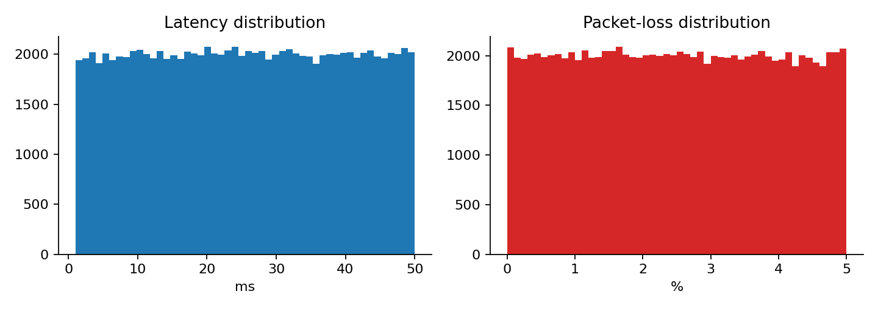
Figure 1 — Latency and packet-loss distributions

4.2 Network vs efficiency
Network quality | Low eff. | Medium eff. | High eff.
Low | 77.9% | 19.1% | 3.0%
Medium | 77.8% | 19.3% | 2.9%
High | 77.8% | 19.2% | 3.0%

The efficiency mix is virtually identical across network-quality segments (chi-square p = 0.89, Cramér's V = 0.0023). By latency band p = 0.69; by packet-loss band p = 0.58. Efficiency shift per +10 ms latency is -0.0006 efficiency-score points (p = 0.61).
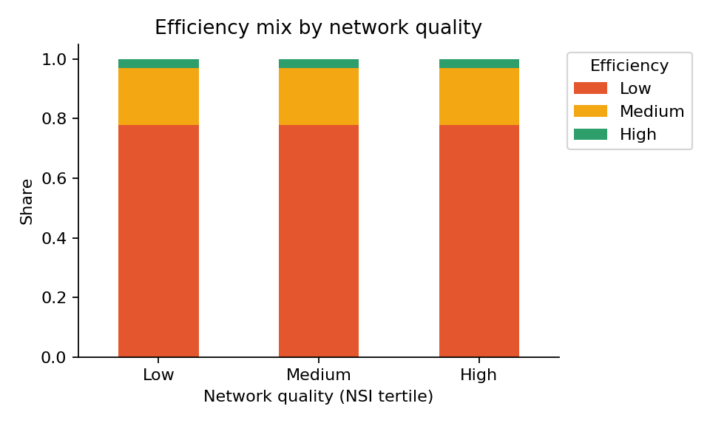
Figure 2 — Efficiency mix by network quality

4.3 Latency impact on production speed
Latency band (ms) | Mean speed (units/hr)
0-10 | 275.2
10-20 | 276.7
20-30 | 275.6
30-40 | 276.5
40-50 | 275.5

Speed varies by under 1.5 units/hr (0.5 %) across bands; Kruskal–Wallis p = 0.73. OLS slope = -0.0097 units/hr per ms (p = 0.74). Real-time (≤ 10 ms) vs delayed communication: 275.2 vs 276.1 units/hr — no slowdown for delayed periods.
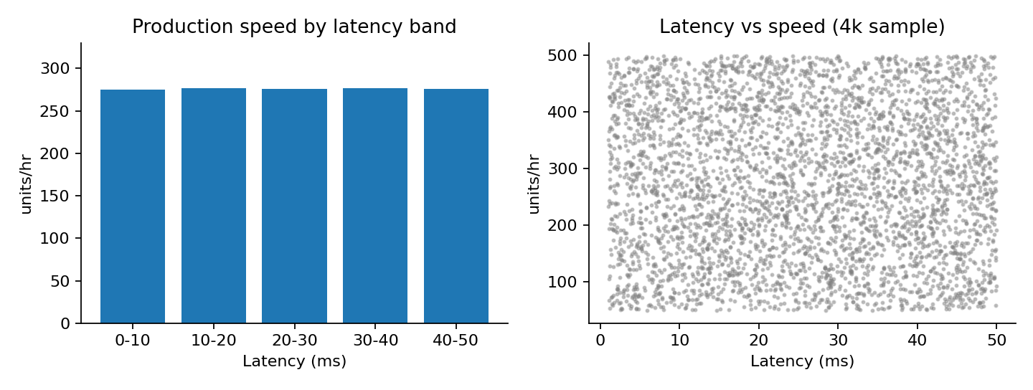
Figure 3 — Production speed vs latency

4.4 Packet-loss impact
Packet-loss band (%) | Error rate (%) | Defect rate (%)
0-1 | 7.51 | 5.04
1-2 | 7.50 | 5.02
2-3 | 7.54 | 4.99
3-4 | 7.48 | 4.96
4-5 | 7.49 | 5.02

Spearman ρ between packet loss and error rate is -0.0024 (p = 0.45); with defect rate ρ = -0.0049 (p = 0.12). The Packet-Loss Impact Ratio is 0.91% of production speed. A Kruskal–Wallis test on defect rate across loss bands gives p = 0.039, but the band means differ by only 0.08 percentage points and the direction is that loss bands are not worse — we regard this as a negligible, multiple-testing-level effect, not an operational risk. Likewise stable vs unstable hours give p = 0.045 with Cramér's V = 0.008 (negligible).
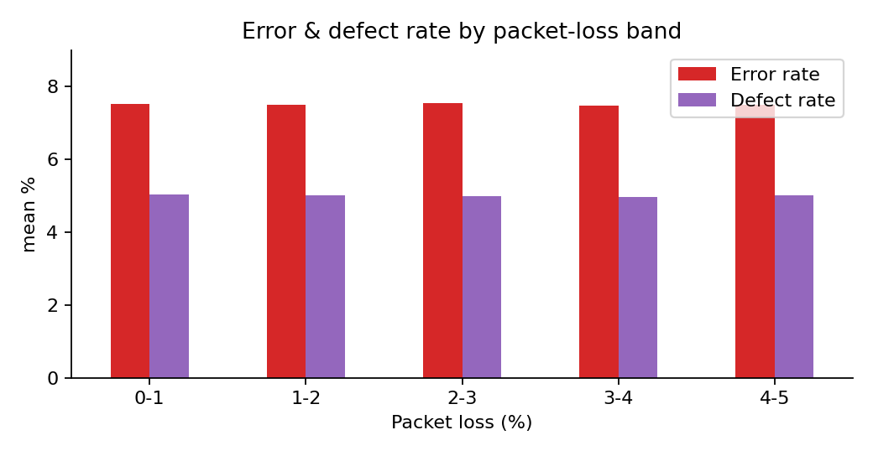
Figure 4 — Error and defect rate by packet-loss band

4.5 Operation-mode interaction
Mode | Low | Medium | High
Active | 77.7% | 19.3% | 3.0%
Idle | 78.2% | 18.9% | 2.8%
Maintenance | 77.8% | 19.2% | 2.9%

No operation mode is more sensitive to delay (chi-square p = 0.47). Under identical mechanical conditions, efficiency stability does not change with network quality.

4.6 What actually determines efficiency
Inspecting class ranges reveals the labelling logic: High ≈ error rate < 2 % and speed > 400 units/hr; Medium ≈ error rate < 5 % and speed > 200 units/hr; everything else Low.
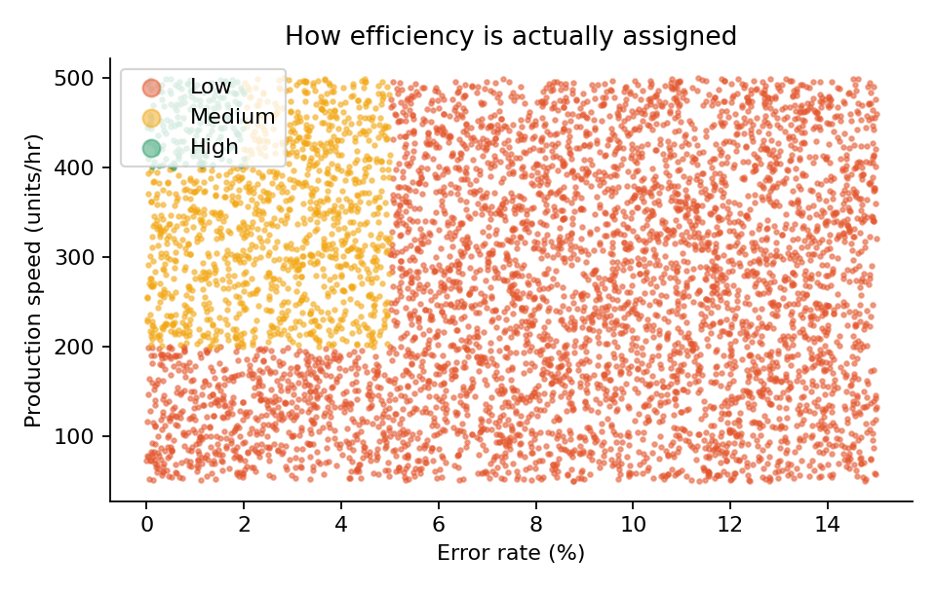
Figure 5 — Efficiency classes in error-rate / speed space
Feature set | Balanced accuracy (3-fold CV)
network_only | 0.333
mechanical_only | 0.329
network+mechanical | 0.332
outputs(speed,error,defect) | 1.000
all | 0.999

Network-only and mechanical-only models perform at chance (0.333); adding error rate and speed gives ≈ 0.999. Permutation importance for latency and packet loss is 0.000.
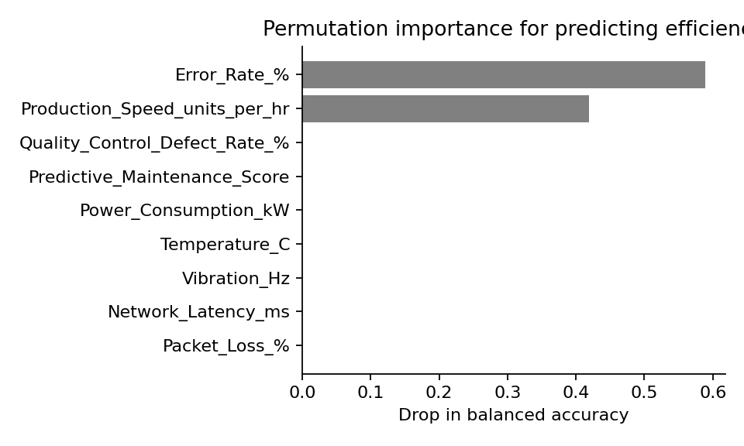
Figure 6 — Permutation importance

4.7 KPI summary
KPI | Value | Interpretation
Network Stability Index | 49.5 / 100 (σ 20.1) | Mid-range, wide spread; no outcome impact
Latency Sensitivity Score | -0.0006 per +10 ms (p = 0.61) | Indistinguishable from zero
Packet-Loss Impact Ratio | 0.91% | < 1 % speed difference (loss >4 % vs ≤1 %)
Network-Efficiency breakpoint | 44.5 ms (drop 0.36 pp); loss 4.75 % (drop 0.72 pp) | Largest of many scanned splits — within noise; no real knee

5. 6G optimisation insights
- Latency tolerance benchmark: no degradation observed anywhere between 1 and 50 ms; the whole observed range is tolerable.
- Packet-loss risk zones: no risk zone identified between 0 and 5 %.
- Most sensitive efficiency level / operation mode: none — High, Medium and Low shares and all three modes are statistically flat.
- Network metrics should not be assumed the root cause of efficiency drops in this dataset; the diagnostic path should start with error rate and throughput.

6. Discussion and limitations
- The brief's hypothesis — network performance is a critical independent driver — is not supported by this dataset. This is an important, reportable result, not a failure of analysis.
- Variables are uniform and mutually independent, which strongly suggests simulated data; real factories would show correlations (e.g. temperature vs vibration) that are absent here.
- Efficiency_Status is a deterministic function of two outcome variables (error rate, speed); predicting it from them is circular, so only the network-only/mechanical-only models are informative about drivers.
- Observed range is limited to ≤ 50 ms and ≤ 5 % loss; effects at extreme degradation (e.g. > 100 ms, > 10 % loss) cannot be ruled out.
- Records are not a continuous per-machine time series (about one record per minute across 50 machines), so lagged cause-and-effect cannot be tested.

7. Recommendations
- Do not prioritise latency or loss reduction below current levels for efficiency reasons; keep ≤ 50 ms / ≤ 5 % as a safe envelope.
- Diagnose efficiency drops via error rate and throughput first, to avoid mislabelling machine problems as network problems (and vice-versa).
- Collect richer telemetry: per-machine continuous series, jitter, retransmissions, network-slice ID, control-loop timing, and degradation events beyond the current range.
- Run controlled experiments (inject latency/loss on a pilot line) to measure causal impact before committing 6G investment.
- Re-run this pipeline on real data; the accompanying Streamlit dashboard is designed to do so without code changes.

8. Conclusion
The connectivity-first lens is methodologically sound and the KPIs defined here are reusable, but this dataset does not show network performance driving manufacturing efficiency. Within the observed envelope, networks are not the bottleneck; error rate and throughput are. Thales and partners should validate on real telemetry before reallocating network budgets.

