**FINAL PROJECT PROPOSAL**

Problem statement

Airbnb wants it analysis and prediction for prices available to their customers to make right decisions while choosing venues for providing good customer experience.

Airbnb also to extend its services to owners or hosts by providing their feedback on how they can improve business.

Also, for investors they decide to help them with searching for good investment opportunities based on location. Based on best model evaluation outcome they wish to deploy the services on cloud.

Dataset for AIRBNB

Dataset:

Link for Airbnb public dataset:

Dataset have 3 files which provide the listing, reviews and calendar dataset.

FlowChart for Working or processes involved in Project

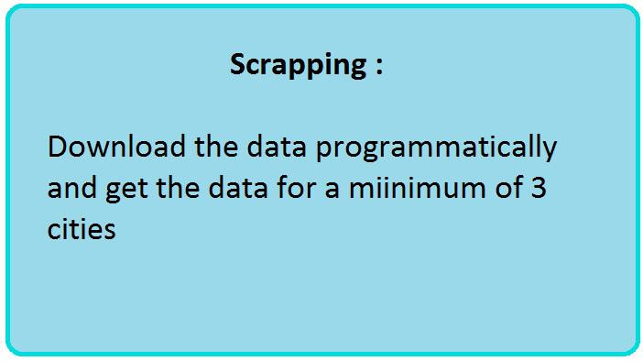

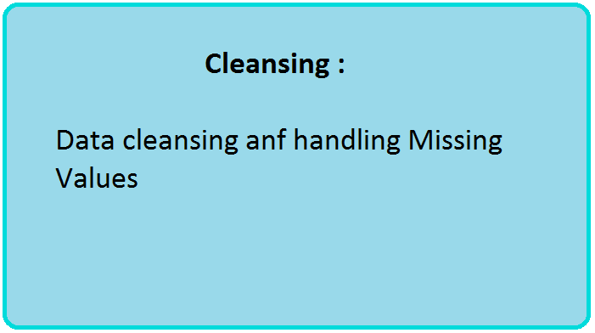

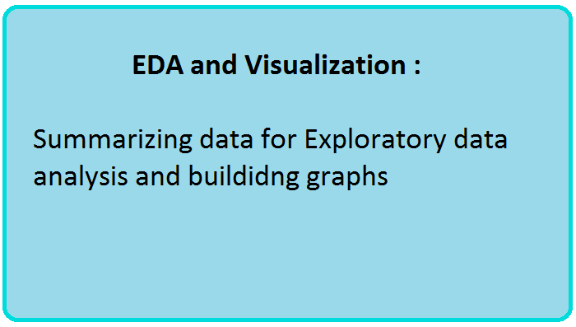

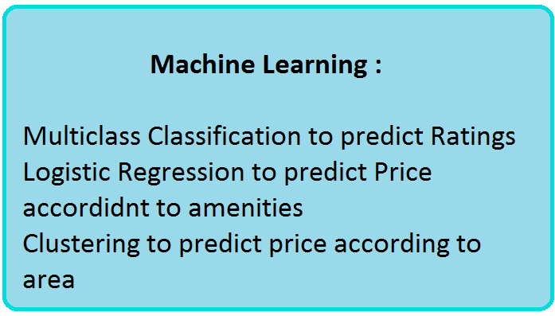

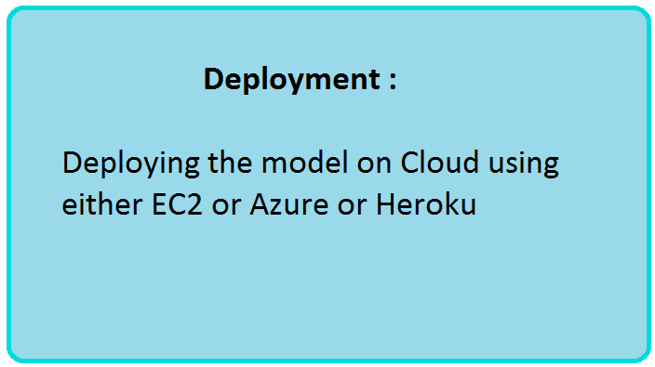

Project Architecture and detailed work flow

Explanaion of Work flow for project:

* Data Ingestion>
* Data Wrangling>
* EDA>
* variable selection>
* Trained Dataset & Test Dataset>
* Machine Learning Algorithm
  + Predicting prices based on utilities
  + Multiclass Classification for host rating
  + Clustering to predict area-specific price range
* Deploy the best model >
* Create APIs >
* Deploy model using web app on cloud
* Dockerizing the modules
* Creating pipelines for implementation.

Process for evaluation:

The problem is to predict the price value for a venue as per the location

Using Airbnb dataset we will predict prices for the available or new venues as per the user rating and current market price .

Prediction for price according to facilities and amenities provided in the venue for customers

Multiclass Classification for host ratings for individual host assessment.

Summarization:

User can use the web app for analysis and prediction.

Present the analysis result using tableau and python notebook

Tools:

* Python notebook
* matplotlib,
* R studio
* Amazon aws
* Azure ML studio
* Pipeline
* Docker

**WEBAPP**

Personas: customer, host

Use cases: each user has analysis and prediction

System Architecture :

Docker -> AMAZON S3 ->(trained data)-> AZURE ML-> (publishes API)> --- website

WEB UI:

**Airbnb Home Page**

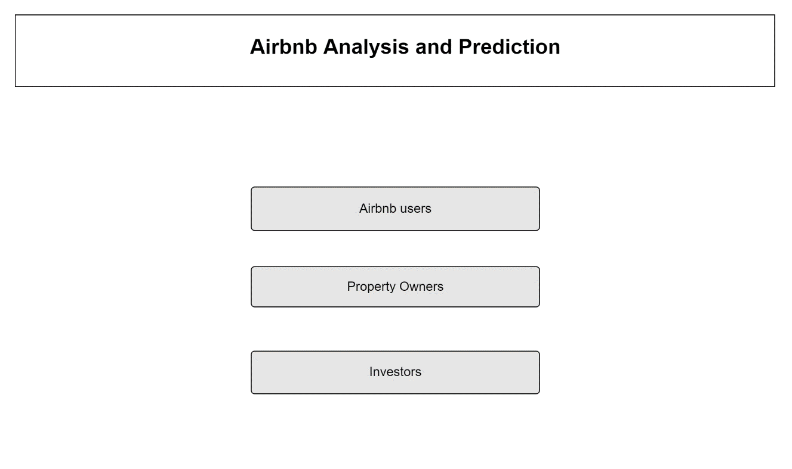

**User Home Page** 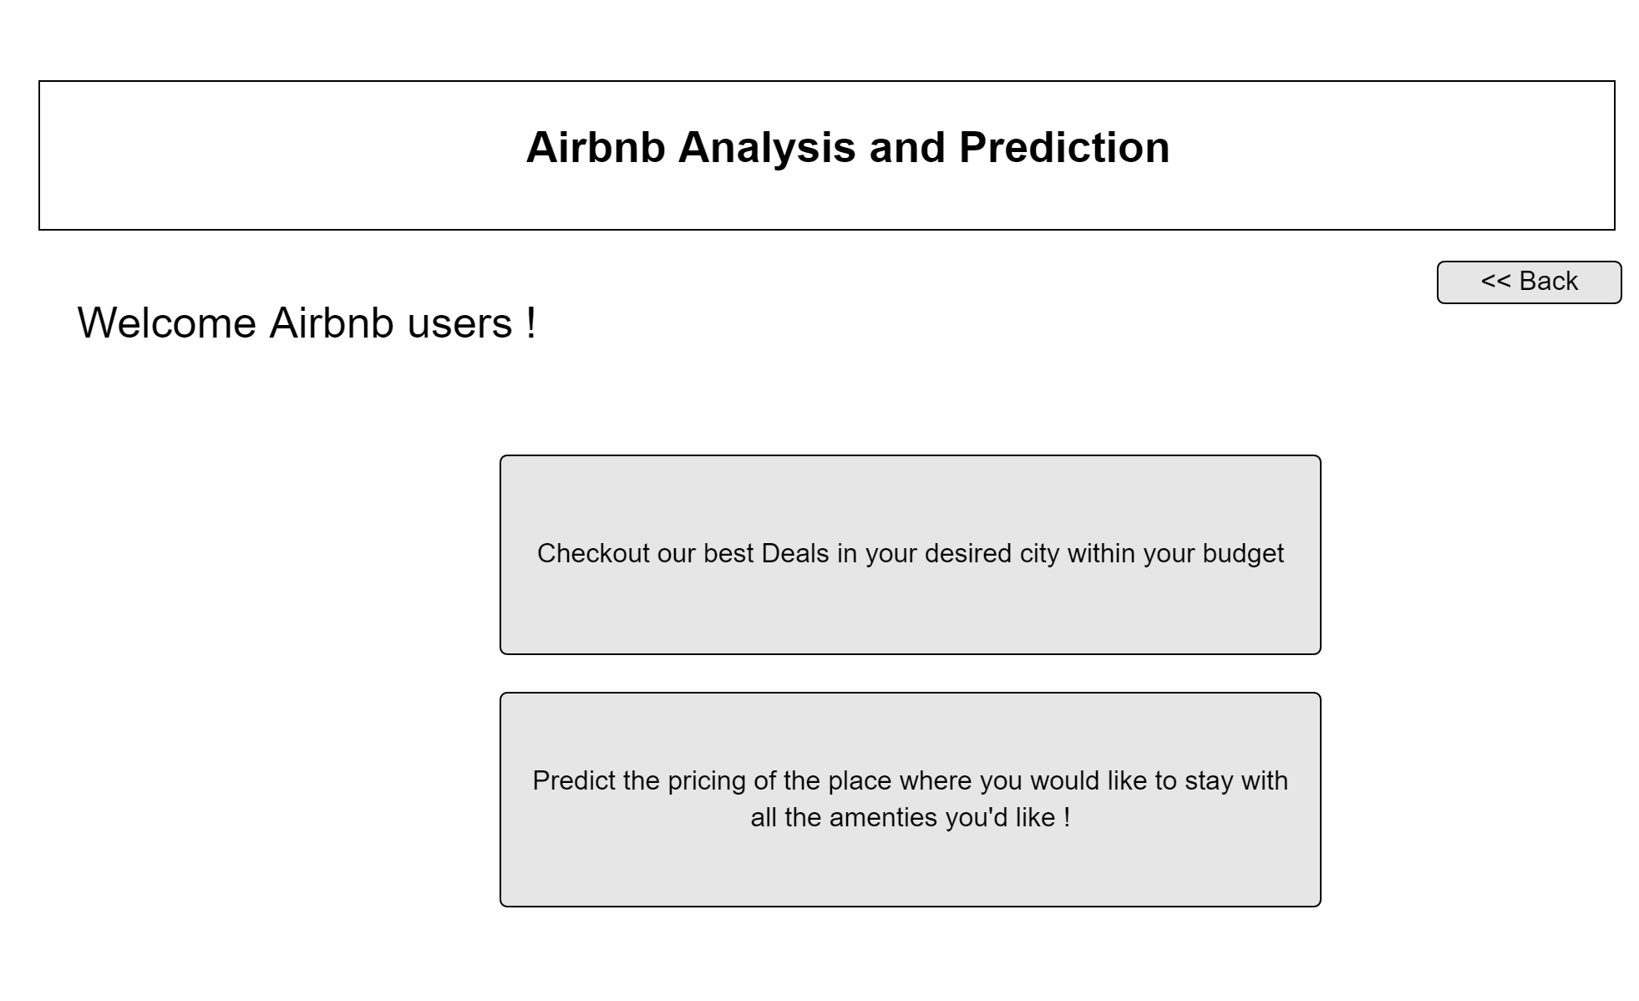

**User analysis page :**

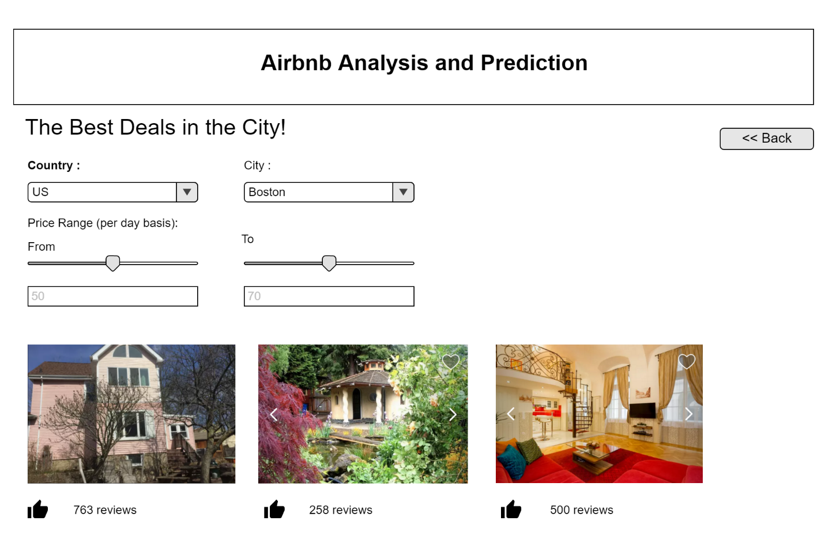

User Prediction page :

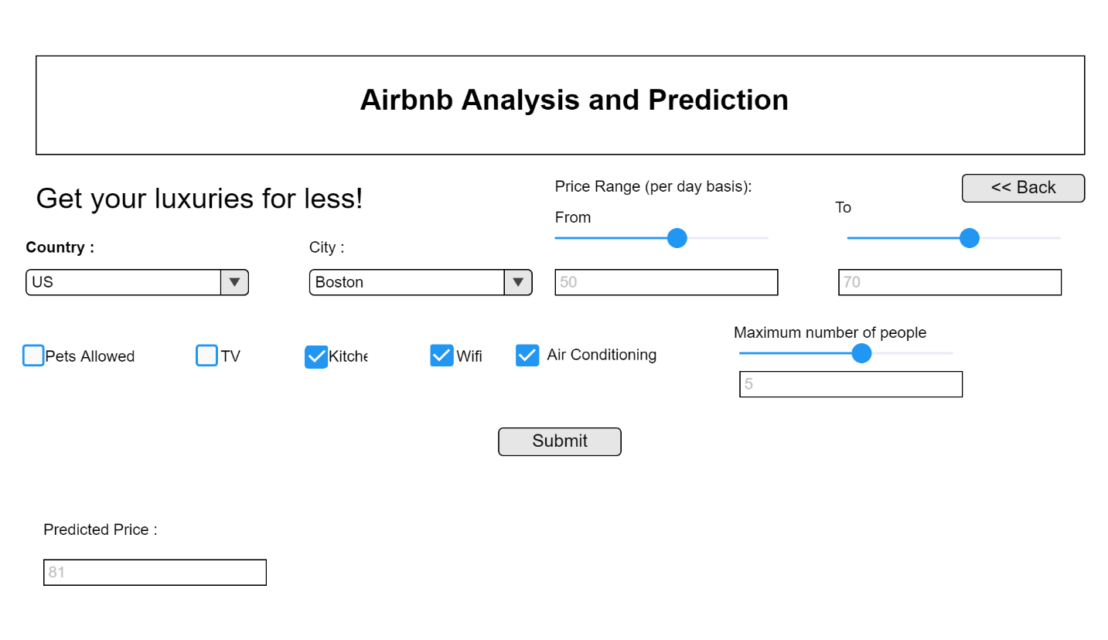**Owner home page :**

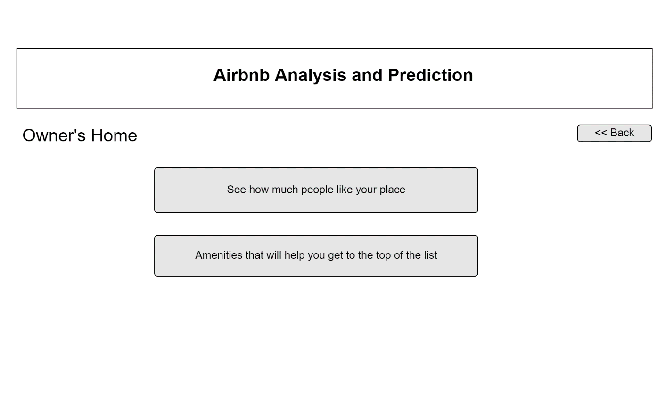

**Owner Analisis page :**

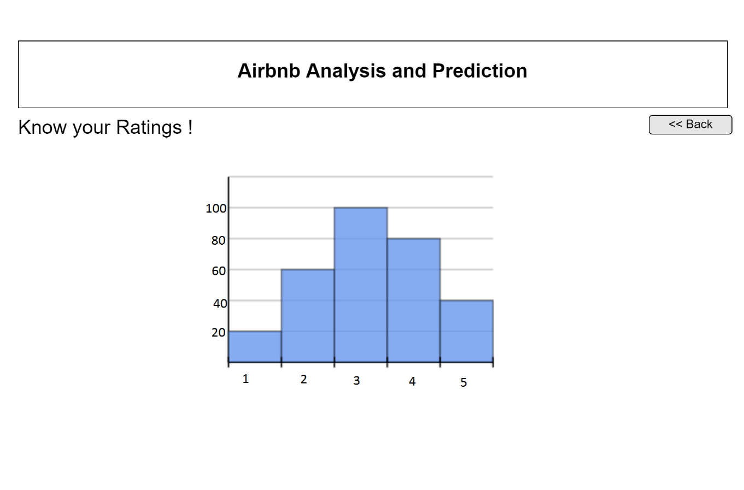

**Owner prediction :**

