**CSE1901 - Technical Answers to Real World Problems (TARP)**

**Project Report**

**LPG GAS LEAKAGE DETECTION**

By

VAISHNAVI .G 19MIS1135

SNEHA .M 19MIS1103

YESANULLA .D 19MIS1006

DHANYASREE .N 19MIS1058

M.Tech (Integrated) Software Engineering

Submitted to

**Dr. NISHA V M**

School of Computer Science and Engineering

**November 2022**

**DECLARATION**

I hereby declare that the report titled “**LPG GAS LEAKAGE DETECTION**” submitted

by me to VIT Chennai is a record of bona-fide work undertaken by me under the

supervision of **Dr**. **NISHA V M**, School of Computer Science and Engineering, Vellore

Institute of Technology, Chennai.

**Signature of the Candidate**

VAISHNAVI .G

SNEHA .M

YESANULLA .D

DHANYASREE .N

19MIS1135

19MIS1103

19MIS1006

19MIS1058

**CERTIFICATE**

This project report entitled “**LPG GAS LEAKAGE DETECTION**” is a bonafide work of VAISHNAVI. G(19MIS1135), SNEHA. M (19MIS1103) , YESANULLA D (19MIS1006), DHANYASREE N (19MIS1058) and they carried out the Project work under my supervision and guidance for CSE1901 - Technical Answers to Real World Problems (TARP).

**Dr. NISHA V M**

HoD , VIT Chennai

**ACKNOWLEDGEMENT**

We would like to acknowledge that my assignment has been completed and I am ensuring that this was done by me and not copied.

In this accomplishment,We would like to express my special gratitude to all my teachers and most importantly our principal Dr. Nisha V M of college name, without their guidance and feedback it is not possible to complete this project.

Finally, we would like to thank my parents and friends who helped me a lot in finishing this assignment.

VAISHNAVI .G

SNEHA .M

YESANULLA .D

DHANYASREE .N

**19MIS1135**

**19MIS1103**

**19MIS1006**

**19MIS1058**

**CONTENTS**

DECLARATION

CERTIFICATE

ACKNOWLEDGEMENT

ABSTRACT

1. Introduction

2. Literature Survey

3. System Design

4. Implementation of System

5. Conclusion and Future Work

6. REFERENCES

**1. INTRODUCTION**

Our project aims to present such a design that can automatically detect, alarm, and control gas leakage using an exhaust fan to suck the gas away from the premises where there is gas leakage. Arduino UNO is used as the main controller of the system and the buzzer is used as a medium of notification. The system will detect the leakage of the Liquefied Petroleum Gas (LPG) using a gas sensor and use the buzzer to alarm about the gas leakage, simultaneously when the home appliance gets off to prevent the undesirable instant to take place. The device is intended for use in household safety where appliances and heaters that use natural gas and LPG may be a source of risk. The system can also be used for other applications in the industries or companies that depend on LPG and natural gas in their operation.

**2. LITERATURE SURVEY**

In this paper lpg leakage detection system using gps and gsm technology, Dr. Deepak P. Kadam, Tushar P. Pandhi (2022), The methodology they used is Controller is used to control all the processes of a system. LPG sensor used to sense the leakage of LPG gas and give indication to the controller. . LCD is used to display the percentage of LPG gas. GSM is used to send the Leakage message and alert SMS to users. Buzzer is used to give audio signals to users in case of leakage. GPS is used to give the exact location of leakage.

Gas Leakage Detection Based on IOT,V Suma, RR Shekar, KA Akshay (2019), proposed model Mq 5 sensor, Arduino,Relay,LCD display,Load cell ,Wifi modem,Buzzer Mq 5 sensor capable of measuring electrode and heater covered by plastic and stainless steel Arduino Arduino is a microcontroller, whose main aim is to make electronic to be as easy as possible. It uses different microcontrollers, containing several input and output pins

Relay A relay is an electrical switch which is used to control all other electronic devices

LCD display LCD (liquid crystal display) contains two interfaces on the upper and lower side of the module, Load cell Load cell is a transducer which is used to transform force into electronic output. Wifi modem WiFi network can easily establish a connection through a serving WiFi adapter.. Buzzer A buzzer is an audio signaling device which is capable of controlling microcontrollers

gas leak detection using iot(A.Mahalingam, r. T. Naayagi, n. E. Mastorakis

) ,They introduce the design and implementation of an economic gas leakage detector. They gave the formulation of many problems in previous gas leakage detectors. They said that several standards have been formulated for the design of a gas leakage detection system such as IEEE, BS 5730, and IEC.For this work, the recommended UK safety standards have been adopted. The proposed alarm system is mainly meant to detect LPG leakage, which is most commonly used in residential and commercial premises. The system detects not only the presence of gas (gas leak), but also the amount of leakage in the air, and accordingly raises an appropriate audio visual alarm. The objective of the system is to detect LPG gasses such as propane and butane. The allowed UK level for butane is 600 ppm above which it is considered to be of high level and poses a danger. The proposed system ensures a continuous monitoring of the gas levels. If the gas level increases above the normal threshold level of 400 ppm butane (LPG), the system starts to issue early warning alarms at 100ms intervals, which implies low level gas leakage. If the leakage level increases to 575 ppm of butane (LPG), the system activates high severity audio alarms at 50 ms intervals warning the occupants to run to safety.

gas leak detection using iot(B. B. Did paye, Prof. S. K. Nanda)They talked about their research on leakage detection and review of“Automated unified system for LPG using microcontroller and GSM module”. Their paper proposed an advanced and innovative approach for LPG leakage detection,prevention and automatic booking for refill. In advance, the system provides the automatic controlling of the LPG regulator. Also if leakage is detected the system will automatically turn off the main switch of power supply. Hence it helps to avoid the explosion and blast.

In this paper lpg leakage detection system using gps and gsm technology, Dr. Deepak P. Kadam, Tushar P. Pandhi (2022), The methodology they used is Controller is used to control all the processes of a system. LPG sensor used to sense the leakage of LPG gas and give indication to the controller. . LCD is used to display the percentage of LPG gas. GSM is used to send the Leakage message and alert SMS to users. Buzzer is used to give audio signals to users in case of leakage. GPS is used to give the exact location of leakage.

Gas Leakage Detection Based on IOT,V Suma, RR Shekar, KA Akshay (2019), proposed model Mq 5 sensor, Arduino,Relay,LCD display,Load cell ,Wifi modem,Buzzer Mq 5 sensor capable of measuring electrode and heater covered by plastic and stainless steel Arduino Arduino is a microcontroller, whose main aim is to make electronic to be as easy as possible. It uses different microcontrollers, containing several input and output pins.

Relay A relay is an electrical switch which is used to control all other electronic devices

LCD display LCD (liquid crystal display) contains two interfaces on the upper and lower side of the module, Load cell Load cell is a transducer which is used to transform force into electronic output.

Wifi modem WiFi network can easily establish a connection through a serving WiFi adapter.. Buzzer A buzzer is an audio signaling device which is capable of controlling microcontrollers.

Gas leak detection using iot (A.Mahalingam, r. T. Naayagi, n. E. Mastorakis) ,They introduce the design and implementation of an economic gas leakage detector. They gave the formulation of many problems in previous gas leakage detectors. They said that several standards have been formulated for the design of a gas leakage detection system such as IEEE, BS 5730, and IEC. For this work, the recommended UK safety standards have been adopted. The proposed alarm system is mainly meant to detect LPG leakage, which is most commonly used in residential and commercial premises. The system detects not only the presence of gas (gas leak), but also the amount of leakage in the air, and accordingly raises an appropriate audio visual alarm. The objective of the system is to detect LPG gasses such as propane and butane. The allowed UK level for butane is 600 ppm above which it is considered to be of high level and poses a danger. The proposed system ensures a continuous monitoring of the gas levels. If the gas level increases above the normal threshold level of 400 ppm butane (LPG), the system starts to issue early warning alarms at 100ms intervals, which implies low level gas leakage. If the leakage level increases to 575 ppm of butane (LPG), the system activates high severity audio alarms at 50 ms intervals warning the occupants to run to safety.

Gas leak detection using iot (B. B. Did paye, Prof. S. K. Nanda) They talked about their research on leakage detection and review of Automated unified system for LPG using microcontroller and GSM module”. Their paper proposed an advanced and innovative approach for LPG leakage detection, prevention and automatic booking for refill. In advance, the system provides the automatic controlling of the LPG regulator. Also if leakage is detected the system will automatically turn off the main switch of power supply. Hence it helps to avoid the explosion and blast.

LPG Leakage Detector using Arduino with SMS Alert and Sound Alarm (2019). The V-model technique was used to acquire the project. This technique is very easy to apprehend and utilize. The simplicity of this technique also makes it simpler to accomplish. The V-Model is based on the relationship of a testing stage for each corresponding improvement level. This means that for every single segment in the improvement drive, there is a directly correlated testing phase. This is a highly-restricted model and the next stage starts only after the end of the previous phase.

LPG Gas Leakage Monitoring and Alert System using Arduino(2020)The systematic, theoretical analysis of the methods applied to a field of study. It comprises the theoretical analysis of the body of methods and principles associated with a branch of knowledge. Typically, it encompasses concepts such as paradigm, theoretical model, phases and quantitative or qualitative techniques. A methodology does not set out to provide solutions—it is therefore, not the same as a method. Instead, a

methodology offers the theoretical underpinning for

understanding which method, set of methods, or best practices

can be applied to a specific case. Through a methodology, we are achieving the knowledge about planning, design, and

implementation and testing.

**PROBLEM DEFINITION**

Gas leakage is a serious problem and nowadays it is observed in many places like residences, industries. It is noticed that due to gas leakage, dangerous accidents occur.

The Liquefied petroleum gas (LPG), or propane, is a flammable mixture of hydrocarbon gasses used as fuel in many applications like homes, hostels, industries, automobiles, and vehicles because of its desirable properties which include high calorific value, less smoke, less soot, and meager harm to the environment. Liquid petroleum gas (LPG) is highly inflammable and can burn even at some distance from the source of leakage. This energy source is primarily composed of propane and butane which are highly flammable chemical compounds. These gasses can catch fire easily. In homes, LPG is used mainly for cooking purposes. When a leak occurs, the leaked gasses may lead to an explosion. Gas leakage leads to various accidents resulting in both material loss and human injuries.

**MOTIVATION**

The reason for such explosions is due to substandard cylinders, old valves, no regular checking of gas cylinders, worn out regulators and a lack of awareness of handling gas cylinders. Therefore, the gas leakage should be detected and controlled to protect people from danger.

So for this problem we find a solution called gas leakage detection which detects the gas and gives an alarm by using a buzzer and a lubrication system.

**3. SYSTEM DESIGN**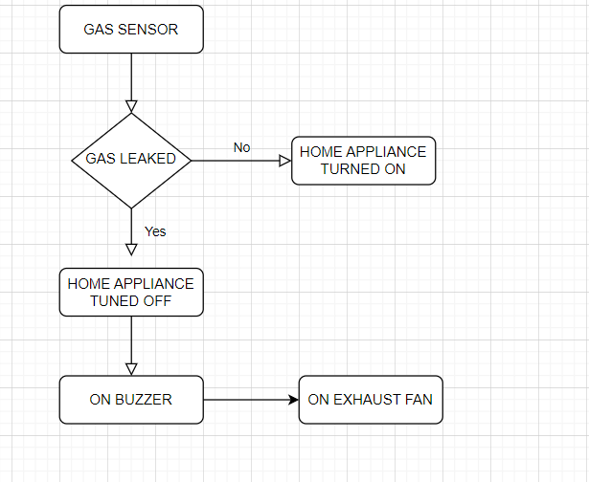

**4. IMPLEMENTATION OF SYSTEM**

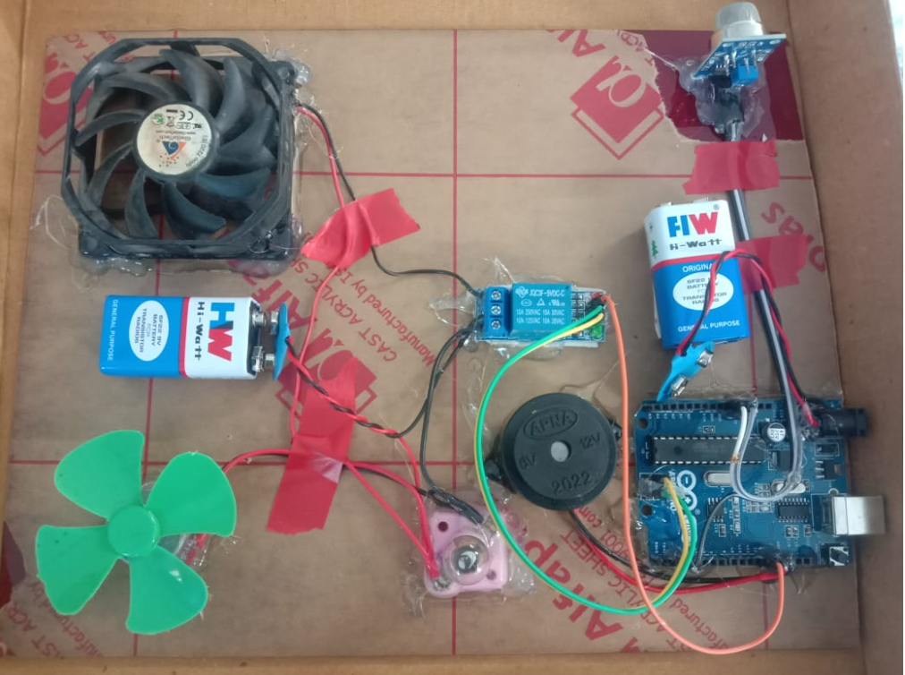

The above implementation of LPG gas leakage detection consists of arduino,

Relay ,MQ5 gas sensor, bulb and fan implies home appliances ,two batteries,exhaust fan and buzzer indicates the signal when the gas leak has been detected.

Lets see the purpose of the components ,

1. Arduino: The most important and the most useful part of the system is Arduino Uno. All the output devices are controlled by Arduino. At the same time, it reads and manipulates the input from the sensor. LCD Display receives various messages from Arduino.
2. LPG Sensor: This sensor detects the LPG gas molecules in the air. And gives respective voltage output to the Arduino.
3. Relay: We have used a 12-volt relay in this system. Arduino can not turn on a 12-volt relay so we have used a relay driver circuit to turn on this relay. We can control any AC or DC device with the help of this Relay.
4. Buzzer: A piezoelectric buzzer is connected to the system using a transistor circuit. This buzzer gives a warning signal to the user.
5. Exhaust fan or cooler: Will exhaust the gas molecules there by trying to maintain the level of atmospheric gas.
6. Bulb and fan are meant for home appliance purpose.

**WORKING OF THE APPLICATION**

Arduino board is the main component which manipulates and maintains the hardware components which are connected towards it. There is a gas sensor where the mq5 gas sensor is being used , which poses a certain threshold value such as .5 ppm . The relay is power supply which is been connected to the arduino the connection from relay is given to exhaust fan and other home applicants such as light and fan .Gas sensor helps to detect the leakage gives signal to arduino ,then input given to relay it power off the home Appliance simultaneously the exhaust fan and buzzer will be turned on which are battery based, so it runs as well the intimation is made.

**CODING PART DUMPED INSIDE ARDUINO**

#define ledPin_ON LOW

#define ledPin_OFF HIGHA

#define ledPin_1_ON HIGH

#define ledPin_1_OFF LOW

const int buttonPin = 2; // the number of the pushbutton pin

const int ledPin = 13; // the number of the LED pin

const int ledPin_1 = 12;

// variables will change:

int buttonState = 0; // variable for reading the pushbutton status

void setup() {

// initialize the LED pin as an output:

pinMode(ledPin, OUTPUT);

pinMode(ledPin_1, OUTPUT);

digitalWrite(ledPin, ledPin_OFF);

digitalWrite(ledPin_1, ledPin_1_OFF);

// initialize the pushbutton pin as an input:

pinMode(buttonPin, INPUT);

}

void loop() {

// read the state of the pushbutton value:

buttonState = digitalRead(buttonPin);

// check if the pushbutton is pressed. If it is, the buttonState is HIGH:

if (buttonState == HIGH) {

// turn LED on:

digitalWrite(ledPin, ledPin_OFF);

digitalWrite(ledPin_1, ledPin_1_OFF);

} else {

// turn LED off:

digitalWrite(ledPin, ledPin_ON);

digitalWrite(ledPin_1, ledPin_1_ON);

}

}

**EXISTING SYSTEM**

Arduino: An Arduino is a microcontroller, whose main goal is to make electronics as easy as possible. It provides an Integrated Development Environment (IDE). Arduino contains several numbers of parts and integrated interfaces in a particular circuit board.

Buzzer: A buzzer is an audio signaling device which is capable of controlling microcontrollers IO via, with the working voltage of 5V.22. If the LPG sensor detects a gas leak at the workplace or at home, the sensor will detect the noise and the gas leak will stop.

Mq 5 sensor: This sensor is constructed by micro AL203 ceramic pipe and contains a SnO2 (Tin Dioxide) layer, capable of measuring electrodes and the heater is covered by plastic and stainless steel.

Relay: Relays are electrically operated switches that open and close the circuits by receiving electrical signals from outside sources. They receive an electrical signal and send the signal to other equipment by turning the switch on and off.

**COMPARISON WITH EXISTING METHODS**

We did a comparison with the gas leakage detection research paper and they proposed the system using a buzzer and alarm system. So, in our project we implemented that it will automatically turn off the home appliances during gas leakage and on the lubricating fan along with the buzzer system after the removal of the gas molecules the home appliances will automatically turn on if it’s already on and the buzzer system will automatically turn off.

**5.CONCLUSION**

Gas leakage leads to severe accidents resulting in material losses and human injuries. Gas leakage occurs mainly due to poor maintenance of equipment and inadequate awareness of the people. Hence, LPG leakage detection is essential to prevent accidents and to save human lives. This paper presented LPG leakage detection and alert system. This system triggers LED and buzzer to alert people when LPG leakage is detected. This system is very simple yet reliable.

**6.REFERENCES:**

1. <http://gradivareview.com/gallery/grj%203732.pdf>
2. https://www.researchgate.net/publication/347495607_Gas_leakage_detection_and_alerting_system_using_Arduino_Uno
3. <https://www.researchgate.net/publication/347326171_Sensor-Based_Gas_Leakage_Detector_System>
4. <https://www.ripublication.com/ijeer17/ijeerv9n7_15.pdf>
5. <https://www.irjet.net/archives/V5/i7/IRJET-V5I7232.pdf>
6. <https://www.trendytechjournals.com/files/issues/volume4/issue7-2.pdf>