Software Requirements Specification

October 25, 2019

Book App
Team Members
Rajyalakshmi Grande,
Sneha Meshram,
Neha Palod

Submitted in partial fulfillment
Of the requirements of
NHT Training by CGI

Table of Contents
Table of Contents
List of Figures
1.0. Introduction
1.1. Purpose
1.2. Scope of Project
1.3. Glossary
1.4. References
1.5. Overview of Document
2.0. Overall Description
2.1 Entity Relationship Diagram
2.2 Use Case
2.2.1 Use Case Search diagram
2.3 Initial step by step Desciption
2.4 User Charactersticks
2.5 User Interface
3.0 Specific Requirements
3.0.1 Software Requiremt
3.0.2 Technology Used
3.1 Supplementary Requirement
3.1.1 Safety Requirement
3.1.2 Non-Functional Requirement

1.0. Introduction

1.1. Purpose

Almost every activity in the world today is controlled by computer driven software programs. However, as the life became more and more complex,every area of human interactions was invaded by various software system,such as real time,business,simulation etc.
According to the above facts, managing a book website could also be

efficient. Software.

The purpose of this document is to present a detailed description of the

Book website. It will explain the purpose and features of the website, what

the website will do, the constraints under which it must operate and how the

system will react to external stimuli. This document is intended for the User

and the Reader.

1.2. Scope of Project
This software system will be a Book Website for a local user or a reader. This system will be designed to maximize the book productivity by providing books to read and review the new and bestseller books, which would otherwise have to be performed manually. By maximizing the work efficiency and production the website will meet the user’s needs while remaining easy to understand and use.
Here we are try to develop such type of system which is provide the books to read and facility to the user to see the bestseller and popular books of current period.

1.3. Glossary
Term | Definition
Active Book | The book that is tracked by the system; it is a narrative that is planned to be posted to the public website.
User | Person using a website to be visit and see books. In case of multiple authors.
Database | Collection of all the information monitored by this system.
Field | A cell within a form.
Login and Register Database | The new and existing membership database (MySQL and Mongodb Database).
Member | A member of the Book App listed in the database.
Reader | Anyone visiting the site to read books.
Recommend | Recommendation of book; may include for later reading purpose or re read purpose .
Favourite | Add the favourite book to the favourite list.
Software Requirements Specification | A document that completely describes all of the functions of a proposed system and the constraints under which it must operate. For example, this document.
User | Reader.

1.4. References
- Open Library

- Goodreads

- Amazon(Kindle)

- BookFinder.com

- .IEEE standard for Software test documentations-IEEE standard

829/1998

1.5. Overview of Document
The following subsections provide the complete overview of functionality

and Specifications requirements documentation for the product

Book Website.

2.0. Overall Description

2.1 Diagram:Entity Relationship
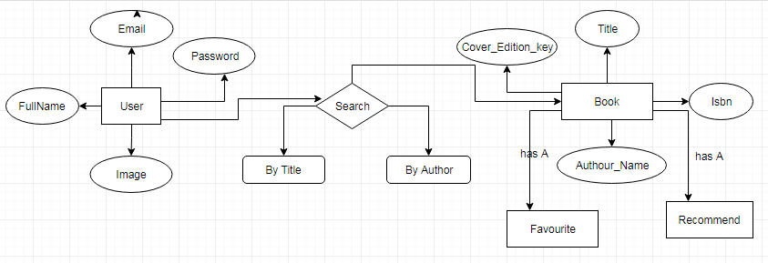

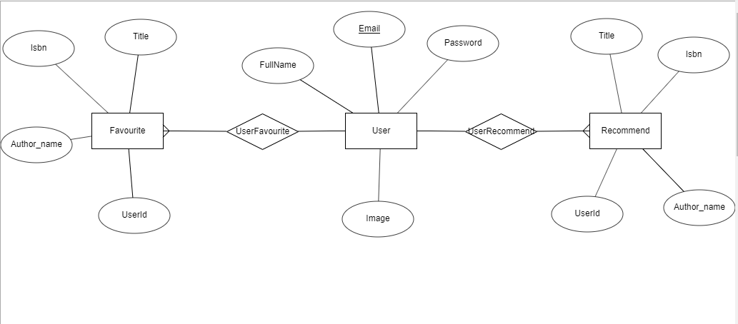

2.2 Diagram:Use case:

Use cases were designed for object oriented software development they focus on what the user need to do with the system. This approach is more powerful as compared to traditional approach. It used a combination of text and pictures in order to improve the understanding of requirements. The use case describe ‘what of a system and not how of a system’. They only give the functional view of the system.

2.2.1 Use case:Search Book

By Title
Search

By Author

2.3 Initial Step-By-Step Description
The Reader chooses to search by and book title.
- Book Title
- Book Author
The Reader selects the book desired.
- And add to favourite.
- And recommend
The system provides the requested book

2.4 User Characteristics
The Reader is expected to be Internet literate and be able to use a search engine. The main screen of the BookLand will have the search function and a link to Search Information.”
Then detailed look of these pages is mentioned by title and author.
2.5 User Interface
The bookLand will have the following user friendly and menu driven interfaces:
- Login: Allow the entry of Only authorised users through valid login ID and password.
- Profile: Check your profile details and also edit it.
- My Favourites: Can see favourite books.
- My Recommendation: Can see recommended books.
- Logout: To allow user to sign out.
- Search: Allow user to search the books by:
- Book Title
2. Book Author
3.0 Specific Requirement
3.0.1 Software Requirement
- Visual Studio code
- Spring Tool Suite4
- Node.js 10.16.2
- MySQL 8.0
- MongoDB 34.2
3.0.2 Technology Used
- Angular (Front-End Design)
- Spring Boot (Back-End Design)
- Mockito (Back-End Testing)
- MySQL 8.0 ( Tabular database)
- MongoDB (Json Database)
- Docker
- Karma-Jasmine (Front-End Testing)
3.1 Supplementary Requirement
3.1.1 Safety Requirements
Highly recommend Quick Heal internet security to been installed in users Pc to prevent the harm that may occurs by unwanted malicious software, phishing URLs and all the types of virus attacks during using this application.

3.1.2 Non-Functional Requirements
The BookLand will be on a server with high speed Internet capability. The software developed here assumes the use of a tool such as Tomcat for connection between the Web pages and the database. The speed of the Reader’s connection will depend on the hardware used rather than characteristics of this system.
- Better component design to get better performance at peak time.
- Secure access of confidential data(user’s details).
- Flexible service based architecture will be highly desirable for future extension.
3.1 Licensing Requirement
Not applicable

Benefits of a SRS?
The IEEE 830 standard defines the benefits of a good SRS:
Provide a basis for estimating costs and schedules.
Provide a baseline for validation and verification.
Serve as a basis for enhancement.

THANK YOU

