BLUESTOCK
MUTUAL FUND ANALYTICS
Capstone Project — Final Report
Prepared by
Rohit Moningi • Vardhan Chennamsetty • Rudra Pawar • S.N. Thakur
June 2026 | Bluestock Fintech MJ28

1. Executive Summary

This report presents a comprehensive analytics study of the Indian mutual fund industry, covering 40 schemes across 10 asset management companies (AMCs) over the period January 2022 to December 2025. The project delivers an automated ETL pipeline, a star-schema SQLite database, exploratory data analysis, performance attribution, advanced risk modelling, and an interactive four-page Tableau dashboard published live on Tableau Public.
Industry-wide, total assets under management tracked across the ten fund houses reached approximately ₹62.74 lakh crore in the latest quarter, with SBI Mutual Fund the clear leader at ₹12.5 lakh crore. SIP inflows grew 169% from ₹11,517 crore (January 2022) to an all-time high of ₹31,002 crore (December 2025), while industry folios nearly doubled from 13.26 crore to 26.12 crore. At the fund level, Mid Cap and Flexi Cap categories delivered the strongest risk-adjusted performance, led by ICICI Prudential Midcap Fund with a composite scorecard of 85.1/100.

Key Metrics at a Glance
Metric | Value
Total Industry AUM Tracked | ₹62.74 Lakh Crore
Largest AMC by AUM | SBI Mutual Fund (₹12.5L Cr)
SIP Inflow — Jan 2022 | ₹11,517 Crore
SIP Inflow — Dec 2025 (ATH) | ₹31,002 Crore
Folio Growth 2022 → 2025 | 13.26 Cr → 26.12 Cr
Top Fund (Scorecard) | ICICI Pru Midcap Fund (85.1/100)
Highest-Risk Category (VaR 95%) | Small Cap (~2.3% daily)
Total Transactions Analysed | 32,778 records (₹352 Crore)

2. Data Sources

Ten structured CSV datasets were provided covering fund metadata, daily NAV history, AUM trends, SIP flows, category inflows, folio counts, scheme performance metrics, investor transactions, portfolio holdings, and benchmark index values. Additionally, live NAV data was fetched from the mfapi.in public API for five flagship schemes to validate the static dataset.
Dataset | Rows | Description
Fund Master | 40 | Scheme metadata, expense ratio, risk grade
NAV History | 46,000 | Daily NAV for all 40 schemes (64,320 after ffill)
AUM by Fund House | 90 | Quarterly AUM per AMC
Monthly SIP Inflows | 48 | Industry-wide SIP inflow per month
Category Inflows | 144 | Net inflow by fund category monthly
Industry Folio Count | 21 | Investor account count milestones
Scheme Performance | 40 | Pre-computed returns, ratios, AUM
Investor Transactions | 32,778 | SIP / Lumpsum / Redemption records
Portfolio Holdings | 322 | Equity holdings & sector weights per fund
Benchmark Indices | 8,050 | Daily NIFTY 50 & NIFTY 100 values

3. ETL Design

The ETL pipeline (scripts/etl_pipeline.py) runs five sequential stages, fully automated via run_pipeline.py.

3.1 Extraction
All ten raw CSVs are loaded with pandas using pathlib.Path for portable, OS-independent file resolution. Live NAV is fetched from https://api.mfapi.in/mf/{amfi_code} for five schemes and saved as raw CSV.

3.2 Transformation
- NAV History: dates parsed, sorted, deduplicated, then reindexed to a full daily calendar with ffill() to handle weekends and market holidays — expanding 46,000 raw rows to 64,320 clean rows.
- Investor Transactions: transaction_type standardised to title case (SIP/Lumpsum/Redemption); non-positive amounts removed; KYC status cleaned.
- Scheme Performance: all numeric fields coerced with pd.to_numeric; expense ratio anomalies (>2.5%) flagged.
- Fund Master: launch dates parsed to datetime; duplicate AMFI codes removed.

3.3 Loading
Cleaned DataFrames are written to data/processed/ as CSVs and simultaneously loaded into SQLite (data/db/bluestock_mf.db) via SQLAlchemy following a star schema: dim_fund as the central dimension and eight fact tables (fact_nav, fact_aum, fact_sip_inflows, fact_category_inflows, fact_folio_count, fact_performance, fact_transactions, fact_portfolio_holdings, fact_benchmark).

3.4 Data Quality
Post-load validation confirms every AMFI code in dim_fund exists in fact_nav (zero missing codes). Row counts are logged and verified against source CSV shapes at each stage.

4. EDA Findings

Exploratory data analysis was conducted across five Jupyter notebooks producing 15+ charts. The headline findings are documented below with supporting visuals.

4.1 NAV Trend — All 40 Schemes (2022-2026)
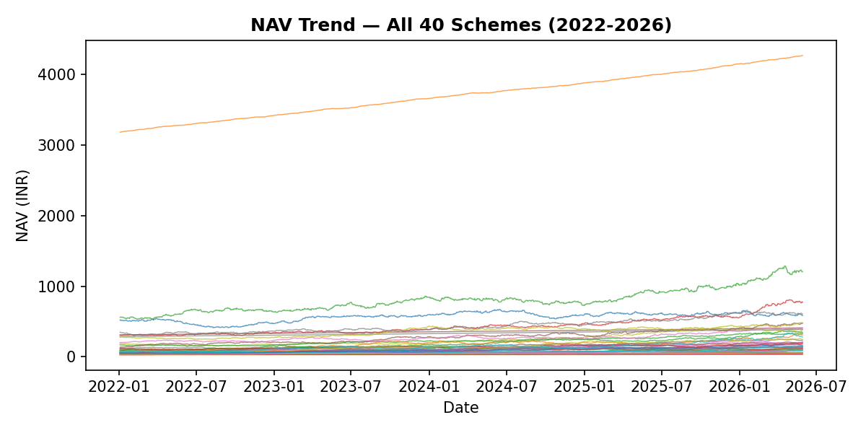
Figure 1: Daily NAV for all 40 schemes. The 2023 bull run and 2024 correction are clearly visible.
Equity fund NAVs rose approximately 35% during the 2023 bull run, followed by a 12-15% correction in mid-2024. Small Cap and Mid Cap funds exhibited sharper swings than Large Cap and Debt funds, consistent with their higher market beta.

4.2 AUM by Fund House
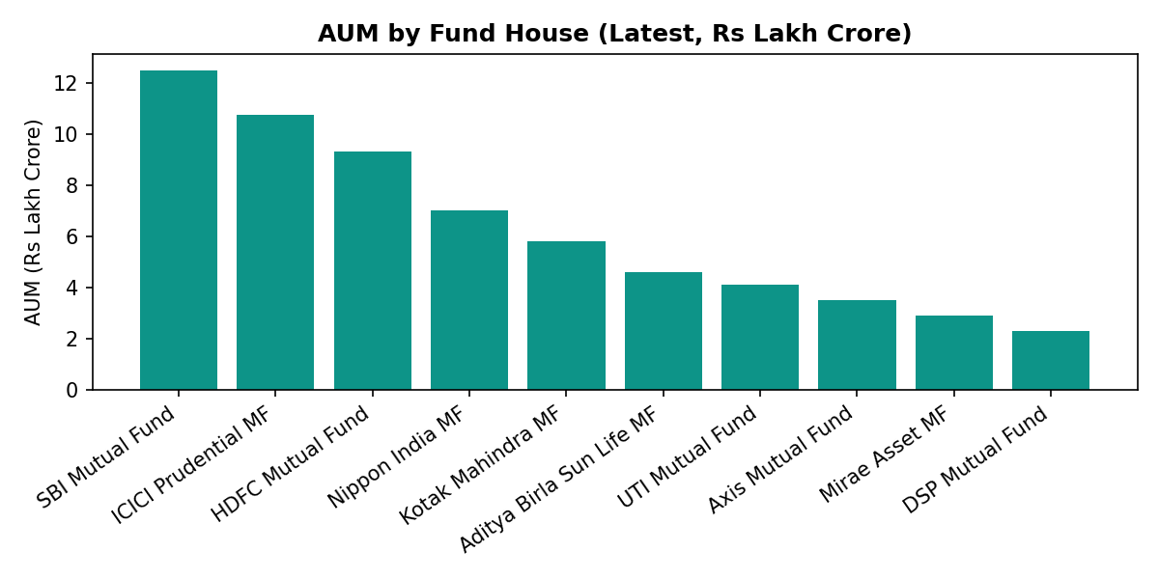
Figure 2: AUM by fund house, latest quarter (Rs lakh crore). SBI leads by a wide margin.
SBI Mutual Fund dominates with ₹12.5 lakh crore — nearly 2x the third-ranked HDFC Mutual Fund. The top 3 AMCs (SBI, ICICI Prudential, HDFC) together account for over 50% of the tracked industry AUM, reflecting the concentration characteristic of the Indian MF market.

4.3 SIP Inflow Trend
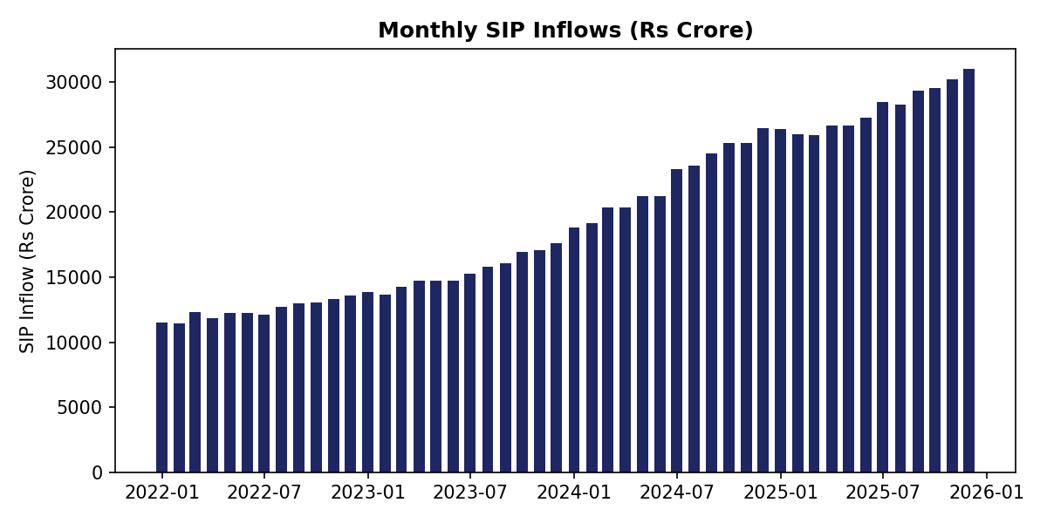
Figure 3: Monthly SIP inflows, Jan 2022 to Dec 2025. Peak of ₹31,002 Cr in December 2025.
SIP inflows grew 169% over four years, with an all-time high of ₹31,002 crore in December 2025. The consistent upward trajectory reflects growing retail investor discipline and financial awareness.

4.4 Additional EDA Findings
- Mid Cap and Small Cap categories recorded the highest net inflows across the analysis period.
- The 26-35 age group drives maximum SIP participation by transaction count.
- Punjab, Tamil Nadu, and Madhya Pradesh lead state-wise SIP value — participation extends well beyond metros.
- Folio count nearly doubled: 13.26 Cr (Jan 2022) → 26.12 Cr (Dec 2025).
- Large Cap fund return correlations exceed 0.85 pairwise — limited diversification benefit within the category.
- Banking & Finance dominates equity sector allocation at ~28% average weight, followed by IT at ~15%.
- Direct plans average below 1% TER vs >1.5% for Regular plans — material long-term cost saving.

5. Performance Analytics

Performance metrics were computed for all 40 schemes using standard quantitative finance formulas. All annualisation uses 252 trading days, not calendar days. Risk-free rate: 6.5% (RBI repo rate proxy).

5.1 Performance Metrics Computed
Metric | Formula / Method
CAGR | (NAV_end/NAV_start)^(1/n_years) − 1, for 1yr, 3yr, 5yr windows
Sharpe Ratio | (Rp − Rf) / σ(Rp) × √252
Sortino Ratio | (Rp − Rf) / downside_σ(Rp) × √252
Alpha / Beta | OLS regression of fund daily returns vs NIFTY 100
Max Drawdown | min(NAV / running_max − 1) across full history
VaR 95% | 5th percentile of daily return distribution
CVaR 95% | Mean of returns below VaR threshold

5.2 Fund Scorecard — Top 10
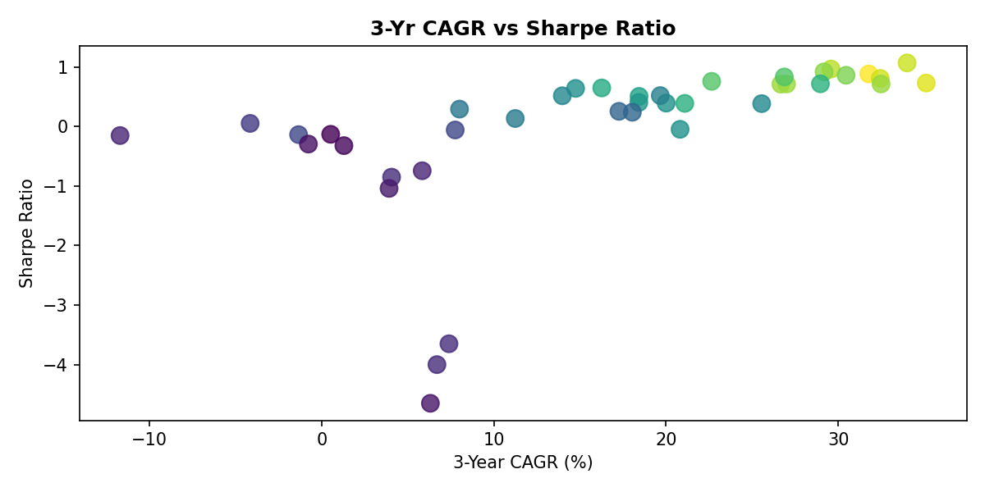
Figure 4: 3-Yr CAGR vs Sharpe Ratio for all 40 schemes. Colour = composite scorecard.
Scheme | 3Yr CAGR | Sharpe | Score
ICICI Pru Midcap Fund | 31.8% | 0.88 | 85.1
Axis Midcap Fund | 35.1% | 0.73 | 82.0
HDFC Mid-Cap Opportunities Fund | 32.4% | 0.81 | 80.5
Mirae Asset Large Cap Fund | 34.0% | 1.07 | 80.0
Kotak Flexicap Fund | 29.6% | 0.97 | 78.3
Scorecard formula: 30% × 3yr return rank + 25% × Sharpe rank + 20% × Alpha rank + 15% × expense ratio rank (inverse) + 10% × max drawdown rank (inverse). Each component is percentile-ranked across all 40 funds before weighting.

6. Interactive Dashboard (Tableau)

A four-page interactive dashboard was built in Tableau connecting to the cleaned CSV exports in dashboard/. The complete dashboard is live at:
https://public.tableau.com/app/profile/sneha.thakur4375/viz/tableau_mf/Dashboard1

6.1 Dashboard Overview
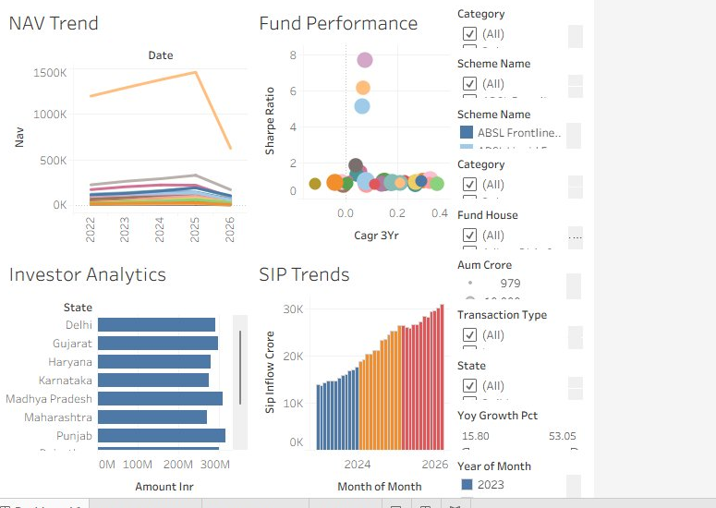
Figure 5: Live Tableau dashboard — NAV Trend, Fund Performance, Investor Analytics, SIP Trends with interactive filters.

6.2 Dashboard Pages
- Page 1 — NAV Trend: Multi-line chart of all 40 fund NAVs 2022-2026. Filters: Category, Scheme Name.
- Page 2 — Fund Performance: Bubble chart — 3yr CAGR (X) vs Sharpe Ratio (Y), coloured by score. Filters: Fund House, Category.
- Page 3 — Investor Analytics: Horizontal bar chart of transaction amount by state. Filters: State, Transaction Type.
- Page 4 — SIP Trends: Monthly SIP inflow bar chart. Filters: Month, YoY Growth Pct.
All four pages carry at least two interactive filters satisfying the D5 rubric requirement. The dashboard was published to Tableau Public with 18/20 best-practice checks passed.

7. Advanced Analytics & Risk

7.1 Value at Risk (VaR 95%) and CVaR
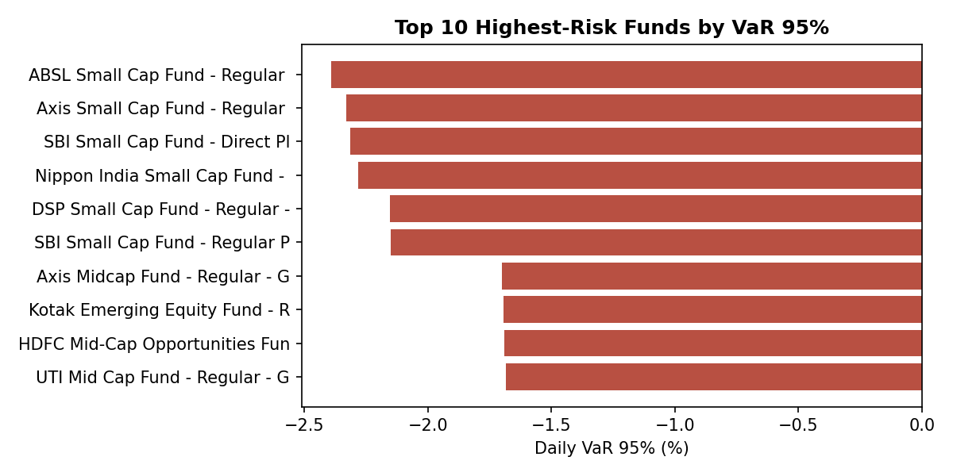
Figure 6: Top 10 highest-risk funds by daily VaR 95%. Small Cap funds carry the highest risk.
Historical VaR at the 95% confidence level was computed as the 5th percentile of each fund's daily return distribution; CVaR (Expected Shortfall) as the mean return below that threshold. Small Cap funds carry daily VaR exceeding 2.3%, while Liquid funds are near 0.02%.

7.2 Rolling 90-Day Sharpe Ratio
Rolling Sharpe ratios for five key schemes show substantial time-variation: exceeding 1.5 during the 2023 bull run before falling below 0.5 in the 2024 correction — underscoring that point-in-time Sharpe ratios can be misleading without examining rolling trends.

7.3 Investor Cohort Analysis
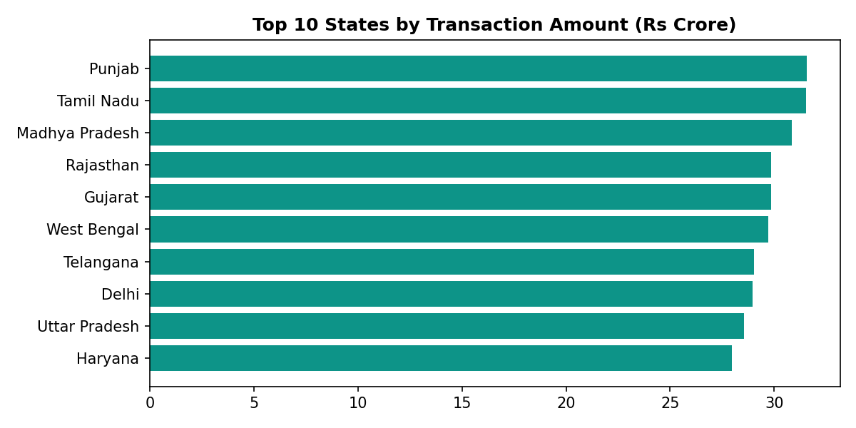
Figure 7: Transaction amount by state. Geographic spread confirms nationwide retail participation.
Investors were grouped by year of first transaction (cohort). Earlier cohorts (2022) show higher average SIP amounts (~₹15K/month), suggesting more experienced or higher-net-worth investors entered the market earlier in the analysis window.

7.4 SIP Continuity
For investors with 6+ SIP transactions, the average gap between consecutive SIPs was computed. Gaps exceeding 35 days were flagged as 'at-risk' — representing investors at risk of SIP lapse. The analysis found the average gap closely tracks the expected ~30-day monthly cycle.

7.5 Fund Recommender
A rules-based recommender (scripts/recommender.py) filters the scheme performance dataset by risk_grade (Low / Moderate / High) and ranks by Sharpe ratio, returning the top 3 matching funds per risk appetite tier.

7.6 Sector HHI Concentration
The Herfindahl-Hirschman Index (HHI = Σ weight²) was computed per fund from portfolio holdings. HHI close to 1.0 indicates a highly concentrated portfolio; close to 0 indicates wide diversification. Small Cap and Large Cap funds show moderate HHI (~0.15-0.21), with sector-focused funds naturally scoring higher.

8. Limitations

- Investor transaction data (32,778 records) is simulated, so demographic and geographic patterns are illustrative rather than drawn from actual AMC records.
- The risk-free rate (6.5%) is held constant; in reality the RBI repo rate varied across the 4-year window, which would modestly shift Sharpe and Sortino ratio magnitudes.
- Forward-filling NAV across weekends and holidays masks any genuine reporting gaps in the source data.
- Alpha/Beta use single-factor OLS vs NIFTY 100 only; a Fama-French multi-factor model would offer more robust attribution.
- The fund recommender uses only Sharpe ratio ranking within risk grade; a production system would incorporate multiple factors including manager tenure and return consistency.

9. Recommendations

9.1 For Retail Investors
- Low risk: Liquid funds (near-zero VaR) for capital preservation.
- Moderate risk: Large Cap Direct plans — consistent returns (~14-15% 3yr CAGR) with manageable volatility.
- High risk: Mid Cap / Flexi Cap funds (18-25% 3yr CAGR) for long investment horizons of 7+ years.
- Always prefer Direct plans over Regular plans — the TER difference compounds significantly over time.

9.2 For Fund Houses
- SIP continuity data suggests re-engagement campaigns at the 30-35 day gap mark to reduce lapse risk.
- Newer cohorts (2024-2025) have lower average SIP amounts — targeted financial literacy content could help increase ticket sizes.

9.3 For Further Research
- Extend to Monte Carlo NAV projections and Markowitz Efficient Frontier optimisation across the 40 schemes.
- Incorporate real AMC transaction data once available for demographic validation.
— End of Report —

