IBM INTERNSHIP PROJECT REPORT
Bakery Sales, Waste and Profitability Analysis
Identifying What Drives Loss-Making Sales in a Multi-Store Bakery Using Python Data Analytics and Machine Learning
Student Name: Sneha Yadav
Organization: IBM Internship
Submission Date: 11 October 2026
Project Type: Data Analytics and Machine Learning (Python)
This report documents an internship assignment prepared by the student. It does not imply endorsement or approval by IBM.

Abstract
Fresh bakery products spoil quickly, so a bakery can lose money through discounts and unsold stock even when sales look healthy. This project analyses a dataset of 16,569 bakery sales records from three stores between 1 January 2023 and 31 December 2024. The dataset has 41 columns covering customers, products, prices, discounts, weather, shelf life, stock, waste cost and profit.
The work was carried out in Python using pandas, Matplotlib, Seaborn, SciPy and scikit-learn. After checking data quality, cleaning the data and creating new features, the study measured revenue, waste cost and profit by product, category, store, season and month. It then tested the effect of promotions with statistical tests and trained two classification models (Logistic Regression and Random Forest) to predict whether a sales row is loss-making. The models were trained on 2023 data and tested on 2024 data, and columns that would leak the answer were excluded.
The dataset records total revenue of 3,444,112.95 currency units, recorded waste cost of 1,388,812.80 (40.3% of revenue) and a total profit of -230,339.25. Twenty-three of 35 products have a net loss, led by Black Forest Cake, Chocolate Cake, Honey and Eggs, while Coffee, Cold Coffee, Tea and Juice are the most profitable. Loss is present in every store, season and month. Rows with promotions average a loss of 69.13 per row compared with a profit of 0.15 for rows without promotions, and rows with a 20-30% discount are loss-making 94.3% of the time. On the unseen 2024 data the Random Forest reached a ROC-AUC of 0.871 and an F1-score of 0.791. Because the dataset is synthetic and its profit rules are not documented, the findings describe this dataset only.

1. Introduction
Bakeries sell products with short shelf lives. Every cake, sandwich or pack of milk that is not sold before it expires becomes waste, and the cost of that waste reduces profit. Discounts and promotions are often used to increase sales, but they also reduce the price received for each item. Managers therefore need to understand which products, prices and promotions create profit and which create losses.
Data analytics helps answer these questions. By exploring transaction records, we can see patterns that are hard to notice in daily operations. Machine learning can then learn those patterns and warn when a sale or production decision is likely to lose money.
This project applies a complete data analytics workflow to a bakery dataset: understanding the data, checking and cleaning it, exploring it with charts, testing ideas with statistics, building a simple prediction model and finally turning the results into recommendations. All explanations are written in simple language so that a beginner can follow each step.

2. Problem Statement
The dataset records about 3.44 million currency units of revenue across three stores over two years, but the profit column adds up to a net loss of about 230,339 currency units. Recorded waste cost alone equals about 40% of revenue. The bakery needs to know which products, categories, promotions and shelf-life groups are responsible for the loss, whether the problem is concentrated in particular stores or periods, and whether loss-making sales can be predicted from information available before the sale.

3. Objectives
- Inspect the dataset and check its quality: missing values, duplicates and inconsistent values.
- Clean the data and create useful new features such as month, hour, profit margin, loss flag, shelf-life group and price band.
- Measure revenue, waste cost and profit by product, category, store, season and time period.
- Study the relationship between discounts, promotions and profit.
- Study how shelf life, unsold stock and expiry risk relate to waste and profit.
- Build and correctly evaluate a classification model that predicts whether a sales row will be loss-making.
- Present clear, data-backed findings and recommendations.

4. Scope of the Project

4.1 In scope
- Descriptive and exploratory analysis of the supplied bakery dataset (2023-2024, three stores).
- Data-quality checks, cleaning and feature engineering.
- Visual analysis with Matplotlib and Seaborn.
- Simple statistical tests (Mann-Whitney U and chi-square).
- A binary classification model for loss-making rows, evaluated on a later year of data.
- Business recommendations based on the observed patterns.

4.2 Out of scope
- Real-time prediction, deployment or dashboard development.
- Demand forecasting and inventory optimisation models.
- Any claim that the findings apply to a real bakery, because the dataset is synthetic.
- Causal conclusions: the data is observational and cannot prove that a factor causes a loss.

5. Dataset Description and Source
The dataset was provided privately for this internship assignment and has no public web link. The file name (bakery_synthetic_dataset_csv__1_.xlsx) and the sheet name show that it is a synthetic dataset. The currency is not stated, so the report uses the term currency units. To reproduce the work, the Excel file must be placed in a folder named data next to the notebook.
Table 1: Dataset overview
Property | Value
File / sheet | bakery_synthetic_dataset_csv__1_.xlsx / bakery_synthetic_dataset
Rows x columns | 16,569 x 41 (one row = one product line in a customer transaction)
Date range | 1 January 2023 to 31 December 2024 (731 distinct days)
Stores | 3 (ST01, ST02, ST03)
Products / categories | 35 products in 10 categories
Customers | 2,173 unique customer IDs
Duplicate rows | 0
Columns with missing values | Festival (15,960 empty), Promotion_Type (13,209 empty)

Table 2: Column groups
Column group | Columns
Transaction and customer | Transaction_ID, Date, Time, Customer_ID, Customer_Age, Customer_Gender, Customer_Segment, Loyalty_Member, Customer_Rating, Payment_Method, Store_ID, Employee_ID
Product and price | Product, Category, Quantity, Unit_Price, Selling_Price, Total_Bill
Discount and promotion | Discount_Percentage, Discount_Amount, Promotion_Applied, Promotion_Type, Promotion_Score, Recommended_Product, Recommended_Discount
Environment and calendar | Weather, Temperature, Season, Day_of_Week, Weekend, Festival
Stock and shelf life | Shelf_Life_Days, Manufacturing_Date, Expiry_Date, Units_Produced, Units_Sold, Unsold_Units, Stock_Available, Expiry_Risk
Financial outcome | Profit, Waste_Cost

The dataset has no single column named as a target. Because the business problem is about profit, a new target Is_Loss was created: it equals 1 when Profit is below zero and 0 otherwise. The dataset also does not document how Profit and Waste_Cost are calculated, and it contains no cost-price column; these are limitations discussed in Section 14.

6. Tools and Technologies Used
Table 3: Technologies
Tool / library | Purpose in this project
Python 3 | Programming language for the whole analysis
Jupyter Notebook | Interactive environment combining code, charts and explanations
pandas and NumPy | Loading, cleaning, grouping and calculating on the data
Matplotlib and Seaborn | Creating charts
SciPy | Statistical tests (Mann-Whitney U, chi-square)
scikit-learn | Pre-processing, Logistic Regression, Random Forest, grid search, evaluation metrics and permutation importance
openpyxl | Allows pandas to read the .xlsx dataset

The versions used to run the notebook were Python 3.12, pandas 3.0.2, NumPy 2.4.4, Matplotlib 3.10.8, Seaborn 0.13.2, scikit-learn 1.8.0, SciPy 1.17.1 and openpyxl 3.1.5. The requirements.txt file lists the minimum compatible versions.

7. System Requirements
Table 4: System requirements
Item | Requirement
Operating system | Windows, macOS or Linux
Python | Version 3.10 or newer (tested on 3.12)
Memory | A standard laptop is sufficient; the dataset is small (16,569 rows)
Software | Jupyter Notebook or JupyterLab and the packages in requirements.txt
Input file | data/bakery_synthetic_dataset_csv__1_.xlsx placed next to the notebook
Internet | Needed only once to install the packages with pip

Installation commands:
python -m venv venv
pip install -r requirements.txt
jupyter notebook

8. Project Methodology
The project follows the steps below. The same order is used in the notebook SnehaYadav_ProjectName.ipynb.
- Understand the problem and load the dataset.
- Inspect shape, data types and statistical summary.
- Check data quality: missing values, duplicates, logical consistency between columns, label spelling and outliers.
- Clean the data and engineer new features.
- Explore the data with summary tables and charts.
- Test important ideas with statistical tests.
- Build a classification model to predict loss-making rows, using only information that is available before the outcome is known.
- Evaluate the model on a later, unseen year and interpret the results.
- Summarise findings, limitations and recommendations.

8.1 Model design
The machine learning task is binary classification: predict Is_Loss (1 = loss-making row). Two models were compared against a baseline that always predicts the most common class. Logistic Regression was chosen because it is simple and easy to explain; Random Forest (an ensemble of many decision trees, Breiman, 2001) was chosen because it can capture non-linear relationships and combinations of features.

8.2 Avoiding target leakage
Target leakage happens when a model is given information that is only known after the outcome, or that is calculated from the outcome. Profit is derived from revenue, cost and waste. Therefore Profit, Profit_Margin_%, Waste_Cost, Unsold_Units, Stock_Available, Units_Sold, Sell_Through_% and Expiry_Risk were excluded from the inputs, together with IDs, dates, customer rating and the recommendation columns. A check in the code stops the notebook if any of these columns is accidentally used.
The 17 input features were: Product, Category, Promotion_Applied, Promotion_Type, Season, Weekend, Store_ID, Payment_Method, Loyalty_Member, Customer_Segment (categorical) and Unit_Price, Quantity, Discount_Percentage, Shelf_Life_Days, Units_Produced, Hour, Customer_Age (numeric). Units_Produced is the planned batch size, which is a decision known before the day's sales.

8.3 Correct evaluation
A random train/test split would place rows from the same product-day batch in both sets and could make scores look better than they are. The models were therefore trained on the 2023 rows (8,190) and tested on the 2024 rows (8,379), as a business would use past data to predict the future. Hyper-parameters were tuned with time-ordered cross-validation (TimeSeriesSplit, 4 folds) inside the 2023 data only, so the 2024 test data was never used for tuning.

9. Data Preprocessing and Cleaning

9.1 Data quality checks
Table 5: Data quality checks and results
Check | Result
Duplicate rows / duplicate Transaction_IDs | None found
Missing values | Only Festival (96.3% empty) and Promotion_Type (79.7% empty)
Meaning of the missing values | Not applicable: Promotion_Type is empty exactly when Promotion_Applied is No; Festival is empty on days without a festival
Unsold_Units = Units_Produced - Units_Sold | True for all rows
Stock_Available = Unsold_Units | True for all rows
Expiry_Date - Manufacturing_Date = Shelf_Life_Days | True for all rows
Manufacturing_Date = sale Date | True for all rows
Quantity <= Units_Sold | True for all rows
Weekend flag matches Day_of_Week | True for all rows
Total_Bill = Selling_Price x Quantity | Matches within 0.05 (rounding)
Discount_Amount = Unit_Price x Quantity x Discount% | Matches within 0.05 (rounding)
Customer attributes consistent per Customer_ID | No customer has more than one age, gender or segment
Category labels (gender, payment, season, etc.) | No spelling or case problems found
Negative or zero prices, quantity below 1 | None

Outliers were checked with the interquartile range (IQR) rule. Many numeric columns have outliers (for example 15.7% of Unit_Price values and 10.5% of Profit values), but they are valid business events such as expensive cakes or large baskets. They were flagged and kept rather than removed.

9.2 Cleaning steps
- Empty Festival cells were replaced with the label No Festival, and empty Promotion_Type cells with No Promotion, because the blanks mean not applicable.
- The Time text was converted to a numeric Hour.
- Leading and trailing spaces were removed from text columns (a safety step).
- After cleaning, no missing values remained.

9.3 Feature engineering
Table 6: Engineered features
New feature | Meaning
Year, Month, Month_Name, Hour | Time of sale
Profit_Margin_% | Profit divided by revenue x 100
Is_Loss | 1 if Profit < 0, otherwise 0 (modelling target)
Promo | 1 if a promotion was applied
Sell_Through_% | Units sold divided by units produced x 100
Shelf_Life_Group | 1 day, 2-3 days, 4-7 days, 8-30 days, 31+ days
Price_Band | Low / Medium / High / Premium (quartiles of Unit_Price)
Hour_Band | Morning, Afternoon, Evening

10. Exploratory Data Analysis

10.1 Business overview
Table 7: Key business totals (currency units)
Metric | Value
Rows (transactions lines) | 16,569
Unique customers | 2,173
Total revenue | 3,444,112.95
Total discount given | 244,985.40
Total recorded waste cost | 1,388,812.80
Total profit | -230,339.25
Waste cost as % of revenue | 40.3%
Loss-making rows | 50.4%

10.2 Statistical summary
Customers are aged 16 to 74 (average 34.5). Most rows have 2 items (average quantity 2.59). Unit price ranges from 24.25 to 463.49 with a median of 50.81, and the median total bill is 119.96. Shelf life is strongly skewed: the median is 3 days, but some products last up to 365 days. Profit per row ranges from -2,152.66 to +898.42, with a median of -0.42 and an average of -13.90. Average customer rating is 3.68 out of 5.

10.3 Correlation with profit
Table 8: Selected correlations with Profit
Variable | Correlation with Profit
Waste_Cost | -0.62
Discount_Percentage | -0.29
Unsold_Units | -0.27
Unit_Price | -0.24
Promotion_Score | -0.18
Shelf_Life_Days | -0.14
Units_Sold | +0.21
Quantity | +0.16
Temperature | 0.00
Customer_Rating | 0.00

Waste cost has the strongest negative relationship with profit, followed by discount percentage, unsold units and unit price. Temperature and customer rating have essentially no relationship with profit. Correlation shows association only; it does not prove cause.

11. Implementation Details
The analysis is implemented in one Jupyter Notebook (SnehaYadav_ProjectName.ipynb) with the following structure:
Table 9: Notebook structure
Notebook section | What it does
1-4 Introduction | Project title, problem statement, objectives, dataset description
5-6 Libraries and loading | Imports libraries, sets a fixed random seed (42), reads the Excel file from data/
7-8 EDA and quality checks | Shape, data types, summary statistics, missing values, duplicates, logical checks, outliers
9-10 Cleaning and features | Fills not-applicable blanks, creates new features
11-12 Business overview and charts | Key totals and eleven charts
13 Statistical tests | Mann-Whitney U and chi-square tests on promotions
14 Machine learning | Time-based split, pipelines, grid search, evaluation, permutation importance
15-18 Findings and conclusion | Findings generated from the computed results, recommendations, limitations, conclusion

11.1 Modelling pipeline
A scikit-learn Pipeline combines pre-processing and the model so that the same steps are applied to training and test data. Categorical columns are converted to numbers with One-Hot Encoding, and numeric columns are standardised (StandardScaler). The Random Forest grid search tried 2 values for the number of trees (150, 300), 3 for maximum depth (8, 14, no limit) and 2 for the minimum samples per leaf (3, 10), scored by ROC-AUC. The selected settings were 150 trees, no maximum depth and a minimum of 3 samples per leaf (cross-validated ROC-AUC 0.8688 inside 2023). For Logistic Regression the regularisation strength C was chosen from 0.1, 1 and 10; C = 0.1 was selected (cross-validated ROC-AUC 0.8425).

11.2 Evaluation metrics
Table 10: Metrics used
Metric | Simple meaning
Accuracy | Share of all predictions that are correct
Precision | Of the rows predicted as loss, the share that really were losses
Recall | Of the real loss-making rows, the share the model found
F1-score | A balance of precision and recall
ROC-AUC | How well the model ranks loss rows above profitable rows (0.5 = guessing, 1.0 = perfect)

12. Visualizations and Interpretation of Results

12.1 Distribution of profit and total bill
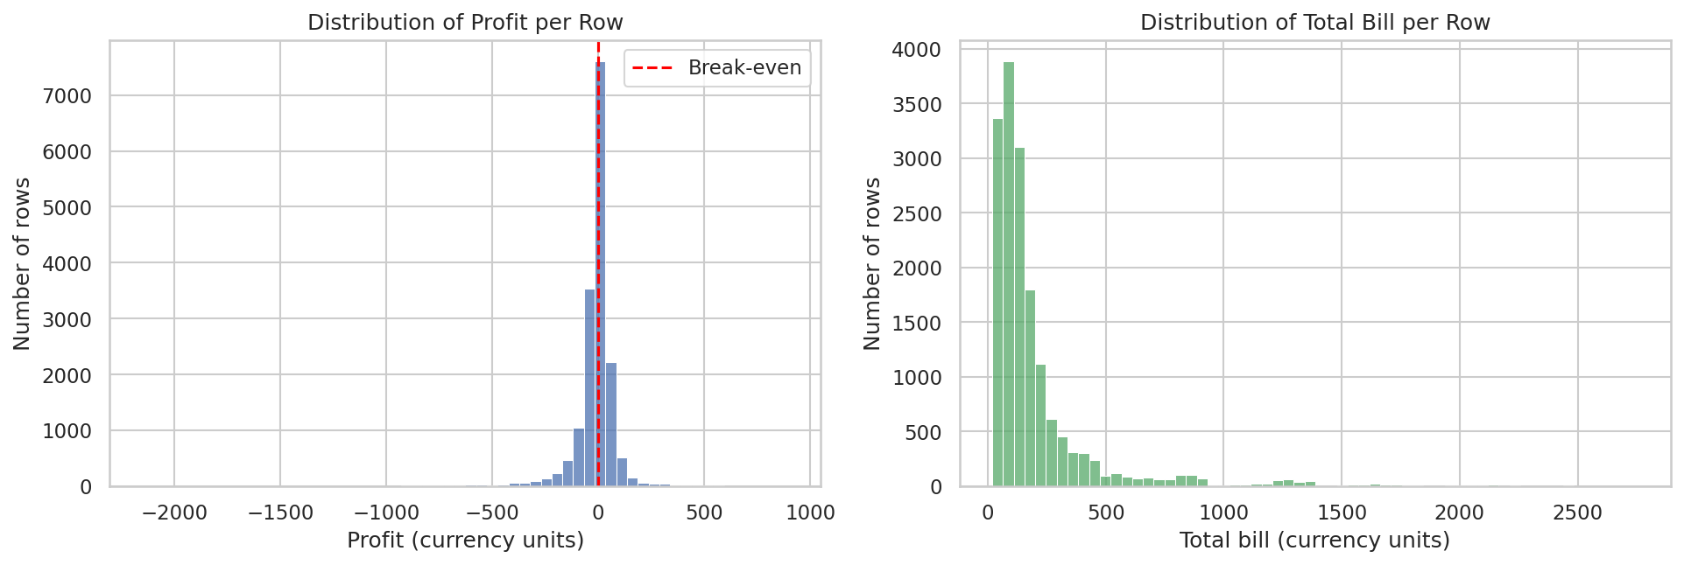
Figure 1: Distribution of profit and total bill per row
Most rows are small gains or small losses around zero, but a long tail of large losses pulls the average profit below zero. Total bill is right-skewed because a few expensive products (cakes) create very large bills.

12.2 Profit by product
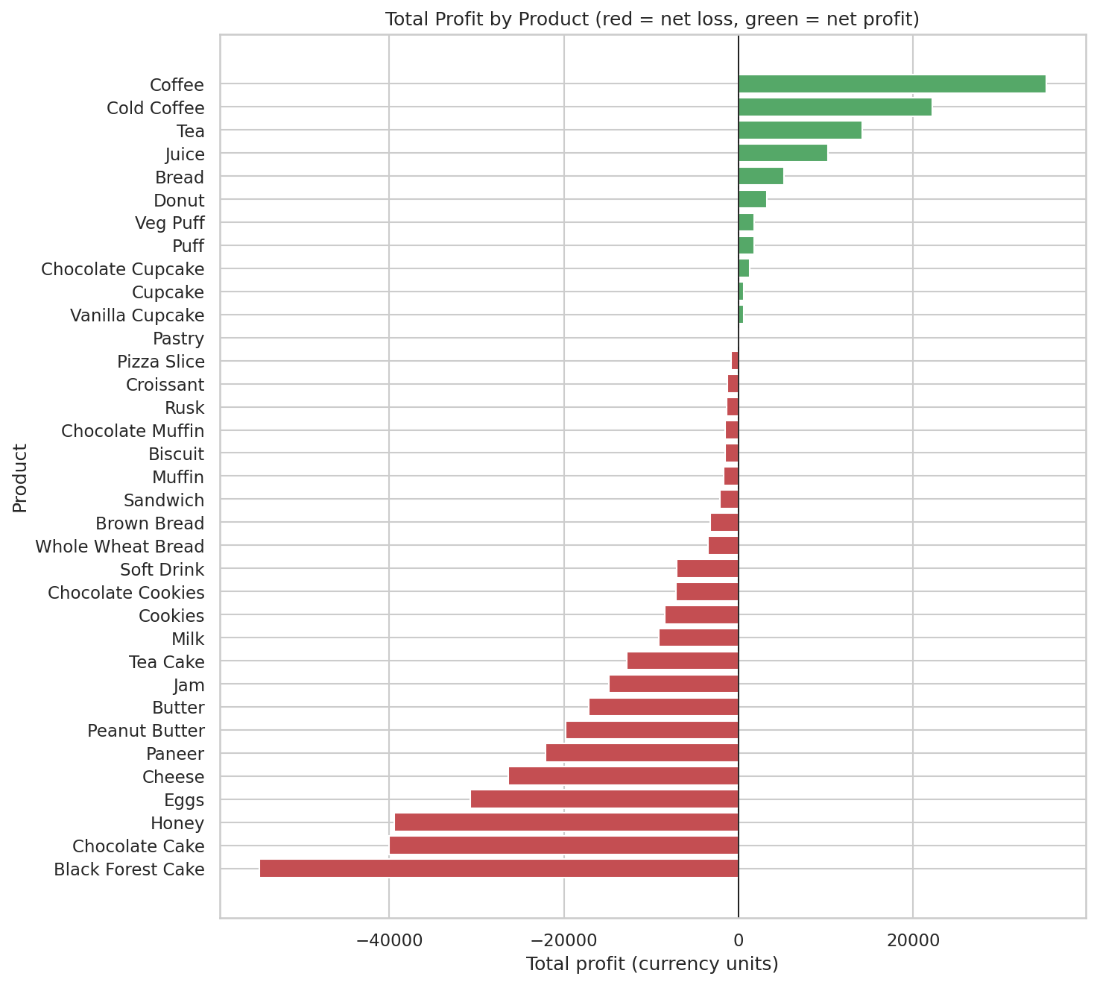
Figure 2: Total profit by product (red = net loss, green = net profit)
Twenty-three of 35 products have a net loss. The largest losses come from Black Forest Cake (-54,908.52), Chocolate Cake (-40,012.97), Honey (-39,437.53) and Eggs (-30,753.30). The most profitable products are Coffee (+35,301.44), Cold Coffee (+22,204.34), Tea (+14,168.81) and Juice (+10,216.41).
Table 11: Selected products (currency units)
Product | Revenue | Waste cost | Profit | Loss rate
Black Forest Cake | 529,732.87 | 220,480.04 | -54,908.52 | 58.2%
Chocolate Cake | 531,066.35 | 206,879.97 | -40,012.97 | 55.9%
Honey | 160,684.62 | 88,139.99 | -39,437.53 | 73.7%
Eggs | 85,500.19 | 45,359.98 | -30,753.30 | 87.3%
Coffee | 104,281.43 | 20,988.00 | +35,301.44 | 11.6%
Cold Coffee | 91,001.41 | 23,212.00 | +22,204.34 | 22.7%
Tea | 39,977.33 | 8,920.04 | +14,168.81 | 12.9%

12.3 Category performance
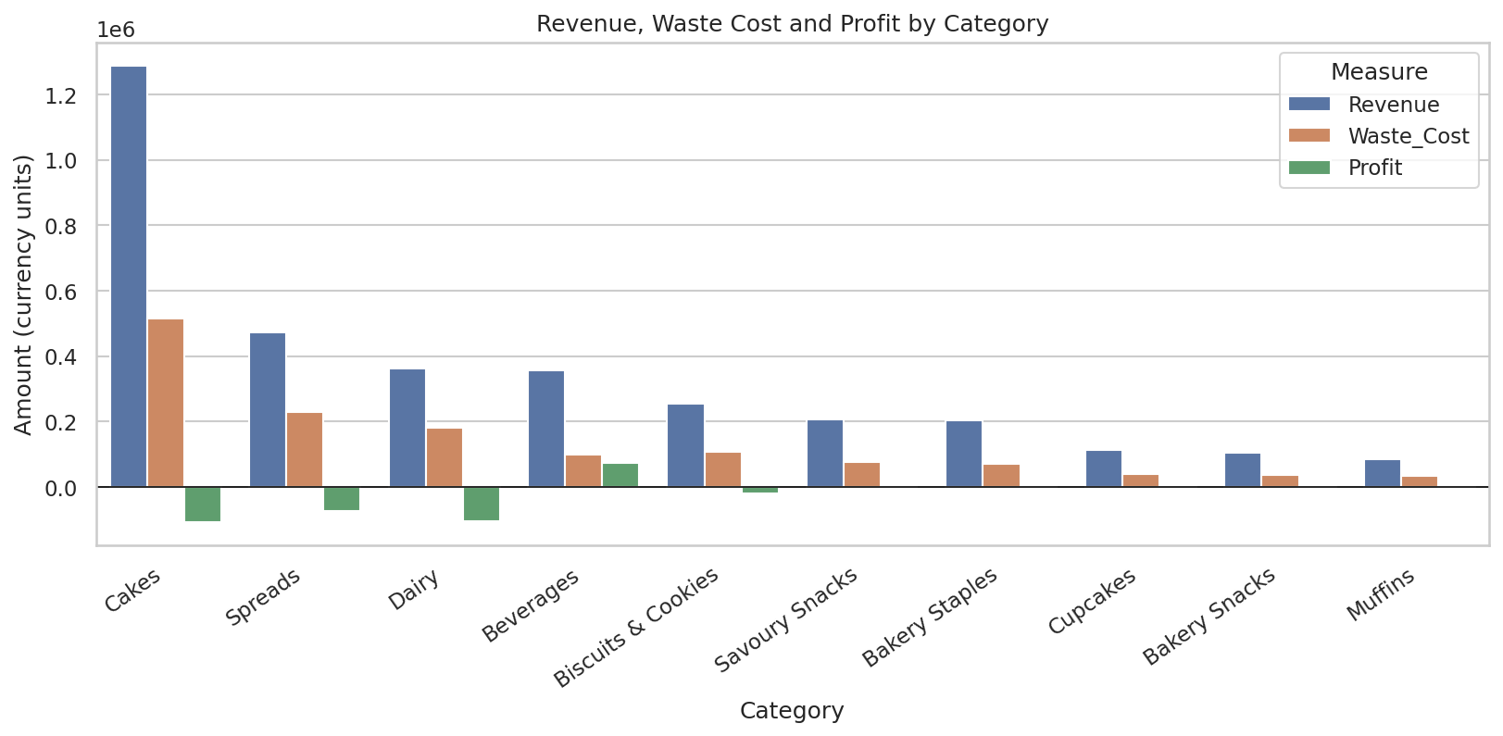
Figure 3: Revenue, waste cost and profit by category
Table 12: Category totals (currency units)
Category | Revenue | Waste cost | Profit
Cakes | 1,288,747.25 | 515,610.98 | -107,657.26
Spreads | 471,715.05 | 227,979.99 | -74,018.07
Dairy | 362,120.30 | 181,999.93 | -105,527.20
Beverages | 356,122.32 | 99,195.05 | +74,823.99
Biscuits & Cookies | 253,973.20 | 106,720.02 | -18,558.17
Savoury Snacks | 205,352.82 | 75,839.92 | +667.53
Bakery Staples | 203,043.67 | 70,145.00 | -1,436.10
Cupcakes | 112,313.00 | 40,845.98 | +2,550.53
Bakery Snacks | 105,506.11 | 37,559.95 | +1,993.42
Muffins | 85,219.23 | 32,915.98 | -3,177.92

Cakes bring the highest revenue but also the highest waste cost and the largest loss, closely followed by Dairy. Spreads also lose heavily. Beverages are the only large category with a strong profit.

12.4 Shelf life and expiry risk
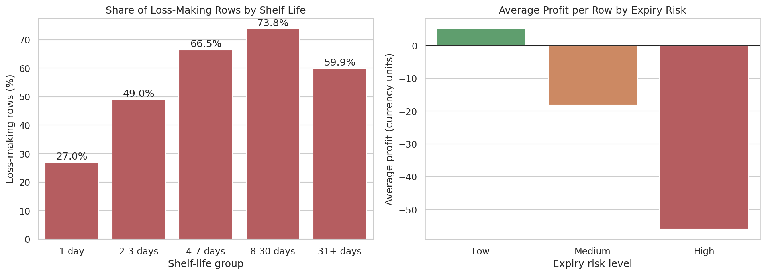
Figure 4: Loss rate by shelf-life group and average profit by expiry risk
Table 13: Shelf life and profit
Shelf-life group | Rows | Avg. waste cost | Avg. profit | Loss rate
1 day | 3,339 | 39.15 | +23.63 | 27.0%
2-3 days | 7,615 | 87.42 | -13.19 | 49.0%
4-7 days | 849 | 122.44 | -41.10 | 66.5%
8-30 days | 2,150 | 96.23 | -41.80 | 73.8%
31+ days | 2,616 | 107.64 | -32.12 | 59.9%

Products with a one-day shelf life (such as coffee, tea and juice) are the least likely to lose money. Loss rates are highest for products with a shelf life of 4 to 30 days. Rows marked as High expiry risk lose far more on average (-56.00 per row) than Low-risk rows (+5.28 per row).

12.5 Discounts and promotions
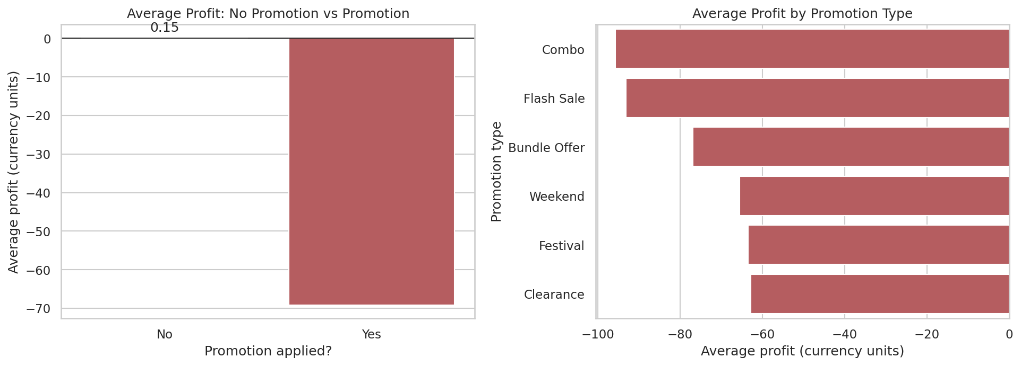
Figure 5: Average profit with and without promotion, and by promotion type
Table 14: Promotion vs no promotion
Group | Rows | Avg. discount % | Avg. quantity | Avg. profit | Loss rate
No promotion | 13,209 | 3.21 | 2.60 | +0.15 | 41.7%
Promotion | 3,360 | 20.19 | 2.56 | -69.13 | 84.6%

Promotion rows average a loss while non-promotion rows are close to break-even. Every promotion type has a negative average profit: Combo (-95.77), Flash Sale (-93.22), Bundle Offer (-76.84), Weekend (-65.53), Festival (-63.54) and Clearance (-62.78). Promotions carry discounts of 10-30%, but the quantity bought per row is not higher than for non-promotion rows.

12.6 Trends over time, by store and by season
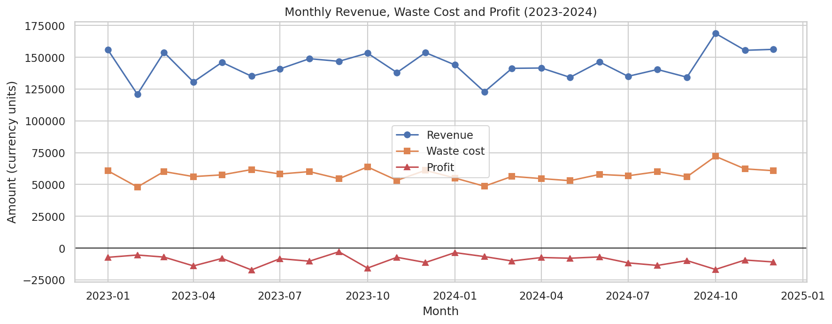
Figure 6: Monthly revenue, waste cost and profit, 2023-2024
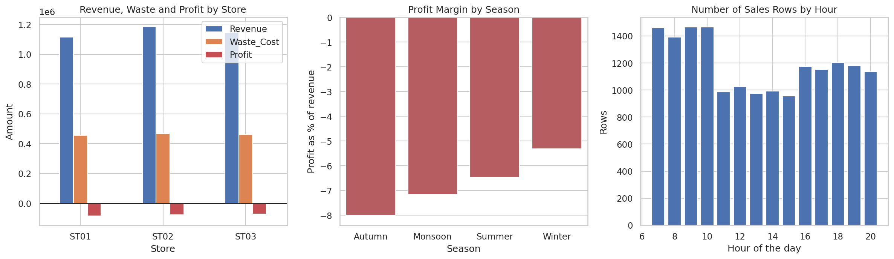
Figure 7: Profit by store, margin by season and sales by hour
Table 15: Totals by store (currency units)
Store | Revenue | Waste cost | Profit
ST01 | 1,115,030.02 | 456,860.35 | -83,213.28
ST02 | 1,184,448.13 | 469,916.00 | -75,319.83
ST03 | 1,144,634.80 | 462,036.45 | -71,806.14

Profit is negative in all 24 months, in all three stores, and in all four seasons (profit as a share of revenue: Autumn -8.00%, Monsoon -7.17%, Summer -6.48%, Winter -5.31%). The loss is therefore spread evenly rather than being caused by one location or period, which points to product, pricing and discount decisions. Sales rows are most frequent in the morning (7-10 am) and early evening (4-8 pm).

12.7 Customers
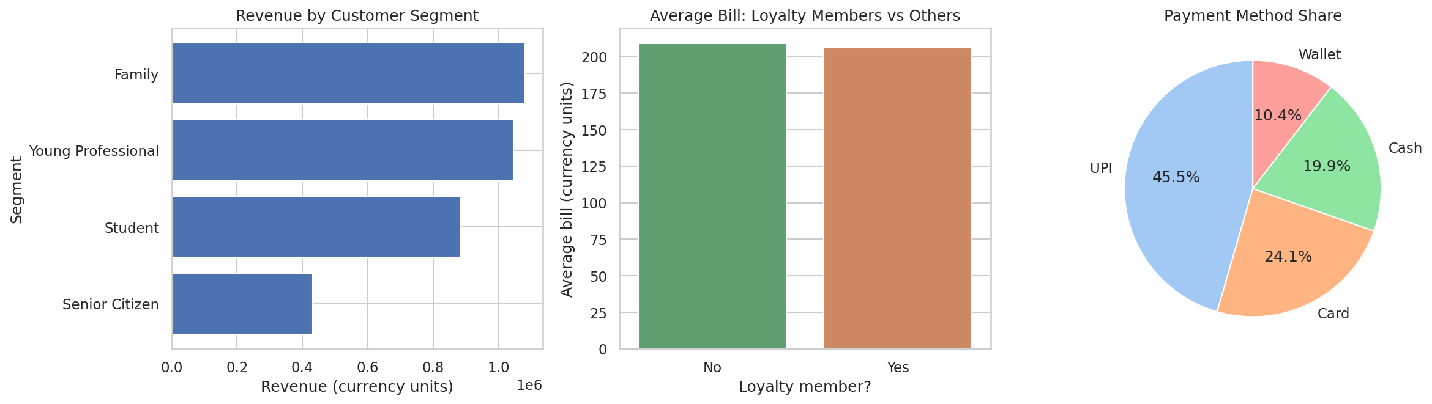
Figure 8: Revenue by customer segment, average bill by loyalty status and payment methods
Young Professionals, Families and Students contribute most revenue. Loyalty members have an average bill of 205.93 and an average discount of 6.62%, compared with 208.96 and 6.67% for non-members, so the loyalty programme does not show a visible difference in this data. Average profit is similar across customer ratings from 2 to 5, so rating is not a useful signal for profit. UPI is the most common payment method (7,541 rows).

12.8 Correlation heatmap
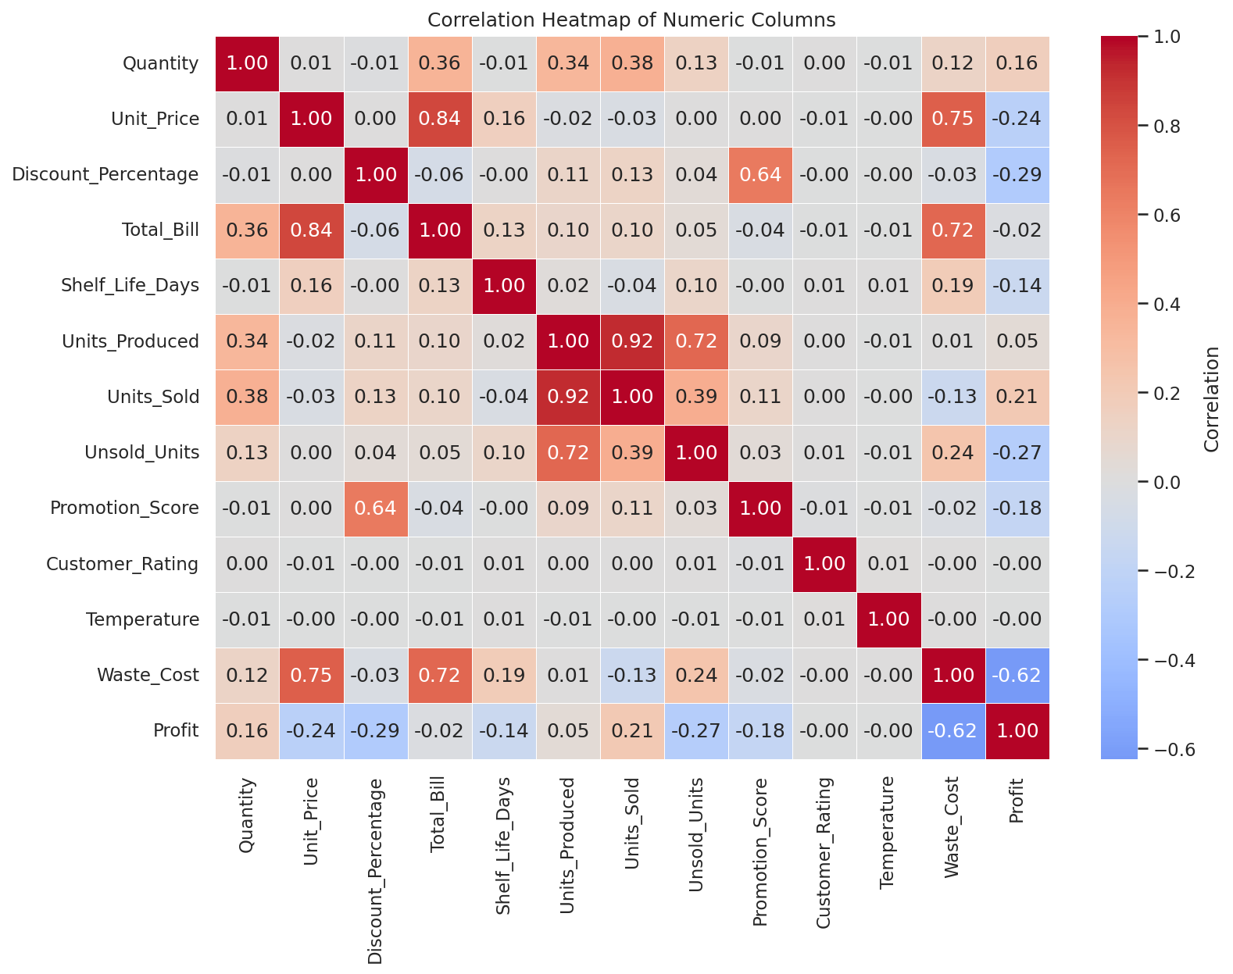
Figure 9: Correlation heatmap of numeric columns
The heatmap confirms that Waste_Cost has the strongest negative correlation with Profit. Waste_Cost is also strongly related to Unit_Price (0.75) and Total_Bill (0.72), which means that expensive products create expensive waste. Units_Produced and Unsold_Units are strongly related (0.72), as expected.

12.9 Statistical tests
Table 16: Statistical test results (significance level 0.05)
Test | Question | Result
Mann-Whitney U | Is profit different with a promotion? | p < 0.001: significant
Chi-square | Is loss-making linked to promotion? | p < 0.001: significant
Mann-Whitney U | Does quantity bought differ with a promotion? | p = 0.103: not significant

The lower profit and higher loss rate on promotion rows is statistically significant. However, the difference in quantity bought (2.56 vs 2.60) is not significant, so this dataset gives no evidence that promotions increased the quantity per purchase. Because the data is observational, these tests show association and do not prove that promotions cause losses.

12.10 Model results
Table 17: Performance on unseen 2024 data (4,268 loss rows and 4,111 profitable rows)
Model | Accuracy | Precision | Recall | F1 | ROC-AUC
Baseline (majority class) | 0.491 | 0.000 | 0.000 | 0.000 | 0.500
Logistic Regression | 0.748 | 0.759 | 0.740 | 0.749 | 0.833
Random Forest | 0.790 | 0.804 | 0.777 | 0.791 | 0.871

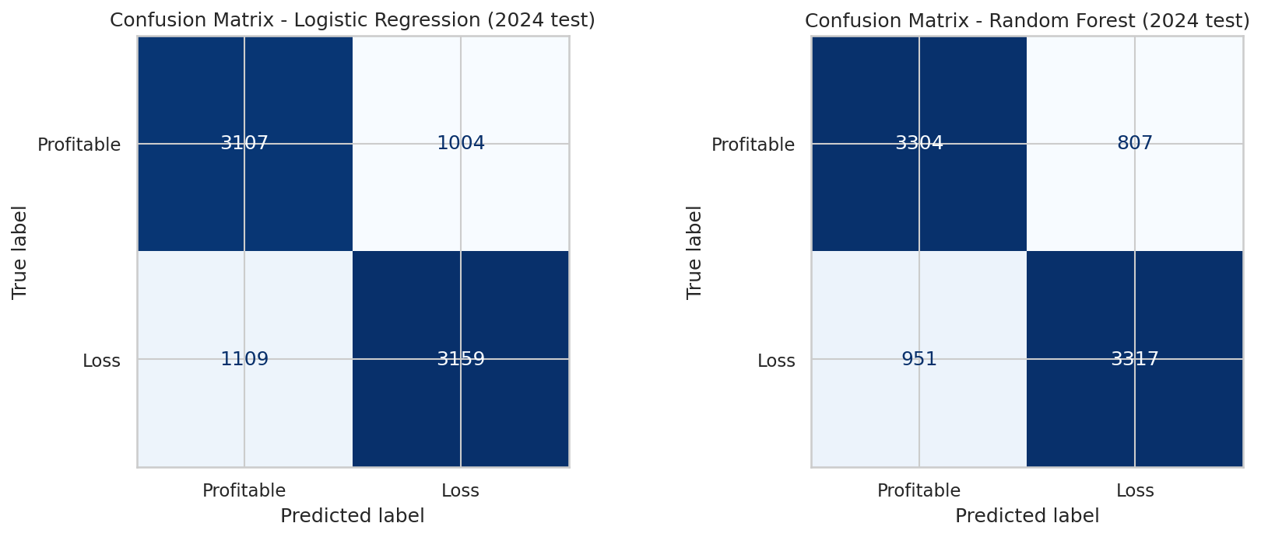
Figure 10: Confusion matrices on the 2024 test data
Both models clearly beat the baseline, which has no predictive skill (ROC-AUC 0.5). The Random Forest is the best model: it finds about 78% of the loss-making rows (recall 0.777) and about 80% of its loss warnings are correct (precision 0.804). Per class, the Random Forest scores an F1 of 0.79 for both Profitable and Loss rows, so it is not biased towards one class.
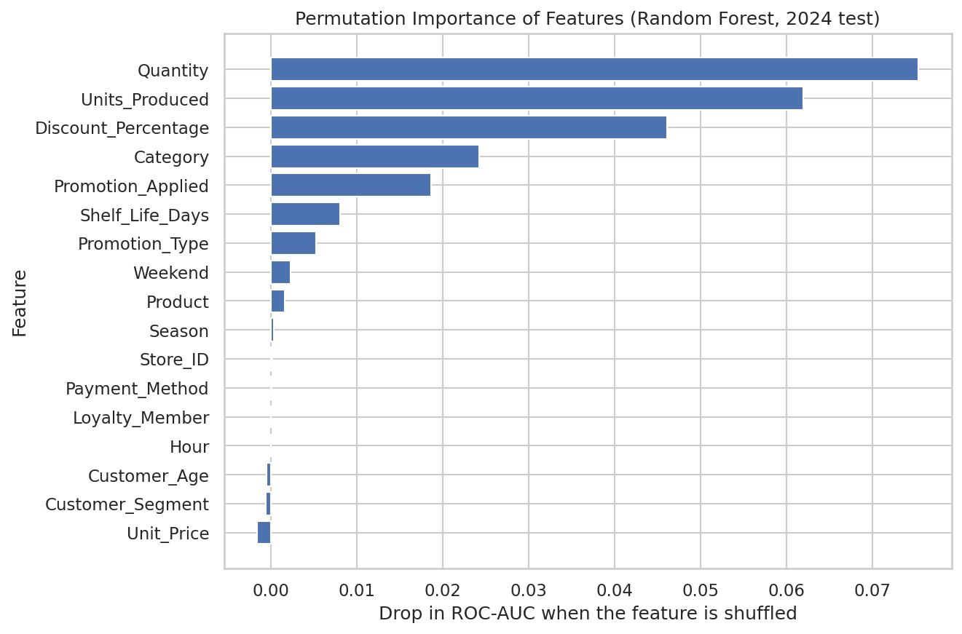
Figure 11: Permutation importance of features (Random Forest, 2024 test data)
Permutation importance measures how much the ROC-AUC drops when one feature is shuffled. Quantity (0.075), Units_Produced (0.062), Discount_Percentage (0.046), Category (0.024) and Promotion_Applied (0.019) rank highest. Product and Unit_Price score close to zero, but this does not mean they are unimportant: they overlap with Category, so shuffling one of them barely hurts the model because the others carry similar information.
Table 18: Loss rate behind the top model features
Group | Loss rate
Quantity = 1 / 2 / 3 / 4 / 5 / 6 | 70.1% / 54.7% / 42.4% / 36.2% / 33.4% / 30.4%
Units produced 2-4 / 5-7 / 8-10 / 11+ | 64.7% / 51.7% / 39.8% / 41.5%
Discount 0% / 0-5% / 5-10% / 10-20% / 20-30% | 39.4% / 37.0% / 47.9% / 67.4% / 94.3%

The raw loss rates support the model: loss rate falls as the quantity per row rises, and rises steeply with deeper discounts. Small batches (2-4 units produced) have a higher loss rate than larger batches, but this is probably mixed up with the product mix, because expensive cakes are produced in small batches. It should not be read as proof that larger batches are better.

13. Findings and Insights
- Total profit is negative (-230,339.25) on revenue of 3,444,112.95, and recorded waste cost equals 40.3% of revenue.
- Twenty-three of 35 products lose money. Cakes, Honey, Eggs, Cheese, Paneer and Peanut Butter account for the biggest losses.
- Coffee, Cold Coffee, Tea and Juice are the most profitable products; Beverages are the only large profitable category.
- Cakes generate 1,288,747 revenue but 515,611 waste cost and a loss of 107,657. Dairy also loses 105,527.
- Promotion rows are loss-making 84.6% of the time versus 41.7% without promotion, and rows with a 20-30% discount are loss-making 94.3% of the time.
- Promotions are not linked to a significant increase in quantity per purchase (p = 0.103).
- Loss appears in all 24 months, all 3 stores and all 4 seasons, so the cause lies in product and pricing decisions rather than location or time.
- Short-shelf-life items sold in one-day cycles (coffee, tea, juice) are the safest; loss rates are highest for products with a 4-30 day shelf life.
- A Random Forest trained on 2023 data predicts 2024 loss-making rows with ROC-AUC 0.871, F1 0.791 and recall 0.777, without using any leaked information.

Recommendations
- Review production planning for high-waste products (cakes, dairy, spreads, eggs, honey) and match production more closely to demand, for example by making cakes to order. The data cannot show the best batch size because batch size is mixed up with product type, so changes should be tested.
- Review discounting rules. Pause or redesign the deepest (20-30%) discounts and test changes on a few products first.
- Review the pricing of loss-making products. If the selling price does not cover cost plus expected waste, raise the price or drop the item.
- Protect and promote the profitable products (coffee, cold coffee, tea, juice, bread).
- Use the loss-prediction model as a screening tool, for example before launching a promotion, and retrain it as new data arrives. Treat it as decision support, not a replacement for judgement.
- Improve data capture: record waste per batch rather than per sale row, and document the currency, cost price and the rule used to calculate Profit.

14. Limitations
- The dataset is synthetic, so the findings describe this dataset and may not hold for a real bakery.
- Units produced, units sold and unsold units are identical for rows with the same date, store and product, while Waste_Cost and Profit are given per row. If batch waste was charged to every row of a batch, losses may be overstated. The dataset does not explain how Profit is calculated, so it was used as provided.
- No cost-price column is provided and the currency is not stated.
- The 2023 and 2024 data look very similar (loss share 49.9% vs 50.9%), so the 2024 test result may be more optimistic than a real change in business conditions would allow.
- The findings show association, not cause. Product, category and price overlap, which affects how feature importance should be read.
- Only a small hyper-parameter search was run, and only two models were compared.

15. Future Scope
- Obtain batch-level waste and cost-price data to calculate profit accurately.
- Forecast daily demand for each product to guide production quantities.
- Run a controlled experiment (A/B test) on discount levels to measure their true effect.
- Predict the profit amount with regression models, and compare other models such as gradient boosting.
- Build a dashboard so store managers can monitor waste and profit by product each day.
- Test the approach on real bakery data if it becomes available.

16. Conclusion
This project analysed 16,569 bakery sales records to understand why recorded profit is negative. The analysis shows that the problem lies in what is produced, how much of it is wasted and how it is discounted, and not in a particular store or season. A small number of products and categories (cakes, honey, eggs, dairy and spreads) account for most of the loss, whereas beverages and a few fast-selling items make a profit. Promotions and deep discounts are strongly associated with loss-making sales and did not show a significant increase in quantity bought.
A Random Forest model, trained on 2023 and tested on 2024 without target leakage, flagged loss-making rows with ROC-AUC 0.871, F1 0.791 and recall 0.777, clearly beating the baseline. The results are limited by the synthetic nature of the dataset and by undocumented profit and waste calculations. Even so, the project shows a complete and reproducible workflow, and it points to three practical next steps: review discount rules, plan production of high-waste products more carefully, and review pricing of loss-making items.

17. References
- Breiman, L. (2001). Random Forests. Machine Learning, 45(1), 5-32.
- Harris, C. R., et al. (2020). Array programming with NumPy. Nature, 585, 357-362.
- Hunter, J. D. (2007). Matplotlib: A 2D graphics environment. Computing in Science & Engineering, 9(3), 90-95.
- McKinney, W. (2010). Data structures for statistical computing in Python. Proceedings of the 9th Python in Science Conference, 56-61.
- Pedregosa, F., et al. (2011). Scikit-learn: Machine learning in Python. Journal of Machine Learning Research, 12, 2825-2830.
- Virtanen, P., et al. (2020). SciPy 1.0: Fundamental algorithms for scientific computing in Python. Nature Methods, 17, 261-272.
- Waskom, M. L. (2021). seaborn: statistical data visualization. Journal of Open Source Software, 6(60), 3021.
- Bakery synthetic dataset (bakery_synthetic_dataset_csv__1_.xlsx). Provided privately for this internship assignment; no public source or link available.

