|  |  |
| --- | --- |
| **Ex. No:** | **PERSONALITYANALYSIS** |
| **Date:** |

**1. Problem analysis and project planning**

**1.1 Introduction**

The Personality Analysis System is a software application designed to analyse and assess personality traits based on user input. This document outlines the functional and non-functional requirements of the system.

**1.2 Objectives**

The purpose of the document is to define the requirements of the Personality Analysis System. All the functional and Non-functional requirements are listed. This document presents the overall description of the Project. The overall working of the project will be detailed, encompassing the system's functionalities, user interactions, and system performance to ensure a comprehensive understanding of the project's scope and objectives.

**1.3 Scope**

These additional requirements are relevant to the system Personality Analysis. This specification outlines the system's non-functional requirements, including those related to performance, usability, reliability, and supportability. As well as typical functional requirements found in several use cases.

**1.4 Problem statement**

Students are confused about their career choices and the traditional methods of counselling are inefficient and inadequate for the students to make the right decision on their career.

The Personality Analysis system presents students the opportunity to make the right choices about their career. The system will do the evaluation of the registered users upon some fields and generate a detailed report about the user in order to suggest the career choice that best suits the individual. The user can view their profiles generated based on the test taken and they can see all the career opportunities available for them.

**2. Problem statement (Use case) analysis**

**2.1 Identified use cases**

**i. Register:**

The user initiates the registration process to create a new account on the platform. This involves providing necessary information and agreeing to terms and conditions.

**ii. Login:**

The student and administrator initiate the login process to access the platform. This involves providing valid credentials (such as username/email and password) to authenticate their identity.

**iii. Take test:**

User undergoes some set of tests which assess the personality of the user based on test criteria.

**iv. View Test Report:**

The user and administrator both can view the test report, which presents the results and insights derived from the tests they have taken.

**v. View Profile:**

The Administrator can see the registered students' profiles about their basic information such as age, gender, address, interest etc.

**vi. Take Recommendations:**

Personalised recommendations for users based on their profile. Provide options for users to explore and act upon these recommendations.

**2.2 Identified Actors**

**i. Student:**

The student can take the test, View Test Report, assess profile and View Recommendations of the available career choices.

**ii. Admin:**

The administrator maintains all the databases. He is responsible for managing all the students database and keeping a track about all the registered students.

**iii. Database**

The database is the collection of data where the data is stored and form where the data can be retrieved.

**2.3 Use Case Diagram**

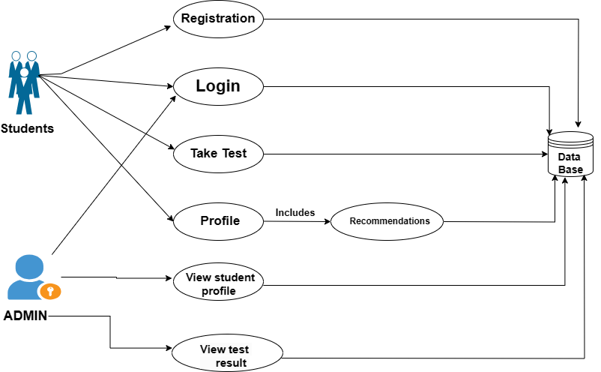

# Design of Personality Analysis

1. **Student Registration**

**1.1Brief description:**

This use case describes how students can register on the application to create an account.

* 1. **Flow of events:**

**5.2.1 Basic flow:**

This use case starts when a student accesses the registration page of the application.

* + - The student selects the option to create a new account.
    - The application presents a registration form where student fills out their information such as name, email address, password and submits it to the application.
    - The application validates the student's information, ensuring that the email address provided is unique.
    - If the validation is successful, the application creates a new student account and stores the student's information in the database.

**5.2.2Alternative flow:**

* + - If the student attempts to register with an email address that is already associated with an existing account, the application displays an error message prompting the student to use a different email address.
    - If there are technical issues or errors during the registration process, such as database connectivity problems, the application displays an appropriate error message and advises the student to try again later.

* 1. **Pre-condition:**

* The student must have access to the application's registration page.
  1. **Post condition:**

* If the use case is successful, the student can proceed to log into their account.
* If there are any issues or errors during the registration process, the system state remains unchanged, and the student is unable to create a new account.

1. **Login**

**2.1Brief description:**

This use case describes how the students log onto the application and view their profile.

* 1. **Flow of events:**

**2.2.1 Basic flow:**

This use case starts when the student wishes to log in to the application and view their dashboard or portal.

* + - The student will log in to the system using id and password.
    - The application validates the id and the password logs the student into the system.

**2.2.2Alternative flow:**

* + - If the id or password is incorrect then it will show the pop saying “invalid id or password”.
    - The student can either re-enter the correct id or password else they can click on “forget password” and can retrieve.

* 1. **Pre-condition:**

* The administrator has signed up on the web application.
  1. **Post condition:**

* If the use case is successful then student is now logged in the system else the system state is unchanged.
* Students can take test and view their report after taking personality test.

1. **Take Test**

**3.1Brief description:**

This use case describes how students can take a personality test to assess their personality traits.

* 1. **Flow of events:**

**3.2.1 Basic flow:**

This use case starts when the student navigates to the "Take Test" section of the application to begin the personality assessment.

* + - The student selects the option to take the personality test.
    - The application presents a series of questions designed to evaluate different aspects of the student's personality.
    - The student responds to each question according to their preferences or traits.
    - Once all questions are answered, the application processes the responses and generates a personality profile for the student.

**3.2.2Alternative flow:**

* + - If the student exits the test before completing all questions, the application prompts them to confirm if they want to discard their progress or resume the test later.
    - If there are technical issues during the test-taking process, such as server errors, the application provides appropriate error messages and instructions for troubleshooting.
  1. **Pre-condition:**

* The student must be logged into the system.
* The personality test must be available and accessible to the student.
  1. **Post condition:**

* If the use case is successful, the student receives their test result and can view their personality profile and recommendations.
* If the test is interrupted or not completed, the system retains the student's progress or prompts them to resume the test later.

1. **View Test Report**

**4.1Brief description:**

This use case describes how students can view their test reports and personality profiles.

* 1. **Flow of events:**

**4.2.1 Basic flow:**

This use case starts when the student navigates to the "View Test Report" section of the application to access their personality assessment results.

* + - The student selects the option to view their test report from the application's menu or dashboard.
    - The application retrieves the student's test results and personality profile from the database.
    - The student's test report and personality profile are displayed on the screen, providing insights into their personality traits, strengths, weaknesses and career fields matching to their strengths.

**4.2.2Alternative flow:**

* + - If the student has not yet taken the personality test, the application prompts them to complete the test before accessing their test report.
    - If there are technical issues or errors retrieving the student's test report, the application displays an appropriate error message and advises the student to try again later.

* 1. **Pre-condition:**

* The student must be logged into the system.
* The student must have previously taken the personality test to have a test report available for viewing.
  1. **Post condition:**

* If the use case is successful, the student gains insights into their personality traits.
* If there are any issues or errors during the process, the system state remains unchanged, and the student is unable to access their test report.

1. **Take Recommendations**

**5.1Brief description:**

This use case describes how students can receive personalized career recommendations based on their personality test results.

* 1. **Flow of events:**

**5.2.1 Basic flow:**

This use case starts when the student navigates to the "Take Recommendations" section of the application after completing the personality test.

* + - The student selects the option to take recommendations from the application's menu or dashboard.
    - Based on the student's personality traits and profile, the application generates personalized career recommendations.
    - The student's personalized career recommendations are displayed on the screen, providing insights into potential career paths aligned with their personality.

**5.2.2Alternative flow:**

* + - If the student has not yet taken the personality test, the application prompts them to complete the test before accessing the “Taking Recommendations”.
    - If there are technical issues or errors, the application displays an appropriate error message and advises the student to try again later.

* 1. **Pre-condition:**

* The student must be logged into the system.
* The student must have previously taken the personality test to have career recommendation available for viewing.
  1. **Post condition:**

* If the use case is successful, the student receives personalized career recommendations tailored to their personality traits, providing valuable guidance for career planning and decision-making.
* If there are any issues or errors during the process, the system state remains unchanged, and the student is unable to access personalized career recommendations.

1. **Login (administrator)**

**6.1Brief description:**

This use case describes how administrators can view profiles of students registered on the application.

* 1. **Flow of events:**

**6.2.1 Basic flow:**

This use case starts when an administrator navigates to the administrator login page of the application.

* + - The administrator enters their username and password in the respective fields on the login page.
    - The application validates the administrator's credentials by checking them against the stored records in the database.
    - If the entered credentials are valid, the application grants access to the administrator and redirects them to the administrator dashboard.

**6.2.2Alternative flow:**

* + - If the administrator enters invalid credentials, the application displays an error message indicating that the login attempt failed. The administrator is prompted to re-enter the correct credentials.
    - If there are technical issues or errors during the login process, the application displays an appropriate error message and advises the administrator to try again later.

* 1. **Pre-condition:**

* The administrator must have a registered account with valid login credentials.
  1. **Post condition:**

* The administrator gains access to administrative functionalities such as managing student profiles, viewing test results, and other administrative tasks.
* If there are any issues or errors during the process, the system state remains unchanged, and the administrator is unable to view student profiles.

1. **View Profiles (Administrator Functionality)**

**5.1Brief description:**

This use case describes how administrators can view profiles of students registered on the application.

* 1. **Flow of events:**

**7.2.1 Basic flow:**

This use case starts when an administrator logs into the application and navigates to the "View Profiles" section.

* + - The administrator selects the option to view profiles from the application's menu or dashboard.
    - The application retrieves a list of registered student profiles from the database.
    - The administrator selects a specific student profile from the list to view detailed information of report.
    - The application displays the selected student's profile, including their name, email address, registration date, and their test report.

**7.2.2Alternative flow:**

* + - If there are no registered student profiles in the database, the application displays a message indicating that there are no profiles to view.
    - If there are technical issues or errors retrieving student profiles from the database, the application displays an appropriate error message.

* 1. **Pre-condition:**

* The administrator must be logged into the system with appropriate permissions to view student profiles.
* Student profiles must exist in the database for the administrator to view.
  1. **Post condition:**

* If the use case is successful, the administrator gains access to the selected student's profile information.
* If there are any issues or errors during the process, the system state remains unchanged, and the administrator is unable to view student profiles.

**3. Non-Functional Requirements**

* 1. **Logical Structure of the Data (E R Diagram)**

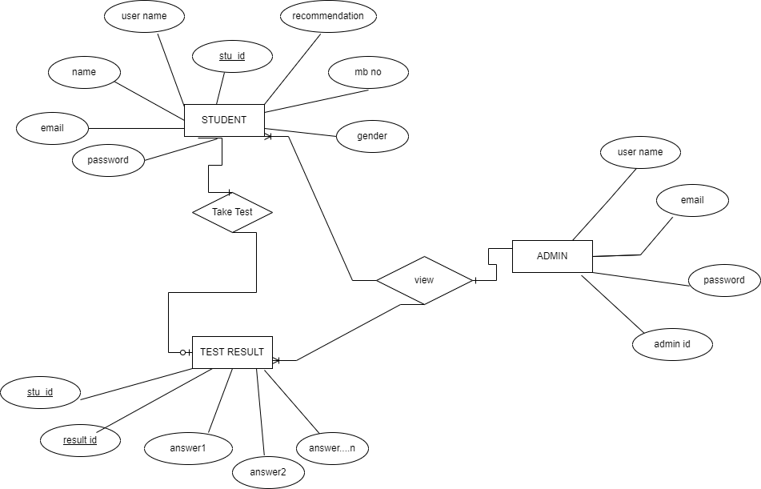

**3.2 Security**

Security systems, like many other applications, need databases for storage. However, because of the unique needs of the security industry, vendors must choose their database partners wisely, so we are using MYSQL.

**3.3 Privacy**

Ensure secure storage of login credentials and personal data in MySQL. Implement strict access controls, encryption, and HTTPS for data transmission. Provide robust password recovery. Log and audit user data access. Comply with privacy regulations, define data retention policies, and transparently communicate privacy practices to users.

4. S**oftware Quality Attributes**

* + AVAILABILITY: Since project will be hosted on the server it will be available all the time.
  + CORRECTNESS: The system should generate an appropriate report
  + MAINTAINABILITY: The system should maintain correct schedules
  + USABILITY: The system should satisfy the maximum number of users’ needs.

5. **Software and Hardware Requirements**

5.1 Software Requirements

* + Python (front end)
  + HTML & CSS
  + JavaScript
  + Web Browser: Microsoft Internet Explorer, Mozilla, Google Chrome or later
  + MySQL Server (back-end)
  + Operating System: Windows XP / Windows7/ Windows Vista/Windows 8 /Windows10 /Windows11

5.2. Hardware Requirements

* + Pentium IV or higher, (PIV-300GHz recommended)
  + 256 MB RAM
  + 1 Gb hard free drive space server Required.
  + Four 2.8 GHz core processors
  + 4 GB of RAM

**6. Limitations**

AS project will be Locally hosted in initial stages so will not be always available. So, we can only Fix working hours in a day where a locally hosted program will work.

**7. Conclusion**

**8. DATA FLOW DIAGRAM**

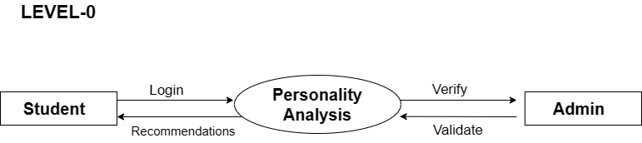

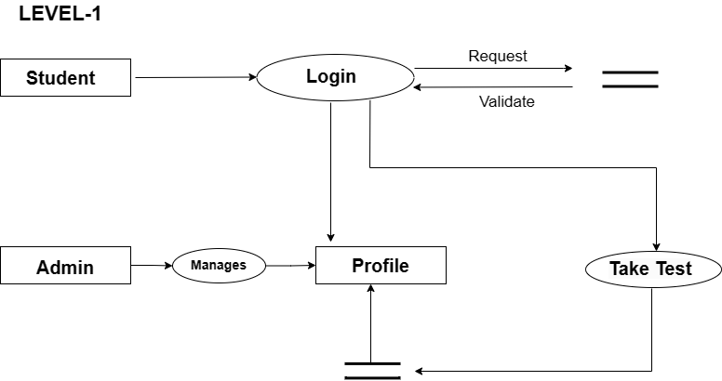

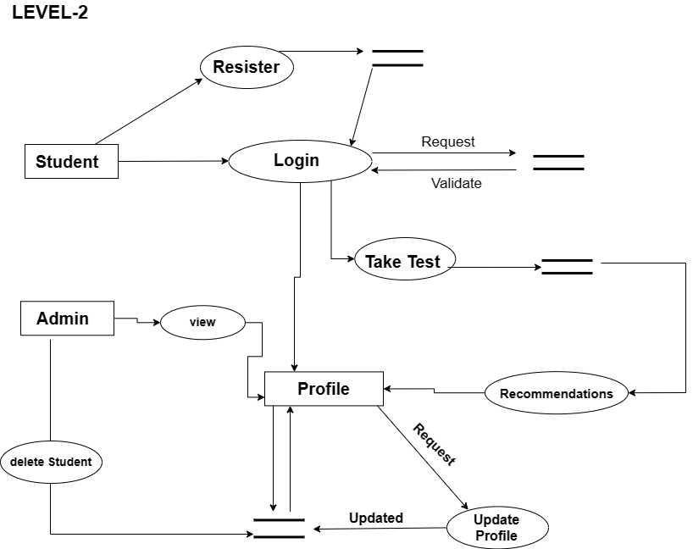

**9. SEQUENCE DIAGRAMS**

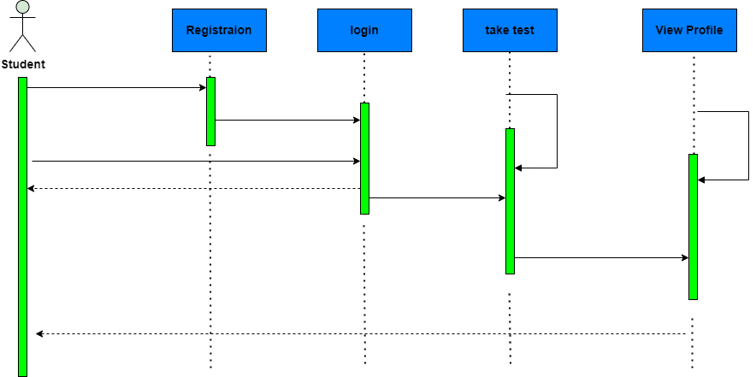

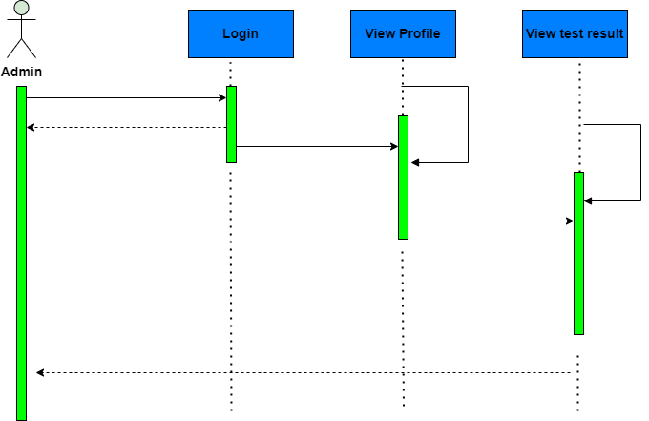

**Conclusion:**

In conclusion, our project represents a significant step forward in the realm of career exploration and guidance. By leveraging technology and innovative methodologies, we have developed a platform that empowers individuals to make informed decisions about their professional futures. Through our user-friendly website, users can undergo a personalized personality assessment to gain insights into their unique strengths and interests. This assessment serves as the foundation for our tailored career recommendations, which aim to match individuals with suitable job roles based on their personality traits and aspirations. Whether you're a student uncertain about your next steps or a young professional seeking a career change, our platform offers a valuable resource to guide you along your journey. Our commitment to accessibility, transparency, and data security ensures that users can trust our platform to provide reliable guidance while protecting their privacy. As we continue to evolve and expand our services, we remain dedicated to democratizing career counseling and helping individuals unlock their full potential in the ever-changing landscape of the job market. Join us on this exciting journey towards discovering your ideal career path and embarking on a fulfilling professional adventure.

References:

<https://www.kaggle.com/datasets/noorsaeed/student-studeis-recommendation>