**Hiring Process Analytics**

**Project Description:**

This project focuses on analysing the hiring data to gain insights into the company's recruitment process. The main objectives are to explore hiring patterns, salary distributions, departmental and position tier analysis, and identify trends that can help improve future hiring strategies.

**Approach:**

1. Data cleaning for handling missing values and outliers.
2. Data analysis using excel to perform the tasks.
3. Data visualisation to interpret and draw the insights.

**Tech-Stack Used:**

Microsoft excel 2019 is used for statistical calculations, creating visualisations like bar graphs and pie charts, forming pivot tables and charts to interpret hiring data.

**Insights:**

1. Hiring Analysis: The gender distribution analysis revealed the proportion of male and female hires, providing a clear picture of gender representation in the company.

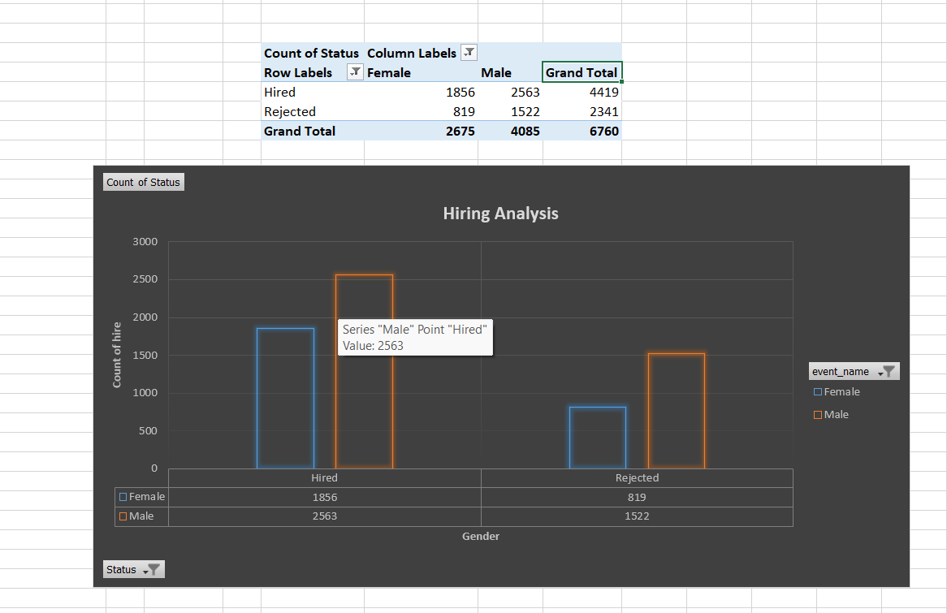

1. Salary Analysis: The average salary offered was calculated, and class intervals for salary distribution highlighted the spread and concentration of salaries across various ranges.

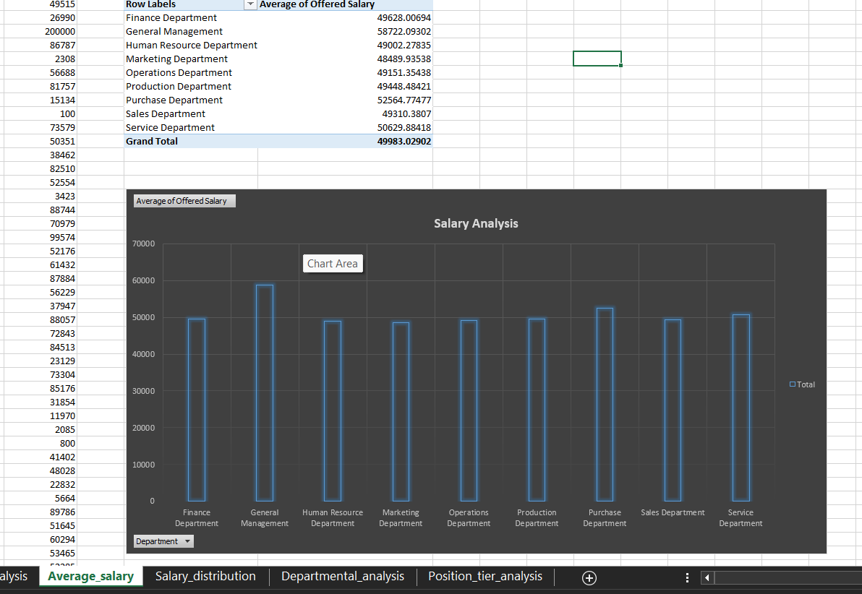

1. Salary Distribution: The salary distribution showed that most salaries fall within the 10,000–50,000 range, with fewer employees earning above 100,000. The distribution exhibited a right-skewed pattern, indicating limited high-tier positions compared to mid-level roles.

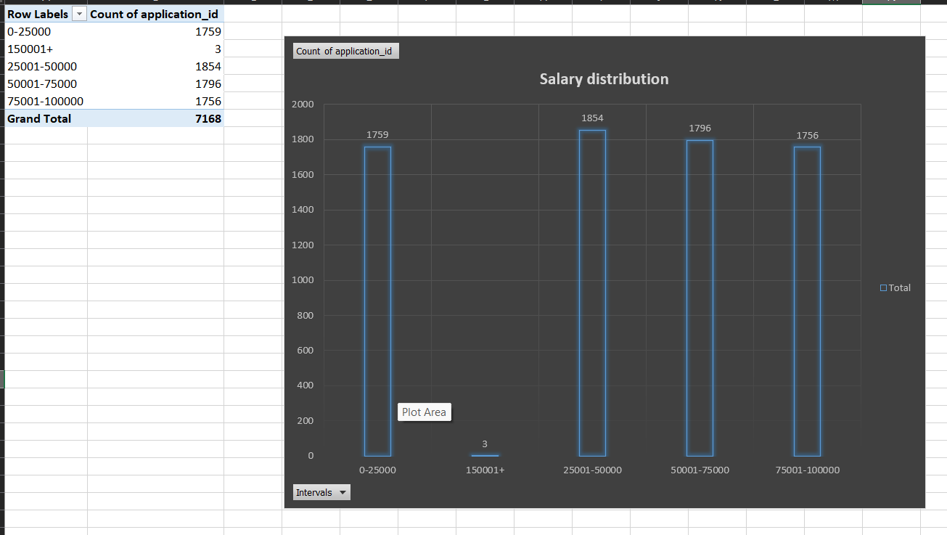

1. Departmental Analysis: Visual representations showed the distribution of employees across departments, identifying areas with higher or lower staffing.

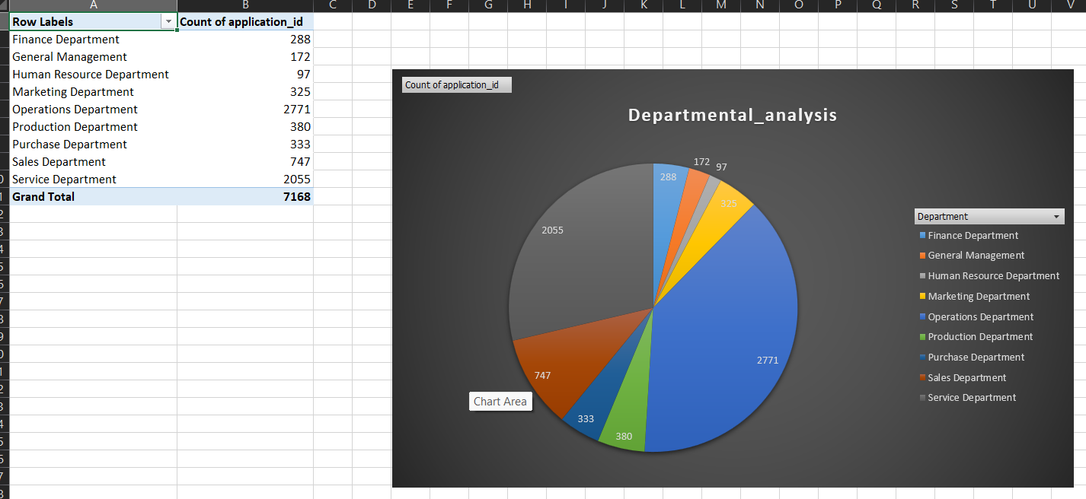

1. Position Tier Analysis: Analysed the spread of job tiers, helping to understand the distribution of roles within the organization.

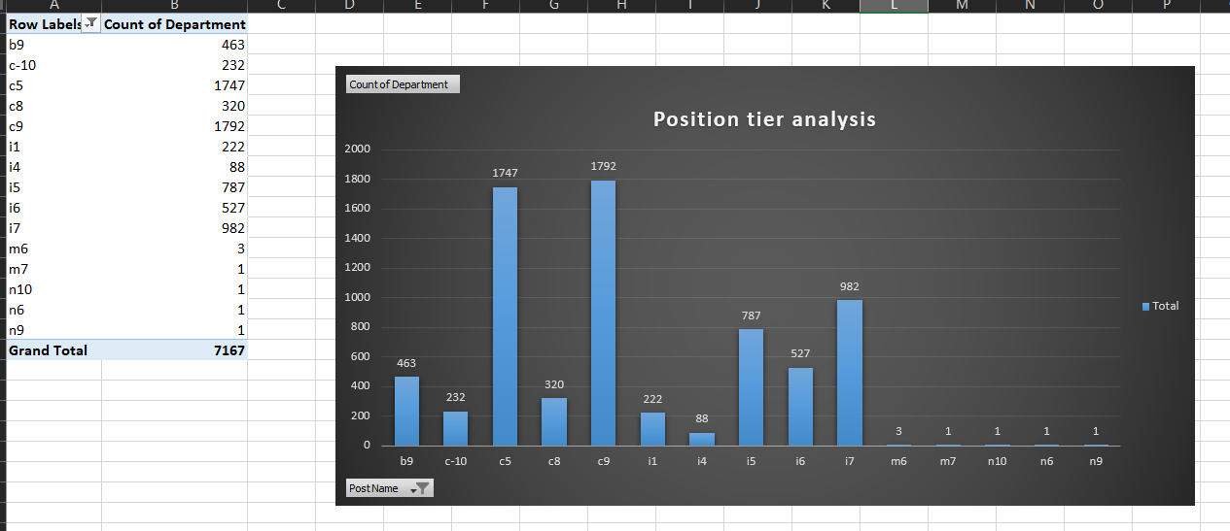

**Results:**

Through this project, we gained a deeper understanding of the company's hiring patterns, salary distribution, and departmental composition. The insights derived can support data-driven decisions for more balanced hiring practices and salary structuring. This analysis contributes to improving recruitment strategies and identifying potential areas for optimization.

**Hyperlink:** [**https://docs.google.com/spreadsheets/d/16t6u2EwihGZns0C3bOIDw1-bn2Yg38m0/edit?usp=sharing&rtpof=true&sd=true**](https://docs.google.com/spreadsheets/d/16t6u2EwihGZns0C3bOIDw1-bn2Yg38m0/edit?usp=sharing&rtpof=true&sd=true)