**IMDB Movie Analysis**

**Project Description**

The IMDB Movie Analysis project aims to uncover insights about movies by analysing various factors such as genre, duration, language, director influence, and budget. The goal is to understand how these elements impact movie ratings and financial success, providing data-driven insights for filmmakers, producers, and enthusiasts.

**Approach**

1. **Genre Analysis:**
   1. Calculated descriptive statistics (mean, median, mode) for IMDB scores across unique genres.
   2. Used Excel functions like AVERAGE, MEDIAN, and MODE to identify trends.
   3. Compared statistics to explore the relationship between genre and movie ratings.

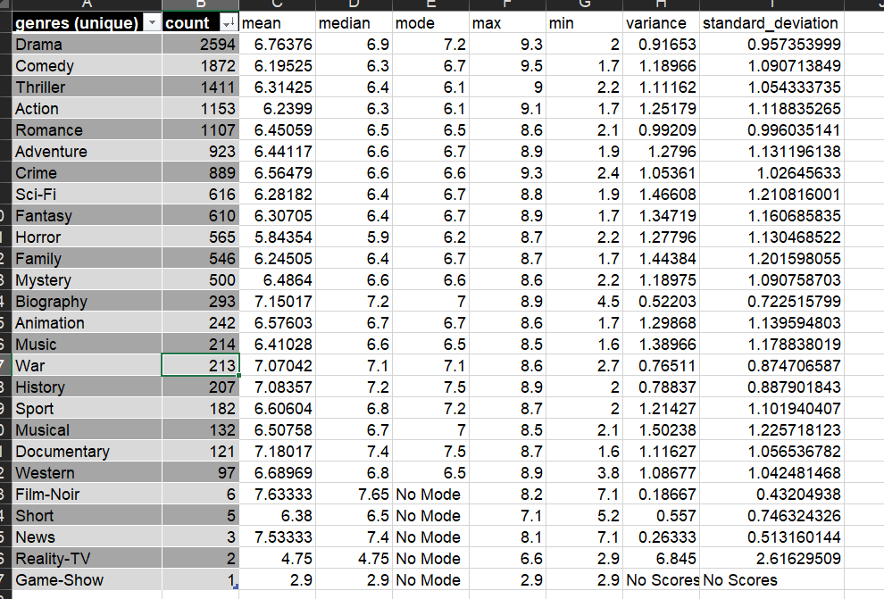

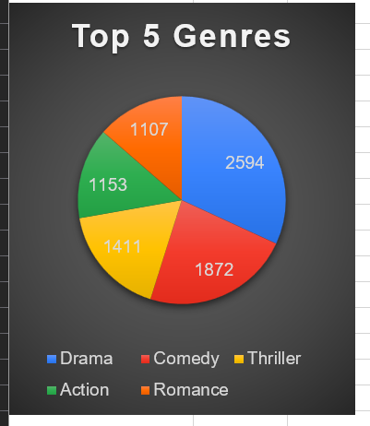

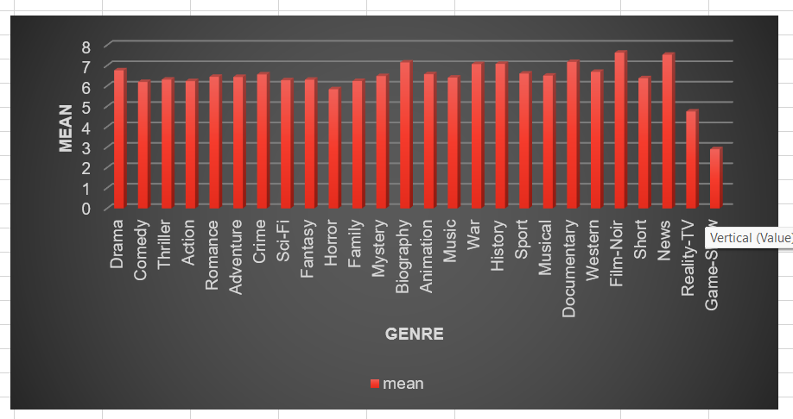

1. **Duration Analysis:**
   1. Cleaned the data by removing blanks in the movie duration column.
   2. Computed mean, median, and standard deviation for movie durations.

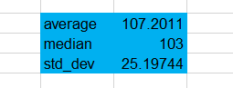

* 1. Created a scatter plot in Excel to visualize the relationship between movie duration and IMDB scores.
  2. Added a trendline to assess the strength and direction of the correlation.

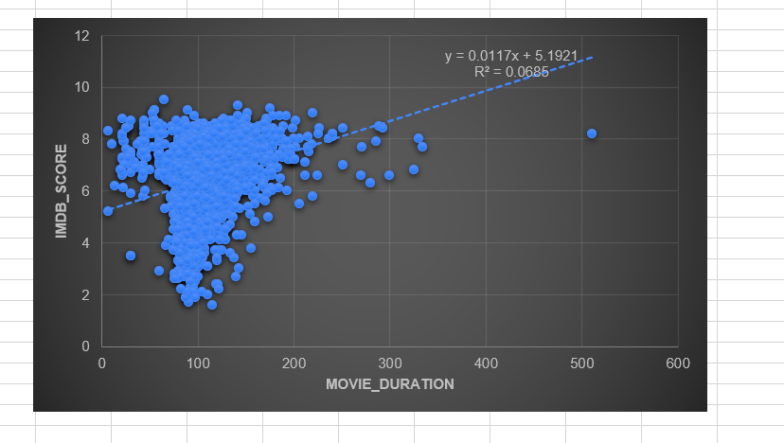

1. **Language Analysis:**
   1. Created a unique language column.
   2. Used COUNTIF to count the number of movies for each language.
   3. Calculated mean, median, and standard deviation for IMDB scores for each language.
   4. Compared language-wise statistics to observe their impact on ratings.

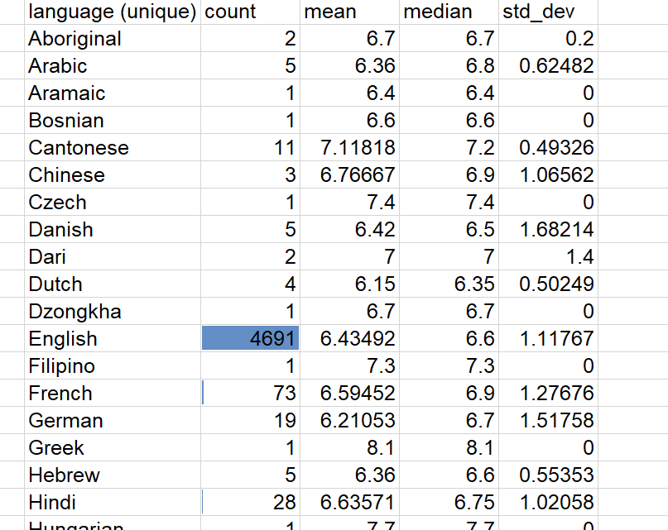

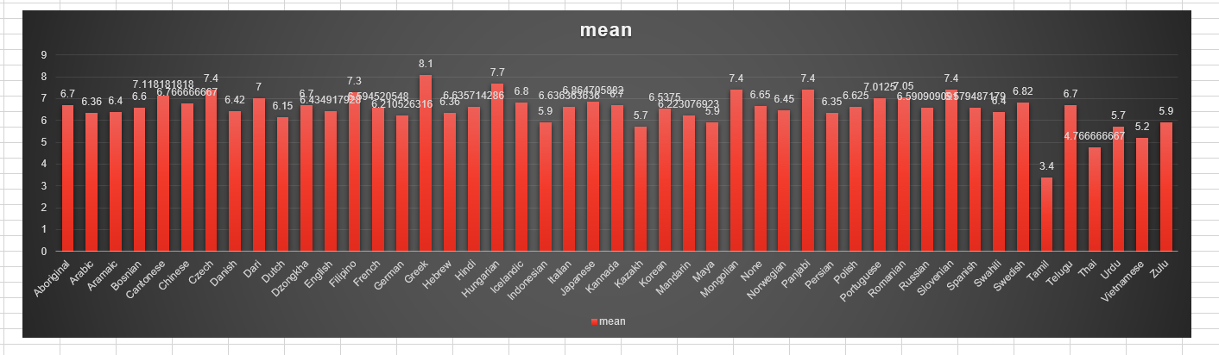

1. **Director Analysis:**
   1. Generated a list of unique directors.
   2. Computed the average IMDB score for each director using AVERAGEIF.
   3. Applied Excel’s PERCENTILE function to identify top-performing directors.
   4. Compared their scores against the overall IMDB score distribution.

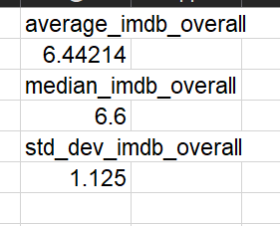

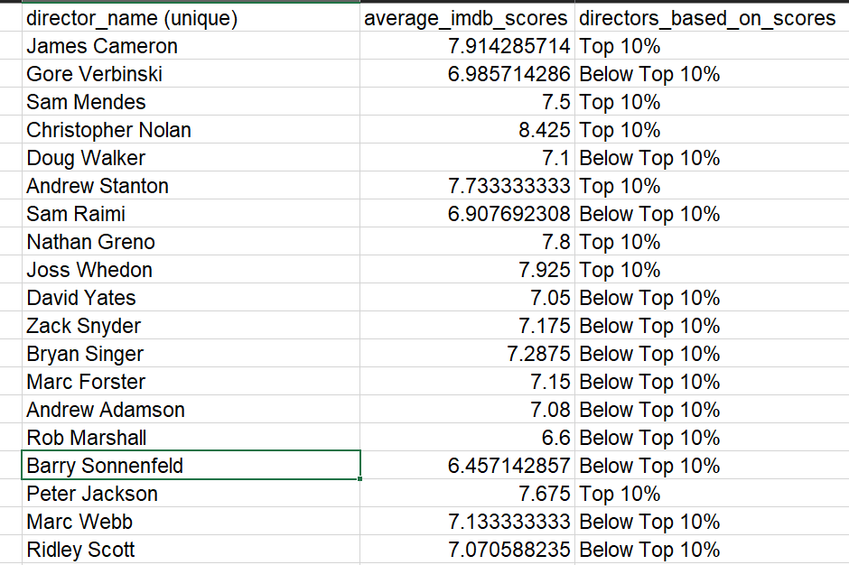

1. **Budget Analysis:**
   1. Analysed the correlation between movie budgets and gross earnings using the CORREL function.
   2. Calculated profit margins (gross earnings - budget) for each movie.
   3. Used MAX to identify the top 10 most profitable movies.

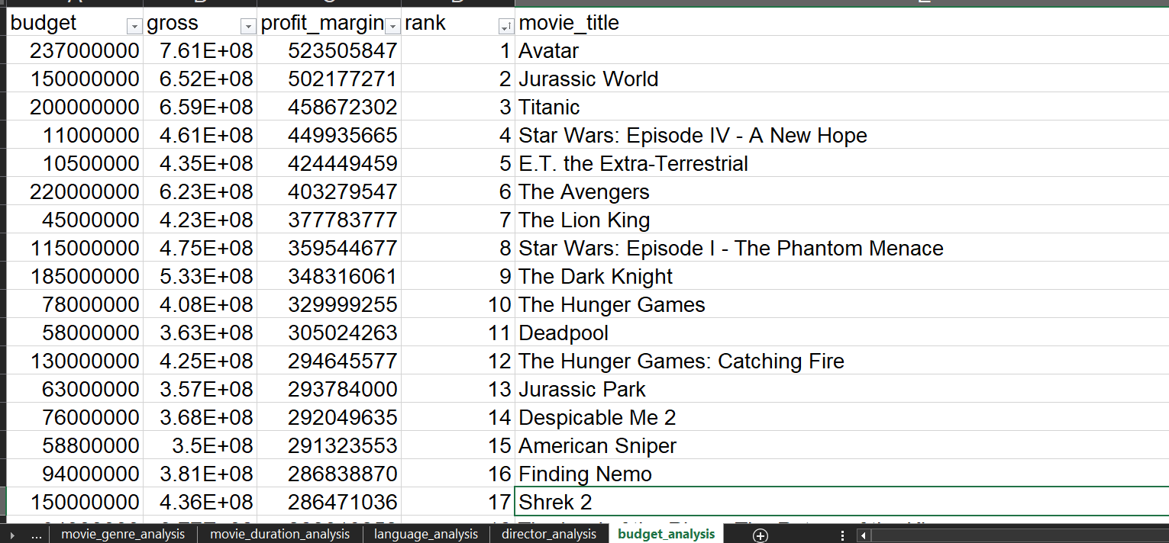

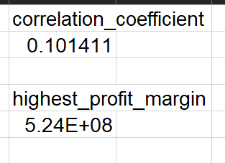

**Tech-Stack Used**

1. **Microsoft Excel:** For data cleaning, statistical analysis, visualization (scatter plots, trendlines), and correlation studies.
2. **Functions Used:** AVERAGE, MEDIAN, MODE, STDEV, COUNTIF, CORREL, MAX, PERCENTILE, AVERAGEIF.

**Insights and Results**

1. **Genre Impact:** Certain genres like Thriller and Adventure showed higher average IMDB scores, while others like Romance and Comedy had wider variability.
2. **Duration Correlation:** A slight positive correlation was observed between movie duration and IMDB scores — longer movies tended to have slightly better ratings.
3. **Language Trends:** English-dominated movies had the most entries, but other languages like French and Spanish showed promising average scores.
4. **Director Influence:** Top directors (as per PERCENTILE analysis) consistently produced high-rated movies, reinforcing their impact on a movie's success.
5. **Budget vs. Profit:** No strong correlation was found between high budgets and high ratings, but the top 10 most profitable movies had moderate budgets and massive box office earnings, emphasizing smart investments over extravagant spending.

**Hyperlink:** [**https://docs.google.com/spreadsheets/d/19K_4qHNaUgjhxlghvWycWlB5pPebGuLM/edit?usp=sharing&ouid=111719312717552042778&rtpof=true&sd=true**](https://docs.google.com/spreadsheets/d/19K_4qHNaUgjhxlghvWycWlB5pPebGuLM/edit?usp=sharing&ouid=111719312717552042778&rtpof=true&sd=true)