ABC call volume trend analysis

**Project Description**: This project focuses on Customer Experience (CX) analytics for ABC Insurance Company, specifically analyzing inbound call data spanning 23 days. The goal is to derive insights that help optimize call handling, improve customer satisfaction, and support strategic manpower planning. Key call-related metrics such as duration, volume, and abandon rate were analyzed across different time buckets.

**Approach:** We performed an in-depth data analysis using Microsoft Excel to clean and structure the dataset. Calculations and visualizations were developed to determine average call durations, call volumes by time bucket, and agent requirements to reduce the abandon rate. We applied time-based aggregation, pivot tables, bar charts, and manpower efficiency assumptions to generate actionable insights and forecasts.

**Tech Stack Used**: **Microsoft Excel**: Used for time-series analysis, statistical calculations, and data visualization.

**Insights:**

1. **Average Call Duration:** Average duration was calculated for each time bucket (e.g., 9-10 am, 10-11 am, etc.). Higher average durations were noted in mid-morning and late afternoon slots, indicating possible complexity in customer queries during those periods.

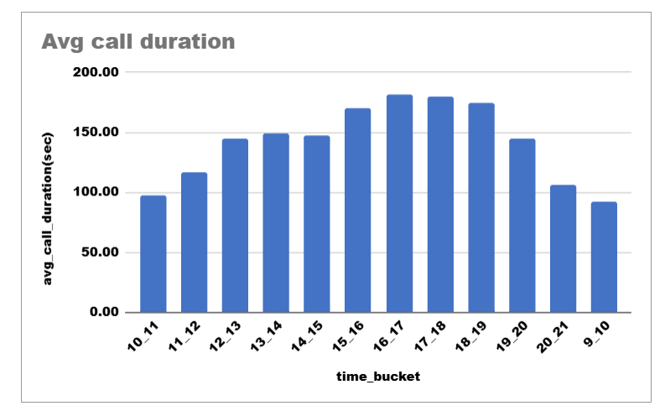

1. **Call Volume Analysis:** A time-bucketed bar chart showed peak call volumes between 10 am to 12 pm and again from 9 pm to 10 pm. These peaks suggest the need for focused manpower allocation during these hours.

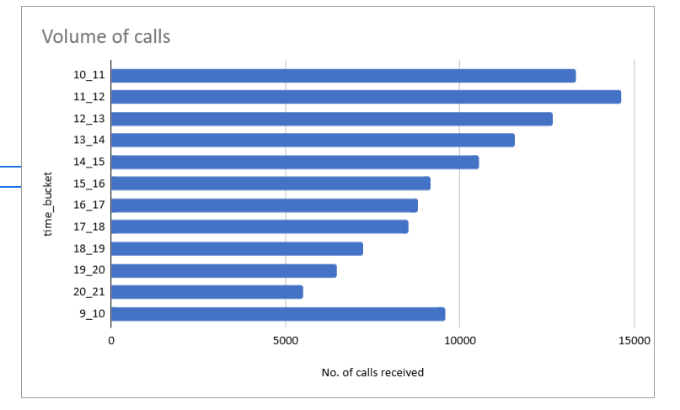

1. **Manpower Planning:** Based on the existing 30% abandon rate and target of 10%, the number of agents per time bucket was recalculated. The number of agents was proportionally scaled to ensure at least 90 out of 100 calls are answered during peak hours.

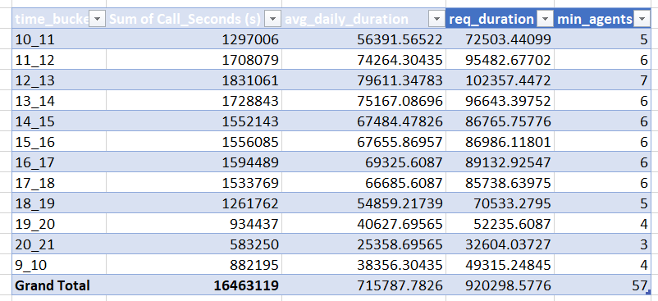

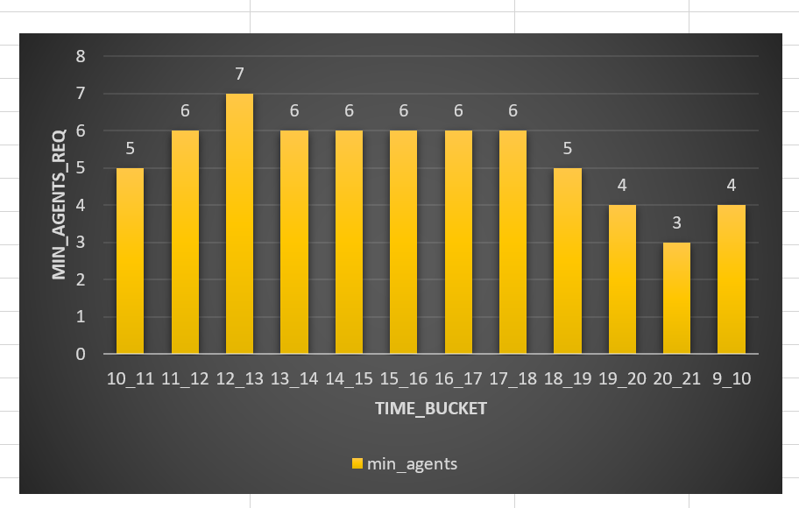

1. **Night Shift Planning:** Assuming night calls are 30% of day calls, the call distribution was modeled across 9 pm to 9 am in hourly buckets. A manpower plan was proposed for night shifts to meet the same 10% maximum abandon rate, considering operational constraints.

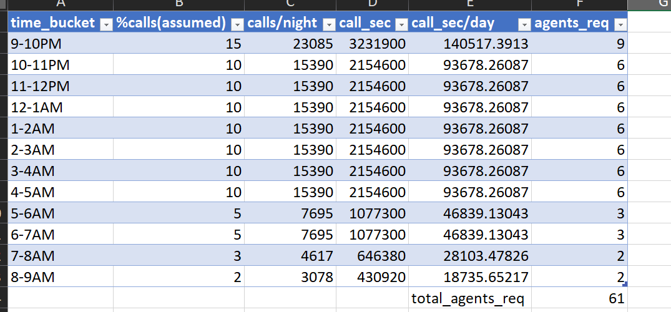

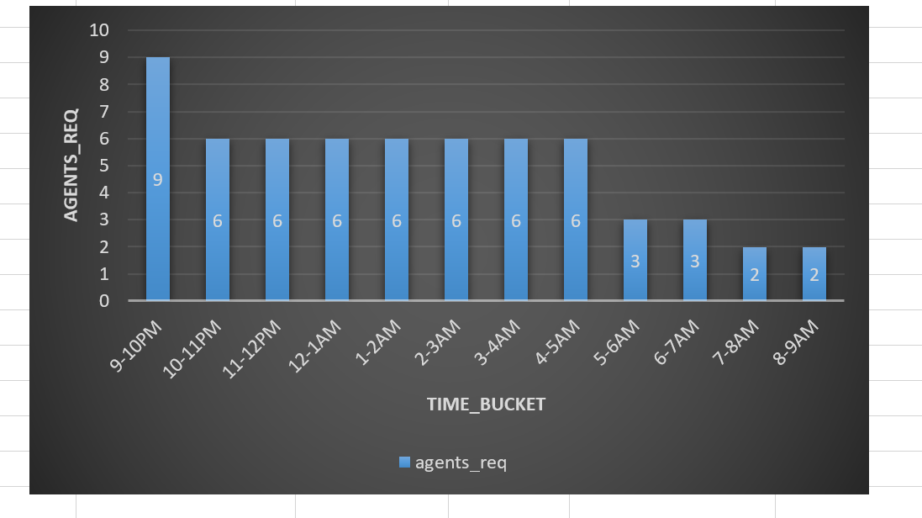

**Results**: The project resulted in a detailed hourly manpower allocation plan aimed at reducing call abandon rates to 10% during both day and night operations. The analysis also revealed high-demand periods, enabling more efficient resource scheduling. This contributes to improved customer satisfaction and operational efficiency for ABC Insurance Company's inbound support team.

**Hyperlink:** [**https://docs.google.com/spreadsheets/d/1TQ7ATd9Jd-oDA6N64QesVc0FTXu7gYtP/edit?usp=sharing&ouid=111719312717552042778&rtpof=true&sd=true**](https://docs.google.com/spreadsheets/d/1TQ7ATd9Jd-oDA6N64QesVc0FTXu7gYtP/edit?usp=sharing&ouid=111719312717552042778&rtpof=true&sd=true)