**THE MAVEN BUILD WAS SUCCESS:**

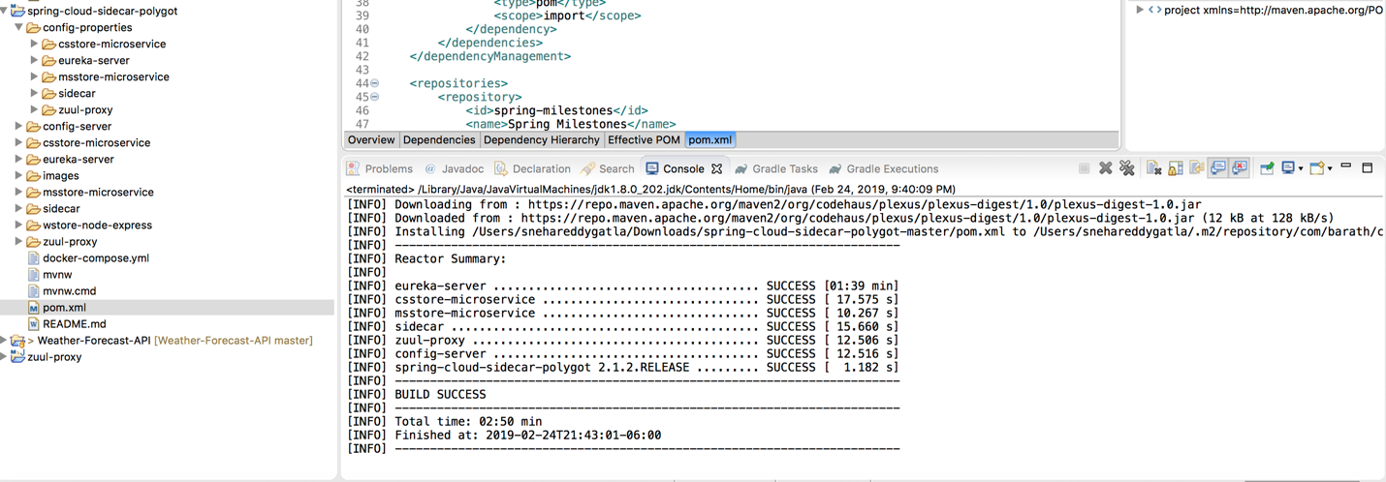

**SCREENSHOT FOR MSSTORE:**

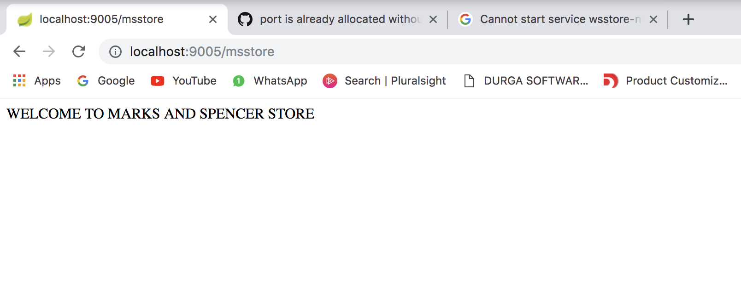

**SCREENSHOT FOR CSSTORE:**

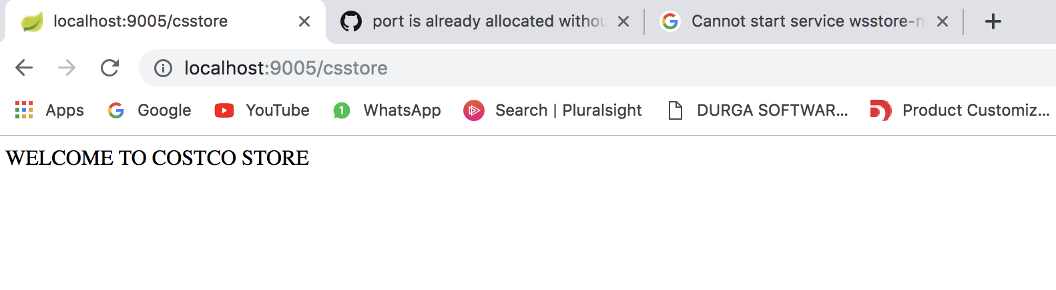

**WHEN GIVEN DOCKER-COMPOSE UP THROWN BELOW ERROR SHOWN IN THE SCREENSHOT:**

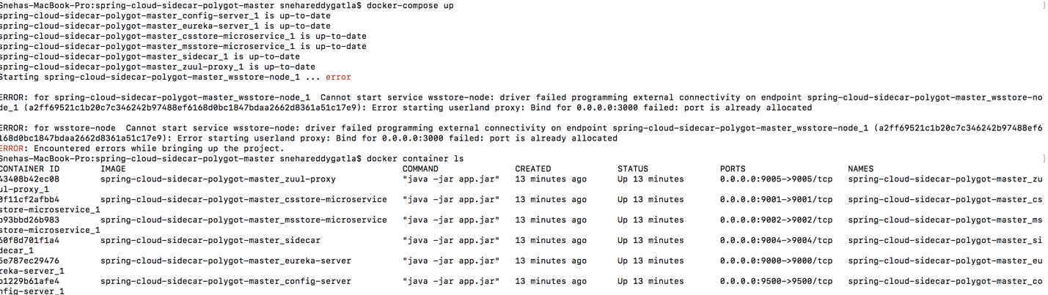

**TRIED USING BELOW COMMAND DOCKER-COMPOSE DOWN:**

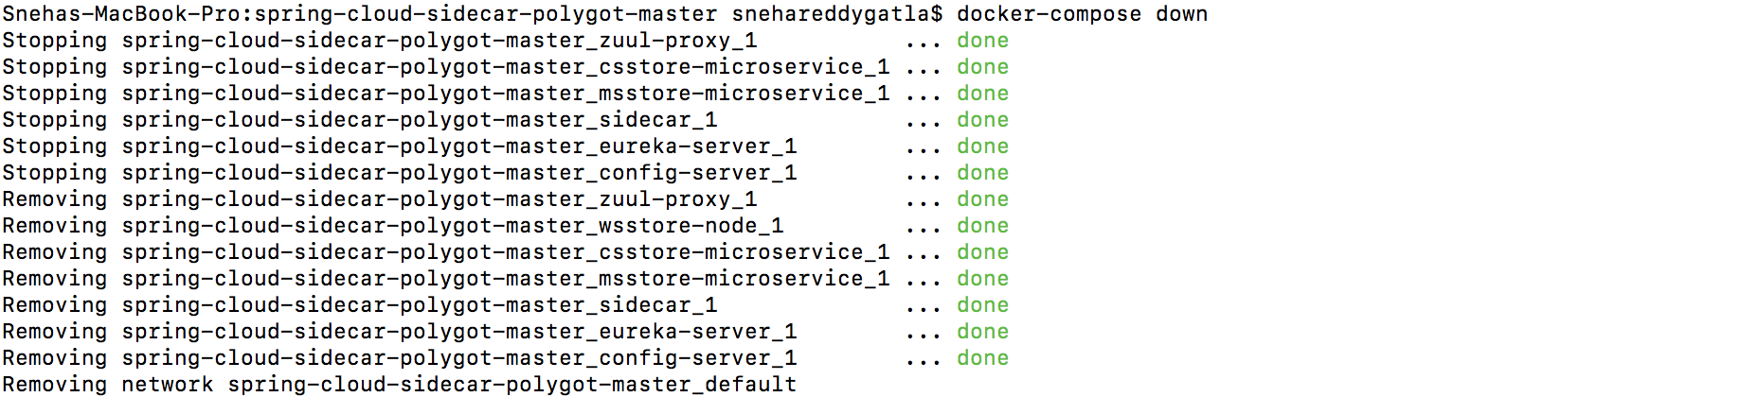

**WHEN TRIED RUNNING THE PAGE IS GIVING ME THE ERROR:**

