## MINI PROJECT on

## HOSPITAL MANAGEMENT SYSTEM

by

**Batch**:12 and 13

G.sreekanth 17121a1234

G.Malli reddy 17121a1235

G.Vamsi 17121a1236

G.V.lakshmi 17121a1237

G.Sainath 17121a1238

G.Sneha 17121a1239



Department of Information Technology

SREE VIDYANIKETHAN ENGINEERING college

(autonomous)

(Affiliated to JNTUA, Ananthapuramu, Approved by AICTE, Accredited by NB&NAAC)

Sree Sainath Nagar, Tirupati – 517 102, A.P., INDIA

# 1.TABLE OF CONTENT:

# S.no content page.no

# 1 abstract 1

# 2 Introduction 2

# 3 Analysis 3-9

# 4 Design 10-11

# 5 Roles 12

# 6 Hardware and software 13

# 7 Results 14

# 8 Code 15-17

# 9 Conclusion 18

# 10 References 19

## 2.INTRODUCTION

We all want a healthy life and do a lot to get it. We exercise and eat healthy foods so that our body is free of fats and stays healthy. If the body is not functioning well or we feel ill we go to the doctor so that they can find the cause and provide solution. However finding a doctor is a very difficult task and you should make sure you visit the best practitioner. This will help you get a onetime resolution and also keep your body off the unwanted medications. Doctors these days are dead busy and booking an appointment is a big task. You will need to wait for hours in queue before you get to meet them in person. However with the advent of the technology it is now possible to book an appointment for a doctor online and make a big confusionIt is a great way to be booked for an appointment which will ease the work for both the patient and the doctor. There are many ways in which you can book an online appointment. You will find many websites that do so. The doctors can work more in the designated hours by managing their time appropriately. But in our website, It helps them to make their circle and network stronger and wider. The process of managing the patients is simplified and does not need additional charges to be paid by the patient. The paper work gets easy as the appointments can be arranged appropriately and on a timely basis. The customer service of the patients can be done accurately and a good service can be provided. The history of the patients can be managed well and upkeepis important in this area.The another feature in our website is feedback,which make customer thoughts and tension will be cleared and tracing hospital location without any difficulty.applications are patient’s record management,bed management,in patient management,medical management,out-patient management.it comes under public sector.user easy access to patient data,cost effective,improved efficiency,reduces scope of error,improved patient care,improve data security&retrieve-ability,better revenue management.

## 3.IMPLEMENTATION:

This MINIPROJECT will be consisting of 4 different modules.

## 1.Reception

the reception handles various enquires such as

1.patience admission

2.discharge details

3. bed census

4. doctors consultance fees.

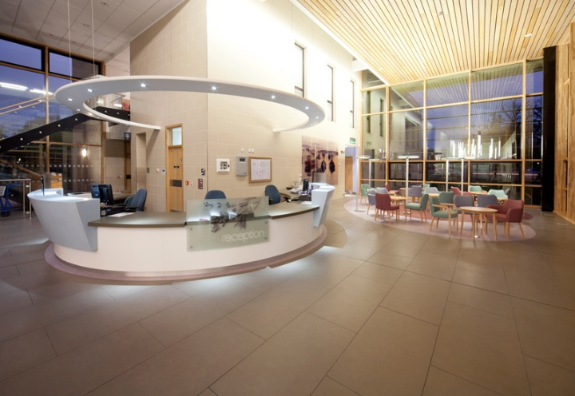

Fig:1.1

**Functions:**

* Reception acts as the first line of guidance for patients visiting Civil Hospital, Amdavad.
* Guide the patients and their attendants regarding location and timings of OPD clinics, laboratories, wards and departments.
* Attend to all telephonic enquiries regarding information concerning the patients, the doctors and clinics and OPD schedule.
* Above Fig.1.1 shows the receiption.

## 2.Administration:

administration handles all entry details such as....

1.patient detail recording

2.Doctor type

3.service charge

Fig:1.2

* Health systems management describes the leadership and general management of [hospitals](https://en.wikipedia.org/wiki/Hospitals), [hospital networks](https://en.wikipedia.org/wiki/Hospital_network), and/or [health care systems](https://en.wikipedia.org/wiki/Health_care_systems). In international use,
* The term refers to management at all levels.[[1]](https://en.wikipedia.org/wiki/Health_administration#cite_note-1) In the United States, management of a single institution (e.g. a hospital) is also referred to as "medical and health services management",[[2]](https://en.wikipedia.org/wiki/Health_administration#cite_note-2) "healthcare management", or "health administration".

## 3.Billing:

The laboratory handles with.

1. Patient details display  
   2. doctors details display



Fig:1.3

* We will bill services you receive based on our tariffs. An itemised statement of your account will be made available to you on request (this is not applicable for packages). You will be given interim bills and are requested to replenish the advance amount periodically.
* Your bill can be settled with cash, pay orders, Demand Drafts, Debit/Credit Cards (Visa or MasterCard). The hospital does not accept cheques except for the planned admission where the cheque can be cleared before the admission.

## 

## 4.registration:

The registration modules deals with..0

* 1.x-ray  
  2.ultrasound test03.clinical pathology.

Each module is implemented by using Structures, functions, loops ..,  
  
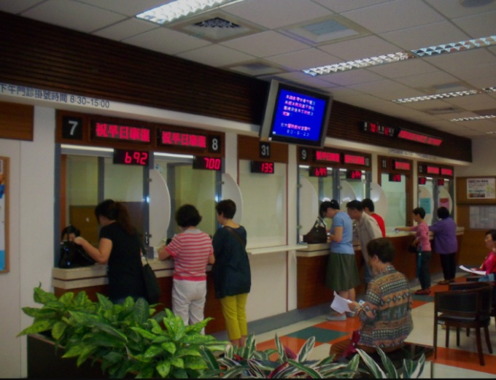

Fig:1.4

* **Patient registration** is the concept and set of methods needed to correlate the reference position of a [virtual](https://en.wikipedia.org/wiki/Virtuality) [3D](https://en.wikipedia.org/wiki/Three-dimensional_space) [dataset](https://en.wikipedia.org/wiki/Dataset)gathered by computer [medical imaging](https://en.wikipedia.org/wiki/Medical_imaging) with the reference position of the patient.
* This procedure is crucial in [computer assisted surgery](https://en.wikipedia.org/wiki/Computer_assisted_surgery), in order to insure the reproducitibility of the preoperative registration and the clinical situation during surgery. The use of the term "patient registration" out of this context can lead to a confusion with the procedure of registering a patient into the files of a medical institution.

## 4.ROLES

17121A1234: Coding for module 1 and 2

17121A1235: Coding for module 3

17121A1236: Coding for module 4

17121A1237: Coding for module 4 and documentation

17121A1238: Desiging of PPT and presentation

17121A1239: Testing of the code

## 5.DESIGN

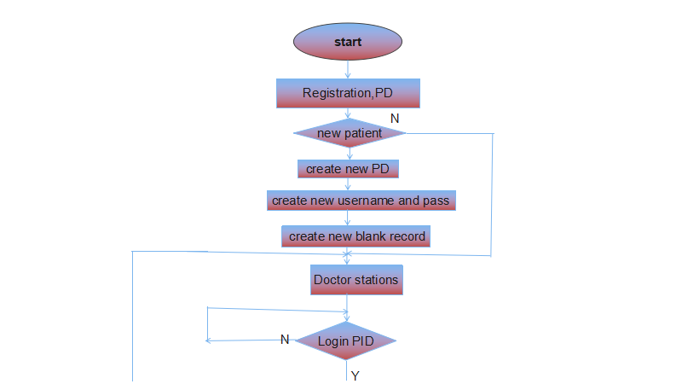

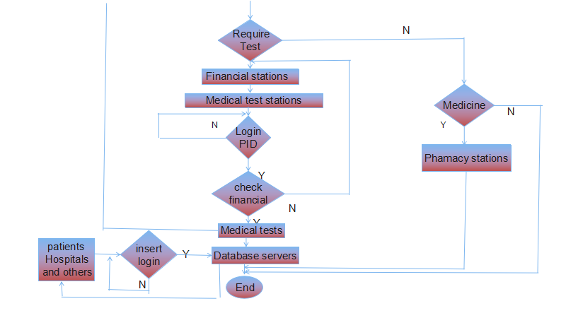

## 6.CODE:

#include<iostream>

#include<fstream>

using namespace std;

class patient

{

public:

int id,count=0;

int age;

char name[15],dname[15];

char gender[10],specialisation[10];

void pdetails()

{

cout<<"enter the patient name"<<endl;

cin>>name;

cout<<"enter patient id number"<<endl;

cin>>id;

cout<<"enter the age"<<endl;

cin>>age;

cout<<"enter patient gender"<<endl;

cin>>gender;

count++;

}

void pdisplay()

{

cout<<"patient nameis:"<<name<<endl;

cout<<"patient id is"<<id<<endl;

cout<<"patient ageis"<<age<<endl;

cout<<"patient gender is"<<gender<<endl;

}

void ddetails()

{

cout<<"enter doctorname"<<endl;

cin>>dname;

cout<<"enter specialisation"<<endl;

cin>>specialisation;

}

void ddisplay()

{

cout<<"doctor name"<<dname<<endl;

cout<<"doctor specilasation"<<specialisation<<endl;

}

void bill()

{ int d1,d2,m1,m2,y1,y2;

int days;

int month_days[]={31,28,31,30,31,30,31,31,31,3031,30,31};

fstream b;

b.open("price.txt",ios::out|ios::in|ios::app);

cout<<"enter first date"<<endl;

cin>>d1>>m1>>y1;

/*

b<<d1<<m1<<y1;

*/

cout<<"enter second date"<<endl;

cin>>d2>>m2>>y2;

if(y1==y2)

{

if(m1==m2)

days=d2-d1;

else

{

for(int i=m1;i<m2-1;i++)

days+=month_days[i];

days+=month_days[m1-1]-d1+d2;

}

}

else

{

for(int i=0;i<m2-1;i++)

days+=month_days[i];

for(int i=m1;i<12;i++)

days+=month_days[i];

if(y2-y1>=0)

days+=(y2-y1-1)*365+month_days[m1-1]-d1+d2;

}

cout<<"no of days in hospital"<<days<<endl;

int  amount;

amount=(days*100)+150;

cout<<"total amount is"<<amount<<endl;

}

};

|  |  |  |  |  |
| --- | --- | --- | --- | --- |
|  | class hospital:public patient  { public:  void enquiry()  {  hospital a;  int found=0,bid;  do  {  fstream file("patie.txt",ios::in|ios::out|ios::app);  cout<<"enetr ur bid no"<<endl;  cin>>bid;  file.read((char*)&a,sizeof(hospital));  while(!file.eof())  {  if([a.id](http://a.id/)==bid)  {  a.bill();  found=1;  break;  }  file.read((char*)&a,sizeof(hospital));  }  if([a.id](http://a.id/)!=bid)  cout<<"incorrectid"<<endl;    }while(found==0);  }  };  void counsultancy()  {  cout<<"thanku for visiting"<<endl;  }  main()  {  int ch,count=0;  int op;  do  {  cout<<"enter ur choice"<<endl;  cout<<"1.registration for patient\n2.registration for doctor\n3.patient details display\n4.doctor details display\n5.billing6.exit"<<endl;  cin>>ch;  //switch(ch)  //{  // case 1:  if(ch==1)  {      fstream file;  file.open("patie.txt",ios::out|ios::in|ios::app);  if(!file.is_open())  {  cout<<"file opening error"<<endl;  }  hospital p;  char op;  do  {  p.pdetails();  file.write((char*)&p,sizeof(hospital));  cout<<"any other registration"<<endl;  cin>>op;  }while(op=='Y'||op=='y');  }  if(ch==2)  {  fstream file;  file.open("doctor.txt",ios::out|ios::in|ios::app);  if(!file.is_open())  {  cout<<"file opening error"<<endl;  }  hospital q;  char po;  do  {  q.ddetails();  file.write((char*)&q,sizeof(hospital));  cout<<" any other registration"<<endl;  cin>>po;  }while(po=='Y'||po=='y');  }  if(ch==3)  {  hospital r;  fstream file;  file.open("patie.txt",ios::out|ios::in);  file.seekg(0);  file.read((char*)&r,sizeof(hospital));  while(!file.eof())  {  r.pdisplay();  file.read((char*)&r,sizeof(hospital));  }  }  if(ch==4)  {  hospital s;  fstream file;  file.open("doctor.txt",ios::out|ios::in|ios::app);  file.seekg(0);  file.read((char*)&s,sizeof(hospital));  while(!file.eof())  {  s.ddisplay();  file.read((char*)&s,sizeof(hospital));  }  }  if(ch==5)  {  hospital t;  t.enquiry();  }  /* if(ch==6)  {  fstream file;  file.open("patie.txt",ios::in|ios::out|ios::app);  file.seekg(0);  int count=0;  hospital y;  if(!file.eof())  {  count++;  }  cout<<"no of patients  are"<<count+1<<endl;  }*/  }while(ch!=6);  }     |  |  | | --- | --- | | …. | . | |  |

7.Results

This system is very simple in design and to implement. This systemrequires very low system 0resources.

* security of data
* minimize manual data entry
* user friendly and interactive
* minimum time required
* security of data....



## Patient details entering

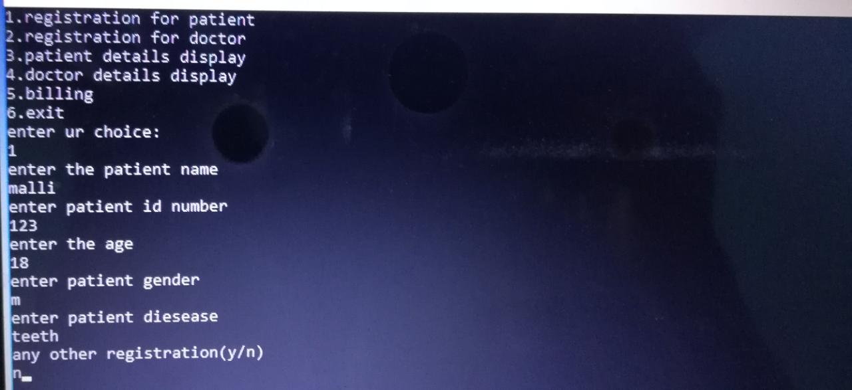

Fig.1.5:entering patient details

## Patient details display

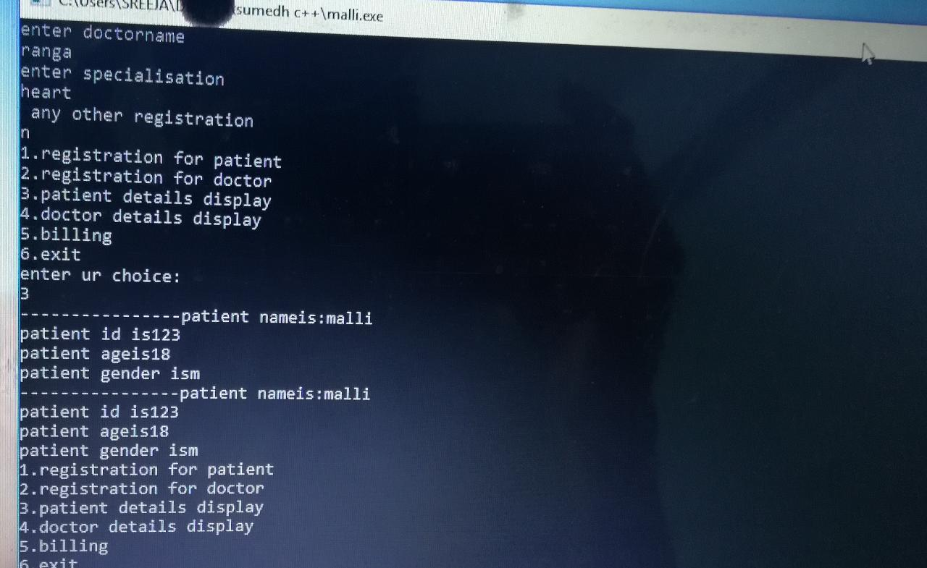

Fig.1.6: Displaying patient details

## Doctors details entering:

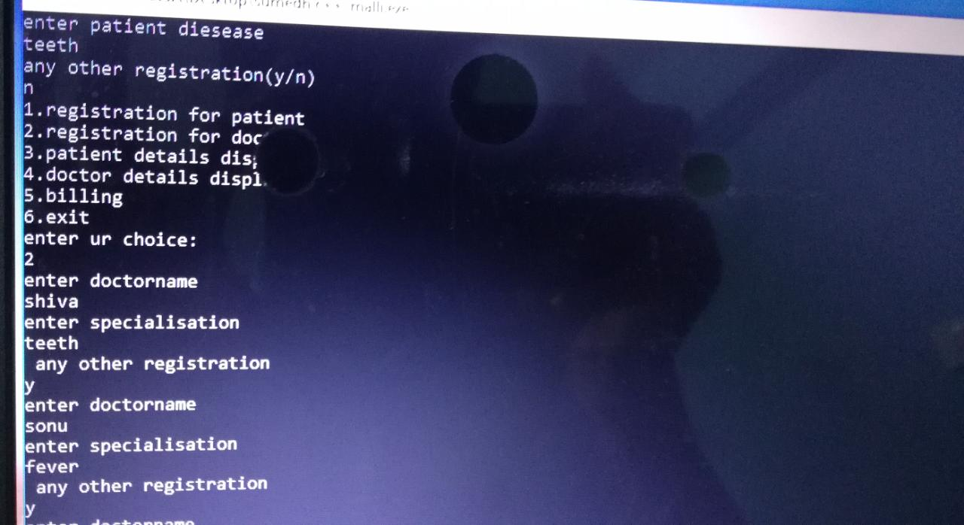

Fig.1.7:Entering docter details

## Doctors details display:

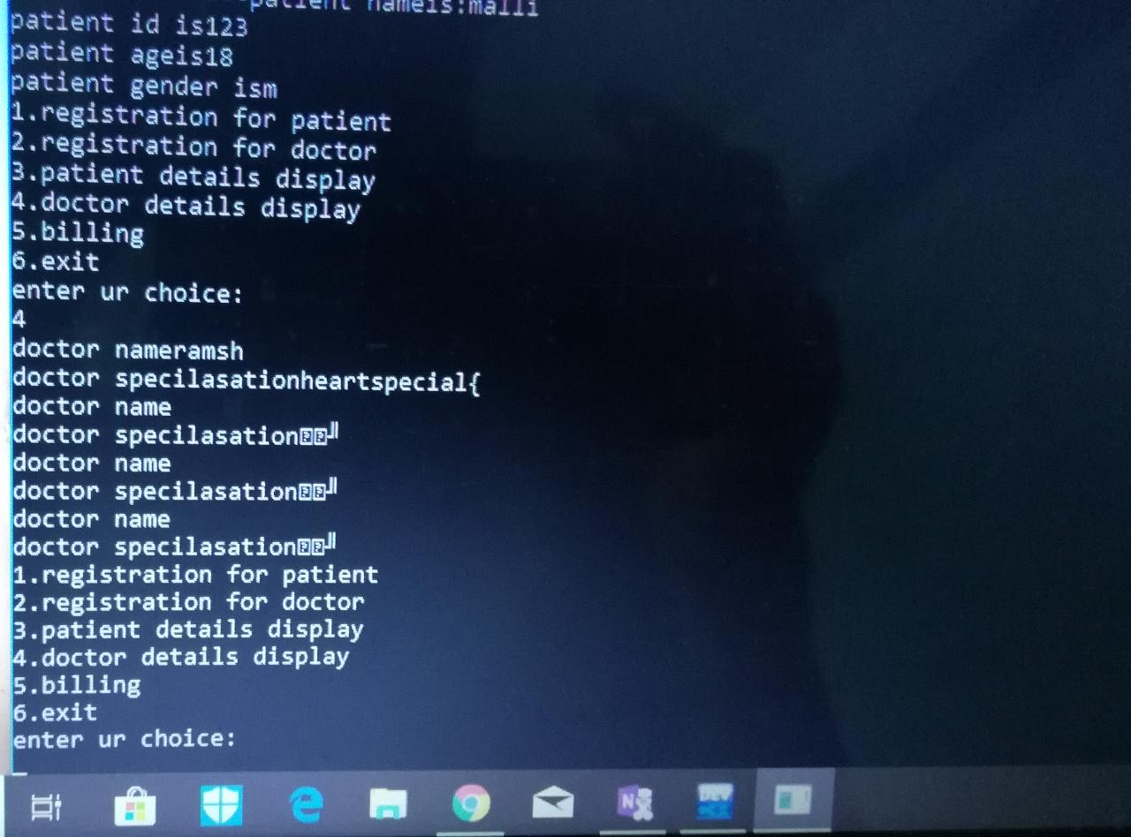

Fig.1.8 Displaying docters details

## 8.CONCLUSION:

Existing system refers to the system that is being followed till now .presently all hospital functionalities are done manually the main disadvantage is time consuming To make this situation easier the better technology has to be implemented.This may be the one.high job growth is anticipated in the field of medical and health services management..

## 9.References:

Richard Petersen,linux: The Complete Reference, Tata McGraw-Hill,Sixth Edition,2007.

E.Balagurusamy,”programming in c”,seventh edition, Mc Graw Hill Education(india)Pvt,Ltd,New Delhi,2014.

abstract”https://www.google.co.in/search?q=mini+project+on+hospital+management&oq=mini+project+on+hospital+management&aqs=chrome..69i57.18450j0j7&sourceid=chrome&ie=UTF-8” drafed on 05-10-2018 at 12:00 am.