PROSTHETIC BIONIC PALM

A PROJECT REPORT

Submitted by

ANURAG C NAIR (ASI22EBE008) AUFFIN RASHEED (ASI22EBE010) EBY MATHEW (ASI22EBEO12)
to
the APJ Abdul Kalam Technological University
in partial fulfillment of the requirements for the award of the Degree
of
Bachelor of Technology in
Electronics and Biomedical engineering



Department of Electronics and Biomedical Engineering
ADISHANKARA INSTITUTE OF ENGINEERING AND TECHNOLOGY
KALADY, ERNAKULAM - 683574

DECLARATION
We, undersigned, hereby declare that the project report “Prosthetic Bionic palm”, submitted for partial fulfillment of the requirements for the award of degree of Bachelor of Technology of the APJ Abdul Kalam Technological University, Kerala is a Bonafide work done by us under the guidance of Dr.Lakshmi M Hari, Department of Electronics and biomedical engineering. This submission represents our ideas in our own words and where ideas or words of others have been included; We have adequately and accurately cited and referenced the original sources. We also declare that we have adhered to the ethics of academic honesty and integrity and have not misrepresented or fabricated any data or idea or fact or source in our submission. We understand that any violation of the above will be a cause for disciplinary action by the institute and/or the University and can also evoke penal action from the sources which have thus not been properly cited or from whom proper permission has not been obtained. This report has not been previously formed the basis for the award of any degree, diploma or similar title of any other University.

ANURAG C NAIR AUFFIN RASHEED EBY MATHEW

KALADY 05-04-2025

DEPARTMENT OF ELECTRONICS& BIOMEDICALENGINEERING
ADISHANKARA INSTITUTE OF ENGINEERING & TECHNOLOGY


BONAFIDE CERTIFICATE

This is to certify that the project report entitled PROSTHETIC BIONIC PALM submitted by
ANURAG C NAIR(ASI22EBE008),AUFFIN RASHEED(ASI22EBE010), EBY MATHEW
(ASI22EBE012) to the APJ Abdul Kalam Technological University in partial fulfillment of the requirements for the award of the Degree of Bachelor of Technology in Electronics and Biomedical Engineering is a Bonafide record of the project work carried out by him under our guidance and supervision. This report in any form has not been submitted to any other University or Institute for any other purpose.

GUIDE CO-GUIDE
Dr Lakshmi M Hari Mr.Shinu MM
Assistant Professor Assistant Professor

PROJECT-COORDINATOR
Ms.Krishna S Nair Assistant Professor

HEAD OF THE DEPARTMENT
Dr. REMYA GEORGE
Associate Professor

Kalady
05-04-2025

ACKNOWLEDGMENT
We would like to express our immense gratitude and profound thanks to all those who helped us to make this project a great success. We express our gratitude to the almighty God for all the blessings endowed on us.

We express our sincere thanks to our Principal Dr. Murali M.S for providing us with such a great opportunity.

We also convey our gratitude to our Head of the Department Dr. Remya George for having given us a constant inspiration and suggestion. We extend our deep sense of gratitude to our project coordinator Ms.Krishna S Nair, Assistant Professor of Electronics and Biomedical Engineering Department for providing enlightening guidance through the project. We can hardly find words to express our deep appreciation for the help and warm encouragement that we have received from our project guide Dr Lakshmi M Hari, Assistant Professor of Electronics & Biomedical Engineering Department for his whole-hearted support.

It was their encouragement that helped us to complete the project. We can hardly find words to express our deep appreciation of the help and warm encouragement that we received from our parents. We are extremely thankful and indebted to our friends who supported us in all aspects of the project work.

ANURAG C NAIR AUFFIN RASHEED & EBY MATHEW

INSTITUTIONAL VISION

To emerge as a Center of Excellence in Engineering, Technology and Management by imparting quality education, focusing on empowerment and innovation.

INSTITUTIONAL MISSION

Impart quality professional education for total upliftment of the society.
Create congenial academic ambience that kindles innovative thinking and research. Mold competent professionals who are socially committed and responsible citizens.

QUALITY POLICY

We are committed to the total upliftment of the society by imparting quality professional education.

We aim at modeling totally competent professionals with ingenuity, adaptability, scial commitment and ethical and spiritual values by creating a congenial academic ambience that kindles innovative thinking.

We continually upgrade the Quality Management System through empowerment and involvement.

DEPARTMENTAL VISION
Evolve as a premier center in Electronics and Biomedical Engineering to meet
the ever-increasing needs for affordable and accessible health care technology.

DEPARTMENT MISSION
- Provide quality professional education at par with global standards in the field of Biomedical Engineering with excellent faculty and infrastructure.
- Foster a culture of multidisciplinary research, comprehensive practical learning, and generating pioneering innovations by collaborating with industrial and clinical experts.
- Inspire biomedical engineers’ graduates to be responsible to address critical healthcare challenges with empathy and dedication for the betterment of mankind.

PROGRAMME EDUCATIONAL OBJECTIVES (PEOS)

PEO1 | Function as creative professionals who excel in conducting re- search, designing, manufacturing, and testing of biomedical devices  with an unwavering focus on quality and patient-safety.
PEO2 | Engage in continuous learning to overcome the ever-evolving challenges of biomedical technology to support healthcare industries,  allied healthcare sectors, and academia.
PEO3 | Evolve as successful engineers, entrepreneurs and healthcare technology leaders through professional development and collaborations.

PROGRAMME SPECIFIC OBJECTIVES (PSOS)

PSO1 | To nurture students with technically inquisitive attitude so that any real- world problem could be tackled with a problem-solving perspective, finding a suitable mathematical model with strong funda- mental technological concepts to solve and apply to rapid growing  arena of computer technology.
PSO2 | To develop professionals with excellent exposure to the latest technologies to design high quality products unique in innovation, technology, software, security, hardware and usefulness; making high  impact on society, business and technology.
PSO3 | To enhance knowledge in practical implementation of technology with regard to parallelism, virtualization of networks, scientific analysis and modeling, visualization, natural language processing, digital synthesis of data and its manipulation, wireless and mobile  communication, storage and retrieval of huge amount of data etc.

PROGRAMME OUTCOMES (POS)

PO1 | Engineering knowledge: Apply the knowledge of mathematics, science, engineering fundamentals, and an engineering specialization  to the solution of complex engineering problems.
PO2 | Problem analysis: Identify, formulate, review research literature, and analyze complex engineering problems reaching substantiated conclusions using first principles of mathematics, natural sciences,  and engineering sciences.

PO3 | Design/development of solutions: Design solutions for complex engineering problems and design system components or processes that meet the specified needs with appropriate consideration for the public health and safety, and the cultural, societal, and environmental considerations.
PO4 | Conduct investigations of complex problems: Use research-based knowledge and research methods including design of experiments, analysis and interpretation of data, and synthesis of the information  to provide valid conclusions.
PO5 | Modern tool usage: Create, select, and apply appropriate techniques, resources, and modern engineering and IT tools including prediction and modeling to complex engineering activities with an  understanding of the limitations.
PO6 | The engineer and society: Apply reasoning informed by the con- textual knowledge to assess societal, health, safety, legal and cultural issues and the consequent responsibilities relevant to the professional engineering practice.
PO7 | Environment and sustainability: Understand the impact of the professional engineering solutions in societal and environmental con- texts, and demonstrate the knowledge of, and need for sustainable  development.
PO8 | Ethics: Apply ethical principles and commit to professional ethics  and responsibilities and norms of the engineering practice.
PO9 | Individual and team work: Function effectively as an individual, and as a member or leader in diverse teams, and in multidisciplinary  settings.
PO10 | Communication: Communicate effectively on complex engineering activities with the engineering community and with society at large, such as, being able to comprehend and write effective reports and design documentation, make effective presentations, and give and  receive clear instructions.
PO11 | Project management and finance: Demonstrate knowledge and understanding of the engineering and management principles and apply these to one’s own work, as a member and leader in a team, to  manage projects and in multidisciplinary environments.

PO12 | Life-long learning: Recognize the need for, and have the preparation and ability to engage in independent and life-long learning in the broadest context of technological change.

COURSE OBJECTIVES
To develop skills in doing literature survey, technical presentation and report prepa-
ration.

COURSE OUTCOMES

The student will be able to

CO1 | Envisage applications for societal needs.
CO2 | Develop skills for analysis and synthesis of practical systems.
CO3 | Learn to use new tools effectively and creatively.
CO4 | Learns to carry out analysis and cost-effective, environmental  friendly designs of engineering systems.
CO5 | Develops the ability to write Technical / Project reports and oral  presentation of the work done to an audience.

ABSTRACT

The field of prosthetics has seen remarkable advancements in recent years, driven by developments in biomechanics, materials science, and robotics. Losing a hand or part of it due to injury, illness, or congenital conditions can drastically affect an individual’s quality of life. Advanced bionic prosthetic devices remain expensive, which makes them inaccessible to many who could benefit from them, particularly in low- income regions or developing countries. This project presents the development of a bionic prosthetic palm integrated with an ESP-32 microcontroller, Electromyography (EMG) sensors, and a temperature sensor to enhance functionality and adapt- ability. The EMG sensor detects muscle signals from the residual limb, allowing the user to control the prosthetic palm with natural muscle contractions. The ESP- 32 microcontroller, with its high processing capability and wireless communication features, processes the EMG signals and translates them into finger and wrist movements. Additionally, a temperature sensor is incorporated to monitor environmental and body temperature, ensuring user comfort and detecting potential risks such as overheating or excessive cold exposure. The system is designed to be lightweight, energy-efficient, and cost-effective, making it accessible to a broader population.

CONTENTS

ACKNOWLEDGMENT . . . . . . . . . . . . . . . . . . . . . . . . . . | i
INSTITUTIONAL VISION, MISSION AND QUALITY POLICY . . | ii
DEPARTMENTAL VISION, MISSION, PEOs ,PO AND PSOs . . . . | iii
ABSTRACT . . . . . . . . . . . . . . . . . . . . . . . . . . . . . . . . | vii
LIST OF FIGURES . . . . . . . . . . . . . . . . . . . . . . . . . . . . . | x
LIST OF ABREVIATIONS . . . . . . . . . . . . . . . . . . . . . . . . . | xi
1 INTRODUCTION | 1
1.1 GENERAL BACKGROUND . . . . . . . . . . . . . . . . . . . . . | 2
1.2 PROBLEM DEFINITION . . . . . . . . . . . . . . . . . . . . . . | 2
1.3 MOTIVATION . . . . . . . . . . . . . . . . . . . . . . . . . . . . | 3
1.4 OBJECTIVES . . . . . . . . . . . . . . . . . . . . . . . . . . . . . | 3
2 LITERATURE SURVEY | 4
3 METHODOLOGY | 5
3.1 PROPOSED SYSTEM . . . . . . . . . . . . . . . . . . . . . . . . | 5
3.2 HARDWARE REQUIREMENTS . . . . . . . . . . . . . . . . . . | 5
3.3 SOFTWARE REQUIREMENTS . . . . . . . . . . . . . . . . . . . | 8
4 DESIGN AND METHODOLOGY | 10
4.1 ARCHITECTURE DIAGRAM . . . . . . . . . . . . . . . . . . . . | 10
4.2 PROCESS FLOW DIAGRAM . . . . . . . . . . . . . . . . . . . . | 11
4.3 FUNCTIONAL BLOCK DIAGRAM . . . . . . . . . . . . . . . . . | 13
5 RESULTS AND DISCUSSIONS | 14
5.1 HARDWARE DEVELOPED . . . . . . . . . . . . . . . . . . . . . | 14
5.2 SOFTWARE DEVELOPED . . . . . . . . . . . . . . . . . . . . . | 15
6 CONCLUSION AND FUTURE SCOPE | 17
6.1 FUTURE SCOPE . . . . . . . . . . . . . . . . . . . . . . . . . . . | 17
6.2 CONCLUSIONS . . . . . . . . . . . . . . . . . . . . . . . . . . . | 17
APPENDICES | xiv

- Paper Publications and Achievements xiv
- Code xxiii

LIST OF FIGURES

  - ESP32 Microcontroller . . . . . . . . . . . . . . . . . . . . . . . . 6
  - EMG sensor with electrodes . . . . . . . . . . . . . . . . . . . . . 6
  - Servo Motor . . . . . . . . . . . . . . . . . . . . . . . . . . . . . . 7
  - NTC Thermocouple temperature sensor . . . . . . . . . . . . . . . 7
  - OLED Display . . . . . . . . . . . . . . . . . . . . . . . . . . . . . 7
  - 9V Battery . . . . . . . . . . . . . . . . . . . . . . . . . . . . . . . 8

  - Architecture diagram 10
  - Process flow diagram 12
  - Block diagram 13

  - Final Assembly 16
  - Temperature sensing 16

LIST OF ABBREVIATIONS

ABBREVIATION | DESCRIPTION
EMG | Electro Myography
NTC | Negative Temperature Coefficient
ESP | Expressive systems
ADC | Analog to Digital Converter
IoT | Internet of Things

CHAPTER 1

INTRODUCTION

The need for affordable and highly functional prosthetic devices has become increasingly evident, as many existing solutions are either prohibitively expensive or fail to provide a natural and intuitive user experience. Traditional prosthetic hands often lack the dexterity and responsiveness required for seamless daily functionality, limiting their effectiveness in restoring lost capabilities. As a result, millions of amputees worldwide struggle with prosthetic solutions that do not adequately meet their needs.
These challenges arise due to the absence of cost-effective yet technologically advanced solutions in the prosthetics industry. The development of prosthetic hands involves intricate engineering, integrating muscle signal processing and sensory feedback mechanisms. However, conventional approaches often compromise either affordability or functionality. Striking the right balance between these factors is essential to ensure that prosthetic solutions are both accessible and effective for users.
To address these issues, our project focuses on the development of a bionic palm that leverages advanced electronics alongside cost-efficient 3D printing technology. The proposed prosthetic hand incorporates an ESP32 microcontroller to process electromyography (EMG) signals from the Carpi Radialis and Carpi Ulnaris muscles, enabling precise and responsive control of hand movements. Furthermore, embedded tactile and temperature sensors in the fingertips provide critical sensory feedback, enhancing the user’s interaction with their environment. The integration of 3D printing allows for customization and affordability, ensuring that the device is accessible to a wider range of users.
By combining real-time muscle signal processing with enhanced sensory capabilities, our project seeks to bridge the gap between cost and functionality in prosthetic technology. The proposed bionic palm not only improves dexterity and control but also fosters a more natural and immersive experience for amputees. This innovative approach has the potential to redefine prosthetic solutions, making them more inclusive, functional, and user-friendly.

GENERAL BACKGROUND
Bionic prosthetic palms have significantly advanced, particularly through the integration of EMG signals for intuitive control. EMG measures the electrical activity produced by skeletal muscles, enabling prosthetic devices to interpret a user’s muscle movements and translate them into corresponding hand actions. This technology allows for more natural and responsive prosthetic control, enhancing the user’s ability to perform daily tasks. [1] The system comprises both mechanical and electronic components, integrating artificial intelligence to process EMG signals. The researchers developed an experimental methodology to record muscle activity associated with specific tasks using three surface EMG sensors. By leveraging 3D printing technologies, such prostheses can be produced more affordably and customized to individual users, making advanced prosthetic solutions more accessible. [2]

PROBLEM DEFINITION
EMG sensors are used to capture electrical signals generated by muscle con- tractions, but these signals are inherently weak, typically in the microvolt (V) range, making them challenging to work with. The signals are easily susceptible to noise and interference from various sources, such as power lines (50/60 Hz), electromagnetic interference from nearby electronics, and static electricity. These sources can distort the EMG signal, making it difficult to separate the useful muscle activity from external noise. Additionally, the interface between the electrodes and the skin introduces variability in the signal quality, as skin resistance can fluctuate due to moisture, cleanliness, or even electrode placement. Higher skin impedance can de- grade signal quality, leading to weak or unreliable readings. Muscle fatigue and the involvement of multiple muscles during a contraction can further complicate the signal, as these factors introduce variability and can cause signal degradation over time. Proper amplification of these weak signals is necessary, but it can also amplify the noise, making the filtering process crucial. However, overly aggressive filtering can lead to the loss of important signal characteristics. Moreover, different users have distinct muscle patterns, which means that a system must adapt to individual variations, adding another layer of complexity. To address these challenges, basic filtering and smoothing techniques can be applied to EMG signals for simpler and more direct control of prosthetics.

MOTIVATION
Current prosthetic options often lack the necessary adaptability and ease of use which leads to underutilization. The project emphasizes the integration of advanced materials and 3D printing technology, thereby making the arm not only cost-effective but also customizable to meet individual needs and preferences. Utilizing EMG allows for a more intuitive interface that enables users to control the arm and mimic natural movement patterns.

OBJECTIVES
The objectives of this work are:
    - Develop an a*ffordable Prosthetic Solution using 3D printing technology.
    - Implement EMG Signal Control to accurately interpret muscle signals from the forearm.
    - Ensure a lightweight, ergonomic design for daily use.
    - Allow adjustments to fit individual user needs and preferences.
    - Help users regain independence and confidence.

CHAPTER 2

LITERATURE SURVEY

The paper "A 3D Printed, Bionic Hand Powered by EMG Signals" by Karla Avilés-Mendoza, Neil George Gaibor-León, and Víctor Asanza presents a bionic hand controlled by electromyography (EMG) signals generated by muscle contractions. Using 3D printing, the prosthetic is customizable, affordable, and ergonomic, enabling intuitive control and mimicking natural hand movements. The research highlights the potential of this technology to improve prosthetics' functionality and accessibility while addressing challenges like signal accuracy and system reliability. Future directions include enhancing human-prosthetic interfaces and improving materials. [3]

The study "Comparison of Electromyography and Force as Interfaces for Prosthetic Control" by Corbett, Perreault, and Kuiken compares EMG-based and force-based interfaces for controlling prosthetics. While EMG measures electrical activity indirectly related to muscle force, force interfaces directly measure exerted force. Both performed similarly in position-tracking tasks, with EMG excelling at higher tracking frequencies. These findings inform the design of prosthetics that align with user needs. [4]

The study "Clinical Implementation of a Bionic Hand Controlled with Kinetic myographic Signals" by Cipriani et al. introduces a novel approach to bionic hand control using kinetic myographic (KMG) signals generated by implanted magnetic tags in forearm muscles. Through tendon transfer surgery, magnets are embedded in synergistic muscles responsible for hand movements, creating magnetic signals that are processed by neural algorithms to control the prosthetic hand. This method bypasses traditional magnet localization, directly mapping muscle contractions to hand gestures. Clinical trials demonstrated the feasibility of this system, enabling intuitive control and gesture recognition. The research highlights advancements in magnetic-based prostheses and suggests potential for improved functionality and user experience in bionic hands. [5]

CHAPTER 3

METHODOLOGY

  - PROPOSED SYSTEM
The prosthetic bionic arm system is designed to provide real-time control using electromyography (EMG) signals processed by an ESP32 microcontroller. The system integrates multiple hardware components, including EMG sensors, servo motors, an OLED display, and additional sensors such as an NTC thermocouple sensor for enhanced functionality. The design aims to ensure precise control of finger movements, real-time feedback, and safe operation for the user. The system begins with data acquisition from the EMG sensor, which detects muscle activity through electrodes placed on the user’s forearm. These signals are amplified using the onboard AD8226 instrumentation amplifier and transmitted to the ESP32 microcontroller. The ESP32 processes the raw EMG signals, applies filtering techniques to eliminate noise, and interprets the data to generate PWM signals that control three servo motors responsible for finger movements. The servos operate based on predefined thresholds, enabling accurate and proportional control of the prosthetic fingers. An NTC thermocouple sensor is integrated to monitor temperature variations, ensuring safe operation of the system by preventing overheating. The OLED display provides real-time visualization of EMG signal strength and motor states, offering intuitive feedback to the user. Power is supplied through two 9V batteries, ensuring stable voltage delivery to all components. The ESP32 also facilitates wireless communication for remote monitoring and control.

HARDWARE REQUIREMENTS
ESP32 Microcontroller
The ESP32 microcontroller serves as the central processing unit for this system. It features a dual-core processor with integrated Wi- Fi and Bluetooth capabilities, making it suitable for IoT applications. The ESP32 processes EMG signals and controls actuators using PWM outputs while managing wireless communication for remote monitoring.
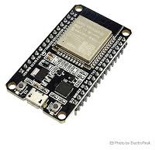

Fig. 3.1: ESP32 Microcontroller
EMG Sensor Functionality
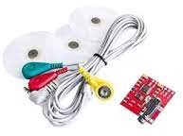
The EMG sensor plays a critical role in capturing muscle activity from the user’s forearm. It measures electrical impulses generated during muscle contractions and outputs analog signals that are amplified and processed by the AD8226 amplifier. These signals are then sent to the ESP32 microcontroller for further processing. The EMG data is filtered to remove noise and interpreted using predefined thresholds to control servo motors proportionally. This ensures smooth and responsive finger movements based on muscle activation.
Fig. 3.2: EMG sensor with electrodes

Servo Motors
Three servo motors are used in this system to control the individual finger movements of the prosthetic arm. These motors receive PWM signals generated by the ESP32 based on processed EMG data. The servos allow precise control of finger positions, enabling tasks such as grasping or releasing objects. Their compact design makes them ideal for integration into a wearable prosthetic device.

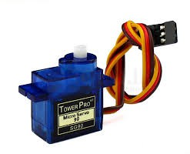
Fig. 3.3: Servo Motor

NTC Thermocouple Sensor
The NTC thermocouple sensor monitors temperature variations within the system or the surrounding environment. This sensor ensures safe operation by detecting overheating conditions that could damage components or cause discomfort to the user. It provides analog temperature readings that are processed by the ESP32 for safety alerts.
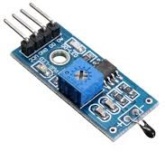
Fig. 3.4: NTC Thermocouple temperature sensor

OLED Display
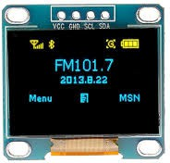
The OLED display offers a user-friendly interface by showing real-time updates on EMG signal strength, servo motor states, and temperature readings from the NTC sensor.
Fig. 3.5: OLED Display

Power Management
Power is supplied through two 9V batteries connected in parallel to provide stable voltage delivery to all components of the system. Efficient energy utilization ensures prolonged operation without frequent replacements or recharging.

Fig. 3.6: 9V Bettery

SOFTWARE REQUIREMENTS
The software requirements for the prosthetic bionic arm project encompass various tools, programming languages, libraries, and development environments essential for interfacing, signal processing, debugging, and real-time control of hard- ware components. The primary programming language used in this project is C++, specifically within the Arduino framework, which provides a structured yet flexible approach for programming the ESP32 microcontroller and managing connected sensors and actuators. The Arduino IDE serves as the main development platform for writing, compiling, and uploading code to the ESP32. It offers a user-friendly interface and built-in libraries that simplify sensor communication, data processing, and motor control.
To ensure the seamless integration of multiple components, the project relies on various Arduino libraries. The Wire library is utilized for I2C communication with peripherals such as the OLED display. The Adafruit GFX and SSD1306 libraries are employed for controlling the OLED screen, enabling real-time visualization of EMG signal strength and motor states. For EMG signal processing, customized algorithms are implemented to filter noise and extract meaningful data from muscle activity. These algorithms are designed to interpret EMG signals based on predefined thresholds, ensuring proportional control of servo motors.
The servo motors are controlled using PWM signals generated by the ESP32 microcontroller. Libraries such as Servo.h are used to manage precise motor movements required for finger articulation. Additionally, real-time temperature monitoring is facilitated by interfacing the NTC thermocouple sensor with analog-to-digital conversion routines in the ESP32. This ensures safe operation by detecting overheating conditions.

For debugging and real-time monitoring during development, the Serial Monitor in Arduino IDE is extensively used to print sensor values, actuator states, and anomalies in system behavior. This allows developers to identify issues quickly and optimize performance. Timing operations critical for signal synchronization are handled using non-blocking functions like Millis(), ensuring efficient multitasking within the system.
Beyond development, simulation tools such as Proteus or similar circuit design software may be utilized to validate circuit functionality before hardware implementation. The final deployment involves flashing the ESP32 with compiled firmware and testing compatibility with power supply modules and communication protocols.

CHAPTER 4

DESIGN AND METHODOLOGY

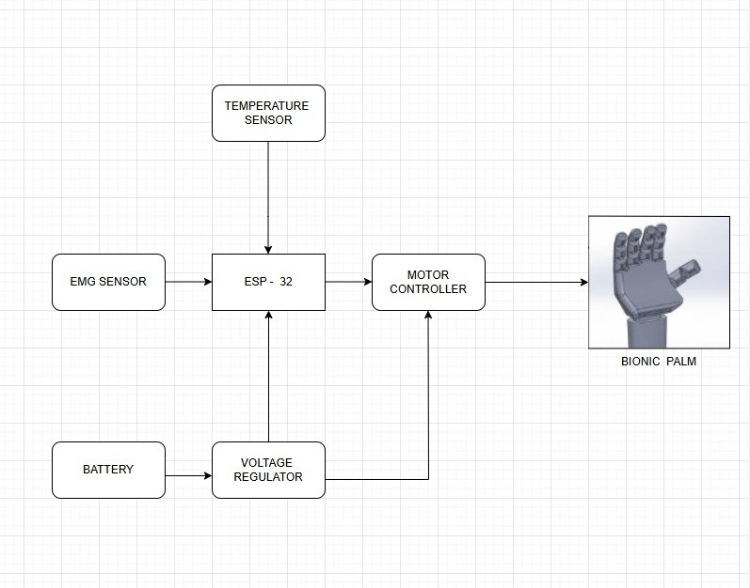
  - ARCHITECTURE DIAGRAM
Fig. 4.1: Architecture diagram

The Bionic Palm System is an advanced prosthetics controlled using bioelectrical signals and environmental data. The system comprises multiple components, including an EMG sensor, a temperature sensor, an ESP-32 microcontroller, a motor controller, a voltage regulator, and a battery. The EMG sensor detects electrical activity from the user’s muscles and sends signals to the ESP-32, which interprets the data to generate movement commands. Additionally, the temperature sensor monitors environmental conditions, ensuring safe and adaptive operation.

The ESP-32 serves as the core processing unit, receiving inputs from both sensors, processing them, and sending control signals to the motor controller. The motor controller then translates these signals into appropriate electrical outputs to drive the Bionic Palm, enabling precise and natural hand movements. The system is powered by a battery, which supplies energy through a voltage regulator, ensuring stable power distribution to all components. This design enables real-time muscle-based control, making the bionic palm highly functional for prosthetic users or robotic applications.

PROCESS FLOW DIAGRAM
The process flow begins with the user’s muscle contractions, which are detected by the EMG sensors that capture the electrical signals produced by the muscles. These signals are then amplified and converted from analog to digital form, ensuring they are suitable for processing. The ESP32 microcontroller takes over by processing both the EMG data and temperature data gathered from the temperature sensor, which monitors both the environmental and body temperatures. Within the ESP32, a condition check determines whether the temperature is safe or unsafe: if safe, the process continues to activate the actuators, which control the motors responsible for moving the prosthetic palm (fingers and wrist); if unsafe, an alert is generated or adjustments are made to ensure user safety and comfort. The system is supported by a power supply that feeds both the ESP32 and the actuators, and it continuously loops back to the beginning, maintaining real-time monitoring and control.

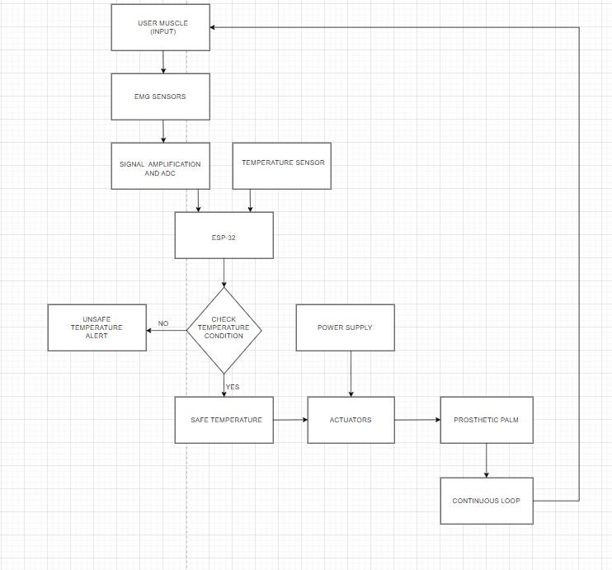
Fig. 4.2: Process flow diagram

FUNCTIONAL BLOCK DIAGRAM
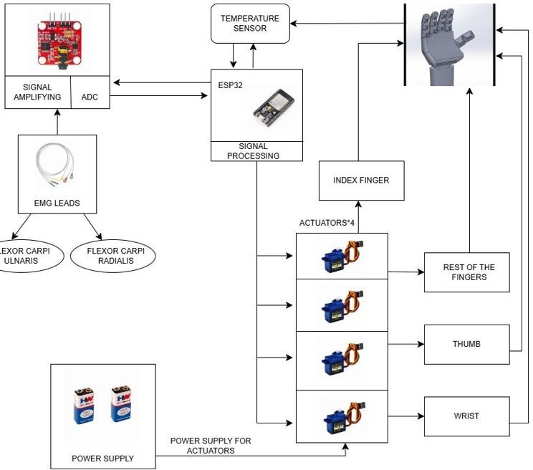
Fig. 4.3: Block diagram

The prosthetic hand control system utilizes EMG signals and an ESP32 micro- controller to enable intuitive movement. EMG leads are placed on the Flexor Carpi Ulnaris and Flexor Carpi Radialis muscles to detect electrical activity generated by muscle contractions. These signals are then sent to a signal amplification and ADC module, where they are amplified and converted into digital data for processing. The ESP32 microcontroller interprets these signals to determine the corresponding hand movements. Additionally, a temperature sensor provides environmental or safety feedback to the microcontroller. The processed signals from the ESP32 control four servo actuators, each responsible for a specific part of the prosthetic hand. One servo motor moves the index finger, another controls the remaining fingers, a third operates the thumb, and the fourth enables wrist movement. A dedicated power supply ensures the proper functioning of the actuators, while another power source supports the ESP32 and signal processing unit. By converting muscle activity into precise motorized actions, the system allows users to control the prosthetic hand naturally. The integration of sensors (NTC temperature sensor) and microcontroller-based processing enhances responsiveness, providing a functional, user-friendly assistive solution.

CHAPTER 5

RESULTS AND DISCUSSIONS

The prosthetic bionic arm system embedded with EMG sensors, an NTC thermocouple sensor, and an OLED display, with the ESP32 microcontroller efficiently processing real-time data. When muscle activity was detected, the ESP32 triggered three servo motors to control finger and wrist movements, helping users perform tasks with precision. The system’s data was displayed on the OLED screen, showing real-time EMG signal strength, actuator states, and temperature readings. Users could monitor system performance and receive feedback on muscle activity and motor states. The combined functionality of the hardware and software resulted in a responsive, wearable solution capable of controlling critical prosthetic arm parameters and providing intuitive feedback to users.

HARDWARE DEVELOPED
The hardware system integrated multiple components into a compact and wearable form. EMG sensors were used to capture muscle activity, converting electrical signals into digital data accurately read by the ESP32 microcontroller. The NTC thermocouple sensor provided real-time temperature monitoring, ensuring a comprehensive view of the device’s conditions, especially important for user safety. The ESP32 microcontroller played a central role in managing sensor data, executing control algorithms, and controlling the servo motors. These motors acted as actuators, allowing precise finger movements based on muscle signals. The use of a dual-core ESP32 allowed simultaneous data acquisition and real-time feedback without noticeable latency, ensuring responsive and reliable performance.
To ensure portability and usability, a power management system was implemented using two 9V batteries. This setup ensured a stable power supply to the ESP32 and peripheral devices while allowing for extended operation. The compact layout made the system practical for integration into a prosthetic arm, demonstrating the feasibility of wearable prosthetic control without compromising user comfort.

Overall, the hardware system performed effectively in test scenarios. It responded promptly to changes in muscle activity, detected temperature variations, and activated precise motor movements. The compactness, energy efficiency, and wireless capability of the ESP32 made the hardware system suitable for continuous monitoring in real-world conditions.

SOFTWARE DEVELOPED
The software component of the prosthetic bionic arm was developed using the Arduino framework, providing a seamless bridge between the ESP32 hardware and the end user. A custom program was designed to visualize real-time EMG data and control servo motors based on muscle activity. Users could monitor system performance and receive feedback on muscle signals and motor states. A key functionality of the software was the implementation of a control system that translated muscle signals into proportional motor movements. When muscle activity exceeded predefined thresholds, the software triggered the servo motors to execute precise movements.
The software system not only offered real-time insights and control but also served as a digital interface for users. Its integration with the ESP32’s capabilities enabled smooth and reliable data transfer. Together with the hardware, the software formed a robust, user-friendly prosthetic arm ecosystem aimed at intuitive control and feedback.
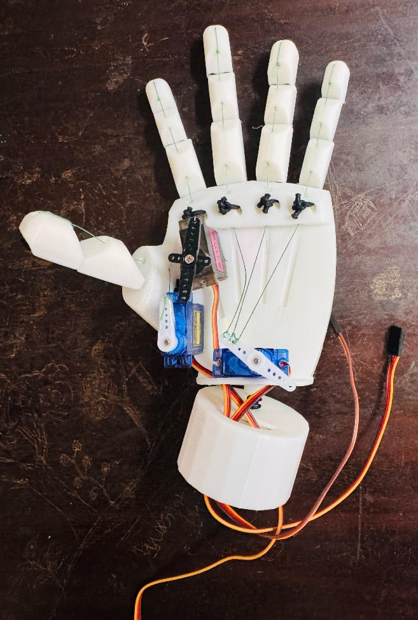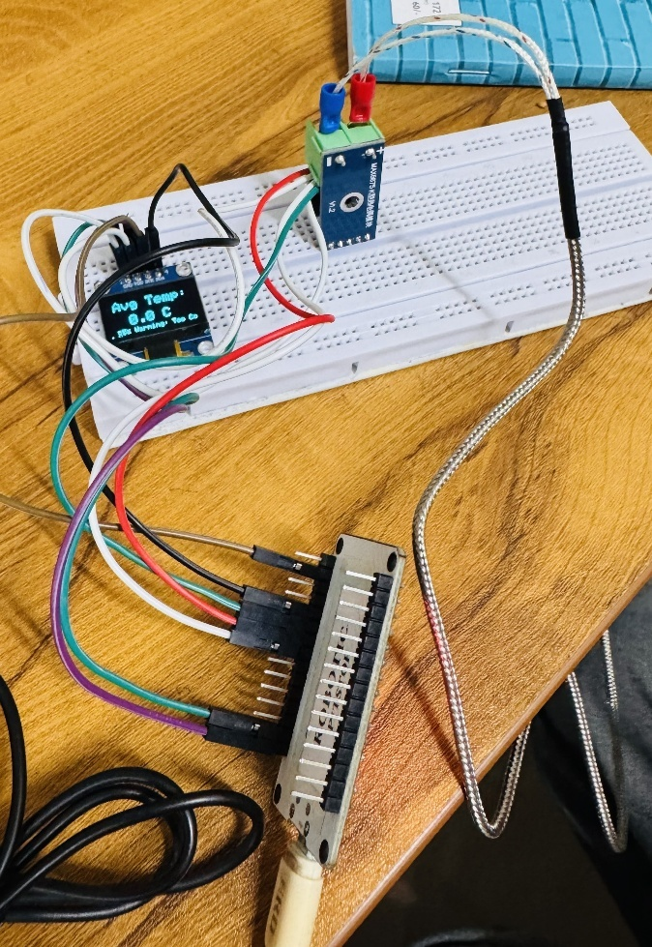

Fig. 5.1: Final Assembly

Fig. 5.2: Temperature sensing

CHAPTER 6

CONCLUSION AND FUTURE SCOPE

  - FUTURE SCOPE
The future development of the Bionic Palm System presents numerous opportunities for enhancement, focusing on advanced sensory integration, artificial intelligence, user-centric design, and cost optimization. Incorporating pressure and temperature sensors will enable real-time haptic feedback, improving grip precision and user interaction. Additionally, AI-driven machine learning algorithms will enhance responsiveness by analyzing muscle signals, predicting user intent, and adapting dynamically to different environments.[6] Future iterations will prioritize ergonomics, material optimization, and weight reduction, ensuring greater comfort and usability for extended wear. Customizable and modular designs will further enhance the user experience. Moreover, reducing production costs through innovative manufacturing techniques and scalable production strategies will make the prosthetic more afford- able and accessible to a wider audience, improving the quality of life for individuals with limb loss. By integrating these advancements, the Bionic Palm will become a more intelligent, efficient, and user-friendly assistive device, seamlessly bridging the gap between human capability and technological innovation.

CONCLUSIONS
A bionic prosthetic palm based on EMG sensors and the ESP32 microcontroller offers a promising solution for enhancing prosthetic functionality. The in-tegration of EMG sensors allows precise detection of muscle signals, enabling the prosthetic to respond to the user’s intent with minimal latency, creating a near-natural experience. The ESP32 microcontroller processes these signals efficiently, ensur- ing real-time control and responsiveness while maintaining low power consumption, which is essential for extended use. Additionally, the system’s flexibility allows for easy customization to suit individual needs, while its Wi-Fi and Bluetooth capabil-

ities offer potential for remote monitoring and feedback. Although challenges like signal noise and interference can affect performance, the cost-effectiveness of the system makes it more accessible, improving the viability of bionic prosthetics for a wider population. With further advancements in signal processing and machine learning, this system could evolve to offer even greater accuracy and adaptability, providing a valuable solution for those with limb loss.

REFERENCES

- M., et al. Mind-controlled arm prostheses that 'feel' are now a part of everyday life. New England Journal of Medicine, 2020.

- M., Zbinden, J., Millenaar, J., et al. A highly integrated bionic hand with neural control and feedback for use in daily life. Science Robotics, 2023.

- Corbett, E. A., Perreault, E. J., & Kuiken, T. A. Comparison of electromyography and force as interfaces for prosthetic control. Journal of Rehabilitation Research & Development, 2011.

- Li, G., Schultz, A. E., Bravo-Esteban, E., Popovic, M. R., & Pacelli, M. C. Proportional and simultaneous control of a hand prosthesis using surface electromyography. IEEE Transactions on Biomedical Engineering, 2010.

- Ortiz-Catalan, M., et al. A highly integrated bionic hand with neural control and feedback for use in daily life. Science Robotics, 2023.

- Jiang, H. Research on Multiple Control Methods for Bionic Hands. SHS Web of Conferences, 2022.

Appendix I

Paper Publications and Achievements

PROSTHETIC BIONIC PALM
ANURAG C NAIR (ASI22EBE008),AUFFIN RASHEED(ASI22EBE010) EBY MATHEW(ASI22EBE012)

anuragnanduuz1221@gmail.com , rashiauffinalif16@gmail.com , ebymathew30@gmail.com
Department of Electronics and Biomedical Engineering, Adi Shankara Institute of Engineering and Technology,
APJ Abdul Kalam University,India

Head of Department: Dr Remya George

ABSTRACT

Bionic prosthetics have made significant advancements in recent years, offering improved functionality, adaptability, and sensory feedback. This project presents the development of a bionic palm equipped with temperature sensors and electromyography (EMG) sensors, powered by the ESP32 micro-controller. The system is designed to enhance the capabilities of individuals with upper-limb disabilities by enabling them to interact with their environment more naturally and efficiently.

The core objective of this project is to create a smart, responsive, and cost-effective prosthetic palm that can detect muscle signals from the residual limb and external temperature variations. By combining EMG sensors, which capture electrical activity from muscles, and temperature sensors, which sense thermal changes in objects and surroundings, the bionic palm allows users to experience an enriched level of interaction. The ESP32 micro-controller, known for its high processing power, low energy consumption, and wireless connectivity, acts as the central processing unit of the system, facilitating data acquisition, signal processing, and motor control.

The EMG sensors play a crucial role in interpreting the user’s muscle activity. These sensors detect electrical impulses generated by muscle contractions, which are then processed to determine the intended movement. Once the ESP32 processes these signals, it sends corresponding commands to the actuators controlling the movement of the bionic fingers. This ensures that the prosthetic palm moves in response to the user’s muscle contractions, providing a near-natural experience. The real-time responsiveness of the system is crucial, allowing users to execute precise and intuitive movements.

The temperature sensors embedded in the bionic palm add another layer. Traditional prosthetic limbs lack temperature perception, making it difficult for users to distinguish between hot and cold surfaces, which can lead to potential burns or discomfort. By integrating temperature sensors, the bionic palm can detect temperature variations and provide feedback through haptic or visual signals. For instance, the ESP32 can be programmed to trigger a vibration or LED alert when the temperature exceeds a safe threshold, helping users navigate their surroundings safely.

The mechanical design of the bionic palm incorporates lightweight and durable materials, ensuring comfort and usability. The actuators responsible for finger movement are selected based on power efficiency, torque, and speed to optimize grip strength and dexterity. The system is also designed with a modular architecture, allowing for easy upgrades and customization based on user preferences.

In terms of power efficiency, the ESP32 micro-controller is an optimal choice due to its low-power modes, which significantly extend battery life. The system can be powered by rechargeable lithium-ion batteries, providing long-lasting functionality. Power management techniques such as adaptive sleep modes ensure minimal energy consumption without compromising performance.

In conclusion, the bionic palm powered by ESP32, with EMG and temperature sensors, represents a significant advancement in prosthetic technology. By providing enhanced control, sensory feedback, and wireless connectivity, it offers a more natural and intuitive experience for users. The use of affordable and readily available components ensures that such prosthetics can be developed at a lower cost, making them accessible to a wider population. Further research and development in this area will continue to bridge the gap between biological and artificial limbs, enhancing the quality of life for individuals with limb differences.

- Introduction

The need for affordable and functional prosthetic devices has become increasingly important, as many existing solutions are expensive and lack the ability to replicate natural hand movements effectively. Traditional prosthetic hands often fail to provide users with a realistic and intuitive experience, limiting their daily functionality. To address this issue, our project focuses on developing a bionic palm that integrates advanced electronics and cost-effective 3D printing technology.

This prosthetic hand will utilize an ESP32 micro-controller to process electromyography (EMG) signals from the Carpi Radial is and Carpi Ulnar is muscles, enabling precise and responsive control of hand movements. Additionally, tactile and temperature sensors embedded in the fingertips will provide essential sensory feedback, enhancing user interaction and experience. The incorporation of 3D printing ensures affordability and customization, making the device accessible to a broader range of users.

By combining real-time muscle signal processing with enhanced sensory capabilities, this project aims to bridge the gap between affordability and functionality in prosthetic technology. The proposed bionic palm will not only offer improved dexterity and control but also contribute to a more natural and immersive experience for amputees. This innovative approach has the potential to redefine prosthetic solutions, making them more inclusive and user-friendly.

The paper by the authors Author Karla Avil´es-Mendoza,Neil George Gaibor-Le´on, V´ıctor Asanza Explains about the “3D Printed, Bionic Hand Powered by EMG Signals and Controlled by an Online Neural Network" was published in the journal Biomimetics in 2023.

The authors of this study are Karla Avilés-Mendoza, Neil George Gaibor-León, Víctor Asanza, Leandro L. Lorente-Leyva, and Diego H. Peluffo-Ordóñez.

This research focuses on the design and development of a hand prosthesis that utilizes electromyography (EMG) signals for control. The system employs a five-layer neural network to process EMG data, achieving an accuracy of 78.67% in detecting muscle tasks with a response time of 80 milliseconds. The prosthesis was 3D printed and designed to support a weight of 500 grams with a safety factor of 15.

- Materials and Methods

Developing a functional and cost-effective bionic palm requires a combination of advanced electronics and mechanical components. Each element plays a crucial role in ensuring smooth operation, affordability, and user comfort.

- ESP32 Micro-controller
The ESP32 serves as the brain of the bionic palm, processing data from EMG sensors and controlling the movement of the prosthetic fingers. Its dual-core processor and built-in

Wi-Fi/Bluetooth support allow for efficient real-time processing and potential wireless connectivity for future enhancements.

- EMG Sensors
These sensors detect electrical activity from the Carpi Radial is and Carpi Ulnar is muscles in the forearm, converting muscle signals into commands that control hand movements. This enables intuitive and responsive operation of the prosthetic hand.

- 3D Printed Exterior Structure
The prosthetic’s framework is designed using 3D printing technology, ensuring a lightweight, durable, and customizable structure. This reduces production costs and allows for modifications based on individual user needs.

- Temperature Sensors
Integrated into the fingertips, these sensors allow the user to perceive temperature variations, enhancing interaction with the environment and improving the overall user experience.

- DC Motors
Small yet powerful DC motors are responsible for finger movements, translating EMG signals into mechanical motion. These motors ensure smooth and precise control of the prosthetic hand.

- Printed Circuit Board (PCB)
A custom-designed PCB integrates all electronic components, optimizing signal processing, power distribution, and motor control in a compact and efficient layout, enhancing the overall performance of the bionic palm.

- DESIGN AND METHODOLGY
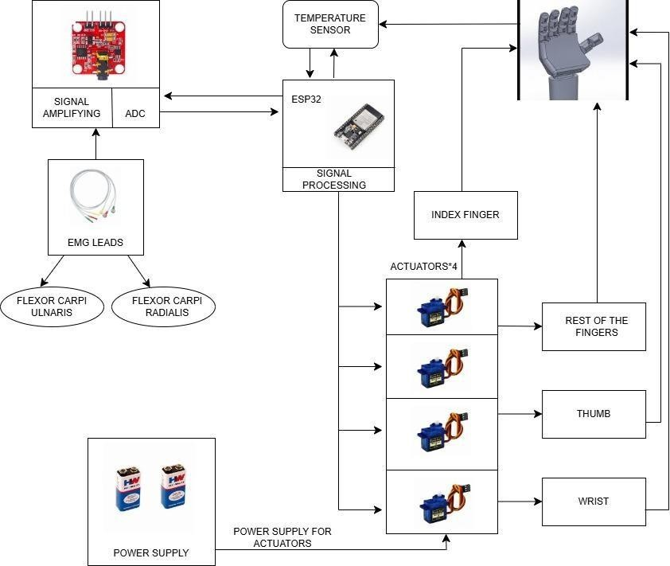
Fig 3.1
Methodology for Developing the Bionic Palm

Fig 3.1 shows the development of the bionic palm follows a structured approach, ensuring an efficient and cost-effective design that provides enhanced functionality. The primary objective is to create a prosthetic hand that closely mimics natural hand movements while remaining affordable and accessible. The methodology involves several key stages, including design, hardware integration, signal processing, and user interaction.

- Design and 3D Printing

The first stage of the development process involves designing the prosthetic hand using 3D modeling software. The design must be lightweight, durable, and anatomically accurate to ensure comfort and proper functionality. Various parameters, such as finger joint flexibility and grip strength, are considered during the design phase. Once finalized, the components are 3D printed using high-quality materials that provide strength while maintaining affordability. The modular nature of the design allows for customization, making it adaptable to different users' needs.

- Integration of EMG Sensors

To enable intuitive and responsive control, electromyography (EMG) sensors are placed on the forearm, specifically over the Carpi Radial is and Carpi Ulnar is muscles. These sensors detect electrical activity generated by muscle contractions, converting them into signals that can be processed by the micro-controller. The placement of these sensors is carefully calibrated to ensure accurate signal acquisition, reducing errors in movement interpretation.

- Microcontroller and Signal Processing

The ESP32 microcontroller serves as the central processing unit of the bionic palm. It receives raw EMG data from the sensors and processes it in real time to determine the appropriate motor movements. The ESP32’s dual-core processing capability ensures smooth and efficient operation, allowing the prosthetic to respond quickly to user inputs. The microcontroller also manages power distribution, sensor feedback, and wireless communication for additional functionality.

- Motor Control and Actuation

DC motors are embedded within the prosthetic hand to control finger movements. These motors are activated based on processed EMG signals, enabling the user to perform gripping, pinching, and other hand motions. The motor control system is fine-tuned to ensure smooth and natural movement, mimicking the functionality of a real hand.

- Sensor Integration for Feedback

Temperature sensors are integrated into the fingertips to provide environmental feedback to the user. This feature enhances the user’s ability to interact with their surroundings, offering an added layer of functionality. The sensory feedback system is designed to improve the overall user experience, making the prosthetic more intuitive and practical.

- Printed Circuit Board (PCB) and Connectivity

All electronic components are integrated onto a custom-designed Printed Circuit Board (PCB). This compact and efficient PCB houses the microcontroller, motor drivers, power supply circuits, and sensor connections. The system also includes Bluetooth connectivity, allowing for wireless communication with a mobile app. Through the app, users can calibrate the prosthetic, adjust settings, and receive real-time feedback, enhancing ease of use.

- Affordability and User-Centered Design

One of the core objectives of this project is to ensure affordability without compromising functionality. By leveraging 3D printing technology and low-cost, high-performance electronic components, the overall cost of production is significantly reduced. The user- centered design approach ensures that the prosthetic is comfortable, easy to use, and adaptable to various needs.

- BLOCK DIAGRAM
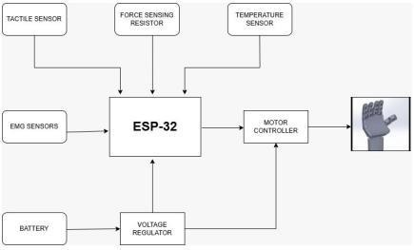
Fig 4.1

Fig 4.1 shows the bionic palm system powered by the ESP32 utilizes an EMG sensor, a temperature sensor, and servo motors to mimic human hand movements. The EMG sensor detects electrical signals generated by muscle contractions, which are read using the read EMG() function. These signals are then processed by the ESP32 to determine the movement intensity required for the fingers. Simultaneously, the temperature sensor measures body or environmental temperature using the read-temperature() function, which helps in adjusting grip strength or monitoring external conditions. The ESP32 processes these inputs and controls the movement of servo motors using the move Fingers() function, which maps the EMG signal strength to servo angles, allowing the fingers to move in a lifelike manner. Additionally, an OLED or LCD display can be integrated, where the display Data() function is used to show real-time EMG and temperature readings, enhancing system transparency and monitoring. For wireless connectivity, the send Data() function enables Bluetooth or Wi-Fi transmission of sensor data, allowing remote monitoring or control via a mobile application. The main loop of the system continuously reads sensor values, processes them, and actuates the fingers accordingly, ensuring smooth and responsive operation of the bionic palm. This system can be beneficial for prosthetic applications, robotic assistance, and rehabilitation purposes.

REFERENCES
  - A New Era for Bionic Limbs - IEEE Pulse Link.
  - Bionic prosthetic hands- A review of present technology and future aspirations Link.
  - The ’mind-bending’ bionic arm powered by AI - BBC Link.
  - Bionic Movements - NIH News in Health Link.
  - The Latest Research Progress on Bionic Artificial Hands - MDPI Link.

Appendix II

Code

Code for Servo movement with respect to EMG signals:

#include <Servo.h>

// Create Servo objects Servo servo1;
Servo servo2; Servo servo3; Servo servo4;

// EMG sensor pin
const int emgPin = A0; // EMG sensor connected to analog pin A0

// Servo motor pins (use PWM pins: 3,5,6,9,10,11 on Uno) const int servoPin1 = 9;
const int servoPin2 = 10; const int servoPin3 = 11; const int servoPin4 = 6;
// Adjusted for Uno's 10-bit ADC (0-1023)

void setup() {
// Initialize serial communication Serial.begin(9600);

// Attach servos to pins servo1.attach(servoPin1); servo2.attach(servoPin2); servo3.attach(servoPin3); servo4.attach(servoPin4);
}

void loop() {
int emgValue = analogRead(emgPin);

// Print EMG value for debugging Serial.print("EMG Value: "); Serial.println(emgValue);

// Control servos based on EMG reading if (emgValue <= 450) {
servo1.write(0); servo2.write(180); servo3.write(0); servo4.write(0);
}
else if (emgValue =) { servo1.write(0); servo2.write(180); servo3.write(0); servo4.write(0);
else { servo1.write(180); servo2.write(0); servo3.write(90); servo4.write(180);
}

delay(785); // Reduced delay for better responsiveness
}

Code for NTC thermocouple temperature sensor:

#include <Wire.h>
#include <Adafruit_GFX.h> #include <Adafruit_SSD1306.h> #include <max6675.h>
#include <SPI.h>

#define SCREEN_WIDTH 128
#define SCREEN_HEIGHT 64

// OLED I2C Address (0x3C or 0x3D)

Adafruit_SSD1306 display(SCREEN_WIDTH, SCREEN_HEIGHT, &Wire, -1);

// MAX6675 Thermocouple Pins #define SCK 18
#define CS 5
#define SD 19

// Initialize MAX6675 module MAX6675 thermocouple(SCK, CS, SD);

void setup() { Serial.begin(115200);

// Initialize OLED display
if (!display.begin(SSD1306_SWITCHCAPVCC, 0x3C)) { Serial.println("OLED not found!");
while (1);
}

display.clearDisplay(); display.setTextSize(1); display.setTextColor(WHITE); display.setCursor(10, 10); display.println("Initializing..."); display.display();
delay(2000);

Serial.println("MAX6675 Temperature Sensor Test");
}

void loop() {
float totalTemp = 0; int readings = 3;

// Collect 5 readings and calculate the average for (int i = 0; i < readings; i++) {
float tempC = thermocouple.readCelsius();

if (tempC < -1) { // MAX6675 returns -1 if no thermocouple is connected Serial.println("Error: No Thermocouple Detected!"); display.clearDisplay();
display.setTextSize(2); display.setCursor(10, 20); display.println("No Sensor!"); display.display(); delay(2000);
return;
}

Serial.print("Reading "); Serial.print(i + 1); Serial.print(": "); Serial.print(tempC); Serial.println(" °C");

totalTemp += tempC;
delay(1000); // 1-second delay between readings
}

float avgTemp = totalTemp / readings; // Calculate average temperature Serial.print("Average Temperature: ");
Serial.print(avgTemp); Serial.println(" °C");

// Display on OLED display.clearDisplay(); display.setTextSize(2); display.setCursor(10, 10); display.println("Avg Temp:");

display.setCursor(30, 35);
display.print(avgTemp, 1); // Display with 1 decimal place display.print(" C");

// Alert Conditions if (avgTemp > 45) {
display.setTextSize(1); display.setCursor(10, 55); display.print("🔥 Danger: Burn Risk!");
Serial.println("🔥 Warning: High Temperature! Burn Risk!");
}
else if (avgTemp < 10) { display.setTextSize(1); display.setCursor(10, 55); display.print("❄ Warning: Too Cold!");
Serial.println("❄ Warning: Very Low Temperature!");
}

display.display();

delay(5000); // Wait 5 seconds before repeating
}

