Appendix I
Paper Publications and Achievements
PROSTHETIC BIONIC PALM USING EMG SENSORS AND ESP32

Anurag C Nair Electronics and Biomedical
Engineering
Adi Shankara Institute of Engineering and Technology anuragnanduuz1221@gmail.co m
Auffin Rasheed Electronics and Biomedical Engineering
Adi Shankara Institute of Engineering and Technology rashiauffinalidf16@gmail.com

Dr. Lakshmi M Hari, Assistant Professor, Dept. of Electronics and Biomedical Engineering Adi Shankara Institute of
Engineering and Technology lakshmi.eb@adishankara.ac.in
Eby Mathew Electronics and Biomedical
Engineering
Adi Shankara Institute of Engineering and Technology ebymathew30@gmail.com

Abstract— Bionic prosthetics have advanced significantly, offering improved functionality and sensory feedback. This project develops a bionic palm equipped with electromyography (EMG) and temperature sensors, powered by the ESP32 micro- controller, to enhance interaction for individuals with upper-limb disabilities. The system detects muscle signals and temperature variations, enabling intuitive movements and sensory feedback.
EMG sensors capture muscle activity, which the ESP32 processes to control actuators for responsive finger movements. Temperature sensors provide feedback to distinguish hot and cold surfaces, improving safety. The palm's lightweight design, modular architecture, and energy-efficient ESP32 ensure comfort, adaptability, and extended battery life. Combining affordability and advanced technology, this prosthetic offers a natural user experience while remaining accessible to a broader population.
Introduction
The need for affordable and functional prosthetic devices has become increasingly important, as many
existing solutions are expensive and lack the ability to replicate natural hand movements effectively. Traditional prosthetic hands often fail to provide users with a realistic and intuitive experience, limiting their daily functionality. To address this issue, our project focuses on developing a bionic palm that integrates advanced electronics and cost-effective 3D printing technology.
This prosthetic hand will utilize an ESP32 micro- controller to process electromyography (EMG) signals from the Carpi Radial is and Carpi Ulnar is muscles, enabling precise and responsive control of hand movements. Additionally, tactile and temperature sensors embedded in the fingertips will provide essential sensory feedback, enhancing user interaction and experience. The incorporation of 3D printing ensures affordability and customization, making the device accessible to a broader range of users.
By combining real-time muscle signal processing with enhanced sensory capabilities, this project aims to bridge the gap between affordability and functionality in prosthetic technology. The proposed bionic palm will not only offer improved dexterity and control but also contribute to a more natural and immersive experience for amputees. This innovative approach has the potential

to redefine prosthetic solutions, making them more inclusive and user-friendly.
- RELATED WORK

Recent advancements in bionic prosthetics have focused on improving functionality, user experience, and accessibility. Researchers have developed prosthetic limbs that increasingly resemble biological counterparts, leveraging technologies such as artificial intelligence (AI), machine learning, and advanced materials. Despite these innovations, challenges remain in achieving intuitive control and addressing issues like device weight and durability.
The PSYONIC Ability Hand exemplifies progress in lightweight and resilient designs using soft robotics materials like silicone and rubber, enhancing impact resistance and robustness. Additionally, advancements in surgical techniques, such as the agonist-antagonist myoneural interface, aim to improve user control by mimicking natural muscle movements. These efforts highlight the importance of integrating end-user feedback early in the design process to ensure functionality aligns with user needs.
Anthropomorphic prosthetic hands with underactuated mechanisms have also been developed to enable self- adaptive grasping and complex motions like flexion/extension and adduction/abduction. Such designs prioritize lightweight construction and efficient motion control, demonstrating significant improvements in dexterity and usability.
Systematic reviews of bionic artificial hands underline the importance of combining sensory feedback with intuitive control systems. For instance, embedding sensors for temperature perception or tactile feedback enhances user interaction with their environment while addressing safety concerns. These studies emphasize the need for modular architectures and energy-efficient designs to reduce costs and improve accessibility for a broader population.

- LITERATURE SURVEY

Recent years have witnessed substantial advancements in bionic prosthetics, particularly in areas such as neural control, sensory feedback, and practical implementation. This literature survey highlights key developments and insights from prominent studies in the field.

Neural Control and Sensory Feedback
One of the most significant breakthroughs in bionic prosthetics is the integration of neural control and sensory feedback. Ortiz-Catalan et al. and M. et al. have
demonstrated the feasibility of highly integrated bionic hands with neural control and feedback. These systems allow users to perform complex tasks with enhanced dexterity and sensory awareness, effectively restoring a more natural hand function. The inclusion of sensory feedback, such as tactile and proprioceptive sensations, significantly improves user experience by enabling a more intuitive interaction with the environment.

Electromyography (EMG) in Prosthetic Control
Electromyography (EMG) has been a cornerstone in prosthetic control due to its ability to capture muscle activity. Corbett et al. conducted a comparative study between EMG and force as interfaces for prosthetic control. Their findings underscored the potential of EMG in providing precise and intuitive control, although challenges remain in signal processing and noise reduction.
Building on this, Li et al. developed a system for proportional and simultaneous control of a hand prosthesis using surface EMG. This approach enabled users to achieve finer motor control and execute more complex movements, such as grasping and releasing objects. The use of surface EMG simplifies the setup process and reduces the invasiveness of the control system, making it more accessible for a broader range of users.

Multiple Control Methods
Jiang's research emphasizes the importance of exploring multiple control methods for bionic hands. This approach acknowledges the diversity in user needs and preferences, suggesting that no single control strategy is universally optimal. By developing and integrating various control methods, researchers can cater to different user profiles, enhancing the overall usability and adaptability of bionic prosthetics.

Practical Implementation and Challenges
Despite these advancements, practical challenges persist in the widespread adoption of bionic prosthetics. Issues such as device weight, durability, and cost remain significant barriers. Furthermore, the integration of advanced technologies like neural interfaces and sensory feedback systems requires sophisticated signal processing and control algorithms, which can increase the complexity and cost of the prosthetic.
However, ongoing research is addressing these challenges through innovations in materials science, mechanical design, and software development. For instance, the use of lightweight yet durable materials and modular architectures can improve user comfort and facilitate customization. Additionally, advancements in power management and energy harvesting technologies

are crucial for extending battery life and reducing maintenance needs.
The literature surveyed highlights significant progress in bionic prosthetics, particularly in neural control, EMG- based control, and sensory feedback. While challenges remain, the field is moving towards creating prosthetic limbs that more closely mimic natural function and provide a more intuitive user experience. Future research should focus on refining control strategies, enhancing sensory feedback, and improving device reliability to further bridge the gap between biological and artificial limbs.

- MATERIALS AND METHODS

Proposed system
The prosthetic bionic arm system is designed to provide real-time control using electromyography (EMG) signals processed by an ESP32 microcontroller. The system integrates multiple hardware components, including EMG sensors, servo motors, an OLED display, and additional sensors such as an NTC thermocouple sensor for enhanced functionality. The design aims to ensure precise control of finger movements, real-time feedback, and safe operation for the user. The system begins with data acquisition from the EMG sensor, which detects muscle activity through electrodes placed on the user’s forearm. These signals are amplified using the onboard AD8226 instrumentation amplifier and transmitted to the ESP32 microcontroller. The ESP32 processes the raw EMG signals, applies filtering techniques to eliminate noise, and interprets the data to generate PWM signals that control three servo motors responsible for finger movements. The servos operate based on predefined thresholds, enabling accurate and proportional control of the prosthetic fingers. An NTC thermocouple sensor is integrated to monitor temperature variations, ensuring safe operation of the system by preventing overheating. The OLED display provides real-time visualization of EMG signal strength and motor states, offering intuitive feedback to the user. Power is supplied through two 9V batteries, ensuring stable voltage delivery to all components. The ESP32 also facilitates wireless communication for remote monitoring and control.

Hardware Implementations
The proposed bionic prosthetic system comprises several key hardware components that enable real-time monitoring, feedback generation, and intuitive control. These include the ESP32 microcontroller, EMG sensor, servo motors, NTC thermocouple sensor, OLED display, and power supply. Each component is selected based on its efficiency, accuracy, and suitability for a wearable prosthetic system.
The ESP32 microcontroller serves as the central processing unit of the system, responsible for EMG signal processing, actuator control, and wireless communication. It is a low-power, high-performance microcontroller designed for embedded applications that require real-time data processing and wireless connectivity. The ESP32 is programmed to retrieve EMG data from the sensor, process it to determine muscle activity, and control servo motors using PWM outputs. Additionally, the ESP32 integrates Wi-Fi and Bluetooth capabilities, allowing it to transmit real-time data for remote monitoring. The selection of the ESP32 is based on its built-in wireless connectivity, energy efficiency, and computational capability, making it well- suited for wearable prosthetic applications.

EMG Sensor
The EMG sensor plays a critical role in capturing muscle activity from the user’s forearm. It measures electrical impulses generated during muscle contractions and outputs analog signals that are amplified and processed by an amplifier. These signals are then sent to the ESP32 microcontroller for further processing. The EMG data is filtered to remove noise and interpreted using predefined thresholds to control servo motors proportionally, ensuring smooth and responsive finger movements based on muscle activation.

Servo Motors
Three servo motors are used in this system to control the individual finger movements of the prosthetic arm. These motors receive PWM signals generated by the
ESP32 based on processed EMG data. The servos allow precise control of finger positions, enabling tasks such as grasping or releasing objects. Their compact design makes them ideal for integration into a wearable prosthetic device.

NTC Thermocouple Sensor
The NTC thermocouple sensor monitors temperature variations within the system or the surrounding environment. This sensor ensures safe operation by detecting overheating conditions that could damage components or cause discomfort to the user. It provides analog temperature readings that are processed by the ESP32 for safety alerts.

OLED Display and Power Supply
The OLED display offers a user-friendly interface by showing real-time updates on EMG signal strength,

servo motor states, and temperature readings from the NTC sensor.
Power is supplied through two 9V batteries connected in parallel to provide stable voltage delivery to all components of the system. Efficient energy utilization ensures prolonged operation without frequent replacements or recharging. The power management circuit in the system is designed to optimize energy consumption, preventing overheating, battery drain, or power surges.

Bluetooth Communication Module (Integrated in ESP32): The Bluetooth module integrated within the ESP32 microcontroller enables real-time data transmission to a dedicated application. The wireless connectivity allows users to monitor their prosthetic status in real time and receive notifications and alerts when necessary.
The primary functions of the Bluetooth communication module include:
- Continuous transmission of EMG data and system status to the application for live monitoring.
- Sending alerts and notifications to inform the user of system updates or issues.
- Providing historical data storage, allowing users to analyse their usage trends over time.
- Enabling user customization, allowing adjustments in feedback settings and notification preferences via the app interface.

Architecture Block Diagram

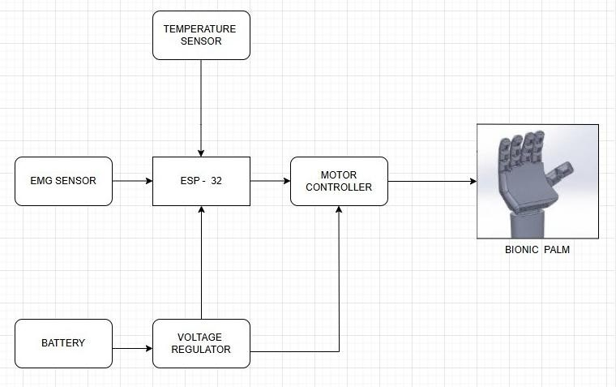
Fig 3.1 Architecture Block Diagram
The Bionic Palm System is an advanced prosthetics controlled using bioelectrical signals and environmental data. The system comprises multiple components, including an EMG sensor, a temperature sensor, an ESP-
32 microcontroller, a motor controller, a voltage regulator, and a battery. The EMG sensor detects
electrical activity from the user’s muscles and sends signals to the ESP-32, which interprets the data to generate movement commands. Additionally, the temperature sensor monitors environmental conditions, ensuring safe and adaptive operation.
The ESP-32 serves as the core processing unit, receiving inputs from both sensors, processing them, and sending control signals to the motor controller. The motor controller then translates these signals into appropriate electrical outputs to drive the Bionic Palm, enabling precise and natural hand movements. The system is powered by a battery, which supplies energy through a voltage regulator, ensuring stable power distribution to all components. This design enables real-time muscle- based control, making the bionic palm highly functional for prosthetic users or robotic applications.

Process Flow Diagram
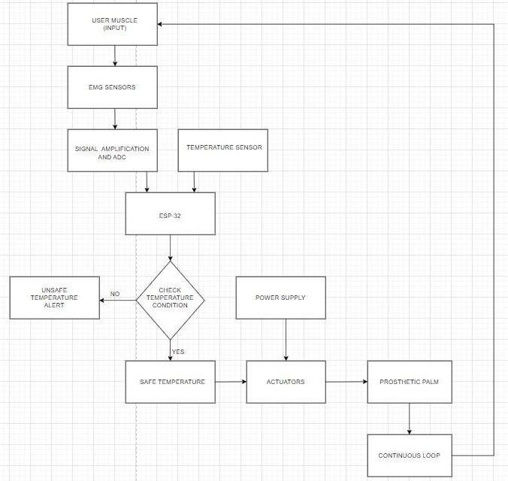
Fig 3.2 Process Flow Diagram
The process flow begins with the user’s muscle contractions, which are detected by the EMG sensors that capture the electrical signals produced by the muscles. These signals are then amplified and converted from analog to digital form, ensuring they are suitable for processing. The ESP32 microcontroller takes over by processing both the EMG data and temperature data gathered from the

temperature sensor, which monitors both the environmental and body temperatures.
Within the ESP32, a condition check determines whether the temperature is safe or unsafe: if safe, the process continues to activate the actuators, which control the motors responsible for moving the prosthetic palm (fingers and wrist); if unsafe, an alert is generated or adjustments are made to ensure user safety and comfort. The system is supported by a power supply that feeds both the ESP32 and the actuators, and it continuously loops back to the beginning, maintaining real-time monitoring and control.
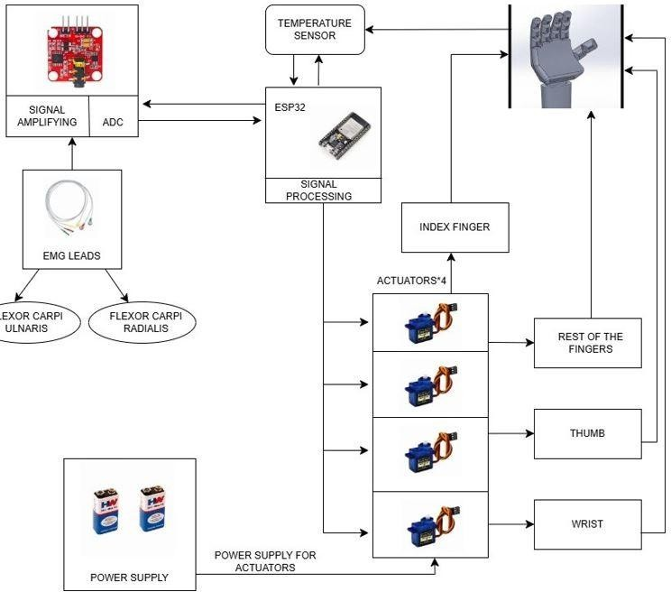
Fig 3.2 Functional Block Diagram

The prosthetic hand control system utilizes EMG signals and an ESP32 micro- controller to enable intuitive movement. EMG leads are placed on the Flexor Carpi Ulnaris and Flexor Carpi Radialis muscles to detect electrical activity generated by muscle contractions. These signals are then sent to a signal amplification and ADC module, where they are amplified and converted into digital data for processing. The ESP32 microcontroller interprets these signals to determine the corresponding hand movements. Additionally, a temperature sensor provides environmental or safety feedback to the microcontroller. The processed signals from the ESP32 control four servo actuators, each responsible for a specific part of the prosthetic hand. One servo motor moves the index
finger, another controls the remaining fingers, a third operates the thumb, and the fourth enables wrist movement. A dedicated power supply ensures the proper functioning of the actuators, while another power source supports the ESP32 and signal processing unit. By converting muscle activity into precise motorized actions, the system allows users to control the prosthetic hand naturally. The integration of sensors (NTC temperature sensor) and microcontroller-based processing enhances responsiveness, providing a functional, user-friendly assistive solution.

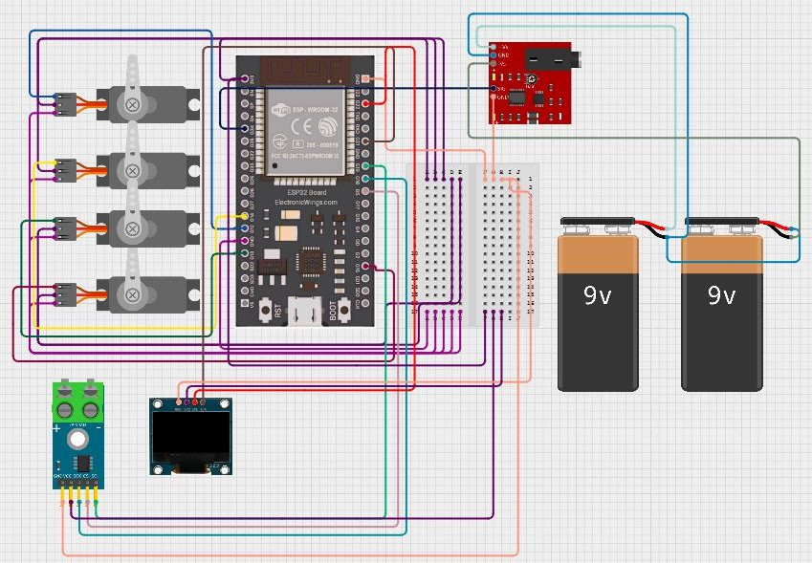
Circuit Diagram

Fig 3.2 Circuit Diagram

The prosthetic hand control system utilizes EMG signals and an ESP32 micro- controller to enable intuitive movement. EMG leads are placed on the Flexor Carpi Ulnaris and Flexor Carpi Radialis muscles to detect electrical activity generated by muscle contractions. These signals are then sent to a signal amplification and ADC module, where they are amplified and converted into digital data for processing. The ESP32 microcontroller interprets these signals to determine the corresponding hand movements. Additionally, a temperature sensor provides environmental or safety feedback to the microcontroller. The processed signals from the ESP32 control four servo actuators, each responsible for a specific part of the prosthetic hand. One servo motor moves the index finger, another controls the remaining fingers, a third operates the thumb, and the fourth enables wrist movement. A dedicated power

supply ensures the proper functioning of the actuators, while another power source supports the ESP32 and signal processing unit. By converting muscle activity into precise motorized actions, the system allows users to control the prosthetic hand naturally. The integration of sensors (NTC temperature sensor) and microcontroller-based processing enhances responsiveness, providing a functional, user-friendly assistive solution.

3.3 Software Implementations
This section introduces the computational framework that governs the functionality of the bionic prosthetic arm. This framework integrates advanced algorithms for real-time processing of neural signals, enabling intuitive motor control and sensory feedback. The code is designed to interpret electrical impulses from the user's nervous system, translating them into precise movements of the prosthetic arm while simultaneously relaying sensory data back to the brain. This bidirectional communication ensures seamless interaction between the user and the device, mimicking natural limb behavior and enhancing usability.
Code for temperature sensing: #include <Wire.h>
#include <Adafruit_GFX.h> #include <Adafruit_SSD1306.h> #include <max6675.h>
#include <SPI.h>
#define SCREEN_WIDTH 128
#define SCREEN_HEIGHT 64
Adafruit_SSD1306 display(SCREEN_WIDTH, SCREEN_HEIGHT, &Wire, -1);
#define SCK 18
#define CS 5
#define SD 19
MAX6675 thermocouple(SCK, CS, SD); void setup() {
Serial.begin(115200);
if (!display.begin(SSD1306_SWITCHCAPVCC, 0x3C))
{
Serial.println("OLED not found!"); while (1);
}
display.clearDisplay(); display.setTextSize(1); display.setTextColor(WHITE); display.setCursor(10, 10); display.println("Initializing..."); display.display();
delay(2000);
Serial.println("MAX6675 Temperature Sensor Test");
}
void loop() {
float totalTemp = 0; int readings = 3;
for (int i = 0; i < readings; i++) {
float tempC = thermocouple.readCelsius(); if (tempC < -1) {
Serial.println("Error: No Thermocouple Detected!");
display.clearDisplay(); display.setTextSize(2); display.setCursor(10, 20); display.println("No Sensor!"); display.display(); delay(2000);
return;
}
Serial.print("Reading "); Serial.print(i + 1); Serial.print(": "); Serial.print(tempC); Serial.println(" °C"); totalTemp += tempC; delay(1000);
}
float avgTemp = totalTemp / readings; Serial.print("Average Temperature: "); Serial.print(avgTemp);
Serial.println(" °C"); display.clearDisplay();

display.setTextSize(2); display.setCursor(10, 10); display.println("Avg Temp:"); display.setCursor(30, 35);
display.print(avgTemp, 1); place display.print(" C");
if (avgTemp > 45) { display.setTextSize(1); display.setCursor(10, 55); display.print(" ● Danger: Burn Risk!");
Serial.println(" ● Warning: High Temperature!
Burn Risk!");
}
else if (avgTemp < 10) { display.setTextSize(1); display.setCursor(10, 55); display.print("❄ Warning: Too Cold!");
Serial.println("❄ Warning: Very Low Temperature!");
}
display.display();
delay(5000); // Wait 5 seconds before repeating
}
This code is designed for an Arduino-based ESP32 system that integrates a MAX6675 thermocouple temperature sensor and an OLED display using the Adafruit SSD1306 library. It initializes serial communication and sets up the OLED display, checking for proper connection. The system then takes multiple temperature readings from the MAX6675 sensor, calculates the average, and displays it on the OLED screen. An alert system is also implemented, warning if the temperature exceeds 45°C or drops below 10°C, with messages displayed both on the OLED and in the serial output.
// Create Servo objects Servo servo1;
Servo servo2; Servo servo3; Servo servo4;
// EMG sensor pin const int emgPin = 35;
// Servo motor pins
const int servoPin1 = 13; // Servo motor 1 connected to GPIO13
const int servoPin2 = 14; // Servo motor 2 connected to
GPIO14
const int servoPin3 = 15; // Servo motor 3 connected to GPIO15
const int servoPin4 = 12; // Servo motor 4 connected to GPIO16
const int threshold = 778; // void setup() {
// Initialize serial communication for debugging Serial.begin(115200);
// Set ADC resolution to 12 bits analogReadResolution(12); analogSetAttenuation(ADC_11db);
// Attach servos to pins servo1.attach(servoPin1); servo2.attach(servoPin2); servo3.attach(servoPin3); servo4.attach(servoPin4);
}
void loop() {
int emgValue = analogRead(emgPin);
// Print EMG value for debugging Serial.print("EMG Value: "); Serial.println(emgValue);
// Control servos based on EMG reading if (emgValue <= threshold) {
// Rotate all servos to 0 degrees servo1.write(0); servo2.write(0); servo3.write(0); servo4.write(0);
} else {
// Rotate all servos to 90 degrees servo1.write(90); servo2.write(90); servo3.write(90); servo4.write(90);
}
delay(795); // Small delay for stability
}
This code is designed for an ESP32-based system that controls four servo motors using input from an EMG (Electromyography) sensor. The EMG sensor is connected to GPIO35, and the servo motors are attached to GPIO13, GPIO14, GPIO15, and GPIO12. The system reads the EMG sensor value and uses it to determine whether to rotate the servos to 0 degrees or 90 degrees based on a predefined threshold of 778. If the EMG value is below this threshold, the servos remain at 0 degrees; otherwise, they rotate to 90 degrees. The code includes serial debugging to monitor the EMG sensor readings and uses a small delay for stability between servo movements. This setup can be used in applications

like prosthetic limbs, where muscle signals are translated into motor movements.
Future developments in bionic prosthetic palms are set to revolutionize the field of prosthetics by integrating cutting-edge technologies that enhance user experience and functionality. One of the key innovations on the horizon is the development of myography band-type sensors. These sensors, designed to be worn like a band around the forearm, utilize surface electromyography (EMG) to detect even the slightest muscle contractions. This technology promises to provide more precise control over prosthetic movements, allowing users to perform complex tasks with greater ease and accuracy.
Myography band sensors represent a significant leap forward in prosthetic control systems. Unlike traditional electrode setups, which often require precise placement and can be cumbersome, these bands offer a more comfortable and adaptable solution. By covering a larger surface area of the forearm, they can capture a broader range of muscle signals, providing a more comprehensive understanding of the user's intended movements. This not only enhances the precision of prosthetic control but also reduces the learning curve for users, as they can rely on more intuitive gestures to operate their prosthetics.
The integration of myography band sensors with machine learning algorithms is another critical aspect of future developments in bionic prosthetics. These algorithms can learn to recognize patterns in muscle activity over time, allowing the prosthetic to adapt to the user's habits and preferences. This adaptive capability means that users can enjoy more natural and seamless interaction with their prosthetics, as the system learns to anticipate and respond to their needs more effectively. Additionally, machine learning can help improve signal processing, reducing noise and enhancing the accuracy of muscle signal interpretation, which is crucial for precise control.
Future myography band sensors will also prioritize ergonomic design and wireless connectivity to ensure that they are both non-intrusive and convenient to use. Lightweight materials and flexible designs will make the bands comfortable to wear for extended periods, minimizing fatigue and maximizing user comfort. Wireless connectivity will enable seamless communication between the sensor band and the prosthetic, eliminating the need for cumbersome cables and allowing users greater freedom of movement. This combination of comfort, flexibility, and connectivity will make these sensors an integral part of daily life for prosthetic users, enhancing their ability to engage in various activities without restriction.
The potential applications of myography band sensors in bionic prosthetics extend far beyond basic limb replacement. They could enable users to perform delicate tasks such as playing musical instruments, cooking, or even typing with precision. Moreover, these sensors could be integrated into exoskeletons or assistive
devices for individuals with muscle weakness or paralysis, offering them greater independence and mobility. The impact on quality of life will be significant, as users can engage more fully in social, professional, and personal activities. Furthermore, advancements in this field could also lead to breakthroughs in other areas of medical technology, such as rehabilitation and physical therapy, by providing new tools for monitoring and enhancing muscle recovery.
Despite the promising potential of myography band sensors, several challenges remain to be addressed. One of the primary concerns is ensuring consistent signal quality across different users and environments. Variations in muscle anatomy, skin conductivity, and external interference can affect signal reliability, necessitating robust algorithms for signal processing and noise reduction. Additionally, there is a need for more extensive clinical trials to validate the long-term efficacy and safety of these sensors in real-world settings. Future research should focus on developing standardized protocols for sensor calibration and user training, as well as exploring the integration of other sensing modalities, such as pressure or vibration, to further enhance prosthetic feedback and control.

- RESULTS

4.1 Hardware and component interaction
The bionic prosthetic palm integrates several key hardware components, each selected for its reliability, performance, and suitability in wearable applications. This integration includes the ESP32-WROOM-32 microcontroller, EMG sensors, servo motors, a temperature sensor, and an OLED display. The ESP32 serves as the central controller, processing EMG signals and controlling servo motors. It offers dual-core processing, integrated Wi-Fi and Bluetooth, and multiple GPIOs, making it ideal for real-time data handling and cloud communication.
The ESP32-WROOM-32 microcontroller is connected to EMG sensors via GPIO35, allowing it to capture muscle activity in the forearm. The servo motors are attached to GPIO13, GPIO14, GPIO15, and GPIO12, enabling precise control over prosthetic finger movements. A temperature sensor is integrated into the fingertip, providing real-time temperature feedback. This sensor is connected to the ESP32 via the I2C protocol using pins D21 as SDA and D22 as SCL. An OLED display is also connected via I2C, displaying temperature readings and system status with a resolution of 128x64 pixels.
The assembly of the bionic prosthetic palm involves integrating the ESP32 microcontroller with EMG sensors, servo motors, a temperature sensor, and an

OLED display. The EMG sensors capture muscle activity, which is processed by the ESP32 to control the servo motors, mimicking forearm movements. The temperature sensor provides real-time temperature readings displayed on the OLED screen, enhancing user feedback. This integration ensures that the prosthetic hand can respond naturally to muscle signals and provide sensory feedback, significantly enhancing user experience.
The system is powered by a 7.4V lithium-ion battery, ensuring sufficient voltage for the servo motors and other components. The ESP32's integrated Wi-Fi enables wireless communication with cloud platforms for remote monitoring and updates. This connectivity allows users to receive notifications and updates directly on their smartphones, enhancing the overall user experience and system functionality. The common ground and regulated power supply ensure consistent performance across all modules, minimizing potential issues related to power fluctuations.
The system successfully interprets EMG signals, controlling the servo motors to perform precise finger movements. The temperature sensor provides accurate readings displayed on the OLED screen, enhancing user feedback. This integration demonstrates a reliable and responsive prosthetic system capable of real-time control and sensory feedback. The observed output shows that the system can accurately detect muscle activity and translate it into precise movements, while also providing real-time temperature feedback.
The hardware integration of the bionic prosthetic palm showcases a robust and functional system that enhances user experience through precise motor control and real- time sensory feedback. Future enhancements could include integrating additional sensors for tactile feedback and machine learning algorithms for personalized control, further improving the system's adaptability and user comfort. The integration of advanced technologies like myography band sensors could also enhance precision and comfort, offering users a more natural interaction with their environment.
Future developments in this field may focus on integrating advanced sensing technologies, such as pressure sensors or vibration motors, to provide additional tactile feedback. Machine learning algorithms could be implemented to personalize the prosthetic's response to individual users' muscle signals, enhancing precision and comfort. Additionally, integrating the prosthetic with wearable devices or smartphones could enable remote monitoring and updates, ensuring that users have access to the latest software improvements and personalized settings. These advancements would not only improve the functionality of the prosthetic but also enhance its integration into daily life, making it an indispensable tool for users.
The integration of myography band sensors into the bionic prosthetic palm could further enhance its
capabilities. These sensors, worn like a band around the forearm, can detect muscle activity with greater precision and comfort than traditional EMG electrodes. By combining these sensors with the ESP32's processing capabilities, the system could offer more intuitive control and adaptability, allowing users to perform complex tasks with greater ease. Additionally, the use of machine learning algorithms could enable the system to learn and adapt to the user's habits over time, providing a more personalized experience. This integration would represent a significant step forward in prosthetic technology, offering users a more natural and responsive interaction with their environment.
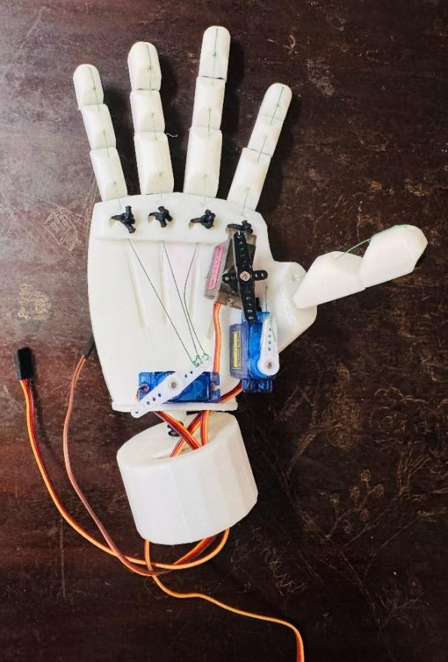
Fig 4.1 Final Assembly
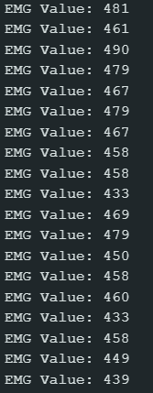
Fig 4.2 EMG sensor values

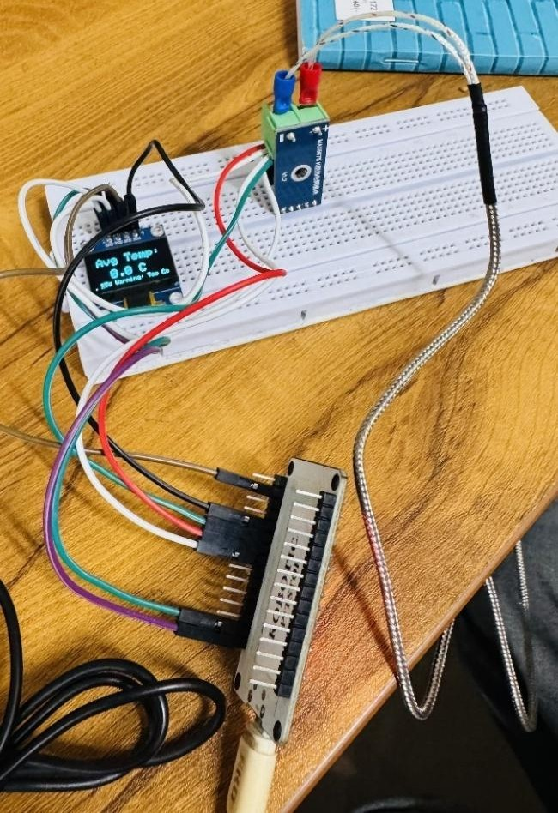
- CONCLUSION

The sensors allows precise detection of muscle signals, enabling the prosthetic to respond to the user’s intent with
minimal latency, creating a near-natural experience.
.TheESP32 microcontroller processes these signals efficiently, ensuring real-time control and responsiveness while maintaining low power consumption, which is essential for extended use. Additionally, the system’s flexibility allows for easy customization to suit individual needs, while its Wi-Fi and Bluetooth capabilities offer potential for remote monitoring and feedback. Although challenges like signal noise and interference can affect performance, the cost-effectiveness of the system makes it more accessible, improving the viability of bionic prosthetics for a wider population. With further advancements in signal processing and machine learning, this system could evolve to offer even greater accuracy and adaptability, providing a valuable solution for those with limb loss

Fig 4.3 Temperature sending

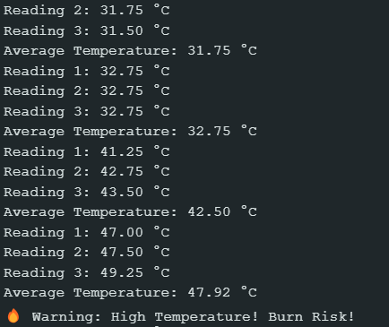

Fig 4.4 Temperature readings
- REFERENCES

- M., et al. Mind-controlled arm prostheses that 'feel' are now a part of everyday life. New England Journal of Medicine, 2020.

- M., Zbinden, J., Millenary, J., et al. A highly integrated bionic hand with neural control and feedback for use in daily life. Science Robotics, 2023.

- Corbett, E. A., Perreault, E. J., & Kuiken, T. A. Comparison of electromyography and force as interfaces for prosthetic control. Journal of Rehabilitation Research & Development, 2011.

- Li, G., Schultz, A. E., Bravo-Esteban, E., Popovic, M. R., & Pacelli, M. C. Proportional and simultaneous control of a hand prosthesis using surface electromyography. IEEE Transactions on Biomedical Engineering, 2010.

- Ortiz-Catalan, M., et al. A highly integrated bionic hand with neural control and feedback for use in daily life. Science Robotics, 2023.

- Jiang, H. Research on Multiple Control Methods for Bionic Hands. SHS Web of Conferences, 2022.

