PROJECT REPORT
SMART WASTE CLASSIFICATION
AND RECYCLING ANALYSIS
Using Machine Learning and Deep Learning

Week 6 Task: Integrative Capstone Project and Evaluation
Virtual Data Science with Python Internship
Submitted by: SNEHA YADAV
Course: Bachelor of Computer Applications (BCA)
University: Babasaheb Bhimrao Ambedkar University
Internship Organization: yuvaintern
Internship Program: Virtual Data Science with Python Trainee
Submission Date: 2-11-2026

Abstract
Waste segregation is an important step in effective recycling and sustainable waste management. Manual sorting can be time-consuming and may be inconsistent when different waste materials have similar appearances. This project develops and evaluates an image-based waste classification workflow using the TrashNet dataset. The dataset contains 2,527 images belonging to six categories: cardboard, glass, metal, paper, plastic and trash.
The workflow includes image inspection, preprocessing, exploratory data analysis, unsupervised clustering, supervised machine learning and deep learning. Images were resized to 128 × 128 pixels and normalized. The dataset was divided into 1,768 training images, 379 validation images and 380 testing images. For classical machine learning, 304 handcrafted features were extracted from RGB colour histograms and resized grayscale pixels. K-Means clustering was used to explore visual groupings, while Support Vector Machine (SVM) and Random Forest models were trained for classification. A Convolutional Neural Network (CNN) was also developed to learn image features directly.
In the initial model comparison, Random Forest achieved the highest test accuracy of 68.95%, followed by SVM at 62.89% and CNN at 58.16%. K-Means produced a highest silhouette score of 0.1906 for K = 2, indicating weak separation in the selected feature space. Feature importance analysis showed that grayscale features contributed 66.94% of the Random Forest's total feature importance. Hyperparameter tuning increased validation accuracy to 69.66%, while the selected model's test accuracy remained 68.95%. A separate balanced sample of 60 test images produced 81.67% accuracy in the practical multiple-image demonstration; this result is reported separately and is not treated as the full test-set accuracy.
The project demonstrates an end-to-end image classification workflow and highlights practical challenges such as class imbalance, visual similarity between materials and limited dataset size. The results suggest that the system can support learning and prototype-level waste classification, but further data collection, model optimization and real-world testing are required before practical deployment.
Keywords: Waste classification, TrashNet, machine learning, deep learning, CNN, Random Forest, SVM, K-Means, image processing, recycling.

Table of Contents
- 1. Introduction
- 2. Problem Statement and Objectives
- 3. Dataset Description
- 4. Tools and Technologies
- 5. Project Methodology
- 6. Data Acquisition and Inspection
- 7. Image Preprocessing and Dataset Split
- 8. Exploratory Data Analysis
- 9. Unsupervised Learning: K-Means Clustering
- 10. Supervised Learning
- 11. Deep Learning: CNN Model
- 12. Model Performance Comparison
- 13. Error Analysis
- 14. Feature Importance Analysis
- 15. Hyperparameter Tuning and Model Improvement
- 16. Practical Prediction Demonstration
- 17. Overall Discussion and Key Findings
- 18. Limitations
- 19. Future Scope
- 20. Conclusion
- 21. References
- Appendix A. Evidence and Screenshots

1. Introduction
Waste management has become an important environmental and public-health concern. Different waste materials require different handling and recycling processes. For example, paper and cardboard can be processed as paper-based recyclables, while glass, metal and many plastics follow different recycling routes. If waste is mixed together, recyclable materials may become contaminated and more difficult to recover.
Waste segregation is commonly performed manually. Manual sorting can require time and consistent attention, particularly when objects are dirty, damaged, folded, reflective or photographed under different lighting conditions. Image classification offers one possible way to assist this process. A computer vision model can analyse an image and estimate which waste category it belongs to.
This project explores both traditional machine learning and deep learning approaches. Traditional models use a set of features extracted from each image, whereas a CNN learns useful visual representations from image pixels during training. The project also uses exploratory analysis and clustering to understand the dataset before classification.
The aim is not to claim that a prototype can replace a complete industrial recycling system. Instead, the project provides a practical study of how image data can be inspected, prepared, analysed and used to build waste-category classifiers.

2. Problem Statement and Objectives

2.1 Problem Statement
The project addresses the problem of classifying waste images into six predefined categories: cardboard, glass, metal, paper, plastic and trash. The main challenge is that images within a category can vary in colour, shape, size, texture, lighting and background. In addition, different categories may share visual characteristics. A model must learn patterns that generalize beyond the exact images used during training.

2.2 Objectives
- Acquire and inspect a labelled waste-image dataset.
- Check image readability, dimensions and class distribution.
- Preprocess images through resizing, normalization and dataset splitting.
- Explore visual patterns and possible class imbalance using EDA.
- Apply K-Means clustering to examine whether image features form natural groups.
- Train and evaluate SVM, Random Forest and CNN classification models.
- Compare models using accuracy, precision, recall and F1-score.
- Analyse model errors and identify important handcrafted features.
- Test Random Forest hyperparameter configurations using validation data.
- Demonstrate predictions on individual and multiple images.

3. Dataset Description
The project uses the TrashNet image dataset. It contains 2,527 labelled images arranged into six waste categories. The class distribution is not equal: paper has the largest number of images, while trash has the smallest. This imbalance is relevant because a model may learn more examples from common categories than from less represented categories.
Waste category | Number of images | Percentage
Cardboard | 403 | 15.95%
Glass | 501 | 19.83%
Metal | 410 | 16.22%
Paper | 594 | 23.51%
Plastic | 482 | 19.07%
Trash | 137 | 5.42%
Total | 2,527 | 100%

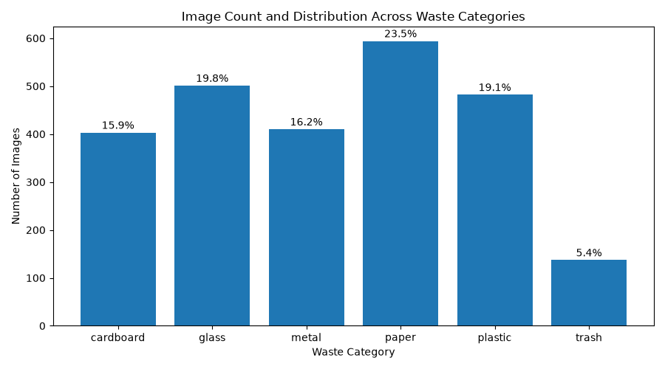
Figure 1. Distribution of images across the six waste categories.
Paper accounts for 23.51% of the dataset and trash accounts for only 5.42%. The difference means the model receives substantially fewer examples of trash during training. Class imbalance can affect how well a classifier learns minority categories, so class-wise metrics and balanced class weights are considered in the experiments.

4. Tools and Technologies
Tool / Library | Purpose in the project
Python | Main programming language
VS Code | Development environment
OpenCV (cv2) | Image loading, resizing and colour conversion
NumPy | Numerical arrays and feature representation
Pandas | Dataset metadata and result tables
Matplotlib / Seaborn | Graphs and visual analysis
Scikit-learn | K-Means, SVM, Random Forest and evaluation metrics
TensorFlow / Keras | CNN model construction and training
Joblib | Saving and loading the trained Random Forest model

The project was implemented in Python using a modular set of scripts. Each script performs a separate stage, making it easier to test the workflow and reproduce results.

5. Project Methodology
The workflow follows a sequence from raw image inspection to model evaluation and prediction. The stages are connected: errors in image paths or preprocessing can affect feature extraction, and weaknesses in the dataset can influence model performance.
- Dataset inspection: count images, verify class folders, check file readability and image dimensions.
- Preprocessing: resize images, normalize pixel values for the CNN workflow and create training, validation and testing subsets.
- EDA: analyse class percentages, brightness and RGB distributions.
- Unsupervised learning: extract handcrafted image features, reduce dimensionality with PCA and apply K-Means.
- Supervised learning: train SVM and Random Forest on handcrafted features.
- Deep learning: train a CNN using image tensors and validation monitoring.
- Evaluation: compare model performance and inspect class-wise errors.
- Improvement and demonstration: tune Random Forest hyperparameters and test image predictions.
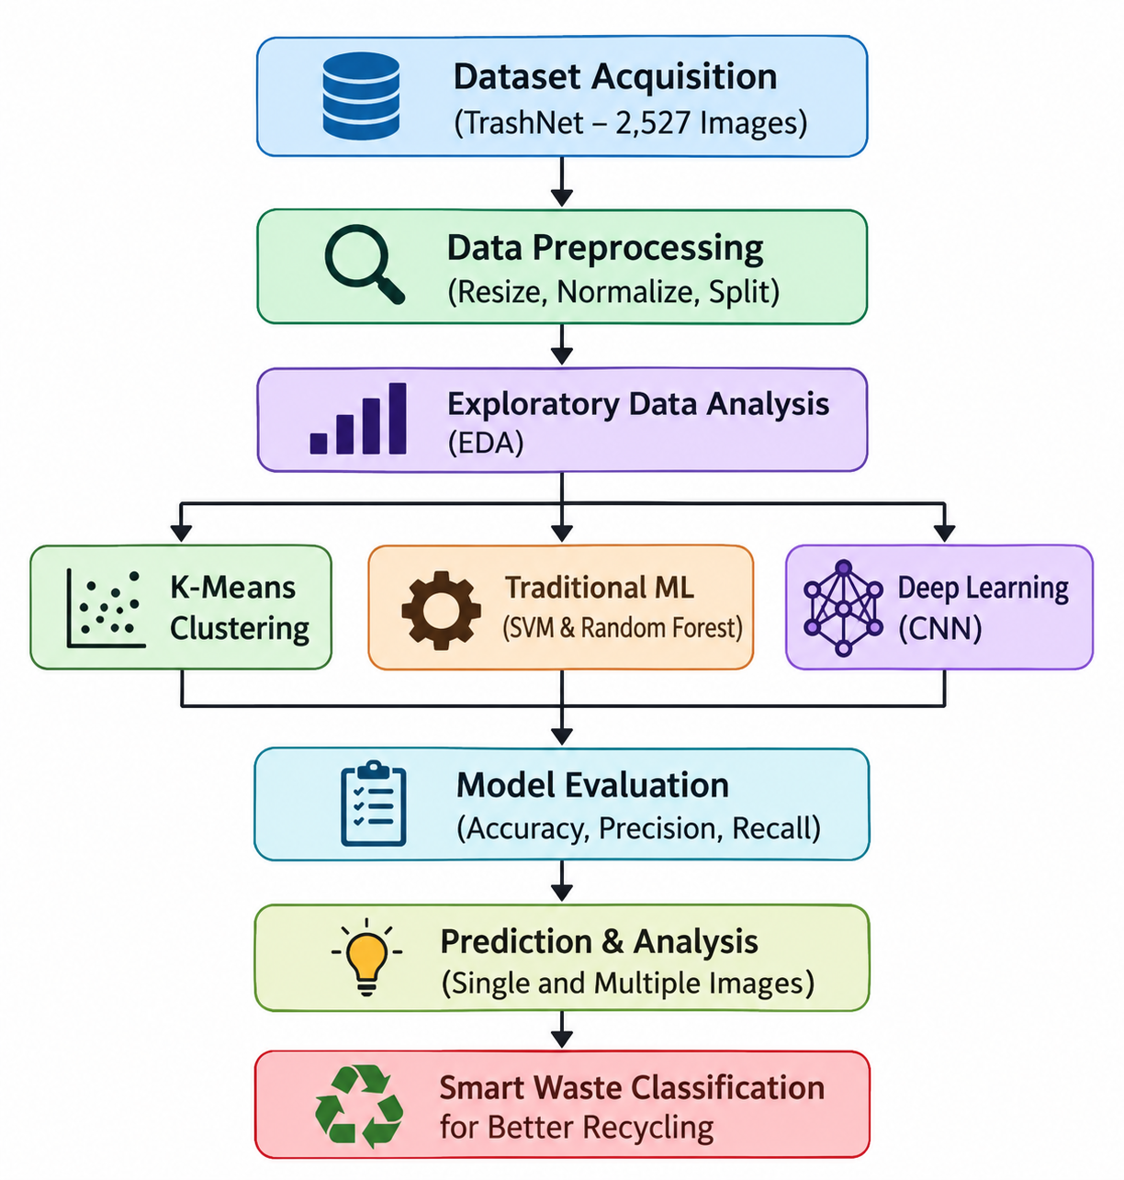

6. Data Acquisition and Inspection
The dataset was organized into six class folders. A data-inspection script counted the files in each folder and checked whether images could be opened. This step is important because a corrupted or unreadable file can interrupt training or create an incorrect dataset count.
Inspection item | Observed result
Total images | 2,527
Corrupted or unreadable images | 0
Common image dimensions | 512 × 384
Dataset classes | 6

All 2,527 images were readable in the inspection run, and the reported image dimensions were 512 × 384. This consistency simplifies preprocessing because images can be resized to a common input shape. It does not mean that the images have identical content or visual quality; background, lighting and object appearance still vary.

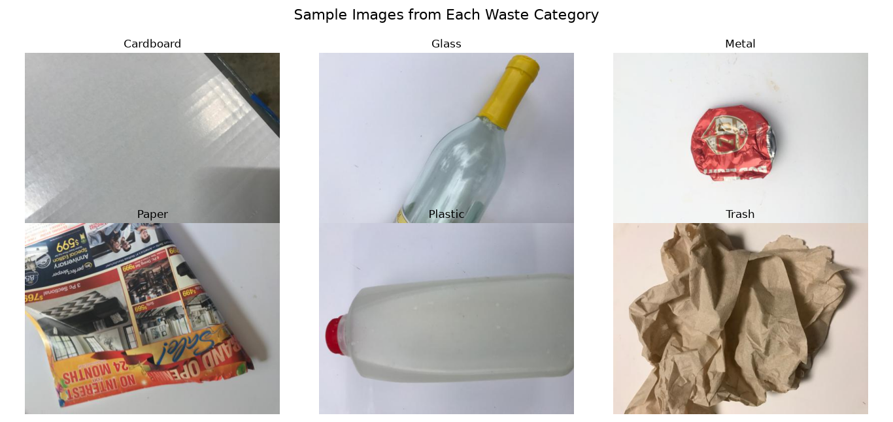
Figure 2. Representative images from the six waste categories.
The sample images show that categories may have different visual cues, but those cues are not always reliable. Transparent glass can reflect its surroundings, metal can appear dark or bright, and paper or cardboard may have overlapping colours and textures. These variations make image classification more challenging than simply identifying an object's dominant colour.

7. Image Preprocessing and Dataset Split

7.1 Resizing
Images were resized to 128 × 128 pixels. A common image size is required so that image arrays can be placed into batches and passed consistently to the CNN. Resizing also reduces computational requirements compared with processing the original 512 × 384 images. However, resizing may remove some fine details, so the selected size represents a trade-off between computational efficiency and visual information.

7.2 Normalization
For the CNN workflow, pixel values were converted to floating-point values and divided by 255.0. This changes the pixel range from 0–255 to 0–1. Normalized inputs generally provide a more convenient scale for neural-network optimization and help training behave more consistently.
image = tf.cast(image, tf.float32) / 255.0

7.3 Dataset Split
Subset | Images | Approximate share
Training | 1,768 | 69.96%
Validation | 379 | 15.00%
Testing | 380 | 15.04%
Total | 2,527 | 100%

The split was stratified so that each subset retained representation from the six classes. The training set was used to fit model parameters, the validation set was used to compare configurations and monitor training, and the test set was reserved for final evaluation. Keeping the test set separate helps provide a more independent estimate of performance.
The preprocessing script confirmed a CNN batch shape of (32, 128, 128, 3), with labels of shape (32,). The normalized pixel range was 0.0 to 1.0.
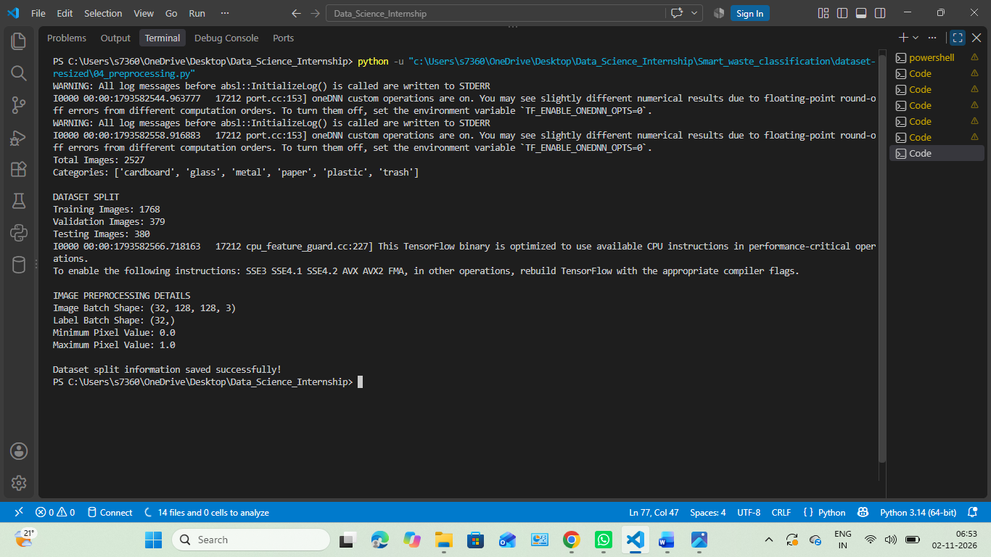

8. Exploratory Data Analysis (EDA)
EDA was performed before model training to understand the image dataset and identify patterns that could affect classification. The analysis included category percentages, average brightness and RGB channel statistics.

8.1 Class Distribution
Paper was the most represented class with 594 images (23.51%), while trash was the least represented with 137 images (5.42%). The trash category has substantially fewer training examples than paper. This imbalance may make the trash class harder to learn and can lead to uneven class-wise performance.

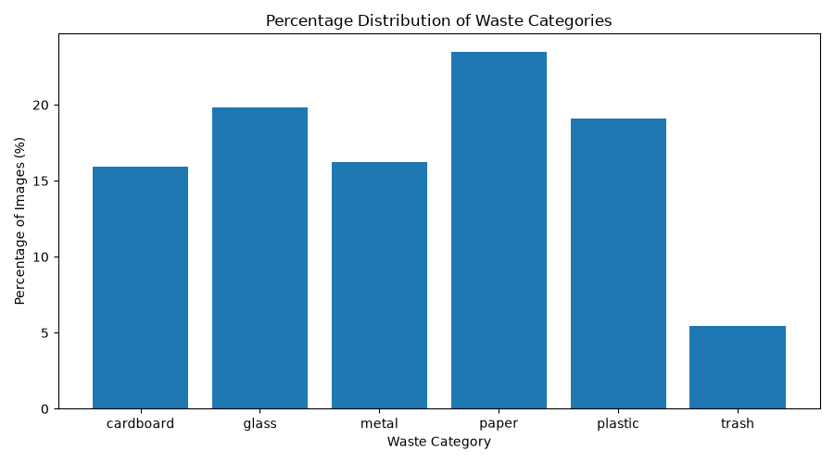
Figure 3. Difference between paper and trash in the discussion.

8.2 Brightness Analysis
Category | Average brightness
Cardboard | 148.96
Glass | 170.00
Metal | 157.91
Paper | 164.05
Plastic | 170.05
Trash | 164.65

Glass and plastic had the highest average brightness values, while cardboard had the lowest. Brightness may reflect object colour, lighting and background conditions together. Therefore, it should not be interpreted as a unique material property. Two images of the same material can have different brightness under different lighting.
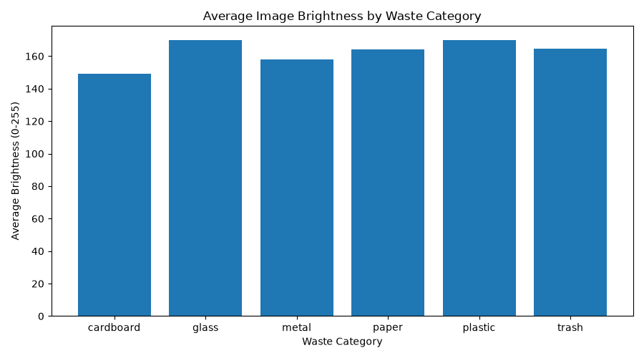
Figure 3. Average Image Brightness by waste category

8.3 RGB Channel Analysis
Category | Mean Red | Mean Green | Mean Blue
Cardboard | 170.08 | 148.86 | 127.93
Glass | 176.37 | 170.52 | 163.10
Metal | 164.83 | 157.00 | 151.90
Paper | 172.18 | 164.55 | 155.43
Plastic | 171.09 | 170.09 | 168.98
Trash | 178.80 | 166.11 | 149.05

The RGB averages differ across categories, but the differences are not strong enough to identify materials by colour alone. For example, lighting, shadows, printed labels, object backgrounds and camera conditions can change the channel values. This supports the use of multiple features rather than relying on a single colour statistic.
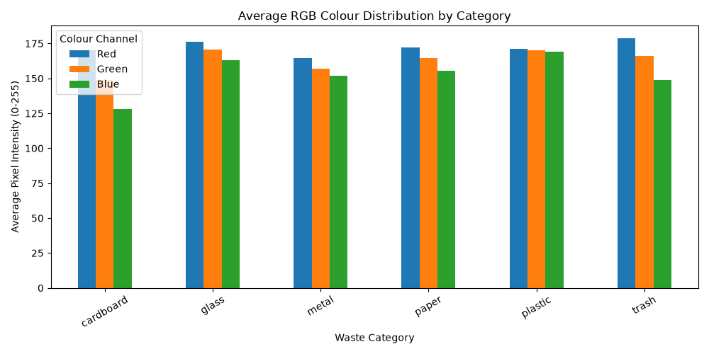
Figure 3. Average RGB Colour Distribution by waste category

8.4 Class Imbalance Implication
The class imbalance analysis highlights the need to inspect precision and recall for every category instead of reporting accuracy alone. A model can obtain a reasonable overall score while performing poorly on a less represented class. Class weighting was used in the Random Forest experiments, and class-wise evaluation was included in the report.

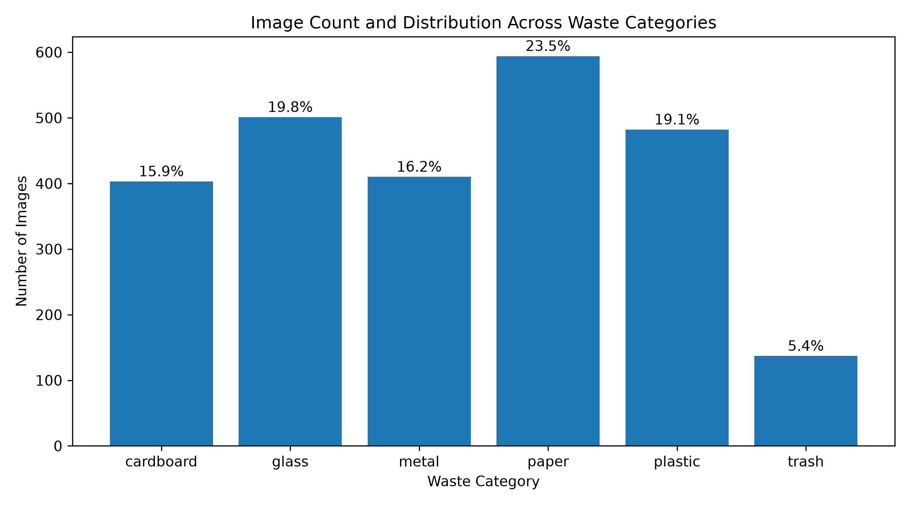
Figure 4. Distribution of Images Across Six Waste Categories.

9. Unsupervised Learning: K-Means Clustering
K-Means clustering was used to explore whether images naturally form groups based on their extracted visual features, without using the category labels to guide the clustering. Each image was represented using 304 handcrafted features: 16-bin histograms for each of the three colour channels (48 features) and a 16 × 16 grayscale representation (256 features).
The features were standardized and reduced to 50 principal components using PCA. The 50 components explained 89.27% of the variance in the original feature representation. K-Means was evaluated for K values from 2 to 8.
Number of clusters (K) | Silhouette score
2 | 0.1906
3 | 0.0900
4 | 0.0837
5 | 0.0846
6 | 0.0820
7 | 0.0795
8 | 0.0783

K = 2 achieved the highest silhouette score among the tested values (0.1906). However, the score is relatively low, which indicates weak separation between clusters. The result does not mean that the dataset contains only two real waste categories. It means that, with the selected features and distance-based clustering approach, two groups were the best separated among the tested configurations.

The cluster composition also showed mixed categories. For example, Cluster 0 contained 195 cardboard, 41 glass, 126 metal, 142 paper, 41 plastic and 23 trash images. Cluster 1 contained 87 cardboard, 309 glass, 161 metal, 274 paper, 296 plastic and 73 trash images. Since both clusters contain several material categories, the clusters do not correspond directly to the six semantic labels.
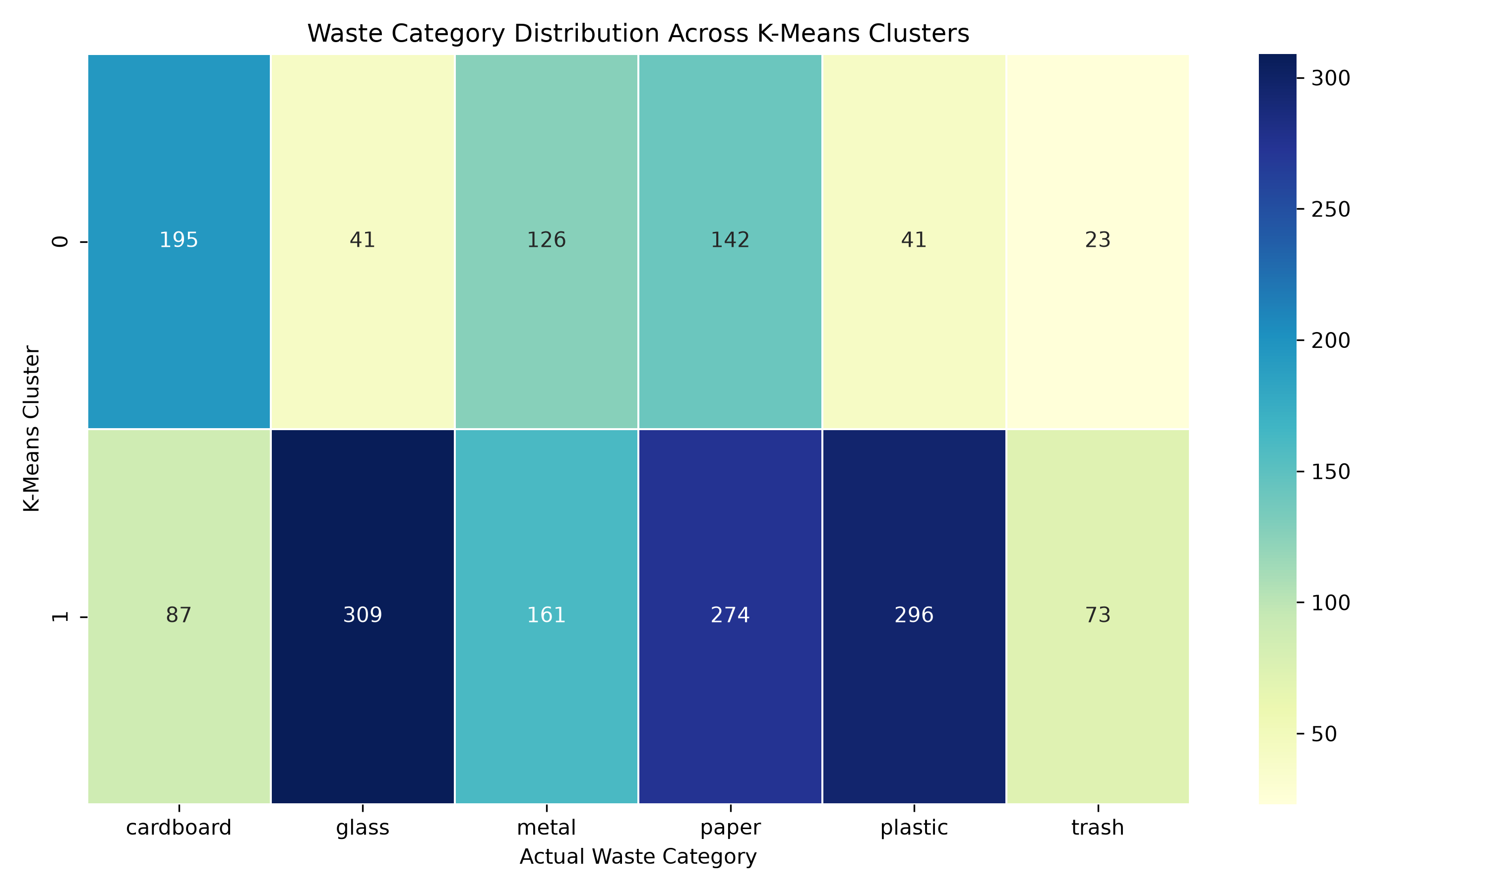

Figure 5. Distribution of Images Across Six Waste Categories.
The main implication is that the selected low-level colour and grayscale features do not create six clean natural groups. K-Means is therefore treated as an exploratory analysis rather than a final waste classifier.

10. Supervised Learning

10.1 Feature Representation
For the classical machine-learning models, each image was represented by 304 handcrafted features. These consisted of 16-bin histograms for the three colour channels and 256 resized grayscale pixel values. This representation converts an image into a fixed-length numerical vector that can be used by conventional classification algorithms.

10.2 Support Vector Machine (SVM)
An SVM with an RBF kernel was trained to classify the six waste categories. The RBF kernel can model non-linear decision boundaries, which may help when classes cannot be separated using a simple straight line in feature space. The SVM achieved 62.89% test accuracy and a weighted F1-score of 0.63.

Class | Precision | Recall | F1-score | Support
Cardboard | 0.78 | 0.72 | 0.75 | 60
Glass | 0.52 | 0.55 | 0.54 | 76
Metal | 0.48 | 0.44 | 0.46 | 62
Paper | 0.67 | 0.74 | 0.71 | 89
Plastic | 0.66 | 0.71 | 0.68 | 73
Trash | 0.82 | 0.45 | 0.58 | 20

The SVM performed relatively well for cardboard and paper, but metal had the lowest F1-score (0.46). Trash precision was high (0.82), but recall was low (0.45), meaning that the model identified some trash predictions accurately but missed a number of actual trash images.

10.3 Random Forest
A Random Forest classifier with 200 trees and balanced class weights was trained using the same 304-feature representation. Random Forest combines predictions from multiple decision trees. The ensemble approach can capture feature interactions and reduce the instability of an individual tree.
Class | Precision | Recall | F1-score | Support
Cardboard | 0.70 | 0.73 | 0.72 | 60
Glass | 0.67 | 0.61 | 0.63 | 76
Metal | 0.56 | 0.65 | 0.60 | 62
Paper | 0.72 | 0.74 | 0.73 | 89
Plastic | 0.75 | 0.71 | 0.73 | 73
Trash | 0.88 | 0.70 | 0.78 | 20

The initial Random Forest comparison produced 68.95% test accuracy and a weighted F1-score of 0.69. It performed better than SVM in overall accuracy and weighted F1-score. Trash achieved an F1-score of 0.78, while glass had the lowest F1-score of 0.63.

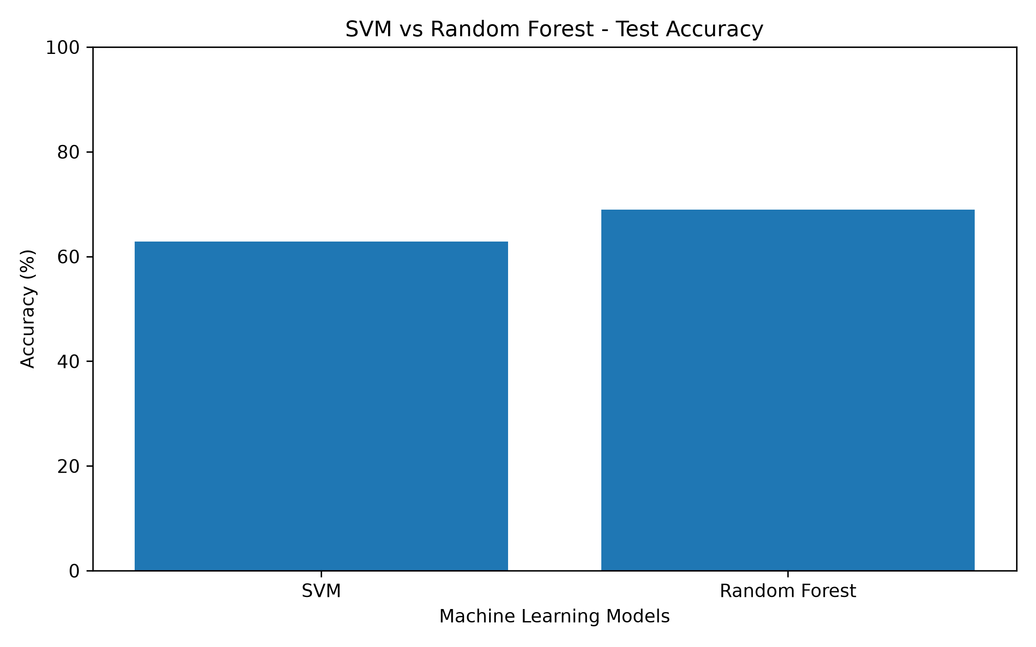
Figure 6. Performance Comparison of SVM and Random Forest Models.

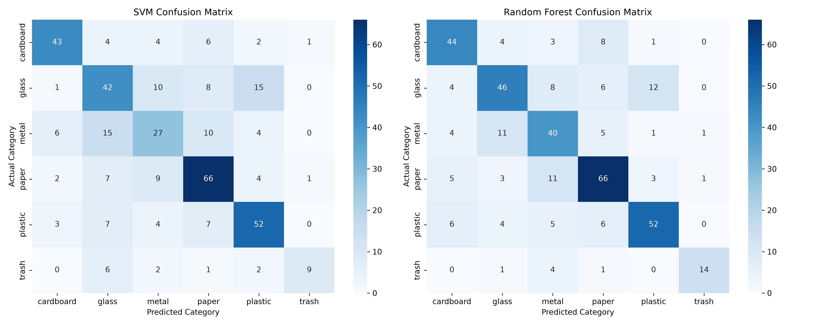
Figure7. Confusion Matrices of SVM and Random Forest Models.

11. Deep Learning: CNN Model

11.1 Why CNN?
A Convolutional Neural Network (CNN) is designed to learn visual patterns directly from images. Unlike the classical models in this project, which use handcrafted colour and grayscale features, a CNN learns filters during training. Early convolutional layers can learn simple patterns such as edges and textures, while deeper layers can combine them into more complex visual features.

11.2 Dataset and Training Setup
The CNN used 128 × 128 RGB images with normalized pixel values. The training data was further divided into 45,000/5,000 only in the earlier CIFAR-10 internship task; that split is not part of this TrashNet project. For this TrashNet project, the correct dataset sizes are 1,768 training, 379 validation and 380 testing images.

11.3 Architecture
Layer / component | Configuration / purpose
Input | 128 × 128 × 3 RGB image
Convolution block 1 | 32 filters, convolution and max pooling
Convolution block 2 | 64 filters, convolution and max pooling
Convolution block 3 | 128 filters, convolution and max pooling
Dropout | 0.25 after convolutional blocks
Flatten | Convert feature maps to a vector
Dense layer | 128 units
Dropout | 0.40
Output | 6 units with softmax activation

The model contained 4,288,454 parameters. Adam optimizer with a learning rate of 0.001 and sparse categorical cross-entropy loss were used. Data augmentation included horizontal flipping and small rotations. Early stopping monitored validation loss with patience 4 and restored the best weights. ReduceLROnPlateau reduced the learning rate when validation loss stopped improving.

11.4 CNN Results
The final CNN test loss was 1.1816 and test accuracy was 58.16%. The weighted F1-score was 0.58. The class-wise results were:
Class | Precision | Recall | F1-score | Support
Cardboard | 0.85 | 0.67 | 0.75 | 60
Glass | 0.85 | 0.37 | 0.51 | 76
Metal | 0.43 | 0.44 | 0.43 | 62
Paper | 0.54 | 0.80 | 0.65 | 89
Plastic | 0.68 | 0.55 | 0.61 | 73
Trash | 0.32 | 0.75 | 0.45 | 20

Paper achieved the highest recall (0.80), meaning that the CNN correctly identified a relatively large proportion of actual paper images. Glass recall was low at 0.37, and metal had the lowest F1-score at 0.43. Trash recall was 0.75, but its precision was only 0.32, which indicates that many images predicted as trash belonged to other actual categories.
The final training accuracy was 58.43%, while validation accuracy was 61.74%. Validation accuracy being slightly higher than training accuracy can occur when training-time augmentation and dropout make the training task harder. This difference alone does not prove overfitting or guarantee that overfitting is absent.
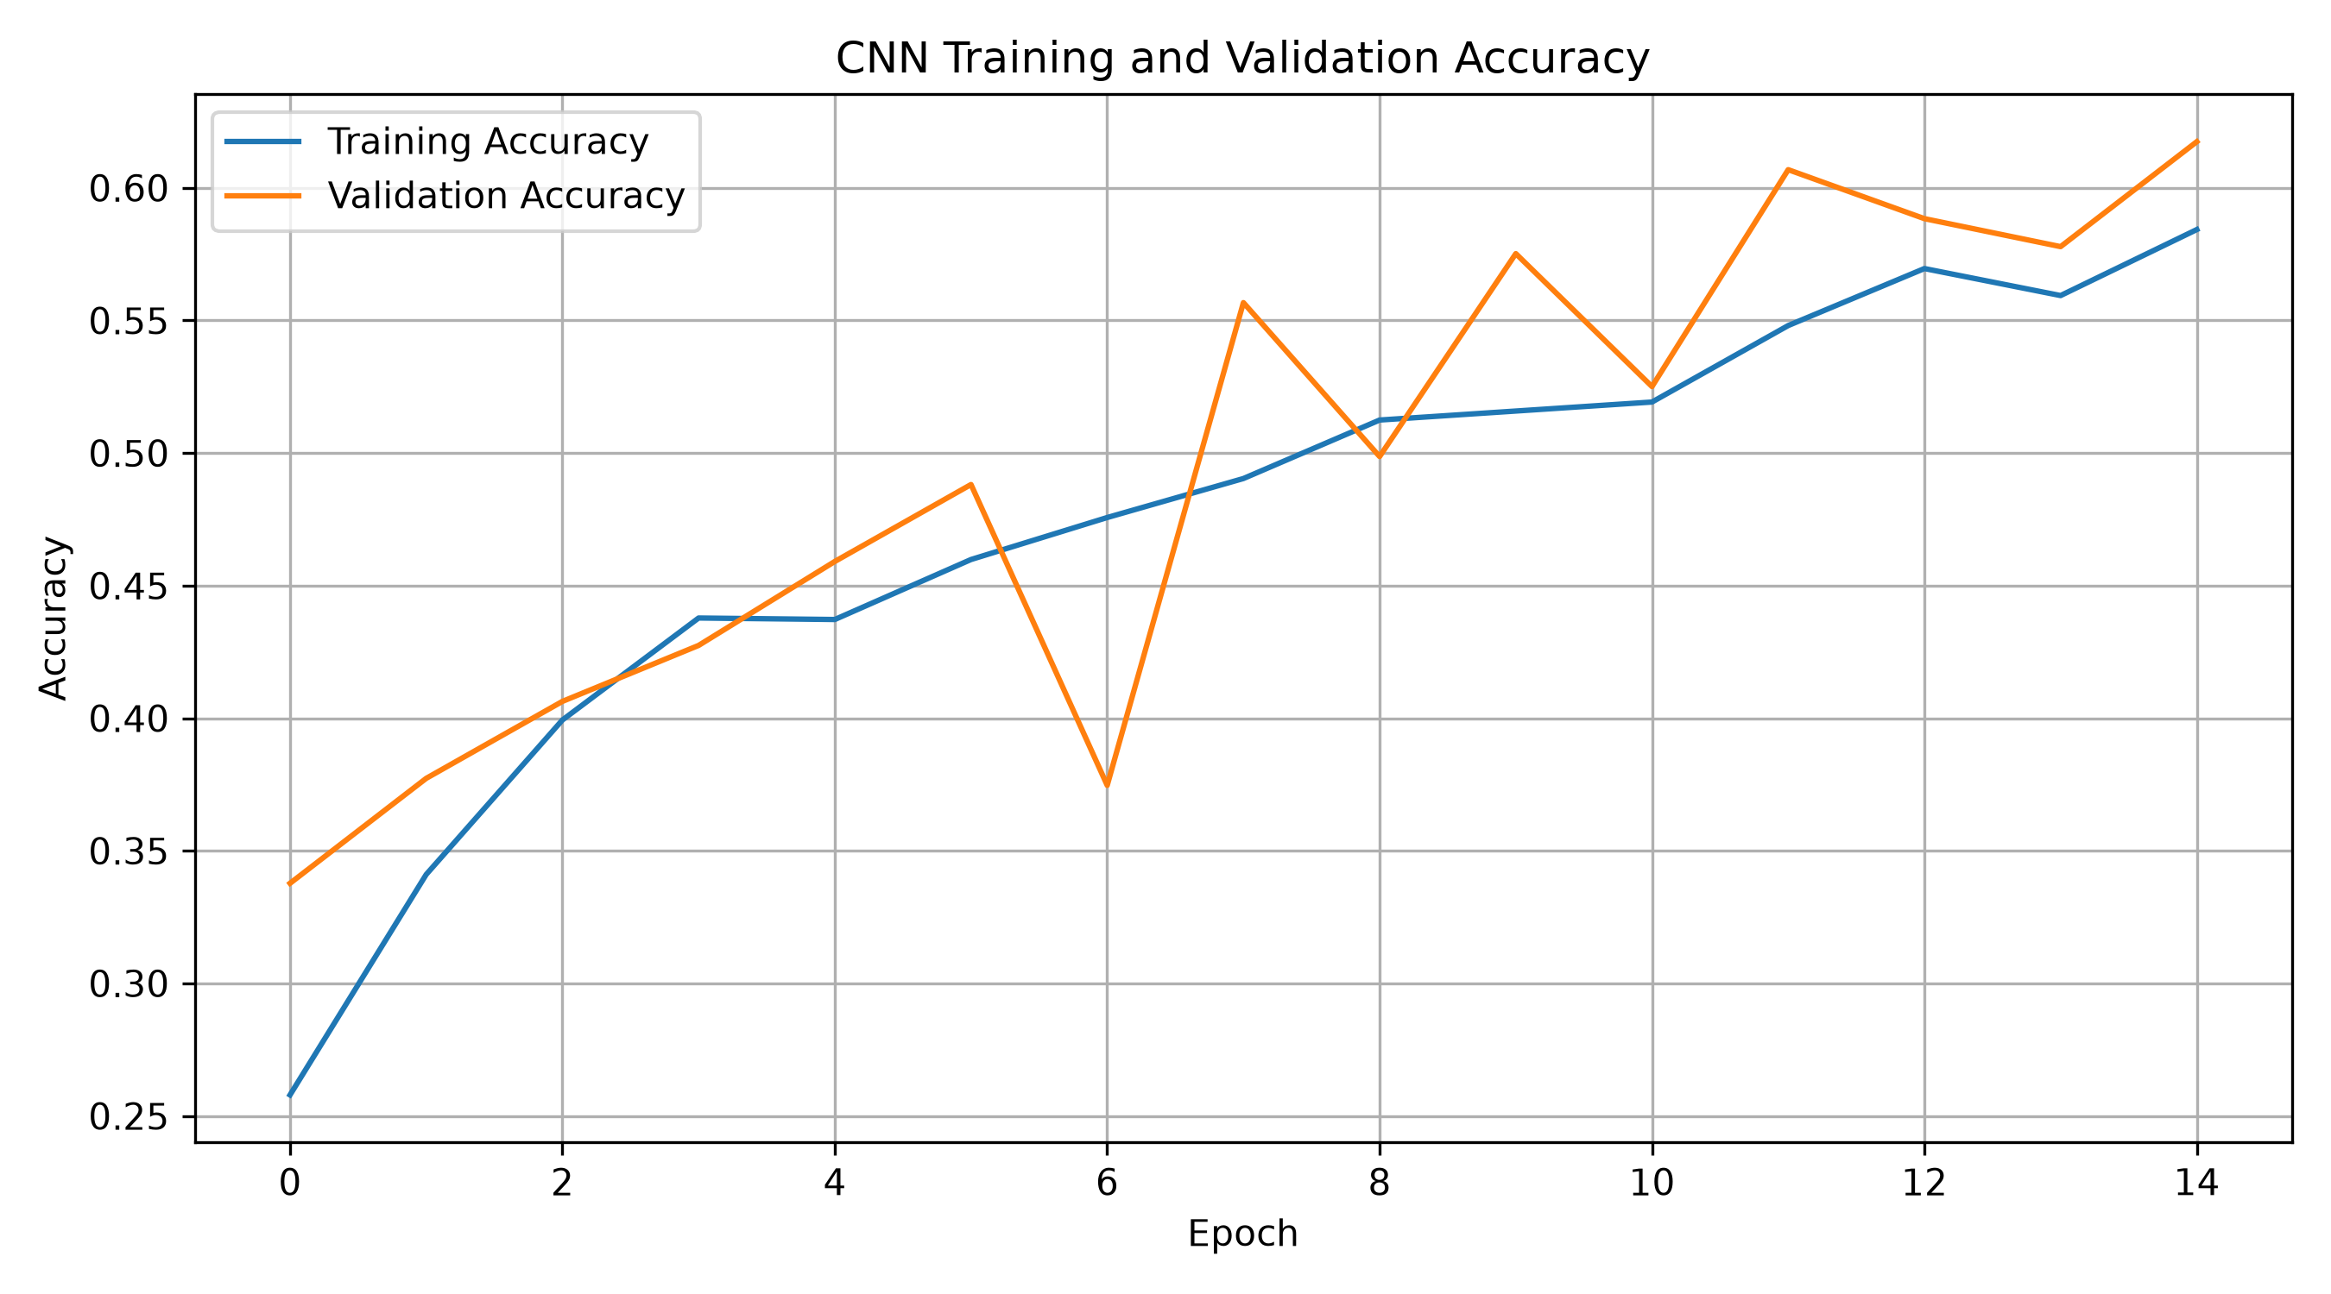
Figure 8. CNN Model Training and Validation Accuracy.

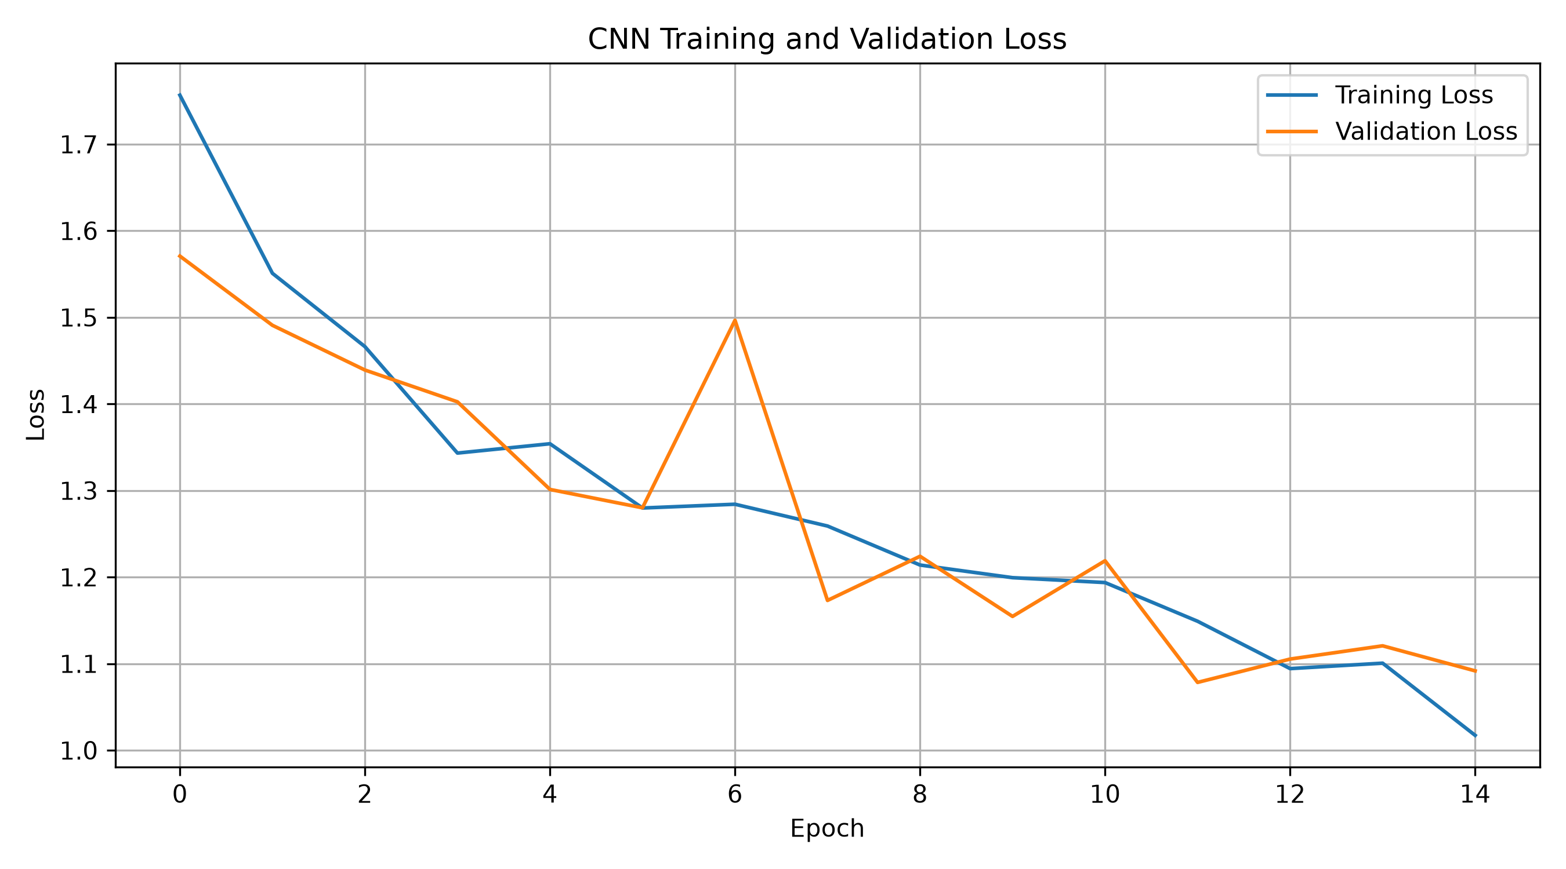
Figure 8. CNN Model Training and Validation Loss.

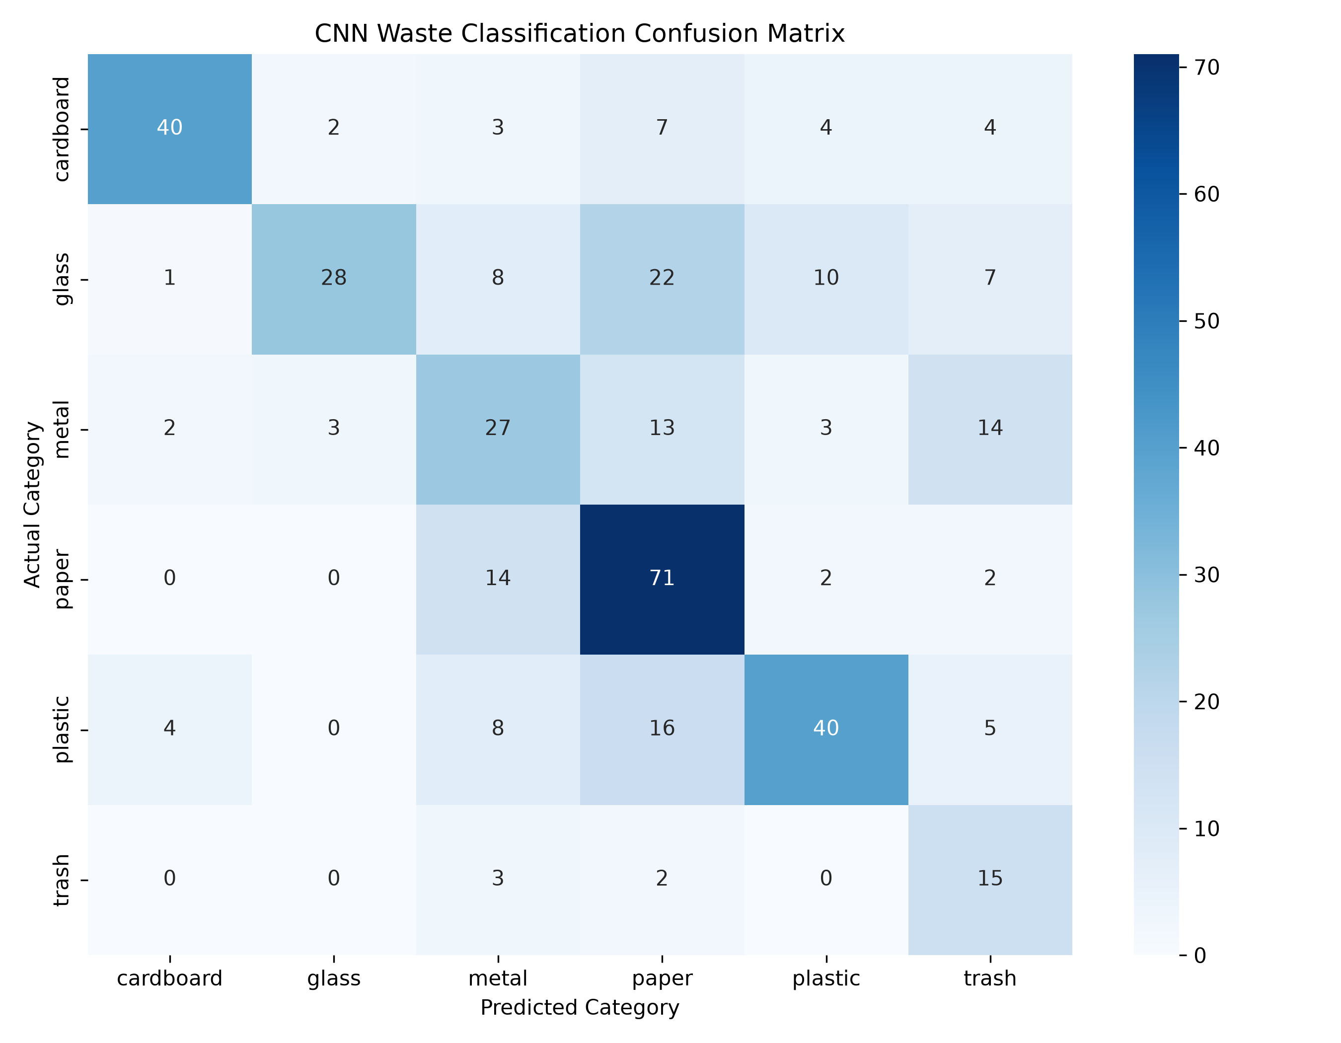
Figure 9. Confusion Matrix of CNN Model on the Test Dataset

12. Model Performance Comparison
Model | Input representation | Test accuracy | Weighted F1
SVM (RBF) | 304 handcrafted features | 62.89% | 0.63
Random Forest | 304 handcrafted features | 68.95% | 0.69
CNN | 128 × 128 RGB images | 58.16% | 0.58

Random Forest achieved the highest test accuracy in the initial comparison. It exceeded SVM by 6.06 percentage points and CNN by 10.79 percentage points. The result suggests that the handcrafted features used in this experiment worked effectively with Random Forest on this dataset.
However, the comparison should be interpreted carefully. SVM and Random Forest used 304 handcrafted features, whereas CNN learned features from raw image inputs. The models therefore did not use identical input representations or learning procedures. The results compare the implemented pipelines on the same test split; they do not prove that Random Forest is universally better than CNN for waste classification.
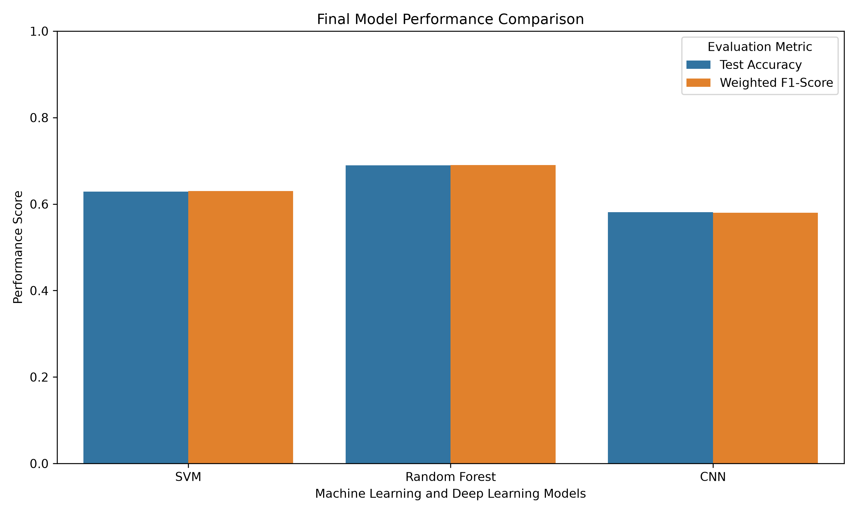
Figure 10. comparison of the three implemented models

13. Error Analysis
Error analysis was conducted to understand the types of mistakes made by the Random Forest classifier. In a separate diagnostic run, the model produced 266 correct predictions and 114 incorrect predictions out of 380 test images, corresponding to 70.00% accuracy in that run. This diagnostic run is reported separately from the original model-comparison result of 68.95%; the two figures should not be merged or presented as one experiment.
Class | Precision | Recall | F1-score | Support
Cardboard | 0.72 | 0.78 | 0.75 | 60
Glass | 0.62 | 0.59 | 0.60 | 76
Metal | 0.58 | 0.65 | 0.61 | 62
Paper | 0.79 | 0.78 | 0.78 | 89
Plastic | 0.76 | 0.71 | 0.74 | 73
Trash | 0.72 | 0.65 | 0.68 | 20

In this diagnostic run, paper had the highest F1-score (0.78), while glass had the lowest (0.60). Metal also had relatively low precision (0.58). The low support for trash (20 test images) means its class-wise score should be interpreted cautiously because a small number of changed predictions can noticeably affect the metric.

Possible reasons for classification errors include similar colours and textures across materials, reflective or transparent surfaces, background variation, object shape differences and limited examples for some classes. These are plausible explanations based on the dataset and observed performance; they should not be treated as confirmed causes for every individual error.
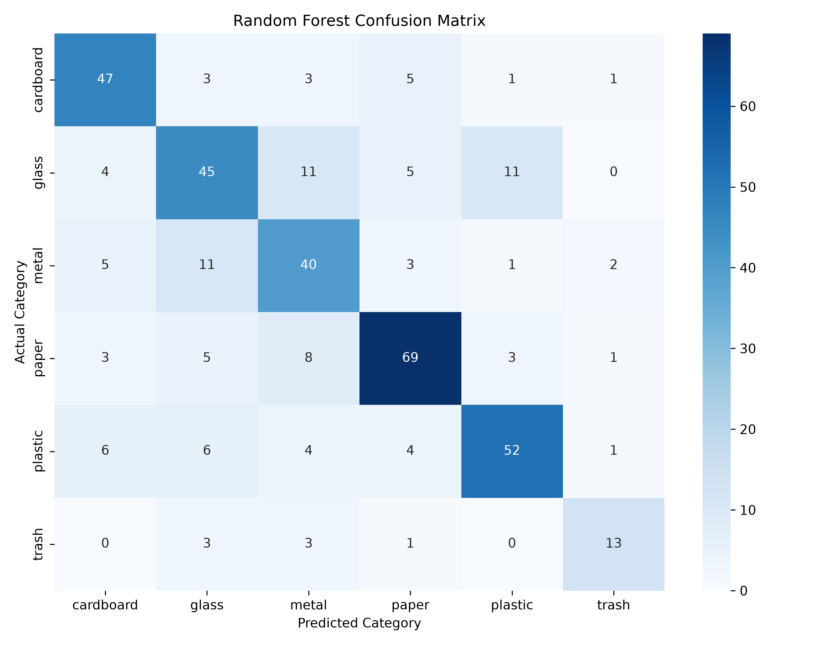
Figure 11. Confusion Matrix of the Random Forest Model for Error Analysis.

14. Feature Importance Analysis
Feature importance was calculated using the Random Forest model trained on the handcrafted feature representation. The analysis grouped the 304 features into red histogram, green histogram, blue histogram and grayscale features.
Feature group | Importance | Percentage
Red histogram | 0.0942 | 9.42%
Green histogram | 0.0960 | 9.60%
Blue histogram | 0.1404 | 14.04%
Grayscale features | 0.6694 | 66.94%
Total | 1.0000 | 100%

Grayscale features contributed 66.94% of the total feature importance, making them the largest group. Blue histogram features contributed 14.04%, followed by green at 9.60% and red at 9.42%. This suggests that the Random Forest relied more on the grayscale pixel representation than on the grouped colour histogram features in this particular experiment.

Among the top 15 individual features, several blue histogram bins appeared, including Blue_Histogram_5 (0.014564), Blue_Histogram_4 (0.013001) and Blue_Histogram_14 (0.011938). This does not conflict with grayscale being the largest group: the top-15 list ranks individual features, while the group analysis sums importance across 256 grayscale features and 48 histogram features.
Feature importance is model-specific. It describes how the trained Random Forest used the available features; it does not prove that grayscale information is always more important for every waste dataset or that a single feature identifies a material by itself.
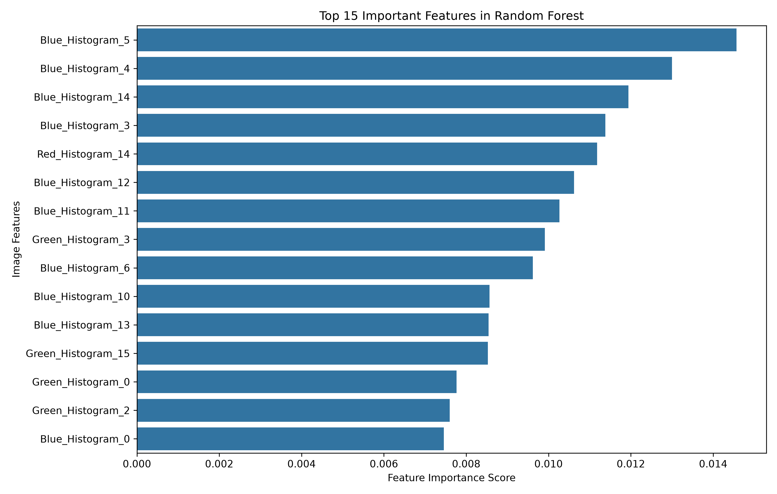
Figure 12. Top 15 Important Features in Random Forest Model.

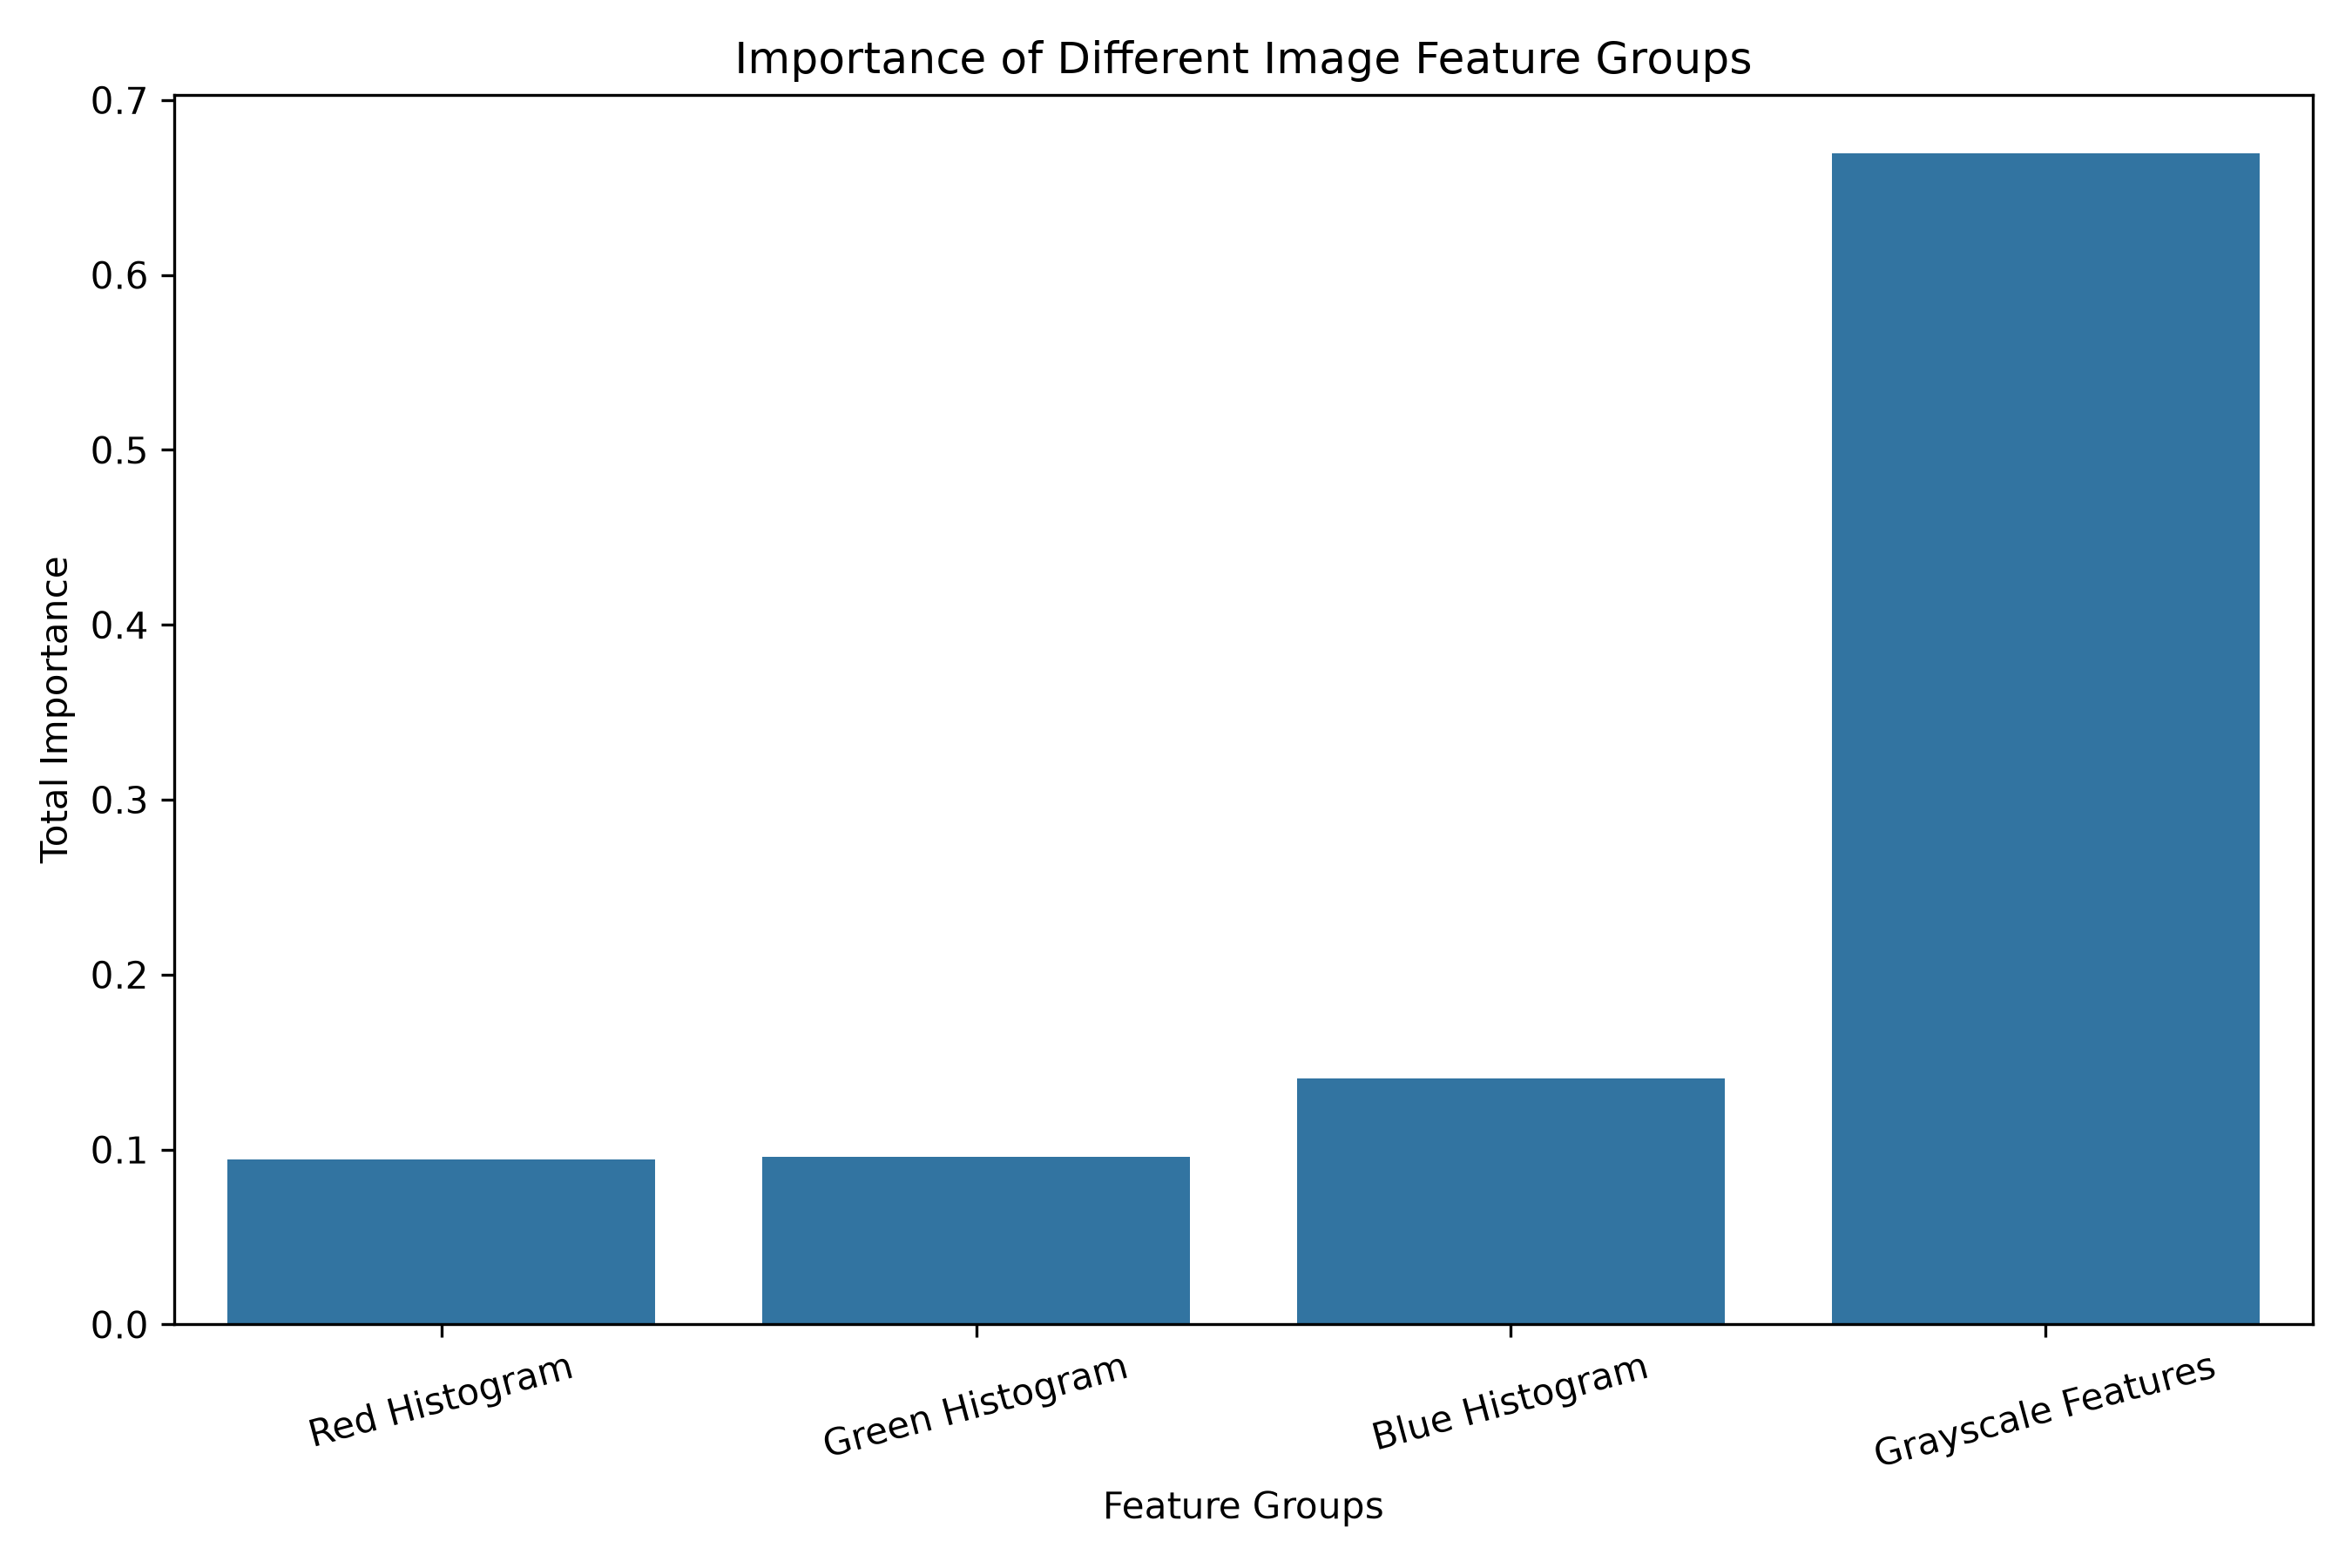

Figure 13. Feature Group Importance in Random Forest Model

15. Hyperparameter Tuning and Model Improvement
Hyperparameter tuning was performed to test whether changing Random Forest settings could improve validation performance. Three configurations were compared. The validation set was used to select the best configuration, and the selected model was then evaluated on the held-out test set.
Configuration | Main settings | Validation accuracy | Weighted F1
Baseline RF | 200 trees; balanced weights | 68.60% | 0.688
Improved RF 1 | 300 trees; min leaf 2; min split 5 | 69.13% | 0.695
Improved RF 2 | 300 trees; max depth 30; min leaf 2; min split 5; balanced subsample | 69.66% | 0.699

Improved RF 2 achieved the highest validation accuracy of 69.66% and was selected for final testing. Its test accuracy was 68.95%. This is the same rounded test accuracy as the original Random Forest comparison. Therefore, tuning improved the validation score but did not produce a measurable increase in the reported test accuracy.
This is an important result rather than a failed experiment. It shows that better validation performance does not always translate into better performance on unseen test data. Further gains may require more representative images, stronger image representations, more systematic tuning and careful investigation of class-specific errors.
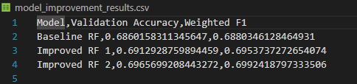
Figure 14. Performance Comparison of Baseline and Improved Random Forest Models.

16. Practical Prediction Demonstration

16.1 Individual Image Prediction
A prediction script was created using the saved Random Forest model. It loads a user-supplied image, extracts the same 304 features and predicts one of the six waste categories. The model also displays class-wise probability estimates.
In the first individual test, an image named metal1.jpg was predicted as Cardboard. The model assigned 30.22% to Cardboard and 29.44% to Metal, showing that the prediction was uncertain and incorrect. In a second test using metal407.jpg, the model correctly predicted Metal with a reported probability of 69.35%. These examples show that predictions can vary between images from the same category.

16.2 Multiple Image Prediction
A separate demonstration tested 60 images selected from the existing testing subset, with 10 images from each class. The model correctly classified 49 images and incorrectly classified 11, producing 81.67% accuracy on this balanced 60-image sample.
Measure | Result
Images tested | 60
Correct predictions | 49
Incorrect predictions | 11
Sample accuracy | 81.67%
Macro F1-score | 0.82
Weighted F1-score | 0.82

Class | Precision | Recall | F1-score | Support
Cardboard | 0.75 | 0.90 | 0.82 | 10
Glass | 0.73 | 0.80 | 0.76 | 10
Metal | 0.73 | 0.80 | 0.76 | 10
Paper | 0.89 | 0.80 | 0.84 | 10
Plastic | 0.89 | 0.80 | 0.84 | 10
Trash | 1.00 | 0.80 | 0.89 | 10

The balanced sample produced a higher accuracy than the full test-set result. This is expected to be possible because the sample contains only 10 images per category and is not the complete test set. Its 81.67% result is useful as a practical demonstration, but the full 380-image test accuracy of 68.95% remains the main Random Forest comparison result.
The sample also shows that a model can classify many images correctly while still making mistakes. Examples included glass predicted as metal, paper predicted as metal and plastic predicted as metal. These confusions support the need for more robust visual features and broader testing.

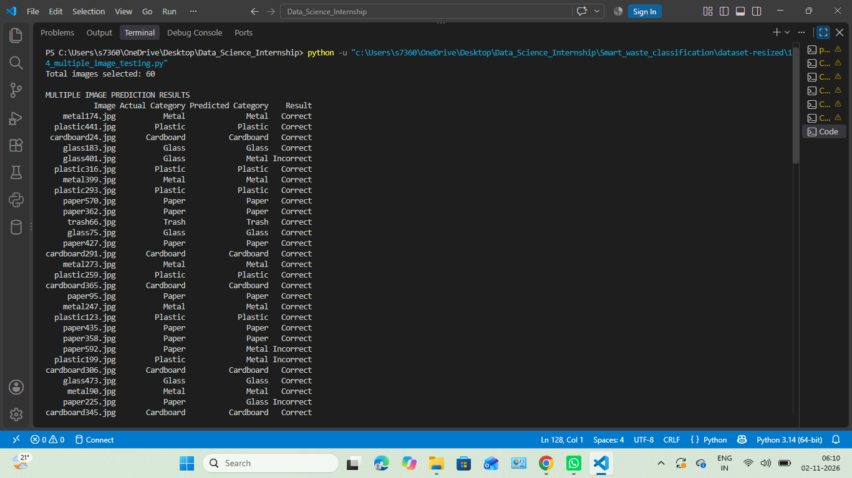

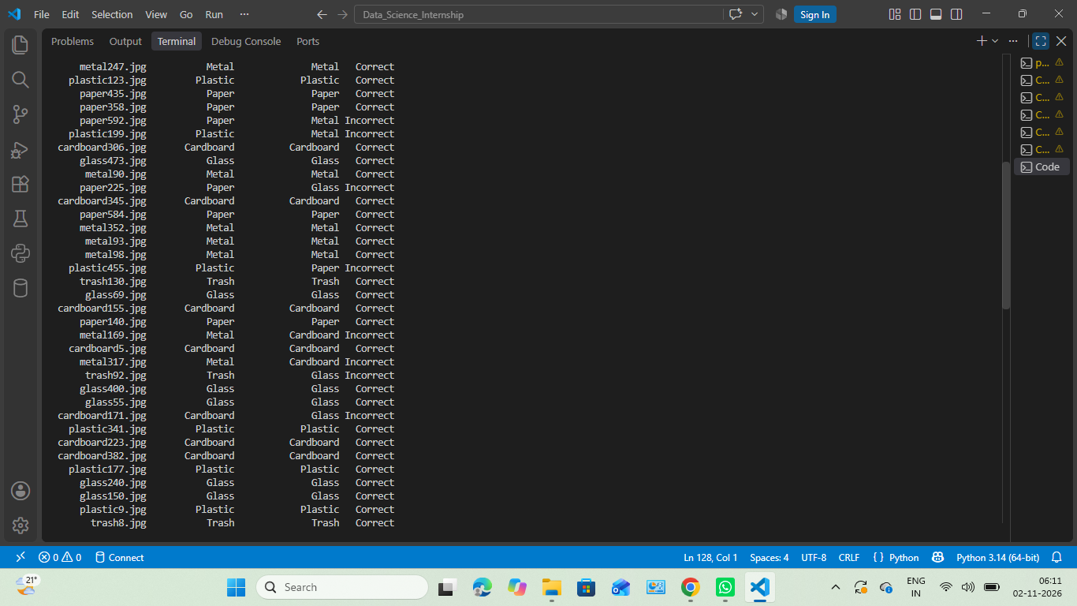

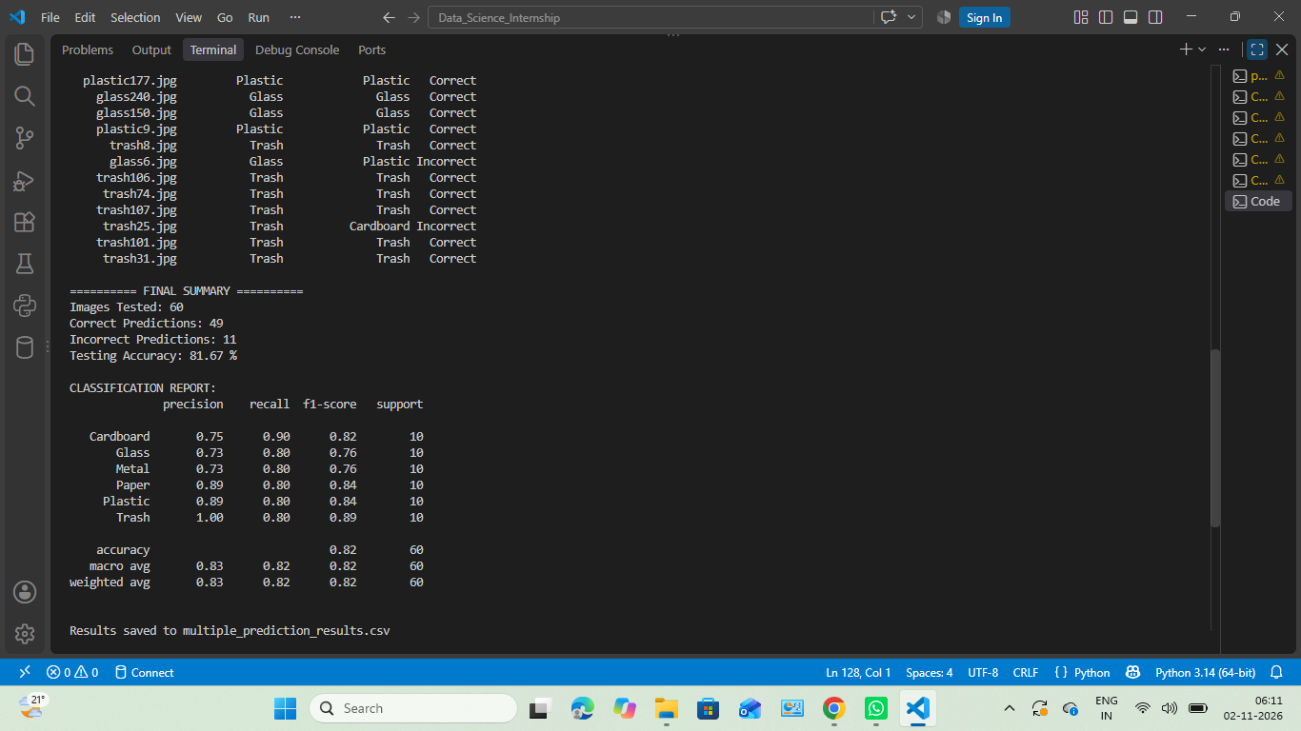

Figure: Terminal Output of Multiple Image Testing on 60 Waste Images.

The prediction demo is a prototype. The model's probability output should be treated as a model confidence estimate, not a guarantee that the predicted category is correct.

17. Overall Discussion and Key Findings
- The dataset contains 2,527 images across six classes, with a noticeable imbalance between paper (594 images) and trash (137 images).
- Image inspection found no corrupted images in the inspection run, and the images shared a reported dimension of 512 × 384.
- EDA showed differences in brightness and RGB values, but these statistics alone are not reliable material identifiers.
- K-Means achieved its best silhouette score of 0.1906 at K = 2, but the clusters contained mixed waste categories and did not reproduce the six labels cleanly.
- Random Forest achieved the best test accuracy among the initial comparison models at 68.95%, followed by SVM at 62.89% and CNN at 58.16%.
- The CNN had uneven class-wise performance: paper recall was 0.80, while glass recall was 0.37 and metal F1-score was 0.43.
- Random Forest feature importance was dominated by grayscale features at 66.94%, while blue, green and red histograms contributed 14.04%, 9.60% and 9.42%.
- Hyperparameter tuning improved validation accuracy to 69.66%, but the selected model's test accuracy remained 68.95%.
- The balanced 60-image prediction sample achieved 81.67%, but it is a separate demonstration result and should not replace full test-set accuracy.
Taken together, the experiments show that the project pipeline can process waste images and build classifiers, but the performance depends on the feature representation, category and image characteristics. The results also demonstrate why model evaluation should include multiple metrics, not accuracy alone.

18. Limitations
- The dataset is relatively small for training a robust image classifier, especially for the trash category.
- The class distribution is imbalanced, which can affect minority-class learning and evaluation.
- Images come from a dataset rather than a broad collection of real-world waste scenes. Performance on phone-camera images, outdoor bins, cluttered scenes or dirty materials may differ.
- Handcrafted colour histograms and small grayscale pixel representations may lose important shape and texture details.
- The CNN achieved lower test accuracy than the classical Random Forest in this implementation; its architecture and training setup may need further optimization.
- K-Means clustering showed weak separation and should be considered exploratory rather than a semantic classifier.
- The 60-image practical demonstration is a balanced subset, not an independent external dataset.
- Prediction confidence values are not guaranteed probabilities of correctness and should not be interpreted as certainty.

19. Future Scope
- Collect more images for all six categories, with special attention to underrepresented classes.
- Capture images under varied lighting, backgrounds, camera angles and object conditions.
- Experiment with transfer learning using pretrained CNN architectures such as MobileNetV2 or EfficientNet, subject to available computing resources.
- Use data augmentation carefully to improve robustness without creating unrealistic images.
- Test alternative feature extraction methods such as HOG, local texture descriptors or learned embeddings.
- Use systematic hyperparameter search with validation data and preserve the test set for final evaluation.
- Investigate class-specific errors using confusion matrices and review misclassified examples.
- Build a simple user interface that allows a user to upload an image and view the predicted category.
- Evaluate the system on a separate real-world image collection before considering deployment.

20. Conclusion
This project developed an end-to-end workflow for smart waste classification using machine learning and deep learning. The work began with dataset inspection and preprocessing, followed by exploratory data analysis, clustering, supervised classification, CNN training, model comparison, error analysis, feature importance, hyperparameter tuning and practical prediction demonstrations.
Among the three initial classification models, Random Forest achieved the highest test accuracy of 68.95%, followed by SVM at 62.89% and CNN at 58.16%. K-Means clustering showed weak separation, with a best silhouette score of 0.1906 at K = 2. Feature importance analysis showed that grayscale features contributed the largest share of the Random Forest's feature importance. Hyperparameter tuning improved validation accuracy to 69.66%, but the selected model's test accuracy remained 68.95%.The practical multiple-image demonstration correctly classified 49 out of 60 balanced sample images, giving 81.67% accuracy on that sample. This result demonstrates the model's ability to make predictions, while also showing that individual errors remain. It is not a replacement for the full test-set result.
Overall, the project provided practical experience in image data handling, feature extraction, machine learning, deep learning and model evaluation. It also highlighted the importance of class balance, meaningful visual representations and honest interpretation of evaluation results. The developed system is a useful educational prototype, while additional data and model improvements are needed for reliable real-world waste sorting.

21. References
- TrashNet dataset: Gary Thung and Mindy Yang, “Classification of Trash for Recyclability Status,” Stanford University project, 2016. Verify and add the exact dataset source URL used for download.
- Scikit-learn documentation: https://scikit-learn.org/stable/
- TensorFlow documentation: https://www.tensorflow.org/learn
- OpenCV documentation: https://docs.opencv.org/
- NumPy documentation: https://numpy.org/doc/
- Pandas documentation: https://pandas.pydata.org/docs/
- Matplotlib documentation: https://matplotlib.org/stable/
- Seaborn documentation: https://seaborn.pydata.org/

Appendix A. Evidence and Screenshots
Add clear screenshots of actual code and execution output. Screenshots should be readable, cropped to the relevant section and numbered consistently. Do not add screenshots that show a different dataset or results from an earlier experiment.
Figure A.1: Folder Structure of the TrashNet Dataset

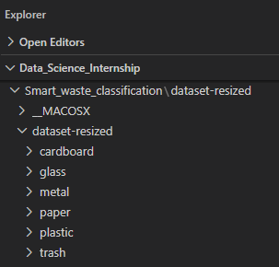

Figure A.2: Dataset Inspection Output.

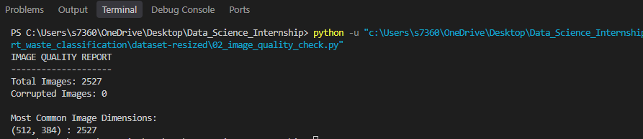

Figure A.3: Image Preprocessing Output Showing Dataset Splitting, Batch Shape and Pixel Normalization.

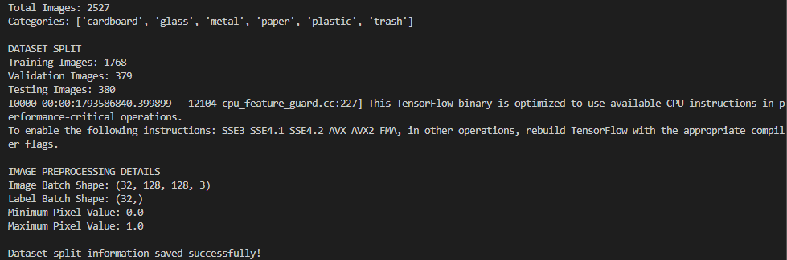

- Preprocessing output showing split sizes, batch shape and pixel range.
- EDA graphs: class percentage, brightness, RGB distribution and imbalance.
- K-Means silhouette scores and cluster heatmap.
Figure A.4: K-Means Clustering Evaluation Output.
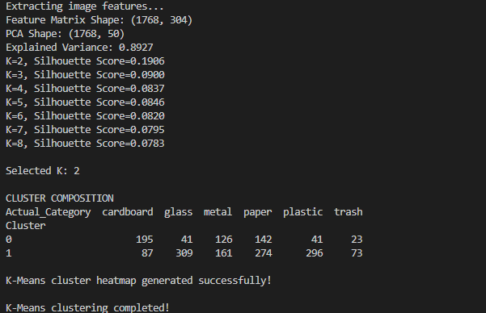

- SVM and Random Forest classification reports and confusion matrices.
Figure A.5: SVM and Random Forest Classification Reports.
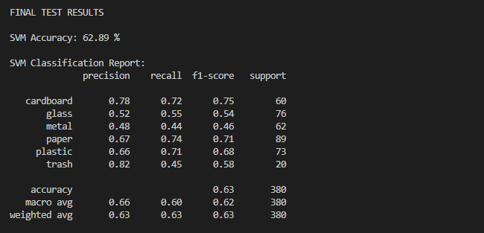

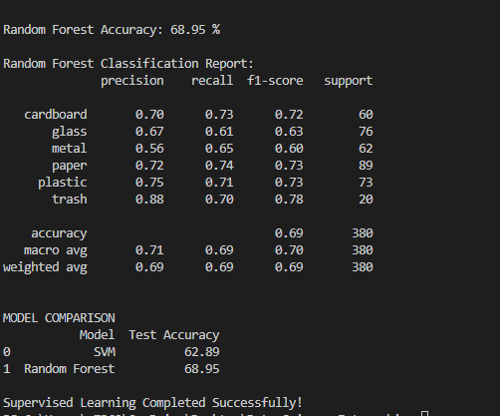
- CNN model summary, training output, accuracy graph, loss graph and confusion matrix.
Figure A.6: CNN Training Execution Output
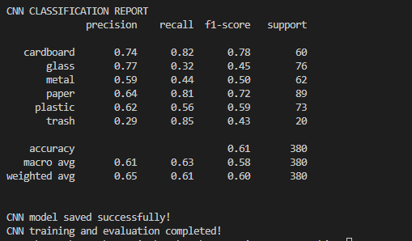
- Model comparison graph and CSV.
Figure A.7: Final Model Comparison Results.
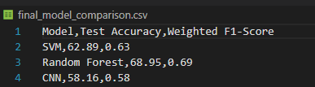

- Error analysis classification report and confusion matrix.
Figure A.8: Classification Report of the Diagnostic Random Forest Run.
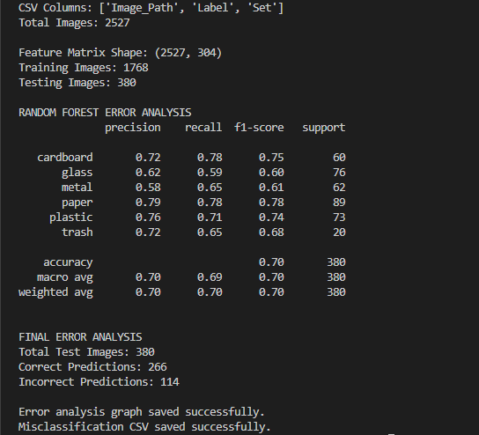

- Feature importance top-15 and group-importance graphs.

Figure A.9: Top 15 Feature Importance Values.
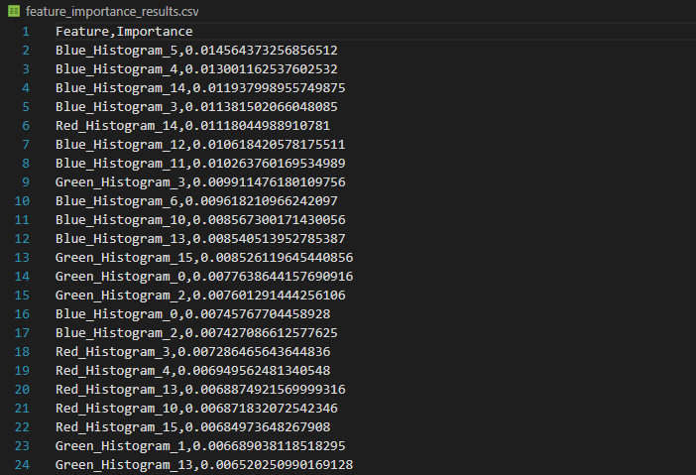

- Hyperparameter tuning terminal output and results CSV.
Figure A.10 Hyperparameter Tuning Execution Output
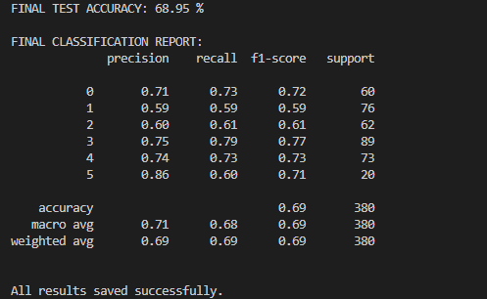

- Individual prediction terminal output.
Figure A.11: Individual Waste Image Prediction Output.
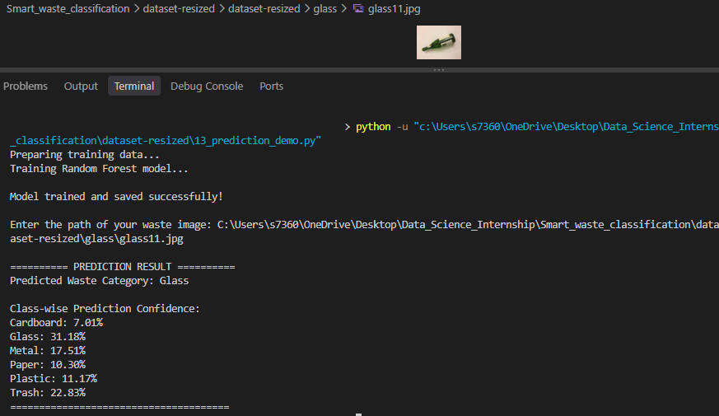

- Multiple-image prediction output and saved CSV.
Figure A.12: Multiple Image Prediction Results in CSV Format.
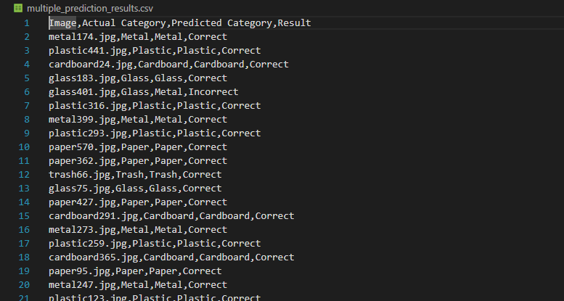

Appendix B. Important Result-Reporting Notes
- Use 68.95% as the initial Random Forest test accuracy in the model comparison.
- Keep the separate 70.00% error-analysis run identified as a separate diagnostic run; do not merge it with the original comparison result.
- Use 58.16% as the final CNN test accuracy for this TrashNet project.
- Use 81.67% only for the balanced 60-image practical sample.
- Use 69.66% as the best Random Forest validation accuracy after tuning; its final test accuracy was 68.95%.
- Do not claim that K-Means found six correct waste clusters. The observed clusters contained mixed categories.
- Do not claim that feature importance proves causation. It describes the trained Random Forest's use of features.

