DATA ACQUISITION, CLEANING AND PREPROCESSING USING PYTHON
Virtual Data Science with Python Trainee Internship

Week 1 Project Report:

Submitted by: SNEHA YADAV
Course: Bachelor of Computer Applications (BCA)
Internship Organization: yuvaintern
Tools Used: Python, Visual Studio Code, Pandas
Dataset: Student Performance Dataset
Submission Date: 24-10-2026

1. ABSTRACT
In this project, I used Python and Pandas to inspect and prepare the Student Performance dataset. I checked the dataset structure, data types, missing values, duplicate rows, and selected column ranges. The results showed no missing values or duplicate rows. Finally, I saved the dataset as a separate CSV file and verified it. This project helped me understand the basic steps of data cleaning and preprocessing.

2. INTRODUCTION
Data is an important part of data science. However, raw data must be inspected and prepared before it can be used reliably for analysis or machine learning.
Data cleaning and preprocessing involve understanding the structure of a dataset, checking for missing or duplicate records, examining data types, identifying unusual values, and preparing the data for subsequent tasks.
In this project, the Student Performance dataset was selected because it contains information about students' academic performance and related factors. The project uses Python and Pandas to inspect the dataset and save a verified CSV file for further analysis.

3. OBJECTIVES
The main objectives of this project are:
1. To obtain a publicly available dataset.
2. To load and inspect the dataset using Python and Pandas.
3. To examine the number of records, columns, and data types.
4. To identify missing values and duplicate rows.
5. To generate a statistical summary of numerical columns.
6. To inspect unique values and the ranges of selected columns.
7. To save the inspected dataset as a separate CSV file.
8. To verify that the saved file can be read successfully.

4. Dataset Description
I used the Student Performance dataset available on the UCI Machine Learning Repository. For this project, I selected the student-mat.csv file, which contains information about students and their mathematics performance.
Some important columns are:
age: Age of the student.
studytime: Weekly study-time category.
absences: Number of absences.
G1: First-period grade.
G2: Second-period grade.
G3: Final grade.
Dataset dimensions: (395,33)
Dataset source: https://archive.ics.uci.edu/dataset/320/student+performance

5. Tools Used
Python: Used to write and run the program.
Visual Studio Code: Used to write and execute the Python code.
Pandas: Used to read the CSV file, check the data, calculate statistics and save the output.

5. Steps Performed
5.1 Loading the Dataset
First, I imported Pandas and loaded the "student-mat.csv" file. Since the file uses semicolons to separate values, I used "sep=";"" in the "read_csv()" function.
5.2 Checking the Dataset
I used "head()" to view the first five rows, "shape" to check the dimensions, and "dtypes" to see the data types of the columns. I also used "describe()" to view the statistical summary.

5.3 Checking Missing Values
I used "isnull().sum()" to check for missing values in each column. The output showed zero missing values, so there was no need to fill in missing data.
5.4 Checking Duplicate Rows
I used "duplicated().sum()" to count duplicate records. The result was zero, so I did not need to remove any duplicate rows.
5.5 Checking Column Values
I checked the values and ranges of age, study time, absences and final grade. This helped me understand the data and identify values that might need further investigation.
5.6 Saving the Dataset
After the checks, I saved the dataset as "cleaned_student_data.csv". I then loaded the saved file again to check whether it could be read properly and whether it contained any completely empty rows.

6. Results and Findings
The following results were observed during the checks:
Check | Result
Total rows | 395
Total columns | 33
Missing values | 0 in all columns
Duplicates row | 0
Statistical summary | 8 rows *16 columns
Age range | 15-22
Study-time range | 1-4
Absences range | 0-75
Final grades (G3) range | 0-20
Empty rows saved in file | 0

6.1 Interpretation of Results
The dataset contained 395 rows and 33 columns. The first five rows and column names were displayed to understand its structure.
The missing-value check returned zero for all columns, and no duplicate rows were found. The data types of all columns were also examined using Pandas.

The statistical summary contained 8 rows and 26 columns, providing information about the numerical data, such as count, mean, standard deviation, minimum, maximum and quartiles.

I also checked the unique values of selected columns, including age, study time, absences and grades. The age values ranged from 15 to 22, study-time values ranged from 1 to 4, absences ranged from 0 to 75, and final grades ranged from 0 to 20.
Finally, I saved the dataset as a separate CSV file and loaded it again. The verification showed zero completely empty rows in the saved file.

7. Screenshots of the Work
I have included screenshots of the Python program and its output to show the steps performed during the project.

Figure 1: Loading the dataset and checking its dimensions.
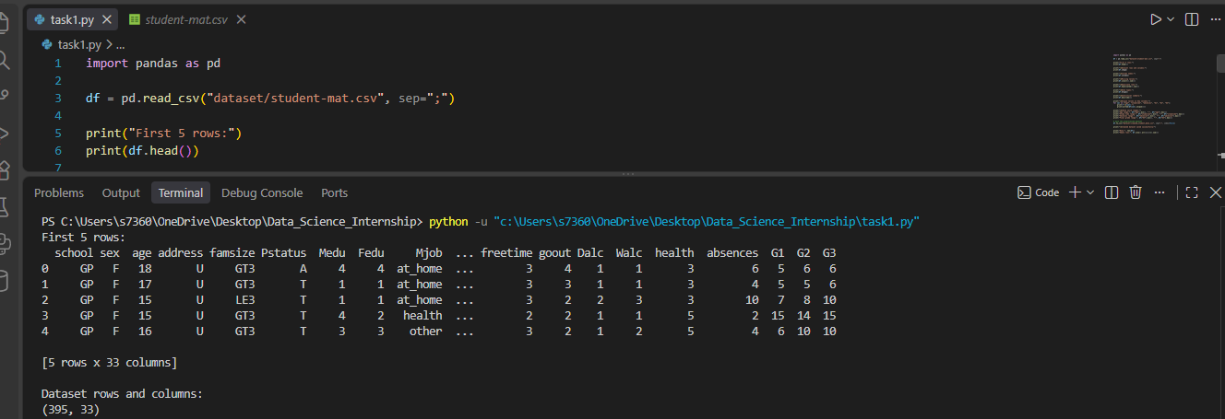

Figure 2: Checking missing values and duplicate rows.
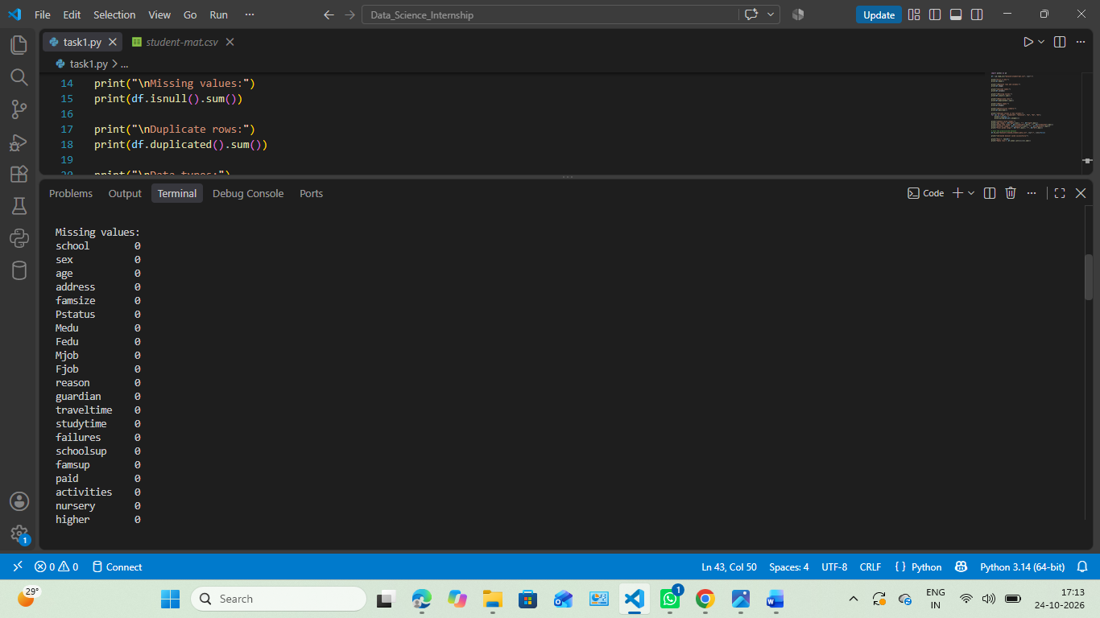

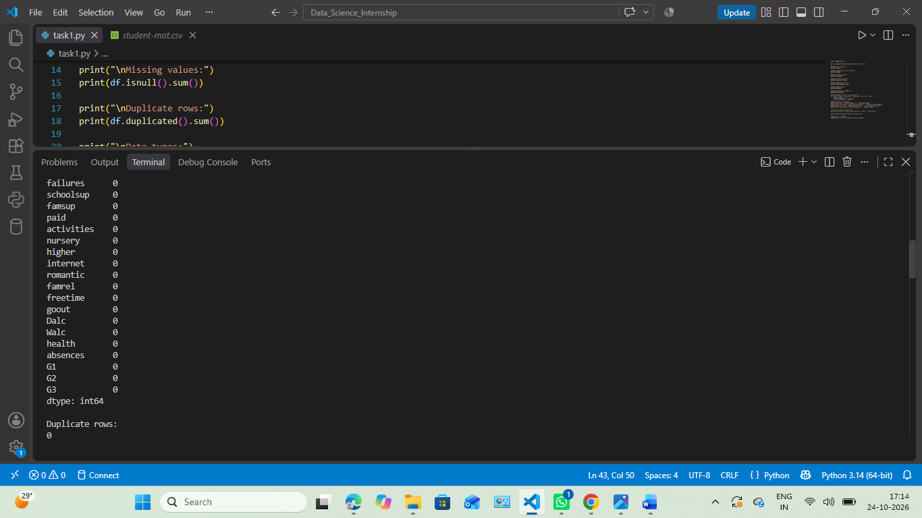

Figure 3: Viewing data types and statistical summary.
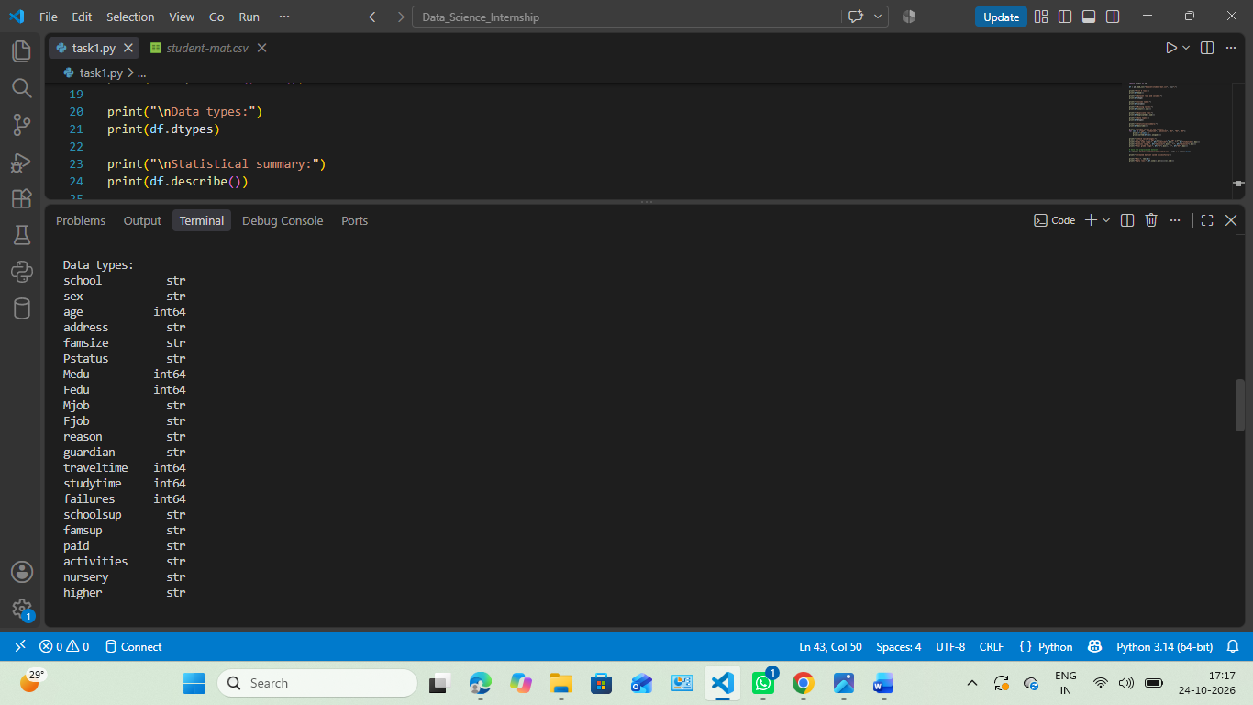
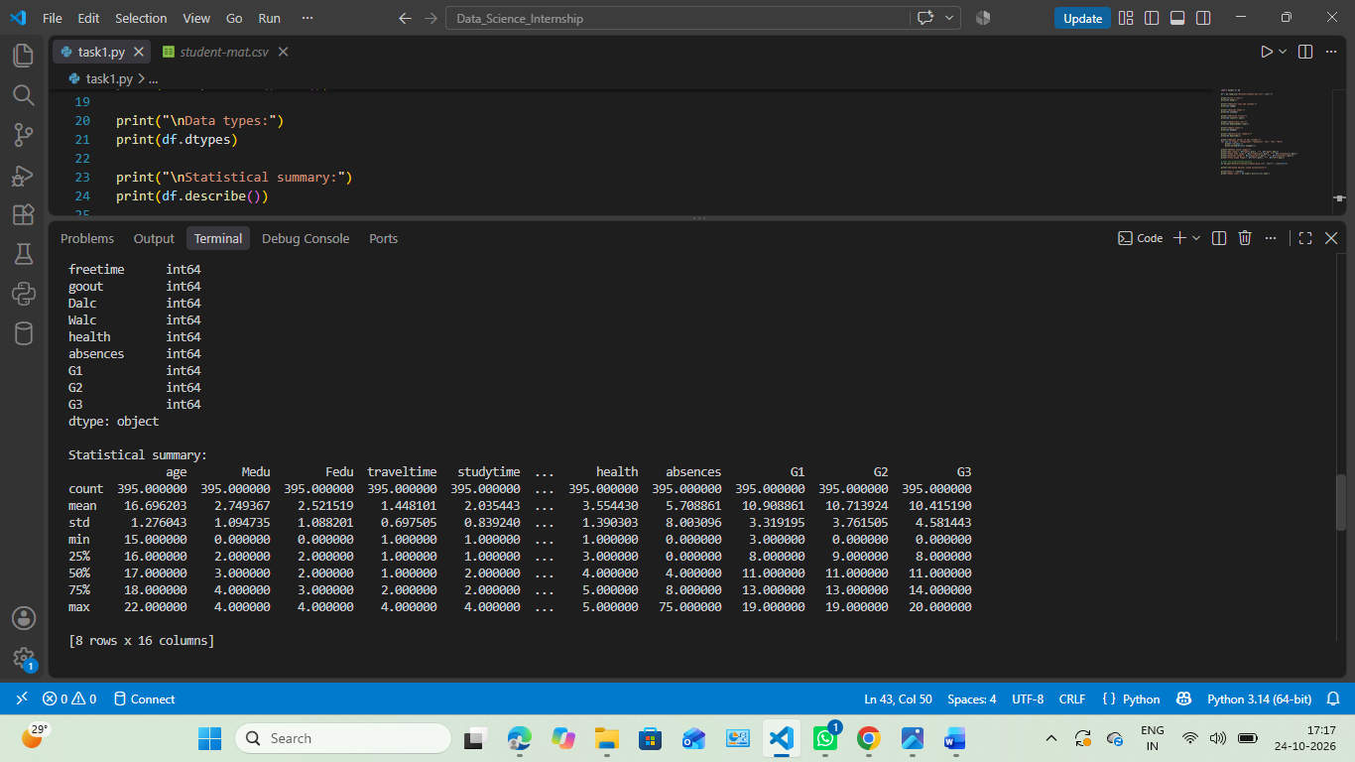

Figure 4: finding unique values and checking valid Ranges
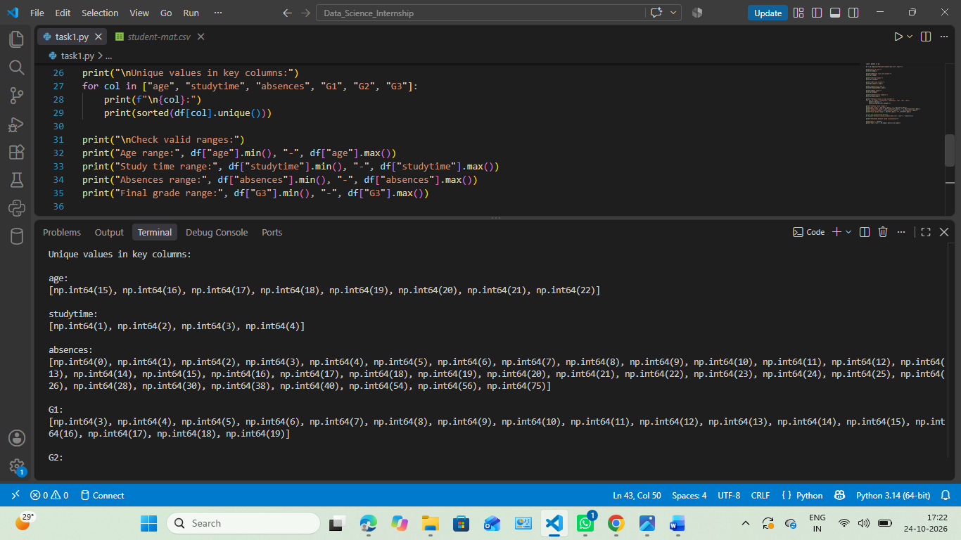

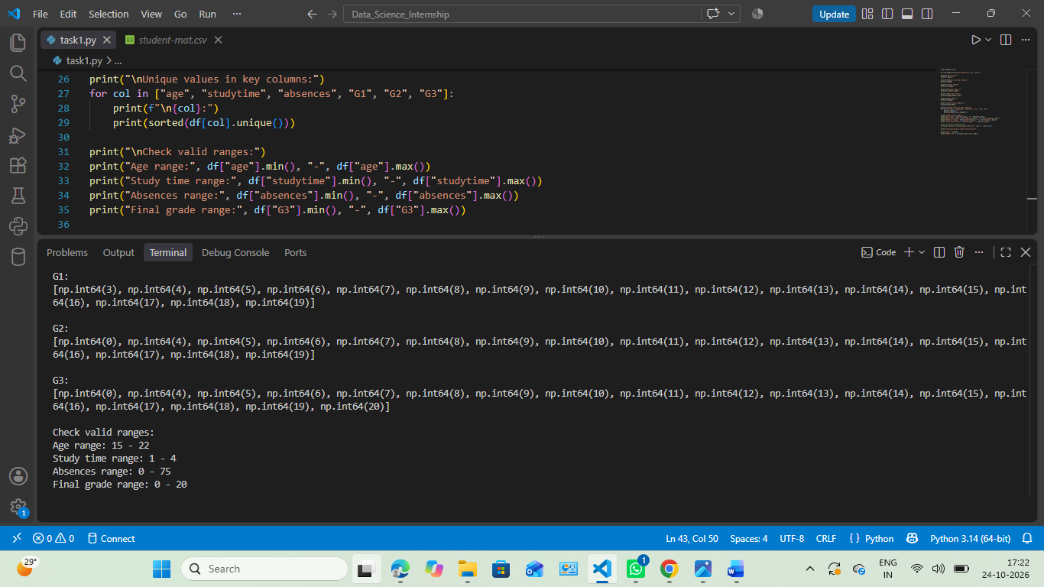

Figure 5: Saved Processed Dataset.
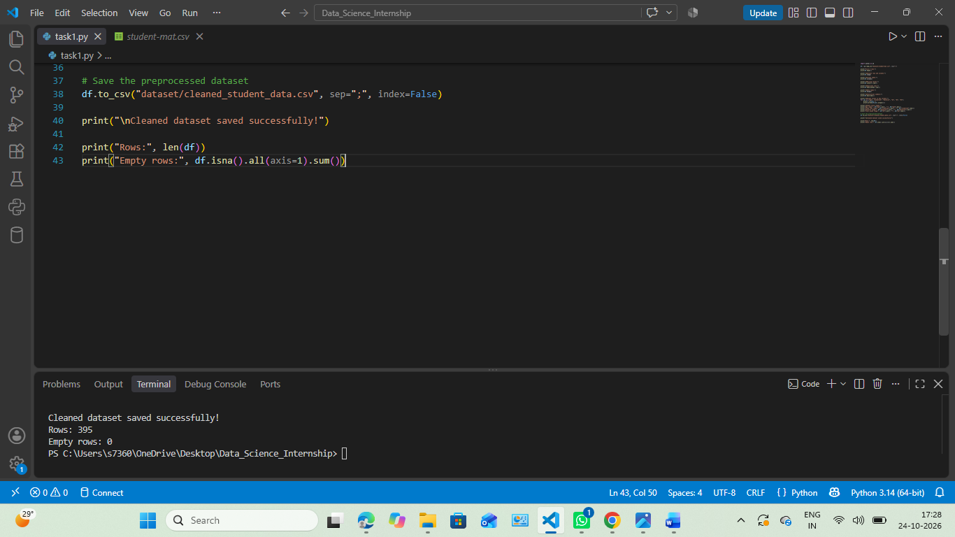

The dataset was saved as "cleaned_student_data.csv" and loaded again to verify its dimensions and check for completely empty rows.
8. Conclusion
In this project, I learned how to load and inspect a dataset using Python and Pandas. I checked the dataset dimensions, data types, missing values, duplicate rows and selected column ranges.
The checks showed that the dataset had no missing values or duplicate rows. I also saved the data in a separate CSV file and verified the saved file.
This task gave me practical experience with basic data preparation. The dataset can now be used for further analysis, such as data visualisation and machine learning, after completing any additional checks required for those tasks.

9. References
1. UCI Machine Learning Repository — Student Performance Dataset: https://archive.ics.uci.edu/dataset/320/student+performance

2. Pandas Documentation: pandas User Guide and Documentation https://pandas.pydata.org/docs/

