Breast Cancer Diagnostic Classification Using Machine Learning
Virtual Data Science with Python Trainee Internship

Task 4. Project Report:
Project Title: Supervised Machine Learning
Virtual Data Science with Python Internship
Submitted by: SNEHA YADAV
Course: Bachelor of Computer Applications (BCA)
University: Babasaheb Bhimrao Ambedkar University
Internship Organization: yuvaintern
Internship Program: Virtual Data Science with Python Trainee
Submission Date: 27-10-2026

Project Overview
This project uses supervised machine learning to classify breast tumour records as Benign (B) or Malignant (M) using the Wisconsin Breast Cancer Diagnostic dataset. A Logistic Regression model is trained using Python, and its performance is evaluated through accuracy, precision, recall, F1-score, and a confusion matrix. The model achieved 96.49% accuracy on the test dataset.

1. Introduction
Supervised learning is a type of Machine Learning in which a model learns from labelled data to make predictions on new data.
In this project, a Breast Cancer Diagnostic Classification model is developed using the Wisconsin Breast Cancer Diagnostic dataset. The project uses Logistic Regression to classify tumour records into two categories: Benign (B) and Malignant (M).
The dataset contains measurements of cell nuclei, such as radius, texture, perimeter, area, smoothness, and concavity. These features are used to train and evaluate the classification model.
The main purpose of this project is to understand supervised learning, prepare the dataset, train a classification model, evaluate its performance using different metrics, and visualize the results using a confusion matrix.
2. Objectives
- To understand the concept of supervised learning and classification.
- To load and explore the Breast Cancer Diagnostic dataset.
- To preprocess the data and separate input features from the target variable.
- To divide the dataset into training and testing sets.
- To apply feature scaling using StandardScaler.
- To train a Logistic Regression classification model.
- To evaluate the model using accuracy, precision, recall, and F1-score.
- To visualize and interpret the model's predictions using a confusion matrix.

3. Dataset Description
Dataset Name: Wisconsin Breast Cancer Diagnostic Dataset
Source: UCI Machine Learning Repository
Dataset Link: https://archive.ics.uci.edu/dataset/17/breast+cancer+wisconsin+diagnostic
The dataset contains 569 records and 32 columns, including an ID column, a diagnosis column, and 30 numerical features.
The diagnosis column contains two labels:
- Benign (B): Non-cancerous tumour.
- Malignant (M): Cancerous tumour.
The ID column was removed because it is an identifier and is not used as a predictive feature. The remaining 30 features were used as input variables, while the diagnosis column was used as the target variable.
The dataset contains 357 Benign records and 212 Malignant records. No missing values were found during the initial data check.
4. Tools and Technologies Used
The following tools and technologies were used to complete this project:
- Python: Used to write and run the machine learning code.
- Pandas: Used to load and organize the dataset.
- NumPy: Used for numerical data operations.
- Scikit-learn: Used for data splitting, feature scaling, model training, and evaluation.
- Matplotlib: Used to create and save the confusion matrix graph.
- VS Code: Used as the code editor to develop and execute the Python program.
- Wisconsin Breast Cancer Diagnostic Dataset: Used to train and test the classification model.

5. Methodology
The project was completed by following these steps:
- Data Loading: The Wisconsin Breast Cancer Diagnostic dataset was loaded using Pandas.
- Data Inspection: The dataset was checked for its shape, column names, diagnosis categories, and missing values.
- Data Preparation: The ID column was removed because it does not help in predicting the diagnosis. The remaining 30 features were used as input variables, and the Diagnosis column was used as the target variable.
- Train-Test Split: The dataset was divided into 80% training data and 20% testing data.
- Feature Scaling: StandardScaler was used to scale the features. It was fitted on the training data and then applied to the test data.
- Model Training: A Logistic Regression classification model was trained using the training data.
- Model Evaluation: The model was evaluated using accuracy, precision, recall, F1-score, classification report, and confusion matrix.
- Visualization: The confusion matrix was plotted using Matplotlib and saved as an image.
6. Python Code and Outputs
The Python program was developed in VS Code using the Scikit-learn library. It loads the dataset, prepares the input features and target variable, splits the data into training and testing sets, scales the features, and trains a Logistic Regression model.
The program also calculates different performance metrics and generates a confusion matrix to evaluate the model's predictions.

6.1 Python Code
# Task 4: Breast Cancer Diagnostic Classification

import pandas as pd
from sklearn.model_selection import train_test_split
from sklearn.preprocessing import StandardScaler
from sklearn.linear_model import LogisticRegression
from sklearn.metrics import (
accuracy_score,
precision_score,
recall_score,
f1_score,
confusion_matrix,
classification_report,
ConfusionMatrixDisplay
)
import matplotlib.pyplot as plt
import seaborn as sns

# 1. Load the dataset
column_names = [
"ID", "Diagnosis",
"Radius_Mean", "Texture_Mean", "Perimeter_Mean",
"Area_Mean", "Smoothness_Mean", "Compactness_Mean",
"Concavity_Mean", "Concave_Points_Mean",
"Symmetry_Mean", "Fractal_Dimension_Mean",
"Radius_SE", "Texture_SE", "Perimeter_SE", "Area_SE",
"Smoothness_SE", "Compactness_SE", "Concavity_SE",
"Concave_Points_SE", "Symmetry_SE", "Fractal_Dimension_SE",
"Radius_Worst", "Texture_Worst", "Perimeter_Worst",
"Area_Worst", "Smoothness_Worst", "Compactness_Worst",
"Concavity_Worst", "Concave_Points_Worst",
"Symmetry_Worst", "Fractal_Dimension_Worst"
]

df = pd.read_csv(
"supervised_learning_model/wdbc.data",
header=None,
names=column_names
)

print("Dataset loaded successfully!")
print("Dataset shape:", df.shape)
print("\nFirst five rows:")
print(df.head())

# Remove ID column
df = df.drop(columns=["ID"])

# Separate features and target
X = df.drop(columns=["Diagnosis"])
y = df["Diagnosis"]

print("\nFeature shape:", X.shape)
print("Target shape:", y.shape)
print("\nDiagnosis counts:")
print(y.value_counts())

# 4. Check missing values
print("\nMissing values:", df.isnull().sum().sum())

# 5. Split into training and testing data
X_train, X_test, y_train, y_test = train_test_split(
X,
y,
test_size=0.2,
random_state=42,
stratify=y
)

print("\nTraining records:", len(X_train))
print("Testing records:", len(X_test))

# 6. Scale the features
scaler = StandardScaler()
X_train_scaled = scaler.fit_transform(X_train)
X_test_scaled = scaler.transform(X_test)

print("\nPreprocessing completed!")

# 7. Train the classification model
model = LogisticRegression(max_iter=5000)
model.fit(X_train_scaled, y_train)

print("Model training completed!")

# 8. Make predictions
y_pred = model.predict(X_test_scaled)

# 9. Evaluate the model
print("\n--- Model Evaluation ---")
print("Accuracy:", round(accuracy_score(y_test, y_pred), 4))
print("Precision:", round(
precision_score(y_test, y_pred, pos_label="M"), 4
))
print("Recall:", round(
recall_score(y_test, y_pred, pos_label="M"), 4
))
print("F1-score:", round(
f1_score(y_test, y_pred, pos_label="M"), 4
))

print("\nClassification Report:")
print(classification_report(y_test, y_pred))

# 10. Display confusion matrix
cm = confusion_matrix(y_test, y_pred, labels=["B", "M"])

disp = ConfusionMatrixDisplay(
confusion_matrix=cm,
display_labels=["Benign (B)", "Malignant (M)"]
)
disp.plot(cmap="Blues")
plt.title("Breast Cancer Classification - Confusion Matrix")
plt.tight_layout()
plt.savefig("supervised_learning_model/confusion_matrix.png", dpi=300, bbox_inches="tight")
plt.show()

# 11. Compare actual and predicted diagnoses
results = pd.DataFrame({
"Actual Diagnosis": y_test.values,
"Predicted Diagnosis": y_pred
})

print("\nActual vs Predicted (first 15 records):")
print(results.head(15).to_string(index=False))

6.2 Dataset Output
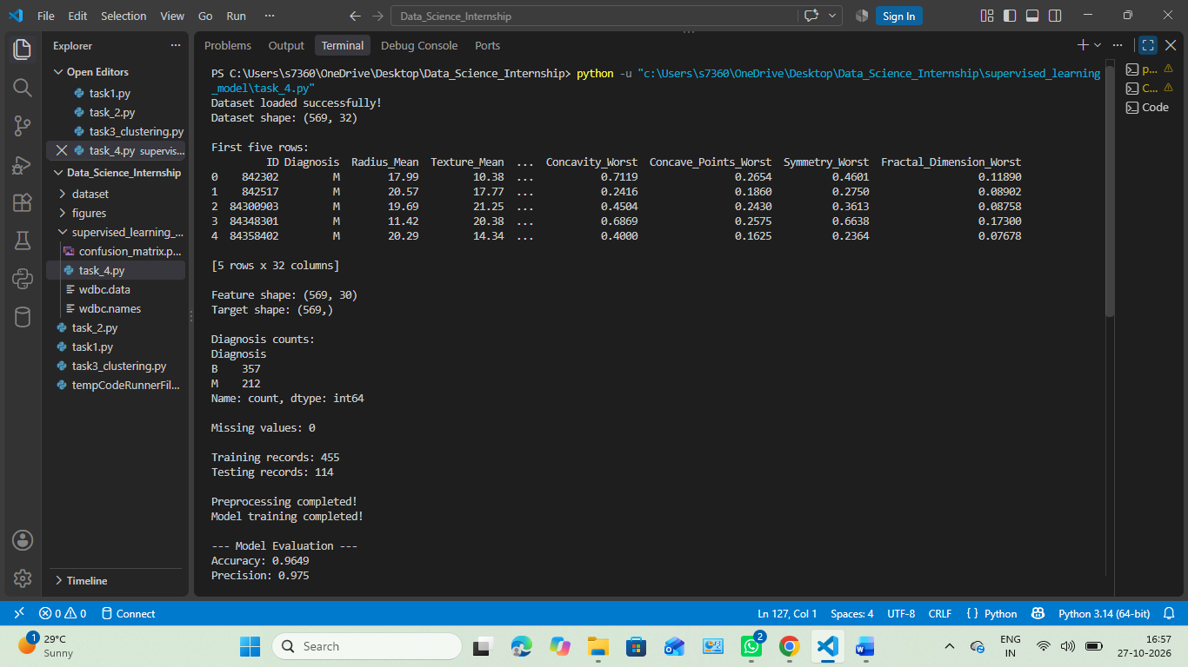
6.3 Model Evaluation Output
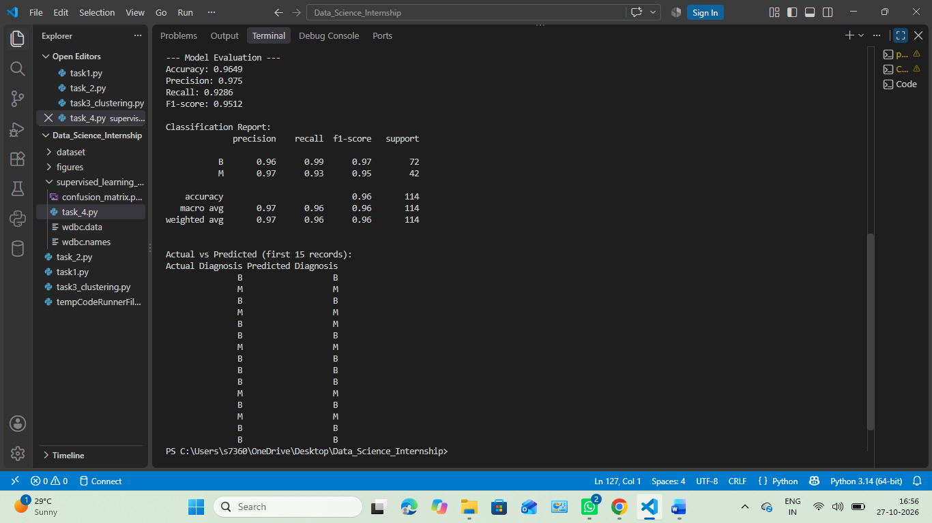

6.4 Confusion Matrix
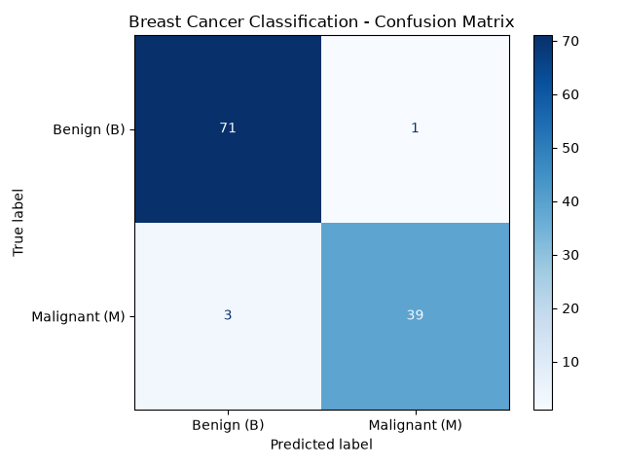
These screenshots show the implementation of the project and the results obtained after running the program.
7. Results and Observations
The Logistic Regression model was successfully trained and tested using the Wisconsin Breast Cancer Diagnostic dataset.
The model achieved an accuracy of 96.49% on the test dataset. The following results were obtained:
- Accuracy: 96.49%
- Precision (Malignant): 97.50%
- Recall (Malignant): 92.86%
- F1-Score (Malignant): 95.12%
- Testing Records: 114

The model correctly classified 110 out of 114 test records. It correctly identified 71 benign cases and 39 malignant cases. One benign case was predicted as malignant, while three malignant cases were predicted as benign.
These results show that the model performed well on this test dataset. However, the results are based on a specific dataset and do not establish that the model is suitable for real-world medical diagnosis.
8. Confusion Matrix and Interpretation
A confusion matrix is used to compare the actual classes with the classes predicted by a classification model. It helps us understand how many predictions were correct and incorrect.In this project, the confusion matrix produced the following results:
- True Negative (TN): 71 — Benign cases correctly predicted as benign.
- False Positive (FP): 1 — A benign case incorrectly predicted as malignant.
- False Negative (FN): 3 — Malignant cases incorrectly predicted as benign.
- True Positive (TP): 39 — Malignant cases correctly predicted as malignant.
The confusion matrix shows that the model correctly classified most of the test records. It also highlights the incorrect predictions, which are important when evaluating a classification model. This model is intended for educational purposes only and must not be used to make medical decisions.
9. Conclusion
In this project, a supervised machine learning model was developed using Python to classify breast tumour records as Benign or Malignant. The Wisconsin Breast Cancer Diagnostic dataset was used for training and testing the model.
Logistic Regression was applied to perform classification. The data was prepared, divided into training and testing sets, and scaled before training. The model achieved 96.49% accuracy, with a precision of 97.50%, recall of 92.86%, and F1-score of 95.12% for the malignant class.This project helped me understand the basic workflow of supervised learning, data preprocessing, model training, and performance evaluation using Scikit-learn. It also demonstrated how a confusion matrix can be used to examine correct and incorrect predictions.
Overall, the project provided practical experience in building and evaluating a classification model. The model is intended for educational purposes and should not be used as a substitute for professional medical diagnosis.

10. References
- UCI Machine Learning Repository — Wisconsin Diagnostic Breast Cancer Dataset:
https://archive.ics.uci.edu/dataset/17/breast+cancer+wisconsin+diagnostic
- Scikit-learn Documentation — Logistic Regression:
https://scikit-learn.org/stable/modules/generated/sklearn.linear_model.LogisticRegression.html
- Scikit-learn Documentation — StandardScaler:
https://scikit-learn.org/stable/modules/generated/sklearn.preprocessing.StandardScaler.html
- Scikit-learn Documentation — Model Evaluation:
https://scikit-learn.org/stable/modules/model_evaluation.html
- Pandas Documentation:
https://pandas.pydata.org/docs/
- Matplotlib Documentation:
https://matplotlib.org/stable/

