EXPLORATORY DATA ANALYSIS AND
VISUALISATION
Virtual Data Science with Python Trainee Internship

Task 2. Project Report:
Project Title: Students Performance Analysis Using Python
Submitted by: SNEHA YADAV
Course: Bachelor of Computer Applications (BCA)
Institution: Babasaheb Bhimrao Ambedkar University
Internship Organization: yuvaintern
Tools Used: Python, Visual Studio Code, Pandas, Matplotlib and Seaborn
Dataset: Student Performance Dataset – UCI Machine Learning Repository
Submission Date: 25-10-2026

1. Introduction
Exploratory Data Analysis (EDA) is the process of examining a dataset to understand its structure, identify patterns and discover useful information. It uses statistical summaries and visualizations to make data easier to understand.
In this task, Python was used to analyse student performance data. The analysis focused on final grades, study time, absences and grade differences across student groups. Pandas was used to inspect and summarize the data, while Matplotlib and Seaborn were used to create visualizations.
2. Objectives
The main objectives of this task were:
- To understand the structure and characteristics of the dataset.
- To check missing values, duplicate records and data types.
- To calculate descriptive statistics for student grades.
- To study relationships between study time, absences and academic performance.
- To compare grades across different groups using graphs.
- To summarize the findings in a clear and meaningful way.
3. Dataset and Tools
3.1 Dataset Description
- Dataset Name: Student Performance Dataset
- Source: UCI Machine Learning Repository
- Total Records: 395 students
- Total Columns: 34 (including the derived absence-group column)
- Target Variable: G3 (Final Grade)
3.2 Tools and Libraries
- Python: Data analysis and processing.
- Pandas: Data cleaning and statistical analysis.
- Matplotlib: Creating graphs and charts.
- Seaborn: Visualizing patterns and comparisons.

Important Variables
- G1: First-period grade.
- G2: Second-period grade.
- G3: Final grade.
- studytime: Weekly study-time category.
- absences: Number of student absences.
- sex: Student gender category.
4. Data Inspection and Statistical Analysis
4.1 Data Inspection
The dataset was inspected using Pandas to understand its structure and data quality.
- Total records: 395 students
- Total columns: 34
- Missing values: 0
- Duplicate rows: 0
The dataset contained no missing values or duplicate records, so no additional removal of such records was required.
4.2 Statistical Analysis
Descriptive statistics were used to understand students' final grades.
Statistical Measure | G3 (Final Grade)
Mean | 10.42
Median | 11
Standard Deviation | 4.58
Minimum | 0
Maximum | 20
25th Percentile | 8
75th Percentile | 14

4.3 Grade Comparison
The average grades across the three periods were:
- G1: 10.91
- G2: 10.71
- G3: 10.42
The average grade decreased slightly across the three periods. The final grade had an average of 10.42 out of 20.

5. Exploratory Data Analysis and Data Visualization
5.1 Final Grade Distribution
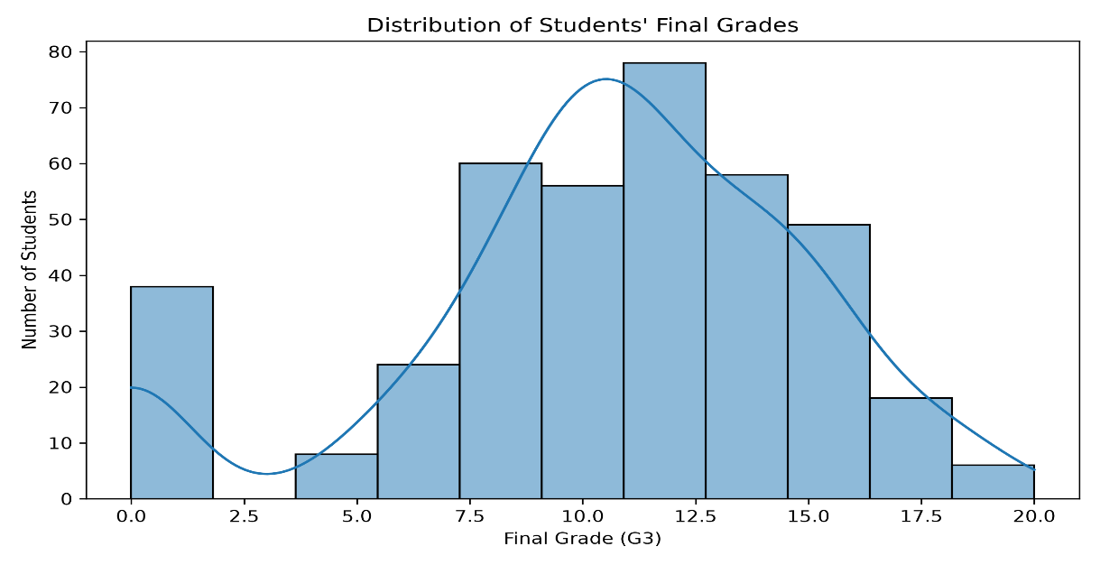
Objective
To understand the distribution of students' final grades (G3).
Observation
The histogram shows the spread of final grades, with most grades concentrated in the middle range.
Interpretation
The average final grade was 10.42 out of 20, with a median of 11 and a standard deviation of 4.58.

5.2 Study Time vs Final Grades
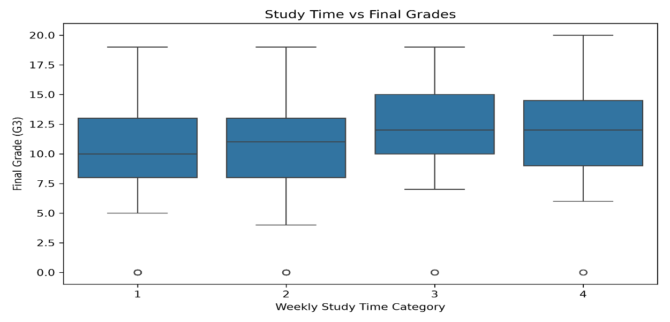
Observation: Students in study-time category 3 had the highest average final grade (11.40), followed by category 4 (11.26).
Interpretation: The results show differences in average grades across study-time categories, but they do not prove that study time alone causes higher grades.
5.3 Absences vs Final Grades
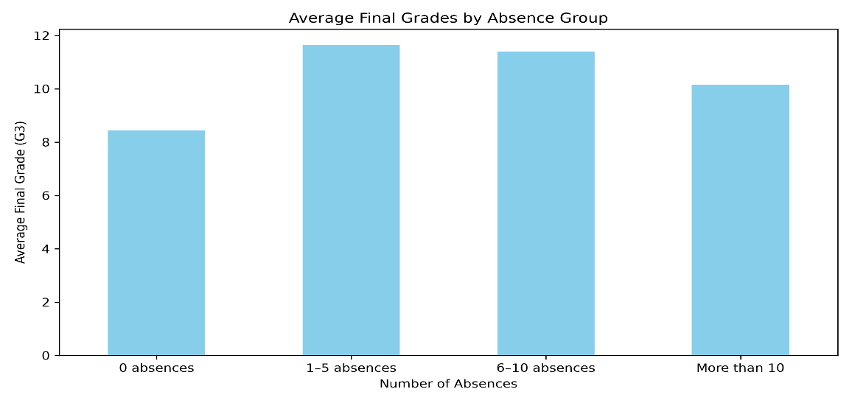

Observation: The 1–5 absences group had the highest average grade (11.65), while the zero-absence group had an average of 8.44.
Interpretation: Average grades did not decrease consistently as absences increased. Therefore, this dataset does not show a simple linear pattern between absences and final grades.

5.4 Gender-wise Final Grades
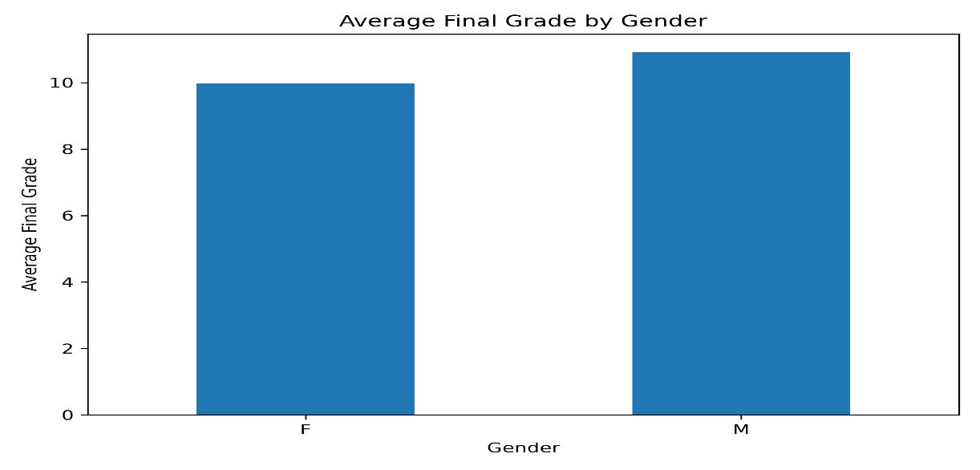
Observation: The average final grade was 9.97 for female students and 10.91 for male students in this dataset.
Interpretation: A difference was observed between the two groups in this sample. This finding should not be generalized to all students.

5.5 Average Grades Comparison
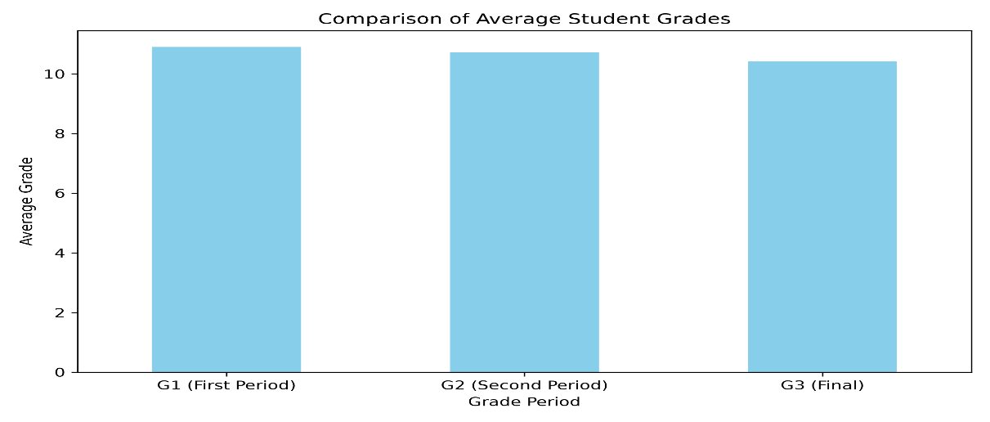
Observation: The average grades were G1 = 10.91, G2 = 10.71 and G3 = 10.42.
Interpretation: The average grade decreased slightly across the three periods

6. Key Findings and Conclusion
Key Findings
- The dataset contained 395 student records and 34 columns.
- No missing values or duplicate rows were found.
- The average final grade was 10.42 out of 20.
- G2 had the strongest correlation with G3 (0.905).
- Average grades varied across study-time, gender and absence groups.
- The average grade decreased slightly from G1 to G3.
Conclusion
This task used Python libraries to perform exploratory data analysis on student performance data. Statistical summaries and five visualizations helped identify grade distributions, group differences and relationships between variables. The analysis showed that previous grades, particularly G2, were strongly associated with final grades. These findings describe patterns in this dataset and do not establish cause-and-effect relationships.

7. References
- UCI Machine Learning Repository — Student Performance Dataset: https://archive.ics.uci.edu/dataset/320/student+performance
- Pandas Documentation: https://pandas.pydata.org/docs/
- Matplotlib Documentation: https://matplotlib.org/stable/
- Seaborn Documentation: https://seaborn.pydata.org/

8.APPENDIX A
Python Code and Execution Evidence
This appendix presents the Python code used for exploratory data analysis, statistical calculations and data visualization. It also includes screenshots of successful code execution and generated outputs to document the implementation of Task 2.

Figure A1: Python Code for Dataset Loading and Inspection
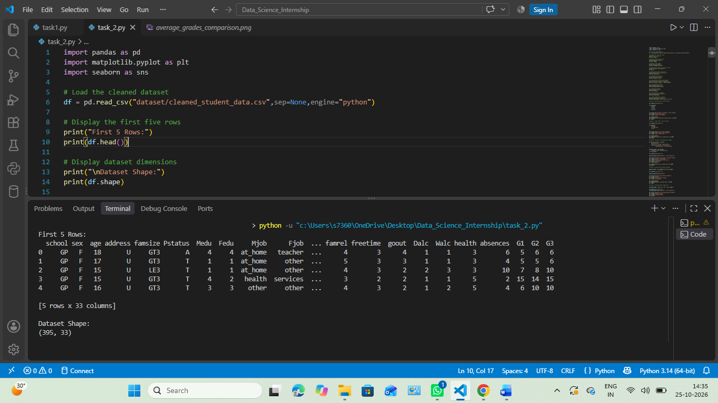

Figure A2: Data Quality Checks and Descriptive Statistical Analysis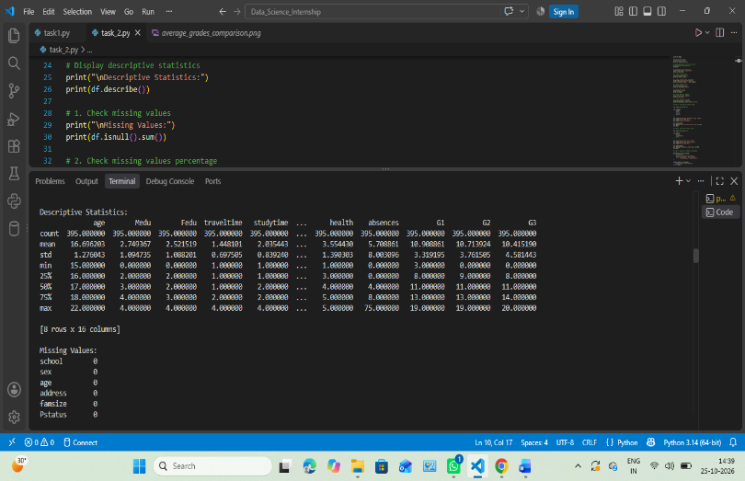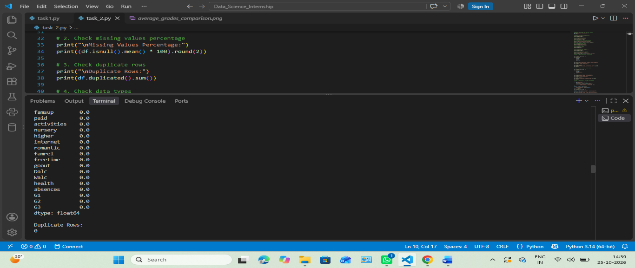

Figure A3: Python Code for Exploratory Data Analysis and Visualization
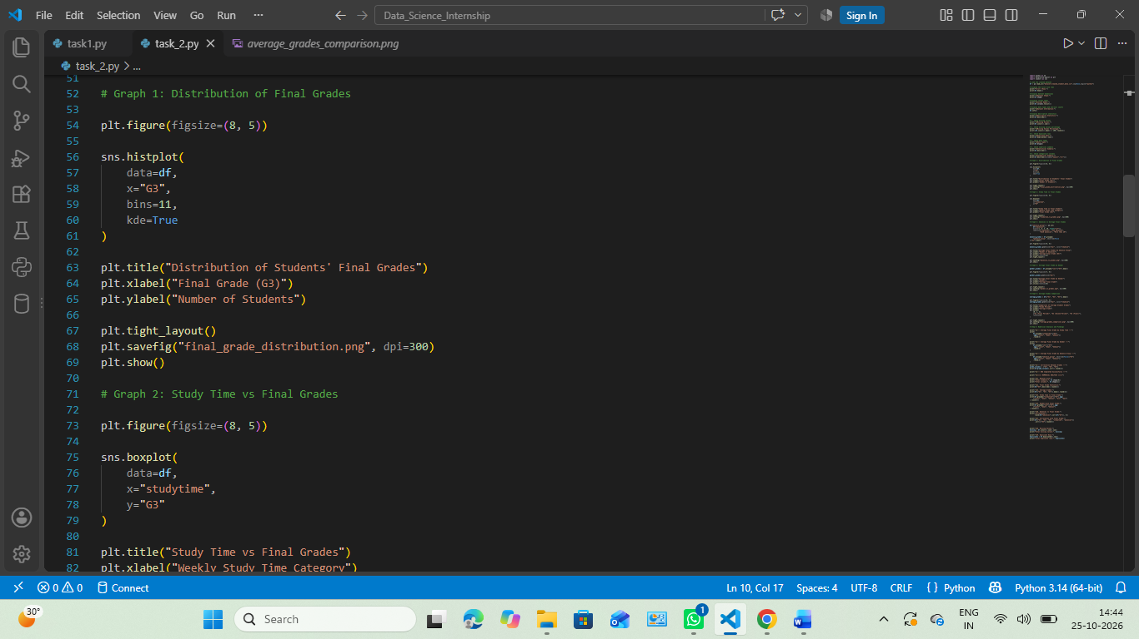
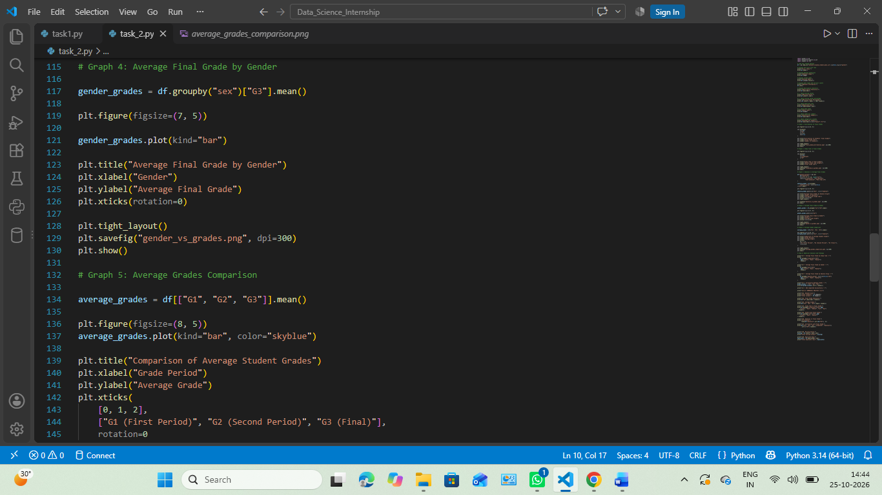

Figure A4: Successful Execution of the EDA Program

