DAY 1

Installations

Postman

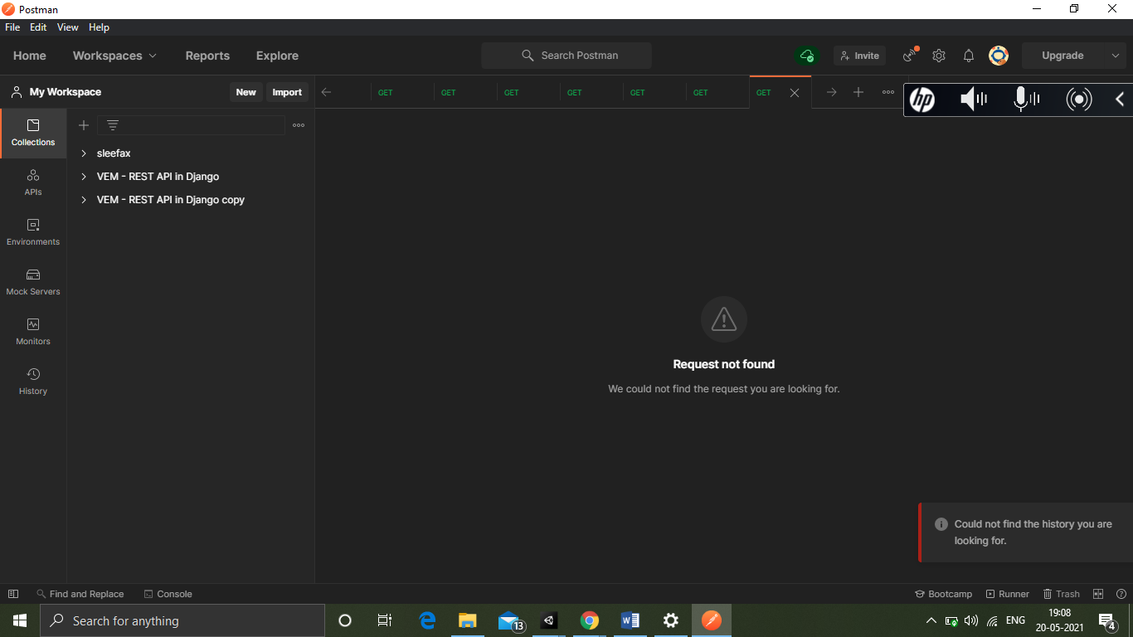

Sublime text editor

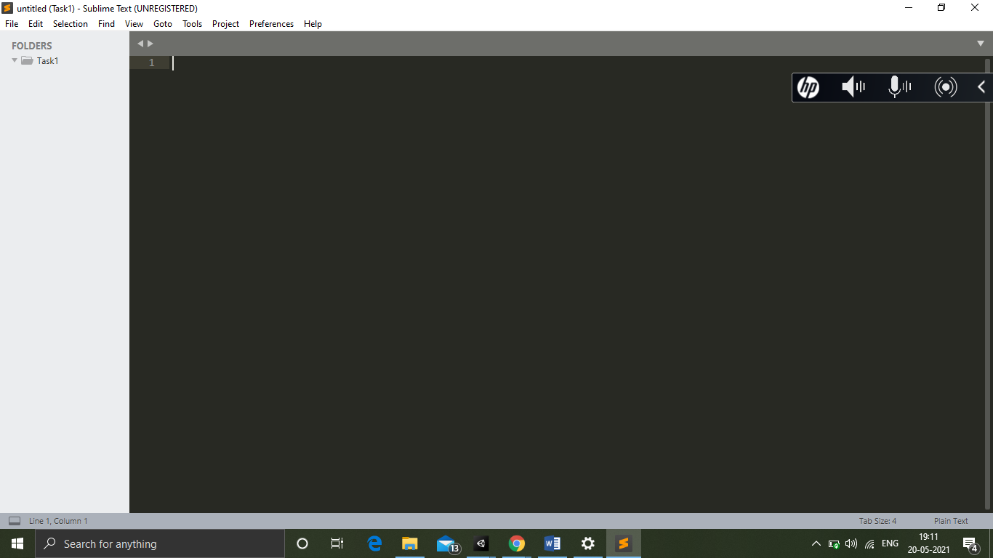

Git

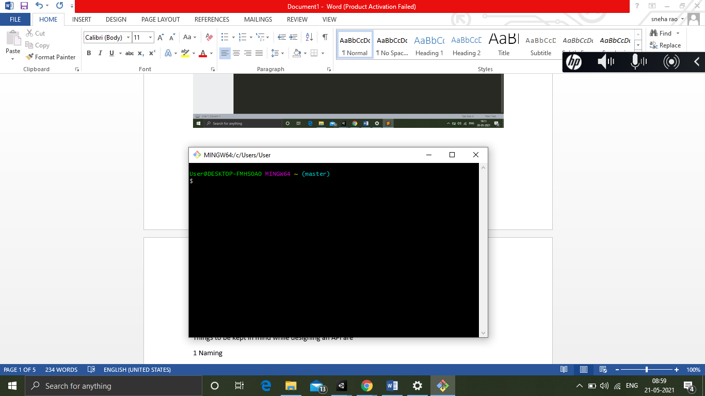

API

An API is a software intermediary that allows two or more applications to talk to each other.

Examples where an API can be used are - Online ticket booking system

Things to be kept in mind while designing an API are

1 Naming

2 Atomicity

3 No side effects

4 Don’t try to do everything in one API

The different methods to use API are

1 GET

2 POST

The different ways in which we can break the response of API and send it to user is –

1 Pagination

2 Fragmentation

References

<https://youtu.be/s7wmiS2mSXY>

<https://www.youtube.com/watch?v=_YlYuNMTCc8>

<https://www.youtube.com/watch?v=E0Qqpn8ymko>

HTTP

Versions

1.0

- Use single request to get resource from the server then close the connection

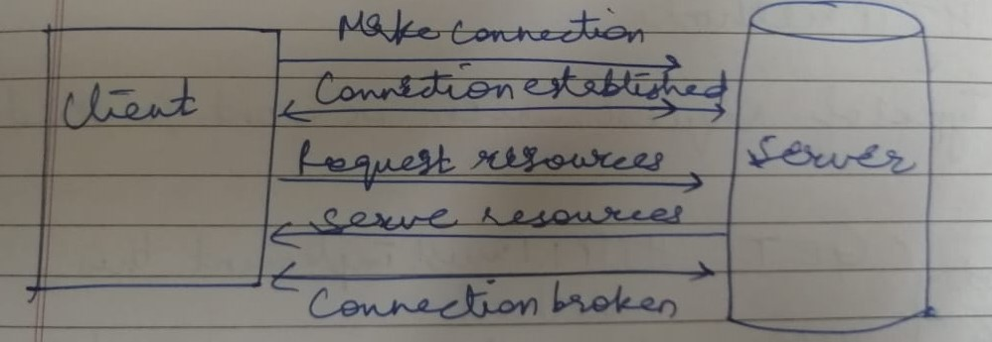

1.1

- Uses single connection to request resources from the server multiple times

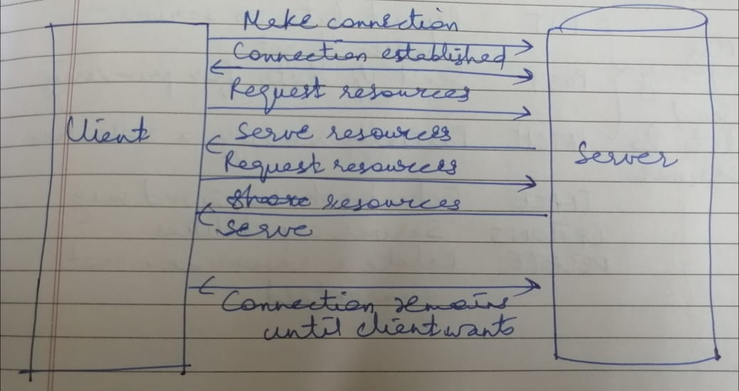

Status codes - Tells the response of server against our request

200 -> Success

404 -> Not found

500 -> Server error

503 -> Unavailable

301 -> Permanent

Methods – Types of request which we want to send

GET – HTTP 1.1 must implement this method

HEAD – Inspect resource headers

PUT – Deposit data on server => Inverse of get

POST – Send input data for processing

PATCH – Partially modify a resource

TRACE – Echo back received message

OPTIONS – Server capabilities

DELETE – Delete a resource, not guaranteed

References

<https://youtu.be/nO4JGop9xZM>

Client Server Architecture

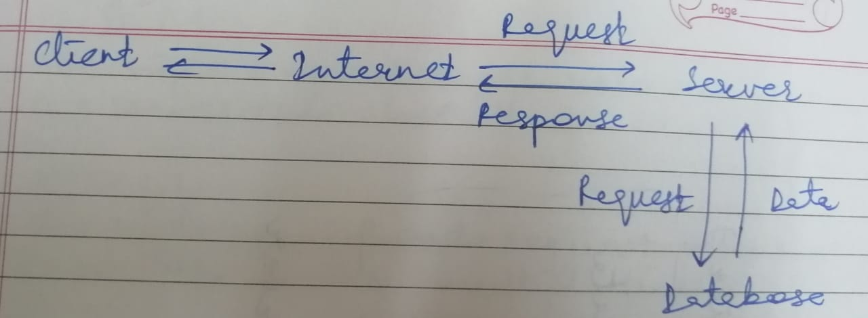

1-tier architecture

* Local machine

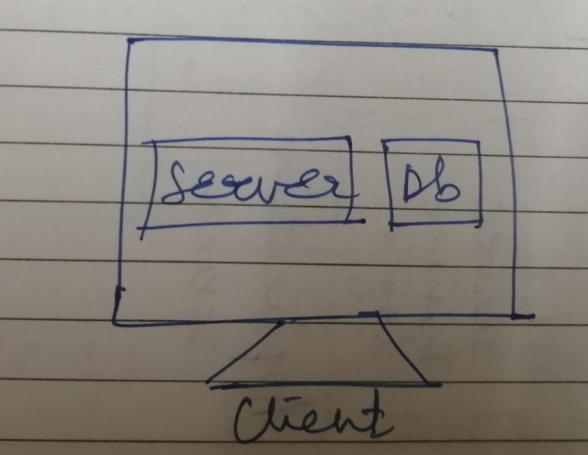

2-tier architecture

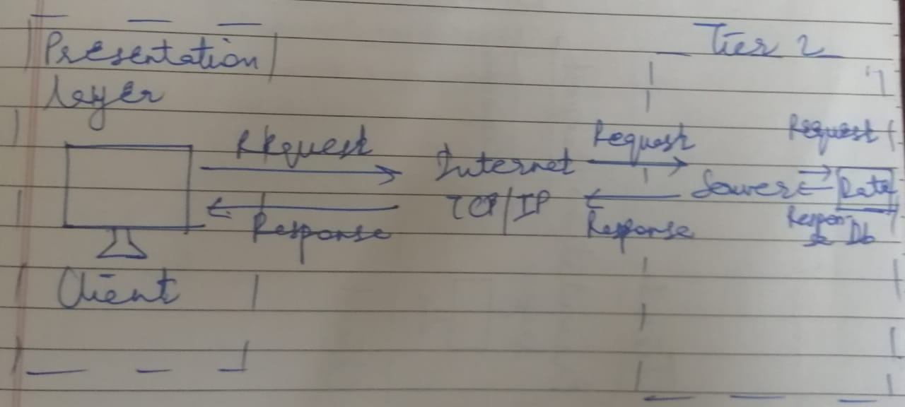

3-tier architecture

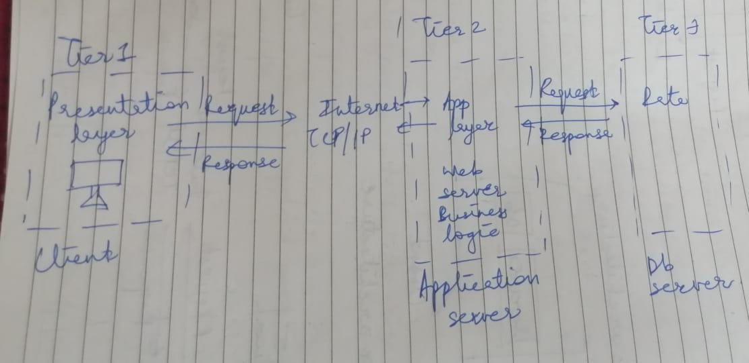

References

<https://www.youtube.com/watch?v=ve82kSSj_Hs&t=3s>

<https://www.youtube.com/watch?v=SKtR7NVxYFA>

<https://www.youtube.com/watch?v=Im-gKjo3MGQ&t=584s>