Day 2

REST API

* REST API creates an object on the server side and sends the values of the object in response to the client request.
* Representational State Transfer
* It is an architectural style as well as an approach for communications purpose that is often used in various web services development
* Often regarded as language of the internet as it uses less bandwidth
* Stateless client-server model

Features

* Simpler than SOAP
* Documentation
* Error messages

Principles

* Stateless => Can be part of url, query or header
* Client server => Has uniform interface that separates client from the server
* Uniform Interface => To obtain uniformity to the application rest has defined 4 interface constraints namely resource identification, resource manipulation using representations, self descriptive messages and hypermedia as the engine of the application state
* Cacheable
* Layered system
* Code on demand

Methods

* POST => for creating a resource
* GET => for reading a resource
* PUT => for updating a resource
* DELETE => for deleting a resource

References

<https://www.youtube.com/watch?v=rtWH70_MMHM>

<https://www.youtube.com/watch?v=qVTAB8Z2VmA&t=404s>

Microservices

* Way of breaking application or service down into standalone independent applications that can run on different hardware. Communication between different microservices happen through REST API and work together to provide the functionality of your application.

OR

* Form of service oriented architecture style wherein services are built as a collection of different smaller services rather than one whole app.

Advantages

* Deployment flexibility
* Technology flexibility
* Can be scaled separately

Disadvantages

* Deployment/ architecture complexity
* Service discovery

Microservices frameworks for java

* Spring boot
* Jersey
* Swagger

References

<https://www.youtube.com/watch?v=j1gU2oGFayY>

<https://dzone.com/articles/java-microservices-code-examples-tutorials-and-more#:~:text=Microservices%20are%20a%20form%20of,rather%20than%20one%20whole%20app>.

SOAP

* Simple Object Access Protocol
* Protocol/ rules/ definition how 2 applications will talk to each other over the web
* All information/ message exchange between two application happens over a common format – XML
* XML messages have a defined structure => Envelope, Header, Body
* Header element provides info about the msg itself. Header might include authentication, complex types, routing info etc.
* Body contains actual data of the request meant to be sent to the server.
* SOAP web services is a web service that compiles to the SOAP Web services specifications
* SOAP Web service specifications
  + SOAP
  + WSDL – Web Service Description Language
  + UDDI

References

<https://www.youtube.com/watch?v=sTGgBoFBDAY>

<https://www.youtube.com/watch?v=74G0fmCvESM>

Difference between SOAP and REST API

|  |  |  |
| --- | --- | --- |
|  | SOAP | REST |
| 1 | A XML-based msg protocol | An architectural style protocol |
| 2 | Uses WSDL for communication between consumer and provider | Uses XML and JSON to send and receive data |
| 3 | Invoke services by calling RPC method | Simply calls services via URL path |
| 4 | Does not return human readable result | Result is readable which is just plain XML or JSON |
| 5 | Transfer is over HTTP. Also uses other protocol such as SMTP, FTP etc | Transfer is over HTTP only |
| 6 | Javascript can call SOAP, but it is difficult to implement | Easy to call from Javascript |
| 7 | Performance is not great compared to REST | Performance is much better compared to SOAP – less CPU intensive, leaner code etc |

References

<https://www.youtube.com/watch?v=TvGLm7BijJY>

HTML

HTML Attributes

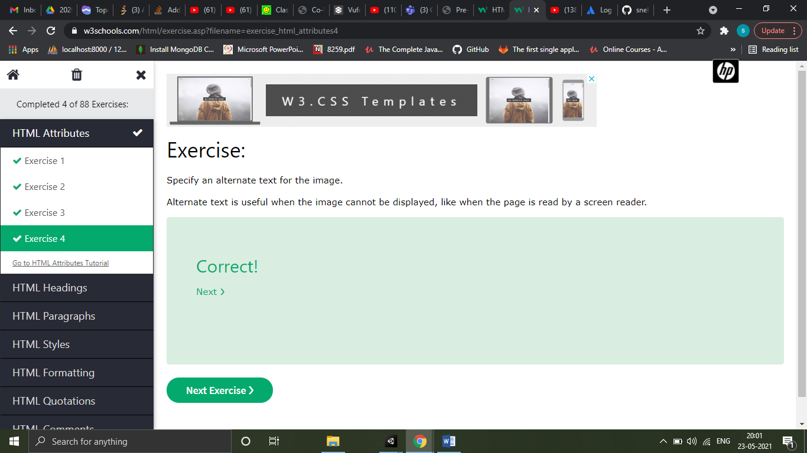

HTML Headings

Heading 1

Heading 2

Heading 3

Heading 4

Heading 5

Heading 6

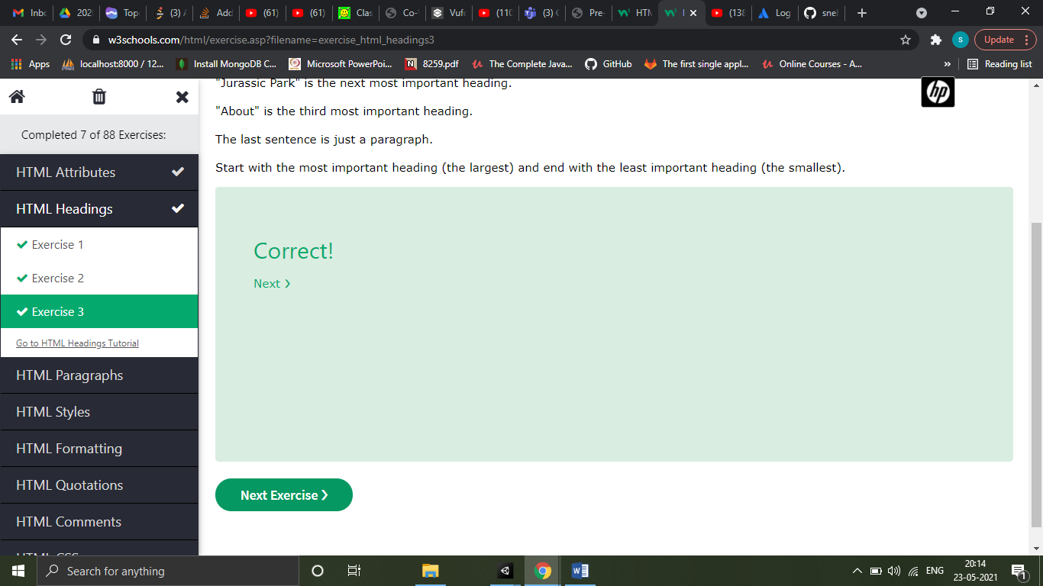

HTML Paragraphs

The HTML <pre> element defines preformatted text.

The text inside a <pre> element is displayed in a fixed-width font (usually Courier), and it preserves both spaces and line breaks

The HTML <br> element defines a line break.

The <hr> tag defines a thematic break in an HTML page, and is most often displayed as a horizontal rule.

The <hr> element is used to separate content (or define a change) in an HTML page

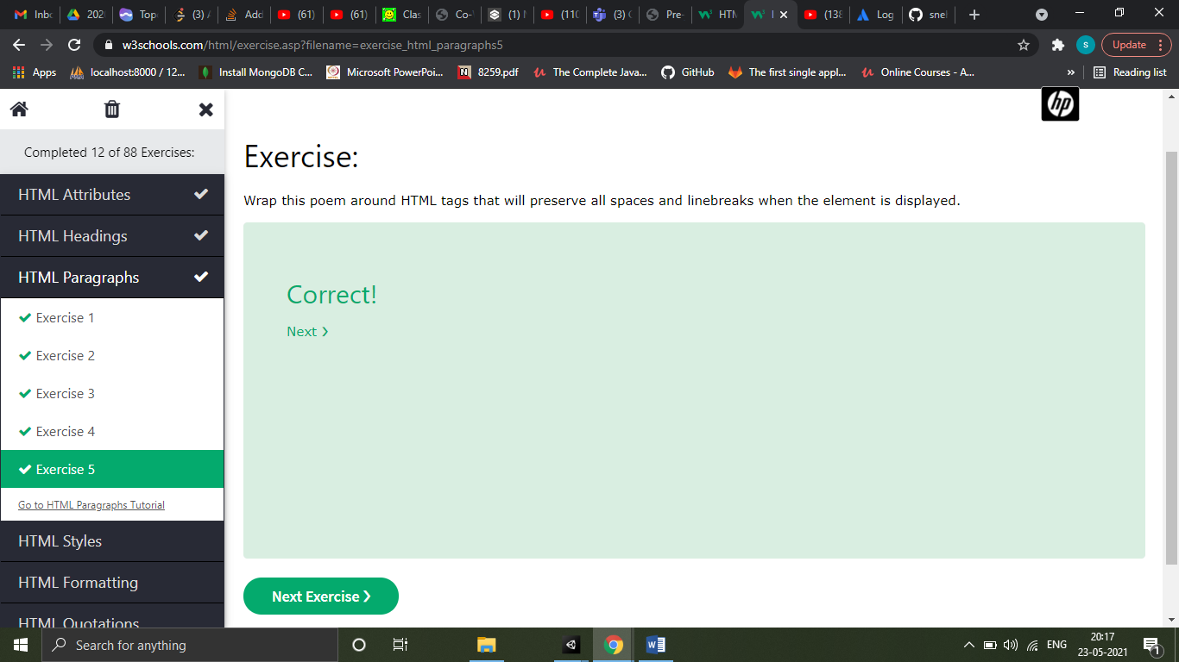

HTML Styles

* Use the style attribute for styling HTML elements
* Use background-color for background color
* Use color for text colors
* Use font-family for text fonts
* Use font-size for text sizes
* Use text-align for text alignment

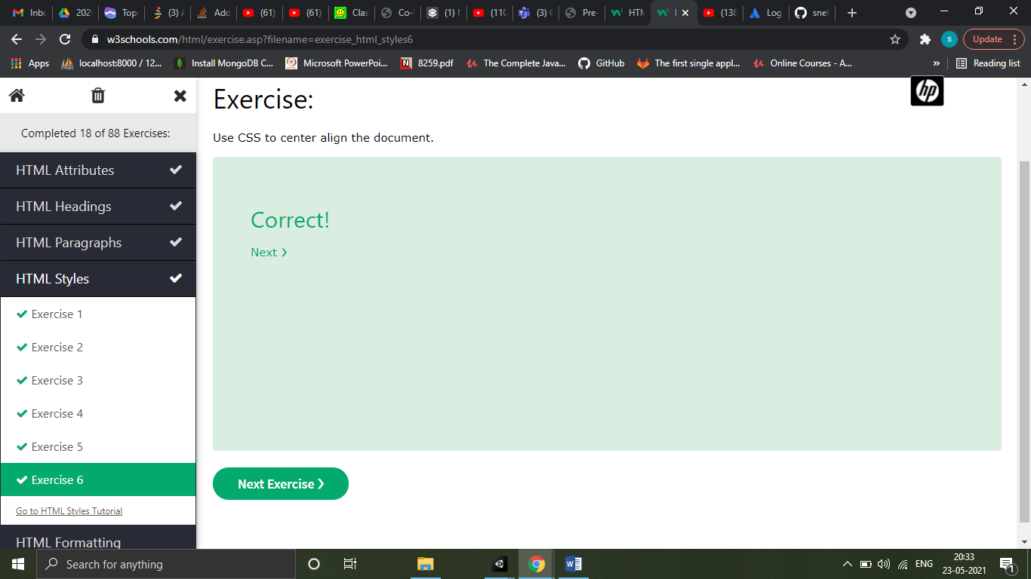

HTML Formatting

* <b> - Bold text
* <strong> - Important text
* <i> - Italic text
* <em> - Emphasized text
* <mark> - Marked text
* <small> - Smaller text
* <del> - Deleted text
* <ins> - Inserted text
* <sub> - Subscript text
* <sup> - Superscript text

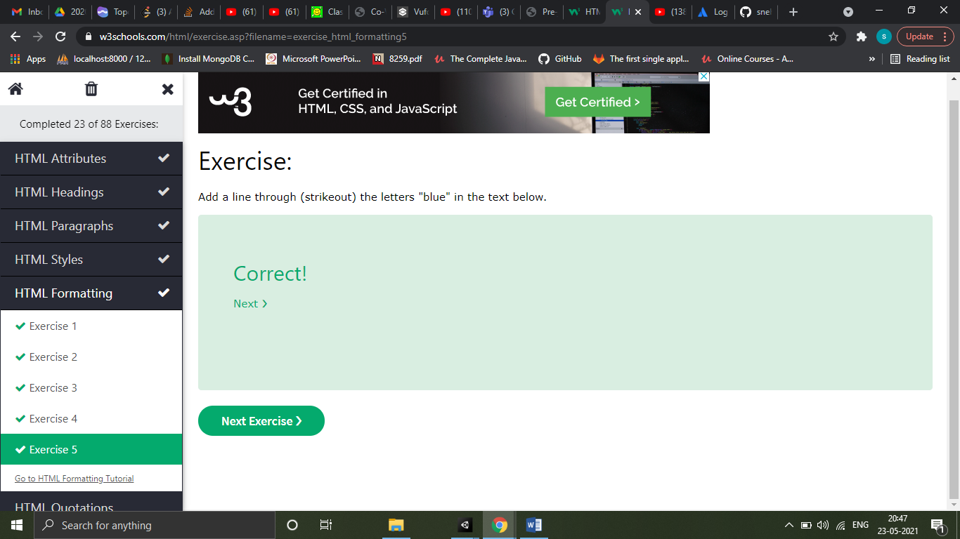

HTML Quotations

|  |  |
| --- | --- |
| [<abbr>](https://www.w3schools.com/tags/tag_abbr.asp) | Defines an abbreviation or acronym |
| [<address>](https://www.w3schools.com/tags/tag_address.asp) | Defines contact information for the author/owner of a document |
| [<bdo>](https://www.w3schools.com/tags/tag_bdo.asp) | Defines the text direction |
| [<blockquote>](https://www.w3schools.com/tags/tag_blockquote.asp) | Defines a section that is quoted from another source |
| [<cite>](https://www.w3schools.com/tags/tag_cite.asp) | Defines the title of a work |
| [<q>](https://www.w3schools.com/tags/tag_q.asp) | Defines a short inline quotation |

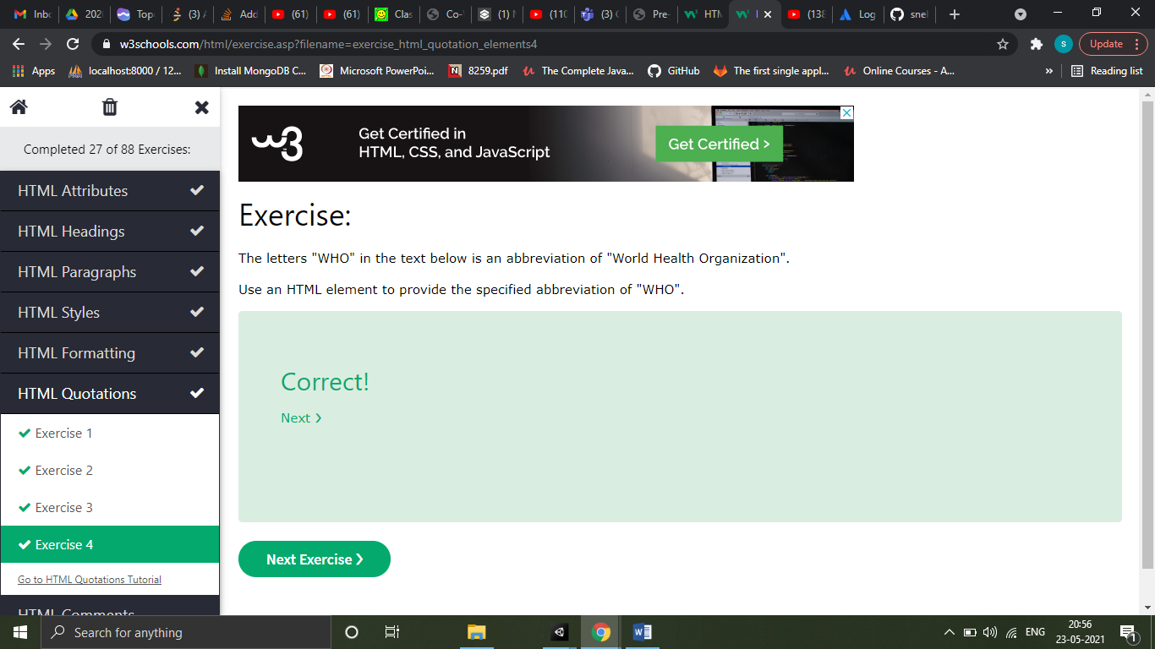

HTML Comments

<!-- Write your comments here -->

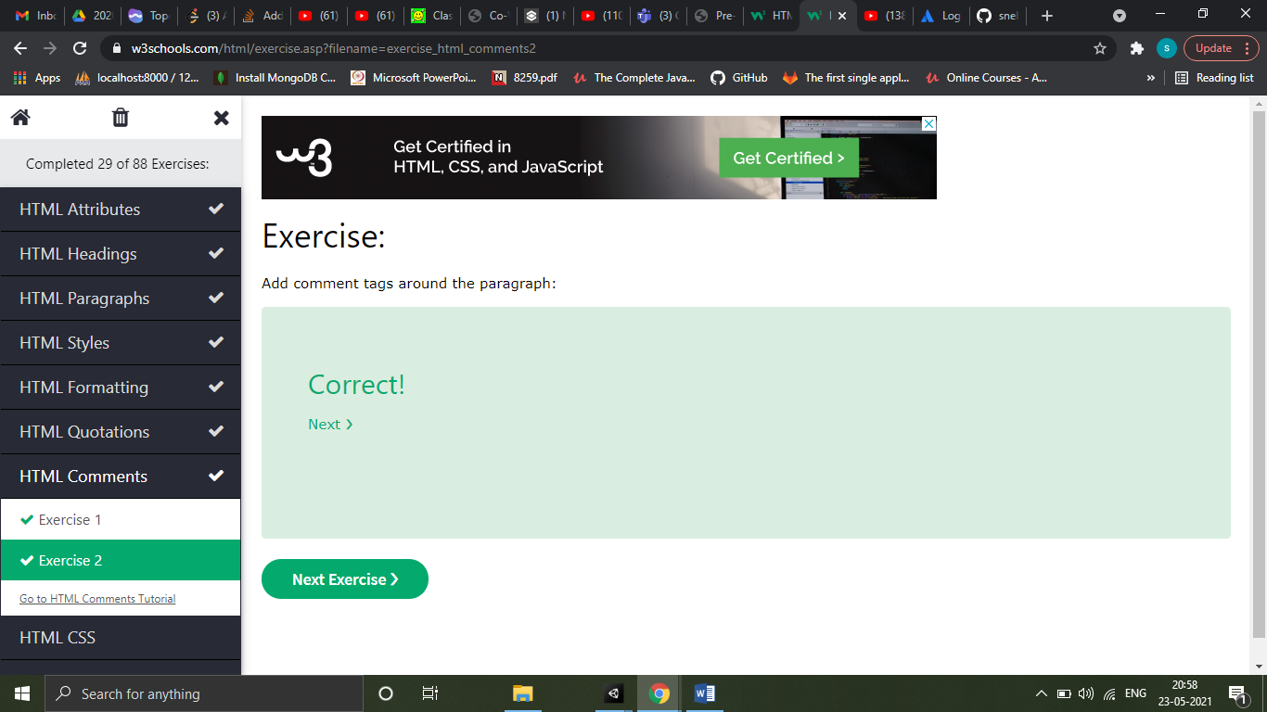

HTML Colors

Rgb (red, green, blue)

Hex color code => #rrggbb

Hsl color values => (hue, saturation, lightness)

HTML CSS

* Use the HTML style attribute for inline styling
* Use the HTML <style> element to define internal CSS
* Use the HTML <link> element to refer to an external CSS file
* Use the HTML <head> element to store <style> and <link> elements
* Use the CSS color property for text colors
* Use the CSS font-family property for text fonts
* Use the CSS font-size property for text sizes
* Use the CSS border property for borders
* Use the CSS padding property for space inside the border
* Use the CSS margin property for space outside the border

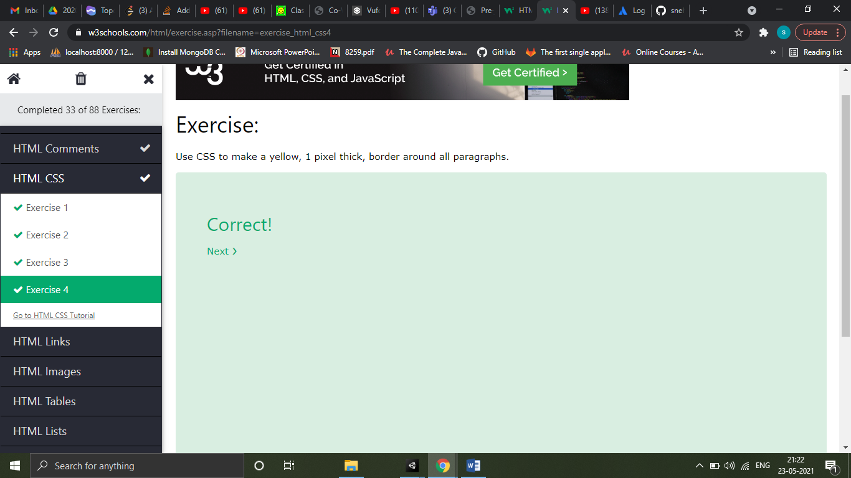

HTML Links

Anchor tag

The target attribute specifies where to open the linked document.

The target attribute can have one of the following values:

* _self - Default. Opens the document in the same window/tab as it was clicked
* _blank - Opens the document in a new window or tab
* _parent - Opens the document in the parent frame
* _top - Opens the document in the full body of the window
* Use the mailto: scheme inside the href attribute to create a link that opens the user's email program

Link Bookmark

* Use the id attribute (id="*value*") to define bookmarks in a page
* Use the href attribute (href="#*value*") to link to the bookmark

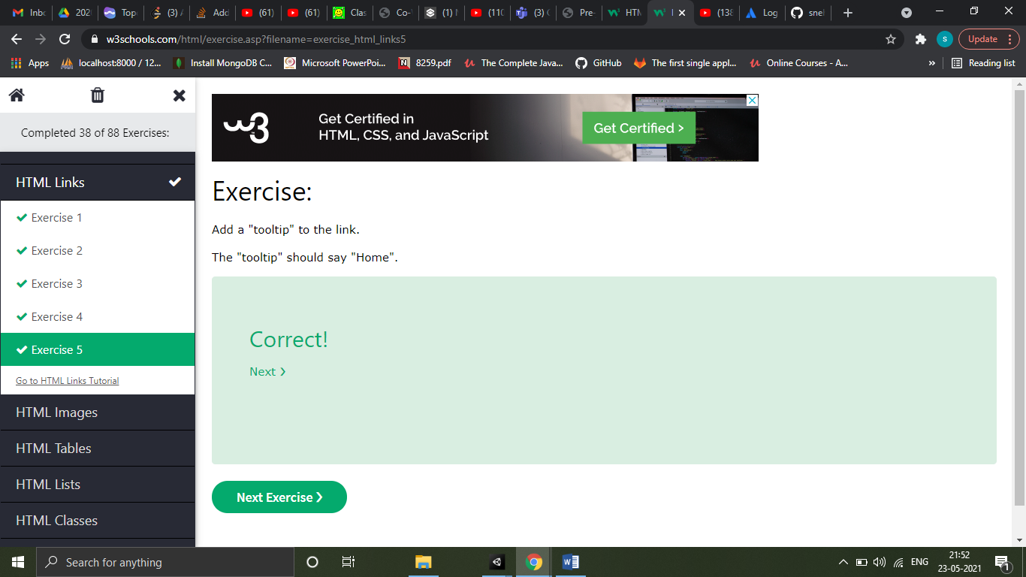

HTML Images

* Use the CSS float property to let the image float to the left or to the right

|  |  |
| --- | --- |
| [<img>](https://www.w3schools.com/tags/tag_img.asp) | Defines an image |
| [<map>](https://www.w3schools.com/tags/tag_map.asp) | Defines an image map |
| [<area>](https://www.w3schools.com/tags/tag_area.asp) | Defines a clickable area inside an image map |
| [<picture>](https://www.w3schools.com/tags/tag_picture.asp) | Defines a container for multiple image resources |

* Use the HTML <map> element to define an image map
* Use the HTML <area> element to define the clickable areas in the image map
* Use the HTML usemap attribute of the <img> element to point to an image map

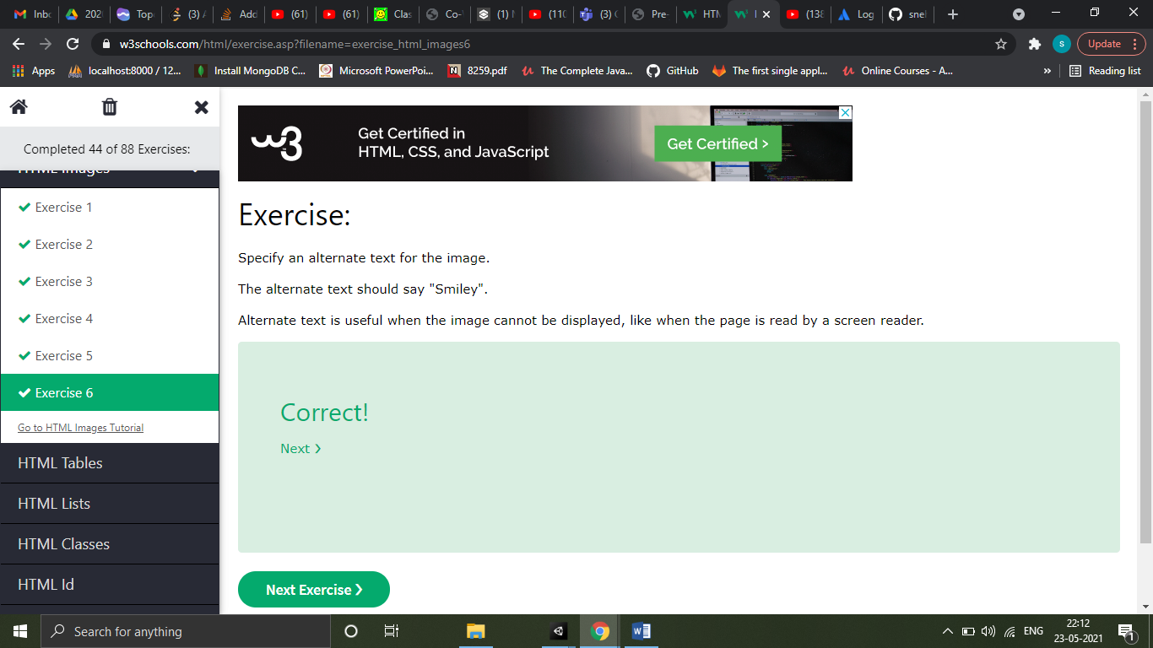

HTML Tables

* Use the HTML <table> element to define a table
* Use the HTML <tr> element to define a table row
* Use the HTML <td> element to define a table data
* Use the HTML <th> element to define a table heading
* Use the HTML <caption> element to define a table caption
* Use the CSS border property to define a border
* Use the CSS border-collapse property to collapse cell borders
* Use the CSS padding property to add padding to cells
* Use the CSS text-align property to align cell text
* Use the CSS border-spacing property to set the spacing between cells
* Use the colspan attribute to make a cell span many columns
* Use the rowspan attribute to make a cell span many rows
* Use the id attribute to uniquely define one table

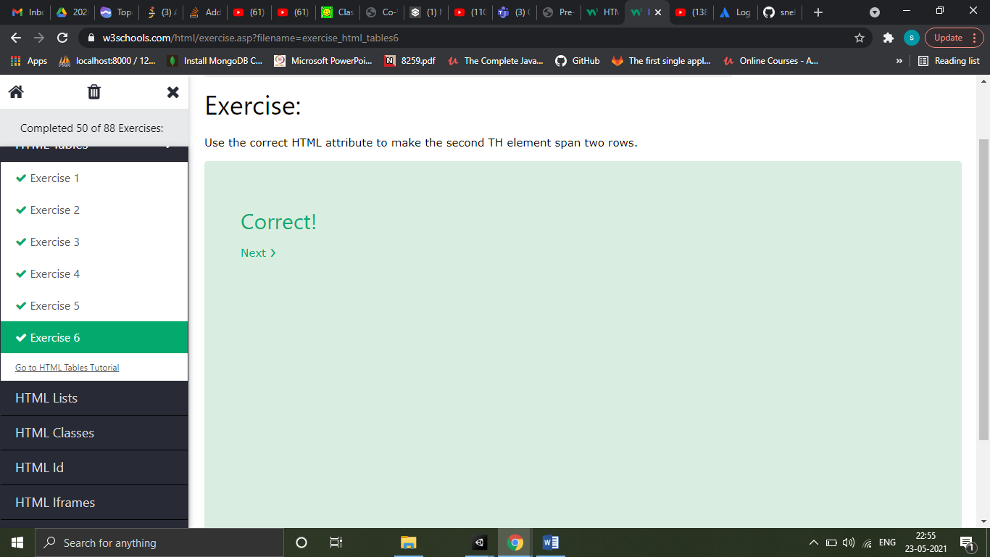

HTML Lists

HTML also supports description lists.

A description list is a list of terms, with a description of each term.

The <dl> tag defines the description list, the <dt> tag defines the term (name), and the <dd> tag describes each term

|  |  |
| --- | --- |
| [<ul>](https://www.w3schools.com/tags/tag_ul.asp) | Defines an unordered list |
| [<ol>](https://www.w3schools.com/tags/tag_ol.asp) | Defines an ordered list |
| [<li>](https://www.w3schools.com/tags/tag_li.asp) | Defines a list item |
| [<dl>](https://www.w3schools.com/tags/tag_dl.asp) | Defines a description list |
| [<dt>](https://www.w3schools.com/tags/tag_dt.asp) | Defines a term in a description list |
| [<dd>](https://www.w3schools.com/tags/tag_dd.asp) | Describes the term in a description list |

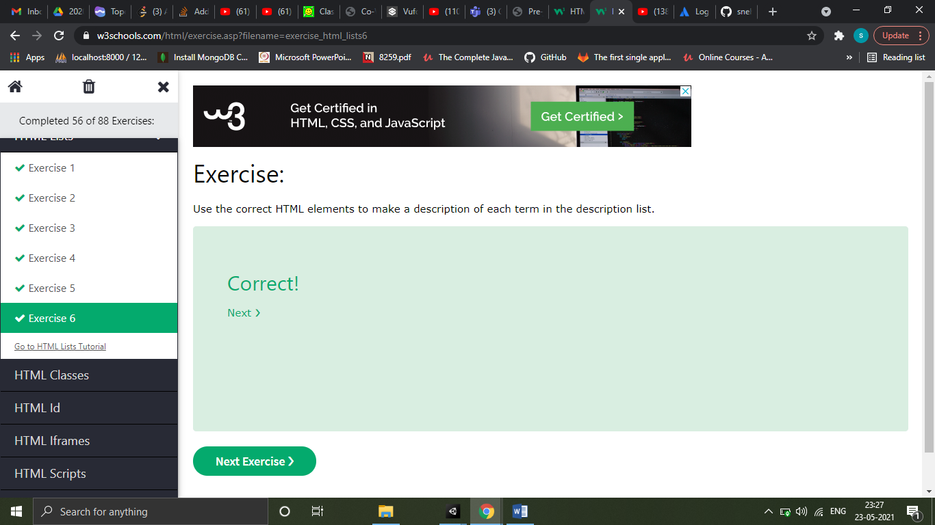

HTML Block and Inline

* There are two display values: block and inline
* A block-level element always starts on a new line and takes up the full width available
* An inline element does not start on a new line and it only takes up as much width as necessary
* The <div> element is a block-level and is often used as a container for other HTML elements
* The <span> element is an inline container used to mark up a part of a text, or a part of a document

HTML Classes

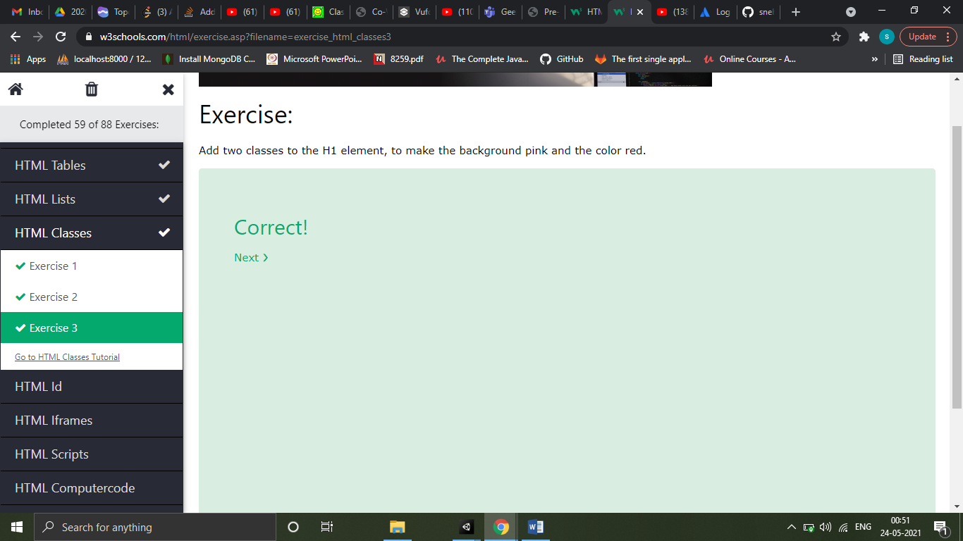

HTML Id

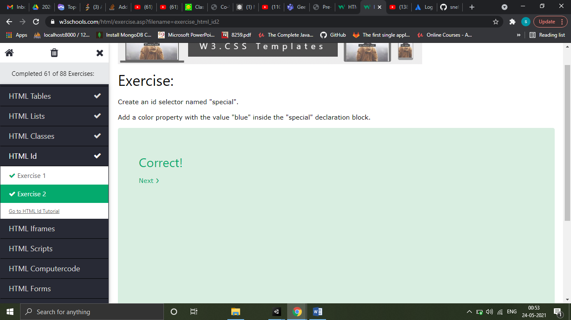

HTML Iframes

An HTML iframe is used to display a web page within a web page.

* The src attribute defines the URL of the page to embed
* Always include a title attribute (for screen readers)
* The height and width attributes specifies the size of the iframe
* Use border:none; to remove the border around the iframe

