Day-3

HTML

HTML Javascript

|  |  |
| --- | --- |
| [<script>](https://www.w3schools.com/tags/tag_script.asp) | Defines a client-side script |
| [<noscript>](https://www.w3schools.com/tags/tag_noscript.asp) | Defines an alternate content for users that do not support client-side scripts |

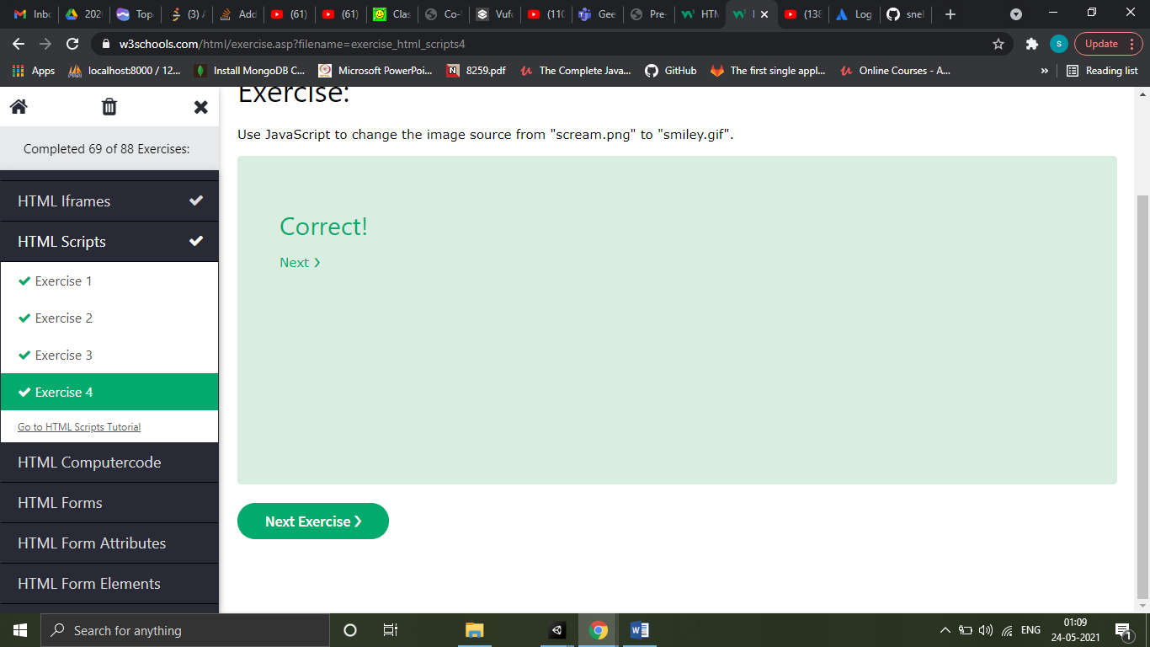

HTML Head

The <head> element is a container for metadata (data about data) and is placed between the <html> tag and the <body> tag.

HTML metadata is data about the HTML document. Metadata is not displayed.

Metadata typically define the document title, character set, styles, scripts, and other meta information.

Title element

The <title> element defines the title of the document. The title must be text-only, and it is shown in the browser's title bar or in the page's tab.

The <title> element is required in HTML documents!

The contents of a page title is very important for search engine optimization (SEO)! The page title is used by search engine algorithms to decide the order when listing pages in search results.

The <title> element:

* defines a title in the browser toolbar
* provides a title for the page when it is added to favorites
* displays a title for the page in search engine-results

Meta Element

The <meta> element is typically used to specify the character set, page description, keywords, author of the document, and viewport settings.

The metadata will not be displayed on the page, but are used by browsers (how to display content or reload page), by search engines (keywords), and other web services.

The viewport is the user's visible area of a web page. It varies with the device - it will be smaller on a mobile phone than on a computer screen.

You should include the following <meta> element in all your web pages:

<meta name="viewport" content="width=device-width, initial-scale=1.0">

This gives the browser instructions on how to control the page's dimensions and scaling.

The width=device-width part sets the width of the page to follow the screen-width of the device (which will vary depending on the device).

The initial-scale=1.0 part sets the initial zoom level when the page is first loaded by the browser.

The <base> element specifies the base URL and/or target for all relative URLs in a page

HTML Layout

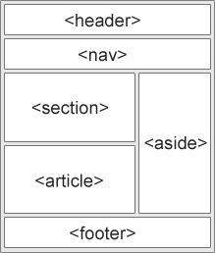

* <header> - Defines a header for a document or a section
* <nav> - Defines a set of navigation links
* <section> - Defines a section in a document
* <article> - Defines an independent, self-contained content
* <aside> - Defines content aside from the content (like a sidebar)
* <footer> - Defines a footer for a document or a section
* <details> - Defines additional details that the user can open and close on demand
* <summary> - Defines a heading for the <details> element

HTML Responsive

To make a web page responsive

* Set the viewport
* Resize images. For ex, set image width=”100%” or max-width:100%
* Resize text to change as per browser size using viewport. For ex, font-size=”1vw”

1vw = 1% of viewport width. If the viewport is 50cm wide, 1vw is 0.5cm

* Media Queries
* Use responsive web design frameworks like w3.css or bootstrap