DAY 5

BOOTSTRAP

* Bootstrap includes HTML and CSS based design templates for typography, forms, buttons, tables, navigation, modals, image carousels and many other, as well as optional JavaScript plugins
* Bootstrap also gives you the ability to easily create responsive designs

BS Containers

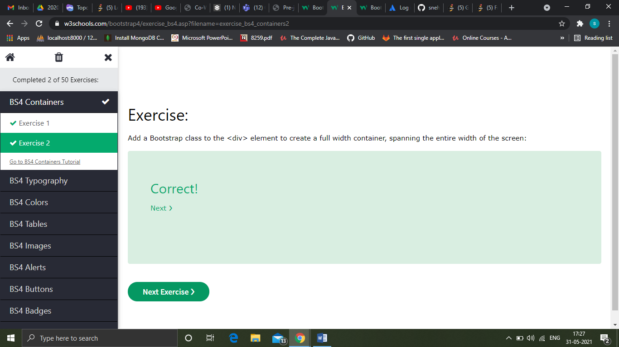

BS Typography

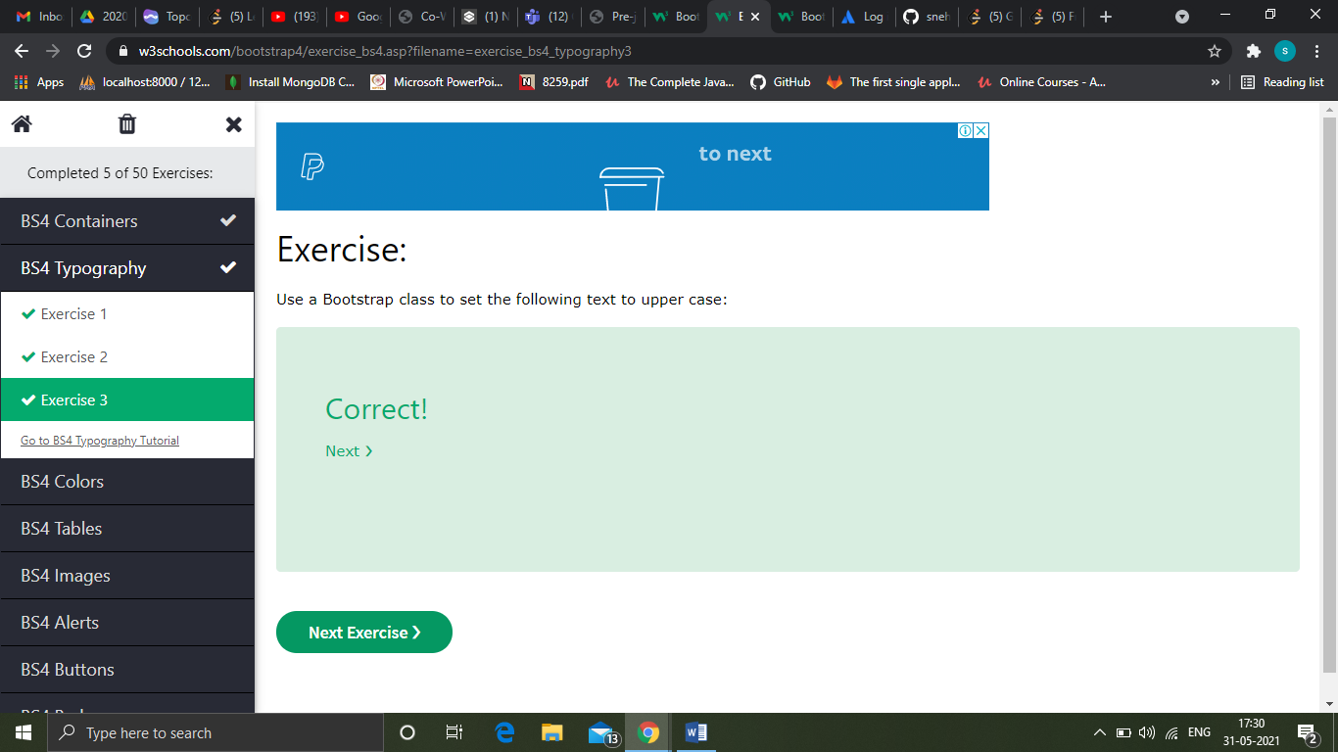

BS Colors

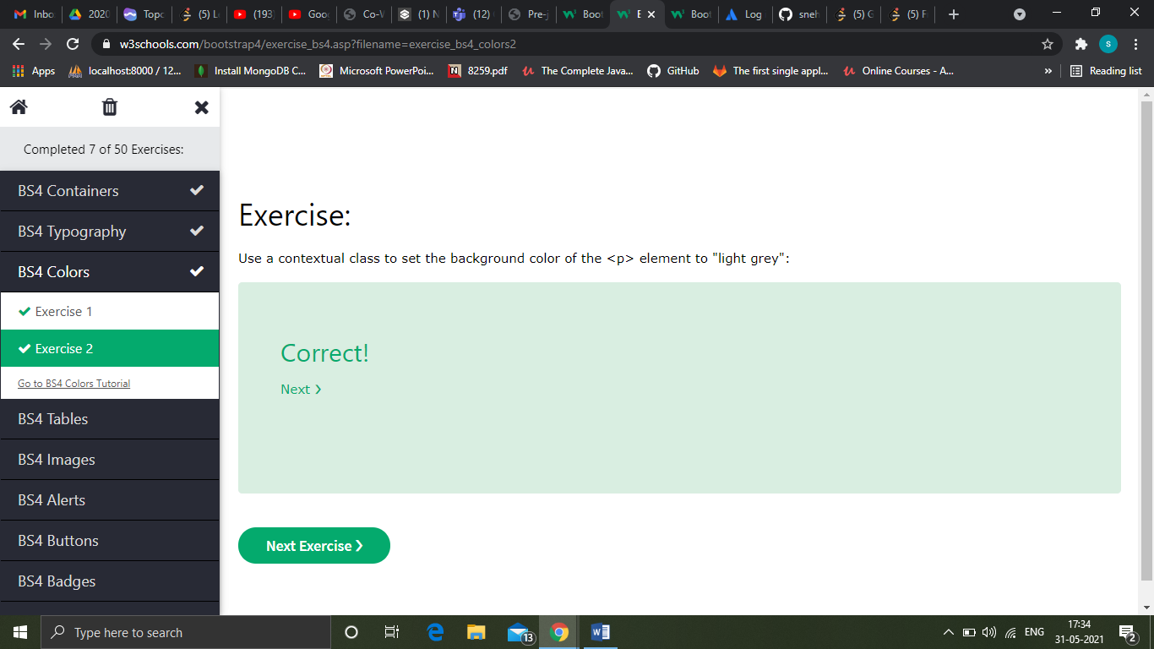

BS Tables

| **Class** | **Description** |
| --- | --- |
| .table-primary | Blue: Indicates an important action |
| .table-success | Green: Indicates a successful or positive action |
| .table-danger | Red: Indicates a dangerous or potentially negative action |
| .table-info | Light blue: Indicates a neutral informative change or action |
| .table-warning | Orange: Indicates a warning that might need attention |
| .table-active | Grey: Applies the hover color to the table row or table cell |
| .table-secondary | Grey: Indicates a slightly less important action |
| .table-light | Light grey table or table row background |
| .table-dark | Dark grey table or table row background |

| **Class** | **Screen width** |
| --- | --- |
| .table-responsive-sm | < 576px |
| .table-responsive-md | < 768px |
| .table-responsive-lg | < 992px |
| .table-responsive-xl | < 1200px |

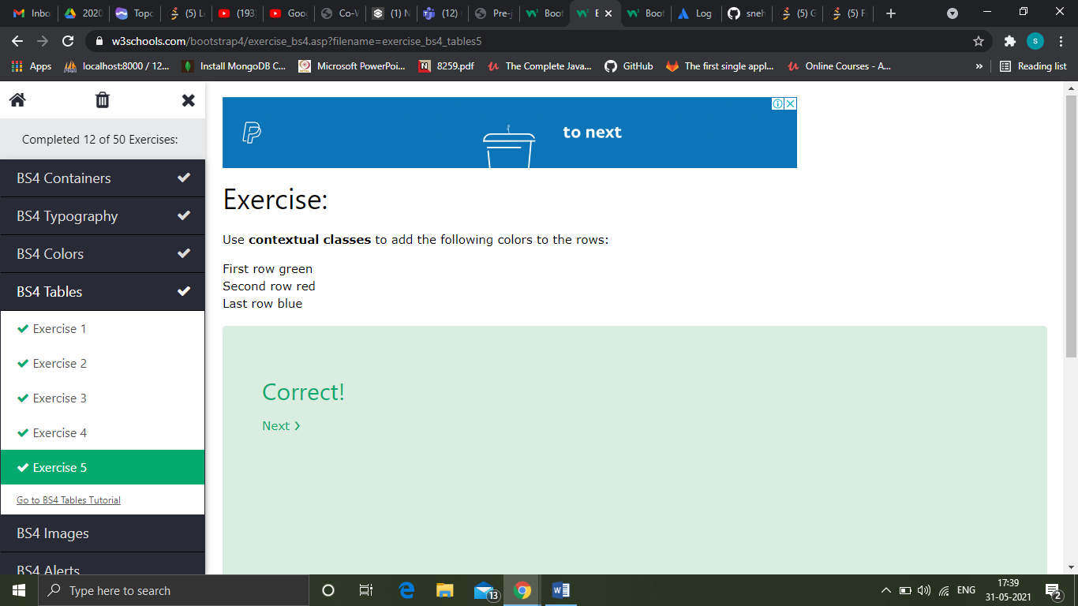

BS Images

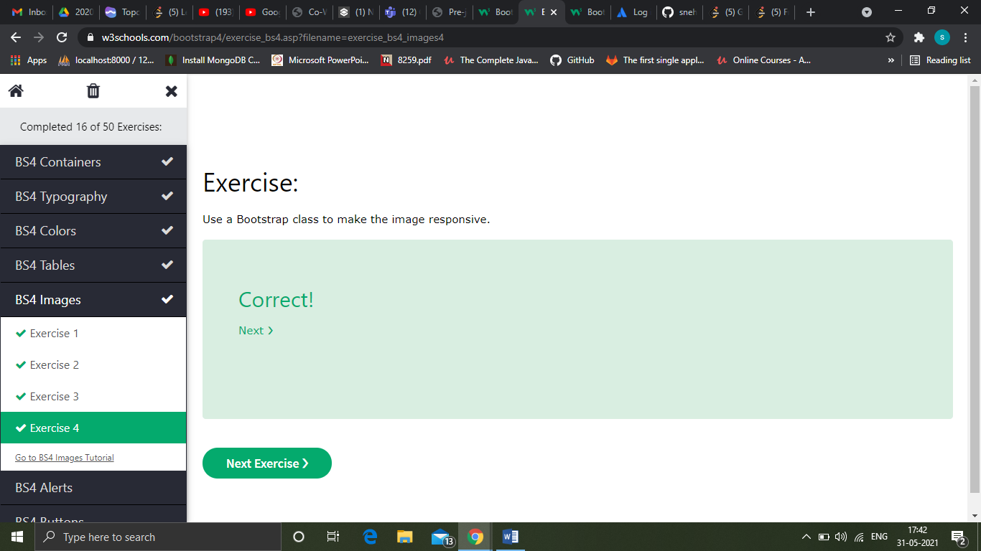

BS Jumbotron

A jumbotron indicates a big grey box for calling extra attention to some special content or information.

BS Alerts

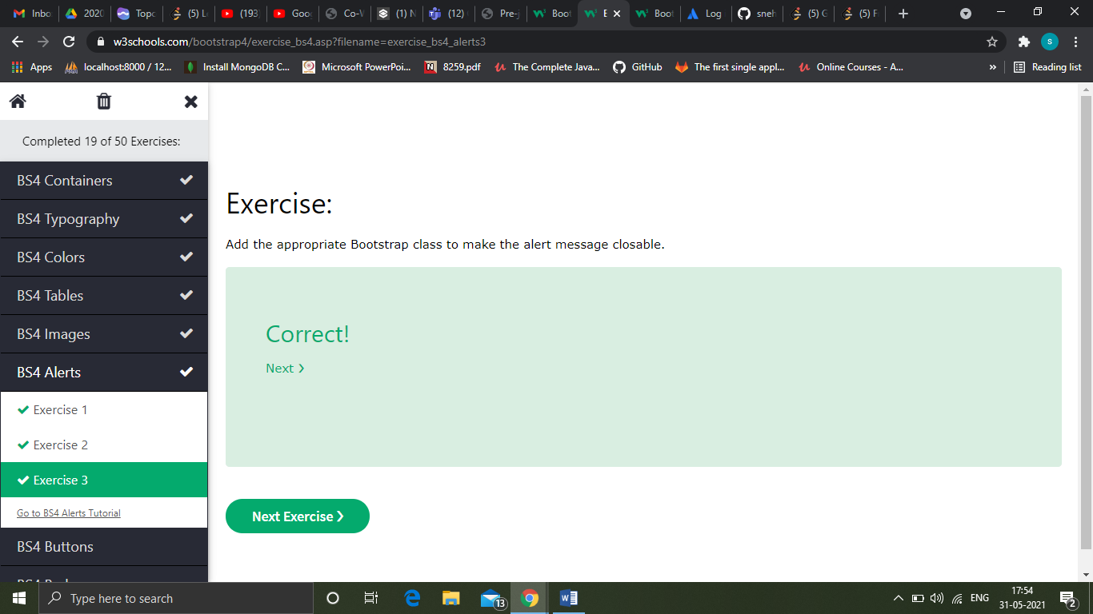

BS Buttons

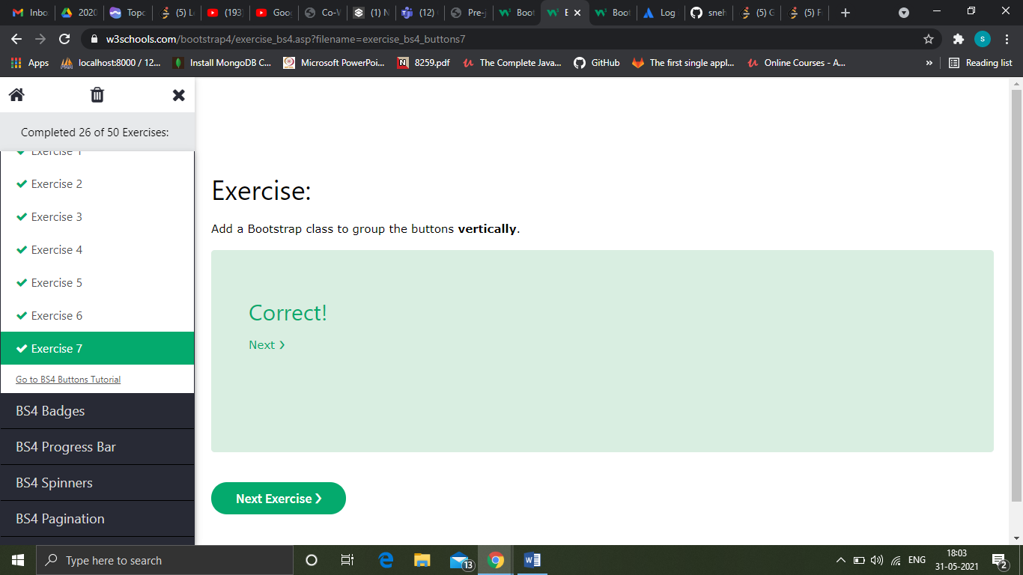

BS Badges

Badges are used to add additional information to any content. Use the .badge class together with a contextual class (like .badge-secondary) within <span> elements to create rectangular badges.

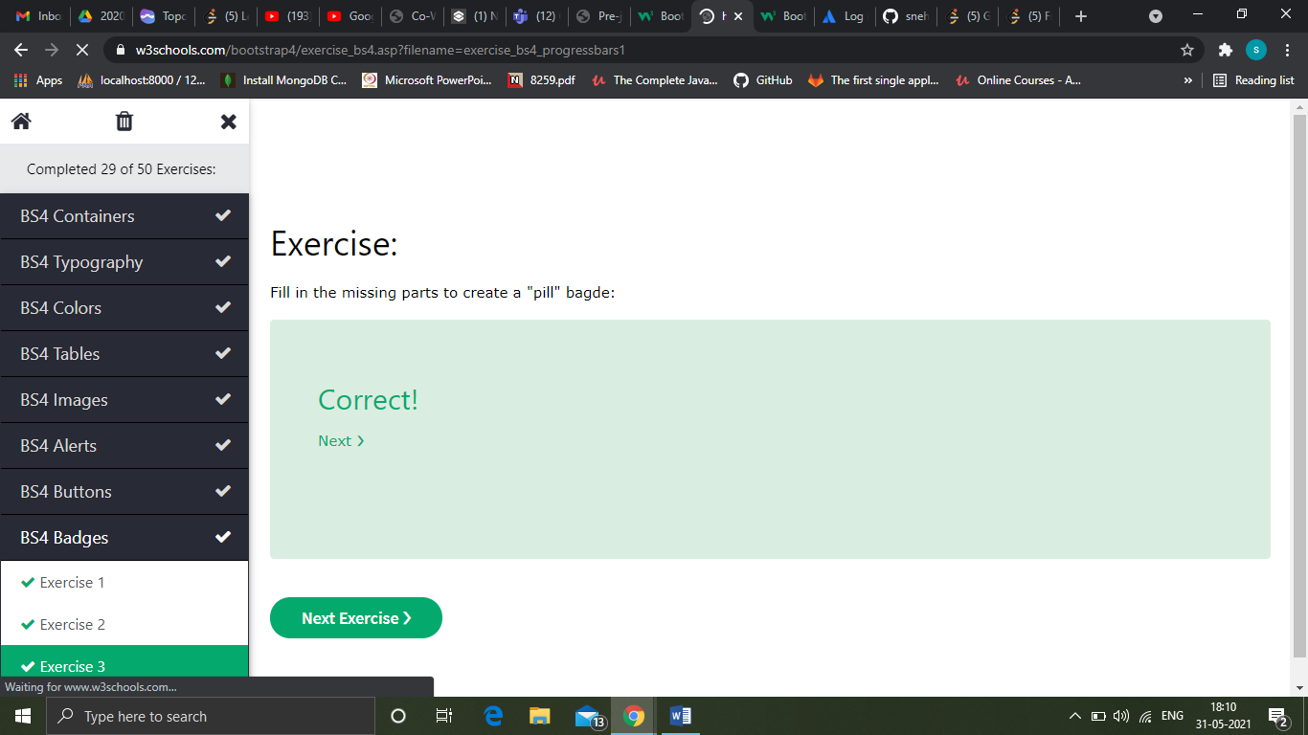

BS Progress Bars

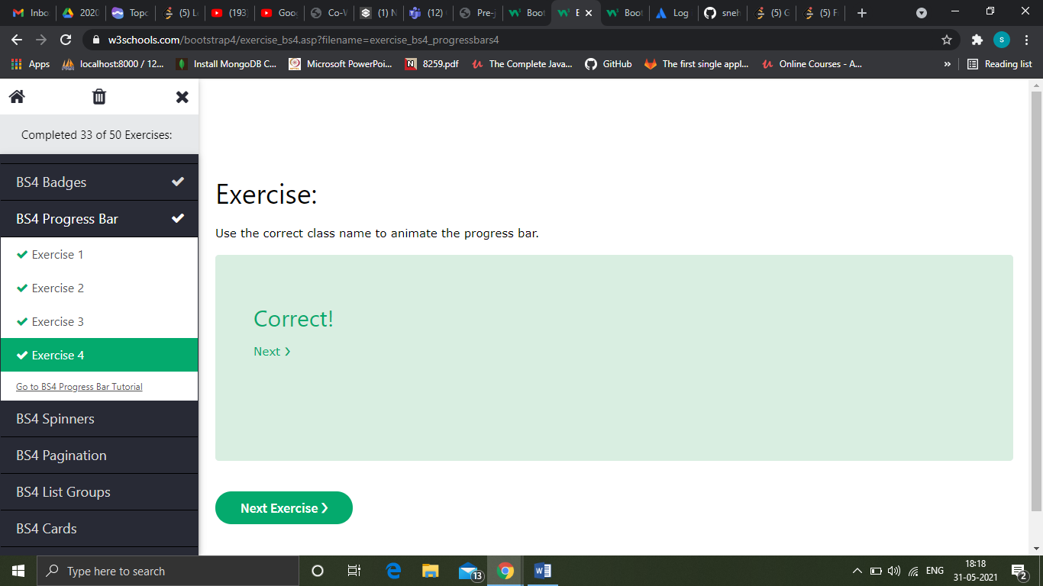

BS Spinners

To create a spinner/loader, use the .spinner-border class

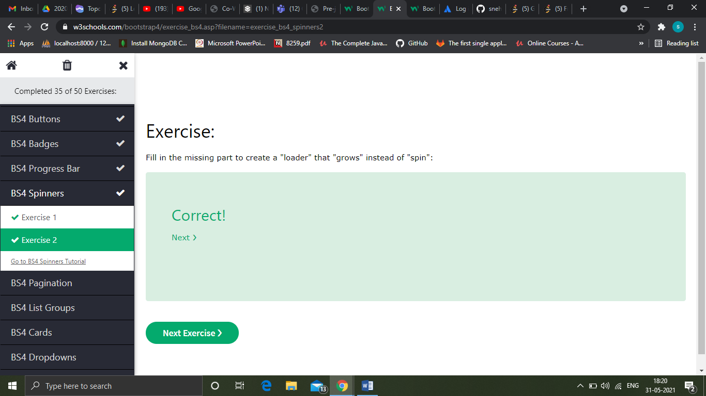

BS Pagination

To create a basic pagination, add the .pagination class to an <ul> element. Then add the .page-item to each <li> element and a .page-link class to each link inside <li>

The .breadcrumb and .breadcrumb-item classes indicates the current page's location within a navigational hierarchy

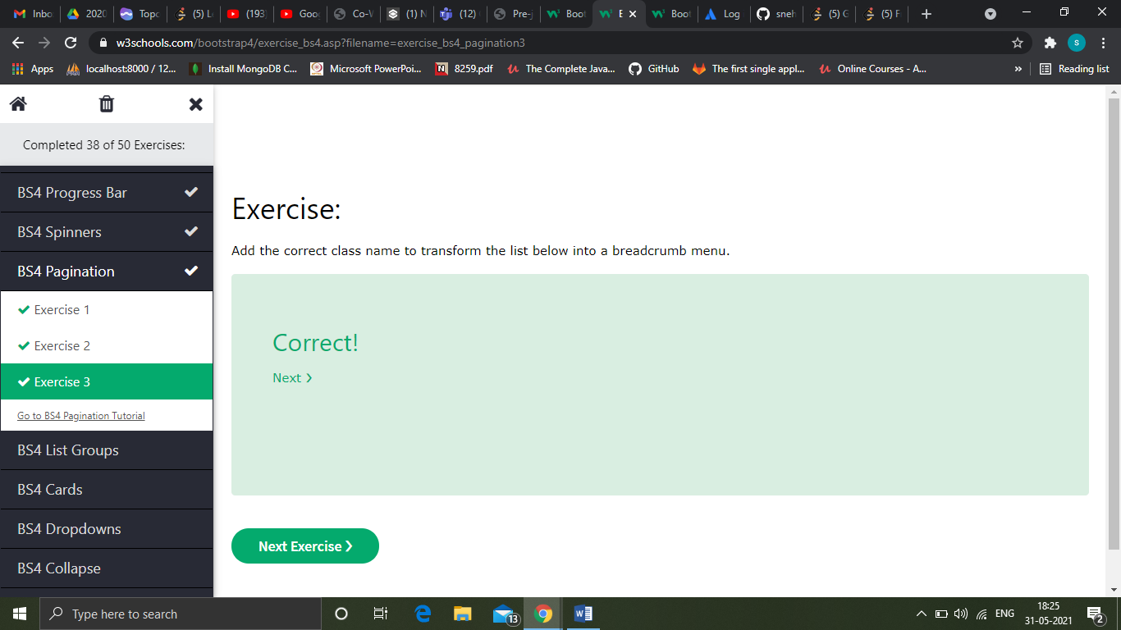

BS List groups

To create a basic list group, use an <ul> element with class .list-group, and <li> elements with class .list-group-item

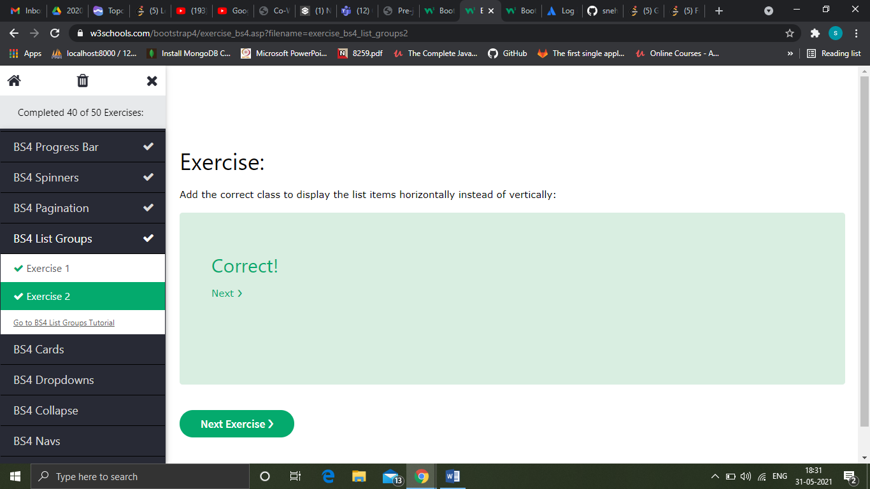

BS Cards

A card in Bootstrap 4 is a bordered box with some padding around its content. It includes options for headers, footers, content, colors, etc.

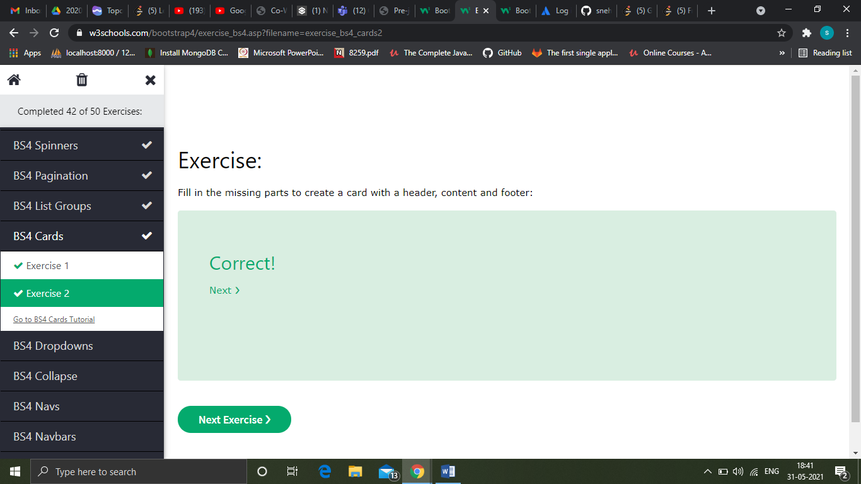

BS Dropdowns

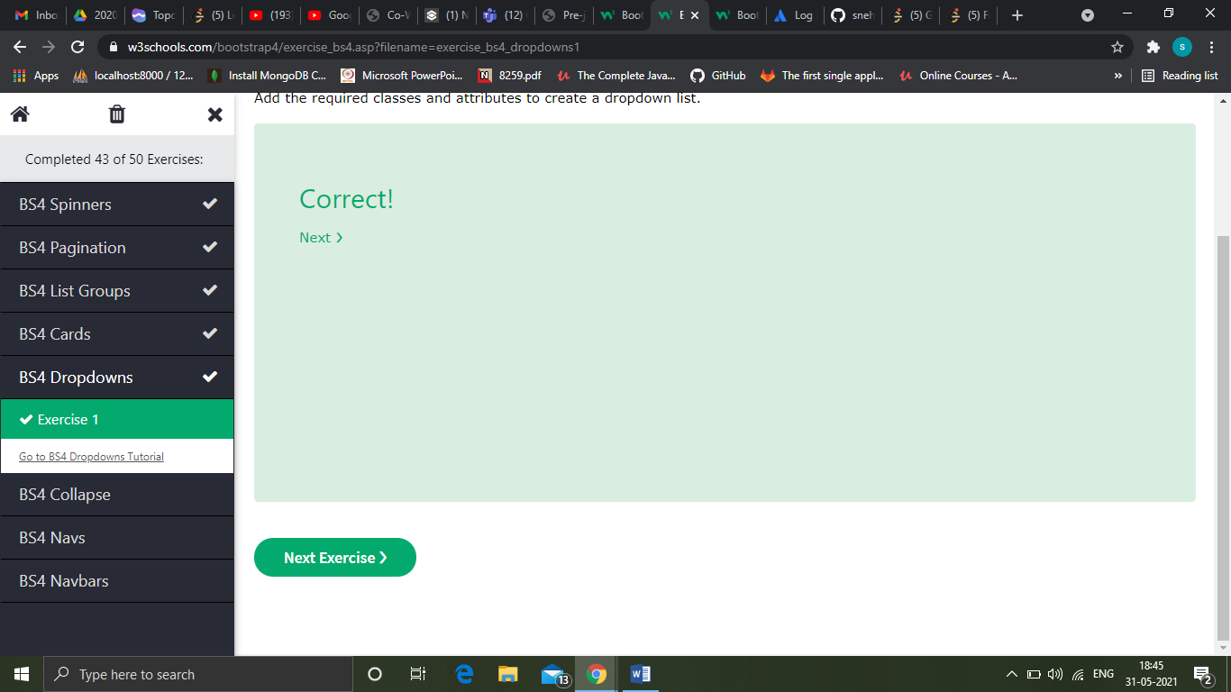

BS Collapse

To control (show/hide) the collapsible content, add the data-toggle="collapse" attribute to an <a> or a <button> element. Then add the data-target="#id" attribute to connect the button with the collapsible content (<div id="demo">)

For <a> elements, you can use the href attribute instead of the data-target attribute

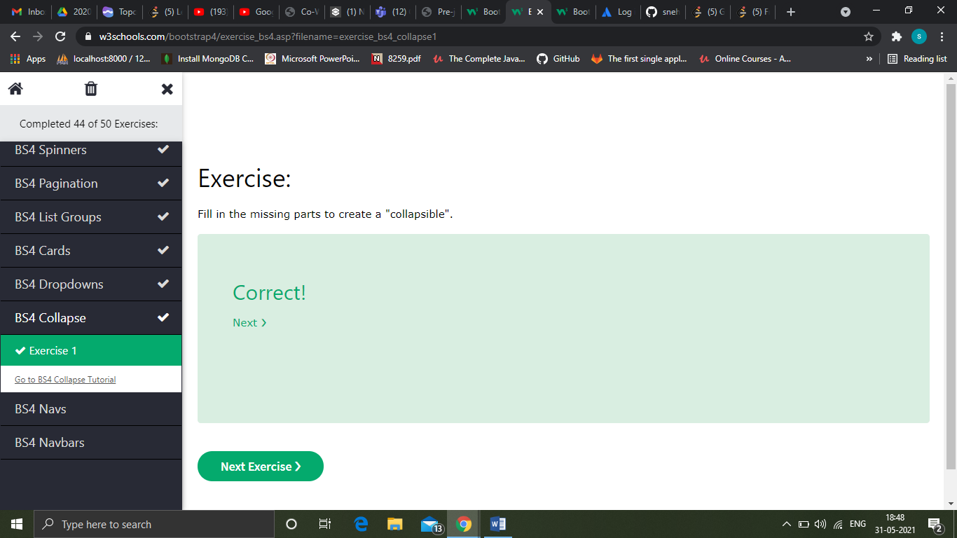

BS Navs

If you want to create a simple horizontal menu, add the .nav class to a <ul> element, followed by .nav-item for each <li> and add the .nav-link class to their links

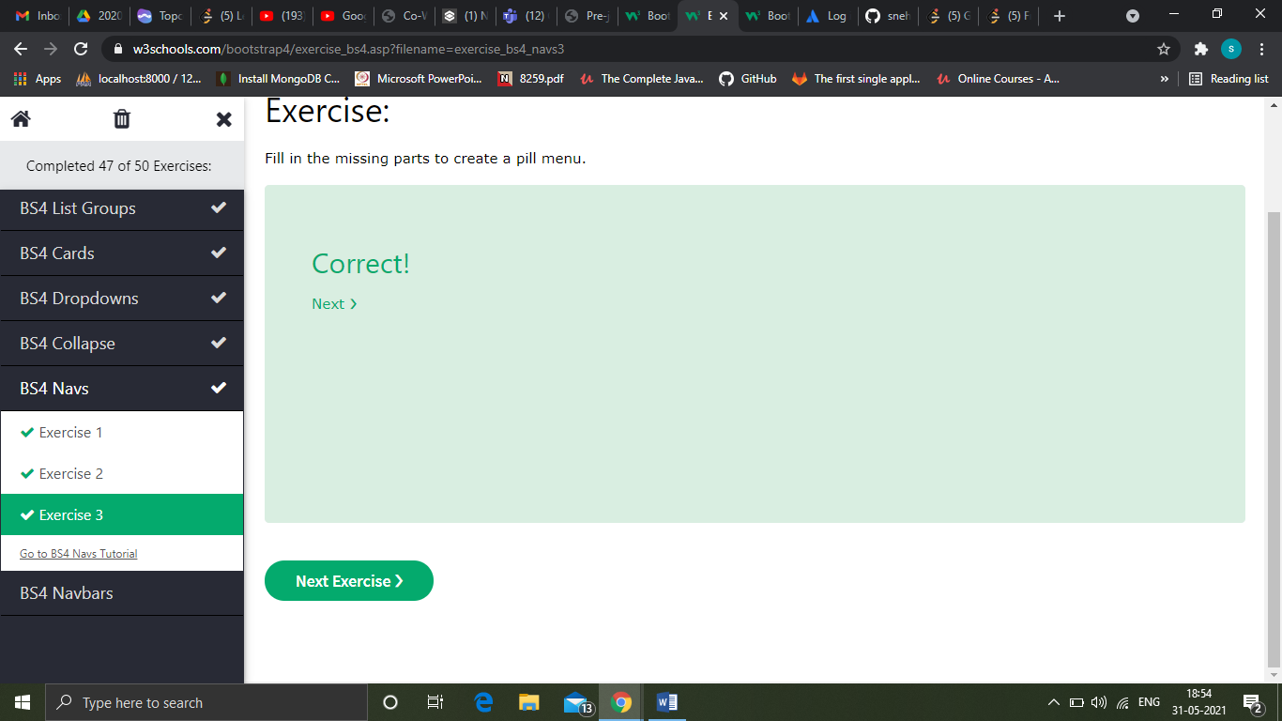

BS Navbars

With Bootstrap, a navigation bar can extend or collapse, depending on the screen size.

A standard navigation bar is created with the .navbar class, followed by a responsive collapsing class: .navbar-expand-xl|lg|md|sm (stacks the navbar vertically on extra large, large, medium or small screens).

To add links inside the navbar, use a <ul> element with class="navbar-nav". Then add <li> elements with a .nav-item class followed by an <a> element with a .nav-link class

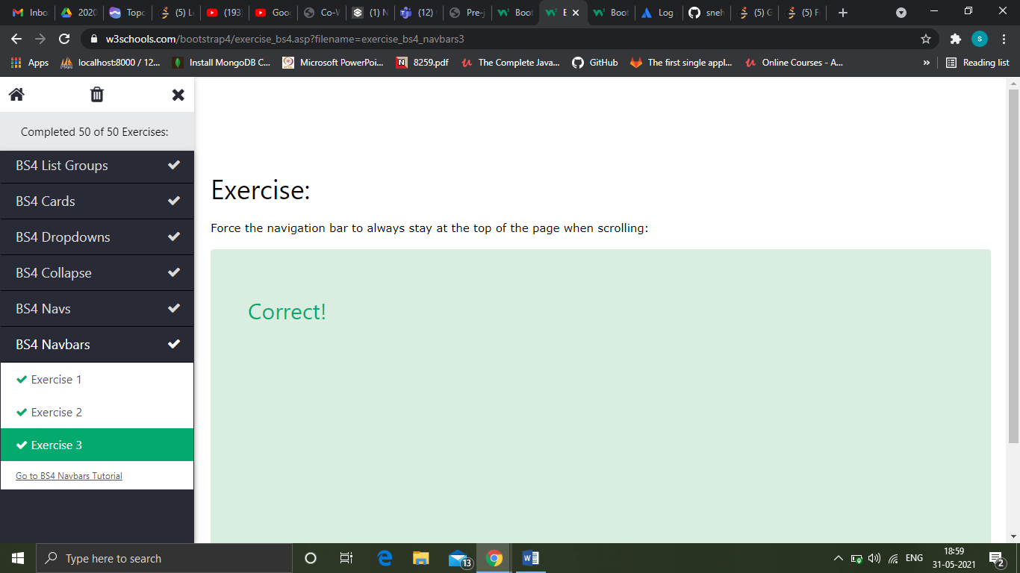

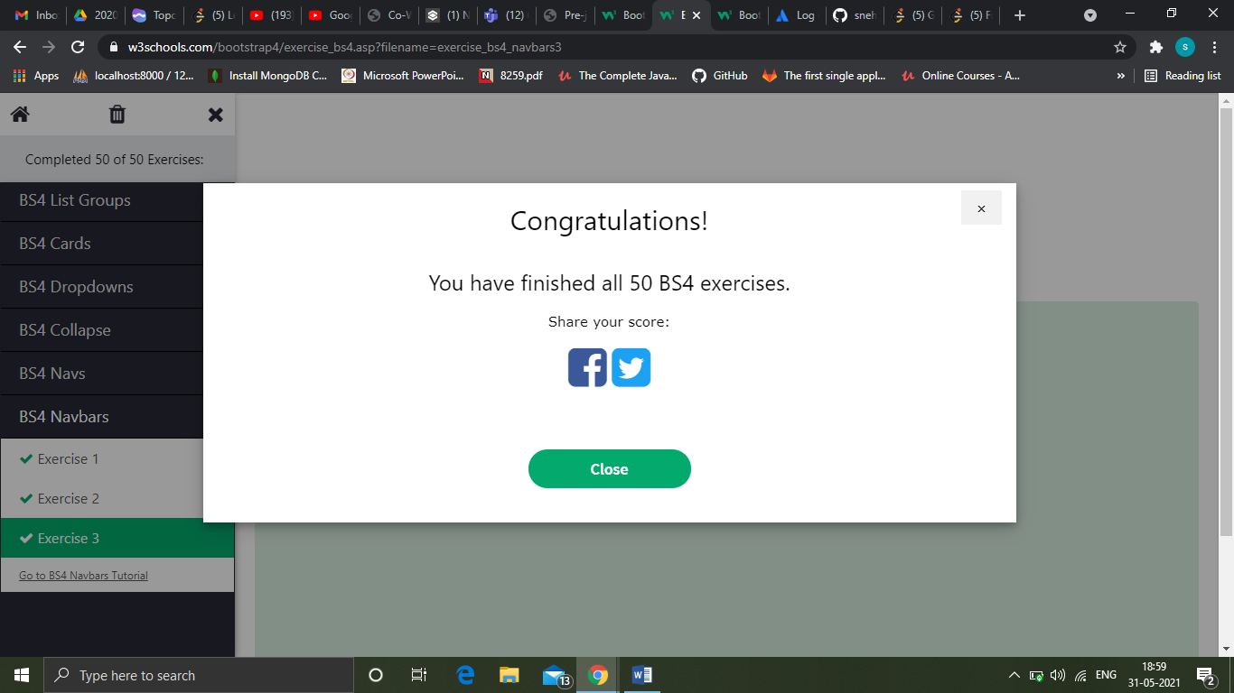

BS Forms

The following example contains two input elements; one of type="text" and one of type="password". As we mentioned in the Forms chapter, we use the .form-control class to style inputs with full-width and proper padding, etc

Use a wrapper element with class="form-check" to ensure proper margins for labels and checkboxes.

Add the .form-check-label class to label elements, and .form-check-input to style checkboxes properly inside the .form-check container.

Add the .form-control-range class to input type"range" or .form-control-file to input type"file" to style a range control or a file field with full-width

QUIZ

