STATISTICS

1. Definition of Statistics
Statistics is the branch of mathematics that deals with collecting, analyzing, interpreting, organizing, and presenting data.

2. Uses of Statistics
Business: decision making and profit analysis
Healthcare: clinical trials and disease analysis
Education: student performance evaluation
Government: planning and policy making
Sports: performance analysis
Technology: Data Science and Machine Learning

3. Types of Statistics

Descriptive Statistics
Summarizes and organizes data.
Examples:
- Calculating average marks of students
- Displaying sales data using charts
- Finding median income
- Reporting highest and lowest temperature

Inferential Statistics
Uses sample data to make predictions about a population.
Examples:
- Predicting election results using surveys
- Estimating average income from a sample
- Testing effectiveness of a medicine
- Forecasting future sales

4. Types of Data

Qualitative Data
Nominal: colors (red, blue), gender (male, female)
Ordinal: rankings (first, second), satisfaction (low, medium, high)

Quantitative Data
Discrete: number of students, number of cars
Continuous: height (170.5 cm), weight (65.8 kg)

5. Variables
Independent Variable: input
Dependent Variable: output

Measure of Central Tendency

Mean
Formula: μ = Σx / N
Example: Data = [10,15,17,13,10,14,18,16]
Mean = 14.125
import numpy as np
np.mean([10,15,17,13,10,14,18,16])
import statistics
statistics.mean([10,15,17,13,10,14,18,16])
Conclusion: Represents the average and uses all values.

Median
Example: Data = [10,20,30,40,50]
Median = 30
np.median([10,20,30,40,50])
statistics.median([10,20,30,40,50])
Conclusion: Middle value and not affected by outliers.

Mode
Mode is the value that appears most frequently.

Unimodal
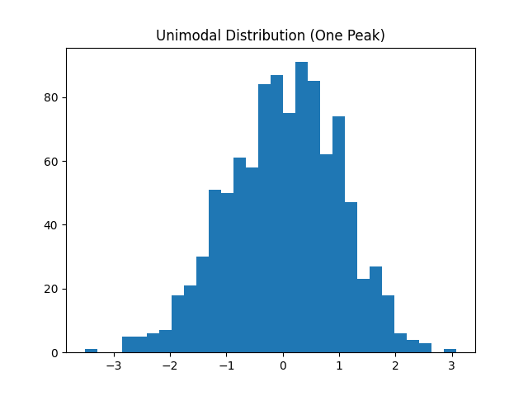
Example: [10,20,15,15,18] → Mode = 15
statistics.mode([10,20,15,15,18])
statistics.multimode([10,20,15,15,18])
Conclusion: One most frequent value.

Bimodal
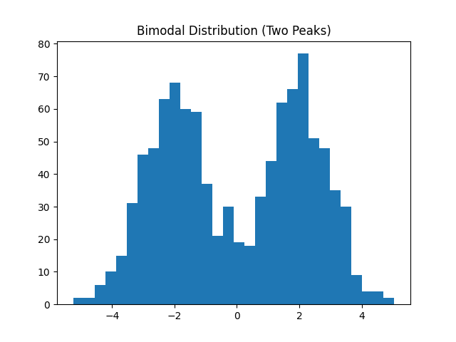
Example: [10,20,15,15,18,20] → Modes = 15, 20
statistics.multimode([10,20,15,15,18,20])
Conclusion: Two most frequent values.

Multimodal
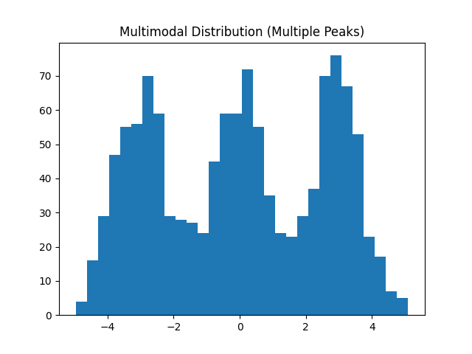
Example: [10,20,15,15,18,20,10] → Modes = 10, 15, 20
statistics.multimode([10,20,15,15,18,20,10])
Conclusion: Multiple frequent values.

No Mode
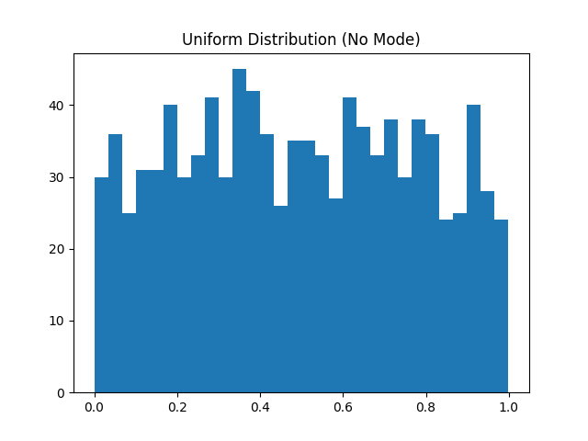
Example: [10,20,30,40,50]
statistics.multimode([10,20,30,40,50])
Conclusion: No repeated value.

Measure of Dispersion

Range
Range = Max - Min
Example: [10,5,4,15,21,7] → Range = 17
max(data) - min(data)
Conclusion: Shows total spread.

Variance
Formula: σ² = Σ(x-μ)² / N
Example: [2,4,6] → Variance = 2.67
np.var([2,4,6])
statistics.pvariance([2,4,6])
Conclusion: Spread from mean (squared).

Standard Deviation
Formula: σ = √σ²
Example: SD = 1.63
np.std([2,4,6])
statistics.pstdev([2,4,6])
Conclusion: Average deviation from mean.

Interquartile Range
IQR = Q3 - Q1
Example: [1,2,3,4,5,6,7] → IQR = 4
np.percentile(data,75) - np.percentile(data,25)
Conclusion: Middle 50 percent spread.

Percentile
Example: 75th percentile means 75 percent of values are below it.
Conclusion: Shows relative position.

Outliers
Outliers are extreme values.
Conclusion: Use median and IQR when outliers exist.

Normal Distribution Rule
68 percent within 1 SD
95 percent within 2 SD
99.7 percent within 3 SD

Note Points
- Statistics analyzes data
- Mean, median, mode describe center
- Range, variance, SD describe spread
- Median and IQR handle outliers
- 68-95-99.7 rule

