HYPOTHESIS TESTING

Hypothesis: An idea or explanation for something that is based on known facts but has not yet been proven to be true.
In Statistics :
A hypothesis is a statement or assumption about a population parameter, such as:
Population mean → μ
Population proportion → p
Population variance → σ²
Since it is usually difficult to collect data from the entire population, we take a sample data to test the hypothesis.
--------------------------------------------------------------------------------------------------------------------------
What is Hypothesis Testing?
Hypothesis testing is a statistical method used to determine whether there is enough evidence in sample data to reject a claim or assumption about a population.
-------------------------------------------------------------------------------------------------------------------------
Population and Sample
Population : The entire group we are interested in studying.
Sample : A subset of the population selected for analysis.
Suppose a company produces 1,00,000 tea packets.
(It is difficult to check every packet . So we select 30 packets)
Population=1,00,000 packets
Sample=30 packets
We use the sample to make an inference about the population.
----------------------------------------------------------------------------------------------------
Why Do We Need Hypothesis Testing?
Average packet weight = 500 g
randomly select 30 packets and calculate: $\overset{ˉ}{x}=495g$
Does this mean that the company's claim is wrong? Not necessarily.
The sample mean may differ from the population mean simply because of sampling variation.
For example:
- Sample 1 → 495 g
- Sample 2 → 502 g
- Sample 3 → 498 g
- Sample 4 → 501 g
Different samples can produce different means.
Therefore, we need a statistical method to determine whether the observed difference is statistically significant.
That method is called Hypothesis Testing.

Types of Hypotheses
There are two main hypotheses:
- Null Hypothesis
- Alternative Hypothesis
  - Null Hypothesis (H₀)
The Null Hypothesis represents the statement of no difference, or no effect. It is assumed to be true until proven otherwise
  - Alternative Hypothesis (Hₐ or H₁)
The Alternative Hypothesis represents the claim we want to investigate or find evidence for.
Example:
- A company claims:Average tea packet weight is 500 g.
H0​ : μ=500
- If we want to check whether the average weight is different from 500 g:
$$H_{a }: μ≠500$$
Types of Alternative Hypothesis
- Two-Tailed Test
Used when we want to check whether the population parameter is different from a specific value.
Example
Company claims: $μ=500$
We want to check whether the actual mean is different.
$$H_{0}:μ=500 \\ H_{a}:μ≠500$$The difference could be: Greater than 500 or Less than 500
Therefore, it is called a two-tailed test.

- Right-Tailed Test

Used when we want to check whether the population parameter is greater than a specific value.

Example
A company claims the average battery life is 10 hours.
We want to check whether it is actually greater than 10 hours.
$$H_{0}:μ=10 \\ H_{a}:μ>10$$
This is a right-tailed test.

- Left-Tailed Test

Used when we want to check whether the population parameter is less than a specific value.
Example
A company claims that the average tea packet weight is 500 g.
We want to check whether the actual average is less than 500 g.
$$H_{0}:μ=500 \\ H_{a}:μ<500$$
This is a left-tailed test.

Significance Level (α)
The significance level is the maximum probability of rejecting the null hypothesis when it is actually true.
Significance Level | Meaning
0.10 | 10%
0.05 | 5%
0.01 | 1%

Test Statistic
A test statistic is a numerical value calculated from sample data.
It tells us how far our sample result is from the hypothesized population value.

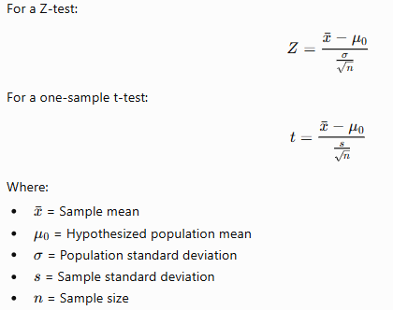

p-value
The p-value helps us determine whether the sample evidence is strong enough to reject the null hypothesis.
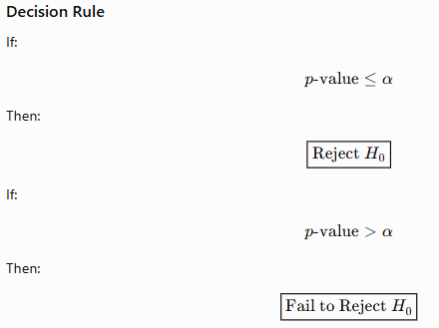
Important
We generally say : Fail to reject H₀ instead of : Accept H₀
Because hypothesis testing does not prove that the null hypothesis is definitely true.
Critical Value
A critical value is a boundary that separates the rejection region from the non-rejection region.

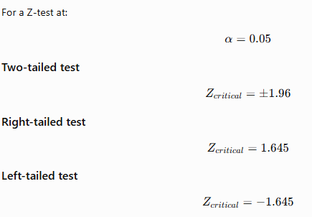

Rejection Region
The rejection region is the range of test statistic values where we reject $H_{0}$.
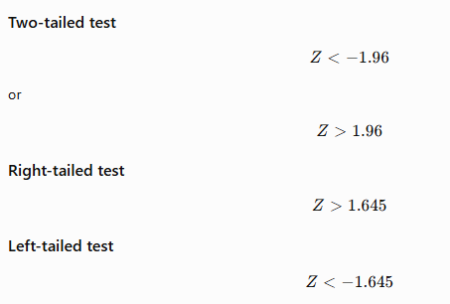

Steps of Hypothesis Testing

Step 1: State the Hypotheses
Step 2: Choose Significance Level $α=0.05$
Step 3: Select the Appropriate Statistical Test
Z-test , t-test , Chi-square test , ANOVA
Step 4: Calculate the Test Statistic
Step 5: Calculate the p-value
Step 6: Make a Decision
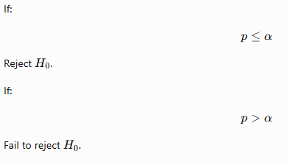
Step 7: State the Conclusion in Context

Type I and Type II Errors
Hypothesis testing can result in two types of errors.

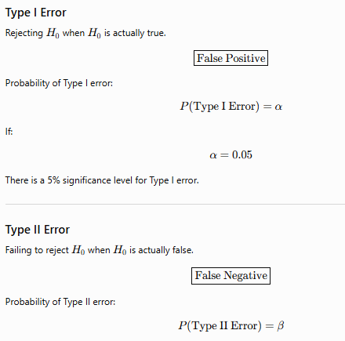

Z-TEST

- What is a Z-test?
A Z-test is a statistical hypothesis test used to determine whether a sample mean is significantly different from a hypothesized population mean when the population standard deviation is known.
The classic one-sample Z-test for a mean is:
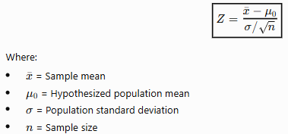
When to Use a Z-Test?
A Z-test for a population mean is appropriate when:
- The population standard deviation $σ$is known, and
- The population is normally distributed, or the sample size is sufficiently large for the Central Limit Theorem to justify the normal approximation.

Example

Problem
A tea company claims that the average weight of its tea packets is 500 g.

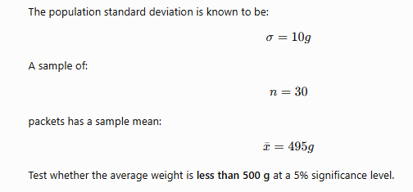
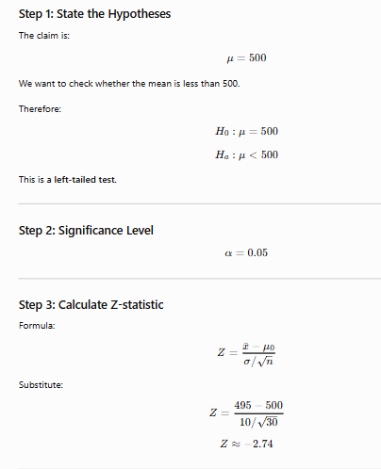
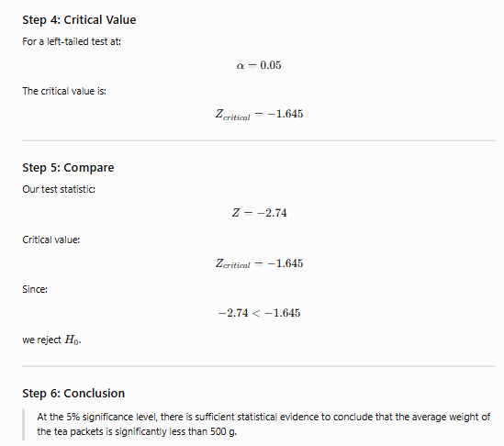

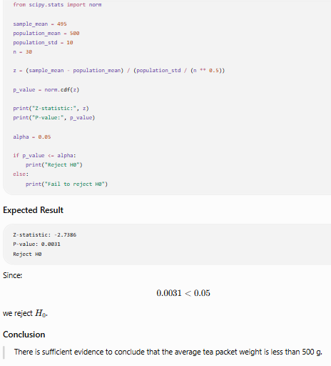

T-TEST

What is a T-test?
A t-test is a statistical hypothesis test used to determine whether a sample mean is significantly different from a hypothesized population mean when the population standard deviation is unknown.
Instead of using the population standard deviation $σ$, we use the sample standard deviation $s$.
The one-sample t-test formula is:
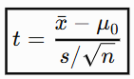
When to Use a T-Test?
A t-test is commonly used when:
- Population standard deviation is unknown.
- Sample standard deviation is used instead.
- Data is approximately normally distributed, especially for small samples.
The t-distribution is particularly useful for small samples because it accounts for the extra uncertainty introduced when estimating the population standard deviation from the sample.

Degrees of Freedom
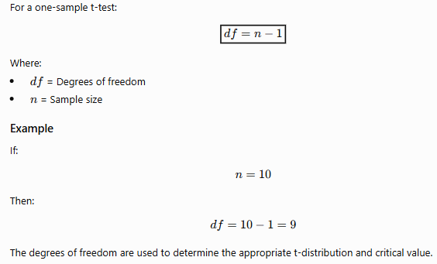
Example