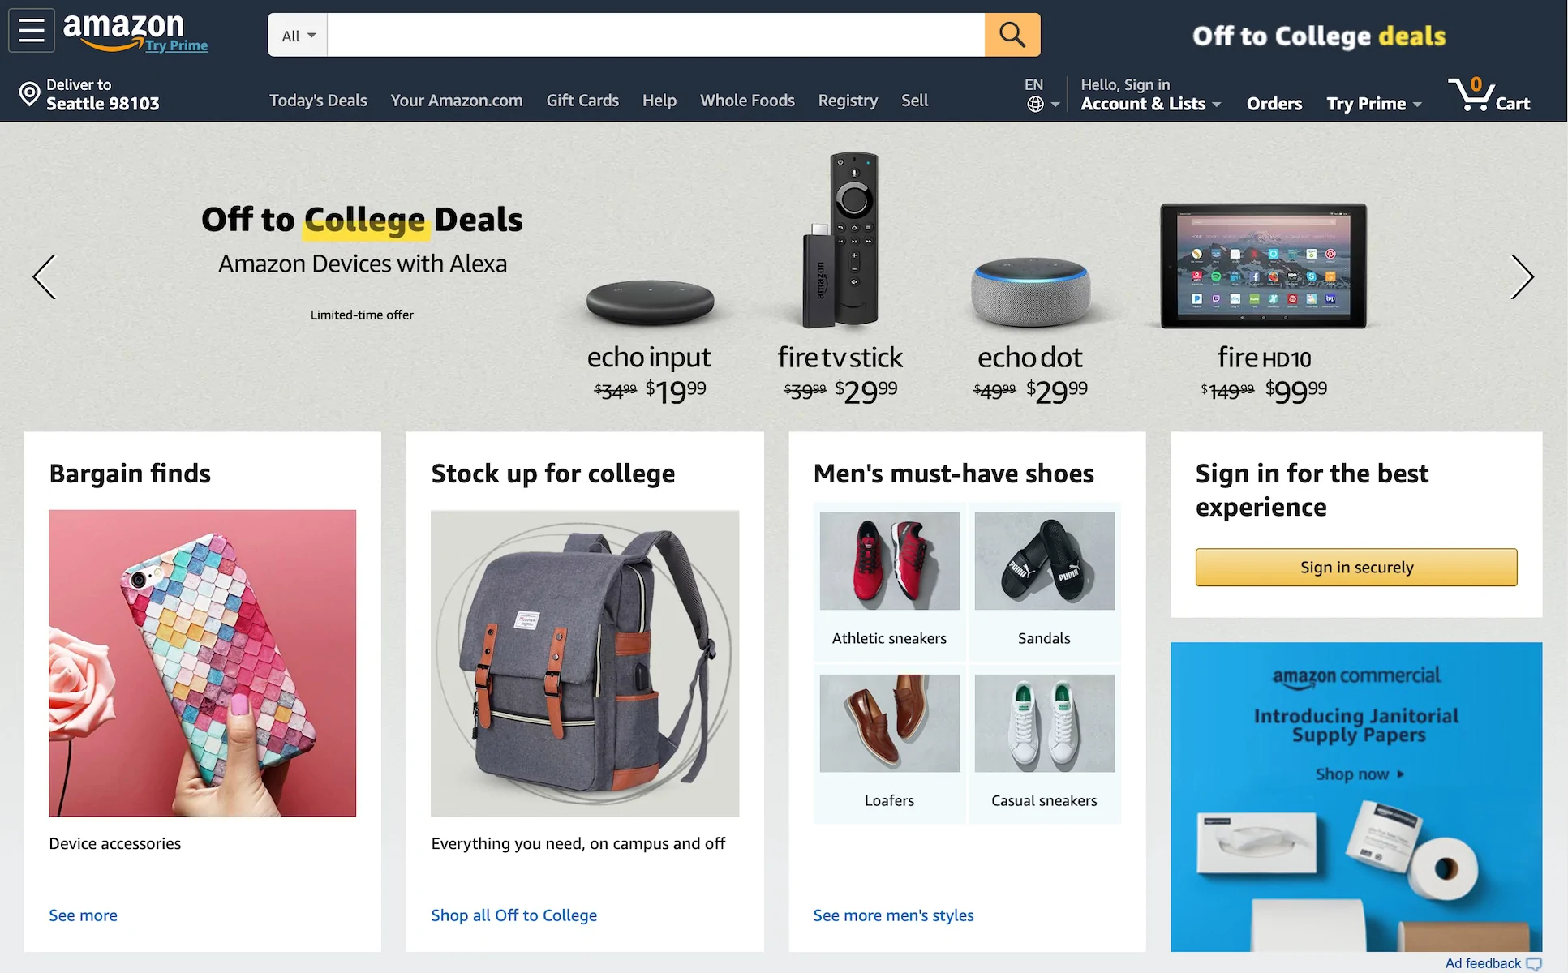

**PRODUCT NAME: AMAZON WEBSITE**

**OVERVIEW:**

Its an e-commerce website for bags, shoes, electronic goods, outfits(for both men and women), books and much more under the same roof.

**LOGIN PAGE:**

* Like a usual login page.
* Asks the user to enter login id and password.

**HOME PAGE:**

* Logo
* Search Bar
* Sliders with arrows (Images)
* Deals(Images)
* Featured(Images)
* Trending(Images)
* Footer(Contact Us , Helplines)

**PRODUCT PAGE:**

* Shows description of selected product.
* Add to cart option
* OR Buy Now option

**PAYMENT PAGE:**

* Address Selection
* Payment Method(COD,CREDIT/DEBIT Card , EMI,NET BANKING)

**TECHNOLOGIES USED:**

* HTML
* CSS
* Bootstrap
* React
* JavaScript

**DATABASE:**

* Mongodb

**CODE COMPILERS:**

* Visual Studio Code
* Git Bash
* Git Hub
* Node js