BOOKSHOP SALES & CUSTOMER INSIGHTS
Tableau Project Report
Business-focused analysis of author performance, genres, ratings, publishers, seasonal sales, and library demand.

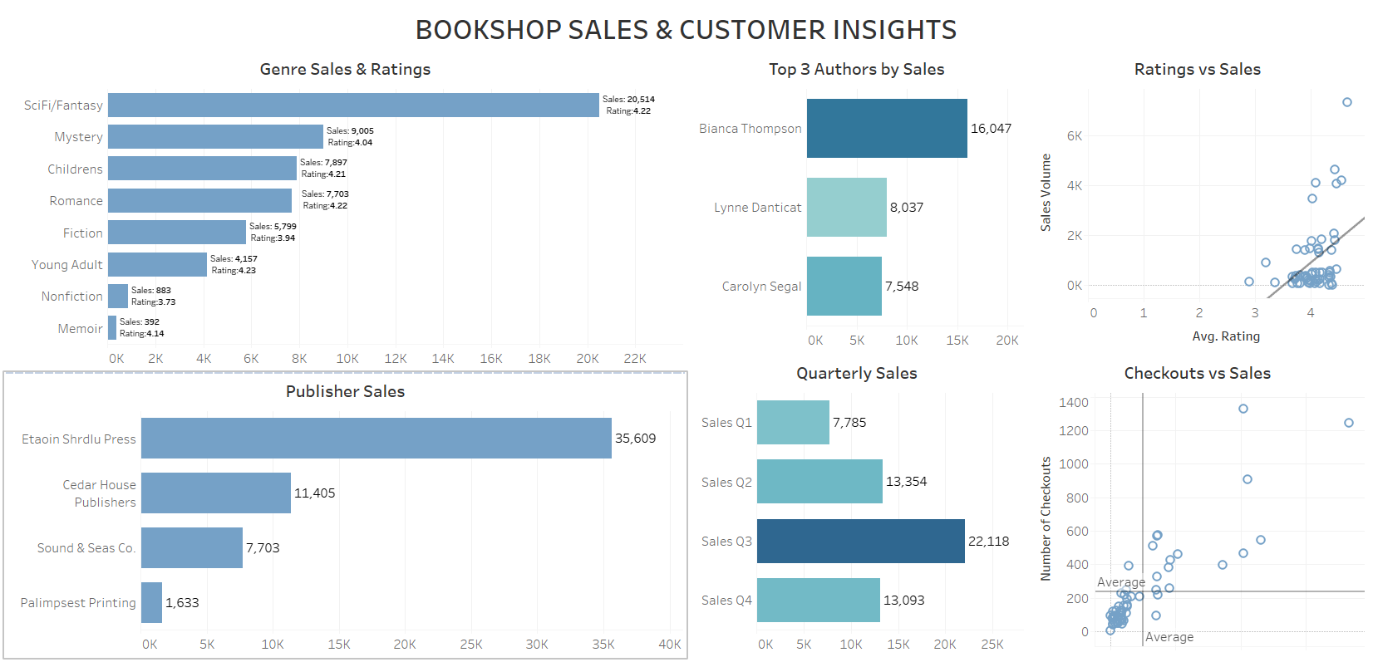
Final Tableau Dashboard

1. Project Overview
This project analyzes a relational bookshop dataset in Tableau to support practical business decisions. The analysis combines information about books, authors, editions, publishers, ratings, library checkouts, and quarterly sales. The final output is an interactive dashboard designed to help the bookshop understand what sells, when demand is highest, which partners and authors perform best, and where additional sales opportunities may exist.

2. Business Objectives
- Identify the top-selling authors and recommend candidates for an author-signing event.
- Determine which genres sell best and compare genre sales with customer ratings.
- Assess whether better-rated books tend to sell more copies.
- Identify the publishing house that contributes the highest sales volume.
- Determine the busiest sales quarter and translate the finding into staffing and inventory implications.
- Compare library checkouts with bookstore sales to identify potential hidden gems that may be under-selling.

3. Dataset and Data Model
The source workbook contains multiple related tables, including Book, Info, Author, Award, Checkouts, Edition, Publisher, Ratings, Series, and four quarterly Sales sheets (Q1-Q4). Tableau relationships were used to preserve the logical structure of the data while allowing analysis across the different subject areas.

Key Data Relationships
From | To | Key
Book and Info | Author | Auth ID = AuthID
Book and Info | Award | Title = Title
Book and Info | Checkouts | Book ID = BookID
Book and Info | Edition | Book ID = BookID
Book and Info | Ratings | Book ID = BookID
Book and Info | Series | Series ID = SeriesID
Edition | Annual Sales | ISBN = ISBN
Edition | Publisher | Pub ID = PubID

The four quarterly sales sheets were combined using a UNION to create an Annual Sales table. A union was appropriate because the quarterly sheets contain the same type of fields and needed to be stacked vertically into a single annual dataset. A join, by contrast, would combine columns horizontally based on matching keys.

4. Tools and Tableau Features Used
- Tableau Desktop for data modeling, analysis, visualization, and dashboard development.
- Microsoft Excel as the source data format.
- Relationships and joins for connecting relational tables.
- Union for combining Q1-Q4 sales into an annual sales dataset.
- Calculated field to create a full author name from first and last name.
- Top-N filtering for identifying the top three authors.
- Bar charts, scatter plots, trend lines, and average reference lines.
- Dashboard actions and interactive genre filtering.
- Tooltip-based detail to keep scatter plots readable while preserving book-level information.

5. Analysis and Findings

5.1 Top Authors by Sales
Business question: Who should be invited for an author-signing event?
- Bianca Thompson - 16,047 copies
- Lynne Danticat - 8,037 copies
- Carolyn Segal - 7,548 copies
Conclusion: Bianca Thompson is the strongest candidate for an author-signing event because she is the highest-selling author and sold almost twice as many copies as the second-ranked author.

5.2 Genre Sales and Ratings
Business question: Which genres should the shop stock more of?
- SciFi/Fantasy - 20,514 copies; average rating approximately 4.22
- Mystery - 9,005 copies; average rating approximately 4.04
- Children's - 7,897 copies; average rating approximately 4.21
- Young Adult - 4,157 copies; average rating approximately 4.23
- Memoir - 392 copies; average rating approximately 4.14
Conclusion: SciFi/Fantasy is the strongest candidate for increased inventory because it combines very high sales with strong ratings. Young Adult and Memoir show relatively strong ratings despite lower sales, suggesting possible promotional or stocking opportunities.

5.3 Ratings vs Sales
Business question: Do better-rated books actually sell more?
Conclusion: The book-level scatter plot and linear trend line show an overall positive relationship between average rating and sales volume. However, books with similar ratings can have very different sales, so ratings alone do not determine commercial success.

5.4 Publisher Sales
Business question: Which publisher is the most valuable partner?
- Etaoin Shrdlu Press - 35,609 copies
- Cedar House Publishing - 11,405 copies
- Sound & Seas Co. - 7,703 copies
- Palimpsest Printing - 1,633 copies
Conclusion: Etaoin Shrdlu Press is the most valuable publishing partner by a wide margin. The bookshop could consider negotiating improved purchasing terms, discounts, or promotional support based on the volume generated through this publisher.

5.5 Quarterly Sales
Business question: When is the busy season?
- Q1 - 7,785 copies
- Q2 - 13,354 copies
- Q3 - 22,118 copies
- Q4 - 13,093 copies
Conclusion: Q3 is the busiest quarter. Inventory replenishment, stock ordering, and staffing should be increased ahead of and during Q3 to prepare for the higher demand.

5.6 Checkouts vs Sales
Business question: Are there hidden gems the shop may be under-selling?
Conclusion: The comparison of library checkouts and bookstore sales highlights titles with above-average borrowing demand but comparatively lower sales. Titles such as Rystwyth and Heliotrope Pajamas appear to be potential under-selling opportunities. These books could be tested with increased visibility, promotions, or additional stock.

6. Dashboard Design and Interactivity
The final dashboard, titled 'BOOKSHOP SALES & CUSTOMER INSIGHTS', brings all six analytical views together in a 2-by-3 layout. A consistent blue/teal visual theme was applied across the dashboard. Q3 was intentionally highlighted with a darker shade to emphasize the busiest quarter. Scatter plots were kept uncluttered by using tooltips rather than permanent book labels. The Genre Sales & Ratings chart was configured as an interactive dashboard filter so that users can select a genre and explore its effect across compatible views.

7. Business Recommendations
- Prioritize Bianca Thompson for an author-signing event based on the highest sales volume.
- Maintain strong inventory levels for SciFi/Fantasy and consider targeted promotion of highly rated but lower-selling genres such as Young Adult.
- Use ratings as one indicator of demand, but combine them with sales and other behavioral measures rather than treating ratings as a standalone predictor.
- Strengthen the commercial relationship with Etaoin Shrdlu Press and explore volume-based negotiation opportunities.
- Increase staffing and inventory planning ahead of Q3, the clear peak-sales quarter.
- Test promotions or improved placement for high-checkout, lower-sales titles to convert demonstrated reader interest into bookstore purchases.

8. Conclusion
The Tableau analysis converts a multi-table bookshop dataset into actionable business insights. By combining sales with author, genre, rating, publisher, seasonal, and checkout information, the project demonstrates how data visualization can support decisions across marketing, inventory, partnerships, staffing, and merchandising. The interactive dashboard allows the analysis to be explored dynamically while keeping the most important findings visible at a glance.

9. Project Deliverables
- Interactive Tableau dashboard: Bookshop Sales & Customer Insights
- Six business-question-driven analytical worksheets
- Relational data model with annual sales union
- Project report and documented business conclusions

