NOVAMART
Retail Analytics Dashboard
Power BI Portfolio Case Study

₹6.90M  Sales Revenue | 30.39%  Gross Margin | 99.58%  Target Achievement

Tools: Microsoft Power BI • Microsoft Excel
Focus: Sales • Stores • Products • Workforce • Customer Experience • Targets

1. Executive Summary
NovaMart is a fictional multi-region retail chain in India. This project develops an interactive Power BI solution that brings together sales, store operations, product profitability, workforce, customer feedback and target performance into a single analytical view. The dashboard is designed to help management identify performance gaps, compare business segments and make data-informed operational decisions.
The analysis found approximately ₹6.90 million in sales revenue and ₹2.10 million in gross profit, producing an overall gross margin of about 30.39%. Clothing emerged as the strongest profitability category, the South was the leading sales region, billing speed was the weakest customer-feedback dimension, and overall target achievement was approximately 99.58%.

2. Business Problem & Objectives
NovaMart's operational data is distributed across transactions, stores, products, employees, customer feedback and monthly targets. Management needs a consolidated view that converts these separate datasets into business-ready insights.
- Evaluate overall sales, profit, margin and unit performance.
- Identify high- and low-performing regions, store formats and individual stores.
- Compare product categories by revenue, gross profit, margin and discount behavior.
- Understand workforce distribution, compensation and employee performance.
- Assess customer satisfaction and identify service areas that require improvement.
- Track actual performance against revenue and unit targets.

3. Dataset Overview
The source workbook contains nine interconnected sheets. The analytical tables used in the project are summarized below.
Table | Size | Purpose
Stores | 25 records | Store location, region, type, size and management attributes
Products | 80 records | Category, subcategory, brand, cost, MRP and supplier attributes
Employees | 200 records | Employee demographics, department, role, compensation and rating
Sales Transactions | 600 records | Transaction-level units, discounts, revenue, COGS and gross profit
Monthly Targets | 1,440 records | Store/category monthly target and actual revenue/unit performance
Suppliers | 25 records | Supplier location, lead time, terms and reliability
Customer Feedback | 300 records | Service dimension ratings, NPS and recommendation response
Data Dictionary | Reference | Field definitions and relationship notes
Relationship Map | Reference | Recommended table joins for the Power BI model

4. Data Preparation & Modeling
The Excel tables were imported into Power BI and prepared for analysis by reviewing field types, business keys and relationships. Common identifiers such as Store_ID, Product_ID and Supplier_ID allow the transactional and operational tables to be analyzed alongside descriptive dimensions.
- Reviewed the source tables and data dictionary before building visuals.
- Used shared identifiers to connect sales, stores, products, employees, targets and feedback.
- Created business KPIs for revenue, gross profit, gross margin, units sold, NPS, headcount and target achievement.
- Designed slicers and cross-filtering so performance can be explored by region, store type, category and other business dimensions.

5. Dashboard Solution
The final solution contains six dashboard pages. Each page answers a distinct management question while maintaining a consistent retail analytics narrative.
Executive Summary: High-level view of revenue, profit, margin, NPS, units, headcount and regional/store-type performance.
Store Performance: Store-level revenue, geographic performance, store-size relationship, top stores and target achievement.
Product Profitability: Category and subcategory revenue, gross profit, margins and discount behavior.
Workforce Analytics: Headcount, compensation, performance, gender, education, department and regional workforce patterns.
Customer Satisfaction: Feedback dimensions, NPS, recommendations, store/state comparisons and monthly customer experience.
Target vs Actual: Revenue and unit targets compared with actual performance by store, category and month.

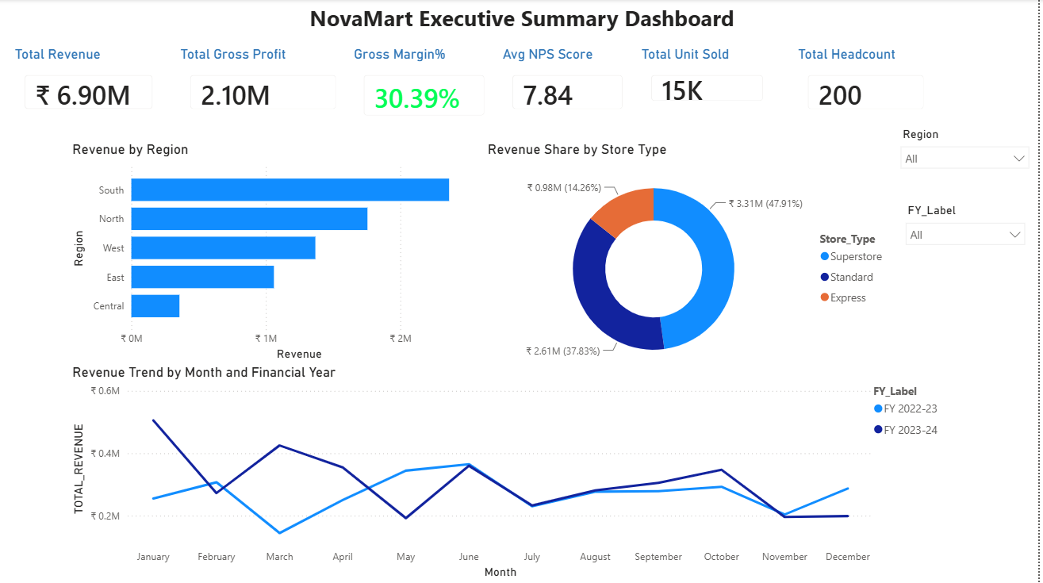
Figure 1. Executive Summary dashboard
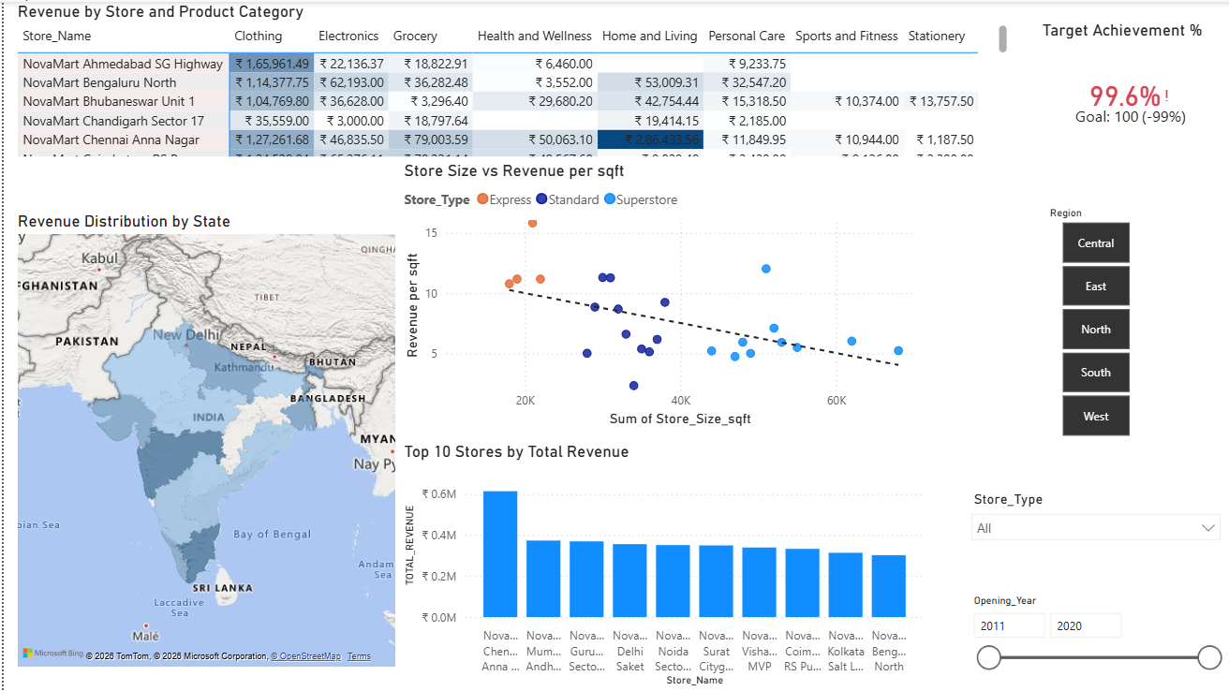
Figure 2. Store Performance dashboard

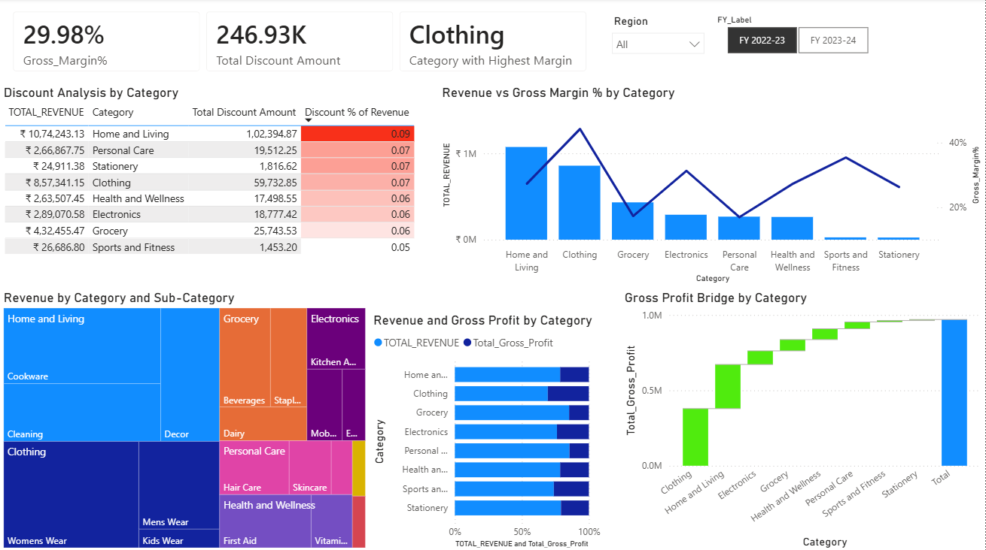
Figure 3. Product Profitability dashboard
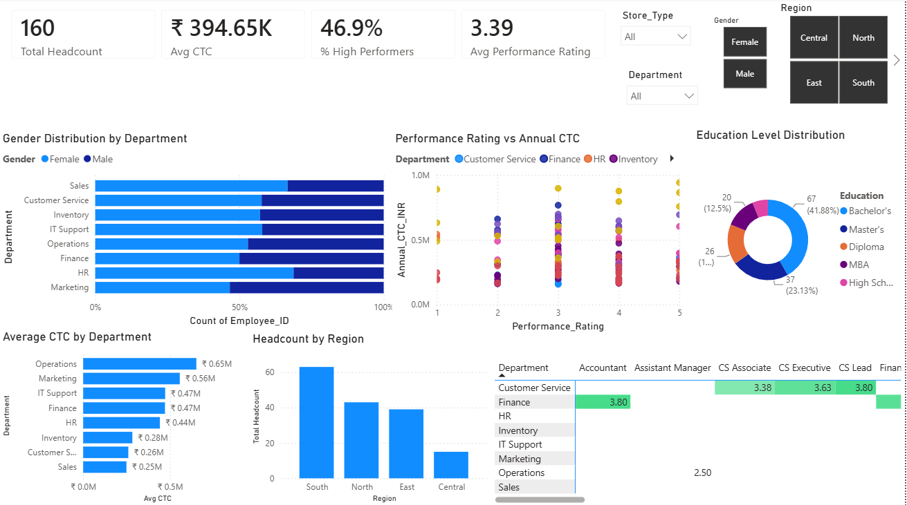
Figure 4. Workforce Analytics dashboard

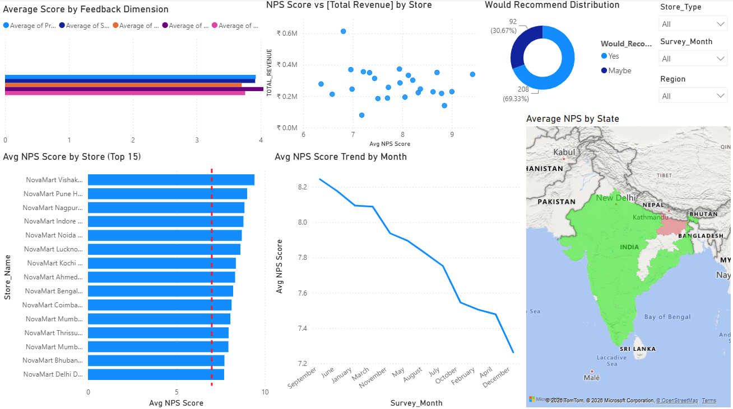
Figure 5. Customer Satisfaction dashboard
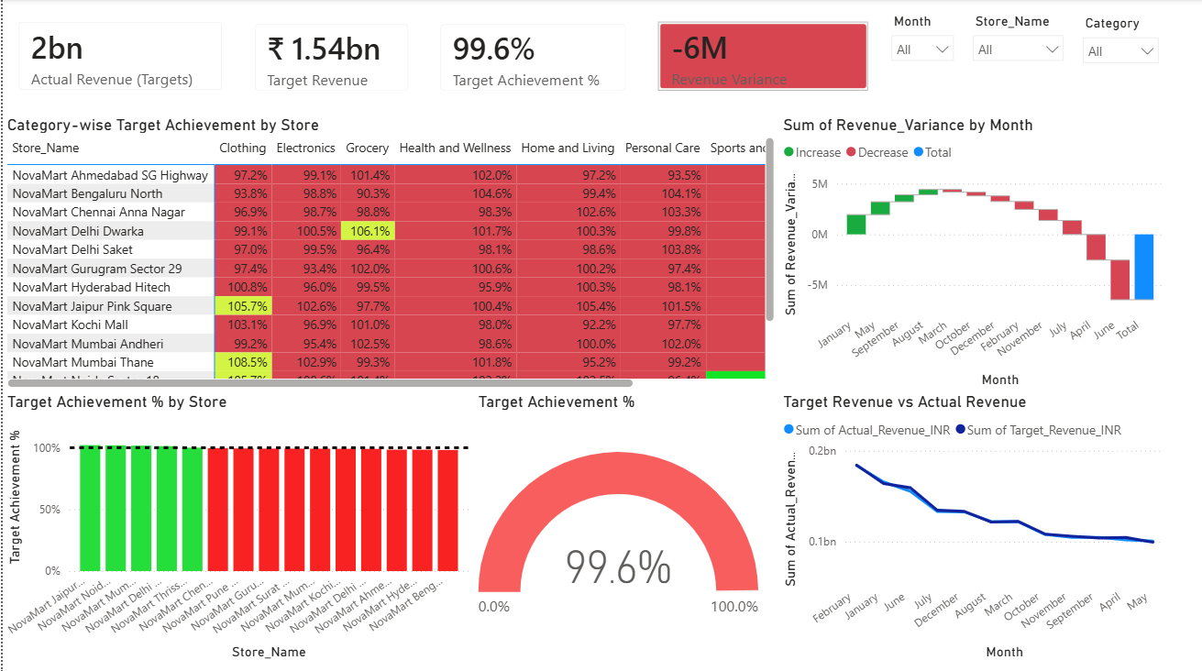
Figure 6. Target vs Actual dashboard

6. Key Analytical Findings
Overall performance — NovaMart generated approximately ₹6.90M in sales revenue and ₹2.10M in gross profit from 600 transactions. The overall gross margin was approximately 30.39%, with 15,369 units sold.
Regional and store-format performance — The South was the largest sales region at approximately ₹2.36M, followed by the North at approximately ₹1.76M. Superstores generated approximately ₹3.31M, making them the strongest store format by sales revenue.
Top-performing store — NovaMart Chennai Anna Nagar generated approximately ₹613.6K in sales revenue and was the strongest individual store in the sales dataset. Mumbai Andheri, Gurugram Sector 29, Delhi Saket and Noida Sector 18 were also among the stronger locations.
Product profitability — Clothing generated approximately ₹2.07M in revenue and about ₹893K in gross profit, with a margin of roughly 43.2%. This made Clothing the strongest category from a profitability perspective.
Volume versus margin — Grocery recorded the highest unit volume at 5,883 units but a gross margin of only about 16.6%. This suggests a high-volume, lower-margin role compared with categories such as Clothing.
Customer experience — Average NPS was approximately 7.84. Store Cleanliness was the highest-rated feedback dimension at about 4.09/5, while Billing Speed was the lowest at about 3.70/5, highlighting checkout efficiency as an improvement opportunity.
Workforce — NovaMart had 200 employees, with an average annual CTC of approximately ₹392.6K. Sales was the largest department with 36 employees, and the South had the largest regional workforce with 63 employees.
Target performance — Across the Monthly Targets table, actual revenue was approximately ₹1.536B against a target of ₹1.542B, producing target achievement of about 99.58% and a shortfall of roughly ₹6.44M. Personal Care and Health & Wellness exceeded their revenue targets, while Electronics, Clothing and Stationery recorded notable shortfalls.

7. Business Recommendations
- Protect availability and visibility of high-margin categories, particularly Clothing, while monitoring whether promotions preserve margin.
- Review supplier cost, pricing and discount strategy in Grocery to improve profitability without undermining its strong unit volume.
- Investigate the drivers behind regional performance gaps before making expansion or marketing decisions, especially between South and Central.
- Improve checkout efficiency because Billing Speed is the weakest customer-feedback dimension; review peak-hour staffing and billing processes.
- Benchmark practices from stronger stores such as Chennai Anna Nagar and compare product mix, local demand and store operations with weaker locations.
- Focus target-recovery actions on underperforming categories such as Electronics, Clothing and Stationery while preserving momentum in categories already exceeding target.
- Further evaluate compensation, role, tenure and performance together to understand whether workforce rewards are appropriately aligned with business outcomes.

8. Limitations & Interpretation Notes
The project uses a fictional portfolio dataset and should be interpreted as a business-analysis exercise rather than a representation of a real retailer. The Sales Transactions and Monthly Targets tables operate at different analytical scales, so their revenue totals should not be directly compared as if they represent the same grain. In addition, the monthly NPS trend should only be interpreted chronologically when the month field is correctly sorted by calendar order.

9. Conclusion
The NovaMart Retail Analytics project demonstrates an end-to-end Power BI workflow: understanding a multi-table retail dataset, building an analytical model, creating business KPIs, designing six focused dashboard pages and translating visual results into actionable recommendations. The solution highlights how retail performance can be assessed across financial, operational, product, workforce and customer dimensions rather than relying on sales alone.

10. Portfolio Skills Demonstrated
- Power BI dashboard design and interactive business reporting
- Multi-table data modeling and relationship-based analysis
- KPI development and target-versus-actual analysis
- Retail sales, profitability and store performance analysis
- Customer satisfaction and workforce analytics
- Business insight generation and recommendation writing

