

Group members

*Zaheda tabassum Guru Nanak Institute of Technology 9266*

*Rampravesh Singh Guru Nanak Institute of Technology 9265*

*Sneha Agarwal Guru Nanak Institute of Technology 8647*

*Nidhi Agarwal Guru Nanak Institute of Technology 8643*

**INDEX**

Item page no.

Acknowledgement 01

Introduction 02

Actors and their Functionalities 03

Problem Definition 04

Benefits 05

Functional Requirements 06

Hardware & software Requirements 07

Entity Relationship Diagram 08

Table Descriptions 09

Page Flow Diagram 11

Screen Shots of Project 15

Future Enhancement 16

Codes 17

**ACKNOWLEDGEMENT**

*We would like to thank Mr. Ayyanar Velliraj for his guidance without which our project Online Travel Deals Booking System using JEE would not have been possible.*

*Our sincere thanks goes to Globsyn Finishing School for providing us with such a friendly environment which helped us a lot during the learning process!*

*And last but not the least our batch-mates deserve our thanks too for making the learning seem so easy in the classroom and never failing to clarify any doubts hovering in our minds from the faculties!!*

**Introduction**

*Online Travel deal project ‘ Travel deals.com’ is an online website to offer the travel and tour deals to its customers.*

*The goal of this process is the complete, integrated management of all processes involved in a business trip and the travel expenses incurred. The process includes the entire procedure of requesting and planning a trip.*

*This website sells deals for the tour to different places in India.*

*Paradise tour serves all types of facilities to its customers and provide a very efficient and full enjoyment tour.*

*Tour packages for different destinations are shown to its customers ,a customer can choose his/her choice of destination with required payment criteria just by booking any of the deals . Booking criteria envolves a very simple procedure, so that all its customer could feel free to book their tour without any hesitation.*

**Actors and their functionalities**

Merchant

* *It provides deals to the salesperson.*
* *It can view bookings and customer’s requirements .*
* *Deals booked by the customers are confirmed or cancelled by the merchant according to availability of resources .*

.

Sales person

* *The sales person view and add deals to the customer’s home page for the choice of tour packages.*
* *It can see all bookings of the customers with all the customer’s*

*informations .*

* *It can delete deals/tour packages from customers home page .*

Customers

* *A customer can view and book deals.*
* *A customer is needed to register itself to the website which will provide login id and password to him/her .*
* *After signing in a customer can book deals by providing all the required fields.*
* *The booking provided by the customer remains in pending status unless and until the merchant don’t confirm it.*

**Benefits**

* *This website provides a very easy and efficient way to its customer to book deals of their choices*

*.*

* *Planning a trip to distant places becomes hard for a person when he/she don’t have any idea about those places ,Paradise tour provide a readymade deals with all facilities for convenience of tourists within a very fare and low price.*
* *Customer’s happiness and care is the main motto of this website.*
* *It arrange for flights , trains, cruise, buses and cars to provide all types of facilities to its customers.*
* *It provide hotel services to its customers, nearest to the tour locations.*

**Functional Requirements**:

* Customer Registration:

*every customer is needed to register themselves before entering their choices. for registering they are needed to provide their personal information like full name, email address, address, phone no. Etc, from this he/she will get its user id and password to login into their account.*

* Booking deals*:*

*A customer is needed to provide all the booking information like number persons, number of hotel rooms , date of departure and arrival etc. this will provide a booking id to the customer, using that booking id the customer can check the status of their bookings*.

* Adding deals*:*

*The merchant will provide different deals of tours to the salesperson, all the deals must contain description of the deal with cost of the tour.*

* Viewing and confirming bookings of customers*:*

*The merchant will view the customer’s booked deals, the merchant will confirm the deals of customers by checking the availability of resources to be provided to the customers.*

* Adding and deleting deals*:*

*The salesperson can add and delete deals to the customer’s page from the deals provided by the merchant.*

* Checking the status of the booked deals:

*The customer will check its booking status by providing the booking id . if the status is still pending the customer is needed to wait for some amount of time until the merchant don’t confirm it.*

**Hardware and software requirements**

Hardware requirements:

* *Database storage*
* *Windows xp/7*

Software requirements:

* *Eclipse Galileo is used for making the software.*
* *For database storage oracle is used.*

**Database design**

Entity Relationship diagram

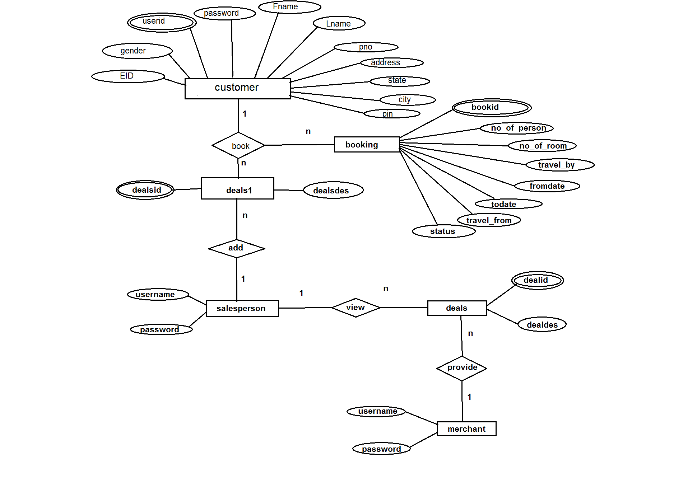

**Table description**:

Customer table

|  |  |  |  |  |  |
| --- | --- | --- | --- | --- | --- |
| column | Data type | length | Primary key | Not null | default |
| userid | Varchar2 | 30 | yes | yes | - |
| password | Varchar2 | 15 | - | yes | - |
| fname | Varchar2 | 20 | - | yes | - |
| lname | Varchar2 | 20 | - | yes | - |
| gender | Varchar2 | 10 | - | yes | - |
| pno | number | 10 | - | yes | - |
| eid | Varchar2 | 30 | - | yes | - |
| address | Varchar2 | 50 | - | yes | - |
| city | Varchar2 | 20 | - | yes | - |
| state | Varchar2 | 25 | - | yes | - |
| pin | Varchar2 | 6 | - | yes | - |

Booking table

|  |  |  |  |  |  |
| --- | --- | --- | --- | --- | --- |
| column | Data type | length | Primary key | Not null | default |
| bookid | Varchar2 | 10 | yes | yes | autoincrement |
| No_of_person | Number | 2 | - | yes | - |
| No_of_room | Number | 2 | - | yes | - |
| Travel_by | Varchar2 | 20 | - | yes | - |
| Fromdate | date | 7 | - | yes | - |
| todate | date | 7 | - | yes | - |
| Travel_from | Varchar2 | 40 | - | yes | - |
| status | Varchar2 | 20 | - | yes | pending |

Master Deal table (deals)

|  |  |  |  |  |  |
| --- | --- | --- | --- | --- | --- |
| column | Data type | length | Primary key | Not null | default |
| dealsid | Varchar2 | 10 | yes | yes | - |
| dealdes | Varchar2 | 100 | - | yes | - |

Slave deal table (deals1)

|  |  |  |  |  |  |
| --- | --- | --- | --- | --- | --- |
| column | Data type | length | Primary key | Not null | default |
| dealid | Varchar2 | 10 | yes | yes | - |
| dealdes | Varchar2 | 100 | - | yes | - |

Page Flow Diagram

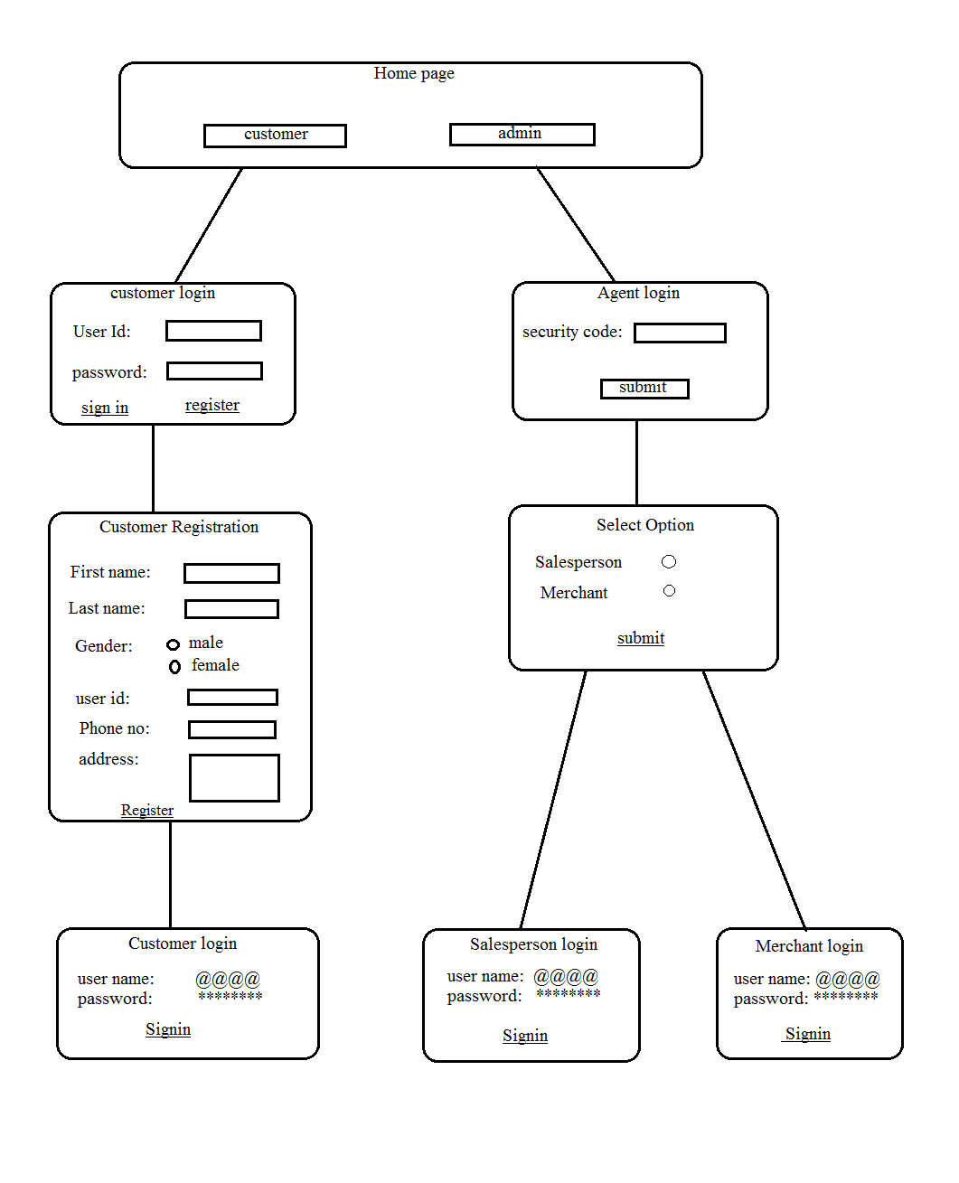

**Customer’s Page**

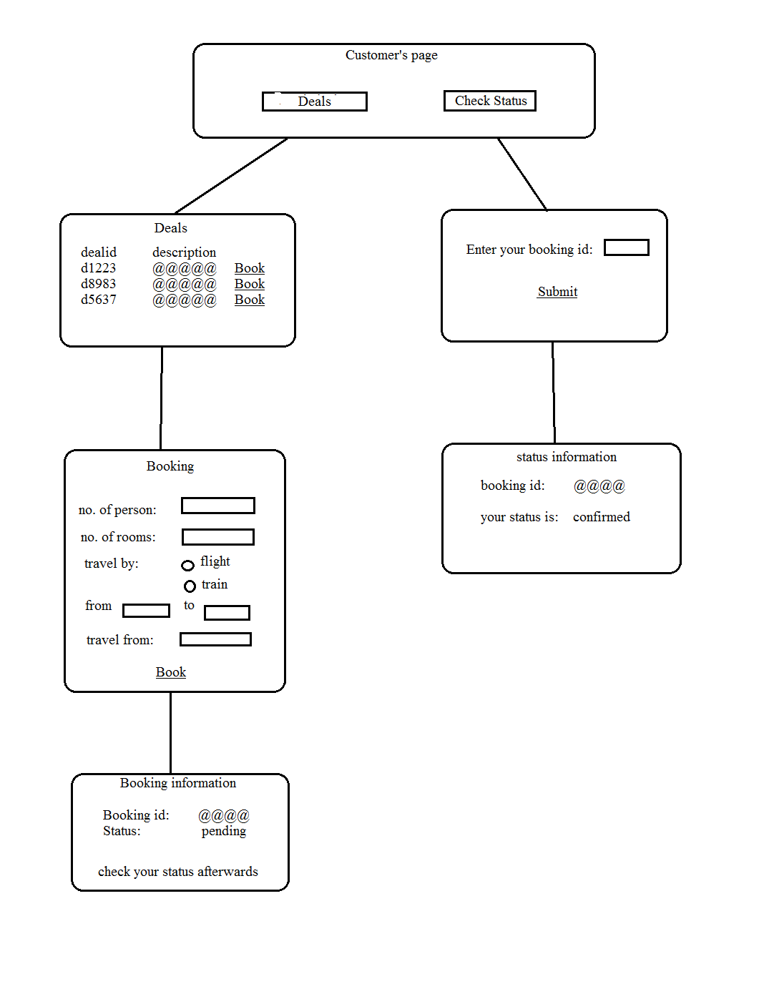

**SalesPerson Page**

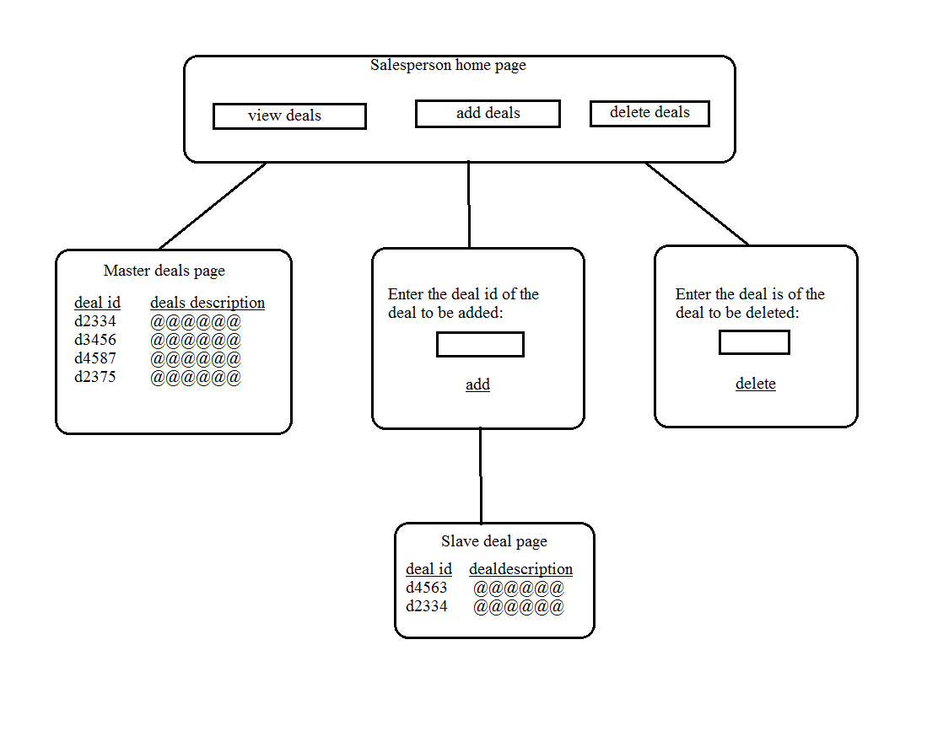

**Merchant Page**

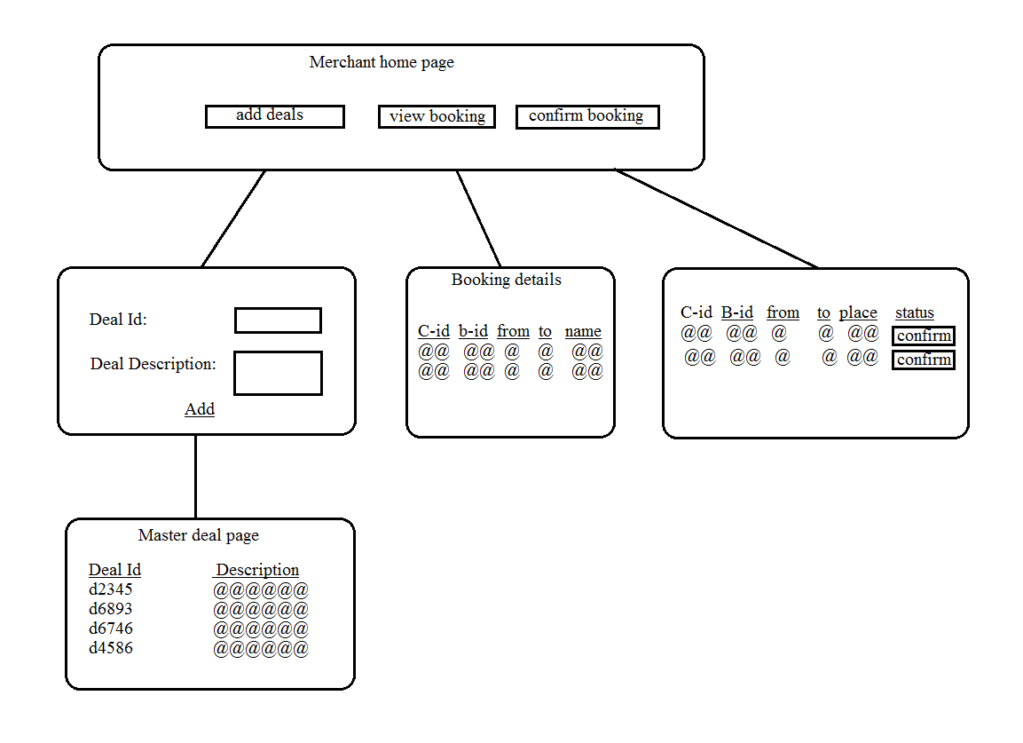

**Screen Shot of Program**

**Future scope of improvements:**

1. *More synchronized and Customizable deals*
2. *More remote location covered with person specific deals.*

*3.You don't have to besiege embassy and wait in long queues.*

*4. vacation is organized. You have a choice of excursions.*

*5. Various travel suppliers today provide for 10-15% gross commissions, while handling processing charges. By integrating special services like flight booking etc in a single system with a solid, user friendly interface, managing online client support, engaging in Facebook activity, and establishing direct travel relations with oversees partners*

**codes**

**Certificate**

This is to certify that Master Ram Pravesh Singh of Guru Nanak Institute of Technology ,registration number : 9265, has successfully completed a project on OnlineTravel deal System using JEE under the guidance of Mr Ayyanar Velliraj .

-------------------------------------------------

Mr Ayyanar Velliraj Globsyn Finishing School

**Certificate**

This is to certify that Miss Zaheda Tabassum of Guru Nanak Institute of Technology, registration number : 9266, has successfully completed a project on OnlineTravel deal System using JEE under the guidance of Mr Ayyanar Velliraj .

-------------------------------------------------

Mr Ayyanar Velliraj Globsyn Finishing School

**Certificate**

This is to certify that Miss Snaha Agarwal of Guru Nanak Institute of Technology, registration number : 8647, has successfully completed a project on OnlineTravel deal System using JEE under the guidance of Mr Ayyanar Velliraj .

-------------------------------------------------

Mr Ayyanar Velliraj Globsyn Finishing School

**Certificate**

This is to certify that Miss Nidhi Agarwal of Guru Nanak Institute of Technology, registration number : 8643, has successfully completed a project on OnlineTravel deal System using JEE under the guidance of Mr Ayyanar Velliraj .

-------------------------------------------------

Mr Ayyanar Velliraj Globsyn Finishing School