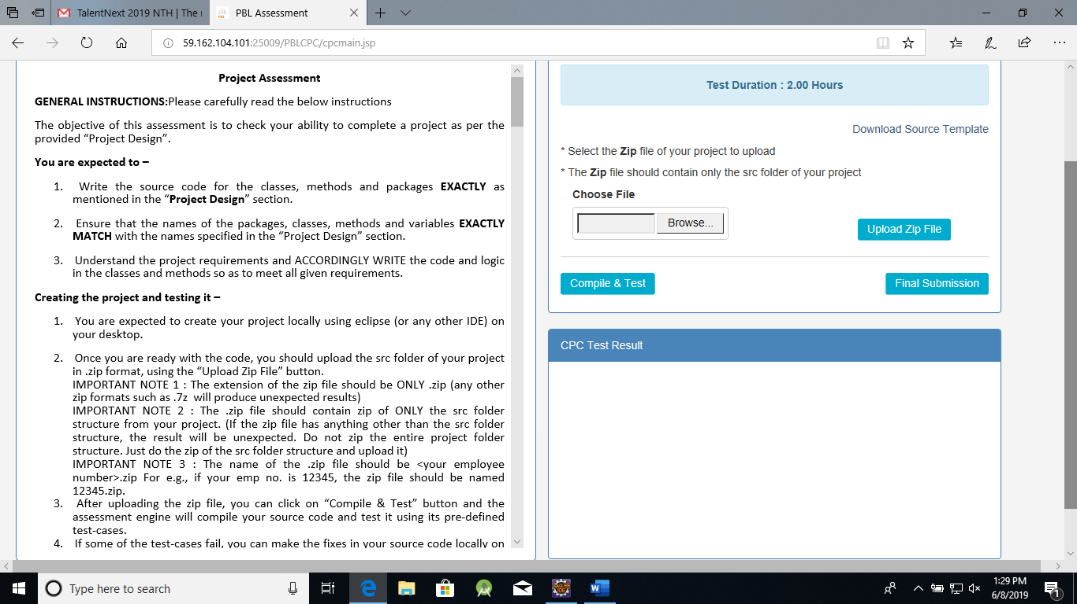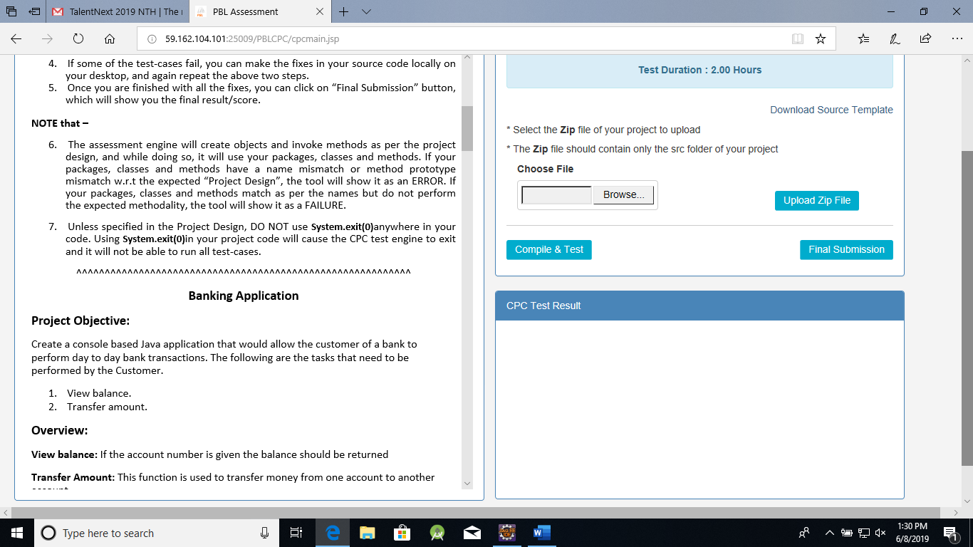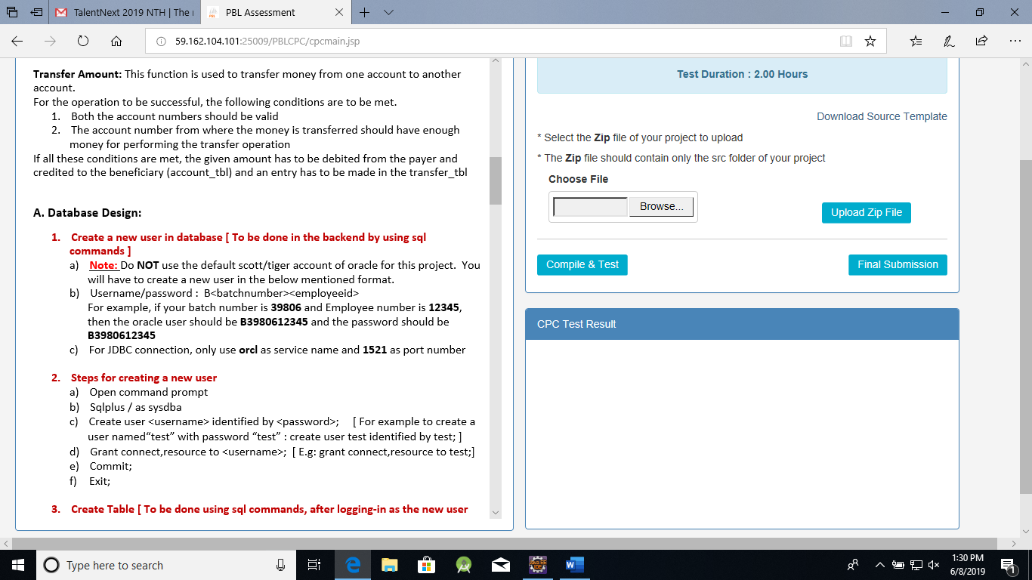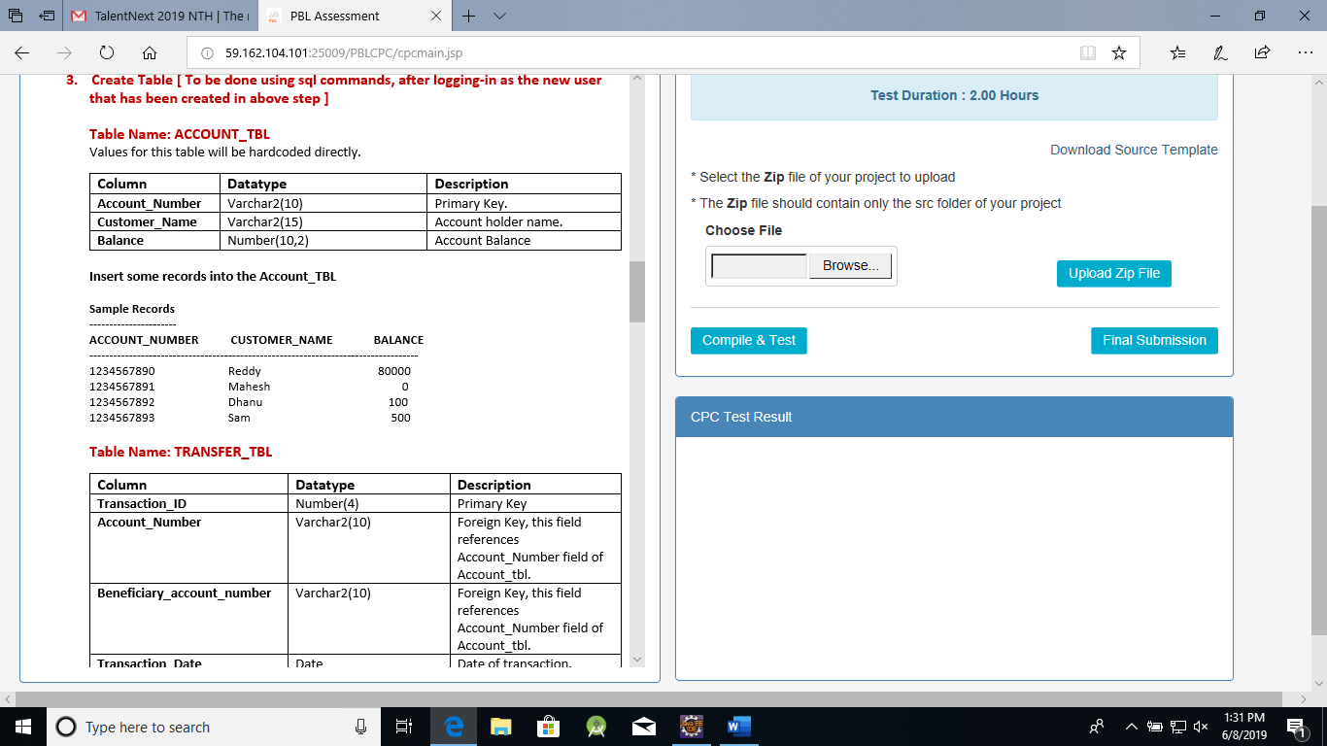 SQL>CREATE TABLE TRANSFER_TBL(TRANSACTION_ID NUMBER(4),ACCOUNT_NUMBER VARCHAR2(10), BENEFICIARY_ACCOUNT_NUMBER VARCHAR2(10), TRANSACTION_DATE DATE,PRIMARY KEY(TRANSACTION_ID),FOREIGN KEY(ACCOUNT_NUMBER) REFERENCES ACCOUNT_TBL(ACCOUNT_NUMBER),FOREIGN KEY(BENEFICIARY_ACCOUNT_NUMBER) REFERENCES ACCOUNT_TBL(ACCOUNT_NUMBER))

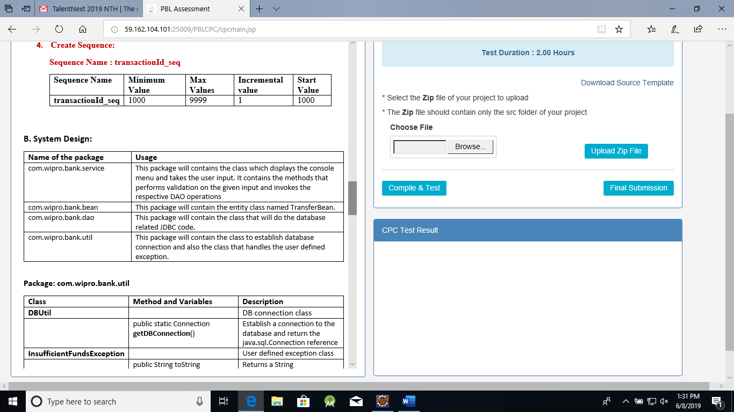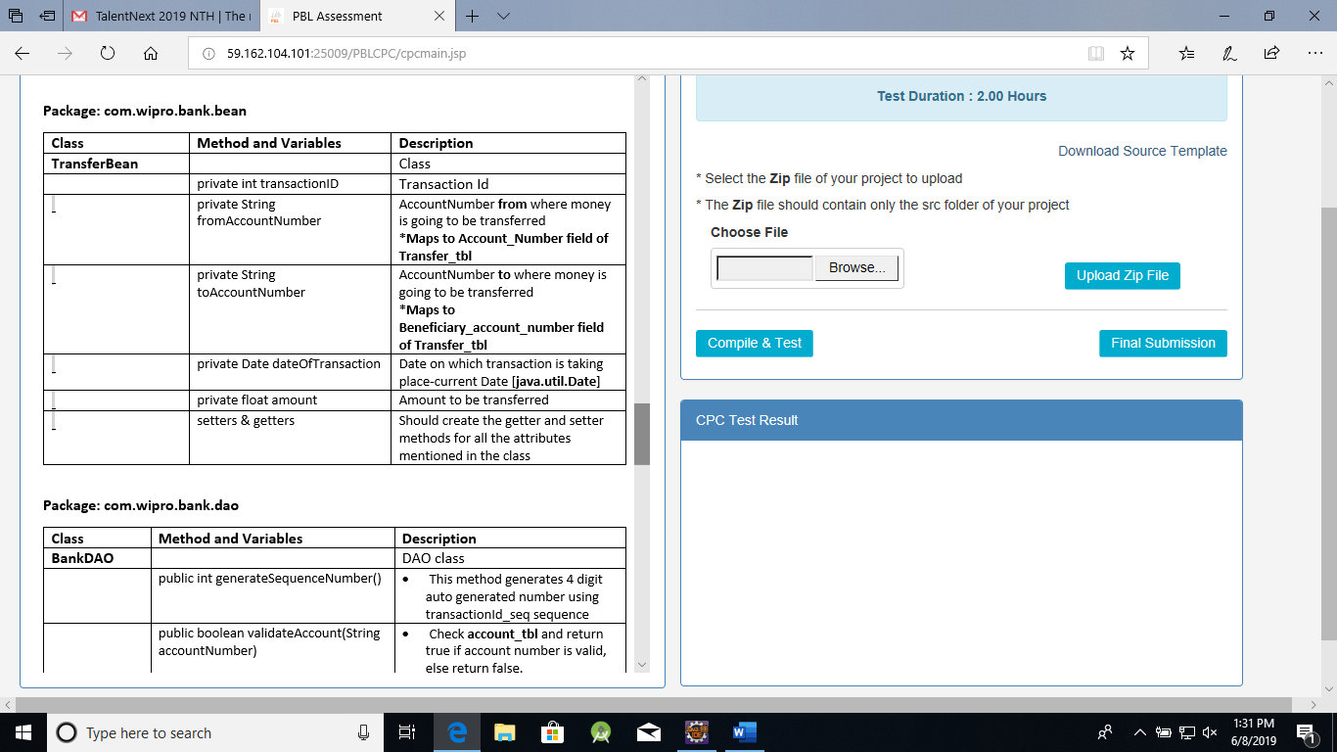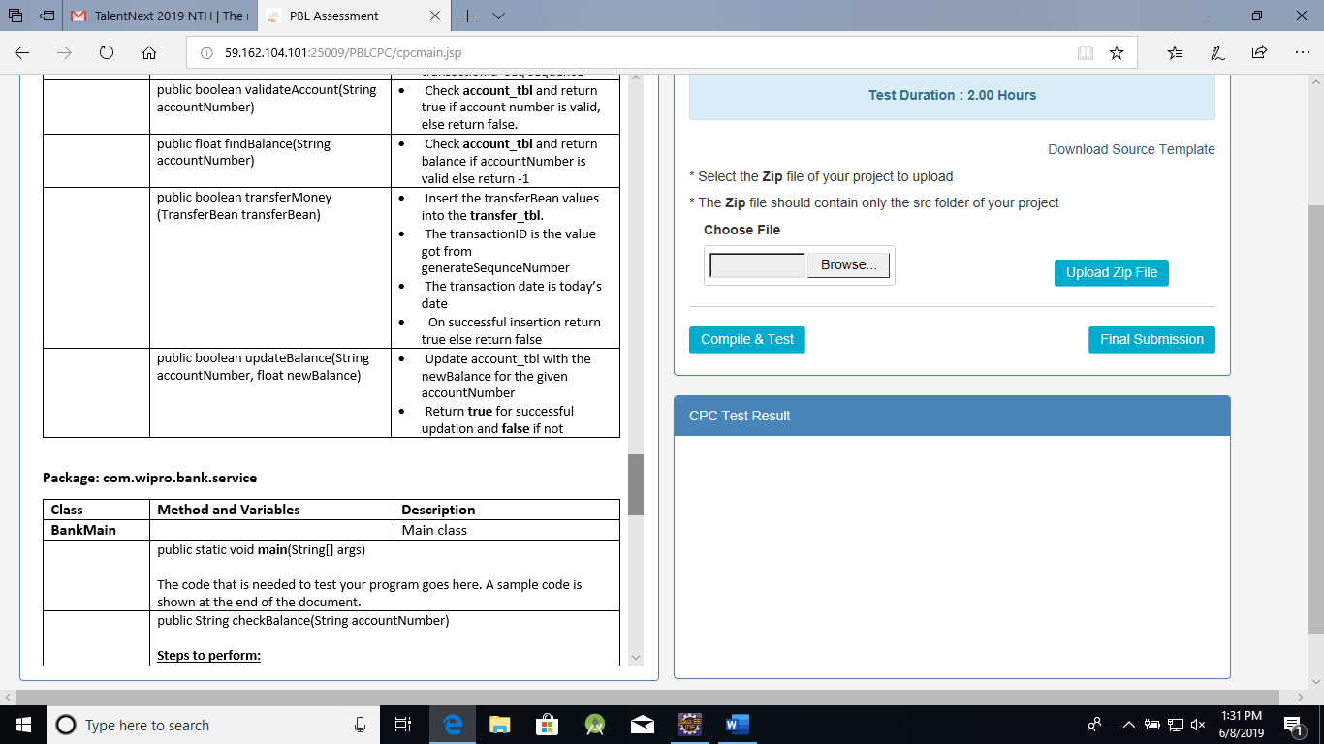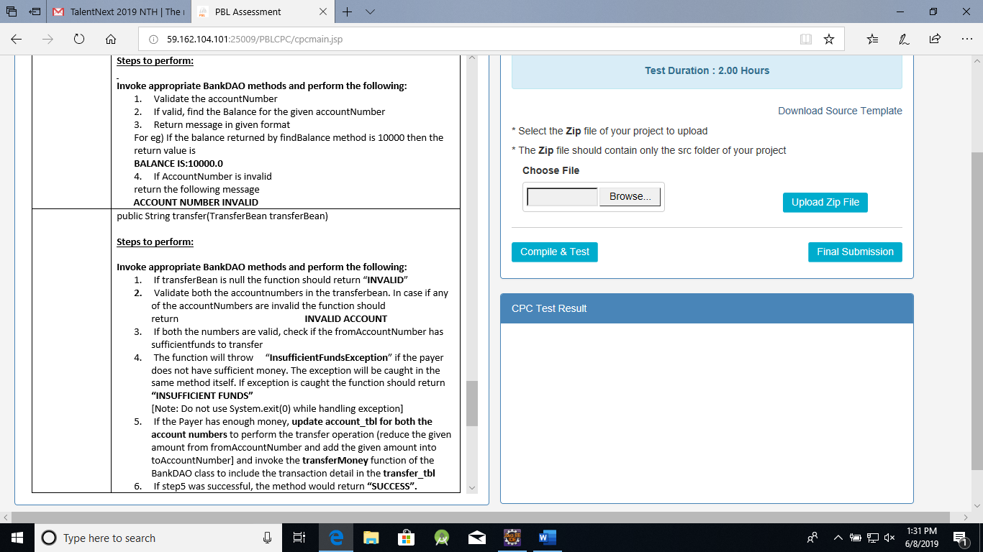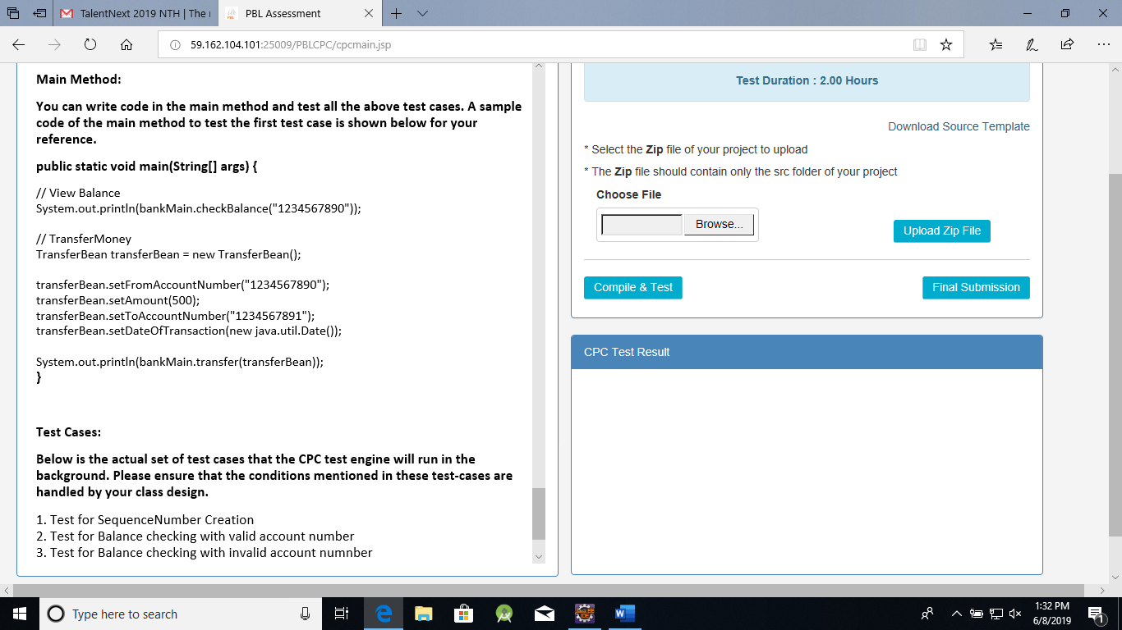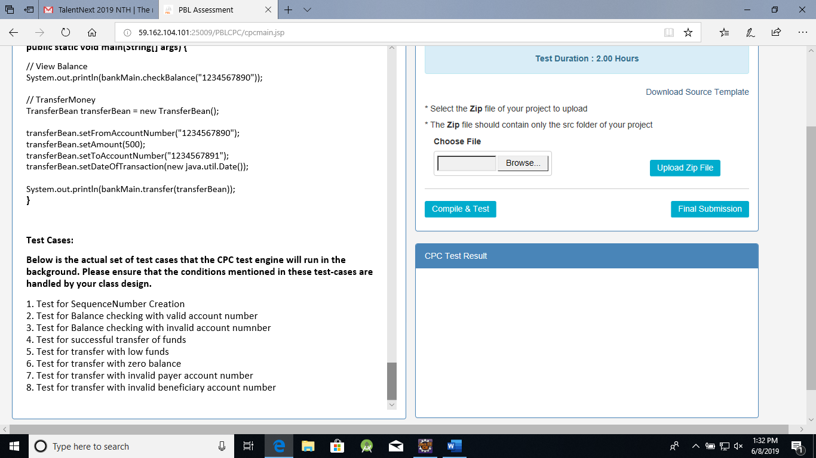

XML 1 and XML 2