RETAIL CUSTOMER SEGMENTATION STRATEGY
Python-Based Clustering Analysis and Retail Marketing Recommendations
Prepared as an academic project using a simulated dataset

1. Executive Summary
This report demonstrates a reproducible Python workflow for retail customer segmentation using 1,000 simulated customer records. Customer behavior variables were standardized and analyzed with K-means clustering. Candidate solutions from k=2 to k=7 were compared using the silhouette score; the highest score in this run was at k=4 (score 0.380). The resulting groups provide a structured way to tailor retention, promotional, digital, and premium-customer strategies. Because the data are synthetic and generated from assumed profiles, the results demonstrate the method rather than establish facts about a real retailer.

2. Problem Statement and Scope
Retailers serve customers with different purchase frequencies, basket values, channel preferences, discount sensitivity, and engagement levels. A single campaign for every customer can waste promotional budget, over-discount customers who would buy anyway, and fail to reactivate customers who are becoming inactive. The problem is to identify behaviorally distinct customer groups and translate those groups into measurable marketing actions. The analysis focuses on transaction behavior and engagement over a 12-month observation window. Demographic variables are retained for descriptive profiling, but are not used in the primary clustering model.

3. Data Simulation and Assumptions
No proprietary customer file was supplied, so a synthetic dataset was created with NumPy and pandas. The dataset contains 1,000 customer records and variables for age, annual income, order count in the last 12 months, average order value, days since last order, online purchase share, discount-order share, return rate, engagement score (0–100), and estimated annual spend. Five latent behavioral profiles informed plausible ranges during simulation; this hidden simulation label was excluded from clustering and is not treated as model output. Annual spend is calculated as orders in 12 months multiplied by average order value. All dollar values are illustrative, not actual customer or market data. The random seed is fixed at 42 so that the dataset and analysis can be reproduced.
Assumptions: each row represents one customer; the 12-month period is comparable across customers; order and engagement measures are consistently defined; and simulated ranges are plausible enough for demonstrating the workflow. A real deployment should use consented, governed first-party data, document missingness and outliers, and test whether the segments remain stable over time.

4. Variables and Business Relevance
Variable | Type / Unit | Why it matters
Orders_12m | Count | Purchase frequency and habit
Avg_Order_Value_USD | Currency | Typical basket value
Days_Since_Last_Order | Days | Recency and possible churn risk
Online_Purchase_Share | Proportion, 0–1 | Digital-channel preference
Discount_Order_Share | Proportion, 0–1 | Price and promotion sensitivity
Return_Rate | Proportion, 0–1 | Post-purchase friction / product fit
Engagement_Score | 0–100 | Interactions with campaigns or loyalty touchpoints
Annual_Spend_USD | Currency | Approximate customer value
Age; Annual_Income_USD | Years; currency | Descriptive profiling only in this model

5. Methodology
- Step 1 — Data preparation: Inspect schema, ranges, missing values, duplicates, and outliers. In this synthetic dataset, the generation process creates complete records; a production workflow should still validate each field.
- Step 2 — Feature selection: Use purchase frequency, average order value, recency, online share, discount share, return rate, engagement, and annual spend. Exclude age and income from clustering to emphasize observed behavior and reduce the risk of treating demographic proxies as customer value.
- Step 3 — Standardization: Apply StandardScaler because K-means uses distance and the variables have different units and scales. Fit the scaler on the training/reference data and reuse it consistently for new customers.
- Step 4 — Model selection: Fit K-means solutions for k=2 through k=7 with a fixed random state and 20 initializations. Compare silhouette scores, which summarize how close each point is to its own cluster versus other clusters. Silhouette is a diagnostic, not an absolute measure of business usefulness.
- Step 5 — Fit and profile: Fit the selected K-means model, assign a cluster ID to every customer, and compare cluster-level averages. Cluster numbers are arbitrary labels; interpretation comes from their behavioral profiles, not their numeric IDs.
- Step 6 — Visual validation: Use a silhouette-by-k line chart, a two-dimensional PCA projection, and a segment profile heatmap. PCA compresses the standardized variables for visualization and may hide separation that exists in the full feature space.
- Step 7 — Translate to action: Create a segment playbook, test campaigns against control groups, and monitor incremental margin, repeat purchase, churn, conversion, and customer experience.

6. Results and Visual Analysis
The best silhouette score among the tested candidates occurred at k=4, with a score of 0.380. This choice is a starting point rather than proof that the number of clusters is optimal: managers should also assess interpretability, stability, segment size, and the ability to design distinct actions.
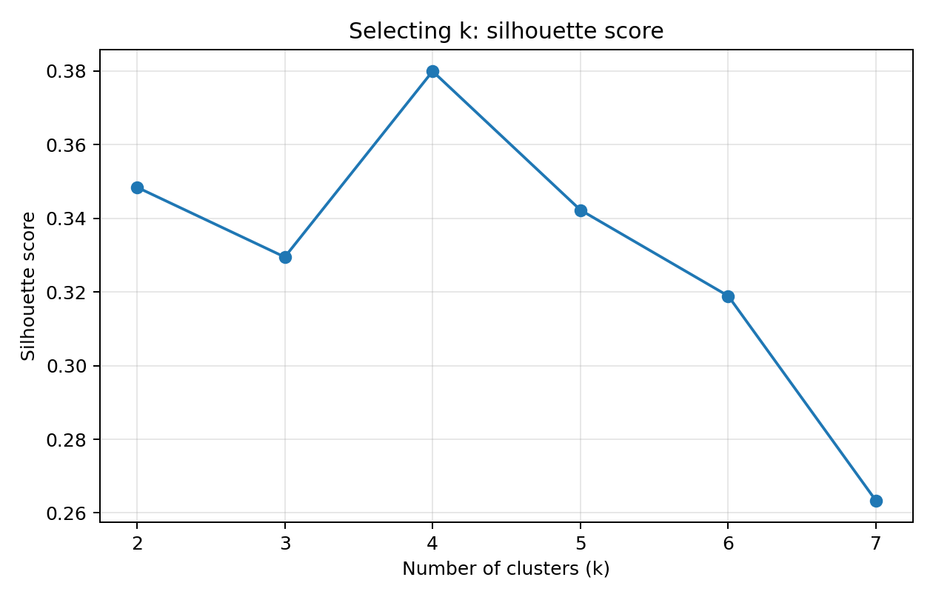
Figure 1. Silhouette score by candidate cluster count. Higher scores indicate better average separation under this metric.
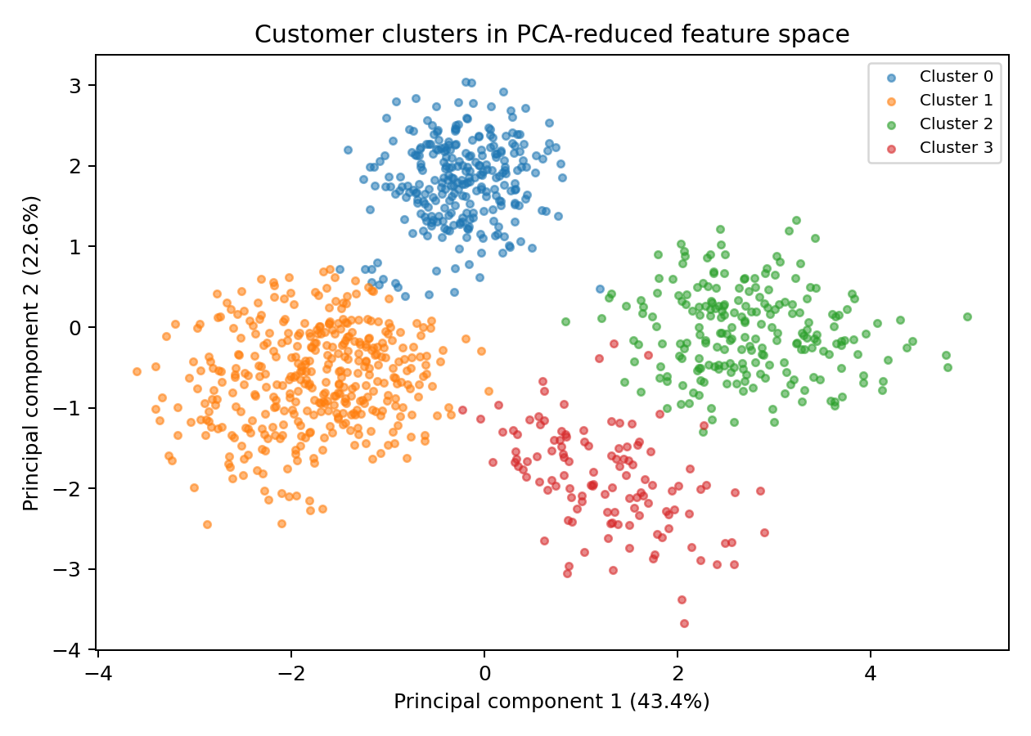
Figure 2. PCA projection of customers colored by K-means cluster. PCA is used only to display the high-dimensional data in two dimensions.
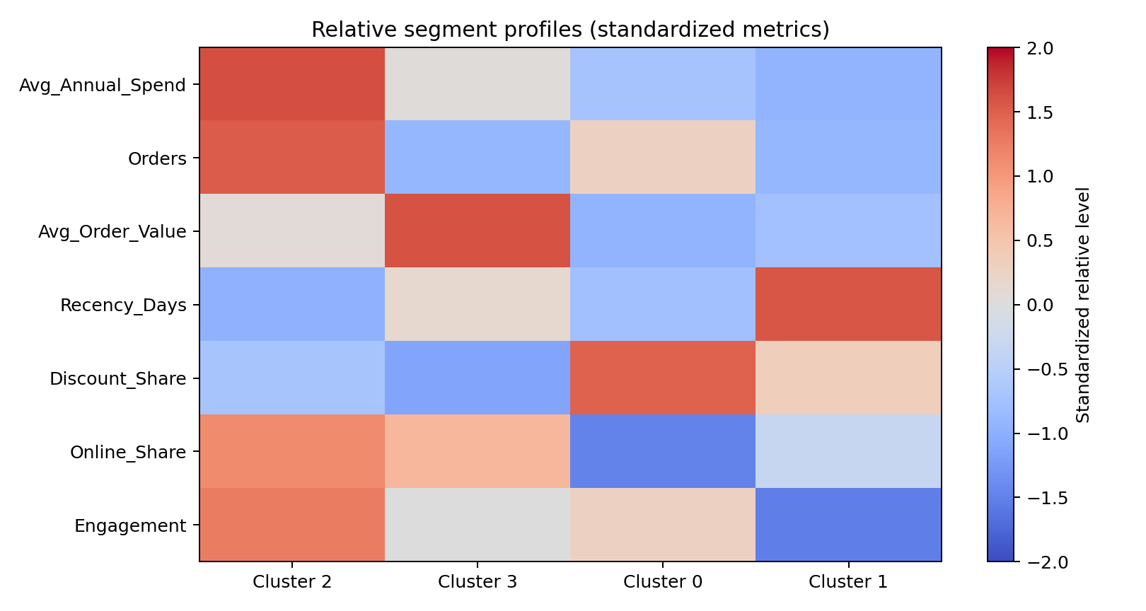
Figure 3. Relative segment profile. Redder/positive values indicate above-average levels for a metric; bluer/negative values indicate below-average levels.

7. Cluster-Level Findings
The table below reports averages from the fitted model. Currency is simulated USD. Values are rounded for readability.
Cluster | Customers | Avg. annual spend | Avg. order value | Orders / year | Days since order | Discount share | Engagement
2 | 219 | $4,594 | $157 | 29.5 | 14 | 21% | 81/100
3 | 120 | $1,993 | $331 | 6.0 | 49 | 13% | 59/100
0 | 273 | $747 | $43 | 17.4 | 20 | 63% | 64/100
1 | 388 | $388 | $63 | 6.0 | 94 | 41% | 32/100
Interpretation should be based on the full pattern rather than one metric. High annual spend may arise from frequent orders, a large basket, or both. High recency (many days since the last order) can signal inactivity, but the appropriate threshold depends on the retailer's normal replenishment cycle. Discount share helps distinguish customers who respond to incentives from those who may purchase without them.

8. Customer Segment Interpretation and Marketing Playbook

Cluster 2: High-value frequent customers
Profile: These customers combine strong annual value with repeat purchasing. Observed averages are annual spend $4,594, 29.5 orders per year, average order value $157, 14 days since last order, discount-order share 21%, online share 69%, and engagement 81/100.
Recommended action: Protect loyalty with early access, service recovery, relevant cross-sell, and recognition benefits. Avoid blanket discounts; test non-price rewards and measure incremental margin.

Cluster 3: High-basket occasional customers
Profile: Their average transaction is relatively large, but purchase cadence is lower. Observed averages are annual spend $1,993, 6.0 orders per year, average order value $331, 49 days since last order, discount-order share 13%, online share 63%, and engagement 59/100.
Recommended action: Use replenishment reminders, curated bundles, seasonal launches, and personalized product recommendations. Test whether post-purchase follow-ups increase the next-order rate.

Cluster 0: Promotion-responsive customers
Profile: A relatively large share of orders uses discounts, suggesting promotions may influence timing or product choice. Observed averages are annual spend $747, 17.4 orders per year, average order value $43, 20 days since last order, discount-order share 63%, online share 40%, and engagement 64/100.
Recommended action: Use threshold offers, value packs, and category-specific promotions with margin guardrails. Run holdout tests to distinguish incremental purchases from purchases that would have occurred anyway.

Cluster 1: Lapsed / at-risk customers
Profile: The time since their last purchase is relatively high, so reactivation is a priority. Observed averages are annual spend $388, 6.0 orders per year, average order value $63, 94 days since last order, discount-order share 41%, online share 53%, and engagement 32/100.
Recommended action: Trigger a staged win-back journey: helpful product discovery first, then a limited targeted incentive if needed. Suppress customers who have opted out and stop spending on repeated non-responders.

9. Strategic Recommendations
- Build a segment-aware campaign calendar: Map each cluster to a distinct objective: retention, reactivation, basket growth, promotion efficiency, or digital engagement. Keep the message relevant to observed behavior.
- Protect margin, not just revenue: Measure incremental gross margin, average order value, conversion, and repeat rate. Discounts should be tested against randomized holdout groups and governed by minimum-margin rules.
- Operationalize the segments: Refresh features monthly or quarterly, score new customers with the same preprocessing/model pipeline, and assign segments to CRM or marketing automation only after validation.
- Use responsible data practices: Minimize personally identifiable data, restrict access, honor consent and opt-outs, check for disparate impacts, and avoid sensitive attributes. Demographics should support aggregate fairness checks rather than automatic exclusion.
- Validate before scaling: Compare cluster stability across time windows and random seeds; review segment sizes with marketing teams; run A/B tests; and retrain only when drift or business needs justify it.

10. Limitations and Next Steps
The dataset is synthetic, its profiles were specified in advance, and its patterns are cleaner than many real-world retail datasets. Therefore, the analysis cannot establish actual customer behavior or forecast campaign lift. K-means favors roughly compact clusters and can be affected by outliers, feature selection, and scaling. The silhouette score may favor a solution that is less actionable for marketing. Future work should use real, permissioned transaction and engagement data; compare K-means with hierarchical clustering or DBSCAN; examine stability and cluster transitions; incorporate product categories and channel journeys; and validate recommendations with controlled experiments.

11. Reproducibility: Python Workflow
Libraries used: pandas and NumPy for data handling and simulation; scikit-learn for scaling, K-means, silhouette scoring, and PCA; Matplotlib for visualizations.
from sklearn.preprocessing import StandardScaler
from sklearn.cluster import KMeans
from sklearn.metrics import silhouette_score
from sklearn.decomposition import PCA
import pandas as pd
df = pd.read_csv("simulated_retail_customers.csv")
features = [
"Orders_12m", "Avg_Order_Value_USD", "Days_Since_Last_Order",
"Online_Purchase_Share", "Discount_Order_Share", "Return_Rate",
"Engagement_Score", "Annual_Spend_USD"
]
X_scaled = StandardScaler().fit_transform(df[features])
scores = {}
for k in range(2, 8):
labels = KMeans(n_clusters=k, random_state=42, n_init=20).fit_predict(X_scaled)
scores[k] = silhouette_score(X_scaled, labels)
best_k = max(scores, key=scores.get)
model = KMeans(n_clusters=best_k, random_state=42, n_init=20)
df["Cluster"] = model.fit_predict(X_scaled)
The accompanying CSV contains the simulated customer features and fitted cluster labels used for this report. Re-running the complete simulation script and model pipeline with the fixed random seed reproduces the analysis.

12. Conclusion
Python-based clustering can turn transaction and engagement data into actionable customer groups, helping retail managers replace broad, undifferentiated campaigns with more relevant strategies. This project demonstrates the full workflow—from transparent data simulation and standardized K-means clustering to visualization, interpretation, and campaign design. The most important next step is not simply to deploy cluster labels, but to validate that segment-specific actions improve incremental customer value and experience when tested against suitable controls.

Appendix A. Model Selection Scores
k | Silhouette score | Inertia
2 | 0.348 | 5196.4
3 | 0.329 | 3804.9
4 | 0.380 | 2872.4
5 | 0.342 | 2475.5
6 | 0.319 | 2320.5
7 | 0.263 | 2188.1

