NOVA ONE
Hydration, in sync.
CONSOLIDATED MARKETING MATERIALS
A single Word portfolio collecting the campaign image, all supplied PDF pages, and an editable version of the design rationale.
INCLUDED
- Artwork contact sheet image
- Four individual print-artwork PDFs
- Four-page consolidated print-artwork PDF
- Two-page design-rationale PDF
- Editable design-rationale text
Note: Artwork pages are embedded as images to preserve the original visual layout. The rationale is also transcribed into editable Word text at the end.

Artwork Contact Sheet
Original campaign overview image supplied with the marketing package.
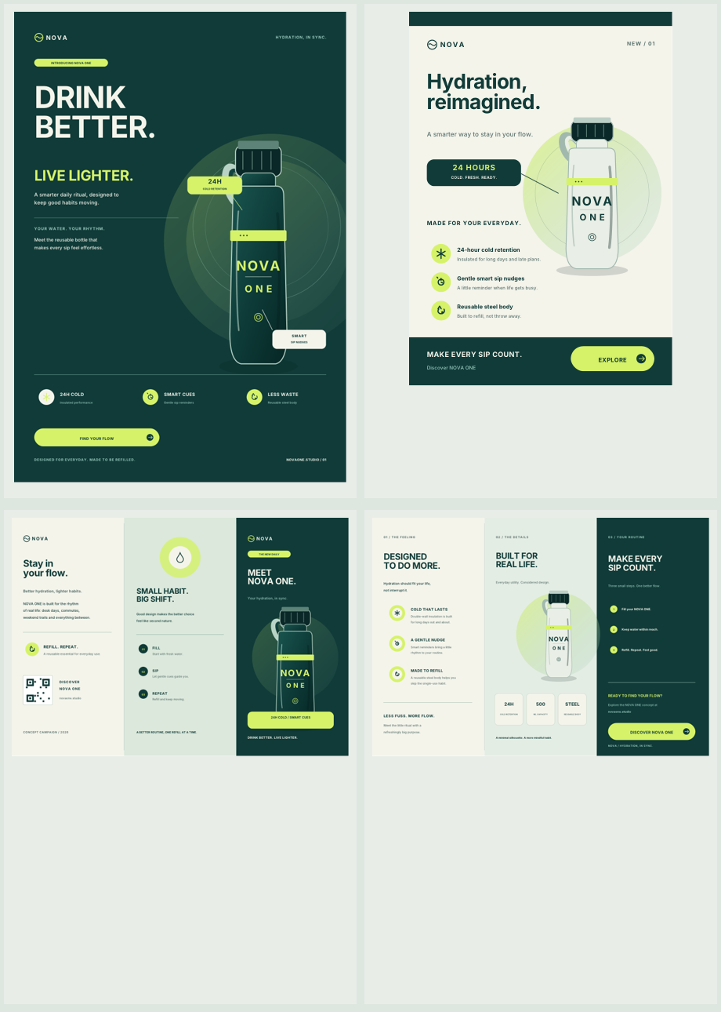

A3 Launch Poster
Source: 01_NOVA_ONE_Poster_A3.pdf
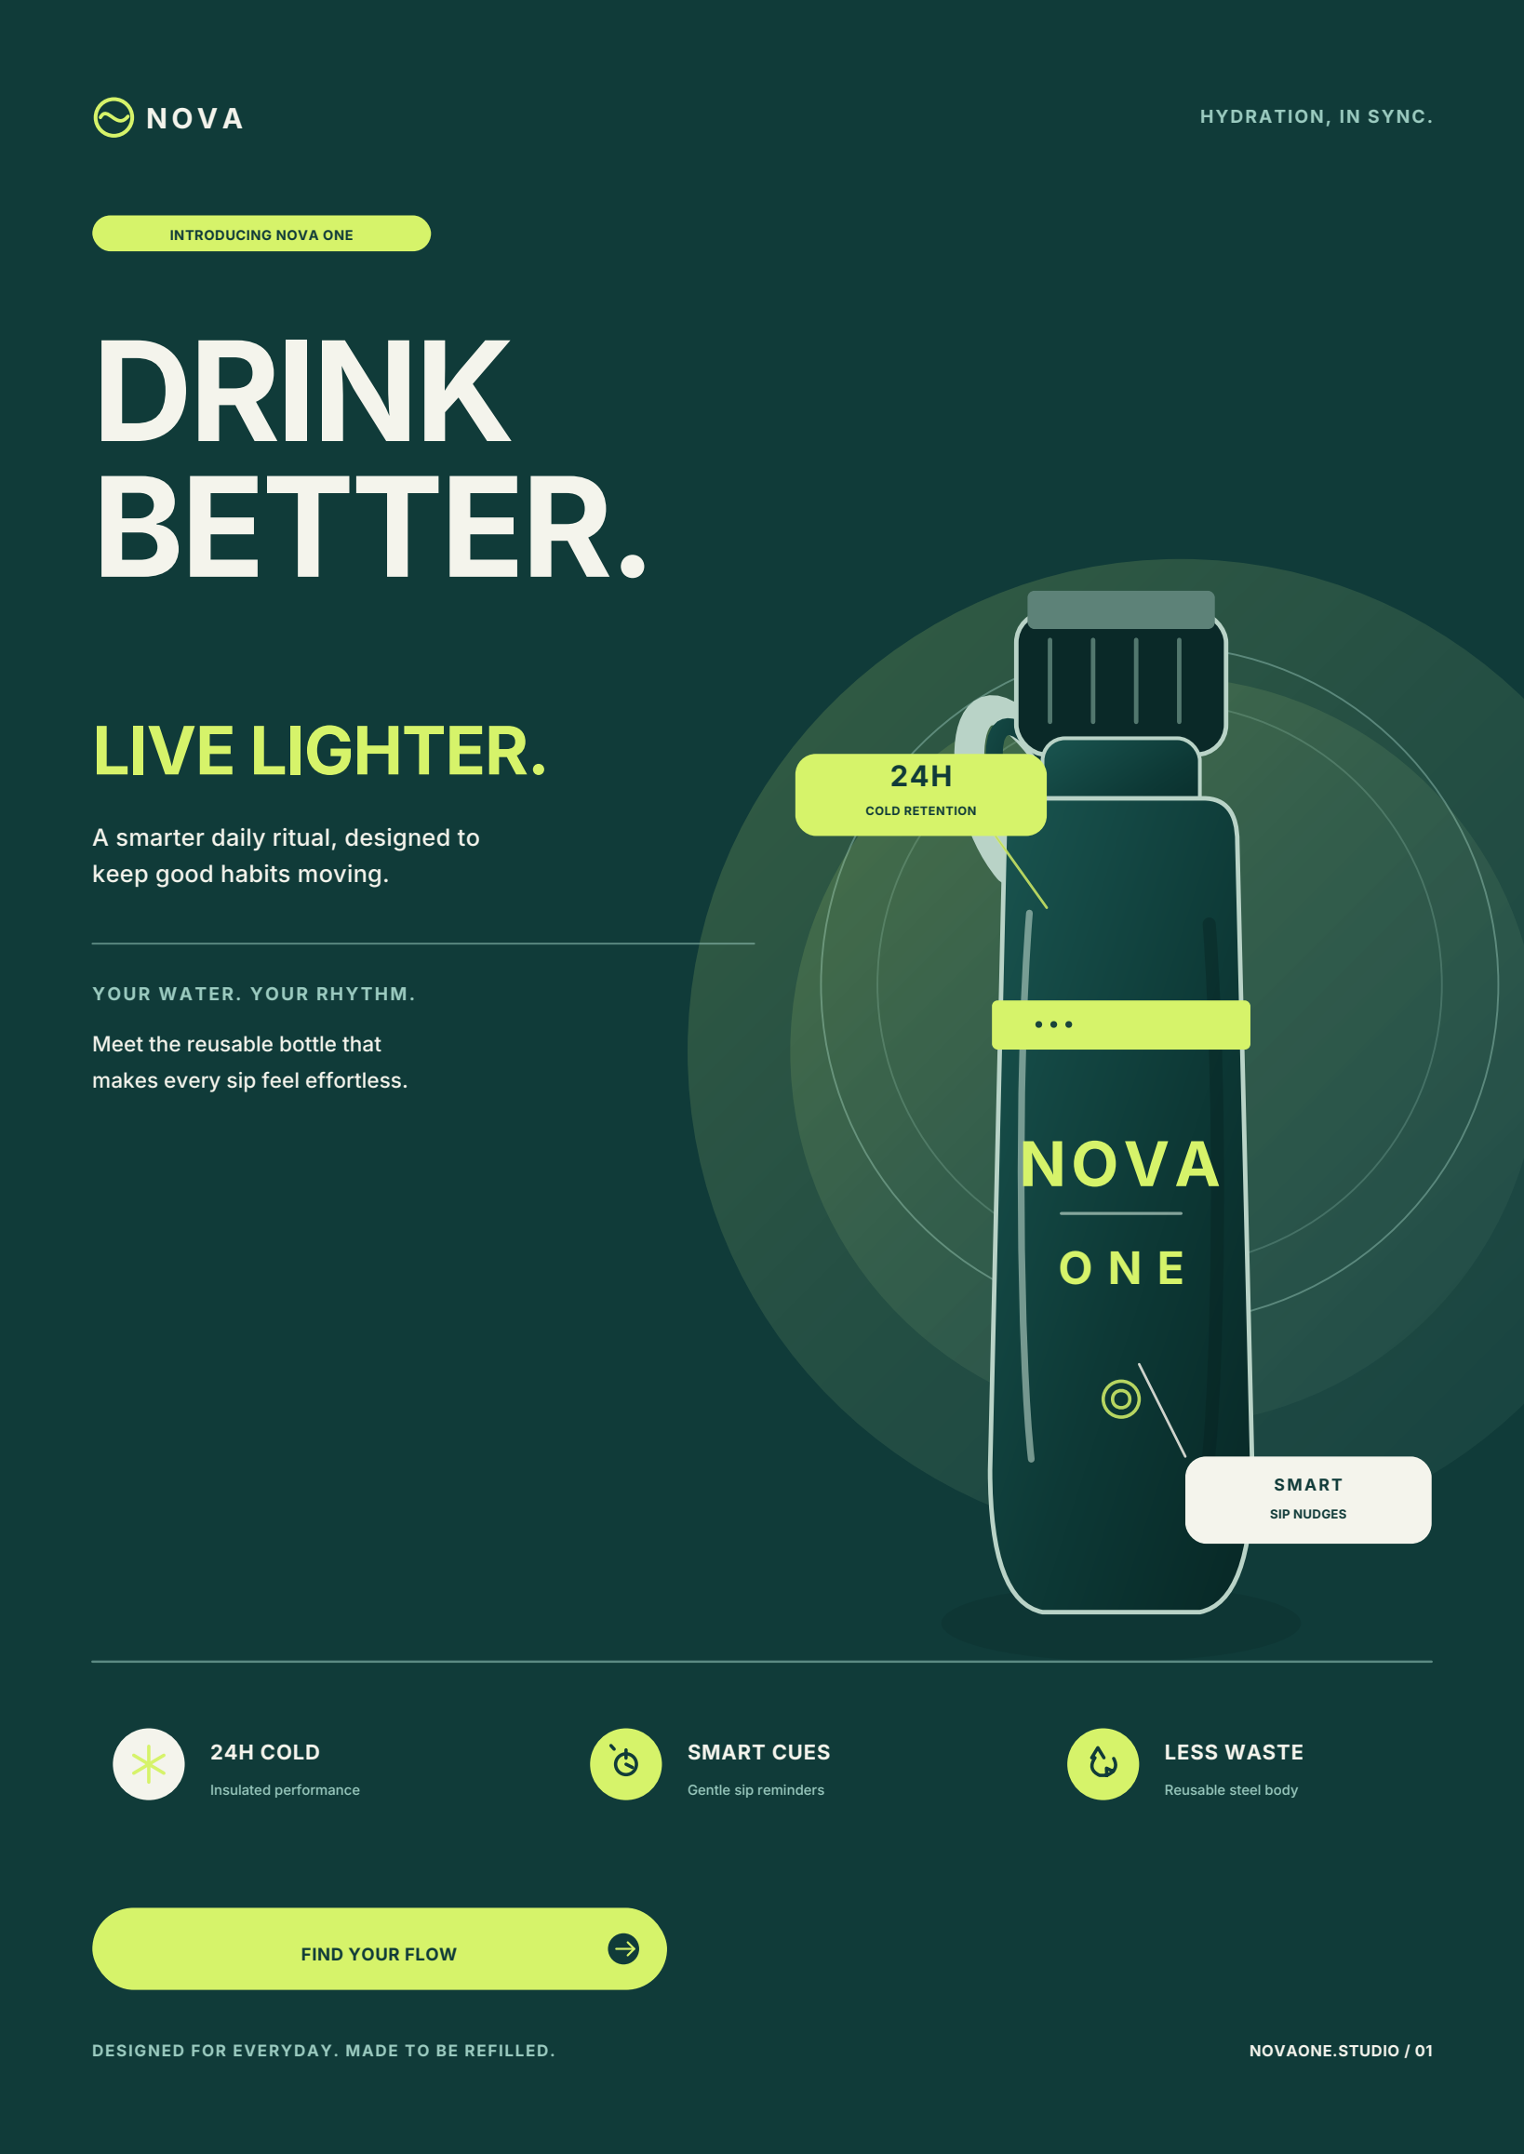

A5 Promotional Flyer
Source: 02_NOVA_ONE_Flyer_A5.pdf
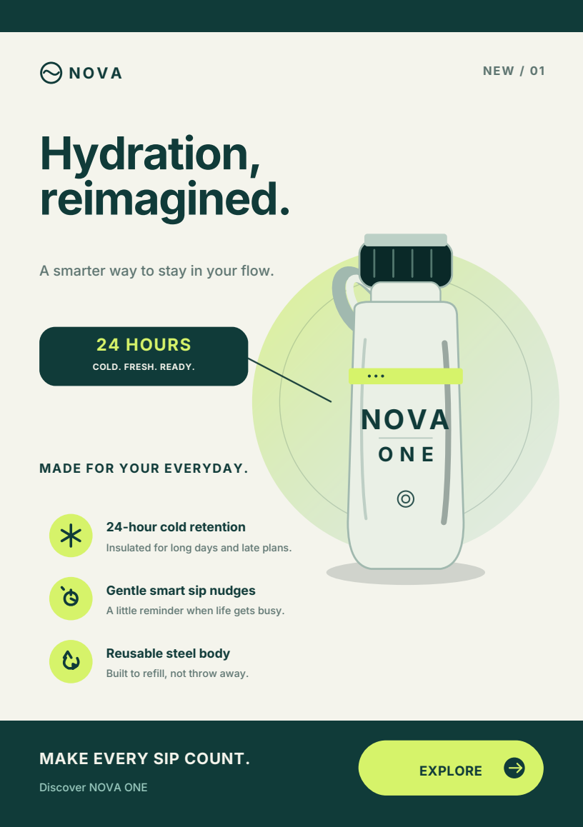

A4 Tri-fold Brochure - Outside
Source: 03_NOVA_ONE_Brochure_Outside_A4.pdf
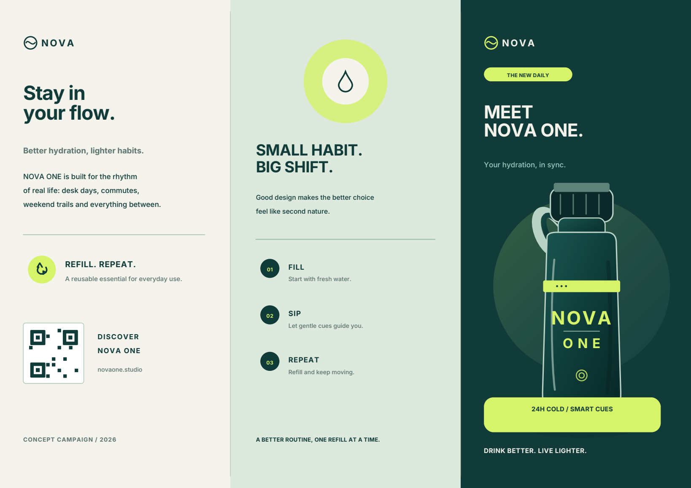

A4 Tri-fold Brochure - Inside
Source: 04_NOVA_ONE_Brochure_Inside_A4.pdf
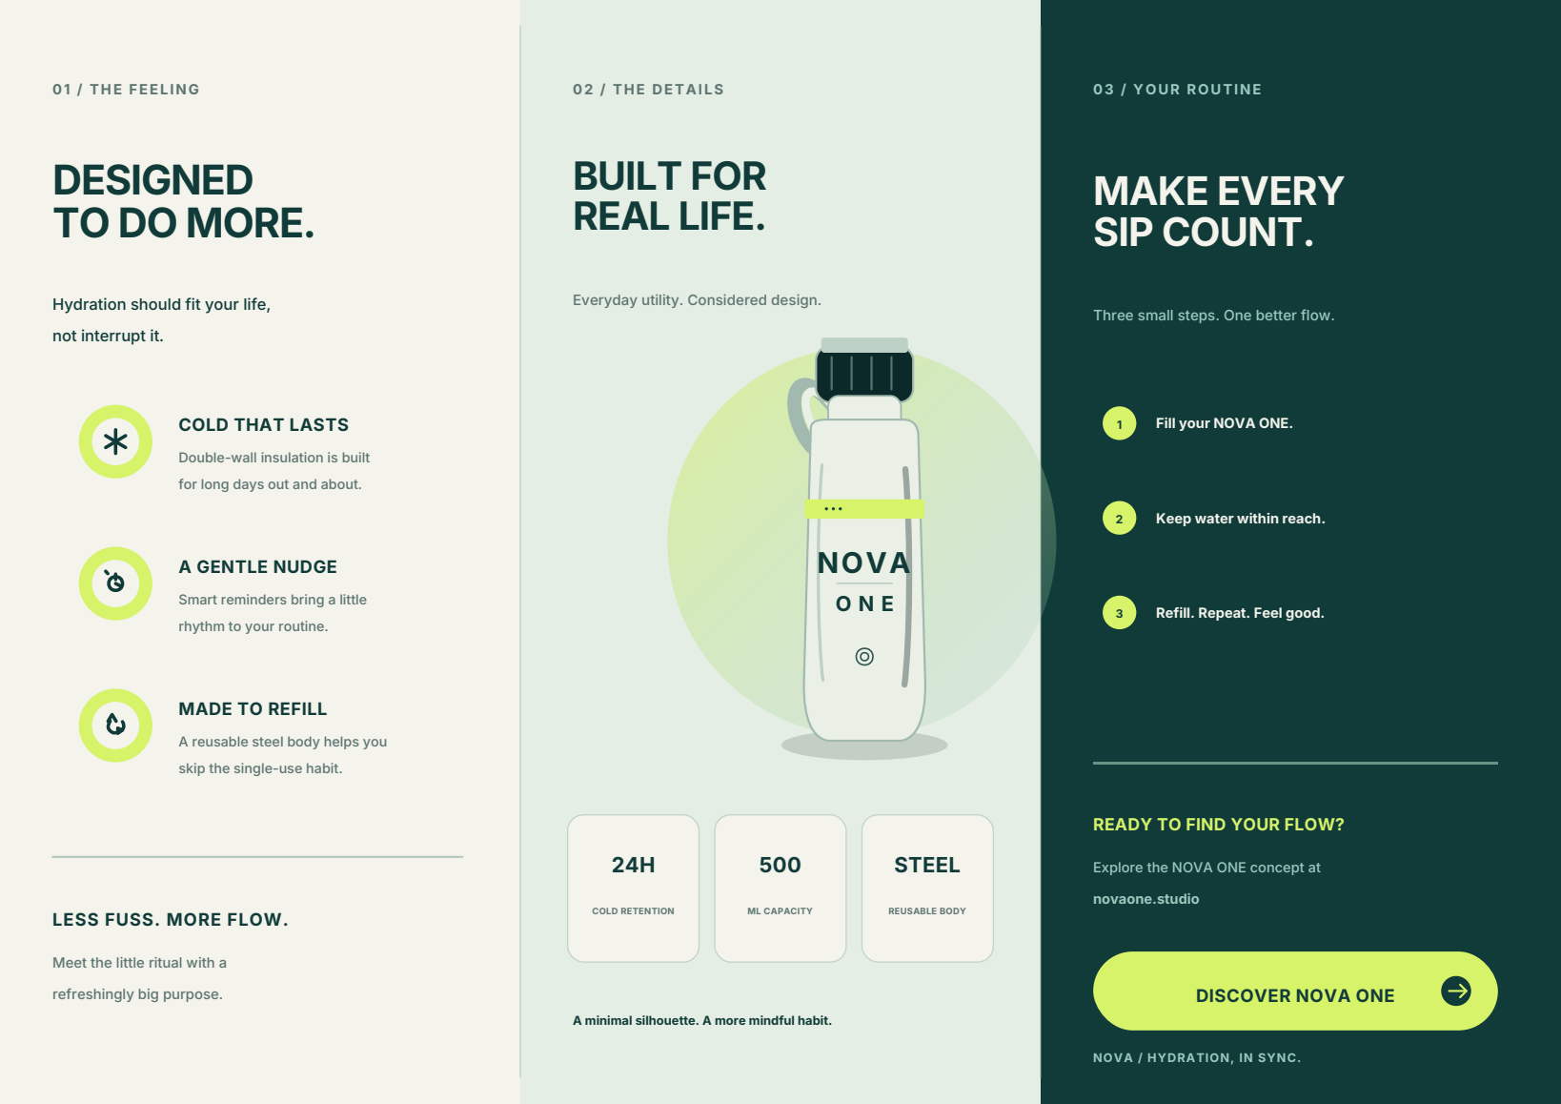

Consolidated Print Artwork Set - Page 1 of 4
Source: NOVA_ONE_Print_Artwork_Set.pdf. This page is intentionally retained as part of the complete supplied PDF set; it duplicates the corresponding standalone artwork.

Consolidated Print Artwork Set - Page 2 of 4
Source: NOVA_ONE_Print_Artwork_Set.pdf. This page is intentionally retained as part of the complete supplied PDF set; it duplicates the corresponding standalone artwork.

Consolidated Print Artwork Set - Page 3 of 4
Source: NOVA_ONE_Print_Artwork_Set.pdf. This page is intentionally retained as part of the complete supplied PDF set; it duplicates the corresponding standalone artwork.

Consolidated Print Artwork Set - Page 4 of 4
Source: NOVA_ONE_Print_Artwork_Set.pdf. This page is intentionally retained as part of the complete supplied PDF set; it duplicates the corresponding standalone artwork.

Design Rationale PDF - Page 1 of 2
Source: NOVA_ONE_Design_Rationale.pdf. Original page retained visually.
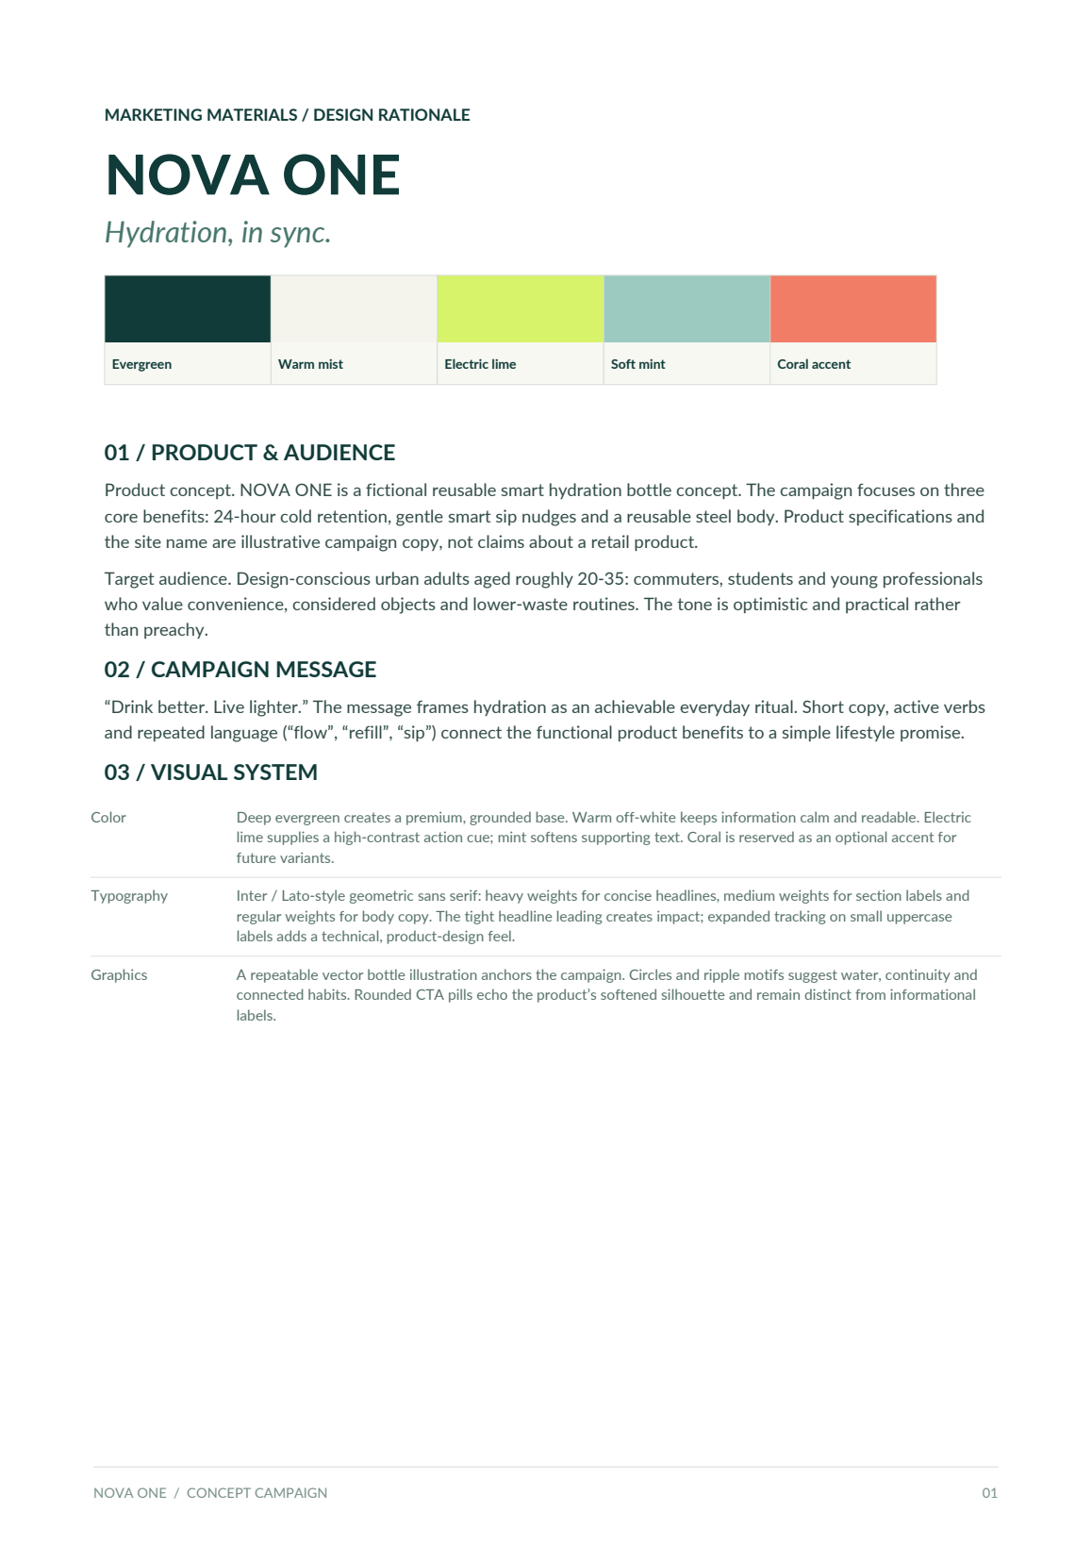

Design Rationale PDF - Page 2 of 2
Source: NOVA_ONE_Design_Rationale.pdf. Original page retained visually.
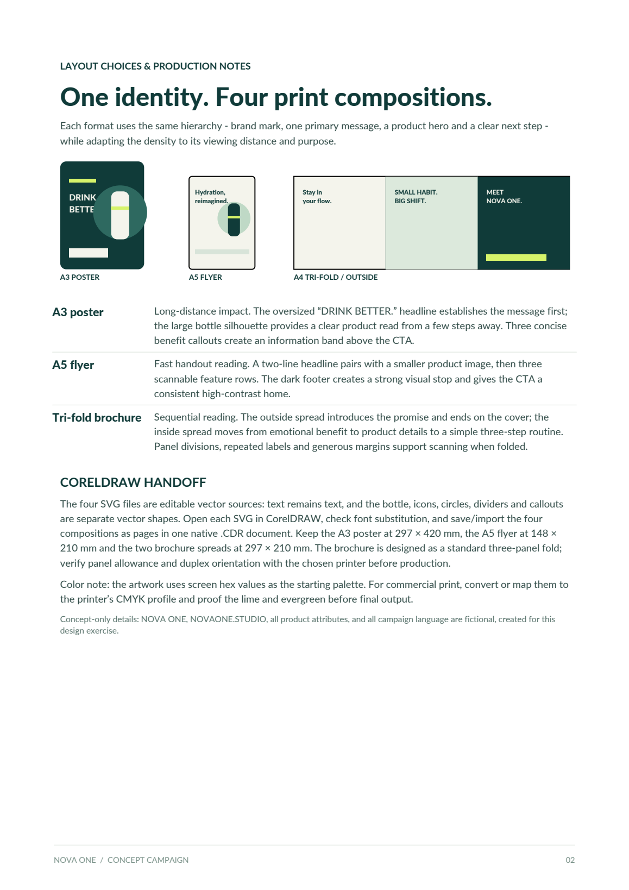

EDITABLE DESIGN RATIONALE
NOVA ONE / Hydration, in sync.

01 / Product and Audience
Product concept. NOVA ONE is a fictional reusable smart hydration bottle concept. The campaign focuses on three core benefits: 24-hour cold retention, gentle smart sip nudges and a reusable steel body. Product specifications and the site name are illustrative campaign copy, not claims about a retail product.
Target audience. Design-conscious urban adults aged roughly 20-35: commuters, students and young professionals who value convenience, considered objects and lower-waste routines. The tone is optimistic and practical rather than preachy.

02 / Campaign Message
“Drink better. Live lighter.” The message frames hydration as an achievable everyday ritual. Short copy, active verbs and repeated language (“flow”, “refill”, “sip”) connect the functional product benefits to a simple lifestyle promise.

03 / Visual System
Color. Deep evergreen creates a premium, grounded base. Warm off-white keeps information calm and readable. Electric lime supplies a high-contrast action cue; mint softens supporting text. Coral is reserved as an optional accent for future variants.
Typography. Inter / Lato-style geometric sans serif: heavy weights for concise headlines, medium weights for section labels and regular weights for body copy. Tight headline leading creates impact; expanded tracking on small uppercase labels adds a technical, product-design feel.
Graphics. A repeatable vector bottle illustration anchors the campaign. Circles and ripple motifs suggest water, continuity and connected habits. Rounded CTA pills echo the product’s softened silhouette and remain distinct from informational labels.

Campaign palette
Evergreen | Warm mist | Electric lime | Soft mint | Coral accent

LAYOUT CHOICES & PRODUCTION NOTES
One identity. Four print compositions. Each format uses the same hierarchy - brand mark, one primary message, a product hero and a clear next step - while adapting the density to its viewing distance and purpose.

A3 poster
Long-distance impact. The oversized “DRINK BETTER.” headline establishes the message first; the large bottle silhouette provides a clear product read from a few steps away. Three concise benefit callouts create an information band above the CTA.

A5 flyer
Fast handout reading. A two-line headline pairs with a smaller product image, then three scannable feature rows. The dark footer creates a strong visual stop and gives the CTA a consistent high-contrast home.

Tri-fold brochure
Sequential reading. The outside spread introduces the promise and ends on the cover; the inside spread moves from emotional benefit to product details to a simple three-step routine. Panel divisions, repeated labels and generous margins support scanning when folded.

CorelDRAW handoff
The four SVG files are editable vector sources: text remains text, and the bottle, icons, circles, dividers and callouts are separate vector shapes. Open each SVG in CorelDRAW, check font substitution, and save/import the four compositions as pages in one native .CDR document. Keep the A3 poster at 297 × 420 mm, the A5 flyer at 148 × 210 mm and the two brochure spreads at 297 × 210 mm. The brochure is designed as a standard three-panel fold; verify panel allowance and duplex orientation with the chosen printer before production.
Color note. The artwork uses screen hex values as the starting palette. For commercial print, convert or map them to the printer’s CMYK profile and proof the lime and evergreen before final output.
Concept-only details. NOVA ONE, NOVAONE.STUDIO, all product attributes, and all campaign language are fictional, created for this design exercise.

