**ASHES ANALYSIS REPORT**

The analysis is done as follows:

A performance score has been calculated for every player based on their batting, fielding and bowling scores.

Batting score is based on batting averages in the year 2015, in England and versus England/Australia. Based on these individual scores, a weighted average is taken to get the final performance score.

Bowling score is based on bowling averages in the year 2015, in England and versus England/Australia. Based on these individual scores, a weighted average is taken to get the final performance score.

Fielding score is based on the total number of catches taken and the number of matches played.

All the data for the analysis has been taken from the ESPNcricinfo site.

Results:

For Australia, following are the predictions:

Worst batsman: David Warner

Best batsman: Steven Smith

Worst bowler: Peter Siddle

Best bowler: Josh Hazlewood

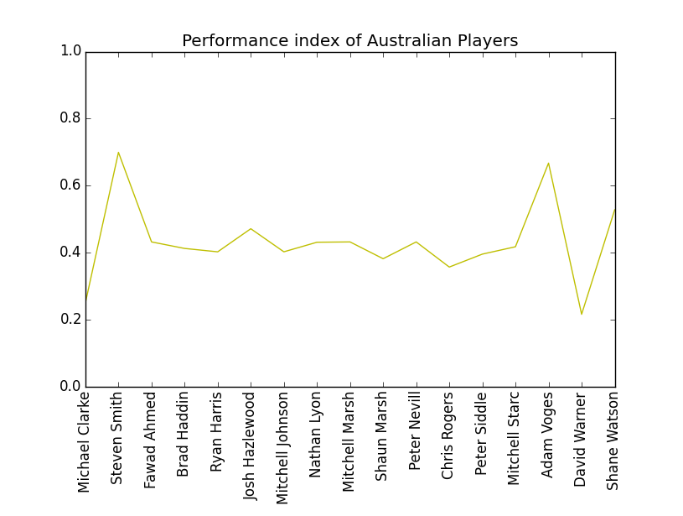

For England, following are the predictions:

Worst batsman: Ian Bell

Best player: Joe Root

Worst bowler: Steven Finn

Best bowler: Stuart Broad

