**Linear Algebra**

**Linear Algebra is a branch of mathematics that deals with vectors, matrices, and systems of linear equations. It helps us understand and solve problems where multiple variables are related in straight-line (linear) ways.**

**Example (Small Store):  
Imagine a small store sells pens for $2 each and notebooks for $3 each. One day, a customer buys 5 pens and 4 notebooks and pays $22.**

**We can write this as a linear equation:**

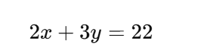

**(where x is the number of pens, and y is the number of notebooks)**

**When we have just a few equations and variables, we can easily solve them using basic algebra. But when we deal with a large amount of data, like hundreds or thousands of equations, it becomes too difficult to solve them one by one. That is why we use matrices to organize the numbers and solve everything more efficiently.**

**Walmart’s Smart Sales Solver**

**Problem Statement**

Walmart’s regional analytics team faced a challenge: **optimize sales strategies** across three major stores for five key product categories -**groceries, electronics, clothing, toys, and furniture**.

**Organizing Data with Matrices**

To begin, the team collected **monthly sales data** from each store and arranged it in a **matrix** A:

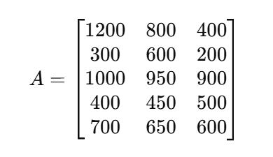

Each **row** represented a product category, and each **column** represented a store.

**Applying a Uniform Discount with a Scalar Matrix**

**They decided to simulate a 10% discount on all products. This was applied as a scalar multiplication: multiplying the entire matrix by 0.9 to forecast the impact on sales.**

**Reversing Changes with the Inverse Matrix**

**To validate their strategy, they needed to reverse the effects of a previous pricing model. Using the inverse matrix, they recalculated the original sales values before discounts.**

**Rotating Perspective using the Transpose**

**The team then took the transpose of the sales matrix A^T to switch the view, now comparing store performance per product rather than product performance per store.**

**Checking Uniqueness with Determinants**

**Business Scenario**

**Walmart’s operations team wants to analyze if sales data from three top product categories, Groceries, Electronics, and Furniture, can be used independently to make decisions on inventory distribution across three stores. But first, they need to make sure the data from these products is not overlapping or redundant.**

**Sales Data Matrix (3×3)**

**They form a matrix of monthly sales for these three categories at three stores**

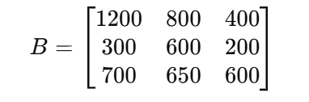

**They want to know:**

**"Is each product category giving us unique information about customer demand at each store, or are some categories just behaving the same?"**

**The determinant of the matrix tells them if the three product categories behave differently enough across stores.**

**If det(B) ≠ 0, the categories provide independent insights.**

**If det(B) = 0, there’s overlap, and some categories might not need separate handling.**

**They calculate the determinant and find it is non-zero.**

**🧾 Business Decision:**

**Perfect. Each category shows a unique pattern. We will stock and manage Groceries, Electronics, and Furniture separately for each store.**

**This means Walmart avoids making generic stocking rules and instead makes tailored decisions per product and per store, ensuring shelves are stocked based on actual, distinct demand.**

**Vector and Scalar:**

**Vector: An ordered set of numbers (even if just one), that lives in a space with both magnitude and direction**

**Scalar: Speed 50 km/h Just the speed, no direction.**

**Velocity vector: 50 km/h north (1D or 2D space).**

**Individual Trends through Vectors**

**Each product's performance in different stores was captured as a vector. For instance,**

**Suppose you track electronics sales each month:**

* **January: [300, 600, 200]**
* **February: [330, 660, 220]**
* **March: [360, 720, 240]**

**These vectors all point in the same direction but grow in magnitude → showing consistent growth trend in all three stores.**

**Why does this mean they point in the same direction?**

The direction of a vector is determined by the relative proportions of its components, not its length. **Normalizing a vector** strip away its magnitude**, leaving only the directional information**. If two vectors have the same normalized components, their directions are identical, regardless of how long or short the vectors are**.**

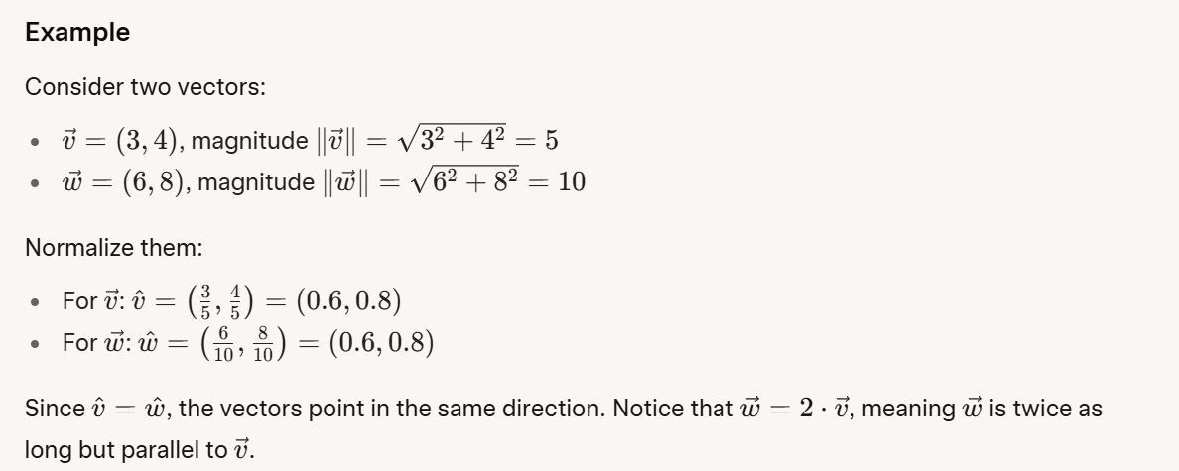

**Walmart uses these vector trend lines to:**

* **Predict stock needs per store**
* **Spot rising or lagging products**
* **Visualize whether a category is steady, growing, or shifting store focus**

**Vector Angle**

The **angle between two vectors** is the angle θ formed when two vectors (arrows) start from the same point. It measures how "aligned" or "different" their directions are:

* If the angle is 0∘the vectors point in the same direction.
* If the angle is 90∘, they are perpendicular (at a right angle).
* If the angle is 180∘, they point in opposite directions.

**Similarity Check via Vector Angles**

The angle between the sales vectors of **clothing and furniture** was close to 90°, indicating **no correlation**, customers buying clothes were not buying furniture.

**Understanding the Vector Space**

All possible combinations of product sales made up a **vector space**. The team mapped where current sales lay inside this space and identified **underutilized combinations**, prompting a new **cross-promotion** between groceries and toys.

**Eigenvalues**, **eigenvectors**, and the **covariance matrix** using **Walmart use case**.

**Walmart Use Case: Understanding Product Sales Relationships**

**Situation:** Walmart tracks **weekly sales** of two products: **Electronics** and **Toys** across many weeks.

| **Week** | **Electronics** | **Toys** |
| --- | --- | --- |
| **1** | **300** | **150** |
| **2** | **400** | **200** |
| **3** | **500** | **250** |
| **4** | **600** | **300** |

**It looks like: when electronics go up, toys go up too.**

**The covariance matrix tells us how much two variables change together.**

**For this case:**

* **Electronics = X**
* **Toys = Y**

**We calculate how:**

* **X varies with X (variance of Electronics)**
* **Y varies with Y (variance of Toys)**
* **X varies with Y (covariance between Electronics and Toys)**

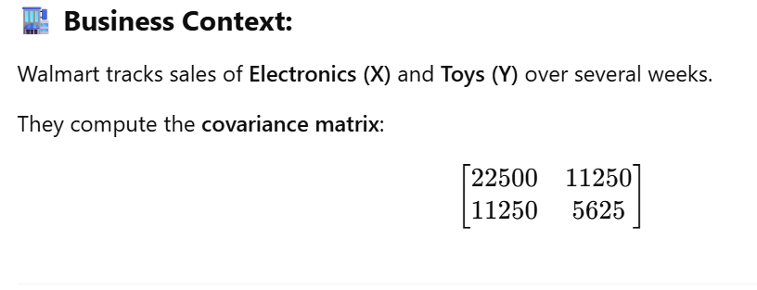

**Positive Covariance (11250):**

* **Electronics and toys have a strong positive relationship.**
* **This means: When electronics sales increase, toy sales also increase (and vice versa).**
* **Insight: These products likely appeal to the same customer group (e.g., families, kids/teens).**

**How Walmart Benefits: Run combo deals (e.g., "Buy a gaming console, get a toy 20% off")**

**High Variance (22500 and 5625):**

* **Electronics (22500) have higher variance = bigger fluctuations in weekly sales**
* **Toys (5625) are more stable, but still vary**

**How Walmart Benefits:**

**Use this insight for stock planning**

**Keep buffer inventory for electronics (because sales spike more)**

**Variance measures how much the data is spread out from its average:**

**A high variance means sales fluctuate a lot—some weeks are high, others low.**

**A low variance means sales are more consistent—similar values week to week.**

**⚠️ Disadvantages of High Covariance**

**1. Redundancy in Data**

**If two products (say, Electronics and Toys) have high covariance, it means their sales always go up and down together. Sounds useful, but… It means you are often getting the same information twice.**

**Why it is a problem:**

**You are analyzing both products, but they are behaving nearly identically.**

**It adds complexity without adding new insight**

**Eigenvectors – directions in the data that represent consistent patterns**

**Eigenvalues – the importance or weight of each pattern**

**When electronics sales go up, toy sales also go up consistently in all three stores.”**

**This pattern was not obvious when looking at store totals because:**

* **Sometimes electronics sold more overall,**
* **Sometimes toys did**
* **But the rise and fall happened together and this was captured by the eigenvector.**

**The eigenvalue linked to this vector was high, meaning:**

**“This joint behavior (electronics + toys) explains a large part of our overall sales variation.”**

**🧾 Business Decision:**

**“Let us run combo promotions for electronics and toys, especially during holidays and weekends. Since they trend together, bundling might boost both.”**

**They also decided to:**

* **Arrange these products near each other in stores,**
* **Include them together in online recommendations.**