🚗 Used Car Price Dashboard Report

# 📘 Introduction

This report provides an insightful analysis of used car pricing trends using interactive data visualization techniques. Built with Streamlit, this dashboard empowers users to explore how key vehicle features influence the resale value of cars.  
  
The primary goals of this project are to:  
- Analyze car features impacting price  
- Enable dynamic visual exploration  
- Build a user-friendly dashboard for insights

# 📊 Dataset Overview

The dataset used contains detailed attributes of second-hand cars listed for resale.

🔑 Key Features:

|  |  |
| --- | --- |
| Attribute | Description |
| year | Year of manufacture |
| selling_price | Resale value in INR |
| fuel | Type of fuel used (Petrol, Diesel, etc.) |
| seller_type | Individual or dealer |
| transmission | Manual or automatic |
| owner | Number of previous owners |
| km_driven | Kilometers driven |
| engine_cc | Engine capacity |
| max_power | Maximum horsepower |
| mil_kmpl | Mileage in km/l |
| torque_rpm | Torque RPM value |

# 🧹 Data Preprocessing

- Missing values were identified and handled  
- Columns like max_power, torque, and mileage were cleaned and converted to numeric  
- New derived columns were created:  
 - mil_kmpl (Mileage as float)  
 - max_power_new  
 - torque_rpm

# 📈 Exploratory Data Analysis (EDA)

The Streamlit dashboard allows users to select from multiple chart types for interactive exploration.

✨ Visuals Included:  
1. Trend Over Time (Line Chart)  
2. Categorical Comparisons (Bar Charts, Box Plot, Count Plot)  
3. Relationship Insights (Scatter Plots)  
4. Distributions (Pie Charts)

# 🧠 Feature Engineering

The following transformations were made for enhanced analysis:

|  |  |
| --- | --- |
| New Feature | Description |
| mil_kmpl | Cleaned mileage value as float |
| max_power_new | Numerical conversion of power data |
| torque_rpm | Extracted numeric RPM values from textual torque entries |

# 📊 Key Insights

- Diesel cars show higher resale value than petrol cars on average.  
- Automatic cars generally fetch higher prices than manual ones.  
- Engine CC and Max Power have a strong positive correlation with price.  
- Higher KM Driven tends to reduce the resale price.  
- More recent models retain more value.

# 🖥️ Application Deployment

This project features a fully functional dashboard:

|  |  |
| --- | --- |
| Tech | Description |
| Streamlit | Web app framework for interactive data apps |
| Seaborn / Matplotlib | Plotting libraries |
| Pandas | Data manipulation and analysis |

Launch with:  
  
streamlit run car_app.py

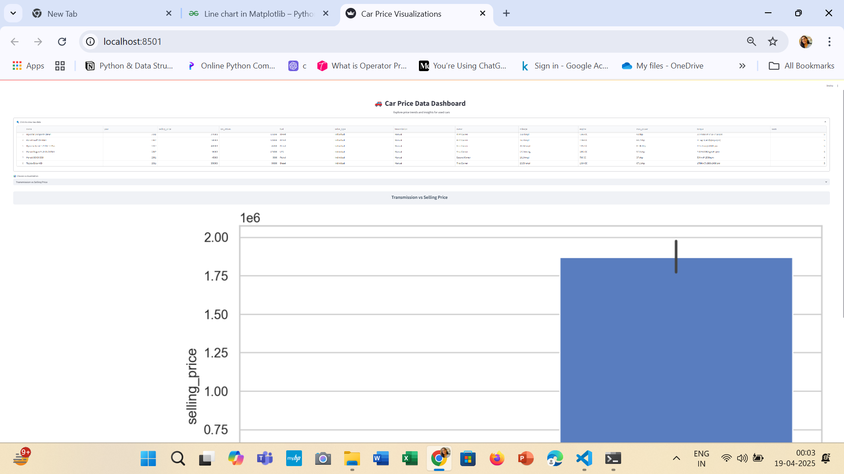

# ✅ Conclusion

This dashboard successfully showcases how data visualization can reveal valuable insights into the used car market. From understanding fuel efficiency trends to examining seller behaviors, this tool helps users make data-informed decisions.  
  
🔮 Future Enhancements:  
- Integrate machine learning for price prediction  
- Add filtering by brand or city  
- Upload user datasets for custom exploration  
  
This project lays the foundation for a complete car price intelligence platform.