**Global Airline Management**

**Name: Sneha Sudhir Dange**

**Employee ID: E5685540**

Database name: fisglobal

Tables: Admin & Passenger

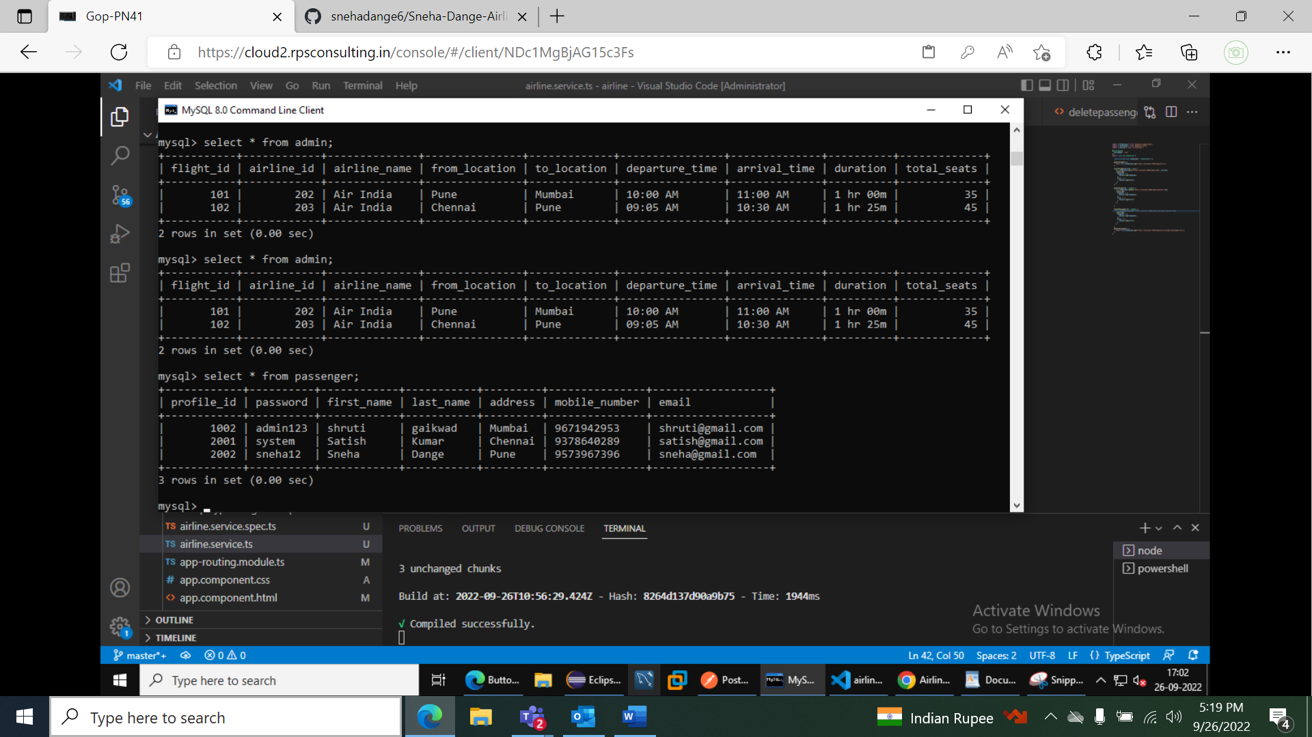

Application Execution:

Display All flights

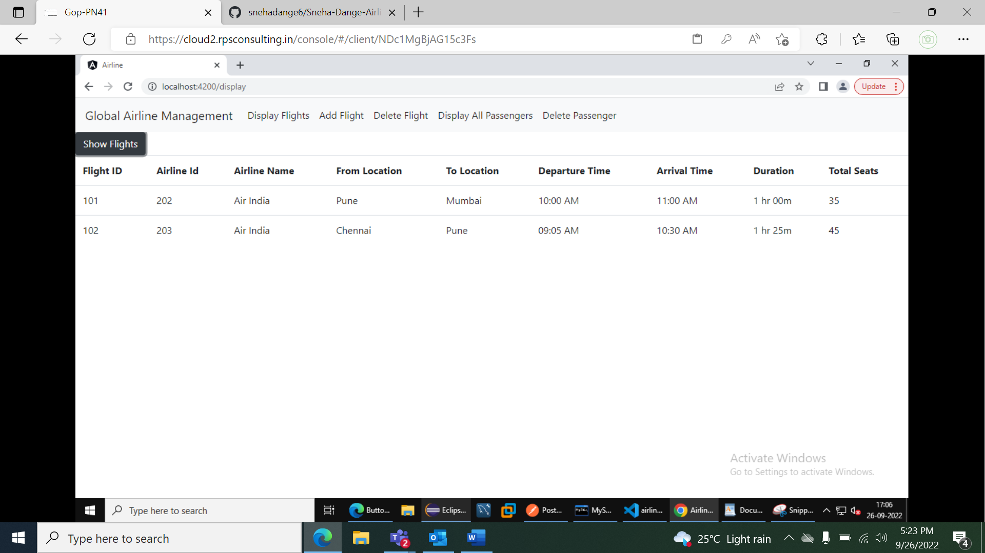

Add new Flight:

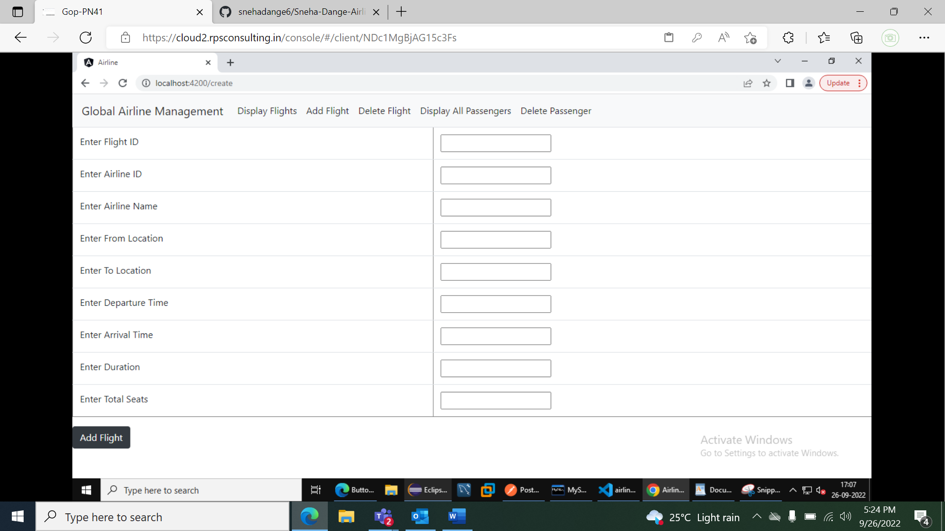

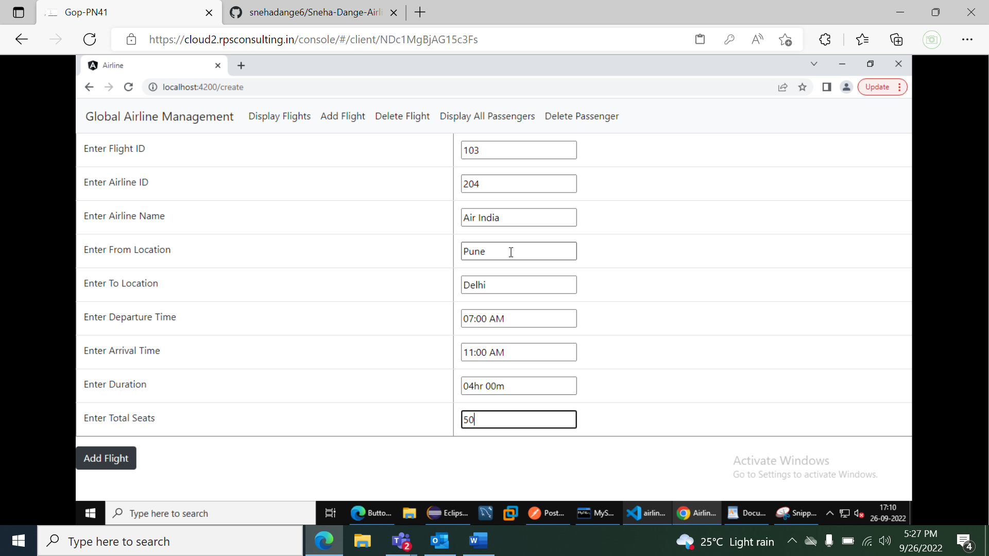

Flight Added:

Delete Flight with flight Id 103:

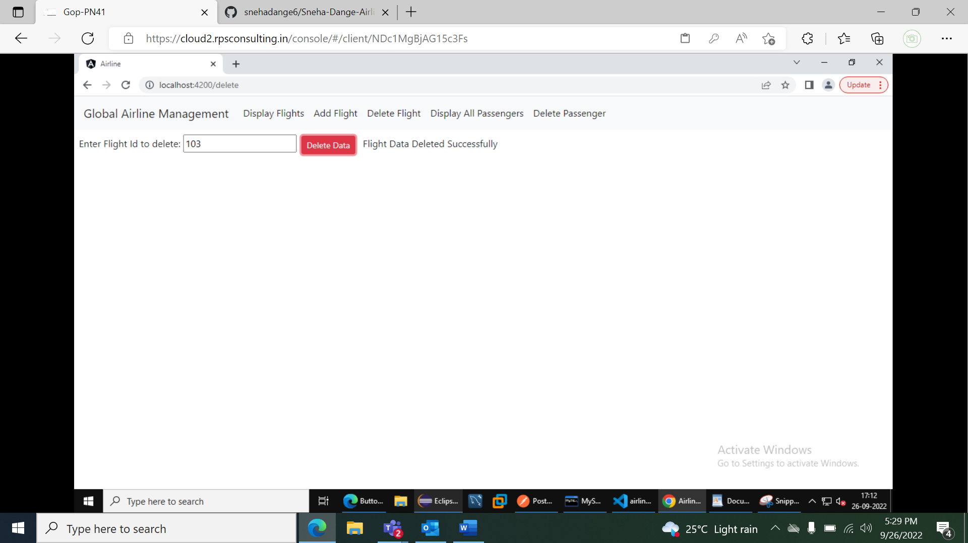

Flight 103 Deleted:

Display All Passengers

Delete Passenger Profile with profile Id 1002:

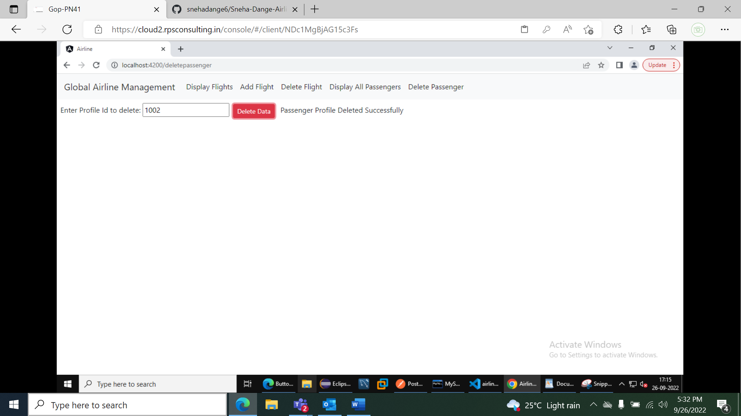

Profile 1002 Deleted:

