Backgrounds

The guidelines we have used includes:

**Four Principles of Good Design (Shneiderman 1998)**

1. State and the action alternatives should be visible

2. Should be a good conceptual model with a consistent system image

3. Interface should include good mappings that reveal the relationships between stages

4. User should receive continuous feedback

**Nielsen’s Ten Heuristic Rules (1993)**

1. Simple and natural dialog

2. Speak the user’s language

3. Minimize user’s memory load

4. Consistency

5. Feedback

6. Clearly marked exits

7. Shortcuts

8. Good error messages

9. Prevent errors

10.Help and documentation

**Jakob Nielsen’s Ten Usability Heuristics**

1. Visibility of system status (Feedback)

2. Match between system and the real world (METAPHOR)

3. User control and freedom (NAVIGATION)

4. Consistency and standards (CONSISTENCY)

5. Error prevention (PREVENTION)

6. Recognition rather than recall (MEMORY)

7. Flexibility and efficiency of use (EFFICIENCY)

8. Aesthetic and minimalist design (DESIGN)

9. Help users recognize, diagnose, and recover from errors (RECOVERY)

10. Help and documentation (Help)

**Shneiderman’s Eight Golden Rules**

1. Strive for consistency

2. Enable frequent users to use shortcuts

3. Offer informative feedback

4. Design dialog to yield closure

5. Offer simple error handling

6. Permit easy reversal of actions

7. Support internal locus of control

8. Reduce short-term memory load

**Smith & Mosier: Data Display**

2.0/1Necessary Data Displayed

2.0/2 Only Necessary Data Displayed

2.0/3 Data Displayed in Usable Form

2.0/4 Data Display Consistent with User Conventions

2.0/6 Consistent Display Format

2.0/8 User Control of Data Display

2.0/12 Familiar Wording

2.0/15 Consistent Grammatical Structure

Methods

The tools we are using includes design tools and software engineering tools.

For the design tools, we used paper and hand drawing to draw the framework of the initial pages, and then we organize the initial pages together to a flow diagram, with a clear indication of how the pages are interacting with each other.

For the engineering tools, we used Android Studio to put the design we made into an android project. We used xml language to define the layout of the page and then we used java language to create the function behind the layout.

Results

**Guideline 01.**

Four Principles of Good Design (Shneiderman 1998)

2. Should be a good conceptual model with a consistent system image

**Implementation:**

|  |  |
| --- | --- |
| Content Items | style |
| Page title | 20sp, dark blue color #4FC3F7, bold |
| Page content subtitle | 12sp, blue color, #4FC3F7 |
| Page content plain text | 12sp, black color #000000 |
| Buttons | background: blue color, #81D4FA  text: 12sp, white color #FFFFFF |
| Text Links | 12sp, blue color, #4FC3F7 |
| Input Text Box | background: light blue color, #E1F5FE |
| Dropdown list | background: light blue color, #E1F5FE |
| Radio Buttons | 12sp, black color #000000 |
| Contact card | background: light blue color, #E1F5FE |

Report Leak

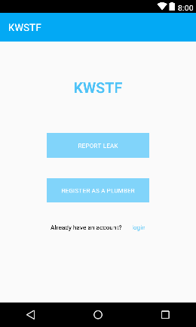 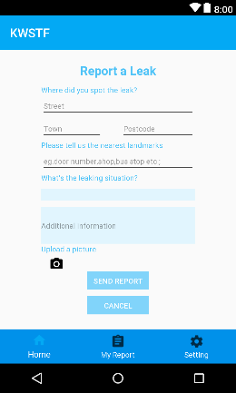 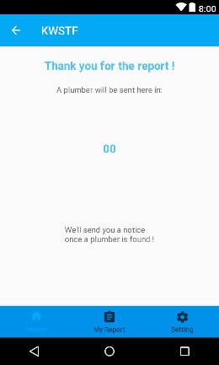 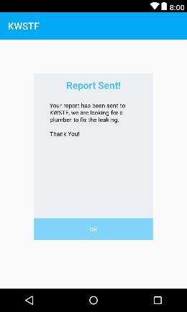 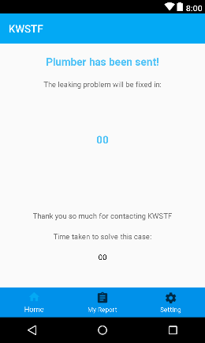

Register as a Plumber

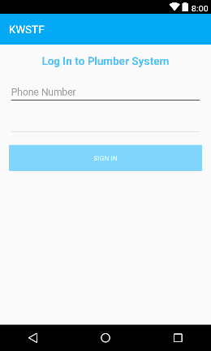 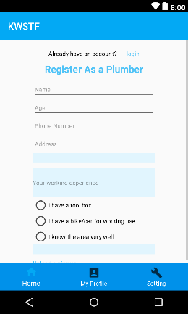 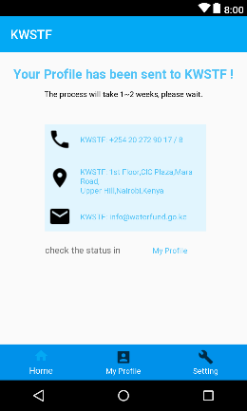 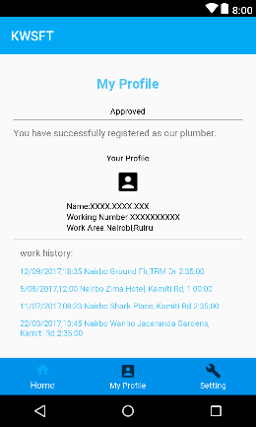 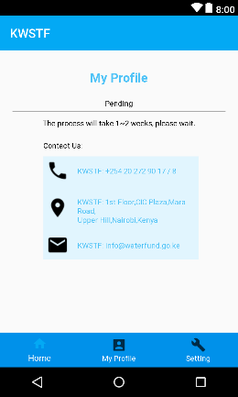

Menu

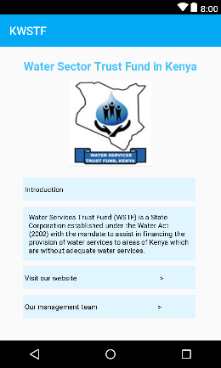 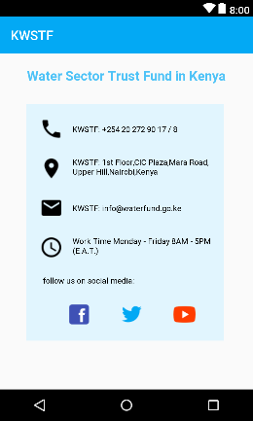 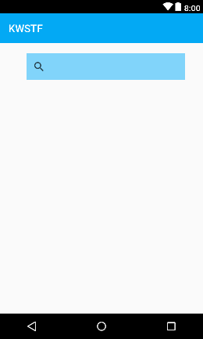

**Guideline 02:**

Four Principles of Good Design (Shneiderman 1998)

4. User should receive continuous feedback

**Implementation:**

* Popup-window
* Time-track and Estimated Time Notice

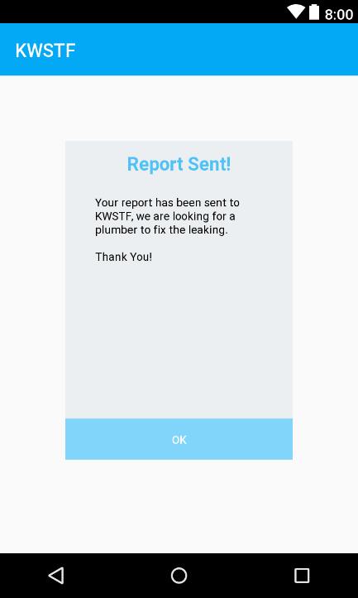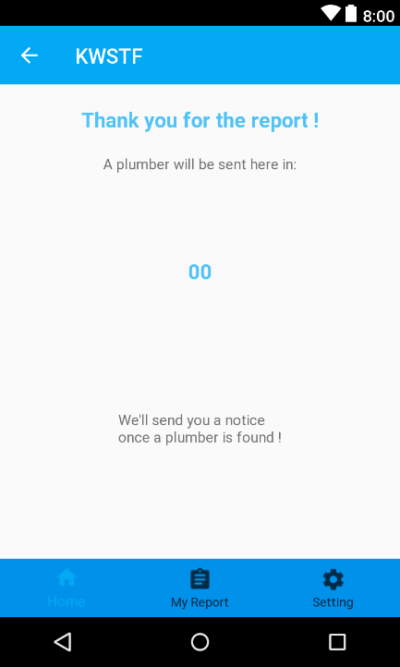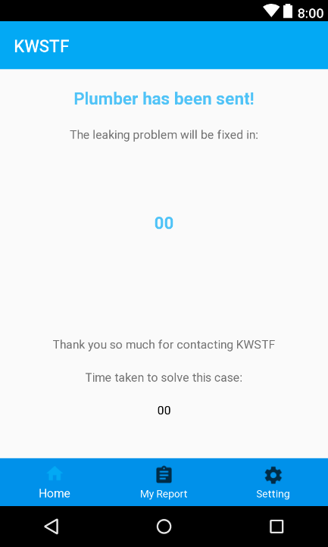

When the user want to report a leak and right after the user hit the “Send Report” button, a pop-up window will be activated and displayed on “My Report” page, give the user positive respond that the report has been sent. At the same time, the timer was sent to track the time that has passed since the user submitted the case, so the user could have a clear image that how fast the KWSTF are responding to the report.

After KWSTF has found a plumber, “My Report” will be updated, a “Count-down” timer will be activated according to the time the plumber estimated to spend on fixing the leak, so the user could be clear that the leak will be fixed in a specific time. At the same time, the previous timer will stop counting and display the time used to find a plumber.

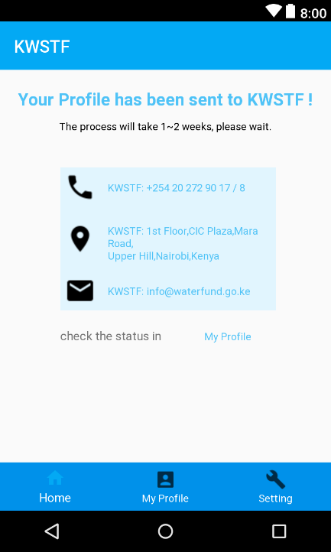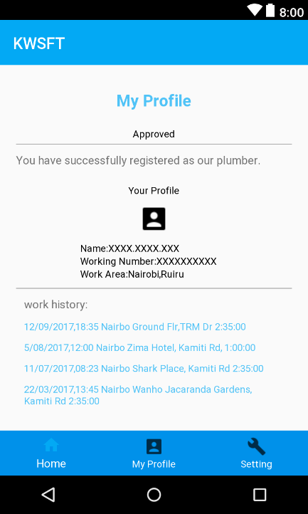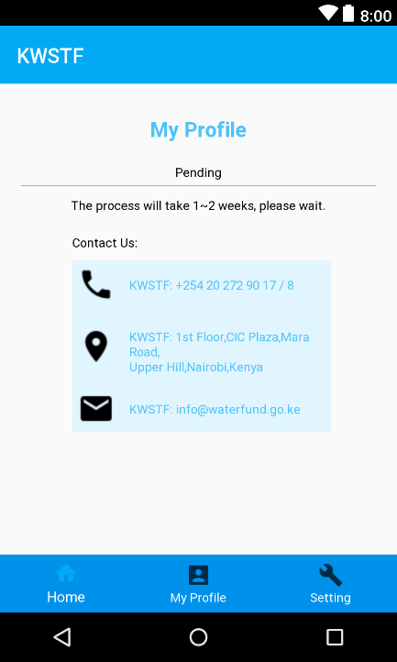

After the plumber has submitted the registrations form, the user will be sent to “My Profile”, with a notification on the title saying the profile has been sent to KWSTF, the estimated time for the process will be displayed under the title, so the user would be clear when he could get the respond from KWSFT, besides that, the contact information are displayed under, the user could choose to call or send an email to inquire about his case.

When a decision is made by KWSTF, “My Profile” page will be updated, with “Approved” or “Pending” or “Rejected” status displayed under, if it’s still in “Pending”, KWSTF contact info are available on the page for user to take the next step.

**Guideline 03:**

Nielsen’s Ten Heuristic Rules (1993)

1. Simple and natural dialog

2. Speak the user’s language

3. Minimize user’s memory load

7. Shortcuts

**Implementation**

* Bottom Navigation Bar
* Menu Items
* Page Update

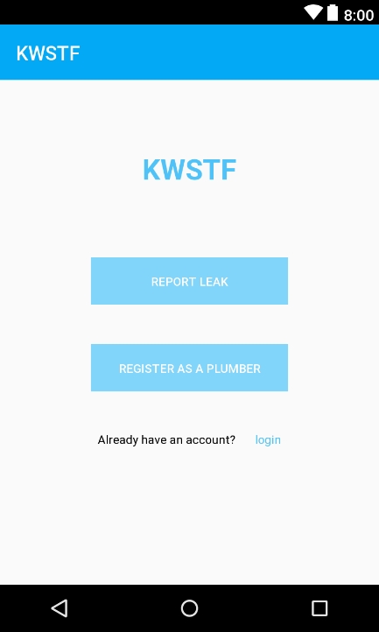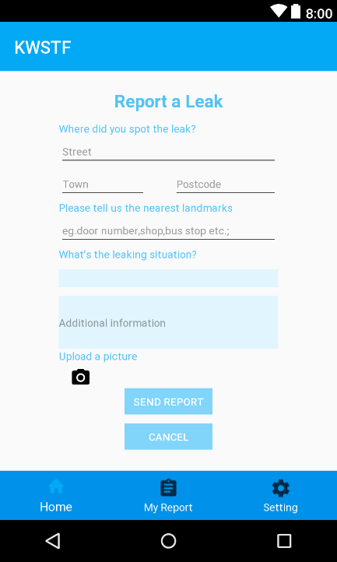

The app use user’s language and give users hint with blue text to prevent erros. “Bottom Navigation” bar is the shortcut for the pages. User can always go back to home page and start over again. After the report was sent, it will be stored in “My Report”, users could go to the page and check the updates.

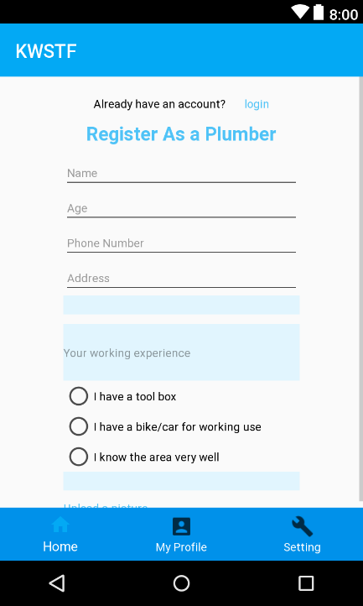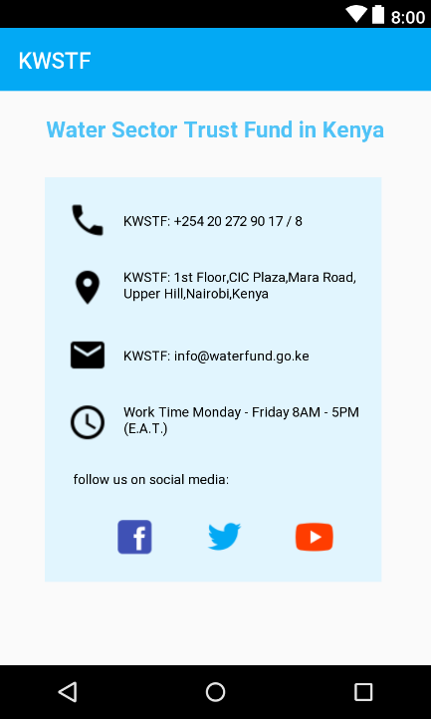

“Login” link was listed on top of the page, so if the user already have an account, he can use the shortcut to login. The KWSTF contact card will be displayed every time there is a need, and the contact info are listed in the menu items, users can also use “Menu” to quickly locate the contact info.

**Guideline 04:**

Jakob Nielsen’s Ten Usability Heuristics

2. Match between system and the real world (METAPHOR)

6. Recognition rather than recall (MEMORY)

8. Aesthetic and minimalist design (DESIGN)

**Implementation:**

* Drop-down list
* Radio Button



A lot of Icons are used to make the app works closely with user’s real life. When we need to have the input from users, we provide “Dropdown menu” or “Radio Button”, so the users don’t need to recall but only to choose from the current. The design have only one main theme color: blue, when there is a need to distinguish, different blue tone is used instead of other colors, which makes the app design is simple and not color-blind users.

**Guidelines 05**

Smith & Mosier: Data Display

2.0/13 Consistent Wording

2.0/15 Consistent Grammatical Structure

**Implementation**

* Grammatical Structure goes like: Report/Register + A leak/ As a plumber
* Wording goes like: I have/know + tool box/the area

