ONLINE VOTING SYSTEM – PROJECT REPORT

Student Details
Name: Sneha Debnath

Introduction
The Online Voting System is a web-based application developed using Python (Flask) and PostgreSQL. It allows users to register, log in, and vote securely. The system ensures one user can vote only once and provides an admin panel.

Objectives
- To develop a secure and user-friendly voting system
- To ensure one user can vote only once
- To provide an admin panel for managing candidates
- To implement authentication and authorization
- To store and manage data efficiently using a database

Technologies Used
Frontend: HTML, CSS, Bootstrap
Backend: Python (Flask)
Database: PostgreSQL
Tools: VS Code, pgAdmin

Database SQL Code
CREATE DATABASE voting_db;
CREATE TABLE users (
id SERIAL PRIMARY KEY,
username VARCHAR(50) UNIQUE,
password VARCHAR(50),
voted BOOLEAN DEFAULT FALSE,
is_admin BOOLEAN DEFAULT FALSE
);
CREATE TABLE candidates (
id SERIAL PRIMARY KEY,
name VARCHAR(50),
votes INT DEFAULT 0
);

System Architecture
The system follows a client-server architecture:
- Frontend (Client): User interacts through web pages
- Backend (Server): Flask handles requests and responses
- Database: Stores user and voting data

Features
User Features
- User registration
- User login authentication
- Vote casting
- One vote per user restriction
Admin Features
- Secure admin login
- Add candidates
- View voting results
- Restricted access to admin panel

Working
- User registers with username and password
- User logs into the system
- System checks credentials from database
- User views available candidates
- User casts vote
- Vote is recorded in database
- User cannot vote again
- Admin logs in separately
- Admin adds candidates and views results

Security
Session authentication, Admin role, One vote restriction

Screenshots
Insert the following screenshots here:
- Register Page
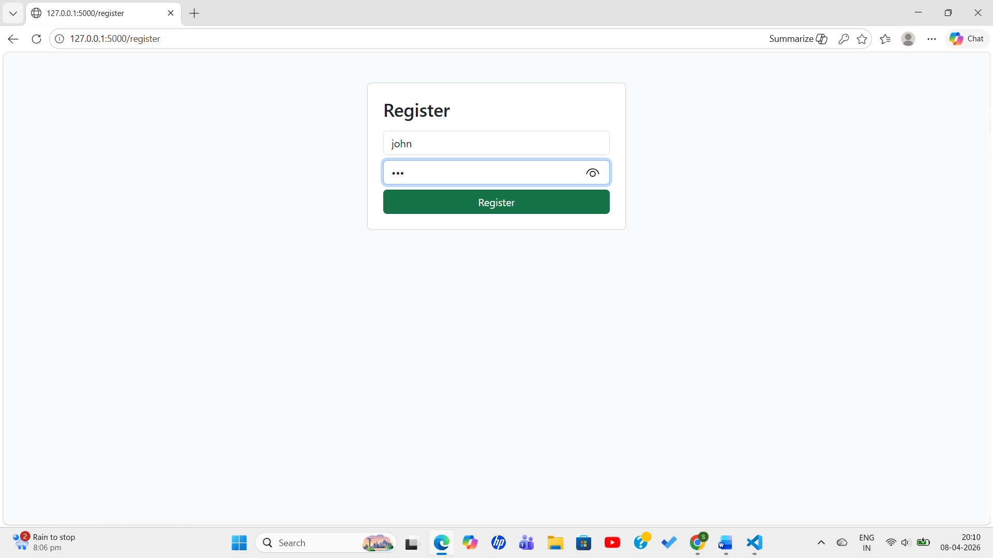
- Login Page
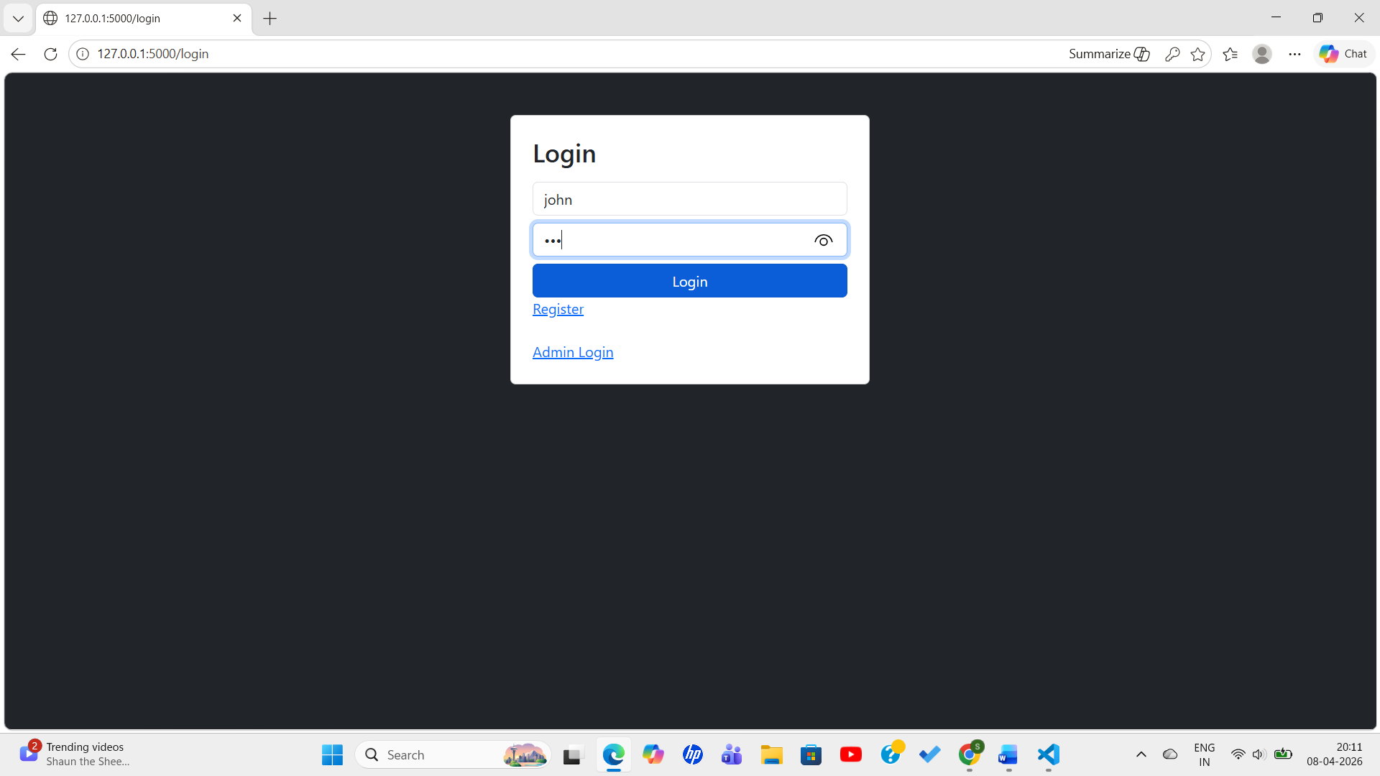
- Dashboard
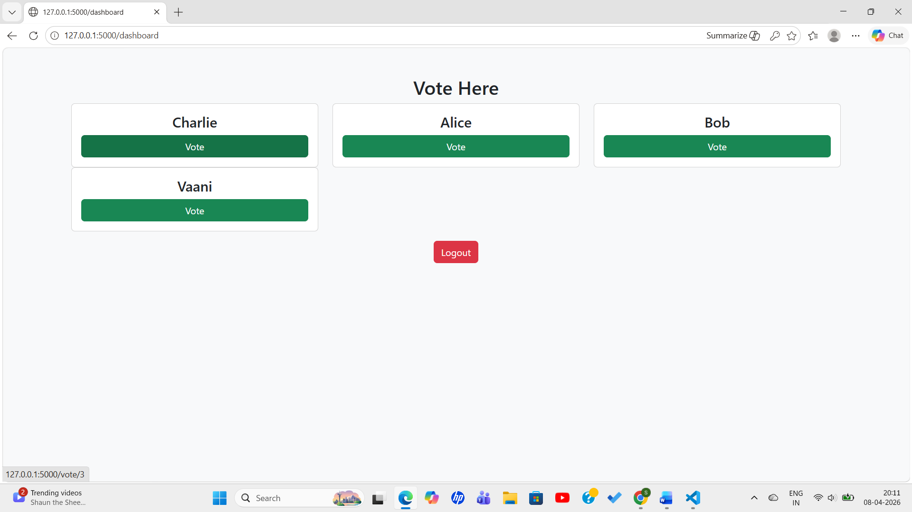
- Vote cast
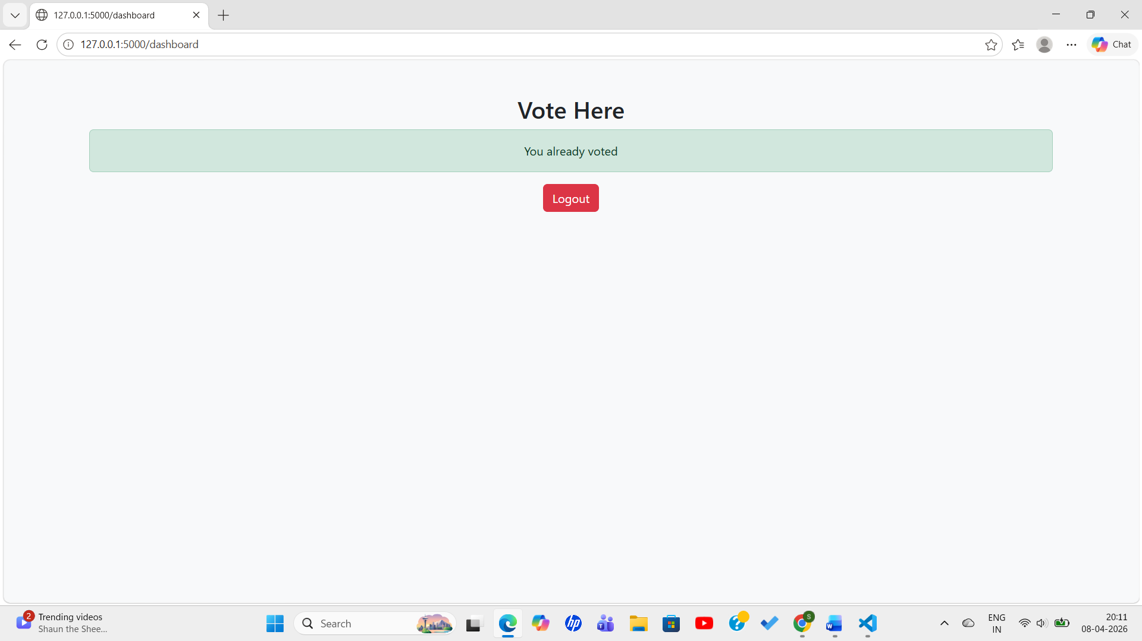
- Admin Login
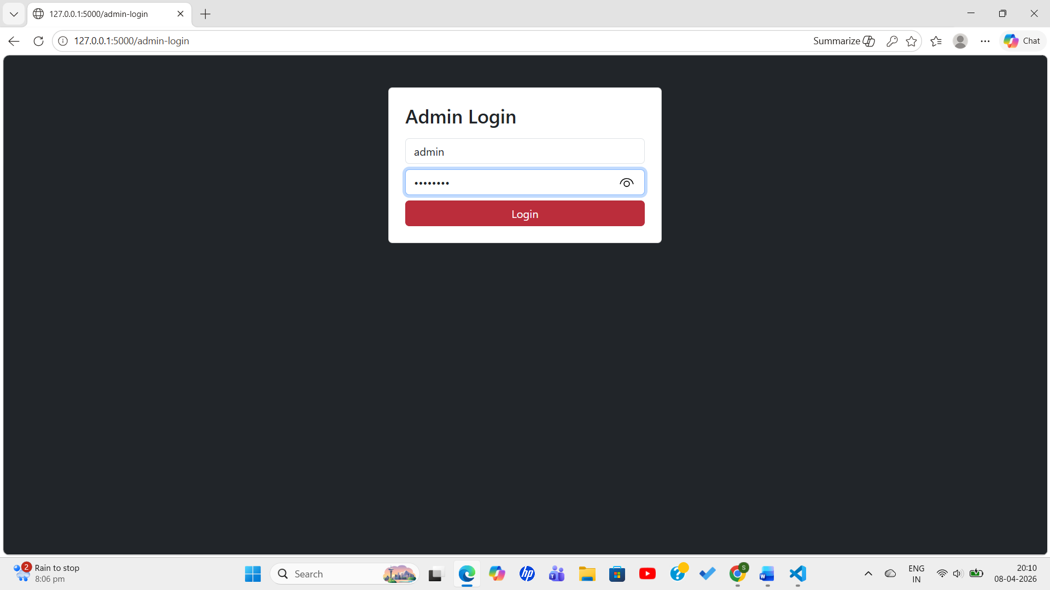
- Admin Panel
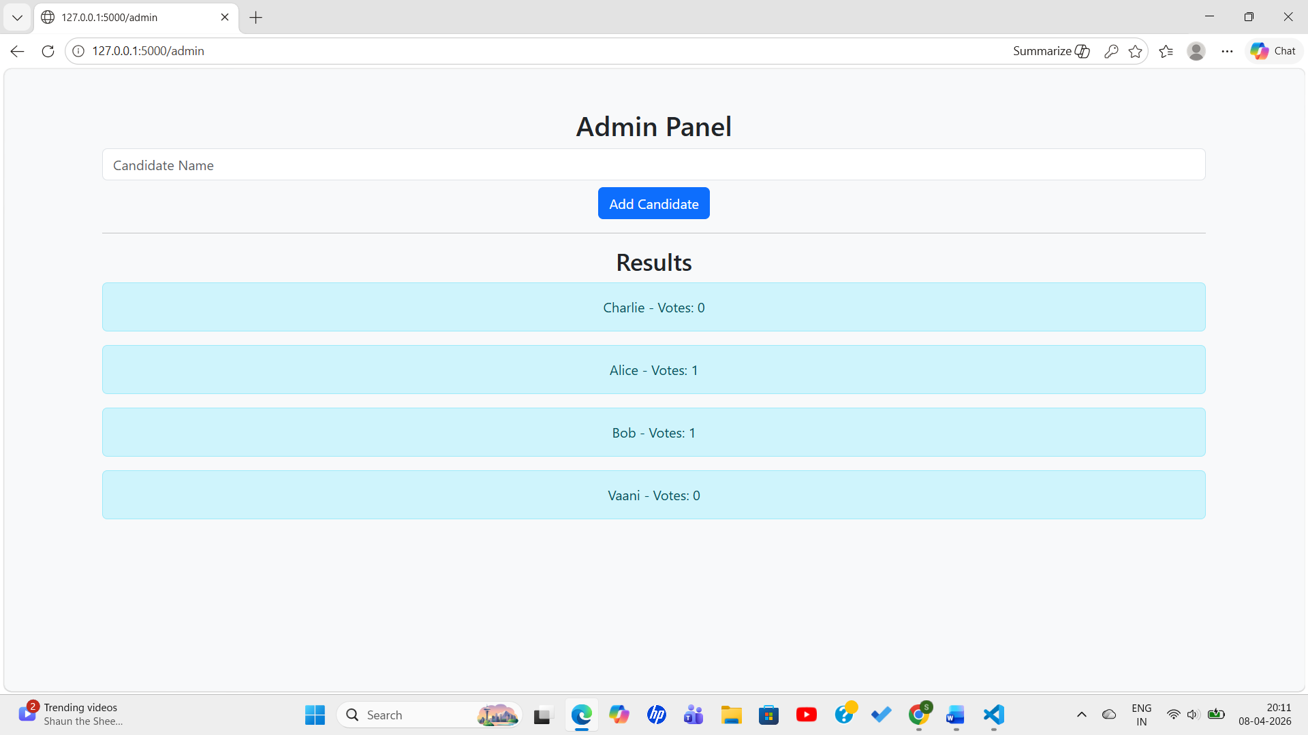

Conclusion
The project demonstrates a secure and efficient voting system using Flask and PostgreSQL.

