MediTrack
Hospital Management System
MySQL Database Project Report
━━━━━━━━━━━━━━━━━━━━━━━━━━━━━━━━
Database design • SQL implementation • Relationships • Query examples

1. Project Overview
MediTrack is a relational database project for organizing core hospital operations. The supplied MySQL implementation stores patient and doctor information, appointment records, prescriptions, and billing transactions. It also demonstrates relational constraints, indexes, views, joins, aggregation, subqueries, and a window function.

2. Database Components
Table | Purpose | Key relationships
Patients | Stores patient demographics and contact information. | Patient_ID primary key; unique index on Email.
Doctors | Stores doctor names, specializations, fees, and experience. | Doctor_ID primary key.
Appointments | Connects patients with doctors and records appointment date/status. | Patient_ID and Doctor_ID foreign keys.
Prescriptions | Stores medicines prescribed for appointments. | Appointment_ID foreign key.
Billing | Stores appointment charges and payment details. | Appointment_ID foreign key.
The SQL file also defines two views: HighValueBills (bills with Amount > 700) and RevenueSummary (revenue grouped by payment method).

3. Database Schema & Relationship Diagram
The supplied diagram summarizes the five database tables, their key attributes, indexes, views, and the relationships between the tables.
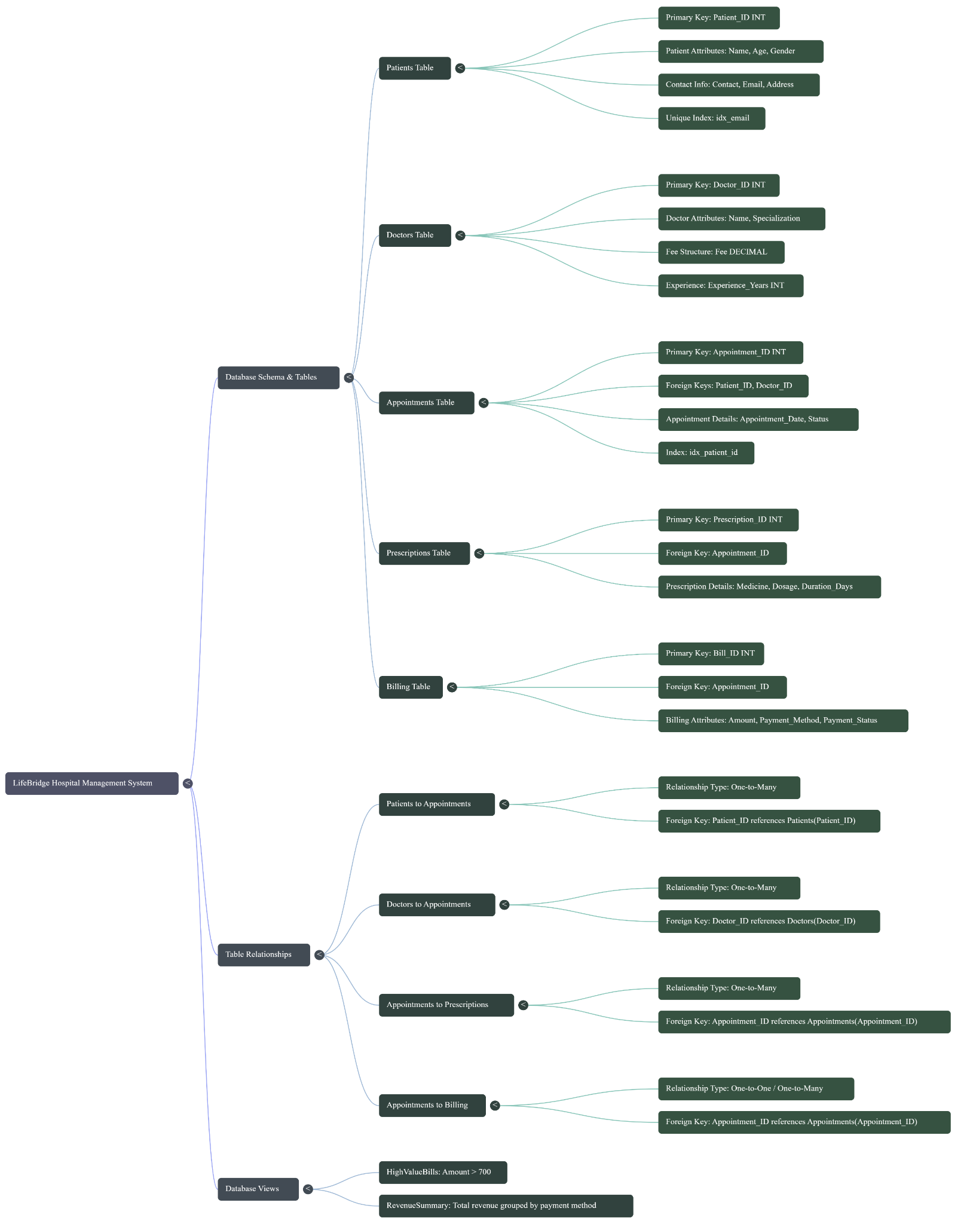
Figure 1. Supplied MediTrack database schema and relationship overview.

4. SQL Implementation
The following statements were extracted from the supplied MySQL Shell transcript and organized by purpose. SQL statements and values are retained from the source file; shell prompts and query result tables are omitted to make the script easier to read.

4.1 Database Setup
\connect root@localhost:3306
CREATE DATABASE MediTrack;
use MediTrack;

4.2 Table Definitions
CREATE TABLE Patients ( Patient_ID INT PRIMARY KEY, Name VARCHAR(100), Age INT, Gender VARCHAR(10), Contact VARCHAR(15), Email VARCHAR(100), Address VARCHAR(100) );
CREATE TABLE Doctors ( Doctor_ID INT PRIMARY KEY, Name VARCHAR(100), Specialization VARCHAR(50), Fee DECIMAL(10, 2), Experience_Years INT );
CREATE TABLE Appointments ( Appointment_ID INT PRIMARY KEY, Patient_ID INT, Doctor_ID INT, Appointment_Date DATE, Status VARCHAR(20), FOREIGN KEY (Patient_ID) REFERENCES Patients(Patient_ID), FOREIGN KEY (Doctor_ID) REFERENCES Doctors(Doctor_ID) );
CREATE TABLE Prescriptions ( Prescription_ID INT PRIMARY KEY, Appointment_ID INT, Medicine VARCHAR(100), Dosage VARCHAR(20), Duration_Days INT, FOREIGN KEY (Appointment_ID) REFERENCES Appointments(Appointment_ID) );
CREATE TABLE Billing ( Bill_ID INT PRIMARY KEY, Appointment_ID INT, Amount DECIMAL(10, 2), Payment_Method VARCHAR(50), Payment_Status VARCHAR(20), FOREIGN KEY (Appointment_ID) REFERENCES Appointments(Appointment_ID) );

4.3 Sample Data
INSERT INTO Patients VALUES (1, "Rohit Sharma", 34, "M", "9831000001", "rohit.sharma@gmail.com", "Kolkata"), (2, "Simran Kaur", 29, "F", "9831000002", "simran.kaur@yahoo.com", "Delhi"), (3, "Amit Ghosh", 45, "M", "9831000003", "amit.ghosh@gmail.com", "Mumbai"), (4, "Nisha Patel", 51, "F", "9831000004", "nisha.patel@hotmail.com", "Ahmedabad"), (5, "Suresh Reddy", 60, "M", "9831000005", "suresh.reddy@gmail.com", "Hyderabad"), (6, "Meera Nair", 38, "F", "9831000006", "meera.nair@yahoo.com", "Chennai"), (7, "Vikas Yadav", 27, "M", "9831000007", "vikas.yadav@outlook.com", "Lucknow"), (8, "Anjali Gupta", 33, "F", "9831000008", "anjali.gupta@gmail.com", "Jaipur"), (9, "Rajesh Kumar", 55, "M", "9831000009", "rajesh.kumar@yahoo.com", "Pune"), (10, "Pooja Singh", 41, "F", "9831000010", "pooja.singh@gmail.com", "Bhopal"), (11, "Sanjay Verma", 48, "M", "9831000011", "sanjay.verma@outlook.com", "Kolkata"), (12, "Kiran Das", 36, "F","9831000012", "kiran.das@gmail.com", "Delhi"), (13, "Manoj Tiwari", 29, "M", "9831000013", "manoj.tiwari@yahoo.com", "Mumbai"), (14, "Ritu Chatterjee", 44, "F", "9831000014", "ritu.chatterjee@gmail.com", "Kolkata"), (15, "Deepak Joshi", 52, "M", "9831000015", "deepak.joshi@outlook.com", "Ahmedabad"), (16, "Swati Bose", 31, "F", "9831000016", "swati.bose@gmail.com", "Hyderabad"), (17, "Arvind Rao", 39, "M", "9831000017", "arvind.rao@yahoo.com", "Chennai"), (18, "Nandini Sen", 26, "F", "9831000018", "nandini.sen@gmail.com", "Lucknow"), (19, "Harish Chandra", 58, "M", "9831000019", "harish.chandra@outlook.com", "Jaipur"), (20, "Lata Mishra", 47,"F", "9831000020", "lata.mishra@gmail.com", "Pune");
INSERT INTO Doctors VALUES (201, "Dr. Rohan Mehta", "Cardiology", "800.00", 12), (202, "Dr. Ananya Roy", "Dermatology", "500.00", 8), (203, "Dr. Vikram Singh", "Orthopedics", "700.00", 15), (204, "Dr. Priya Nair", "Pediatrics", "450.00", 10), (205, "Dr. Arjun Kapoor", "Neurology", "900.00", 18), (206, "Dr. Sneha Iyer", "Gynecology", "600.00", 9), (207, "Dr. Karan Malhotra", "ENT", "400.00", 7), (208, "Dr. Divya Menon", "Ophthalmology", "550.00", 11), (209, "Dr. Rahul Verma", "General Medicine", "300.00", 6), (210, "Dr. Neha Joshi", "Psychiatry", "650.00", 13), (211, "Dr. Sameer Khan", "Urology", "750.00", 14), (212, "Dr. Pooja Desai", "Endocrinology", "700.00", 10), (213, "Dr. Aditya Rao", "Gastroenterology", "800.00", 16), (214, "Dr. Kavita Pillai", "Oncology", "1000.00", 20), (215, "Dr. Manish Agarwal", "Nephrology", "850.00", 17);
INSERT INTO Appointments VALUES (3001, 1, 201, "2024-01-05", "Completed"), (3002, 3, 205, "2024-01-06", "Completed"), (3003, 5, 203, "2024-01-07", "Completed"), (3004, 7, 209, "2024-01-08", "Completed"), (3005, 10, 214, "2024-01-09", "Completed"), (3006, 2, 206, "2024-01-10", "Completed"), (3007, 4, 202, "2024-01-11", "Completed"), (3008, 6, 208, "2024-01-12", "Completed"), (3009, 8, 213, "2024-01-13", "Completed"), (3010, 9, 210, "2024-01-14", "Completed");
INSERT INTO Prescriptions VALUES (5001, 3001, "Aspirin", "75mg", 30), (5002, 3001, "Atorvastatin", "20mg", 30), (5003, 3002, "Levetiracetam", "500mg", 60), (5004, 3002, "Gabapentin", "300mg", 30), (5005, 3003, "Ibuprofen", "400mg", 10), (5006, 3003, "Calcium", "500mg", 30), (5007, 3004, "Paracetamol", "500mg", 5), (5008, 3005, "Tamoxifen", "20mg", 90), (5009, 3006, "Folic Acid", "5mg", 30), (5010, 3007, "Cetirizine", "10mg", 15), (5011, 3008, "Timolol Eye Drops", "0.5%", 30), (5012, 3009, "Omeprazole", "20mg", 14), (5013, 3010, "Sertraline", "50mg", 60);
INSERT INTO Billing VALUES (4001, 3001, "800.00", "Credit Card", "Paid"), (4002, 3002, "900.00", "Credit Card", "Paid"), (4003, 3003, "700.00", "Cash", "Paid"), (4004, 3004, "300.00", "Debit Card", "Paid"), (4005, 3005, "1000.00", "Credit Card", "Paid"), (4006, 3006, "600.00", "UPI", "Paid"), (4007, 3007, "500.00", "Cash", "Paid"), (4008, 3008, "550.00", "Debit Card", "Paid"), (4009, 3009, "800.00", "Credit Card", "Paid"), (4010, 3010, "650.00", "UPI", "Paid");

4.4 Indexes and Views
CREATE INDEX idx_patient_id ON Appointments(Patient_ID);
CREATE UNIQUE INDEX idx_email ON Patients(Email);
CREATE VIEW HighValueBills AS SELECT * FROM Billing WHERE Amount > 700;
CREATE VIEW RevenueSummary AS SELECT Payment_Method, SUM(Amount) AS Total_Revenue FROM Billing GROUP BY Payment_Method;

4.5 Queries and Demonstrations
select * from Patients;
select * from Doctors;
select * from Appointments;
SELECT * FROM Prescriptions;
SELECT * FROM Billing;
SELECT * FROM Appointments WHERE Appointment_Date > '2024-01-08';
SELECT * FROM Billing WHERE Payment_Method = 'Credit Card';
SELECT * FROM Doctors ORDER BY Fee DESC LIMIT 5;
SELECT * FROM Appointments ORDER BY Appointment_Date DESC LIMIT 3;
SELECT pr.Medicine FROM Prescriptions pr JOIN Appointments a ON pr.Appointment_ID = a.Appointment_ID JOIN Patients p ON a.Patient_ID = p.Patient_ID WHERE p.Name = 'Rohit Sharma';
SELECT * FROM Billing WHERE Amount > (SELECT AVG(Amount) FROM Billing);
SELECT Patient_ID, COUNT(*) AS Total_Appointments FROM Appointments GROUP BY Patient_ID;
SELECT Specialization, AVG(Fee) AS Avg_Fee FROM Doctors GROUP BY Specialization;
SELECT COUNT(*) AS Completed_Appointments FROM Appointments WHERE Status = 'Completed';
SELECT a.Patient_ID, SUM(b.Amount) AS Total_Spent FROM Appointments a JOIN Billing b ON a.Appointment_ID = b.Appointment_ID GROUP BY a.Patient_ID ORDER BY Total_Spent DESC LIMIT 1;
SELECT Name FROM Doctors WHERE Doctor_ID NOT IN (SELECT DISTINCT Doctor_ID FROM Appointments);
SELECT a.Appointment_Date, SUM(b.Amount) OVER (ORDER BY a.Appointment_Date) AS Cumulative_Revenue FROM Appointments a JOIN Billing b ON a.Appointment_ID = b.Appointment_ID;
SELECT Payment_Method, SUM(Amount) AS Total_Revenue FROM Billing GROUP BY Payment_Method;
SELECT a.Patient_ID, SUM(b.Amount) AS Total_Billed FROM Appointments a JOIN Billing b ON a.Appointment_ID = b.Appointment_ID GROUP BY a.Patient_ID;
SELECT Appointment_ID FROM Prescriptions GROUP BY Appointment_ID HAVING COUNT(Prescription_ID) > 1;
SELECT DISTINCT p.Name FROM Patients p JOIN Appointments a ON p.Patient_ID = a.Patient_ID JOIN Billing b ON a.Appointment_ID = b.Appointment_ID WHERE b.Payment_Method = 'UPI';
SELECT MONTH(a.Appointment_Date) AS Month, AVG(b.Amount) AS Avg_Amount FROM Appointments a JOIN Billing b ON a.Appointment_ID = b.Appointment_ID GROUP BY Month;
SELECT d.Specialization, SUM(b.Amount) AS Total_Revenue FROM Doctors d JOIN Appointments a ON d.Doctor_ID = a.Doctor_ID JOIN Billing b ON a.Appointment_ID = b.Appointment_ID GROUP BY d.Specialization ORDER BY Total_Revenue DESC LIMIT 1;
SELECT Payment_Method, COUNT(*) AS Transaction_Count FROM Billing GROUP BY Payment_Method ORDER BY Transaction_Count DESC LIMIT 1;
SELECT d.Specialization, SUM(b.Amount) AS Total_Revenue FROM Doctors d JOIN Appointments a ON d.Doctor_ID = a.Doctor_ID JOIN Billing b ON a.Appointment_ID = b.Appointment_ID GROUP BY d.Specialization;
SELECT Specialization, MAX(Fee) AS Max_Fee FROM Doctors GROUP BY Specialization;
DESC Appointments;
DESC Patients;
SELECT * FROM HighValueBills;
SELECT * FROM RevenueSummary;

5. Concepts Demonstrated
- Relational design: Five related tables represent patients, doctors, appointments, prescriptions, and billing.
- Primary and foreign keys: Primary keys identify records; foreign keys connect appointments to patients/doctors and prescriptions/billing to appointments.
- Indexes: idx_patient_id supports lookups by Patient_ID in Appointments; idx_email enforces unique email values in Patients.
- Views: HighValueBills filters bills above 700; RevenueSummary aggregates total revenue by payment method.
- Query techniques: Filtering, sorting, LIMIT, joins, GROUP BY, HAVING, subqueries, aggregate functions, and a cumulative-revenue window function.

6. Notes
This document combines the supplied schema/relationship image with the SQL statements found in the provided MySQL Shell transcript. The diagram is included as supplied, rather than redrawn. The source transcript contains example data and query outputs; outputs are omitted from the SQL sections so the implementation remains clean and readable.

