 | 19 (2) THE PUNJAB MOTOR TRANSPORT WORKERS RULES, 1963
 | INDEX
Rules | Description
1 | Short title and commencement
2 | Definitions
3 | Interruption during running time
4 | Application for Registration
5 | Grant of Certificate of Registration
6 | Validity of Certificate of Registration
7 | Amendment of certificate of registration
8 | Renewal of Certificate of Registration
9 | Transfer of Certificate of Registration
10 | Procedure on death or disability of employer
11 | Issue of duplicate certificate of registration
12 | Payment of fees
13 | Marking of the registration number on the vehicle
14 | Qualification of Inspector
15 | Power of Inspectors
16 | Duties of Certifying Surgeons
17 | Canteens
18 | Canteen Hall
19 | Equipment
20 | Price to be charged
21 | Accounts
22 | Canteen Managing Committee
23 | Rest Rooms
24 | Uniforms
25 | Medical Facilities
26 | First-aid Facilities
27 | Hours of work
28 | Notice of hours of work
29 | Weekly Rest
30 | Compensatory holidays
31 | Overtime
32 | Holidays
33 | Leave with wages
34 | Leave Book
35 | Register of workers
36 | Muster Roll
37 | Overtime Muster Roll
38 | Individual control Book
39 | Returns
Form I | Application for registration and grant of renewal of certificate of registration
Form II | Certificate of registration to work a motor transport undertaking
Form III | Certificate of fitness
Form IV | Record of lime washing, Painting etc.
Form V | Notice of periods of work for motor transport workers
Form VI | Register of Compensatory holidays
Form VII | Register of leave with wages
Form VIII | Leave book for adults/adolescents
Form IX | Register of workers
Form X | Muster Roll
Form XI | Overtime Muster Roll
Form XII | Industrial Control Book
Form XIII | Annual Return
Schedule I | Particulars of Uniforms
Schedule II | Particulars of first aid box to be provided in operating centre and halting station
Schedule III | Particulars of first aid box to be provided in motor vehicle

THE PUNJAB MOTOR TRANSPORT WORKERS RULES, 1963

Notification No. GSR 131/C.A./27/61S.40/63, dated 1st June, 1963
In exercise of the powers conferred by Section 40 of the Motor Transport Workers Act, 1961, the Governor of Punjab, hereby makes the following rules, namely:

CHAPTER I
Preliminary
1. Short title and commencement- (1) These rules may be called the Punjab Motor Transport Workers Rules, 1963.
(2) The whole of these rules except rules 17 to 23 and 25 shall come into force as soon as they are published in the Official Gazette and the State Government may by notification in the Official Gazette direct that rules 17 to 23 and rule 25 shall come into force on such date or dates as may be specified in the notification.
2. Definitions - (1) In these rules, unless the context otherwise requires.
(a) “Act” means the Motor Transport Workers Act, 1961;
(b) “Form” means a form appended to these rules;
(c) “Inspector” means an officer appointed under section 4 of the Act and includes Chief Inspector;
(d) “Qualified medical practitioner” means a person holding a qualification granted by an authority specified in the Schedule to the Indian Medical Degrees Act, 1919 or in the Schedules to the Indian Medical Council Act, 1933;
(e) “Schedule” means a Schedule annexed to these rules;
(f) “Section” means a section of the Act;
(g) “Undertaking” means a motor transport undertaking.
(2) All other words and expression used but not defined in the Act shall have the meaning respectively assigned to them in the Act.
3. Interruption during running time - Any interruption of less than fifteen minutes shall be counted towards running time.

CHAPTER II
Registration of Motor Transport Undertaking
4. Application for Registration - Every employer of an undertaking shall, within not less than thirty days before the date on which he proposes to operate the undertaking, submit to the Chief Inspector or an Inspector duly authorised by him in this behalf an application in Form No. I in duplicate, for the registration of the undertaking and grant of a certificate of registration:
Provided that in the case of an undertaking existing immediately before the commencement of these rules, such application shall be made within sixty days from such commencement:
Provided further that where an undertaking has units operating in more than one State, the employer of the undertaking shall apply for registration to the Chief Inspector or the Inspector as the case may be of the State in which it's Headquarters Office is located.
5. Grant of Certificates of Registration - A certificate of registration for an undertaking shall be granted by the Chief Inspector or an Inspector duly authorised by him in this behalf in Form No. II on payment of fees as specified below.
Maximum number of motor transport Fee
workers to be employed during the year (Rupees)
1 2
5 10
25 25
50 50
100 100
250 250
500 500
750 750
1,000 1,000
1,500 and above 1,500
6. Validity of Certificate of Registration - Every certificate of registration granted under rule 5 renewed under Rule 8 shall remain in force upto 31st December of the year for the certificate is granted or renewed.
7. Amendment of Certificate of Registration - (1) The certificate of registration granted under Rule 5 may be amended by the Chief Inspector or an Inspector duly authorised by him in this behalf.
(2) An employer shall, within thirty days of the day when the cause of amendment arised, submit to the Chief Inspector or an Inspector duly authorised by him in this behalf, an application stating the nature of amendment and reasons there for.
(3) The fee for the amendment of the certificate of registration shall be five rupees plus the amount, if any, by which the fee that would have been payable if the licence had been originally issued in the amended form exceeds the fee originally paid for the certificate of registration.
8. Renewal of certificate of Registration - (1) Every employer shall apply to the Chief Inspector or an Inspector duly authorised by him in this behalf for renewal of the certificate of registration before its validity expires.
(2) Every such application shall be in Form No. I in duplicate and shall be made not less than sixty days before the date on which the certificate of registration expires and if the application is so made the undertaking shall be deemed to be duly registered until such date as the certificate of registration is renewed.
(3) The fees chargeable for renewal of a certificate of registration shall be the same as for the grant thereof:
Provided that if the application for renewal is not received within the time specified in sub-rule (2) a fee of twenty five per cent in excess of the fee ordinarily payable for the certificate of registration shall be payable for such renewal:
Provided further that in case where the Chief Inspector or the Inspector is satisfied that delay in submission of the application is due to unavoidable circumstances beyond the control of employer, he may reduce or remit as he thinks fit, the payment of such excess fee.
9. Transfer of certificate of Registration - (1) An employer holding a certificate of registration may, at any time, before the expiration its validity apply for permission to transfer the certificate to another person.
(2) Such application shall be made to the Chief Inspector or an Inspector duly authorised by him in this behalf who shall if he approves of the transfer, enter upon the certificate of registration under his signature and endorsement to the effect that the certificate of registration has been transferred to the person named,
10. Procedure on death or disability of employer - If the employer holding a certificate of registration dies or becomes insolvent person carrying of the business of the undertaking shall not be liable under the Act during such time as may reasonably be required to allow him to make an application for the amendment of the certificates of registration under rule 7 in his name.
11. Issue of duplicate certificate of registration - Where a certificate of registration granted or renewed under rule 5 or 8, as the case maybe, is lost, defaced or accidentally destroyed, a duplicate may be granted to him on payment of a fee of five rupees.
[12.Payment of fees - (1) All fee to be paid under these rules shall be paid to the local treasury under the head “0230 Labour and Employment, 101 Receipt under the Labour Laws-Fees for registration under Motor Transport Workers Act, 1961” and receipt obtained which shall be submitted along with the application].
(2) If an application for grant, renewal, amendment or issue of a duplicate certificate of registration is rejected the fee paid shall be refunded to the applicant.
13. Marking of the registration number on the vehicle - Registration number of the undertaking shall be marked on the left hand side of every vehicle in lettering .076 meters high and .013 metres thick.

CHAPTER III
Inspecting Staff
14. Qualification of Inspector - (1) No person shall be appointed as an Inspector unless he;
(a) in the case of direct appointment:
(i) is not leas than 25 years,
(ii) possesses a degree of a recognised university and a degree or diploma in Social Science of a recognised institution; and
(iii) has worked as a Labour or Welfare Officer in any industrial establishment or Government Department for a minimum period of two years;
(b) in the case of an appointment by promotion:
(i) possesses a degree of a recognised university; and
(ii) has an experience of working in the Labour Department for minimum period of two years;
(2) Notwithstanding anything contained in sub-rule (1) the Government may appoint a Wage Inspector, Labour Inspector or any other Officer of the Labour Department of a rank higher than that of Wage Inspector or Labour Inspector as an Inspector for the purpose of section 4.
Explanation - For the purpose of this rule, the expression “recognised university” or “recognised institution” shall mean a university or institution as the case may be, recognised by the State Government in this behalf.
15. Powers of Inspectors - An Inspector shall for carrying out the purpose of the Act have power to do all or any of the following acts:
(i) to photograph any motor transport worker to inspect of sketch, as the case may be, any motor transport vehicle, building, room, appliance, apparatus register or document, anything provided for the purpose of securing health and welfare of motor transport worker;
(ii) to prosecute, conduct or defend before any court and complaint or other proceeding arising under the Act or these rule or in discharge of his duties as an Inspector;
(iii) to require any employer to supply or send any return or information relating to the provisions of the Act or these rules; and
(iv) to have a person residing in a State other than one in which an offence under the Act or these rules has been committed examined through an Inspector in that State and to obtain a record of such examination,
16. Duties of Certifying Surgeons - (1) For the purpose of examination and certification of adolescents who wish to obtain certificate of attendance of such person and shall give previous notice in writing of such arrangements to the employees of undertaking or class of undertakings assigned to him.
(2) The Certifying Surgeon shall issue his certificates in Form No. III. The foil and counterfoils shall be filled in and the left thumb mark on them. On being satisfied as to the correctness of the entries made therein and of the fitness of the person examined he shall sign the foil and initial the counterfoil and shall deliver the foil to the person in whose name the certificate is granted, who shall keep the same in his custody and on demand by an Inspector shall produce the same for inspection by him. The foil so delivered shall be the certificate of fitness granted under section 23. All counterfoils shall be kept for a period of at least two years after the issue of the certificate.
(3) The certifying surgeon shall upon request by the Chief Inspector carry out such examination and furnish him with such report as he may indicate in respect of any undertaking or class of transport undertakings where:
(a) cases of illness have occurred which it is reasonable to believe are due to the nature-of work or other conditions of work prevailing therein; or
(b) adolescents are, or are about to be, employed in any work which is likely to cause injury to their health.
(4) If the certifying surgeon finds as a result of this examination that any person employed in any work in any undertaking, is no longer fit to work for medical reason, he shall inform the employer in writing accordingly. On receipts of this information it shall be obligatory on the employer to suspend such a person from working in that work for the period recommended by the certifying surgeon and no person after such suspension shall be employed in that work unless he is certified fit for the work by the certifying surgeon.
(5) The employer shall afford to the certifying surgeon facilities to inspect any work in which any person is employed or is likely to be employed.
(6) The employer shall provide for the purpose of any medical examination which the certifying surgeon wishes to conduct at place of the undertaking to be fixed in consultation with the representatives of the workers (for his exclusive use on the occasion of the examination) a room which shall be properly cleaned and adequately ventilated and lighted and furnished with a screen, a table (with writing material) and chairs.

CHAPTER IV
Welfare and Health
17. Canteens - (1) The employer of every undertaking shall provide for the use of the motor transport workers at every place wherein one hundred motor transport workers or more ordinarily call on duty, during every day, an adequate canteen in or near the place wherein the undertaking is situated according to the standards prescribed in this rule.
(2) The employer shall submit for the approval of the Chief Inspector plans and site plan in duplicate of the building to be constructed or adopted for use as a canteen.
(3) The canteen building shall be situated not less than 15 metres from any latrine, urinal or any other source of dust, smoke, or abnoxious fumes:
Provided that the Chief Inspector may in any particular case relax the provision of this sub-rule to such extent as may be reasonable in the circumstances and may require measures to be adopted to secure the essential purpose of this sub-rule.
(4) The canteen building shall be constructed in accordance with the plans approved by the Chief Inspector and shall accommodate at least a dining hall, kitchen, store room, pantry and washing places, separately, for workers and for utensils.
(5) In a canteen, the floor and inside walls upto a height of 1.2 metres from the floor shall be made a smooth and impervious material; the remaining portion of the inside walls shall be made smooth by the cement plaster or in any other manner approved by the Chief Inspector.
(6) The doors and windows of a canteen building shall be of fly proof construction and shall allow adequate ventilation.
(7) The canteen shall be sufficiently lighted at all times when any person has access to it.
(8) (a) In every canteen:
(i) all inside walls of rooms and all ceilings, passages and state cases shall be lime washed, colour washed or painted, as the case may, and shall also be disinfected. Lime washing or colour washing shall be carried out once in every year, painting once in every three years and disinfecting once in six months;
(ii) all wood-work shall be varnished or painted once in every three years; and
(iii) all internal structural iron or steel work shall be varnished or painted once in every three years:
Provided that inside walls of the kitchen shall be lime washed once in every four months.
(b) Record on dates, on which lime washing, colour washing, varnishing, painting or disinfecting as the case may be, is carried out shall be maintained in a register in Form No. IV.
(9) The precincts of the canteen shall be maintained in a clean and sanitary condition. Wastes water shall be carried away in suitable covered drains and shall not be allowed to accumulate so as to cause a nuisance. Suitable arrangement shall be made for the collection and disposal of garbage.
18. Canteen Hall - The canteen hall shall accommodate at least thirty percent of the motor transport workers likely to come at a time:
Provided that in any particular undertaking or in any particular class of undertakings, the State Government may, by notification in this behalf in the Official Gazette, after the percentage of workers to be accommodated.
(2) The floor area of the canteen hall excluding the area occupied by service counter and any furniture, except tables and chairs, shall not be less than 0.92903 square metres per dinner to be accommodated under sub-rule (1).
(3) Sufficient tables, chairs, or benches shall be available for the number of dinners to be accommodated under sub-rule (1).
19. Equipment - There shall be provided and maintained sufficient utensils, crockery, cutlery, furniture and any other equipment necessary for the efficient running of the canteen. Suitable clean clothes for the employees serving the canteen shall also be provided and maintained by the employer.
(2) The furniture, utensils, and other equipment shall be maintained in a clean and hygienic condition. A service counter, if provided shall have a too smooth
and impervious material. Suitable facilities including an adequate supply of hot water shall be provided for the cleaning of utensils and other equipment.
20. Prices to be Charged - (1) Food, drink and other items served in the canteen shall be sold on a no-profit basis and prices charged shall be subject to the approval of the Canteen Managing Committee constituted under rule 22.
(2) The charges per portion of food stuff, beverages and any other item served in the canteen shall be conspicuously displaced in the canteen.
21. Accounts-(1) Proper accounts pertaining to the canteen shall be maintained. All books of accounts, register or any other documents used in connection with the running of a canteen shall be produced on demand to an Inspector.
(2) The accounts pertaining to the canteen shall be audited once& in every twelve months by registered accountants and auditors. The balance sheet prepared by the said auditors shall be submitted to the Canteen Managing Committee not later than two months of the closing of the audited accounts:
Provided that the account pertaining to the canteen in a public sector undertaking having its own accounts department may be audited in that department.
22. Canteen Managing Committee - (1) The employer shall constitute a Canteen Managing Committee which shall be constituted from time to time as to.
(a) the quality and quantity of food stuffs to be served in the canteen;
(b) the arrangement of the menus;
(c) any other matter as may be directed by the Committee.
(2) The canteen Managing Committee shall consist of as equal number of persons, nominated by the employer and elected by the motor transport workers. The number of elected workers shall be in the proportion of one for every 100 workers employed in the undertaking:
Provided that in no case shall there be more than five or less than two motor transport workers on the Committee.
(3) The employer shall determine the procedure for and supervise the election of the representatives of the motor transport workers to the Canteen Managing Committee.
(4) The members of Canteen Managing Committee shall hold office for a period of two years from the date on which it is constituted:
Provided that such member shall not with standing the expiration of their term continues to hold their office until the constitution of the next Canteen Managing Committee.
23. Rest Rooms - The rest rooms shall confirm to the following standards and the employer of every undertaking shall submit for the approval of the Chief inspector plan and site plan in duplicate of the building to be constructed or adopted.
(a) The building shall be soundly constructed and all the walls and roof shall be suitable heat-resisting materials and shall be water proof. The floor and walls to a height of 09144 metres shall be so laid or finished as to provide a smooth hard and impervious surface,
(b) The height of every room in the building shall be not less than 3.6576 metres from the floor level to the lowest part of the roof and there shall be at least 4.64515 square metres of floor area for every motor transport worker required to halt at night.
(c) Effective and suitable provisions shall be made in every room for securing and maintaining adequate ventilation for the calculation of fresh air and there shall also be provided and maintained sufficient and suitable natural or artificial lighting.
(d) Every rest-room shall be adequately furnished with chairs and cots and provided with adequate number of fans in towns.
(e) Every rest room building and precincts thereof shall be kept in a clean and tidy condition and shall be lime-washed at least once in a period of 12 months and record thereof shall be maintained in Form No. IV prescribed in Rule 17:
Provided that where the Chief Inspector is satisfied that in respect of any particular place the provision of rest rooms to the above standards is not reasonably practicable, he may by order in writing approve any standard if not any reasonably practicable he may by order in writing approve any suitable alternative accommodation subject to such conditions as he may specify.
[24.Uniforms - (1) The drivers, conductors and the line checking staff employed in an undertaking shall be provided with uniforms and rain coats, free of cost, by the employer as specified in Schedule I and it shall be obligatory on the said categories of motor transport workers to wear the uniforms while on duty.]
(2) Where washing of uniforms provided under sub-rule (a) is not arranged by the employer the staff concerned shall be entitled to a washing allowance at the rate of two rupees per month.
25. Medical Facilities-(1) At every operating centre and halting station (which, in the case of city service, shall include only depots and other offices) wherein 250 motor transport workers or more ordinarily call on duty during every day, a dispensary shall be provided and maintained with such equipment and drugs as the State Government may direct.
(2) The dispensary shall have a floor area of at least 25 square metres and smooth hard and impervious walls and floors and shall be adequately ventilated and lighted on both natural and artificial means. An adequate supply of whole some drinking water shall be provided.
(3) At every operating centre and halting station where less than 150 motor transport workers call on duty every first-aid boxes or cup-boards of the standard set out in Schedule II shall be provided. Every first-aid box or cup-board shall be clearly marked “First-Aid” and shall be kept stocked and in good order. These first-aid boxes or cup-boards shall be readily accessible during all working hours and shall be in the charge of an employee of the undertaking trained in first-aid
26. First-aid Facilities - First-aid box containing the equipment mentioned in Schedule III shall be provided in every motor vehicle. Every first-aid box shall be clearly marked as “First-Aid” and shall be kept stocked and in good order,

CHAPTER V
Hours of Limitations of Employment
27. Hours of work - (1) The Chief Inspector on written application from an employer, subject to such conditions and for such period as he may think fit permit motor transport workers to work for more than eight hours in any day or forty-eight hours in any week but in no case more than ten hours in a day and fifty four hours in a week.

(i) on any rate of 150 Kilometers or more; and
(ii) on such festive or other occasion as may be notified by the State Government in Official Gazette.
(2) If any case referred to in the second proviso to section 13, an employer shall not require or allow any motor transport worker to work for not more than sixteen hours in a day and seventy two hours in a week with at least eight consecutive hours of rest between the termination of duty and commencement of the next duty.
28. Notice of hours of work -(1) Notice of hours of work shall be in Form No. V.
(2) It shall be written in English and in a language understood by the majority of workers and shall be displayed at a conspicuous place where the motor transport workers ordinarily call for duty and shall be maintained in clean and legible conditions:
Provided that if the Chief Inspector is of opinion that the duty schedule or any other record maintained as a part of the routine of the undertaking gives the particulars required under this rule, he may be ordered in writing direct that the maintenance of such record shall be sufficient compliance with the provisions of this rule.
(3) No change in the notice of hours of work shall be allowed unless a three day’s clear notice is given to the Inspector indicating the contemplated change in the notice of the hours of work,
29. Weekly Rest-(1) No motor transport worker shall be required or allowed to work on a day of rest fixed for him (herein after referred to as the “said day”), unless:
(a) he has or will have a holiday, for a whole day (herein after called the “substituted day”, on one of the three days immediately before or after the said day; and
(b) the employer has before the said day or substituted day whichever is earlier;
(i) delivered a notice at the office of the Inspector of his intention to require the worker to work on the said day and the day which is to be substituted; and
(ii) displayed a notice to that effect at the premises.
(2) Notice given under sub-rule (1) may be cancelled by a notice delivered at the office of the Inspector and a notice displayed at the premises of the undertaking not later than the day before the said or the substituted day to be cancelled whichever is earlier.
(3) Where in accordance with the provisions of sub-rule (a) any motor transport worker works on the said day and has had a holiday on one of the three days immediately before it, that said day shall, for the purpose of calculating his weekly hours of work be included in the immediately preceding week.
30. Compensatory Holidays - (I) Every employer shall display, on or before the end of the month in which holidays are lost, notice in respect of workers allowing compensatory holidays during the same month or the immediately following two months and of the dates thereon, at the place at which the notice of hours of work prescribed under section 18 is displayed. Any subsequent change in the notice in respect of any compensatory holidays shall be made not less than three days in advance of the date of that holiday.
(2) Any compensatory holiday or holidays to which a worker is entitled shall be given to him before he is discharged or dismissed and shall not be reckoned as part of any period of notice required to be given before discharge or dismissal.
(3) Every employer shall maintain a register of compensatory holidays in Form No. VI, which shall be preserved for a period of three years after the last entry in it and shall be produced before the Inspector on demand.

CHAPTER VI
Wages and Leave
31. Overtime - When any motor transport workers works for more than eight hours on any day or more than forty eight hours in any week in any case referred to in the second proviso to section 13, he shall be entitled to the rate of wages in respect of overtime work at 1-1/2 times the rates of his ordinary wages subject to a maximum of one half of his ordinary wages.
Note-Overtime work means any work in excess of eight hours a day or forty eight hours a week
32. Holidays - The State Government may notify in the Official Gazette the holidays which shall be granted to the motor transport workers.
33. Leave with Wages- (1) Every employer shall maintain a register of leave with wages, in Form No. VII:
Provided that if the Chief Inspector is of opinion that any muster roll or register maintained as part of the routine of any undertaking, or return made by the employer, gives in respect of any or all of the workers, the particulars required for the enforcement of Chapter VII of the Act, he may, by order in writing, direct that such muster-roll or register or return shall, to the corresponding extent, be maintained, in place of and be treated as the register required to be maintained under this rule in respect of that undertaking.
(2) The register of Leave with wages shall be preserved for a period of three years after the last entry in it and shall be produced before the Inspector on demand.
34. Leave Book - (1) Every employer shall provide each worker with a book in Form No. VIII (herein after called the Leave Book). The leave book shall be the property of the worker and the employer or his agent shall not demand it, except to make necessary entries and shall keep it for more than a week at a time:
Provided that if any leave card or similar record giving full particulars of the leave as shown in the leave book is issued by the employer to the motor transport worker such card or record may be accepted by order in writing by the Chief Inspector,
35. Register of Workers - Every employer shall maintain a Register of workers in Form No. I”
Provided that if the Chief Inspector is of opinion that any register of workers or similar record maintained as part of the routine of an undertaking gives the particulars required under this rule, he may by order in writing direct that such register or record shall be maintained in place of and treated as, the register of workers required to be maintained under this rule.
36. Muster Roll - Every employer shall maintain a muster roll of all workers employed in the undertaking in Form No. X:
Provided that, if the Chief Inspector is of opinion that any muster roll or register maintained as part of the routine of an undertaking gives the particulars required under this rule, he may by order in writing direct that such muster roll or register be maintained in place of and treated as the muster roll required to be maintained under this rule.
37. Overtime Muster Roll - Every employer shall maintain muster roll in Form No. XI in which shall be correctly entered overtime hours of work and payments thereof. The muster roll shall always be available for inspection:
Provided that if the Chief Inspector is of opinion that any overtime muster roll or register maintained as part of the routine of an undertaking gives the particulars required under this rule, he may by order in writing direct that such overtime muster roll or register be maintained in place of and treated as the muster roll required to be maintained under this rule.
38. Individual Control Book - (1) No employer shall allow operation of any motor transport unless the worker travelling with the vehicle is provided with and maintains individual control book in Form XII. The book shall be bound with the forms in duplicate and each form shall be numbered consecutively:
Provided that if the Chief Inspector is of opinion that any individual control book; or similar record maintained as a part of the routine of an undertaking gives the particulars required under this rule, he may by order in writing direct that such individual control book or record be maintained in place of and treated as the individual control book required under this rule.
(2) Every motor transport worker travelling with the vehicle shall make entries daily in the individual control book and forward or hand over to his employer the original copy of the form not later than the first working day after completion of the week to which the form related.
(3) Every employer shall maintain the original copies of the individual control book mentioned in sub-rule (2) in separate files for each motor transport workers for a period of three years and shall produce it on demand by any Inspector.
(4) Every motor transport worker travelling with the vehicle shall carry and retain with himself the individual control book for at least six months after the last entry and produce for Inspection on demand by an Inspector.

CHAPTER VII
Miscellaneous
39. Returns - The employer of every undertaking shall furnish to the Inspector or other officer appointed by the State Government in this behalf not later than the first February of the year immediately succeeding to that to which it relates an annual return, in duplicate in Form No. XIII.

FORM NO. I
[See Rules 4 and 8]

Application for Registration and grant of renewal of certificate of registration
1 Name of motor transport undertaking : …………………………………………….
2. Full address to which communications relating to the motor transport undertaking should be sent:…………………………………………………………………………
3. Nature of motor transport, service, e.g. city service, long distance passenger service, long distance freight service:…………………………………………………
4. Total number of routes:………………………………………………………………..
5. Total route mileage:……………………………………………………………………
6. Total number of motor transport vehicles on the last date of the preceding year :.………………………………………………………………………………………..
7. Maximum number of motor transport workers employed on any day during the preceding year :………………………………………………………………………..
8. Full names and residential addresses of the -
(i) Proprietor and partners of the motor transport undertaking in case of a firm not registered under the Companies Act, 1956; or:………………………………
(ii) General manager in case of a public sector undertaking:………………………..
9. Full names and residential addresses of the Directors in the case of a company registered under the Companies Act, 1956:…………………………………………...
10. Amount of fee Rs………………….………………….(Rupees…………………..paid in………………………………….. Treasury on…………………………. (vide Challan No. …………………………………..enclosed)

Dated:…………………………. Signature of the employer
Note - This form should be completed in ink hi block letters or typed.

Form No. II
[See Rule 5]

Certificate of Registration to work a motor transport undertaking

Registration No. .............................................. Fee Rs ........................................ Serial No. ...........................................................................................................
Certificate of Registration is hereby granted to ................................. to operate motor transport services employing not more than ....................................... persons on any one day during the year subject to provision of the Motor Transport Workers Act, 1961 and the Rules made thereunder.
The certificate of Registration shall remain in force till the 31st Day of December.

The…………………….. Chief Inspector
…………………….
Inspector
Date of renewal Date of expiry Signature of the Chief Inspector

FORM NO. III
[See Rule 16] Certificate of fitness
1. Serial No. …………………………………… Serial No. …………………………
Date …………………………………………. Date………………………………..
2. Name …………………………. I certify that I have personally examined (Name)
3. Father’s Name …………………………………………………………………………
4. Residence …………………………….son of ………………………………………. …………………………………………………………………………………………. residing at ……………………………………………………………………………..
5. Date of birth if available………………………………………………………………. ………………………………………………………………………. and/ or certified age ……………………………………………………………………………………..
6. Physical fitness ……………………………………….. Who is desirous of being employed in a motor transport undertaking and that his age, as nearly or can be ascertained from examination is……………………………………………………
7. Descriptive marks ………………………………………………….. and that he is …………………………………………………………….. fit for employment in motor transport under taking as an adolescent.
8. Reasons for
(1) Refusal of certificate His descriptive marks are-
_______________________ ________________________________
_______________________ ________________________________
(2) Certificate being revoked
________________________ ________________________________
_______________________ ________________________________

Thumb impression Thumb impression
Initials of Certifying Surgeon Certifying Surgeon

Note- Exact details of cause of physical disability should be clearly stated.
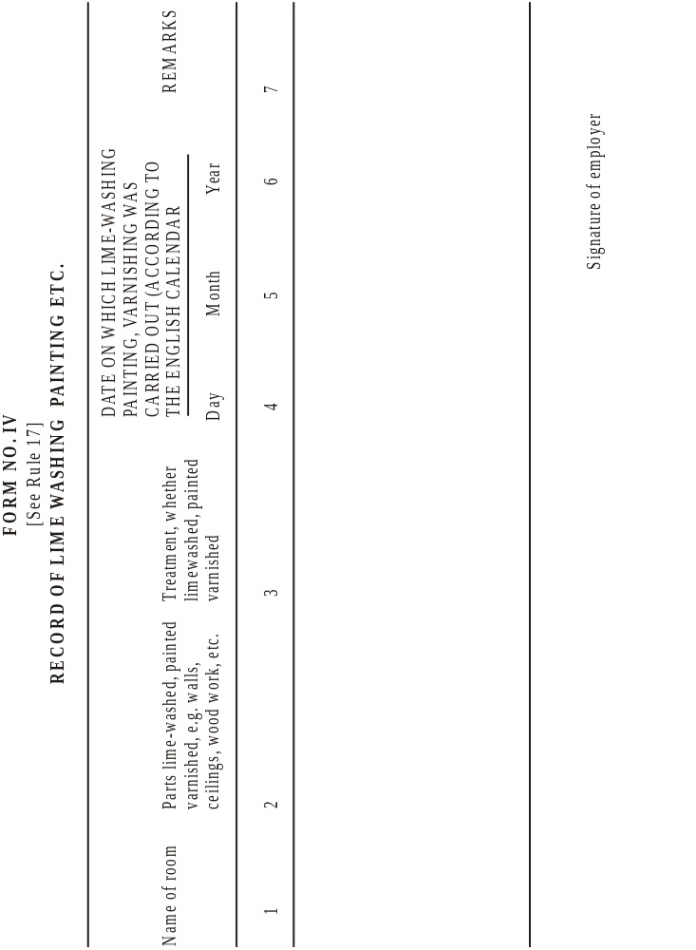
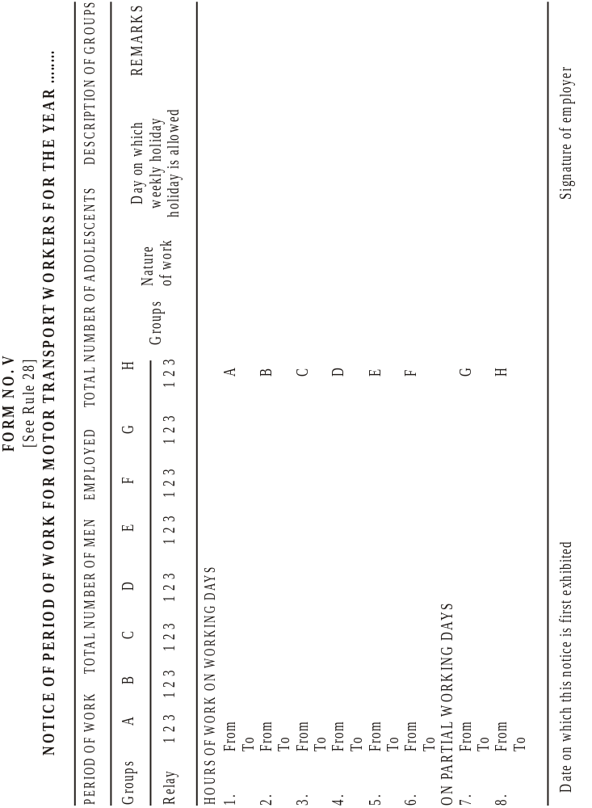
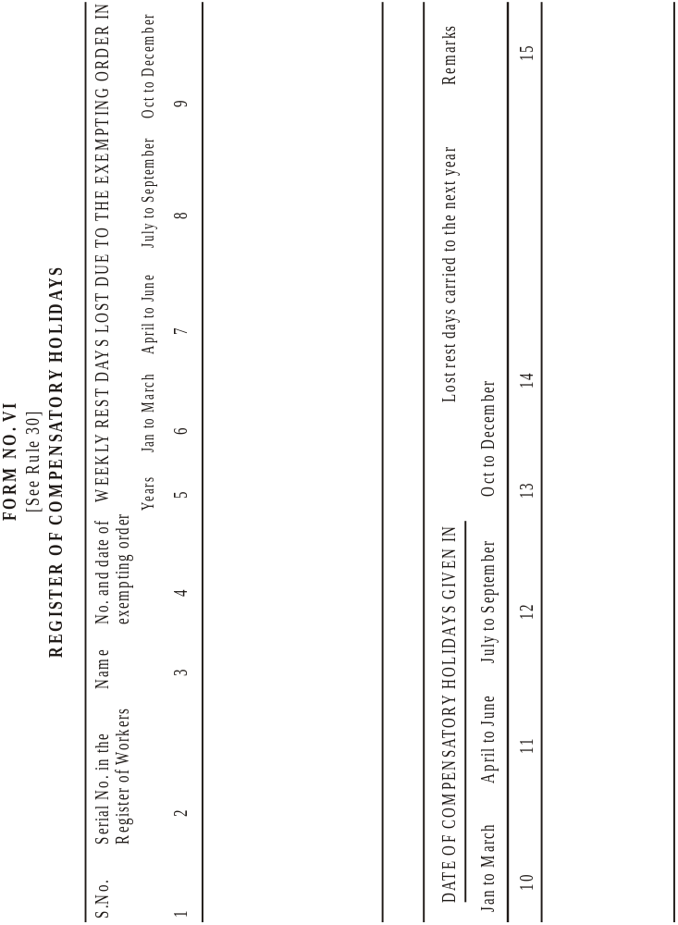
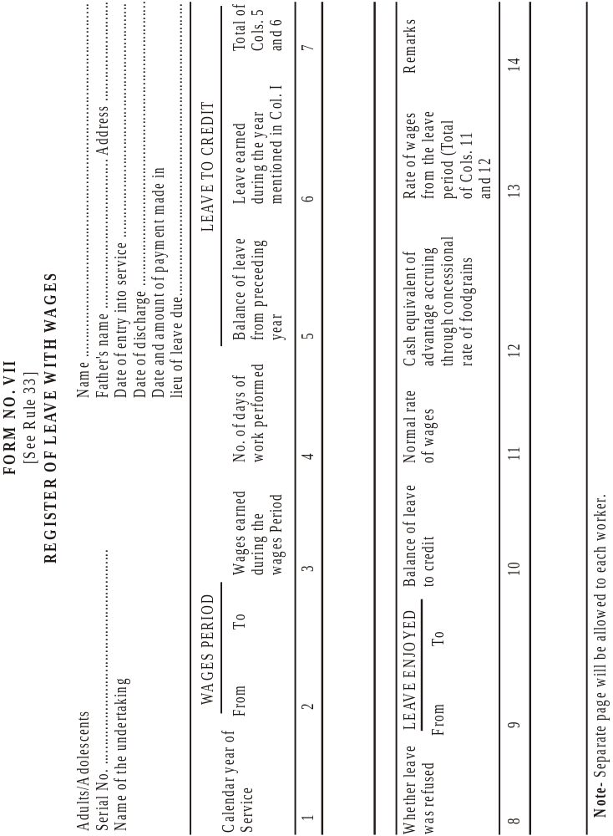
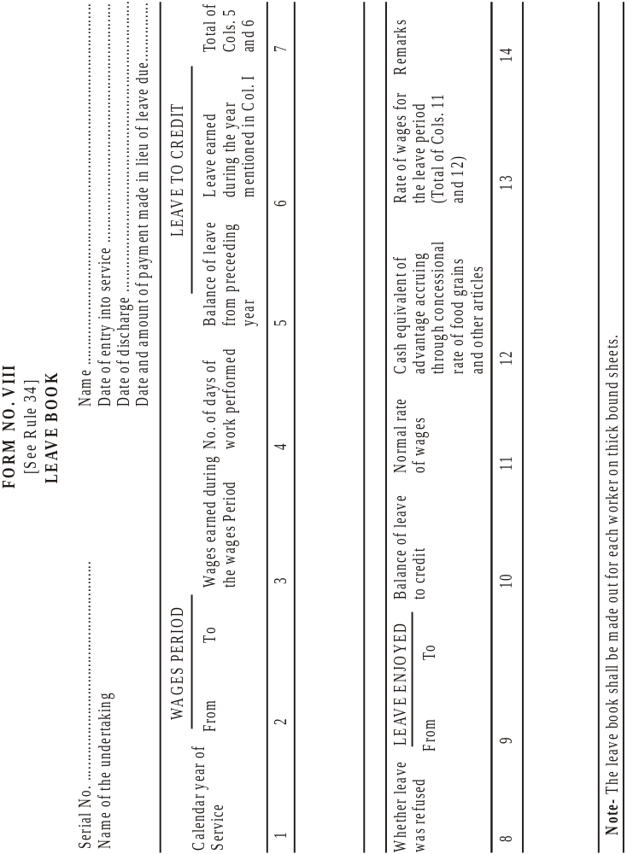
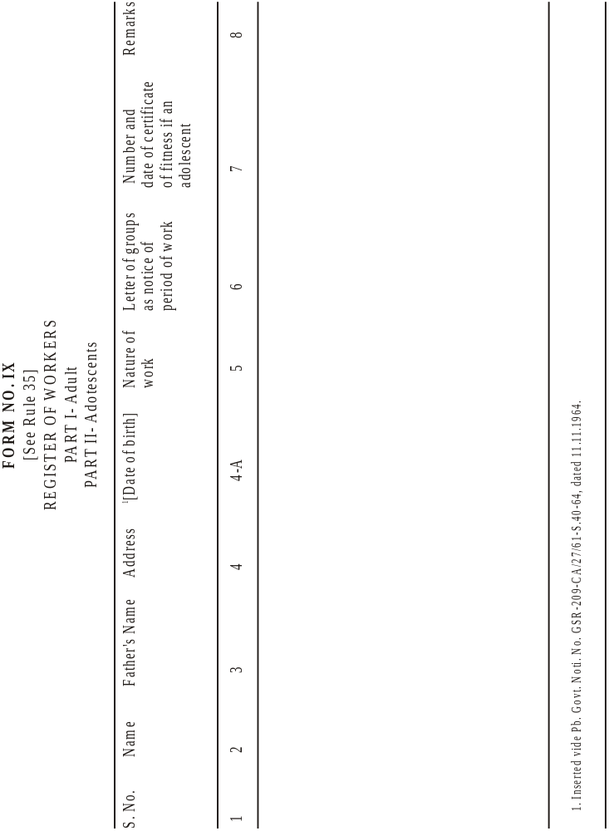
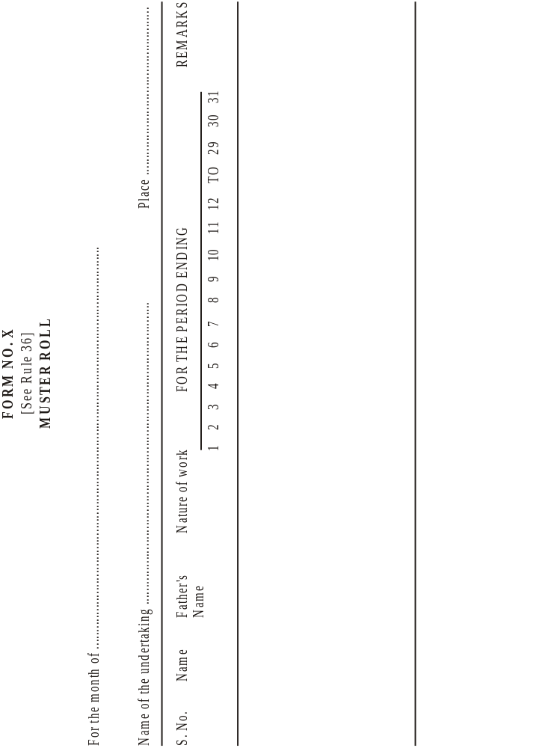
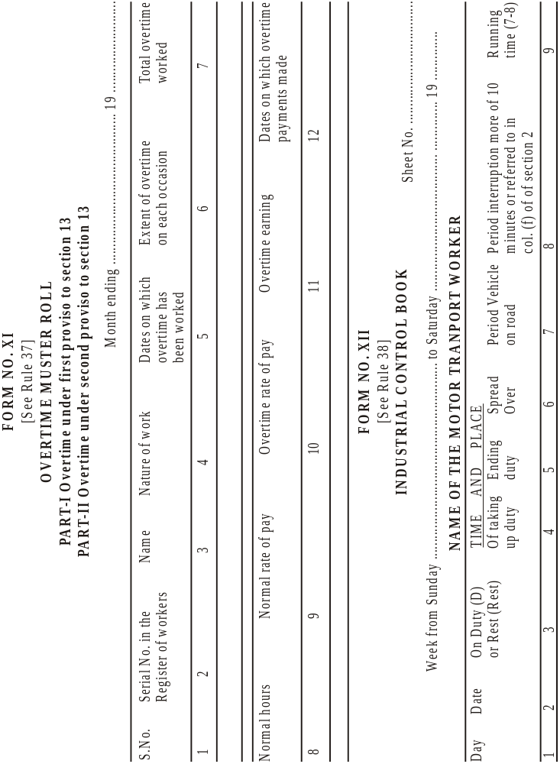
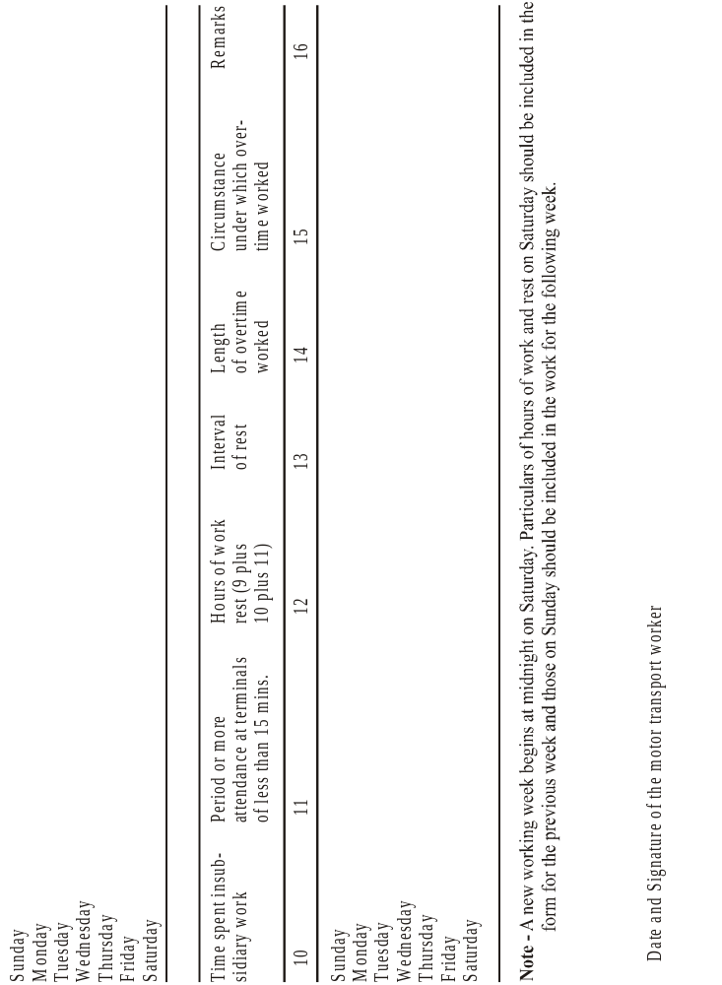

Form No. XIII
[See rule 39]
Annual Return
Year ending 31st December, ..............................................................................

1. Name of the Motor Transport Undertaking:........................................................
2. Postal Address:…..........................................................................................
3. Average number of workers: Adults .................................................................
employed daily : Adolescents ………….............................................................
4. Normal hours worked per day: Adults...............................................................
: Adolescents ................................................................................................
5. What rest intervals were given? : Adults ............................................................
: Adolescents ................................................................................................
6. The number of workers ………......................................................................... exempted from the provisions of sections 19................................................ ....................................................................................................................
7. Leave number of Wages-
(i) No. of workers who are entitled to : Adults ...........................................
annual leave with wages during the
calendar year to which this return
relates : Adolescents ....................................
(ii) No. of workers who were granted : Adults ...........................................
leave during the year : Adolescents ....................................
(iii) No. of workers discharged or : Adults ..........................................
dismissed from service during the : Adolescents ....................................
(iv) No. of discharged workers paid : Adults ...........................................
wages in lieu of leave : Adolescents ....................................
(v) Total amount of wages paid in :.....................................................
lieu of leave ……………..........................................
8. Compensatory holidays -
(i) No. of workers exempted from : Adults ...............................................
section 19 : Adolescents .......................................
(ii) No. of workers who received
holidays in the-
(a) Same month :........................................................
(b) Following month :.......................................................
(c) Third month :.......................................................
9. Canteens-
(Number of canteens and situations)
...................................................................................................................
10. Medical Facilities -
(i) No. of dispensaries and situations : ................................................................
(ii) Details of accommodation, furniture and other equipment provided : ...................

(iii) Approximate average daily attendance of workers: ……......................................

Date ....................................... Signature of the employer

* The average daily number should be calculated by dividing the aggregate number of attendances on working by the number of working days during the year. In reckoning attendances by temporary as well as permanent employees should be counted. Attendances on separate shifts should be counted separately. Days on which the undertaking was not operating for whatever cause, would be treated as working days-
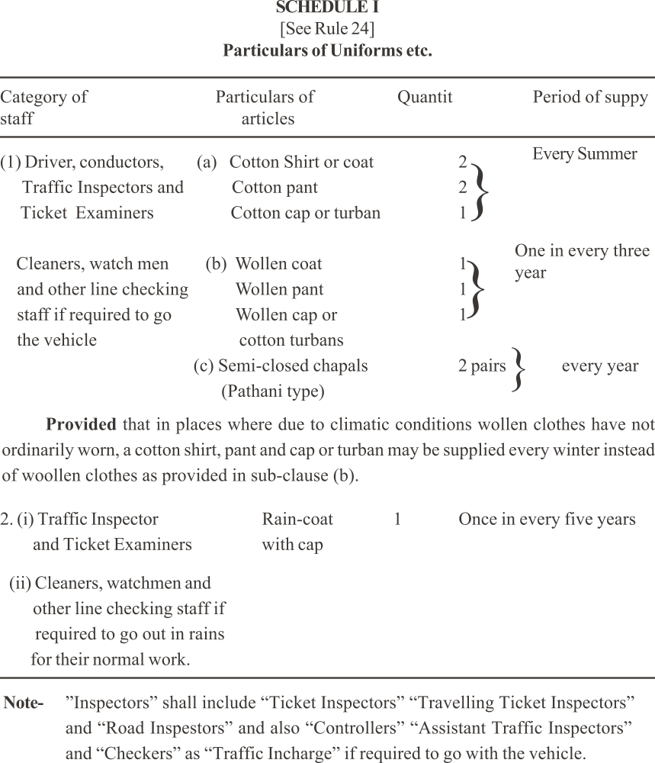

SCHEDULE II
(See Rule 25)
Particulars of first aid box to be provided In operating centre and halting station.
(A) for operating centres and halting stations wherein ten and not exceeding fifty Motor transport workers ordinarily call on duty during every day.

Each first-aid box or cupboard shall contain the following equipment:-
(i) 12 small sterilized dressings;
(ii) 6 medium size sterilized dressings;
(iii) 6 large size sterilized dressings;
(iv) 6 large size sterilized burn dressings;
(v) 6 (14.175 grams) packets sterilized cotton wool;
(vi) 1 (56.699 grams) bottle containing a two per cent alcohol solution of iodine;
(vii) 1 (56.699 grams) bottle containing sal-volatile having the dose and mode of administration indicated on the label.
(viii) 1 roll of adhesive plaster;
(ix) A snake bite lancet;
(x) 1 (28.350 grams) bottle of potassium permanganate crystals.
(xi) 1 pair scissors;
(xii) 1 copy of the approved first-aid leaflet.
(B) For operating centres and halting stations where in more than 5 motor transport workers ordinarily call on duty during every day.

Each first-aid box or cupboard shall contain the following equipment:-
(i) 24 small sterilized dressings;
(ii) 12 medium size sterilized dressings;
(iii) 12 large size sterilized burn dressings;
(iv) 12 large size sterilized dressings;
(v) 12 (14.175 grams) packets sterilized cotton wool;
(vi) 1 snake bite lancet;
(vii) 1 pair scissors;
(viii) 2 (28.350 grams) bottles of potassium permanganate crystals;
(ix) 1 (113.398 grams) bottle containing a two percent solution of iodine;
(x) 1 (113.398 grams) bottle of sal-volatile having the dose and mode of administration indicated on the label;
(xi) 1 copy of the approved first aid leaflet;
(xii) 12 roller bandages 0.1016 meters wide;
(xiii) 12 roller bandages 0.0508 meters wide;
(xiv) 2 rolls of adhesive plaster;
(xv) 6 triangular bandages;
(xvi) 2 packets of safety pins;
(xvii) A supply of suitable splints;
(xviii) 1 tourniquet.

SCHEDULE III
(See rule 26)
Particulars of first aid Box to be provided in motor vehicle
(i) 6 small sterilized dressings;
(ii) 3 medium size sterilized dressings;
(iii) 3 large size sterilized dressings;
(iv) 3 large size sterilized burn dressings;
1 (28.350 grams) bottle containing a two percent alcohol solution of iodine,
(vi) 1 (28.350 grams) bottle containing sal-volatile having and mode of administration indicated on the label, (vii) A snake-bite lancet;
(viii) 1 (28.350 grams) bottle of potassium permanganate crystals
(ix) 1 pair scissors;
(x) 1 copy of approved first-aid leaflet

Rule 17to23 and 25 were made applicable vide Notification No. 1485-V-Lab-II-66/5371, dated 24th February, 1966.
Subs. vide Hr. Govt. Notification No. GSR 84-CA/27/61 S.4/7 dated 13.5.1977.
Subs. vide Hr. Govt. Notification NO.GSR-122/CA/72/61/S.40/72, dated 12th May, 1972.

