INDEX
THE MINIMUM WAGES (CENTRAL) RULES, 1950

Rule | Description
 | CHAPTER I: PRELIMINARY
1. | Short title and extent
2. | Interpretation
 | CHAPTER II: MEMBERS AND STAFF, AND MEETINGS OF THE BOARD, COMMITTEE AND ADVISORY COMMITTEE
3. | Term of office of the members of the committee and the Advisory Committee
4. | Term of office of members of the Board
4A. | Nomination of substitute members
5. | Travelling allowance
6. | Staff
7. | Eligibility for re-nomination of the members of the committee, Advisory Committee and the Board
8. | Resignation of the Chairman and members of the Committee and the Board and filling of the casual vacancies
9. | Cessation and restoration of membership
10. | Disqualification
11. | Meetings
12. | Notice of meetings
13. | Chairman
14. | Quorum
15. | Disposal of business
16. | Method of voting
17. | Proceedings of the meetings
 | CHAPTER III: SUMMONING OF WITNESSES BY THE COMMITTEE, ADVISORY COMMITTEE AND THE BOARD AND PRODUCTION OF DOCUMENTS
18. | Summoning of witnesses and production of documents
19. | Expenses of Witnesses
 | CHAPTER IV: COMPUTATION OF PAYMENT OF WAGES, HOURS OF WORK AND HOLIDAYS
20. | Mode of computation of the cash value of wages
21. | Time and conditions of payment of wages and the deductions permissible from wages
22. | Publicity to the minimum wage fixed under the Act
23. | Weekly day of rest
24. | Number of hours of work which shall constitute a normal working day
24A. | Night shifts
25. | Extra wages for overtime
26. | Form of registers and records
26A. | Preservation of registers
26B. | Production of registers and other records
26C. | Alternative Suitable Form
 | CHAPTER V : CLAIMS UNDER THE ACT
27. | Applications
28. | Authorisation
29. | Appearance of parties
 | CHAPTER VI : SCALE OF COSTS IN PROCEEDINGS UNDER THE ACT
30. | Costs
31. | Court-fees
 | CHAPTER VII: MISCELLANEOUS
32. | Saving
Form No. | Description
FORM I | Register of Fines
FORM II | Register of deductions for damage or loss caused to the employer, by the neglect or default of the employed persons
FORM III | Annual Return
FORM IV | Overtime Register for workers
FORM V | Muster Roll
FORM VI | Form of Application by an Employee under section 20(2)
FORM VIA | Form of Group Application under section 21(1)
FORM VII | Form of Application by an Inspector or Person Acting with the Permission of the Authority under section 20(2)
FORM VIII | Form in Authority in favour of a Legal Practitioner or any Official of a Registered Trade Union referred to in section 20(2)
FORM IX | Form of summons to the opponent to appear before the authority when an application under sub-section (2) of section 20 or under section 21 is entertained
FORM IXA | Notice
FORM X | Register of Wages
FORM XI | Wage Slip

THE MINIMUM WAGES (CENTRAL) RULES, 1950

In exercise of the powers conferred by section 30 of the Minimum Wages Act, 1948 (XI of 1948), the. Central Government is pleased to make the following rules, the same having been previously published as required by the said section, namely:—

CHAPTER I
PRELIMINARY
1. Short title and extent.—The rules may be called The Minimum Wages (Central) Rules, 1950.

2. Interpretation.—In these rules, unless the context otherwise requires,—
(a) ‘Act’ means the Minimum Wages Act, 1948 (11 of 1948);
(b) ‘Advisory Committee’ means an Advisory Committee appointed under section 6 and includes an advisory sub-committee appointed under that section;
(c) ‘authority’ means the authority appointed under sub-section (1) of section 20;
(d) ‘Board’ means the Advisory Board appointed under section 7;
(e) ‘Chairman’ means the Chairman of the Advisory Board, the committee or the Advisory Committee, as the case may be, appointed under section 9;
(f) ‘committee’ means a committee appointed under clause (a) of subsection (1) of section 5 and includes a sub-committee appointed under that section;
(ff) ‘day’ means a period of twenty-four hours beginning at midnight;
(g) ‘Form’ means a form appended to these rules;
(h) ‘Inspector’ means a person appointed as Inspector under section 19;
(i) ‘registered trade union’ means a trade union registered under the Indian Trade Unions Act, 1926 (16 of 1926);
(j) ‘section’ means a section of the Act; and
(k) all other words and expressions used herein and not defined shall have the meanings respectively assigned to them under the Act.

CHAPTER II
MEMBERS AND STAFF, AND MEETINGS OF THE BOARD, COMMITTEE AND ADVISORY COMMITTEE

3. Term of office of the members of the committee and the Advisory Committee.—The term of office of the members of the committee or an Advisory committee shall be such as in the opinion of the Central Government is necessary for completing the enquiry into the scheduled employment concerned and the Central Government may, at the time of the constitution of the committee, or Advisory Committee, as the case may be, fix such terms and may, from time to time, extend it as circumstances may require.

4. Term of office of members of the Board.—
(1) Save as otherwise expressly provided in these rules the term of office of a non-official member of the Board, shall be two years commencing from the date of his nomination:
Provided that such member shall, notwithstanding the expiry of the said period of two years continue to hold office until his successor is nominated.
(2) A non-official member of the Board nominated to fill a casual vacancy shall hold office for the remaining period of the term of office of the member in whose place he is nominated.
(3) The official member of the Board shall hold office during the pleasure of the Central Government.

4A. Nomination of substitute-members.—If a member is unable to attend a meeting of the committee or the Board, the Central Government or the body which nominated him may, by notice in writing signed on its behalf and by such member and addressed to the Chairman of the said committee or the Board, nominate a substitute in his place to attend that meeting. Such a substitute-member shall have all the rights of a member in respect of that meeting.

5. Travelling allowance.—A non-official member of the committee, an Advisory Committee or the Board, shall be entitled to draw travelling and halting allowance for any journey performed by him in connection with his duties as such member at the rates and subject to the conditions applicable to a Government servant of the first class under the appropriate rules of the Central Government.

6. Staff.—
(1) The Central Government may appoint a Secretary to the committee, an Advisory Committee or the Board and such other staff as it may think necessary, and may fix the salaries and allowances payable to them and specify their conditions of service.
(2) (i) The Secretary shall be the Chief Executive Officer of the committee, the Advisory Committee, or the Board, as the case may be. He may attend the meetings of such committee, Advisory Committee or Board but shall not be entitled to vote at such meetings.
(ii) The Secretary shall assist the Chairman in convening meetings and shall keep a record of the minutes of such meetings and shall take necessary measures to carry out the decisions of the Committee, the Advisory Committee or the Board, as the case may be.

7. Eligibility for re-nomination of the members of the committee, Advisory Committee and the Board.—An outgoing member shall be eligible for re-nomination for the membership of the committee, the Advisory Committee or the Board of which he was a member.

8. Resignation of the Chairman and members of the Committee and the Board and filling of the casual vacancies.—
(1) A member of the Committee or the Board, other than the Chairman, may, by giving notice in writing to the Chairman, resign his membership. The Chairman may resign by a letter addressed to the Central Government.
(2) A resignation shall take effect from the date of communication of its acceptance or on the expiry of 30 days from the date of resignation whichever is earlier.
(3) When a vacancy occurs or is likely to occur in the membership of the committee or the Board, the Chairman shall submit a report to the Central Government immediately. The Central Government shall take steps to fill the vacancy.

9. Cessation and restoration of membership.—
(1) If a member of the committee, Advisory Committee, or the Board fails to attend three consecutive meetings, he shall, subject to the provisions of sub-rule (2), cease to be a member thereof.
(2) A person, who ceases to be a member under sub-rule (1) shall be given intimation of such cessation by a letter sent to him by registered post within fifteen days from the date of such cessation. The letter shall indicate that if he desires restoration of his membership, he may apply therefore within thirty days from the receipt of such letter. The application for restoration of membership, if received within the said period, shall be placed before the committee, the Advisory Committee or the Board, as the case may be, and if a majority of members present at the next meeting is satisfied that the reasons for failure to attend three consecutive meetings are adequate, the member shall be restored to membership immediately after a resolution or to that effect is adopted.

10. Disqualification.—
(1) A person shall be disqualified for being nominated as, and for being a member of the committee, Advisory Committee or the Board, as the case may be—
(i) if he is declared to be of unsound mind by a competent court; or
(ii) if he is an undischarged insolvent; or
(iii) if before or after the commencement of the Act, he has been convicted of an offence involving moral turpitude.
(2) If any question arises whether a disqualification has been incurred under sub-rule (1), the decision of the Central Government thereon shall be final.

11. Meetings.—The Chairman may, subject to the provisions of rule 12, call a meeting of the committee, Advisory Committee or the Board, as the case may be, at any time he thinks fit:
Provided that on a requisition in writing from not less than one-half of the members, the Chairman shall call a meeting within fifteen days from the date of the receipt of such requisition.

12. Notice of meetings.—The Chairman shall fix the date, time and place of every meeting and a notice in writing containing the aforesaid particulars along with a list of business to be conducted at the meeting shall be sent to each member by registered post at least fifteen days before the date fixed for such meeting:
Provided that in the case of an emergent meeting, notice of seven days only may be given to every member.

13. Chairman.—
(1) The Chairman shall preside at the meetings of the committee, Advisory Committee or the Board, as the case may be.
(2) In the absence of the Chairman at any meeting, the members shall elect from amongst themselves by a majority of votes, a member, who shall preside at such meeting.

[14. Quorum.—No business shall be transacted at any meeting unless at least one-third of the members are present:
Provided that if at any meeting less than one-third of the members are present, the Chairman may adjourn the meeting to a date not later than seven days from the date of the original meeting and it shall thereupon be lawful to dispose of the business at such adjourned meeting irrespective of the number of members present:
[Provided further that the date, time and place of such adjourned meeting shall be intimated to all the members by telegram or by a written communication.]]

15. Disposal of business.— All business shall be considered at a meeting of the committee, Advisory Committee or the Board, as the case may be, and shall be decided by a majority of the votes of members present and voting. In the event of an equality of votes, the Chairman shall have a casting vote:
Provided that the Chairman may, if he thinks fit, direct that any matter shall be decided by the circulation of necessary papers and by securing written opinion of the members:
Provided further that no decision on any matter under the preceding proviso shall be taken, unless supported by not less than two-thirds, majority of the members.
16. Method of voting.—Voting shall ordinarily be by show of hands, but if any member asks for voting by ballot, or if the Chairman so decides, the voting shall be by secret ballot and shall be held in such manner as the Chairman may decide.

17. Proceedings of the meetings.
(1) The proceedings of each meeting inter alia the names of the members present there shall be forwarded to each member and to the Central Government as soon after the meeting as possible, and in any case, not less than seven days before the next meeting.
(2) The proceedings of each meeting shall be confirmed with such modifications, if any, as may be considered necessary at the next meeting.

CHAPTER III
SUMMONING OF WITNESSES BY THE COMMITTEE, ADVISORY COMMITTEE AND THE BOARD AND PRODUCTION OF DOCUMENTS

18. Summoning of witnesses and production of documents.—
(1) A committee, Advisory Committee or the Board may summon any person to appear as a witness in the course of an enquiry. Such summons may require a witness to appear before it on a date specified therein and to produce any books, papers or other documents and things in his possession or under his control relating to any matter to the enquiry.
(2) A summons under sub-rule (1) may be addressed to an individual or an organisation of employers or a registered trade union of workers.
(3) A summons under this rule may be served—
(i) in the case of an individual, by being delivered or sent to him by registered post;
(ii) in the case of an employers’ organisation or the registered trade union of workers by being delivered or sent by registered post to the secretary or other principal officer of the organisation or union, as the case may be.
(4) The provisions of the Code of Civil Procedure, 1908 (5 of 1908), relating to the summoning and enforcement of the appearance of witnesses and the production of documents shall, so far as may be, apply to proceedings before a Committee, Advisory Committee or the Board.
[(5)All books, papers and other documents or things produced before a committee, or the Board in pursuance of a summons issued under sub-rule (1) may be inspected by the Chairman and independent members, and also by such parties as the Chairman may allow with the consent of the other party, but the information so obtained shall be treated as ‘confidential’ and the same shall be made public only with the consent in writing of the party concerned:
Provided that nothing contained in this rule shall apply to the disclosure of any such information for the purpose of a prosecution under section 193 of the Indian Penal Code (45 of I860).]

19. Expenses of witnesses.—Every person who is summoned and appears as a witness before the committee, the Advisory Committee or the Board shall be entitled to an allowance for expenses by him in accordance with the scale for the time being in force for payment of such allowance to witnesses appearing in Civil Courts in the State.
CHAPTER IV
COMPUTATION OF PAYMENT OF WAGES, HOURS OF WORK AND HOLIDAYS

20. Mode of computation of the cash value of wages.— The retail prices at the nearest market shall be taken into account in computing the cash value of wages paid in kind and of essential commodities supplied at concessional rates. This computation shall be made in accordance with such directions as may be issued by the Central Government from time to time.

21. Time and conditions of payment of wages and the deduction permissible from wages.—
(1) (i) [The wages of a worker in any scheduled employment] shall be paid on a working day,—
(a) in the case of establishment for which less than one thousand persons are employed, before the expiry of the seventh day, and
(b) in the case of other establishments before the expiry of the tenth day after the last day of the wage period in respect of which the wages are payable.
(ii) Where the employment of any person is terminated by or on behalf of the employer, the wages earned by him shall be paid before the expiry of the second working day after the day on which his employment is terminated.
(iii) The wages of an employed person shall be paid to him without deduction of any kind except those authorised by or under these rules.
Explanation. — (1) Every payment made by the employed person to the employer or his agent shall, for the purposes of these rules be deemed to be a deduction from wages.
(2) Deductions from the wages of a person employed in a scheduled employment shall be of one or more of the following kinds, namely.—
(i) fines in respect of such acts and omissions on the part of employed persons as may be specified by the Central Government by general or special order in this behalf;
(ii) deductions for absence from duty;
(iii) deductions from damage to or loss of goods expressly entrusted to the employed person for custody, or for loss of money for which he is required to account, where such damage or loss is directly attributable to his neglect or default;
(iv) deductions for house accommodation supplied by the employer;
(v) Deductions for such amenities and services supplied by the employer as the Central Government may, by general or special order, authorise;
Explanation.—The words ‘amenities and services’ in this clause do not include the supply of tools and protective required for the purposes of employment;
(vi) deductions for recovery of advances or for adjustment of overpayment of wages: Provided that such advances do not exceed an amount equal to wages for two calendar months of the employed person and, in no case, shall the monthly installment of deduction exceed one-fourth of the wages earned in that month;
(vii) deductions of income-tax payable by the employed person;
(viii)deductions required to be made by order of a Court or other competent authority;
(ix) deductions for subscriptions to and for repayment of advances from any Provident Fund to which the Provident Funds Act, 1952 (19 of 1952), applies or any Recognised Provident Fund as defined in section 58A of the Indian Income Tax Act, 1922 (11 of 1922), or any Provident Fund approved in this behalf by the Central Government during the continuance of such approval;
[(x) deductions for payment to Co-operative Societies [or deductions for recovery of loans advanced by an employer from out of a fund maintained for the purpose by the employer and approved in this behalf by the Central Government] or deductions made with the written authorisation of the person employed, for payment of any premium on his life insurance policy to the Life Insurance Corporation of India established under the Life Insurance Act, 1956 (31 of 1956);]
[(xi) deductions for recovery of adjustment of amounts, other than wages paid to the employed person in error in excess of what is due to him;]
[(xii) deductions made with the written authorisation of the employed persons (which may be given once generally and not necessarily every time a deduction is made), for the purchase of securities of the Government of India or of any State Government or for being deposited in any Post Office Savings Bank in furtherance of any savings scheme of any such Government;]
[(xiii) deductions made with the written authorisation of the employed person for contributions to the National Defence Fund or the Prime Minister’s National Relief Fund or to any Defence Savings Scheme [approved by the Central Government] or to such other Fund as the Central Government may, by notification in the Official Gazette, specify in this behalf;]
[(xiv) deductions for recovery of loans granted for house building or other purposes approved by the Central Government, and for the interest due in respect of such loans, subject to any rules made or approved by the Central Government regulating the extent to which such loans may be granted and the rate of interest payable thereon,] for contribution to the National Defence Fund or to any Defence Savings Scheme approved by the Central Government:]
Provided that prior approval of the Inspector or any other officer authorised by the Central Government in this behalf is obtained in writing before making the deductions, unless the employee gives his consent in writing to such deductions.
[(2A) Notwithstanding anything contained in these rules, the total amount of deductions which may be made under sub-rule (2) in any wage period, from the wages of an employee shall not exceed—
(i) 75 per cent, of such wages in cases where such deductions are wholly or partly made for payments to Consumer Co-operative Stores run by any Co-operative Society under clause (x) of sub-rule (2); and
(ii) 50 per cent, of such wages in any other case:
Provided that where the total amount of deductions which have to be made under sub-rule (2) in any wage period from the wages of any employee exceeds the limit specified in clause (i), or, as the case may be, clause (ii) of this sub-rule, the excess shall be carried forward and recovered from the wages of succeeding wage period or wage periods, as the case may be, in such number of installments as may be necessary.]
(3) Any person desiring to impose a fine on an employed person or to make a deduction for damage or loss caused by him shall explain to him personally and also in writing the act or omission or the damage or loss, in respect of which the fine or deduction is proposed to be imposed or made and give him an opportunity to offer any explanation in the presence of another person. The amount of the said fine or deduction shall also be intimated to him.
[(4) The amount of fine or deduction for damage or loss mentioned in sub-rule (3) shall be subject to such limits as may be specified in this behalf by the Central Government. All such fines imposed and deductions made shall be recorded in the register maintained in Forms I and II, respectively. These registers shall be kept at the work-spot and maintained up-to-date. Where no fine or deduction has been imposed or made on or from any employee in a wage period, a ‘nil’ entry shall be made across the body of the relevant register at the end of the wage period, indicating also in precise terms the wage period to which the ‘nil’ entry relates.]
[(4A) Every employer shall send annually a return in Form III [***] so as to reach the Inspector not later than the 1st February following the end of the year to which it relates.]
[(5) The amount of fine imposed under sub-rule (3) shall be utilised only for such purposes beneficial to the employees as are approved by the Central Government.]
(6) Nothing in this rule shall be deemed to affect the provisions of the Payment of Wages Act, 1936 (4 of 1936).

22. Publicity to the minimum wage fixed under the Act.—Notices in [Form IXA] containing the minimum rates of wages fixed together with [extracts of] the Act, the rules made thereunder and the name and address of the Inspector shall be displayed in English and in a language understood by the majority of the workers in the employment [at the main entrances to the establishment and at its office] and shall be maintained in a clean and legible condition. Such notices shall also be displayed on the notice-boards of all sub-divisional and district offices.

[23. Weekly day of rest.—
(1) Subject to the provisions of this rule, an employee in a scheduled employment in respect of which minimum rates of wages have been fixed under the Act, shall be allowed a day of rest every week (hereinafter referred to as the ‘rest day’) which shall ordinarily be Sunday, but the employer may fix any other day of the week as the rest day for any employee or class of employees in that scheduled employment:
Provided that the employee has worked in the scheduled employment under the same employer for a continuous period of not less than six days:
Provided further that the employee shall be informed of the day fixed as the rest day and of any subsequent change in the rest day before the change is effected, by display of a notice to that effect in the place of employment at the place specified by the Inspector in this behalf.]
Explanation.—For the purpose of computation of the continuous period of not less than six days specified in the first proviso to this sub-rule—
(a) any day on which an employee is required to attend for work but is given only an allowance for attendance and is not provided with work, [***]
(b) any day on which an employee is laid off on payment of compensation under the Industrial Disputes Act, 1947 (14 of 1947); [and
(c) any leave or holiday, with or without pay, granted by the employer to an employee in the period of six days immediately preceding the rest day], shall be deemed to be days on which the employee has worked.
(2) Any such employee shall not be required or allowed to work in a scheduled employment on the rest day unless he has or will have a substituted rest day for a whole day on one of the five days immediately before or after the rest day:
Provided that no substitution shall be made which will result in the employee working for more than ten days consecutively without a rest day for a whole day.
(3) Where in accordance with the foregoing provisions of this rule, any employee works on a rest day and has been given a substituted rest day on any one of the five days before or after the rest day, the rest day shall, for the purpose of calculating the weekly hours of work, be included in the week in which the substituted rest day occurs.
(4) An employee shall be granted for rest day wages calculated at the rate applicable to the next preceding day and in case he works on the rest day and has been given a substituted rest day, he shall be paid wages for the rest day on which he worked, at the overtime rate and wages for the substituted rest day at the rate applicable to the next preceding day:
Provided that where the minimum daily rate of wages of the employee as notified under the Act has been worked out by dividing the minimum monthly rate of wages by twenty-six, or where the actual daily rate of wages of the employee has been worked out by dividing the monthly rate of wages by twenty-six and such actual daily rates of wages is not less than the notified minimum daily rate of wages of the employee, no wages for the rest day shall be payable, and in the case the employee works on the rest day and has been given a substituted rest day, he shall be paid, only for the rest day on which he worked, an amount equal to the wages payable to him at the overtime rate; and if any dispute arises whether the daily rate of wages has been worked out as aforesaid, the Chief Labour Commissioner may, on application made to him in this behalf, decide the same, after giving an opportunity to the parties concerned to make written representations:
Provided further that in the case of an employee governed by a piece-rate scheme, the wages for the rest day, or, as the case may be, the rest day, and the substituted rest day, shall be such as the Central Government may, by notification in the Gazette of India, prescribe, having regard to the minimum rate of wages fixed under the Act, in respect of the scheduled employment.
Explanation.—In this sub-rule ‘next preceding day’ means the last day on which the employee has worked, which precedes the rest day or the substituted rest day, as the case may be; and where the substituted rest day falls on a day immediately after the rest day, the next preceding day means the last day on which the employee has worked, which precedes the rest day.
(5) The provisions of this rule shall apply to the employees in scheduled employments other than agricultural employment.
(6) The provisions of this rule shall not operate to the prejudice of more favourable terms, if any, to which an employee may be entitled under any other law or under the terms of any award, agreement or contract of service, and in such a case, the employee shall be entitled only to the more favourable terms aforesaid.
Explanation.—For the purposes of this rule, ‘week’ shall mean a period of seven days beginning at midnight on Saturday night.]

24. Number of hours of work which shall constitute a normal working day.—
(1) The number of hours which shall constitute a normal working day, shall be—
(a) in the case of an adult, 9 hours;
(b) in the case of a child, 4½ hours.
(2) The working day of an adult worker shall be so arranged that inclusive of the intervals of rest, if any, shall not spread over more than twelve hours on any day.
(3) The number of hours of work in the case of an adolescent shall be the same as that of an adult or a child accordingly as he is certified to work as an adult or a child by a competent medical practitioner approved by the Central Government.
(4) The provisions of sub-rules (1) to (3) shall, in the case of workers in agricultural employment, be subject to such modifications as may, from time to time, be notified by the Central Government.
[(4A) No child shall be employed or permitted to work for more than 4½ hours on any day.]
(5) Nothing in this rule shall be deemed to affect the provisions of the Factories Act, 1948 (63 of 1948).

[24A. Night shifts.—Where a worker in a scheduled employment works on a shift which extends beyond midnight—
(a) a holiday for the whole day for the purposes of rule 23 shall, in his case mean a period of twenty-four consecutive hours beginning from the time when his shift ends; and
(b) the following day in such a case shall be deemed to be the period of
twenty-four hours beginning from the time when such shift ends, and the hours after midnight during which such worker was engaged in work shall be counted towards the previous day.]

[25. Extra wages for overtime.—
(1) When a worker works in an employment for more than nine hours on any day or for more than forty-eight hours in any week, he shall in respect of overtime work, be entitled to wages,—
(a) in the case of employment in agriculture, at one and a half times the ordinary rate of wages;
(b) in the case of any other scheduled employment, at double the ordinary rate of wages.
Explanation.—The expression ‘ordinary rate of wages’ means the basic wage plus such allowance including the cash equivalent of the advantages accruing through the concessional sale to the person employed of foodgrains and other articles as the person employed is for the time being entitled to but does not include a bonus.]
[(2) A register of overtime shall be maintained by every employer in Form IV in which entries under the columns specified therein shall be made as and when overtime is worked in any establishment. The register shall be kept at the work-spot and maintained up-to-date. Where no overtime has been worked in any wage-period, a ‘nil’ entry shall be made across the body of the register at the end of the wage-period indicating also in precise terms the wage-period to which the ‘nil’ entry relates.]
(3) Nothing in this rule shall be deemed to affect the provisions of the Factories Act, 1948 (63 of 1948).

26. Form of registers and records.—
[(1) A register of wages shall be maintained by every employer at the work-spot in Form X.
[(1A) Every employer shall in respect of each person employed in the establishment, complete the entries pertaining to a wage period—
(a) in columns 1 to 15 of Form X, before the date on which the wages for such wage-period fall due;
(b) in columns 16 and 17 of the said Form, on the date when payment is made and obtain the signature or thumb impression of the employee in column 18 of the said Form on the date when payment is made.]
(2) A wage slip in Form XI shall be issued by every employer to every person employed by him at least a day prior to the disbursement of wages.
(3) Every employer shall get the signature or thumb-impression of every person employed on the [Register of Wages] and wage slip.
(4) Entries in the [Register of Wages] and wage slips shall be authenticated by the employer or any person authorised by him in this behalf.
[(5) A Muster Roll shall be maintained by every employer at the work-spot and kept in [Form V] and the attendance of each person employed in the establishment shall be recorded daily in that Form within 3 hours of the commencement of the work shift or relay for the day as the case may be.]
[***]

[26A. Preservation of registers.—A register required to be maintained under rules 21(4), 25(2) and 26(1) and [the muster roll required to be maintained under rule 26(5)] shall be preserved for a period of three years after the date of last entry made therein.]

[26B. Production of registers and other records.—
- All registers and records required to be maintained by an employer under these rules shall be produced on demand before the Inspector during the course of inspection of the establishment:

Provided that the Inspector may, if it is necessary, demand the production of the registers and records in his office or such other public place as may be nearer to the employer.
(2) Any infringement of the provisions of the Act or these rules noticed by the Inspector and communicated to the employer during the course of an inspection or otherwise shall be rectified by the employer and compliance report in respect thereof shall be submitted to the Inspector, on or before the date specified by him in this behalf.]
[26C. Notwithstanding anything contained in these rules, where a combined (alternative) form is sought to be used by the employer to avoid duplication of work for compliance with the provisions of any other Act or the rules framed thereunder, an alternative suitable form in lieu of any of the forms prescribed under these rules may be used with the previous approval of the [Central Government].

CHAPTER V
CLAIMS UNDER THE ACT
[27. Applications.—
(1) An application under sub-section (2) of section 20 or sub-section (1) of section 21, by or on behalf of an employed person or group of employed persons shall be made in duplicate in Forms VI, VIA or VII, as the case may be, one copy of which shall bear the prescribed court-fee.
(2) A single application under section 20, read with sub-section (1) of section 21 may be presented on behalf or in respect of a group of employed persons, if they are borne on the same establishment and their claim relates to the same wage-period or periods.]

28. Authorisation.—The authorisation to act on behalf of an employed person or persons, under sub-section (2) of section 20 or sub-section (1) of section 21 shall be given in Form VIII by an instrument which shall be presented to the Authority hearing the application and shall form part of the record.

29. Appearance of parties.—
(1) If an application under sub-section (2) of section 20 or section 21 is entertained, the Authority shall serve upon the employer by registered post a notice in Form IX to appear before him on a specified date with all relevant documents and witnesses, if any, and shall inform the applicant of the date as specified.
(2) If the employer or his representative fails to appear on the specified date, the Authority may hear and determine the application ex parte.
(3) If the applicant or his representative fails to appear on the specified date, the Authority may dismiss the application.
(4) An order passed under sub-rule (2) or sub-rule (3) may be set aside on sufficient cause being shown by the defaulting party within one month of the date of the said order, and the application shall then be re-heard after service of notice on the opposite party of the date fixed for re-hearing in the manner specified in sub-rule (1).

CHAPTER VI
SCALE OF COSTS IN PROCEEDINGS UNDER THE ACT

30. Costs.—
(1) The Authority, for reasons to be recorded in writing, may direct that the cost of any proceeding before it shall not follow the event.
(2) The costs which may be awarded shall include,—
(i) expenses incurred on account of court-fees;
(ii) expenses incurred on subsistence money to witness; and
(iii) pleader’s fees to the extent of ten rupees provided that the Authority in any proceeding may reduce the fees to a sum not less than five rupees or for reasons to be recorded in writing increase it to a sum not exceeding twenty-five rupees.
(3) Where there are more than one pleaders or more than one applicant or opponents the Authority may, subject as aforesaid, award to the successful party or parties such costs as it may deem proper.

31. Court-fees.—The court-fees payable in respect of proceeding under section 20 shall be—
(i) for every application to summon a witness—one rupee in respect of each witness;
(ii) for every application made by or on behalf of an individual—one rupee;
[(iii) for every application made on behalf or in respect of a number of employees—one rupee per employee subject to a maximum of twenty rupees:]
Provided that the Authority may, if in its opinion, the applicant is a pauper, exempt him wholly or partly from the payment of such fees:
Provided further that no fee shall be chargeable—
(a) from persons employed in agriculture; or
(b) in respect of an application made by an Inspector.

[CHAPTER VII
MISCELLANEOUS

[32. Saving.—These rules shall not apply in relation to any scheduled employment in so far as there are in force rules applicable to such employment, which, in the opinion of the Central Government, make equally satisfactory provisions for the matters dealt with by these rules and such opinion shall be final.]

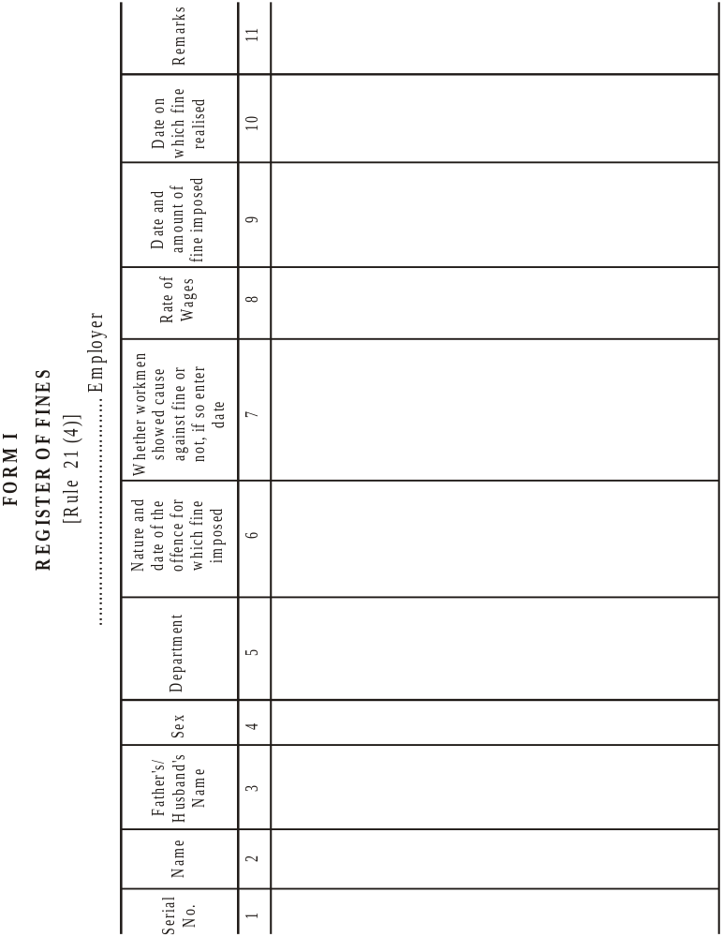
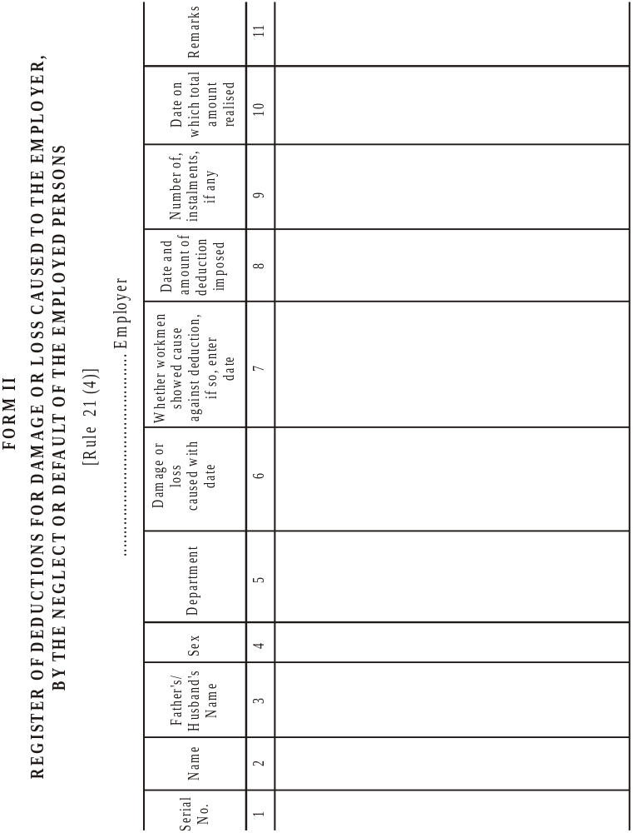

1[FORM III
[Rule 21 (4A)]
ANNUAL RETURNS
Returns for the year ending the 31st December.........................................................
1. (a) Name of the establishment and postal address.................................................
(b) Name and residential address of the owner/contractor.........................................
(c) Name and residential address of the Managing Agent/Director/Partner in charge of the day-today affairs of the establishment owned by a company, body corporate or Association....................................................................................................
(d) Name and residential address of the Manager/Agent, if any..................................
2. Number of days worked during the year...............................................................
*3. Number of mandays worked during the year………..............................................
+4. Average daily number of persons employed during the year...................................
(i) Adults.......................................... (ii) Children......................................
5. Total wages paid in cash ………………………………………………………………
@6. Total cash value of the wages paid in kind…………………………………………..
7. Deductions:…………………………………………………………………………….
 | No. of Cases | Total amount  Rs. nP.
(a) Fines
(b) Deductions for damage or loss
(c) Deductions for breach of contract Disbursement from fines:

 | Purpose | Total amount  Rs. nP.
(a)
(b)
(c)
(d)
8. Balance of fine fund in hand at the end of the year............................................
Dated................. Signature...................... Designation...........................
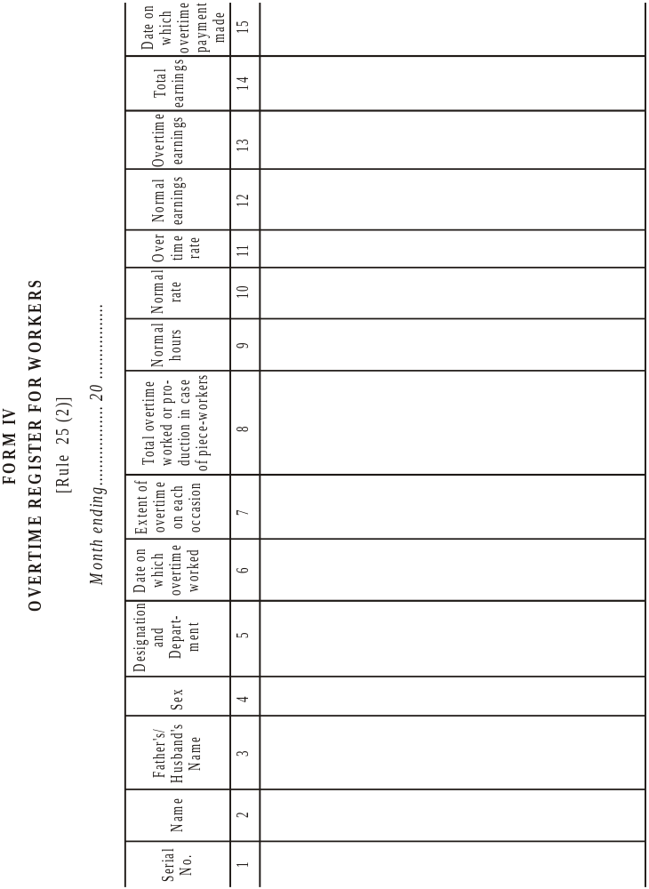
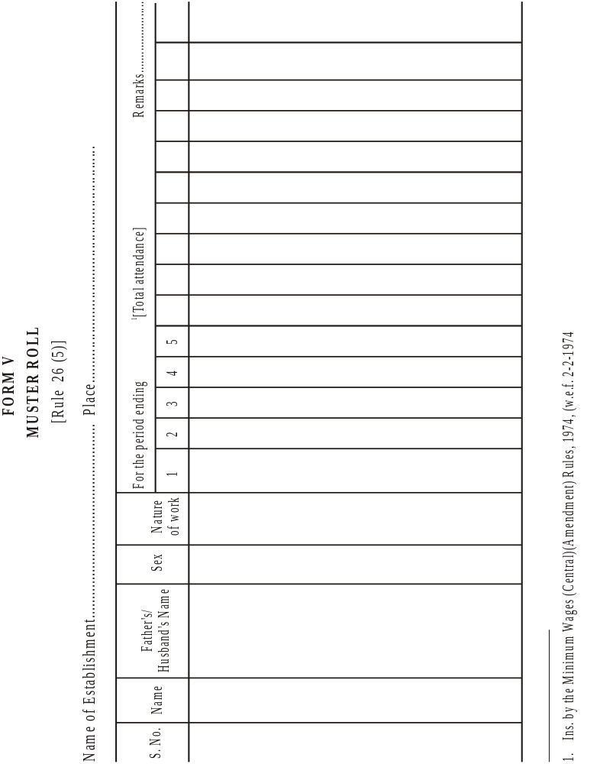
[Form VI]
FORM OF APPLICATION BY AN EMPLOYEE UNDER SECTION 20(2)
In the Court of the Authority appointed under the Minimum Wages Act, 1948, for ………............ area.
Application No.............................................. of 20......
(1) .......................................................................................................Applicant (through............. a legal practitioner/an official of.............. which is a registered Trade Union),
Address...............................................................................................................
Versus
(1).....................................................................................................................
(2).....................................................................................................................
(3)…………………………………………..............................................Opponent(s)
Address...............................................................................................................
The applicant above named states as follows: —
(1) The applicant was/has been employed from.......to..........as ................... (Category) in.....................(establishment) of Shri/ Messers……………....engaged in........... (nature of work) which is a scheduled employment within the meaning of section 2(g) of the Minimum Wages Act.
(2) The opponent(s) is/are the employer(s) within the meaning of section 2(a) of the Minimum Wages Act.
(3) *(a) The applicant has been paid wages at less than the minimum rate of wages fixed for his category of employment under the Act by Rs. ....... .per day for the period from.........to............;
*(b)The applicant has not been paid wages at Rs.....................per day for weekly days of rest from........to. .........;
*(c)The applicant has not been paid wages at the over time rate for the period from. ............. ..to... .........
(4) The applicant estimates the value of relief sought by him on each account as under:
(a) Rs..............................
(b) Rs..............................
(c) Rs..............................
Total Rs.. ........................
(5) The applicant, therefore, prays that a direction may be issued under section 20(3) of the Act for:
*(a)payment of the difference between the wages payable under the Minimum Wages Act and the wages actually paid.
*(b)payment of remuneration for the days of rest.
*(c)payment of wages at the overtime rates. [(d) compensation amounting to Rs... .....]
(6) The applicant begs leave to amend or add to or make alterations in the application, if and when necessary, with the permission of the Authority.
(7) The applicant does solemnly declare that the facts stated in this application are true to the best of his knowledge, belief and information.

Date.......................... Signature or thumb impression
of the employed person, or legal practitioner or official of a Registered Trade Union duly authorised.

[FORM VIA]
FORM OF GROUP APPLICATION UNDER SECTION 21(1)
In the Court of the Authority appointed under the Minimum Wages Act, 1948, for ....... …………………… area
Application No.........................of 20........
Between A.B.C. and (state the number)...................................................others:
Applicants (through a legal practitioner/an official of ............................... which is a registered trade Union), Address.................................................................. and x.y.z ........................................................................................opposite party
Address...............................................................................................................
The applicants state as follows:—
(1) The applicants whose names appear in the attached schedule were/have been employed from.............. to................ as............... (categories).................... in................ (establishment) of Shri/Messers............. engaged in........................ (nature of work) which is/are scheduled employments) within the meaning of section 2(g) of the Minimum Wages Act.
(2) The opponent(s) is/are the employer(s) within the meaning of section 2(e) of the Minimum Wages Act.
(3) *(a) the applicants have been paid wages at less than the minimum rates of wages fixed for their category (categories) of employment(s) under the Act by Rs................ per day for the period (s) from................to............................
*(b)The applicants have not been paid wages at Rs...................... per day for the weekly days of rest from..............to..................:
*(c)The applicants have not been paid wages at the overtime rates(s) for the period from..................................to........................
(4) The applicants estimate the value of relief sought by them on each account as under:
(a) Rs........................ (b) Rs........................
(c) Rs........................ Total Rs......................
(5) The applicants, therefore, pray that a direction may be issued under section 20(3) of the Act for:
*(a)payment of the difference between the wages payable under the Minimum Wages Act and the wages actually paid;
*(b)payment of remuneration for the days of rest;
*(c)payment of wages at the overtime rate(s);
[(d) compensation amounting to Rs........]
(6) The applicants beg leave to amend or add to or make alterations in the application, if and when necessary, with the permission of the Authority.
(7) The applicants do solemnly declare that the facts stated in this application are true to the best of their knowledge, belief and information.

Date........................ Signature or thumb impression of the employed persons or legal practitioner, or official of a Registered Trade Union duly authorised.

[FORM VII]
FORM OF APPLICATION BY AN INSPECTOR OR PERSON ACTING WITH
THE PERMISSION OF THE AUTHORITY UNDER S SECTION 20(2)

In the Court of the Authority appointed under the Minimum Wages Act, 1948, for................ area.
Application No.............................. of 20........
(1) ...................................................................................................... Applicant
Address...............................................................................................................
Versus
(1) ...................................................................................................Opponent(s)
Address...............................................................................................................
The applicant above named states as follows: —
(1) The opponent(s) has/have —
*(a)paid wages at less than the minimum rates of wages fixed for their category (categories) of employment(s) under the Act by Rs. ...................................... per day for the period(s) from... .......... ...........to.. ....................................;
*(b)not paid wages at Rs................ .............. .........per day for the weekly days of rest from. ................................................. to... ..................................;
*(c)not paid wages at overtime rate(s) for the period from................ to. .........................to the following employees;
(2) The applicant estimates the value of relief sought for the employees on each account as under:
(a) Rs........................ (b) Rs........................
(c) Rs........................
(3) The applicant, therefore, prays that a direction may be issued under section 20(3) of the Act for:
*(a)payment of the difference between the wages payable under the Minimum Wages Act and the wages actually paid;
*(b)payment of remuneration for the days of rest;
*(c)payment of wages at the overtime rate(s); [(d) compensation amounting to Rs.. ................................].
(4) The applicant begs leave to amend or add to or make alternations in the application if and when necessary, with the permission of the Authority.
(5) The applicant does solemnly declare that the facts stated in this application are true to the best of his knowledge, belief and information.

Date....................... Signature.]

FORM VIII
FORM IN AUTHORITY IN FAVOUR OF A LEGAL PRACTITIONER OR ANY OFFICIAL OF A REGISTERED TRADE UNION REFERRED TO IN SECTION 20(2)

In the Court of the Authority appointed under the Minimum Wages Act, 1948 for ............. area.
Application No............................................of 20..........
(1) .................................................................................................................... ……..………….............................................................................................
(2) .…................................................................................................................
(3) .................................................................................................Applicant(s)+
Versus
(1) ...................................................................................................................
(2) ...................................................................................................Opponent(s)
(3) ...................................................................................................................

I hereby authorise Mr. ......................................a legal practitioner/an official of the registered trade union of .................................... to appear and act on my behalf in the above described proceedings and to do all things incidental to such appearing and acting.

Date....................... Signature or thumb impression
of the employee.

FORM IX
FORM OF SUMMONS TO THE OPPONENT TO APPEAR BEFORE THE AUTHORITY WHEN AN APPLICATION UNDER SUB-SECTION (2) OF SECTION 20 OR UNDER SECTION 21 IS ENTERTAINED

(Title of the application)
To...................................................
(Name, description and place of residence)

Whereas..................................has made the above said application to me under the Minimum Wages Act, 1948, you are hereby summoned to appear before me in person or by a duly authorised agent, and able to answer all material questions relating to the application, or who shall be accompanied by some person able to answer all such questions on the.........day of ........20............. at................ O’clock in the................. noon, to answer the claim; and as the day fixed for the appearance is appointed for the final disposal of the application, you must be prepared to produce on that day all the witnesses upon whose evidence and all the documents upon which you intend to rely in support of your defence.

Take notice that in default of your appearance on the day before mentioned, the application will be heard and determined in your absence.

Date..................... Signature

[Form IX-A
(Rule 22)
NOTICE
[Abstracts of] the Minimum Wages Act, 1948 and the rule made thereunder
I. Whom the Act affects
1. (a) The Act applies to persons engaged on scheduled employments or in specified class of work in respect of which minimum wages have been fixed,
(b) No employee can give up by contract or agreement his rights in so far as it purports to reduce the minimum rates of wages fixed under the Act.

II. Definition of wages
(1) ‘Wages’ means all remuneration payable to an employed person on the fulfillment of his contract of employment [and includes house rent allowance]. It excludes—
(i) the value of any house-accommodation, supply of light, water, medical attendance or any other amenity or any service extended by general or special order of the appropriate Government;
(ii) contribution paid by the employer to any Pension Fund or Provident Fund or under any scheme of Social Insurance;
(iii) the travelling allowance or the value of any travelling concession;
(iv) the sum paid to the person employed to defray special expenses entailed by him by nature of his employment;
(v) gratuity payable on discharge.
(2) The minimum rate of wages may consist of—
(i) a basic rate of wages and special allowance called the cost of living allowance;
(ii) a basic rate of wages with or without a cost of living allowance and the cash value of any concessions, like supplies of essential commodities at concession rates; and
(iii) in all inclusive rate comprising basic rate, cost of living allowance and cash value of concession, if any.
(3) The minimum wages payable to employees of scheduled employments notified under section 5 read with section 3 or as revised from time to time under section 10, read with section 3, may be—
(a) a minimum time rate, (b) a minimum piece rate,
(c) a guaranteed time rate, (d) an overtime rate,
differing with (1) different scheduled employments, (2) different classes of work, (3) different localities, (4) different wage-periods, and (5) different age groups.

III. Computation and conditions of payment
The employer shall pay to every employee engaged in scheduled employment under him wages at a rate not less than the minimum rate of wages fixed for that class of employee.
The minimum wages payable under this Act shall be paid in cash unless the Government authorises payment thereof either wholly or partly in kind.
[Wage-period shall be fixed for the payment of wages at intervals not exceeding one month or such other larger period as may be prescribed].
Wage shall be paid on a working day within seven days of the end of the wage-period or within ten days if 1000 or more persons are employed.
The wages of a person discharged shall be paid not later than the second working day after his discharge,
If an employee is employed on any day for a period less than the normal working day, he shall be entitled to receive wages for a full normal working day provided his failure to work is not caused by his unwillingness to work but by the omission of the employer to provide him with work for that period.
Where an employee does two or more classes of work to each of which a different minimum rate of wages is applicable, the employer shall pay to such employee in respect of the time respectively occupied in each such class of work, wages at not less than the minimum rate in force in respect of each such class.
Where an employee is employed on piece work for which minimum time rate and not a minimum piece-rate has been fixed, the employer shall pay to such employee wages at not less than the minimum time rate.

IV. Hours of work and holidays
The number of hours which shall constitute a normal working day shall be—
(a) in the case of an adult, 9 hours
(b) in the case of a child, 4 ½ hours.
The working day of an adult worker inclusive of the intervals of rest shall not exceed twelve hours on any day.
[The employer shall allow a day of rest with wages to the employees every week. Ordinarily, Sunday will be the weekly day of rest, but any other day of the week may be fixed as such rest day. No employee shall be required to work on a day fixed as rest day, unless he is paid wages for that day at the overtime rate and is also allowed a substituted rest day with wages. (See rule 23).]
When a worker works in an employment for more than nine hours on any day or for more than forty-eight hours in any week, he shall in respect of overtime worked be entitled to wages in scheduled employment other than agriculture, at double the ordinary rate of wages.

V. Fines and deductions
No deduction shall be made from wages except those authorised by or under the rules.
Deductions from the wages shall be one or more of the following kinds, namely:—
(i) Fines: An employed person shall be explained personally and also in writing the act or omission in respect of which the fine is proposed to be imposed and given an opportunity to offer any explanation in the presence of another person. The amount of the said fine shall also be intimated to him. [It shall be subject to such limits as may be specified in this behalf by the Central Government]. It shall be utilised in accordance with the directions of the Central Government;
(ii) deductions for absence from duty;
(iii) deductions for damage to or loss of goods entrusted to the employee for custody, or for loss of money for which he is required to account, where such damage or loss is directly attributable to his neglect or default. The employed person shall be explained personally and also in writing the damage or loss, in respect of which the deduction is proposed to be made and given an opportunity to offer any explanation in the presence of another person. The amount of the said deduction shall also be intimated to him. [It shall be subject to such limits as may be specified in this behalf by the Central Government];
(iv) deductions for house-accommodations supplied by the employer or by a State Government or any authority constituted by a State Government for providing housing accommodation;
(v) deductions for such amenities and services supplied by the employer as the Central Government may by general or special order authorise. These will not include the supply of tools and protectives required for the purposes of employment;
(vi) deductions for recovery of advances or for adjustment of overpayment of wages, such advances shall not exceed an amount equal to wages for two calendar months of the employed person and the monthly installment of deduction shall not exceed one-fourth of the wages earned in that month;
(vii)deductions of income-tax payable by the employed person,
(viii)deductions required to be made by order of court or other competent authority;
(ix) deductions for subscription to and for repayment of advances from any provident fund;
[(x)deductions for payment to co-operative societies [or deductions for recovery of loans advanced by an employer from out of a fund maintained for the purpose by the employer and approved in this behalf by the Central Government] or deductions made with the written authorisation of the person employed, for payment of any premium on his life insurance policy to the Life Insurance Corporation of India established under the Life Insurance Act, 1956 (31 of 1956);
(xi) deductions for recovery or adjustment of amount other than wages, paid to the employed person in error or in excess of what is due to him:
Provided that prior approval of the Inspector or any other officer authorised by the Central Government in this behalf is obtained in writing before making the deductions, unless the employee gives his consent in writing to such deduction];
[(xii) deductions made with the written authorisation of the employed person (which may be given once generally and not necessarily every time a deduction is made) for the purchase of securities of the Government of India or of any State Government or for being deposited in any Post Office Savings Bank in furtherance of any Savings Scheme of any such Government.
Every employer shall send annually a return in Form III showing the deductions from wages so as to reach the Inspector not later than the 1st February following the end of the year to which it relates.]

VI. Maintenance of Registers and Records
Every employer shall maintain at the work spot a register of wages 1[in the form prescribed] specifying the following particulars for each period in respect of each employed person:—
(a) the minimum rates of wages payable,
(b) the number of days in which overtime was worked,
(c) the gross wages.
(d) all deductions made from wages,
(e) the wages actually paid and the date of payment.
Every employer shall issue wage-slips [in the form prescribed] containing prescribed particulars to every person employed.
Every employer shall get the signature or the thumb-impression of every person employed on the wage-book and wage-slips
Entries in the wage-book and wage-slip, shall be properly authenticated by the employer or his agent.
[A muster-roll, register of fines, register of deductions for damage or loss and register of overtime shall be maintained by every employer at the workspot in the form prescribed.]
[Every employer shall keep exhibited at main entrance to the establishment and its office], notice in English and in a language understood by a majority of the workers of the following particulars in a clean and legible form:
(a) minimum rate of wages,
(b) [abstracts of] the Acts and the rules made thereunder,
(c) name and address of the Inspector.
[Register of wages, muster-roll, register of fines, register of deductions for damage or loss and register of overtime shall be preserved for a period of three years after the date of last entry made therein.
All registers and records required to be maintained by an employer under the rules shall be produced on demand before the Inspector provided that where an establishment has been closed, the Inspector may demand the production of the registers and records in his office or such other place as may be nearer to the employers.]

VII. Inspectors
An Inspector can enter in any premises and can exercise powers of Inspector (including examination of document and taking of evidence) as he may deem necessary for carrying out the purposes of the Act.

VIII. Claims and complaints
Where an employee is paid less than the minimum rates of wages fixed for his class work, or less than the amount due to him under the provisions of this Act, he can make an application in the prescribed form within six months to the authority appointed for purpose. An application delayed beyond this period may be, admitted if the Authority is satisfied that the applicant had sufficient cause for not making the application within such period.
Any legal practitioner, official or a registered trade union, Inspector under the Act or other person acting with the permission of the Authority can make the complaint on behalf of an employed person.
[a single application may be presented on behalf of or in respect of a group of employed perrons whose wages have been delayed, if they are borne on the same establishment and their claim relates to the same wage-period or periods.]
[A complaint under section 22(a) relating to payment of less than the minimum rates of wages or less than the amount due to an employee under the provisions of the Act can be made to the Court only after an application in respect of the facts constituting the offence has been presented under section 20 and has been granted wholly, or in part, and the appropriate Government or an officer authorised by it in this behalf has sanctioned the making of the complaint;
A complaint under section 22(b) or 22(a) regarding contravention of the provisions relating to hours of work and weekly day of rest or other miscellaneous offences relating to maintenance of registers, submission of returns, etc., can be made to the Court by or with the sanction of an Inspector. The time-limits for making such complaints is one month from the date of grant of sanction by the Inspector, in the case of offences falling under section 22(b) and six months; from the date on which the offence is alleged to have been committed, in the case of offences falling under section 22(a).]

IX. Action by the Authority
The Authority may direct the payment of the amount by which the minimum wages payable exceed the amount actually paid together with the payment of compensation not exceeding ten times the amount of such excess. The Authority may direct payment of compensation in cases where the excess is paid before the disposal of the application.
If a malicious or vexatious complaint is made, the Authority may impose a penalty not exceeding Rs. 50 on the applicant and order that it be paid to the employer.
Every direction of the Authority shall be final.

X. [Penalties for offences under the Act]
Any employer who pays to any employee less than the amount due to him under the provisions of this Act or infringes any order or rules in respect of normal working day, weekly holiday, shall be punishable with imprisonment of either description for a term which may extend to six months or with fine which may extend to five hundred rupees or with both,
[Any employer who contravenes any provision of the Act or of any rule or order made thereunder shall, if no other penalty is provided for such contravention by the Act, be punishable with fine which may extend to five hundred rupees. If the person committing any offence under the Act is a company, every person who at the time the offence was committed, was in charge of, and was responsible to, the company for the conduct of the business of the company as well as the company shall be deemed to be guilty of the offence and shall be liable to be proceeded against and punished accordingly. No such person will be liable to punishment, if he proves that the offence was committed without his knowledge or that he exercised all due diligence to prevent the commission of such offence.
Any director, manager, secretary or other officer of the company with whose consent or connivance an offence has been committed is liable to be proceeded against and punished under the Act.
Note.—(a) “company” means any body corporate and includes a firm or other association of individuals,
(b) “director” in relation to a firm means a partner in the firm.]
XI. Minimum Rates of Wages Fixed
Name of undertaking...................................
Serial No. Category of employees Minimum Wages
XII. Name and address of Inspector(s)
Name………………………………………………………………………………………..
Address……………………..................................................................................]

[FORM X
[Rule 26 (1)]
REGISTER OF WAGES
Name of Establishment......................
Wages period from.........................to................................ Place.......................

Minimum rates of wages payable |  | Rates of wages actually paid |  | Deductions wages
Basic | D.A. | Basic | D.A.

Sr. No.
Name of the employee
Father’s/Husband’s name Designation
Total attendance ¢ units of work done
Overtime worked
Gross wages payable
Employee’s contribution to P.F.
Deductions
H.R.
Other deduction
Total deduction
Wages paid
Date of payment
Signature or Thumb-Impression of employee

1 2 3 4 5 6 7 8 9

10 11 12 13 14 15 16 17 18

[FORM XI
[Rule 26(2)]
WAGE SLIP
Name of the establishment
Place
1. Name of employee with father’s/husband’s name
2. Designation
3. Wages Period.
4. Rate of wages payable:
(a) Basic
(b) D.A.
5. Total attendance/units of work done
6. Overtime wages.
7. Gross wages payable
8. Total deductions
9. Net wages paid

Pay-in-charge Employee’s signature/thumb impression].

 | INDEX
 | 9 (3) The Punjab Minimum Wages Rules, 1950
Rule | Particulars | Page
 | Chapter I : Preliminary
1. | Short title and extent | 323
2. | Interpretation | 323
 | Chapter II: Membership, meetings and Staff of the Board and Committee
3. | Terms of office of the members of the Committee | 324
4. | Term of office of members of the board | 324
5. | Travelling Allowance | 324
6. | Staff | 325
7. | Eligibility for renominations of the members of the Committee | 325
8. | Resignation of the Chairman and member of the Committee | 325
9. | Cessation and restoration of membership | 326
10. | Disqualification | 326
11. | Meetings | 326
12. | Notice of Meetings | 327
13. | Chairman | 327
14. | Quorum | 327
15. | Disposal of business | 327
16. | Method of voting | 328
17. | Proceedings of the meeting | 328
 | Chapter III : Summoning of witnesses by the committee, and the Board and production of documents
18. | Summoning of witness and production of documents | 328
19. | Expenses of witnesses | 329
 | Chapter-IV: Computation and Payment of Wages, hours of work and holidays
20. | Omitted | 329
21. | Terms and condition of payment of wages and the deductions permissible from wages | 329
22. | Publicity to the minimum wage fixed under the Act | 332
23. | Weekly day of rest | 333
24. | Number of hour of work which shall constitute a normal working day | 335
24A. | Night shifts | 335
25. | Extra wages for overtime | 336
25A. | Part time employees | 337
26. | Form of registers and record | 337
26A. | Employers to provide cards to employees, engaged in Public motor transport | 338
26B. | Preservation of register | 339
26C. | Production of registers and other records | 339
 | Chapter-V: Claims under the Act
27. | Application | 339
28. | Authorisation | 339
29. | Appearance of Parties | 339
 | Chapter-VI: Scale of cost in Proceedings under the Act
30. | Costs | 340
31. | Court-fees | 340
Form I | Register of fines | 341
Form II | Register of deduction for damage or loss caused to the employer, by the neglect or default of the employed persons | 342
Form III | Annual Return under the Minimum Wage Act, 1948 | 343
Form IV | Overtime Register for workers | 345
Form V | Muster Roll | 346
Form VI | Form of Application by an Employee under Section 20 (2) | 347
Form VII | Form of Application by an Inspector or person acting with the Permission of the Authority under Section 20(2) | 348
Form VIII | Form of Authority in favour of a legal Practitioner or any official of a Registered trade union referred to in section 20(2) | 349
Form IX | Form of summons to the opponent to appear before the Authority when an Application under sub-section (2) of section 20 or under section 21 is entertained. | 350
Form IXA | Notices Abstract of the Minimum Wages Act, 1948 and the Rules made thereunder | 350
Form X | Register of wages | 357
Form XI | Wage Slip | 358
Form XII | Issue of Card to the employees under Rule 26-A | 359
Noti. | Notification with regard to applying the provisions of the Payment of Wages Act to the claims arising out of deduction from, or delay in payment of wages to the employees in Schedule employment. | 359

THE PUNJAB MINIMUM WAGES RULES, 1950
Notification No. 5260-LP/51/3091, dated 6th June, 1951

In exercise of the powers conferred by Section 30 of the Minimum Wages Act, 1948, the Governor of Punjab Government hereby makes the following rules, namely:

CHAPTER I
Preliminary

1. Short title and extent.-
(1) These rules may be called the Punjab Minimum Wages Rules 1950.
(2) These shall extend to the whole of the State of Haryana].

2. Interpretation - In these rules, unless the context otherwise requires:
(a) ‘Act’ means the Minimum Wages Act, 1948;
(b) [x x x x]
(c) ‘Authority’ means the authority appointed under sub-section (l) of section 20;
(d) ‘Board’ means the Advisory Board appointed under section 7;
(e) ‘Chairman’ means the Chairman of the Advisory Boards [or] the Committee or sub-committee [x x x x] or the Advisory Sub-Committee as the case may be, appointed under section 9;
(f) ‘Committee’ means a Committee appointed under clause(a) of sub-section (1) of section 5 and includes a sub-committee appointed under that section;
(ff) ‘day’ means a period of 24 hours beginning at midnight;
(g) ‘form’ means a form appended to these rules;
(h) ‘Inspector’ means a person appointed as Inspector under section 19;
(i) ‘registered trade union’ means a trade union registered under the Indian Trade Unions Act, 1926;
(j) ‘section’ means a section of the Act; and
(k) all other words and expressions used herein and not defined shall have the meaning respectively assigned to them under the Act.

CHAPTER II
[Membership, meetings and Staff of the Board and Committee]

3. [Term of office of the members of the Committee]-The term of office of the members of the Committee [x x x] shall be such as in the opinion of the State Government is necessary for completing the enquiry in to the employment concerned and the State Government may at the time of the constitution of the Committee
[x x x] fix such terms and may, from time to time, extend it as circumstances may require.

4. Term of office of members of the Board -
(1) Save as otherwise expressly provided in these rules, the term of office of a non- member of the Board shall be two years commencing from the date of his appointment:
Provided that such member shall, notwithstanding the expiry of the said period of two years continue to hold office until his successor is nominated.
(2) A member of the Board nominated to fill a casual vacancy shall hold office for the remaining period of the term of office of the member in whose place he is nominated.
(3) The members of the Board shall hold office during the pleasure of the State Government.

[5. Travelling Allowance - A member of the Committee or the Board shall be entitled to draw travelling allowance and daily allowance at such rates as fixed by the Government from time to time, for any journey performed by him in connection with the duties as such member.]
6. Staff-
(1) The State Government may appoint a Secretary to the Committee
[x x x x] of the Board and such other staff as it may think necessary and may fix the salaries and allowances payable to them and specify their condition of service.
(2) (i) The Secretary shall be the Chief Executive Officer of the Committee
[x x x x] or the Board, as the case may be. He may attend the meeting of such Committee, [x x x x x] or Board, but shall not be entitled to vote at such meetings.
(ii) The Secretary shall assist the Chairman in convening meetings shall keep a record of minutes of such meetings and shall take necessary measures to carry out the decision of the Committee; [x x x x x] or the Board, as the case may be.

7. Eligibility for renomination of the members of the Committee
[x x x x x] and the Board - An outgoing member shall be eligible for renomiantion for the membership! of the committee, [xx x x x] or the Board, of which he was a member.

8. Resignation of the Chairman and member of the Committee and the Board and filling of casual vacancies -
(1) A member of the committee, [x x x x x] or the Board other than the Chairman may, by giving notice in writing to the Chairman, resign his membership.
(2) The Chairman may resign by letter addressed to the State Government.
(3) When a vacancy occurs or is likely to occur in the membership of the Committee, [x x x x x] or the Board, the Chairman shall submit a report to Government immediately. Government shall then take steps to fill the vacancy.

9. Cessation and restoration of membership -
(1) If a matter of the Committee [x x x xx] of the Board foils to attend three consecutive meetings, he shall, subject to that provisions of sub-rule (2), cease to be a member thereof.
(2) A person, who ceases to be a member under sub-rule (1) shall be given intimation of such cessation by a letter sent to him by registered post within fifteen day from the date of such cessation. The letter indicate that if he desires restoration of hill members, ship, he may apply therefor within thirty days from the receipt of such letter. The application for restoration of membership, if received within the said period shall be placed before the Committee [x x x x x] or the Board, as the case may be, and if majority of members present at the next meeting is satisfied that the reasons for failure to attend three consecutive meetings are adequate the members shall be restored to membership immediately after a resolution to that effect is adopted.

10. Disqualification -
(1) A person shall be disqualified for being nominated as and for being a member of the Committee [x x x x x ] or the Board, as the case may be:-
(i) if he is declared to be of unsound mind by a competent court; or
(ii) if he is an undischarged insolvent; or
(iii) if before or after the commencement of the Act, he has been convicted of a offence involving moral turpitude.
(2) If any question arises whether a disqualification has been incurred under sub rule (1) the decision of the State Government thereon shall be final.

11. Meetings - The Chairman may, subject to the provisions of rule 12 call a meeting of the Committee, or the Board, as the case may be, at any time he thinks fit:-
Provided that on a requisition in writing from not less than one half of the members the Chairman shall call a meeting within fifteen days from date of the receipt of such requisition.

12. Notice of meetings - The Chairman shall fix date, time and place of every meeting and a notice in writing containing the aforesaid particulars along with a list of business to be conducted at the meeting shall be sent to each member by registered post at least fifteen days before the date fixed for such meeting:-
Provided that in the case of an emergent meeting, notice of seven days only may be given to every member.

13. Chairman - (1) The Chairman shall preside at the meeting of the Committee [x x x x x] or the Board, as the case may be.
(2) In the absence of the Chairman at any meeting the member shall elect from amongst themselves one member, by a majority of votes, who shall preside at such meeting.

[14. Quorum - No business shall be transacted at any meeting unless atleast one-third of the members and atleast one representative each of both the employers and the employees are present: -
Provided that if at any meeting less than one third of the members are present or not even one representative each of both the employers and employees are present the Chairman may adjourn the meeting to a date not later than seven days from the date of the original meeting and it shall there upon be lawful to dispose of the business at such adjourned meeting irrespective of the number of class of members present].

15. Disposal of business - All business shall be considered at a meeting of the Committee [x x x x x] or the Board, as the case maybe, and shall be decided by a majority of the votes of the members present and voting. In the event of an equality of the votes the Chairman shall have a casting vote:-
Provided that the Chairman may if he thinks fit, direct that any matter shall be decided by the circulation of necessary papers and securing written opinion of the members;
Provided further that no decision on any question which is referred under the 1st provision shall be taken unless supported by not less than a two-third majority of the members.

16. Method of voting - Voting shall ordinarily be by show of hands, but if any member asks for voting by ballot, or if the Chairman so decides, the voting shall be by secret ballot, and shall be held in such manner as the Chairman may decide.

17. Proceedings of the meeting -
(1) The Proceedings of each meeting showing inter alia names of the members present thereto shall be forwarded to each member and to the State Government as soon after the meeting as possible and in any case, not less than seven days before the next meeting.
(2) The proceedings of each meeting shall be confirmed with such modifications, if any, as may be considered necessary at the next meeting.

CHAPTER III
Summoning of witnesses by the committee, and the Board and production of documents

18. Summoning of [witnesses] and production of documents -
(1) A Committee or the Board, may summon any person to appear as a witnesses in the course of an enquiry. Such summons may require a witness to appear before it on a date specified therein and to produce any books, papers or other documents and things in his possession or under his control relating in any manner to the enquiry.
(2) A summons under sub-rule (1) may be addressed to an individual or an organisation of employers or a registered trade union of workers.
(3) A summons under this rule may be served
(i) in the case of an individual, by being delivered or sent to him by registered post,
(ii) in the case of an employer’s organisation or a registered trade union of workers by being delivered or sent by registered post to the secretary or other principal officer of the organiation or union, as the case may be.
(4) The provisions of the Civil Procedure Code relating to the summoning and enforcement of the appearance of witnesses and the production of documents shall, so far as may, be apply to proceeding before a Committee. [x x x x x] or the Board.
19. Expenses of witnesses - Every person who is summoned and appears as a witness before the Committee, or the Board shall be entitled to an allowance for expenses incurred by him in accordance with the scale for the time being in force for payment of such allowances to witnesses appearing in civil courts in the State.

CHAPTER IV
Computation and Payment of Wages, hours of work and holidays

20. [Omitted]
21. [Terms] and condition of payment of wages and the deduction permissible from wages -
(1)(i) The wage period with respect to any scheduled employment for which it have been fixed shall not exceed one month and the wages of a worker in such employment shall be paid:-
(a) in the case of establishments in which less than one thousand persons are employed before the expiry of seventh day; and
(b) in the case of other establishments before the expiry of the tenth day, after the last day of the wage period in respect of which the wages are payable.
(ii) Where the employment of any person is terminated by or on behalf of the employer, the wages earned by him shall be paid before the expiry of the second working day after the day on which his employment is terminated:
Provided that the Government, on receipt of a representation in respect of any scheduled employment or class or classes of employees in such employment may, after inviting public comments notify any other wage periods or time limits for payment which shall then apply to all or any class or classes of employees in such employment.
(iii) The wages of an employed person shall be paid to him without deduction of any kind except those authorised by or under these rules.
Explanation - Every payment made by the employed person to the employer or his agent shall, for the purpose of these rules, be deemed to be a deduction from wages.
(2) Deduction from the wages of a person employed in a scheduled employment shall be of one or more of the following kinds, namely :-
(3)(i) Fines which may be imposed on any of the following grounds:-
(a) Absence from duty without leave, without sufficient cause (fine may be imposed only as an alternative to the deduction permissible under clause (ii) of sub-rule (2) of Rule 21),
(b) Negligence in work or neglect of work.
(c) Smoking on the premises of the work place, except in places where smoking is permitted
(d) Entering or leaving or attempting to enter or leave, the premises except by the gate provided for the purpose.
(e) Absence without leave or without sufficient cause from appointed work in the establishment.
(f) Breach of any rules or instructions for the maintenance and running of any department and maintaining its cleanliness.
(g) Damages to work in process or to any other property of the employer,
(h) Interference with any safety devices installed on the premises.
(i) Distributing or exhibiting on the premises handbills, pamphlets or posters without previous sanction of the employer.
(j) Misconduct (fine may be imposed only as an alternative to a heavier permissible punishment].
(ii) deductions for absence from duty.
(iii) deductions for damage to or loss of goods expressly entrusted to the employed person for custody, or for loss of money for which he is retired to account, where such damage or loss is directly attributable to his neglect or default.
(iv) deductions for house accommodation supplied by the employer or by a State Government or any authority constituted by a State Government for providing housing accommodation.
(v) deductions for such amenities and services supplied by the employer as the Government may by general or special order, authorise.
Explanation - The words “amenities and services” in this clause does not include the supply of tools and protective required for the purpose employment.
(vi) deductions for recovery of advances or for adjustment of over-payments of wages:
Provided that such advances do not exceed an amount equal to wages for two calendar months of the employed persons and, in no case, shall the monthly installment of deduction exceed one-fourth of the wages earned in the month.
(vii) deductions of income-tax payable by the employed person.
(viii)deductions required to be made by order of a court of other competent authority,
(ix) deduction for subscriptions to and for repayment of advances from any provident fund to which the Provident Fund Act, 1952, applies or any recognised provident fund as defined in section 58-A of the Indian Income Tax Act, 1922, or any provident fund approved in this behalf by the Government during the continuance of such approval.
(x) deductions for payment to co-operative societies or to a scheme of insurance approved by the Government.
[(xi) deductions made with the written authorisation of the employed persons (which may be given once generally and not necessarily every time a deduction is made, for the purchase of securities of the Government of India or of any State Government or for being deposited in any Post Office Savings Bank in furtherance of any saving scheme of any such Government].
[(xii) deductions for rent of accommodation for cattle sheds and stage supplied by the employer].
[(xiii)deductions made with the written authorisation of :-
(a) the employed person, or
(b) the President or Secretary of the registered Union of which the employed persons is a member on such conditions as may be prescribed for contribution to the National Defence Fund or to any Defense Savings Scheme approved by the Central Government or the State Government.]
(3) Any person desiring to impose a fine on an employed person or to make a deduction for damage or loss caused by him shall explain to him personally and also in writing the act or omission or the damage or loss, in respect of which the fine or deduction is proposed to be imposed or made and give him an opportunity to offer any explanation in the presence of another [workman]. The amount of the said fine or deduction shall also be intimated to him.
[(4)The amount of fine or deduction for damage or loss mentioned in sub-rule (3) shall be subject to such limits as may be specified in this behalf by the State Government. All such fines imposed and deductions made shall be recording the registers maintained in [Forms I and II], respectively. These registers shall be kept at the work spot and maintained up-to-date. Where no fine or deduction has been imposed or made on or from any employee in a wage period, a ’nil’ entry shall be made across the body of the relevant register at the end of the wage period, indicating also in precise terms the wage period to which the ‘nil’ entry relates.
(4A)Every employer shall send annually a return in Form III showing the deductions from wages so as to reach the Inspector not later than 1st February following the end of the year to which it relates.]
[(5) The amount of fine imposed under sub-rule (3) shall be utilized only for such purposes beneficial to the employees as are approved by the State Government]
(6) Nothing in this rule shall be deemed to affect the provisions of the Payment of Wages Act, 1936.

22. Publicity to the minimum wage fixed under the Act - Notices [in form IX-A] containing the minimum rates of wages fixed together with [abstracts of] the Act, the rules made there-under and the name and the address of the Inspector shall be displayed in English and [Hindi in Devi Nagri Script] in the employment [at the main entrances to the establishment and its office] and shall be maintained in a clean and legible condition. Such notices shall also be displayed on the notice boards of all Sub-Divisional and District Offices.
[23. Weekly day of rest -
(1) Subject to the provisions of this rule, an employee in a scheduled employment in respect of which minimum rates of wages have been fixed under the Act, shall be allowed a day of rest every week hereinafter referred to as “the rest day”] which shall ordinarily be Sunday, but the employer may fix any other day of the week as the rest day for any employee or class of employees in that scheduled employment:
Provided that the employee has worked in the scheduled employment under the same employer for a continuous period of not less than six days;
Provided further that the employee shall be informed of the day fixed as the rest day and of and subsequent change in the rest day before the change is effected by display of a notice to that effect in the place of employment at the place specified by the Inspector in this behalf.
[Explanation - For the purpose of computation of the continuous period of not less than six days specified in the first provision to this sub rule :-
(a) any day on which an employee is required to attend for work, but is given only an allowance for attendance and is not provided with work;
(b) any day on which an employee is laid off on payment of compensation under the Industrial Disputes Act, 1947.
(c) any day on which the employee was on leave [or] which was a holiday, with or without pay granted by the employer during the period of six days immediately preceding the rest-day; shall be deemed to be a day on which the employee has worked.]
(2) Any such employee shall not be required or allowed lo work in a scheduled employment on the rest day unless he has or will have a substituted rest day for a whole day on one of the five days immediately before or after the rest day;
Provided that no substitution shall be made which will result in the employee writing for more than ten days consecutively without a rest day for a whole day.
(3) Where in accordance with the foregoing provisions of this rule, any employee writs on a rest day and has been given a substituted rest day on any one of the five days before or after the rest day, the rest day shall, for the purpose of calculating the weekly hours of work, be included in the week in which the substituted rest day occurs.
(4) An employee shall be granted for the rest day wages calculated at the rate applicable to the next preceding day and in case he works on the rest day and has been given a substituted rest day, he shall be paid wages for the rest day on which he worked, i.e. the overtime rate and wages for the substituted rest day at the rate applicable to the next preceding day; -
Provided that where the minimum daily rate of wages of the employee as notified under the Act has been worked out by dividing the minimum monthly rate of wages by twenty-six or where the actual daily rate of wages of the employee has been worked out by dividing the monthly rate of wages by twenty-six and such actual daily rate of wages is not less than the notified minimum daily rate of wages of the employee, no wages for the rest day shall be payable, and in case the employee works on the rest day and has been given a substituted rest day, he shall be paid, only for the rest day on which he worked, an amount equal to the wages payable to him at the overtime rate, and if any dispute arises whether the daily rate of wages has been worked out as afore said the Labour Commissioner may, on application made to him in this behalf decide the same after giving an opportunity to the parties concerned to make written representations:
Provided further that in the case of any employee governed by a piece rate scheme, the wages for the rest day or, as the case may be, the rest day and the substituted rest day, shall be such as the [Haryana] State Government may, by notification in the Official Gazette, prescribe, having regard to the minimum rate of wages fixed under the Act in respect of the scheduled employment.
Explanation - In this sub-rule, [next preceding day] means the last day on which the employee has worked, which precedes the rest day of the substituted rest day as the case may, and where the substituted rest day falls on a day immediately after the rest day, the next preceding day means the last day on which the employee has worked which precedes the rest day.
(5) The provisions of this rule shall apply to the employee in scheduled employment other than agricultural employment.
(6) The provisions of this rule shall not operate to the prejudice of more favourable terms, if any, to which an employee may be entitled under any other law or under the terms of any award, agreement or contract of service, and in such a case, the employee shall be entitled only to the more favourable terms aforesaid.
Explanation - For the purpose of this rule, “Week” shall means a period of seven days beginning at midnight on Saturday night.

24. Number of hours or work which shall constitute a normal working day.—
(1) The number of hours which shall constitute a normal day shall be :-
(a) In the case of an adult 9 hours
(b) In the case of a child 4 hours
(2) The working day of an adult worker shall be so arranged that inclusive of the intervals for rest, if any, it shall not spread over more than 12 hours on any day. [The period of work on any day, in a scheduled employment, shall be so fixed that no continuous period of work shall exceed five hours and that no worker shall be required or allowed to work for more than five hours unless he has had an interval for rest for at least half an hour on the expiry of the said five hours].
[(2-A) Working hours including overtime shall not exceed 10 hours in a day or 60 hours in a week, provided that the total overtime shall not exceed 50 hours in a period of three months.]
(3) The number of hours of work in the case of an adolescent shall be the same as that of an adult or a child according as he is certified to work as an adult or a child by a competent medical practitioner approved by the State Government.
[x x x x x x].
(4) The provisions of sub-rules (1) to (3) shall be subject to such modifications as may, from time to lime, be notified by the State Government.
(5) Nothing in this rule shall be deemed to affect the provisions of the Factories Act, 1948.

24A. Night Shifts - Where a worker in a schedule employment works on a shift, which extends beyond midnight -
(a) a holiday for the whole day for the purposes of rule 23 shall in his case mean a period of twenty-four consecutive hours beginning from the time when his shift ends; and
(b) the following day in such a case shall be deemed to be the period of twenty-four hours beginning from the time when such shift ends, and the hours after midnight during which such worker was engaged in work shall be counted towards the previous day.

25. Extra wages for overtime-
(1) Where an employee in a scheduled employment is governed by the provisions of the Factories Act or any other enactment, prescribing extra wages for overtime, he shall receive overtime wages at the rates so prescribed.
(2) In case not covered by sub-rule (1) when a worker works in an employment for more than the number of hours of work constituting a normal working day prescribed in rule 24 [or for more than 48 hours in a week] he shall in respect of overtime work be entitled to wages -
(a) in the case of employment in Agriculture, at one and a half time the ordinary rate of wages;
(b) [x x x x x].
[(c)in the case of any other scheduled employment, at double the ordinary rate of wages.]
Provided that the Government, receipt of representation in respect of any scheduled employment of class or classes of employees in such employment may, after inviting public comments, notify any other rate of payment of extra wages for overtime in respect of any scheduled employment or class of classes of employees in such employment.
Explanation - The expression “ordinary rate of wages” means the basic wage plus such allowances included the cash equivalent of the advantage accruing through the concessional sale to the person employed of foodgrains and other articles as the person employed is for the time being entitled to but does not include a bonus.
[(3) A register of overtime shall be maintained by every employer in Form IV in which entries under the columns specified therein shall be made as and when overtime is worked in any establishment. The register shall be kept at the work-spot and maintained up-to-date. Where no overtime has been worked in any wage period, a ‘nil’ entry shall be made across the body of the register at the end of the wage period indicating also in precise terms the wage period to which the ‘nil’ entry relates].
(4) Nothing in this rule shall be deemed to affect the provisions of the Factories Act, 1948.

[25A. Part-time Employees - Where an employee is employed on part-time basis, with one or more employers, and his minimum wages are fixed by the day, he shall be entitled to claim from each employer from whom he works in a given day or less than the normal working day, wages for the number of hours for which he works, on pro-rate basis.]

26. Form of registers and record.—
(1) A register of wages shall be maintained by every employer -2[at the work spot] and kept in such form as may be notified by the State Government and shall include the following particulars;-
(a) the minimum rates of wages payable to each person employed;
(b) the number of days for which each employed person worked overtime for each wage period;
(c) the gross wages of each person employed for each wage period;
(d) all deduction made from wages with an indicating in each case of the kinds of deductions mentioned in sub-rule (2) of rule 21;
(e) the wages actually paid to each person employed for each wage period and the date of payment.
(2) Wage slips containing the aforesaid particulars and such other particulars as may be notified by the State Government shall be issued by every employer to every person employed by him at least a day prior to the disbursement of wages.
(3) Every employer shall get the signature or the thumb-impression of every person employed on the wage book and wage slip.
(4) Entries in the wage books and wage slips shall be authenticated by the employer or any person authorised by him in this behalf.
(5) A muster roll shall be maintained by every employer [at the work-spot] and kept in Form X.(substituted vide amendment dated 04.07.2000)
[(6)Notwithstanding anything contained in this rule, where a combined form is to avoid duplication of work for compliance with the provisions of any other Act or rules framed thereunder, an alternative suitable form in lieu of any of the forms prescribed under this rule may be used with the previous approval of the Labour Commissioner, Punjab.]
Provided that the Government on sufficient cause being shown may by notification in the Official Gazette, exempt any scheduled employment or any units of such employment, conditionally or otherwise, from the observance of any of the requirements under this rule, or may vary these requirements, in respect of the employees or a class or classes of employees in such employment.

[26-A. Employers to provide cards to employees, engaged in public motor transport -
(1) Every driver, conductor or any other employee in public motor transport shall, at the beginning of every month, be provided with a card in Form X which may be in [Hindi or English whichever as understood by such employees] or in the language understood by such employees.
(2) The card shall be in the custody of such employee during the month and thereafter shall be returned to the employer who shall preserve it for a period of three years.
(3) The entries in such card shall be made each day in the presence of the employee by the employer or any person authorised by him in that behalf and employee shall produce the card whenever required for this purpose.
(4) If the employee loses his card, the employer shall, on payment of [fifty paise] provide him within a week with another card duly completed from his record.]
[Explanation - Public Motor Transport means a motor transport undertaking engaged in carrying passengers or goods or both by road for hire or reward and includes, a private carrier.]

[26B. Preservation of register -A register required to be maintained under rule 21(4), 25(3) and 26(1) and the muster roll required to be maintained under rule 26(5) shall be preserved for a period of 3 years after the date of last entry made therein.

26C. Production of registers and other records - All registers and records required to be maintained by an employer under these rules shall be produced on demand before the Inspector.
Provided that where an establishment has been closed, the Inspector may demand the production of the registers and records in his office or such other public place as may be nearer to the employer.”]

CHAPTER V
Claims under the Act

27. Application - An application under sub-section (2) of section 20 or sub-section (1) of section 21, by or on behalf of an employed person or group of employed persons shall be made in duplicate in forms VI and VII, as the case may be.

28. Authorisation - The authorisation to act on behalf of an employed person or persons under sub-section (2) of section 20 or of sub-section (1) of section 21 shall be given in form VIII by an instrument which shall be presented to the Authority hearing the application and shall form part of the record.

29. Appearance of parties -
(1) If any application under sub-section 20 or section 21 is entertained, the Authority shall serve upon the employer by registered post a notice in form IX to appear before him on a specified date with all relevant documents and witnesses, if any and shall inform the applicant of the dates so specified,
(2) If the employer or his representative fails to appear on the specified date the authority may hear and determine the application ex-parte:
(3) If the application or his representative fails to appear on the specified date the authority may dismiss the application
(4) An order passed under sub-rule (2) or sub-rule (3) may be set aside on sufficient cause being shown by the defaulting party within one month of the date of the said order, and the application shall then be re-heard after service of notice on the opposite party of the date fixed for re-hearing in the manner specified in sub-rule (1).

CHAPTER VI
Scale of cost in Proceedings under the Act

30. Costs -
(1) The Authority, for reasons to be recorded in writing, may direct that the costs of any proceeding pending before it shall not follow the event.
(2) The costs which may be awarded shall include:
(i) expense incurred on account of court-fees;
(ii) expense incurred on subsistence money to witnesses; and
[(iii) Advocates fees to the extent of Rs. 100/-provided that the Authority in any proceeding may reduce the fees to a sum not less than fifty rupees or for reasons to be recorded in writing or increase it to a sum not exceeding two hundred and fifty rupees.]
(3) Where there are more than one [Advocate] or more than one applicant or opponent the authority may, subject as aforesaid award to the successful party or parties such costs as it may deem proper.

31. Court-fees - The court-fee payable in respect of proceedings under section 20 shall be:
(i) for every application ...... One rupee in respect to summon a witness. of each witness;
(ii) for every application ...... One rupee; made by or on behalf of an individual.
Provided that the Authority may, if in its opinion the applicant is a pauper, exempt him wholly or partly from the payment of such fees:
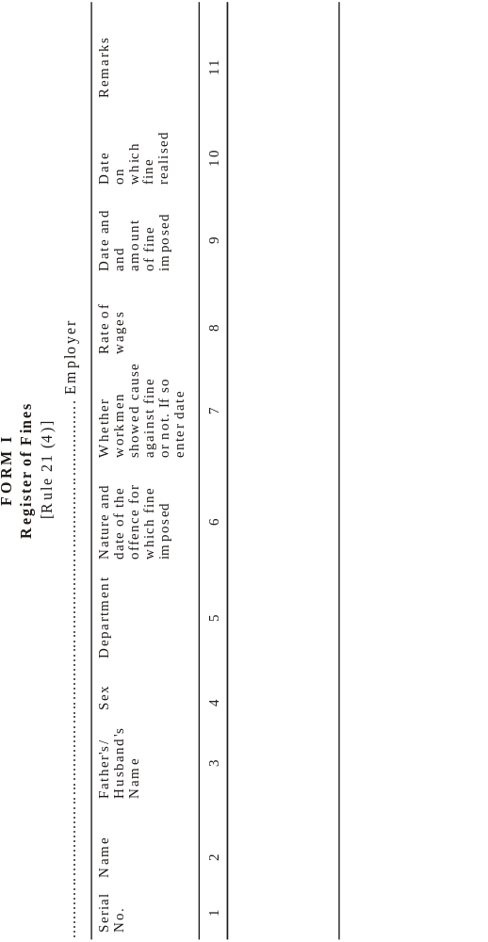
Omitted vide amendment dat 04.07.2000)
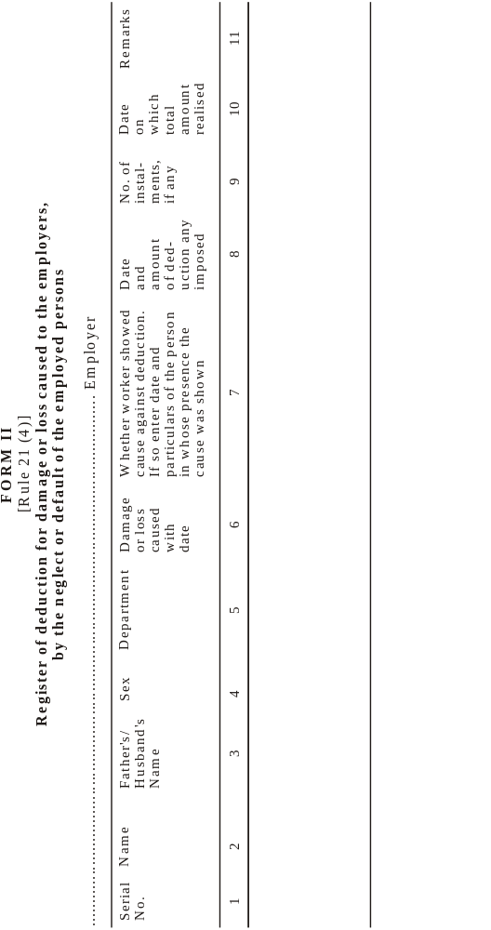
Omitted vide amendment dat 04.07.2000)
Provided further that no fee shall be chargeable:
(a) from persons employed in Agriculture; or
(b) in respect of an application made by an Inspector:
[Provided that Government may by notification reduce the scale of court-fees in respect of any scheduled employment.]

[FORM III]
[See Rule 21 (4A)]
Annual Return under the minimum Wages Act, 1948
Return for the year ending the 31st December, ........................................................
1. (a) Name of the establishment and postal address
(b) Name and residential address of the owner Contractor....................................
(c) Name and residential address of the Managing Agent/Director/Partner incharge of the day-to-day affairs of the establishment owned by a Company, Body corporate or Association ...........................................................................
..............................................................................................................
(d) Name and residential address of the Manager/Agent, if any ........................... ..............................................................................................................
2. Number of days worked during the year..............................................................
3. *Number of man days worked during the year.....................................................
4. **Average daily number of persons employed during the year...............................
(i) Adults............................ (ii) Children ...........................................
5. Total wages paid in cash..................................................................................
6. ***Total cash value of the wages paid in kind ...................................................
7. Balance of Fines Fund at the beginning of the year .............................................
8. Deductions made during the year :-..................................................................
No. of cases Total amount
Rs. Paise
(a) Fines: .....................................................................................................
(b) Deductions for damages or loss : ................................................................
(c) Deductions for breach of contract : .............................................................
Rs. Paise
9. Balance of Fines Fund in hand at the end of the year:
10. Disbursement from the Fines Fund during the year:
Purpose Amount
Rs. Paise
(a) ………………………….........................................................................
(b) ..........................................................................................................
(c) ...........................................................................................................
(d) ..........................................................................................................

Date Signature ..............................................
Designation ............................................................

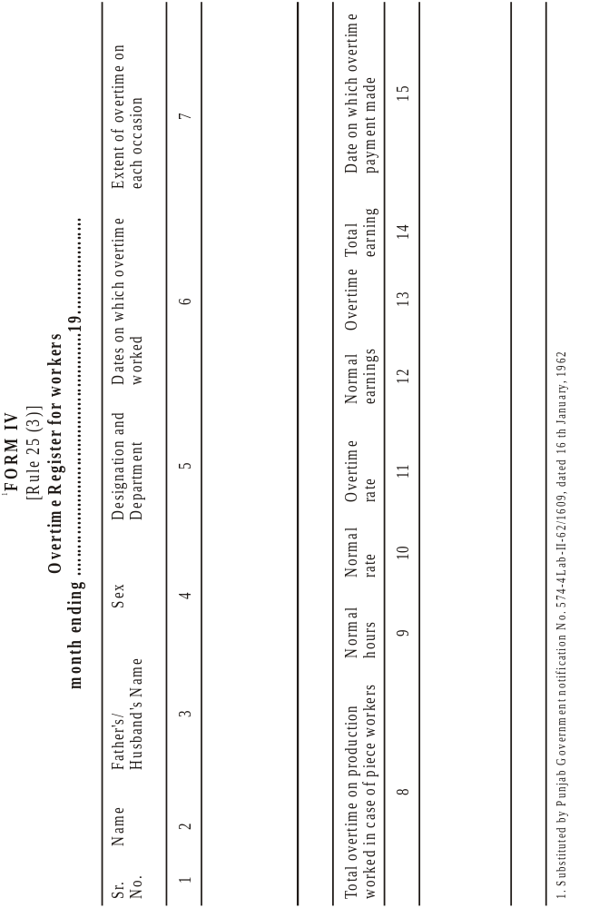
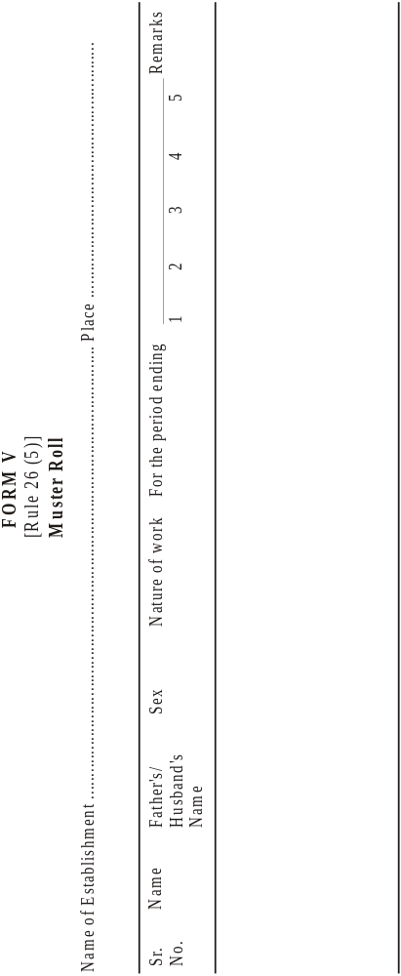
Omitted vide amendment dat 04.07.2000)
[FORM] VI
[FORM OF APPLICATION BY AN EMPLOYEE UNDER SECTION 20 (2)]

In the court of the Authority appointed under the Minimum Wages Act, 1948,
for......................................... Application No................ of 19..........
1. ....................................................................................................................
2. ....................................................................................................................
3. ...................................................................................................................
Applicants)
(through ............... a Legal Practitioner/official of ..................... Union which is registered Trade Union).
Address. ............................................................................................................
Versus
1. ....................................................................................................................
2. ....................................................................................................................
3. ............................................................................................... Opponents)
The applicant (s) above named respectfully submit (s) as follows :-
(1) that..............................................................................................................
(2) that..............................................................................................................
The applicant (s) has (have) been paid wages at less than the minimum rates of wages. The applicant (s) estimate (s) the value of the relief sought by him (at the sum of Rs........................................................................).
The applicant (s) pray (s) that a direction may be issued under sub-section (3) of section 20 for:-
(a) Payment of difference between the wages due according to the minimum rates of wages fixed by Government and the wages actually paid; and
(b) Compensation amounting of Rs……………………………………..........................
The applicant (s) request (s) leave to amend or add to or make alteration in the application if any and when necessary.
Date........................... Signature or *thumb impression of the employee (s) or legal practitioner of official of a registered trade union duly authorised
Verified that the contents of this form, are true and correct to the best of his (their) knowledge, belief and information, Verified at.................. on ................

Signature or *thumb impression of the employee (s) or legal practitioner or official of a registered trade union duly authorised.

[FORM VII
FORM OF APPLICATION BY AN INSPECTOR OR PERSON ACTING WITH THE PERMISSION OF THE AUTHORITY UNDER SECTION 20 (2)

In the court of the authority appointed under the Minimum Wages Act, 1948, for ............. Application No.................. of 19......
(1) ................................................................................................ Applicant
Address……………………………………………….............................. Applicant
Versus
(1) ..............................................................................................................
The applicant above named respectfully submit as follow:-
(1) That........................................................................................................
(2) That........................................................................................................
The opponent is bound to pay wages at the minimum rates of wages fixed by Government but has paid less wages to the following employees:-
(1) .............................................................................................................
(2) ..............................................................................................................
(3) ............................................................................................................
The applicant estimates the value of the relief sought for the employees at the sum of Rs...................
The applicant prays that a direction may be issued under sub-section (3) of section 20 for:-

(a) Payment of the difference between the wages due according to the minimum rates of wages fixed by Government and the wages actually paid; and
(b) Compensation amounting to Rs...............................................
The applicant begs leave to amend or add to or make alteration in the application, if any, and when necessary.
Dated.............. Signature
Verified that the contents of the form are true and correct to the best of his knowledge, belief and information.

Verified at................ on................. Signature

FORM VIII
[Form of Authority In favour of a Legal Practitioner or any Official of a Registered Trade Union referred to in Section 20 (2)]
In the Court of the Authority appointed under the Minimum Wages Act, 1948, for ............................................. area
Application No................. of 19.......
(1) ............................................................... …………………………………..
(2) ………………………………………………………….................... Applicants)
(3) ..............................................................................................................
Versus
(1) ..............................................................................................................
(2) .............................................................................................. Opponents)
(3) ..............................................................................................................
I hereby authorise Mr................................ a legal practitioner......................... official of the registered trade union of.................... to appear and act on my behalf in the above-described proceeding and to do all things incidental to such appearing and acting.

Date: ……………………………………….. Signature or thumb impression
of the employee

FORM IX
[Form of summons to the Opponent to appear before the Authority when an Application under sub-section (2) of section 20 or under section 21 is entertained]
(Title of the application)
To
…………………………………...
…………………………………..
(Name, description and place of residence)
Whereas .................. has made the above said application to me under the Minimum Wages Act, 1948, you are hereby summoned to appear before me in person or by a duly authorised agent and able to answer all material questions relating to the application, or who shall be accompanied by some person able to answer all such question, on the........... day of...........19...... at ............ [O clock ................ to answer the claim; and as the day fixed for the appearance is appointed for the final disposal of the application, you must be prepared to produce on that day all the witnesses upon whose evidence and all the documents upon which you intend to rely in support of your defence.
Take notice that, in default of your appearance will on the day [above] mentioned, the application will be heard and [decide exparte].

Dated............... Signature of the Authority

[FORM IXA]
Sec Rule 22
Notices
Abstract of the Minimum Wages Act, 1948 and the Rules made thereunder
1. Whom the Act affects.
(a) The Act affects to persons engaged on scheduled employments on specified class of work in respect of which minimum wages have been fixed.
(b) No employees can give up by contract or agreement his rights in so far as it purports to reduce minimum rates of wages fixed under the Act.

II Definition of wages
1. “Wages” means, all remuneration payable to an employed person on the fulfillment of his contract of employment It excludes:
(i) the value of any house accommodation, supply of light, water, medical attendance or any other amenity or any service extended by general or special order of the appropriate Government.
(ii) contribution paid by the employer to any Pension Fund or Provident Fund or under any scheme of Social Insurance;
(iii) the travelling allowance or the value of any travelling concession;
(iv) the sum paid to the person employed to defray special expense entailed on him by nature of his employment;
(v) gratuity payable on discharge.
2. The minimum rate of wages may consist of :-
(i) a basic rate of wages and a special allowance called the cost of living allowance;
(ii) a basic rate of wages with or without a cost of living allowance and the cash value of any concession, like supplies of essential commodities at concession rates;
(iii) an all inclusive rates comprising of basic rate, cost of living allowance and cash value of concession, if any.
3. The minimum wages payable to employees of scheduled employments notified under section 5 read with section 3 or as revised from time to time under section 10 read with section 3 may be -
(a) a minimum time rate;
(b) a minimum piece rate;
(c) a guaranteed time rate;
(d) an overtime rate.
differing with (1) different scheduled employments (2) different classes of work (3) different localities (4) different wage period and (5) different age groups.

III. Computation and Conditions of Payment
The employer shall pay to every employee engaged in scheduled employment under him wages at a rate not less than the minimum rate of wages fixed far that class of employee.
The minimum wages payable under this Act shall be paid in cash, [x x x x x). Wage period shall be fixed for the payment of wages at intervals not exceeding one month.
Wage shall be paid on a working day within seven days of the end of the wages period or within ten days if 1,000 or more persons are employed.
The wages of a person discharged shall be paid not later than the second working day after his discharge.
If an employee is employed on any day for a period less than the normal working day he shall be entitled to receive wages for a full normal working day provided his failure to work is caused by his unwillingness to work but the omission of the employer to provide him with work for that period.
Where an employee does two or more classes of work to each of which a different minimum s of wages is applicable, the employer shall pay to such employee in respect of the time lively occupied in each such class of work, wages at not less than the minimum rate in force in respect of each such class.
Where an employee is employed on piece work for which minimum time rate and not a minimum piece rate has been fixed the employer shall pay to such employee wages at not less than the minimum time rate.

IV. Hours of work and holidays
The number of hours which shall constitute a normal working day shall be:
(a) in the case of an adult, 9 hours.
(b) in the case of child, 4½ hours.
The working day of an adult worker inclusive of the intervals of rest shall not exceed twelve hours in any day.
[The employers shall allow a day of rest with wages to the employee every week. Ordinarily Sunday will be the weekly day of rest, but any other day of the week may be fixed as such rest day. No employee shall be required to work on a day fixed as rest day, unless he is paid wages for that day at overtime rate and is also allowed a substituted rest day with wages (see rule 23).
When a worker works in. an employment for more than nine hours on any day or for more than forty-eight hours in any week, he shall in respect of overtime worked be entitled to wages in scheduled employment other than agriculture [x x x x x] at double the ordinary rate of wages.

V. Fine and deductions
No deductions shall be made from wages except those authorised by or under the rules. Deductions from the wages shall be one or more of the following kinds, namely:
(i) Fines - An employed person shall be explained personally and also in writing the act or omission in respect of which the fine if proposed to be imposed and given an opportunity to offer any explanation in the presence of another 3[workman]. The amount of the said fine shall also be intimated to him. It shall be such as may be specified by the State Government of [Haryana], It shall be utilized hi accordance with the directions of the State Government of Haryana.
(ii) Deductions for absence from duty.
(iii) Deductions for damage to or loss of goods entrusted to the employee for custody, or for loss of money for which he is required to account, where such damage or loss is directly attributable to his neglect or default. The employed person shall be explained personally and also in writing the damage or loss, in respect of which the deduction is proposed to be made and given an opportunity to offer any explanation in the presence of another person. The amount of the said deduction shall also be intimated to him. It shall be such as may be specified by the State Government of the State of Haryana.
(iv) deductions for house accommodation supplied by the employer;
(v) deductions for such amenities and services supplied by the employer as the State Government may by general or special order authorise. These will not include the supply of tools and protective required for the purposes of employment;
(vi) deductions for recovery of advances or adjustment of over-payment of wages; such advances shall not exceed and amount equal to wages for two calendar months of the employed persons and the monthly installment of deductions shall not exceed one-fourth of the wages earned in that month;
(vii) deductions of income-tax payable by the employed persons;
(viii)deductions required to be made by order of a court or other competent authority;
(be)deductions for subscriptions to and for repayment of advances from any provident fund;
(x) deductions for payment to co-operative societies or to a scheme of insurance approved by the Government of the State of Haryana.

VI Maintenance of Registers and Records
Every employer shall maintain a register of wages specifying the following particulars for each period in respect of each employed person:-
(a) The minimum rates of wages payable.
(b) The number of days in which overtime was worked.
(c) The gross wages,
(d) All deductions made from wages.
(e) The wages actually paid and the date of payment
Every employer shall issue wage-slips containing prescribed particulars to every person employed.
Every employer shall get the signature or the thumb impression of every person employed on the wages-book and wage-slips.
Entries in the wage-books and wage-slips shall be properly authenticated by the employer or his agent.
A muster Roll shall be maintained by every employer and kept in the form prescribed.
Every employer shall keep exhibited at such places selected by the Inspector, notice in [Hindi and English language] of the following particulars in a clean and legible form:-
(a) Minimum rate of wages.
(b) Abstract from the Act and the Rule made thereunder.
(c) Name and address of the Inspector.

VII. Inspections
Any Inspector can enter in any premises and can exercise powers of inspection (including examination of documents and taking of evidence) as he may deem necessary for carrying out the purposes of the Act.

VIII. Claims and Complaints
Where an employee is paid less than the minimum rates of wages fixed for his class of work, or less than the amount due to him under the provisions of this Act, he can make an application in the prescribed form within six months to the authority appointed for the purpose.
An application delayed beyond this period may be admitted if the authority is satisfied that the applicant had sufficient cause for not making the application within such period.
Any legal practitioner, official of a registered trade union. Inspector under the Act or other person acting with the permission of the Authority can make the complaint on behalf of an employed person.
A single application may be presented by or on behalf of any number of persons belonging to the same factory the payment of whose wages has been delayed.
A complaint regarding less payment of notified wages under section 21 of the Act can be made to the court only with the sanction of the Authority within one month of the grant of such sanction.
A complaint under section 22 of the Act can be made to the court only by or with the sanction of an Inspector within six months of the date on which the offence is alleged to have been committed.
IX. Action by the Authority
The authority may direct the payment of the amount by which the minimum wages payable exceed the amount actually paid together with the payment of compensation not exceeding ten times the amount of such excess. The Authority may direct payment of compensation in cases
where the excess is paid before the disposal of the application.
If a malicious or vexatious complaint is made, the authority may impose a penalty not exceeding Rs. 50/- on the applicant and order that it be paid to the employer.
Every direction of the Authority shall be final.
X. Penalty for offence under the Act
Any employer who pays to any employee matt the amount due to him under the provision of this Act or infringes any order of rules in respect of normal working day, weekly holiday shall be punishable with imprisonment of either description for a term which may extend to six months or with fine which may extend to five hundred rupees or with both.
Any employer who fails to maintain a register or record required to be maintained under section 18 shall be punishable with fine which may extend to five hundred rupees.
XI. Minimum Rates of Wages Fixed
Name of undertaking…………………………………………………………………..
Serial No. Category of employees Minimum Wages

………………………………………………………………………………………….
XII Name and address of the Inspector(s).
Name Address
………………………………………………………………………………………….

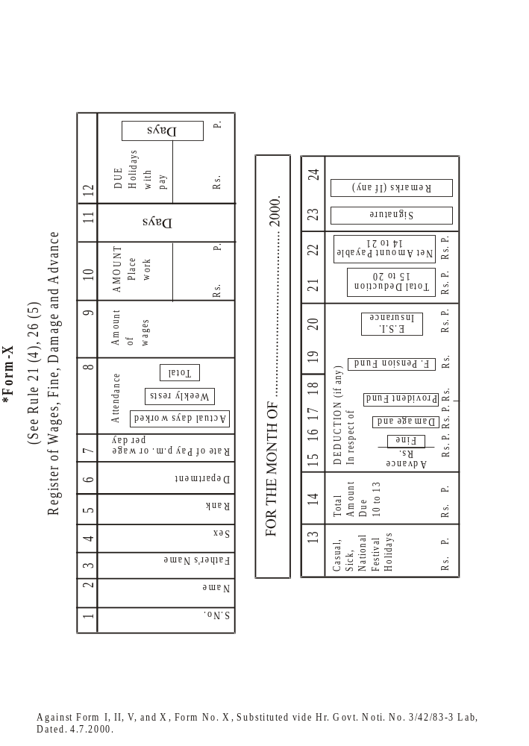
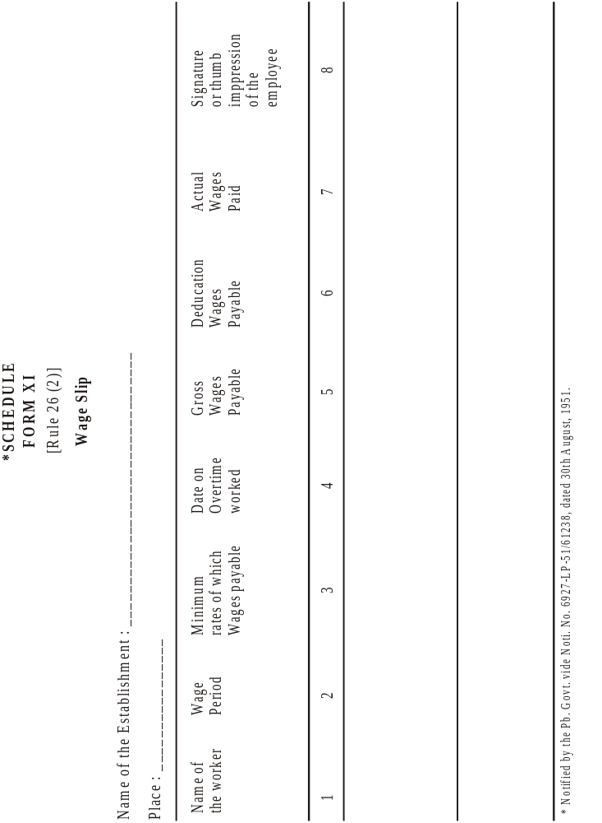
FORM XII
(Rule 26-A)
Issue of Cards to the employees engaged in Public Motor Transport.

Name of employer or establishment ……………………………………………………….
Depot………………………………………………………………………………………..
Garage………………………………………………………………….………………… Name of employee………………………………………………………………………….
Month of…………..19………..
Date | Reporting | Relieving intervals hours | Rest time | Overtime time | Endorsement of employer, office or agent
1 | 2 | 3 | 4 | 5 | 6
Note: The mark “H” shall be made in column, relating to any day on which a weekly holiday is given and “A” if the employee is absent on any other day.

Notification of scheduled employment
In exercise of the powers conferred by sub-section (I) of section 227 of the Minimum Wages Act, 1948, (Central Act 11 of 1948), the Governor of Haryana has directed that the provisions of the Payment of Wages Act, 1936 (Central Act 4 of 1936), specified in column 1 of the Schedule below, shall apply to claims arising out of the deductions from, or delay in payment of the wages payable to the employees in the scheduled employments mentioned in Part-1 of the schedule appended to the Minimum Wages Act, 1948 including also those employments which were subsequently added to it by the State Government and Part-II of the said schedule subject to the modifications specified in corresponding entry in column 2 of the schedule below, vide Haryana Government notification No. SO 35/CA./11/4S/S.22F/71, dated 2nd April, 1971,

SCHEDULE
Provisions of the Payment of Wages Act, 1936 | Modification

Section 15 1. in sub-section (2), reference to “This Act” shall be constructed as reference to the Minimum Wages Act, 1948, and the rules made thereunder.
2. In Sub-section (3) -
(i) reference to “ this Act” shall be construed as reference to “the Minimum Wages Act, 1948: and
(ii) the words and figure “of other person responsible for the payment of Wages under Section 3” shall be omitted
(iii) in the provision in clause (b) for the words, “person responsible for the payment of the wages” the word “employer” shall be substituted.
3. Sob-section (4) shall be omitted.
Section 16 For the words, figure and brackets “after the day fixed by sub-section (5)” the word “after the due date” shall be substituted.
In sub-section (1) -
(i) the words, figure and brackets, *C "sub-section (4)” shall be omitted.
(ii) in clause (a) the words and figure “or other persons responsible for die payment of wages under section 3” shall be omitted.
Section 17-A In sub-section (1), the words, and figure “or other person responsible for the payment of wages under section 3", “or other person” and “or other person responsible for the payment of wages” shall be omitted.
Section 26 So much of section 26 as relates to the Sections aforesaid.

Scheduled Employments
The following employments are declared as Scheduled Employments by the Haryana Govt. as per Section 27 of Minimum Wages Act, 1948:-
1. Agricultural Employments. Machine Tools and General Engg. including electrical goods industry.
2. Cinema Industry,
3. Saw Mills and Timbers Trade Industry.
4. Cotton Ginning and Pressing Industry.
5. Textile Industry.
6. Glass, Glass fire and glass Processing Industry.
7. Public Motor Transport.
S. Tanneries and Leather Manufactory.
9. Rice Mills, Flour Mills and Dal Mills.
10. Rubber Industry.
11. Operation of Tubewell Industry.
12. Local Authority.
13. Woolen Carpet Making of Shawal Weaving establishment run by powerloom or Handloom.
14. Shops and Commercial Establishments.
15. Tailoring and Stitching & Embroidery Establishments.
16. Public Works Departments (Irrigation).
17. Oil Mills.
18. Khandsari, Gur & Shaker Industry.
19. Private Printing Presses.
20. Non-fenous Metal Rolling and Re-Rolling Industry (ii) Brass, Copper and Aluminimum, utensils making Industries.
21. Scientific Industry.
22. Chemical and Distillery Industry.
23. Contractors Establishment of the Forest Deptt.
24. Electroplating using salts or Choromium Nickel or any other compound and connected buffing and polishing Industry.
25. Ferrous Metal Rolling and Re-Rolling Industry,
26. Construction & Maintenance of Roads, Building Operation.
27. Stone Breaking and Stone Crushing.
28. P.W.D. (Public Health).
29. Ayurvedic and Unani Pharmacies.
30. Potteries Ceramics and Refractory Industry.
31. Automobile Repair Workshop.
32. Paper, Card Board and Typewriter Ribbon Industry.
33. Asbestos Cement Factories & Others Cements Products.
34. Petrol & Diesel oil Pumps.
35. Foundries with or without attached machine shop.
36. Ready-made garments.
37. Food Products, Dairy Products, Grain Mill Products and Bakery Products.
38. Soap in any form, other washing products, synthetic detergents and cosmetics.
39. Co-operative credit and service society and mini banks.
40. Forestry or any other development work related there to.
41. Packing Industry.
42. Rags cleaning and Sorting.
43. Bricks-kilns.
44. Private Coaching classes, schools and including nursery school and technical institutions.
45. Any Shops and Commercial Estts. other then covered under any of the entries in the schedule.
46. Hospitals and Nursings.
47. Electronics and Allied or incidental Industry.
48. Any manufacturing process where in manufacturing process as designed under section 2 (k) of the Factories Act, 1948 is carried out and which is not covered under any entry to the schedule part-I and part-D of the Minimum Wages Act, 1948.
49. Plastic Industry.
50. Employment in Transport Industries loading and unloading processing Industry.
51. Any Tobacco (including Bidi making) manufacturing (Does not exist in Haryana.
52. Any Plantation, that is to say, any estate, which is maintained for the purpose of growing cinchona, rubber, tea or coffee (does not exist in Haryana).
53. Any Lac manufacturing (Does not exist in Haryana)
54. Any Mica works (does not exist in Haryana)

PART-II
1. Agriculture.

Vide S.R.O. 776, dated 14th October, 1950.
Subs. by G.S.R. 2201, dated 12th December, 1968.
Subs. by G.S.R. 751, dated 1st July, 1974.
Ins. by G.S.R. 466, dated 2nd March, 1970.
Subs. by G.S.R. 109, dated 14th January, 1959.
Subs. by G.S.R. 659, dated 26th July, 1958.
Ins. by G.S.R. 717, dated 15th June, 1960.
Ins. by S.R.O. 298, dated 23rd January, 1957.
Ins. by G.S.R. 627, dated 22nd April, 1961.
Subs. by G.S.R. 676, dated 7th June, 1980. Earlier item (xiii) was inserted by G.S.R. 945, dated 23rd May, 1963.
Corrected by G.S.R. 463 (E), dated 2nd August, 1980.
Ins. by G.S.R. 676, dated 7th June, 1980.
Ins, by G.S.R. 1060, dated 3rd September, 1980.
Subs. by G.S.R. 1060, dated 3rd September, 1980.
Ins, by G.S.R. 1060, dated 3rd September, 1980.
Omitted by G.S.R. 1542, dated 8th November, 1962.
Subs. by S.R.O. 2574, dated 2nd August, 1954.
Ins. by S.R.O. 2727, dated 11th August, 1954.
Subs. by G.S.R. 918, dated 29th July, 1960.
Subs. by G.S.R. 918, dated 29th July, 1960.
Subs. by G.S.R. 918, dated 29th July, 1960.
Omitted by G.S.R. 1324, dated 2nd August, 1963.
Ins. by G.S.R. 1324, dated 2nd August, 1963
Ins. by S.R.O. 3304, dated 2nd October, 1954.
Added by S.R.O. 1932, dated 6th October, 1954.
Subs. by G.S.R. 158, dated 10th January, 1979.
Subs. by G.S.R. 1060, dated 3rd September, 1960.
Subs. by G.S.R. 1473, dated 17th September, 1966.
Subs. by G.S.R. 139, dated 16th January, 1974. Earlier sub-rule (1A) was inserted by G.S.R. 1473, dated 17th September, 1966.
Subs. by G.S.R. 721, dated 5th May, 1965.
Subs. by G.S.R. 721, dated 5th May, 1965.
Subs. by G.S.R. 139, dated 16th January, 1974.
Against Form I, II, V and X, Form No. X, substituted vide Hr. Govt. Noti. No. 3/42/83-3 lab.
Sub-rule (6) omitted by G.S.R. 1213, dated 9th July, 1963. Earlier sub-rule (6) was inserted by G.S.R. 1512, dated 15th December, 1961.
Ins. by G.S.R. 1060, dated 3rd September, 1960.
Ins. by G.S.R. 1523, dated 16th December, 1960.
Subs. by G.S.R. 255, dated 20th February, 1967. Earlier rule 26B was inserted by G.S.R. 1523, dated 16th December, 1960.
Ins. by G.S.R. 1213, dated 9th July, 1963.
Subs. by G.S.R. 846, dated 19th July, 1984 .
Subs. by G.S.R. 1301, dated 28th October, 1960.
Ins. by G.S.R. 1301, dated 28th October, 1960.
Ins. by S.R.O. 1276, dated 19th June, 1953.
Subs. by S.R.O. 463, dated 28th February, 1955.
Against Form I, II, V and X, Form No. X, substituted vide Hr. Govt. Noti. No. 3/42/83-3 lab.
Against Form I, II, V and X, Form No. X, substituted vide Hr. Govt. Noti. No. 3/42/83-3 lab.
1 Subs by G.S.R. 1542, dated 8th November, 1962.
* This is the aggregate number of attendance during the year.
+ The average daily number of persons employed during the year as obtained by dividing the aggregate number of attendances during the year by the number of working days.
@ Cash value of the wages paid in kind should be obtained by taking the difference between the cost price paid by the employer and the actual price paid by the employees for supplies of essential commodities given at concessional rates.
Against Form I, II, V and X, Form No. X, substituted vide Hr. Govt. Noti. No. 3/42/83-3 lab.
Subs, by G.S.R. 1301, dated 28th October, 1960.
* Delete the portions not required.
* Delete the portions not required.
Ins. by the Minimum Wages (Central) (Second Amendment) Rules, 1961.
Subs, by G.S.R. 1301, dated 28th October, 1960.
* Delete the portions not required.
Ins. by the Minimum Wages (Central) (Second Amendment) Rules, 1961.
Subs, by G.S.R. 1301, dated 28th October, 1960.
* Delete the portion not required.
Ins. by the Minimum Wages (Central) (Second Amendment) Rules, 1961.
+ When the application is by a group of employees, the thumb-impressions or signatures of two of the applicants need be put to the application and a full list of applicants should be attached to the application.
Ins by S.R.O. 2727, dated llth August, 1954, published in Fort St Geo. Gazette 9-6-1954, Supp. to Pt. I, p. 223.
Subs, by G.S.R. 109, dated 14th January, 1959.
Sub. by G.S.R. 213, dated 7th February, 1962.
Ins. by G.S.R. 109, dated 14th January, 1959.
Subs, by G.S.R. 918, dated 29th July, 1960.
Sub. by G.S.R. 213, dated 7th February, 1962.
Subs, by G.S.R. 213, dated 7th February, 1962.
Subs, by G.S.R. 109, dated 14th January, 1959.
Ins by G.S.R 213, dated 7th February, 1962.
Ins by G.S.R 213, dated 7th February, 1962.
Ins. by G.S.R. 213, dated 7th February, 1962.
Subs, by G.S.R. 213, dated 7th February, 1962.
Subs, by G.S.R. 213, dated 7th February, 1962.
Subs, by G.S.R. 109, dated 14th January, 1959.
Ins. by G.S.R. 213, dated 7th February, 1962.
Ins. by G.S.R. 213, dated 7th February, 1962.
`Subs, by G.S.R. 213, dated 7th February, 1962.
Subs, by G.S.R. 109, dated 14th January, 1959.
Subs, by G.S.R. 109, dated 14th January, 1959.
Subs, by the Minimum Wages (Central) (Amdt.) Rules, 1966.
Subs. by the Minimum Wages (Central) (Amdt.) Rules, 1966.
Subs. vide. Govt. Noti. Na3137/85-3Labdt.l4.12.1988.
Omitted vide Pb.Govt. Noti.No.9110/8801-C/LB-58/68S93 dt. 28.8,1958.
Inserted by ibid.
Subs. by ibid
Subs. vide Pb.Govt. Noti. No. 9110/8S01-C/LB-58/68593, dated 28th August, 1958.
Subs. vide Pb.Govt. Noti. No. 9110/8S01-C/LB-58/68593, dated 28th August, 1958.
Subs. vide Pb.Govt. Noti. No. 9110/8S01-C/LB-58/68593, dated 28th August, 1958.
Omitted by ibid.
Subs. vide Hr. Govt. Noti. Na 3/37/85-3-Lab, dated 14.12.1988.
Omitted vide Pb. Govt. Noti. No. 9110/8801 -C-Lab-58-68592, dated 28.8.1958.
Omitted vide Pb. Govt. Noti. No. 9110/8801 -C-Lab-58-68592, dated 28.8.1958.
Omitted vide Pb. Govt. Noti. No. 9110/8801 -C-Lab-58-68592, dated 28.8.1958.
Omitted vide Pb. Govt. Noti. No. 9110/8801-C-Lab-58-68592, Dated 28-8-1958
Omitted vide Pb. Govt. Noti. No. 9110/8801-C-Lab-58-68592, Dated 28-8-1958
Omitted vide Pb. Govt. Noti. No. 9110/8801-C-Lab-58-68592, Dated 28-8-1958
Omitted vide Pb. Govt. Noti. No. 9110/8801-C-Lab-58-68592, Dated 28-8-1958
Omitted vide Pb. Govt. Noti. No. 9110/8801-C-Lab-58-68592, Dated 28-8-1958
Omitted vide Pb. Govt. Noti. No. 9110/8801-C-Lab-58-68592, Dated 28-8-1958
Omitted vide Pb. Govt. Noti. No. 9110/8801-C-Lab-58-68592, Dated 28-8-1958
Omitted vide Pb. Govt. Noti. No. 9110/8801-C-Lab-58-68592, Dated 28-8-1958
Omitted vide Pb. Govt. Noti. No. 9110/880l-C-Lab-58/68593 dated 28th August, 1958.
Subs. by Hr. Govt. Noti No. 3/37/85-3 Lab, dated 14th Dec., 1988.
Omitted vide Pb. Govt. Noti. No. 9110/880l-C-Lab-58/68593 dated 28th August, 1958.
Subs. vide Hr. Govt. Noti. No. 3137/85-3-Lab, dated 14.12.1988.
Omitted vide Pb. Govt Noti. No. 9110/8801-C-Lab-58/68593 dated 28th August, 1958.
Omitted vide Hr.Govt.Noti.No.3/37/85-3-Lab, dated 9th. July, 1990.
Subs. vide Hr.Govt Noti.No.3/37/85-3 Lab, dated 14th December, 1988.
Added videPb. Govt. Notification No. 101-1 Lab-II-62/668. dated 6th January. 1962.
Added Pb Govt. Noti, No. GSR-308/CA/II-48-S-30/Amd(I) 62. dated 14th Dec., 1962.
Added vide Pb. Govt. Noti. No. GSR-393/CA/11 /48/S-30/63, dated 29th Nov., 1964.
Subs. by Hr. Govt. Noti. No. 3/37-85-3-Lab. dated 14th December, 1988.
Subs. by Pb. Govt. Noti. No. 674-4-Lab-II/62/1609. dated 16 January. 1962.
Against Form I, II, V and X, Form No. X, substituted vide Hr. Govt. Noti. No. 3/42/83-3 lab.
Subs. vide Pb. Govt. Noti. No. 1338/1139-C-LP-55/7740. dated 15 February, 1955.
Inserted videPb. Govt. Notification No. 429-C-Lab-56/84914, dated 19th Nov.1956.
Subs. vide Pb- Govt. Noti. No. 65611-4-Lab.-II-61/I6512. dated 15th June, 1961.
Subs. by Hr. Govt. Noti. No.3/37-85-3-Lab, dated 14th December. 1988
Subs. by Pb. govt. Noti. No. 674-4-LabII/62/1609. dated, 16 January, 1962.
Subs. by Pb. Govt. Noti. No. 6561-4-Lab-II-61/16512, dated 15th June. 1961.
Subs. videPb. Govt. Noti. No. GSR-223/CA-11/48/S-30/66, dated 20th Sept., 1966.
Inserted videPb. Govt. Notification No. 429-C-Lab-56/84914, dated 19th Nov.1956.
Inserted vide No. Govt. Noti. No. GSR-49/CA-l 1 /48-S-30/Amd (1)67, dated 24th October, 1967.
Subs. vide Hr. Govt. Noti. No. 3/37/85-3-Lab. dated 14th December. 1988.
Added vide Pb. Govt Noti. No. 12319/63l-C-LP-53/92389, dated 1st December, 1953.
Inserted vide Pb. Govt. Noti. No. 7796/4880-C-Lab-57/62032, dated 13th/18th July, 1957.
Omitted vide Hr. Govt. Noli. No. 3/37/85-3Lab, dated, 14th December, 1980.
Inserted vide Pb. Govt. Noti. No. GSR-307-CA/II/48/S-30/Amd(2) 62, dated 14th Dec., 1962.
Omitted by Hr. Govt. Noti. No. 3/37/85-3-Lab,dated 14th Dec., 1988
Existing clause (b) re-numbered a clause (c), and new clause (b) added by Pb. Govt. Noti. No.3777/-LP-52/2745,dated 7th June. 1952.
Subs. vide Pb. Govt. Noti. No. 574-4-Lab II-62/1609, dated 16th January, 1962.
Added vide. Pb, Govt Noti. No, GSR-10/CA-l 1/48/S-30/65. dated 2nd Feb., 1965.
Added vide Pb. Govt. Noti. No. 12161/C-LP-55/11472, dated 14th March. 1955.
Inserted vide Pb. Govt Noti. No. GSR-275-CA-I l/48/S-30/Amd.(3)62. dated 11th Sept., 1962.
Inserted vide Pb. Govt Noti.No. 2925-S-Lab-58/19244, dated 10th/17th March, 1958.
Subs. vide Hr. Govt, Noti. No. 3/37/85-3-Lab dated 14th Dec., 1988.
Subs. vide Hr. Govt, Noti. No. 3/37/85-3-Lab dated 14th Dec., 1988.
Subs. vide Hr. Govt, Noti. No. 3/37/85-3-Lab dated 14th Dec., 1988.
New rules 26-B and 26C inserted vide Pb. Govt Noti. No. 574-4-Lab II-62/1609, dated 16.1.1962.
Subs. vide Hr. Govt. Noti. No. 3/37/85-3-Lab, dated 14th Decanter, 1988.
Subs. vide Hr. Govt. Noti. No. 3/37/85-3-Lab, dated 14th Decanter, 1988.
Subs. vide Hr. Govt. Noti. No. 3/37/85-3-Lab, dated 14th Decanter, 1988.
Subs. by the Govt. Noti. No. GSR-38/C.A.1 l/48/S-30Amd (1)/69, Dated 14th Feb., 1969
* This is the aggregate number of attendances during the year.
* * This average daily number of persons employed during the year is obtained by dividing the aggregate number of attendances during the year by the number of working days.
* ** Cash value of wages paid in kind should be obtained by taking the difference between the cost price paid by the employer and the actual price paid by the employees for supplies of essential commodities given at concessional rates.
Subs. by Hr. Govt. Noti. No. 3/37/85-3-Lab. dated 14th December, 1988
* When the application is by a group of employees the thumb impression or signature of the Applicants need be put to the application and a full list of applicants should be attached to the application.
* When the application is by a group of employees the thumb impression or signature of the Applicants need be put to the application and a full list of applicants should be attached to the application.
Subs. by Hr. Govt, Noti. No. 3/17/83-3 Lab., dated 14th Dec., 1988
Subs. by Hr. GovL Noti. No. 3/37/85-3 Lab, dated 14th December 1988.
Subs. vide Hr. Govt. Noti No. 3/37-85-3-Lab, dated 14th December. 1988.
Subs. vide Hr. Govt. Noti No. 3/37-85-3-Lab, dated 14th December. 1988.
Subs. vide Hr. Govt. Noti No. 3/37-85-3-Lab, dated 14th December. 1988.
Inserted vide Pb.Govt. Noti. No. 429/308-C-Lab-56/84914, dated 19th November. 1956.
Omitted vide Hr. Govt, Noti. No. 3/37/85-3-Lab, dated 14th December, 1988.
Substituted vide Pb. Govt. Noti. No. 6561-4-Lab-II-61/6512, dated 15th June, 1961.
Omitted by Hr.Govt.Noti No.3137/83-3-Lab, dated 14th December, 1988.
Subs. by ibid.
Added vide Pb- Govt. Noti. No. 1915-S-Lab-58/19244, dated 10th/17th March, 1958.
* Published in Hr. Govt Gaz. Part III on 13th April, 1971 at page 139-140.

