 | THE SALES PROMOTION EMPLOYEES (CONDITIONS OF SERVICE) rules, 1976
 | INDEX
Rules | Particulars
 | CHAPTER I PRELIMINARY
1. | Short title
2. | Definitions
 | CHAPTER II HOLIDAYS AND LEAVE
3. | Applicability of this Chapter
4. | Number of holidays in a year.
5. | Compensatory holidays.
6. | Wages for holidays.
7. | Wages for weekly day of rest.
8. | Competent officers.
9. | Application for leave.
10. | Recording of reason for refusal or postponement of leave.
11. | Affixing of holidays to leave.
12. | Holidays intervening during the period of leave.
13. | Recall before expiry of leave.
14. | Earned leave and cash compensation for earned leave not availed of
15. | Medical leave.
16. | Quarantine leave.
17. | Extraordinary leave.
18. | Leave not due.
19. | Study leave.
20. | Casual leave.
21. | Wages for Casual leave
 | CHAPTER III LETTER OF APPOINTMENT
22. | Appointment letter in form ‘A’
 | CHAPTER IV REGISTERS AND OTHER DOCUMENTS
23. | Maintenance of Registers and other documents.
Form A | Letter of Appointment
Form B | Register of Sales Promotion Employees
Form C | Service Book
Form D | Register of Service Books for Sales Promotion Employees
Form E | Leave Account

THE SALES PROMOTION EMPLOYEES (CONDITIONS OF SERVICE ) RULES, 1976
In exercise of the powers conferred by sub-section (1), read with sub-section (2) of section 12 of the Sales Promotion Employees (Conditions of Service) Act, 1976 (11 of 1976), the Central Government hereby makes the following rules, namely:—

CHAPTER I
PRELIMINARY
1. Short title.— These rules may be called the Sales Promotion Employees (Conditions of Service) Rules, 1976.
2. Definitions.— In these rules unless the context otherwise requires,—
(a) “Act” means the Sales Promotion Employees (Conditions of Service) Act, 1976 (11 of 1976);
(b) “authorised medical attendant” means the medical practitioner authorised by the employer for the purposes of any of the provisions of the Act or the rules made thereunder;
(c) “casual leave” means leave to cover casual absence of the sales promotion employee from duty for personal reasons;
(d) “earned leave” means leave admissible under clause (a) of section 4;
(e) “extraordinary leave” means leave granted to the sales promotion employee in special circumstances and when—

(a) no other leave is admissible; or
(b) other leave is admissible but the employee applies in writing for the grant of extraordinary leave;
(f) “Form” means a form appended to these rules;
(g) “leave” means earned leave, leave on medical certificate, extraordinary leave, leave not due, casual leave, study leave or quarantine leave;
(h) “leave not due” means leave which is not due to the sales promotion employee but which may be granted to him in anticipation of its being earned subsequently;
(i) “leave on medical certificate” means leave admissible under clause (b) of section 4;
(j) “quarantine leave” means leave of absence from duty by reason of the presence of an infectious disease in house-hold of the sales promotion employee;
(k) “section” means a section of the Act;
(1) “study leave” means leave granted to a sales promotion employee to enable him to undertake a course of study.

CHAPTER II
HOLIDAYS AND LEAVE
3. Applicability of this Chapter.— The provisions of this Chapter shall have effect notwithstanding anything inconsistent therewith contained in any agreement or Contract of service or award applicable to a sales promotion employee:
Provided that where under any such agreement or contract of service or award a sales promotion employees is entitled to benefits in respect of any matter provided in this Chapter which are more favourable to him than those to which he would be entitled to under this Chapter, the sales promotion employee shall continue to be entitled to the more favourable benefits in respect of that matter notwithstanding that he received benefits in respect of other matters under these rules.
4. Number of holidays in a year.— A sales promotion employee shall be entitled to ten holidays in a calendar year.
5. Compensatory holidays.— If a sales promotion employee is required to attend to his duties on a holiday, a compensatory holiday shall be given to him, within thirty days immediately following the holiday, on a day mutually agreed upon by him and his employer.
6. Wages for holidays.— A sales promotion employee shall be entitled to wages of all holidays, as if he was on duty.
7. Wages for weekly day of rest.— A sales promotion employee shall be entitled to wages for the weekly day of rest as if he was on duty.
8. Competent officers.— Every establishment may designate one or more officers in the establishment as competent officers for the purpose of this Chapter.
9. Application for leave.— (1) A sales promotion employee who desires to obtain leave of absence shall apply in writing to the competent officer.
(2) Application for leave, other than for casual leave, leave on medical certificate and quarantine leave, shall be made not less then one month before the date of commencement of leave, except in urgent or unforeseen circumstances.
10. Recording of reason for refusal or postponement of leave.— If leave is refused or postponed, the competent officer shall record the reasons for such refusal or postponement as the case may be, and send a copy of the order to the sales promotion employee concerned.
11. Affixing of holidays to leave.— Holidays, other than weekly days of rest, shall not be prefixed or suffixed to any leave without the prior sanction of the competent officer.
12. Holidays intervening during the period of leave.— A holiday, including a weekly rest day, intervening during any leave, except casual leave, granted under these rules shall form part of the period of leave.
13. Recall before expiry of leave.— (1) The establishment may recall a sales promotion employee on leave if the employer considers it necessary to do so and in the event of such recall the employee shall be entitled to travelling allowance for the journey undertaken by him to join duty if at the time of recall the employee is spending his leave at a place other than his headquarters.
(2) The travelling allowance which shall be paid to a sales promotion employee under sub-rule (1) shall be determined in accordance with the rules of the establishment governing travelling allowance for journeys undertaken by the employees in the course of their duties.
14. Earned leave and cash compensation for earned leave not availed of.— (1) The maximum limit up to which earned leave can be accumulated shall be 180 days out of which a sales promotion employee can avail himself of 90 days at a time:
Provided that where a sales promotion employee is suffering from any lingering illness such as, tuberculosis, cancer, leprosy, heart disease or mental illness, or any disability which prevents him from attending to his duties, the competent authority may allow the sales promotion employee to avail himself of earned leave for any period exceeding 90 days at a time.
(2) When a sales promotion employee voluntarily relinquishes his post, or retires from service on reaching the age of superannuation, he shall be entitled to cash compensation for earned leave earned by him and not availed of:
Provided that a sales promotion employee shall not be entitled to cash compensation for earned leave not availed of for a period exceeding 120 days.
(3) Notwithstanding anything contained in sub-rule (2) where a sales promotion employee had applied for earned leave due to him so as to enable him to avail of such leave immediately before he voluntarily relinquishes his post or retires on reaching the age of superannuation and such leave was refused, the sales promotion employee shall be entitled to cash compensation for the entire period of earned leave so refused as well as cash compensation for the period of earned leave due to him, in respect of which no application to avail of the same was made; so, however, that the total period of earned leave for which cash compensation shall be payable under this sub-rule shall not exceed 180 days.
(4) Where a sales promotion employee dies while in service his heirs shall be entitled to cash compensation for the entire earned leave due to such employee and not availed of.
(5) Where a sales promotion employee’s services are terminated for any reason whatsoever (not being termination as punishment), he shall be entitled to cash compensation for the entire earned leave due to him and not availed of.
(6) The cash compensation payable under this rule in respect of earned leave shall be equal to the amount of wages due to the sales promotion employee for the period of leave not availed of or refused.
15. Medical leave.—(1) For the purposes of availing leave on medical certificate under clause (b) of section 4, the sales promotion employee shall produce a medical certificate from an authorised medical attendant:
Provided that where a sales promotion employee has proceeded to a place other than his headquarters with the permission of his employer or in the course of the discharge of his duties and there falls ill, he may produce a medical certificate from any registered medical practitioner practicing at the place where he falls ill:
Provided further that the employer may, when the registered medical practitioner whose certificate is produced is not in the service of the Government, arrange at his own expense for the medical examination of the employee concerned by any Government Medical Officer not below the rank of a Civil Assistant Surgeon or by any other Medical Officer in charge of a hospital run by a local authority or a public organisation at that place.
(2) Leave on medical certificate may be taken in continuation of earned leave.
(3) A sales promotion employee shall be entitled at his option to convert leave on medical certificate on one-half of the wages to half the amount of leave on full wages (hereinafter referred to as converted leave).
(4) Leave on medical certificate or converted leave may be granted to an employee at his request notwithstanding that earned leave is due to him.
(5) Every establishment may authorise one or more medical practitioners registered under the Indian Medical Council Act, 1956 (102 of 1956) as authorised medical attendants for the purposes of the Act or the rules made thereunder.
16. Quarantine leave.—(1) Where, in consequence of the presence of an infectious disease, in the house-hold of a sales promotion employee, his attendance is considered hazardous to the health of other people, the employee concerned may be granted quarantine leave.
(2) The quarantine leave may be granted for a period upto 30 days on the recommendation of the authorised medical attendant or Public Health Officer.
(3) A sales promotion employee on quarantine leave shall be treated as on duty for all purposes.
17. Extraordinary leave.— A sales promotion employee may be granted extraordinary leave in special circumstances without wages at the discretion of the employer.
18. Leave not due.—A sales promotion employee who has no leave to his credit, may be granted leave not due, at the discretion of the employer.
19. Study leave.— A sales promotion employee may be granted study leave with or without wages at the discretion of the employer.
20. Casual leave.—(1) A sales promotion employee shall be eligible for casual leave for fifteen days in a calendar year.
(2) Casual leave not availed of during a calendar year shall not be carried forward to the following year.
(3) The sales promotion employee may take any amount of casual leave at a time and casual leave may be combined with any other kind of leave.
21. An employee on casual leave shall be entitled to wages as if he was on duty.

CHAPTER III
LETTER OF APPOINTMENT
22. (1) The letter of appointment to be furnished to a sales promotion employee under section 5 shall be in Form A.
(2) Every change in the particulars mentioned in the letter of appointment given to an employee shall be communicated to the employee concerned forthwith either by personal service with proper receipt or by registered post acknowledgement due.

CHAPTER IV
REGISTERS AND OTHER DOCUMENTS
23. Maintenance of Registers and other documents.— Every establishment shall prepare and maintain the following registers and records, namely:—
(a) a Register of Sales Promotion Employees in Form B;
(b) Service Books for every employee in Form C;
(c) a Register of Service Books in Form D;
(d) Leave Account of each employee in Form E.

FORM A
[See rule 22 (1)]
LETTER OF APPOINTMENT
1. Name of the establishment...............................................................................
2. Address........................................................................................................
3. Name of the employer...................................................................................

4. Name and address of the sales promotion employee*
5. Shri/Smt...............................................is appointed as..................................in this establishment with effect form..................................................................
6. His/Her appointment is on probation for....................................../temporary basis/ permanent basis.
(insert here the period)
7. His/Her scale of wages/rate of increment in wages per..................................shall be..................................................................... (insert here the period)
(insert here the amount)
8. He/She will draw a total wages of.......................per.........................................
(insert here the amount) (insert here the period)
composed of the following, namely:—
(i) Basic Pay..............................................Dearness Allowance..............................
(insert here the amount) (insert here the amount)
(ii) Other allowances............................................................................................
(insert here the particulars)
9. Other conditions of service...............................................................................

Date............................... Signature of the employer.

* Any Change of address of the employee shall be communicated to the employer.

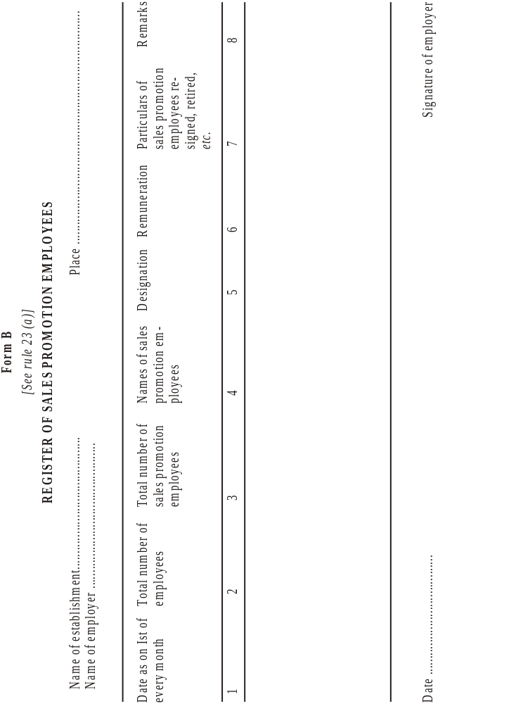
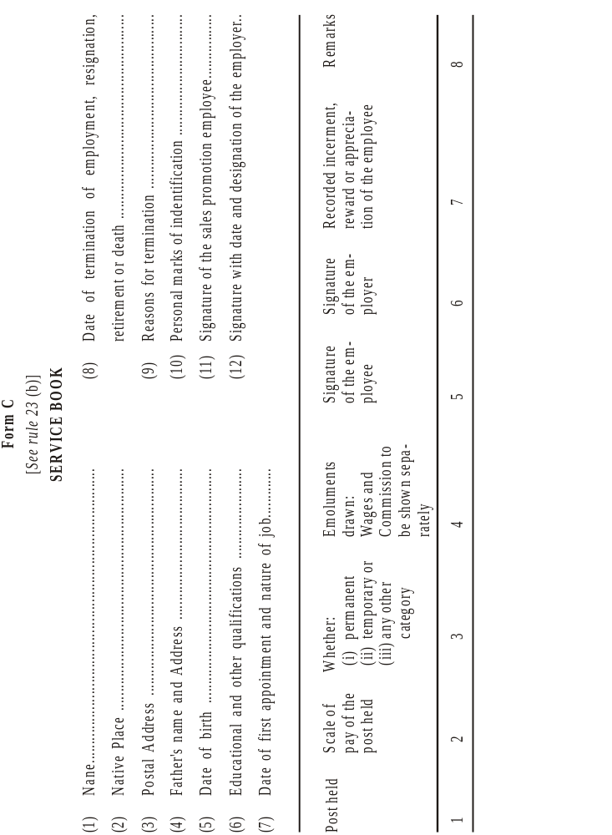
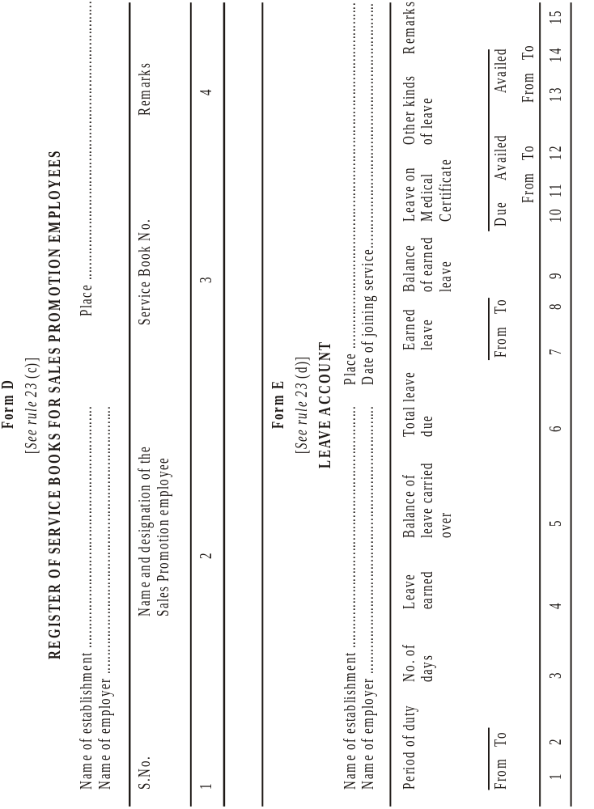

Vide G.S.R. 113 (E), dated 8th March, 1976, published in the Gazette of India, Extra., Pt. II, Section 3 (i), dated 8th March, 1976.

