THE WORKING JOURNALISTS (CONDITIONS OF SERVICE ) AND MISCELLANEOUS PROVISIONS RULES, 1957

 | INDEX
Rules | Description
 | CHAPTLR 1 PRELIMINARY
1. | Short title
2. | Definitions
 | CHAPTER II GRATUITY
3. | Payment of gratuity
4. | Gratuity due to a deceased working journalist to whom payable
5. | Nominations
6. | Deductions from gratuity
 | CHAPTER III HOURS OF WORK
7. | Special provisions regarding editors etc.
8. | Normal working day
9. | Interval for rest
10. | Compensation for overtime work
11. | Conditions governing night shifts
12. | Interval preceding change of shift
 | CHAPTER IV HOLIDAYS
13. | Number of holidays in a year
14. | Compensatory holidays
15. | Wages for holidays
16. | Wages for weekly day of rest
 | CHAPTER V LEAVE
17. | Competent Officers
18. | Application for leave
19. | Recording of reason for refusal or postponement of leave
20. | Affixing of holidays to leave
21. | Holidays intervening, during period of leave
22. | Recall before expiry of leave
23. | Production of medical certificate of fitness before resumption of duty
24. | Designation of authorised medical practitioner
25. | Earned leave
26. | Wages during earned leave
27. | Cash compensation for earned leave not availed of
28. | Leave on medical certificate
29. | Maternity leave
30. | Quarantine leave
31. | Extraordinary leave
32. | Leave not due
33. | Study leave
34. | Casual leave
35. | Wages during casual leave
 | CHAPTER VI MISCELLANEOUS
35A. | Manner of giving notice under section 12 of the Act
36. | Application under section 17 of the Act
37. | Maintenance of registers, records and muster-rolls
38. | Effect of rules and agreements inconsistent with these rules
FORM A. | Nomination form for payment of gratuity under section 5 of the Working Journalists (Conditions of Service) and Miscellaneous Provisions Act, 1955
FORM AA. | Form for payment of gratuity under section 5 of the Working Journalists (Conditions of Service] and Miscellaneous Provisions Act, 1955 in the case of minors
FORM B. | Nomination form for payment of gratuity under section 5 of the Working Journalists (Conditions of Service) and Miscellaneous Provisions Act, 1955
FORM C. | Application under sub-section (1) of section 17 of the Working Journalists (Conditions of Service) and Miscellaneous Provisions Act, 1955
FORM D. | Register of Employees
FORM E. | Service Register
FORM F. | Leave Register
FORM G. | Muster Roll
Form H. | Form of notice to be given under the proviso to clause (a) of sub-section (2) of section 12 of the Working Journalists and other Newspaper Employees (Conditions of Service) Miscellaneous Provisions Act, 1955

THE WORKING JOURNALISTS (CONDITIONS OF SERVICE) AND MISCELLANEOUS

PROVISIONS RULES, 1957
In exercise of the powers conferred by section 29 of the Working Journalists (Conditions of Service) and Miscellaneous Provisions Act, 1955 (45 of 1955), the Central Government hereby makes the following Rules, namely:—

CHAPTER 1
PRELIMINARY
1. Short title.—These rules may be called the Working Journalists (Conditions of Service) and Miscellaneous Provisions Rules, 1957.
2. Definitions.—In these rules, unless the context otherwise requires,—
(a) “Act” means the Working Journalists (Conditions of Service) and Miscellaneous Provisions Act, 1955 (45 of 1955);
(b) “authorised medical practitioner” means a registered medical practitioner designated as such under rule 24 and where no such practitioner has been designated, any registered medical practitioner;
(c) “average pay” shall have the meaning assigned to it in the Industrial Disputes Act, 1947 (14 of 1947);
(d) “competent officer” means an officer designated as such under rule 17;
[***]
(f) “form” means a form appended to these rules;

(g) “leave” means earned leave, leave on medical certificate, maternity leave, extraordinary leave, leave not due, casual leave, study leave or quarantine leave;
(h) “earned leave” means leave admissible under clause (a) of section 7 of the Act;

(i) “leave on medical certificate” means leave admissible under clause (b) of section 7 of the Act;

(j) “leave not due” means leave which is not due to a working journalist but which may be granted to him in anticipation of its being earned subsequently;
(k) “quarantine leave” means leave of absence from duty by reason of the presence of an infectious disease in the family or household of a working journalist;
(1) “study leave” means leave granted to a working journalist to enable him to undergo any special course of training which may be of use to him in his journalistic career; and
(m) “shifts”: ‘day shift’ means a shift when any hours of work of the shift do not fall between the hours of 11 P.M. and 5 A.M.; ‘night shift’ means a shift when any hours of work fall between the hours of 11 P.M. and 5 A.M.

CHAPTER II
GRATUITY
[3. Payment of gratuity.—Gratuity shall be paid to a working journalist or, in the case of his death, his nominee or nominees or, if there is no nomination in force at the time of the death of the working journalist, his family, as soon as possible after it becomes due and in any case not later than three months.]
[4. Gratuity due to a deceased working journalist to whom payable.—On death of a working journalist—
(a) If a nomination made by him in accordance with Rule 5 subsists, the gratuity shall be paid to his nominee or nominees in accordance with such nomination; and
(b) If no nomination subsists or if that nomination relates only to a part of the gratuity, the amount of the gratuity or the part thereof to which the nomination does not relate, as the case may be, shall be paid to his family.]
5. Nominations.—(1) A working journalist shall, as soon as he completes three years of continuous service, or in the case of those who have completed three years of continuous service at the commencement of the Act, as soon as may be after these rules come into force, make a nomination in form A conferring the right to receive any gratuity payable under the Act, in the event of his death before the amount has become payable or, where the amount has become payable, before the payment has been made. [Where the nominee is a minor, a working journalist shall appoint any person in Form AA to receive the gratuity in the event of working journalist’s death during the minority of the nominee.]
(2) A working journalist may, in his nomination distribute the amount that may become due to him amongst his nominees at his own discretion.
[***]
[(3)] A nomination made under sub-rule (1) [***] may at any time be modified by the working journalist after giving a written notice of his intention to do so in Form B. If the nominee predeceases the working journalist, the interest of the nominee shall revert to the working journalist, who may make a fresh nomination in accordance with these rules.
[(4)] A nomination or its modification shall take effect, to the extent it is valid on the date on which it is received by the newspaper establishment.
6. Deductions from gratuity.—The gratuity will be subject to deductions
on account of overpayments made to a working journalist by the newspaper establishment liable to pay such gratuity and monies borrowed by the working journalist from such newspaper establishment.

CHAPTER III
HOURS OF WORK
7. Special provisions regarding editors etc.—(1) The provision of this Chapter shall not apply to editors, or to correspondents, reporters or news-photographers.
(2) Notwithstanding anything contained in sub-rule (1), the following provisions shall apply to every correspondent, reporter or news-photographer stationed at the place at which the newspaper (in relation to which any such person is employed) is published, namely:—
(a) subject to such agreement as may be arrived at either collectively or individually between the parties concerned, every such correspondent, reporter or news-photographer shall, once he enters upon duty on any day, be deemed to be on duty throughout that day till he finishes all the work assigned to him during that day:
Provided that if such correspondent, reporter or news-photographer has had at his disposal for rest any interval or intervals for a total period of two hours or less between any two or more assignments of work, he shall not be deemed to be on duty during such period:
Provided further that where the total period of such interval or intervals exceeds two hours, he shall be deemed to be on duty during the period which is in excess of the said period of two hours;
(b) Any period of work in excess of thirty-six hours during any week (which shall be considered as a unit of work for the purposes of this sub-rule) shall be compensated by rest during the succeeding week and shall be given in one or more spells of not less than three hours each:
Provided that where the aggregate of the excess hours worked falls short of three hours, the duration of rest shall be limited only to such excess.
8. Normal working day.—The number of hours which shall constitute a normal working day for a working journalist exclusive of the time for meals shall not exceed six hours per day in the case of a day shift and five and half hours per day in the case of a night shift and no working journalist shall ordinarily be required or allowed to work for longer than the number of hours constituting a normal working day.
9. Interval for rest.—Subject to such agreement as may be arrived at between a newspaper establishment and working journalists employed in that establishment, the periods of work for working journalists shall be so fixed that no working journalist shall work for more than four hours in the case of day shift and three hours in the case of night shift before he had had an interval of rest, in the case of day shift for one hour, and in the case of night shift for half an hour.
10. Compensation for overtime work.—When a working journalist works for more than six hours on any day in the case of a day shift and more than five and-half hours in the case of a night shift he shall, in respect of that overtime work, be compensated in the form of hours of rest equal in number to the hours for which he has worked overtime.
11. Conditions governing night shifts.—No working journalist shall be employed on a night shift continuously for more than one week at a time or for more than one week in any period of fourteen days:
Provided that, subject to the previous approval of the State Labour Commissioner or any authority appointed by the State Government in this behalf, the limit prescribed in this rule may be exceeded where special circumstances so require.
12. Interval preceding change of shift.—In the case of change of shift from night shift to day shift or vice versa, there shall be an interval of not less than twenty-four consecutive hours between the two shifts and in the case of a change from one day shift to another day shift or from one night shift to another night shift there shall be interval of not less than twelve consecutive hours.
Provided that no such interval may be allowed if such interval either coincides with, or falls within, the interval enjoyed by a working journalist under sub-section (2) of section 6 of the Act.

CHAPTER IV
HOLIDAYS
13. Number of holidays in a year.—A working journalist shall be entitled to ten holidays in a calendar year.
14. Compensatory holidays.—If a working journalist is required to attend on a holiday, a compensatory holiday shall be given to him, within thirty days immediately following the holiday, on a day mutually agreed upon by him and his employer.
15. Wages for holidays.—A working journalist shall be entitled to wages on all holidays as if he was on duty.
16. Wages for weekly day of rest.—A working journalist shall be entitled to wages for the weekly day of rest as if he was on duty.

CHAPTER V
LEAVE
17. Competent Officers.—Every newspaper establishment may designate one or more officers in that establishment as competent officers for the purposes of this Chapter.
18. Application for leave.—(1) A working journalist who desires to obtain leave of absence shall apply in writing to the competent officer.
(2) Application for leave, other than casual leave, leave on medical certificate and quarantine leave, shall be made not less than one month before the date of commencement of leave, except in urgent or unforeseen circumstances.
19. Recording of reason for refusal or postponement of leave.—If leave is refused or postponed, the competent officer shall record the reasons for such refusal or postponement, as the case may be, and send a copy of the order to the working journalist.
20. Affixing of holidays to leave.—Holidays, other than weekly days of rest, shall not be prefixed or suffixed to any leave without the prior sanction of the competent officer.
21. Holidays intervening, during period of leave.—A holiday, including a weekly rest day, intervening during any leave granted under these rules shall form part of the period of leave.
22. Recall before expiry of leave.—(1) A newspaper establishment may recall a working journalist on leave if that establishment considers it necessary to do so. In the event of such recall such working journalist shall be entitled to travelling allowance if at the time of recall he is spending his leave at a place other than his headquarters.
(2) The traveling allowance which shall be paid to a working journalist under sub-rule (1) shall be determined in accordance with the rules of the newspaper establishment governing traveling allowance for journeys undertaken by working journalists in the course of their duties.
[23.Production of medical certificate of fitness before resumption of duty.—A working journalist who has availed himself of leave for reasons of health may, before he resumes duty, be required by his employer to produce a medical certificate of fitness from an authorised medical practitioner, any registered medical practitioner or the medical officer who issued the medical certificate under sub-rule (2) of rules 28.]
24. Designation of authorised medical practitioner.—Every newspaper establishment may designate one or more registered medical practitioner as authorised medical practitioners for the purposes of these rules.
25. Earned leave.—(1) A working journalist shall be entitled to earned leave on full wages for a period not less than one month for every eleven months spent on duty:
Provided that he shall cease to earn such leave when the earned leave due amounts to ninety days.
(2) The period spent on duty shall include the weekly days of rest, holidays, casual leave and quarantine leave.
26. Wages during earned leave.—A working journalist on earned leave shall draw wages equal to his average monthly wages earned during the period of twelve complete months spent on duty, or if the period is less than twelve complete months, during the entire such period, immediately preceding the month in which the leave commences.
27. Cash compensation for earned leave not availed of.—(1) When a working journalist voluntarily relinquishes his post or retires from service on reaching the age of superannuation, he shall be entitled to cash compensation for earned leave not availed of upto a maximum of thirty days:
Provided that a working journalist who has been refused earned leave due to him shall be entitled to get cash compensation for the earned leave so refused:
Provided further that in the case of a working journalist who dies while in service and who has not availed himself of the earned leave due to him immediately preceding the date of his death, his heirs shall be entitled to cash compensation for the leave not so availed of.
(2) When a working journalist’s services are terminated for any reason, whatsoever, other than as punishment inflicted by way of disciplinary action, he shall be entitled to cash compensation for earned leave not availed of upto a maximum of ninety days.
(3) The cash compensation shall not be less than the amount of wages due to a working journalist for the period of leave not availed of, the relevant wage being that which would have been payable to him had he actually proceeded on leave on the day immediately preceding the occurrence of any of the events specified in sub-rules (1) or (2), as the case may be.
28. Leave on medical certificate.—(1) A working journalist shall be entitled to leave on medical certificate on one-half of the wages at the rate of not less than one month for every eighteen months of service:
Provided that he shall cease to earn such leave when the leave on medical certificate amounts to ninety days.
[(2) The medical certificate shall be from an authorised medical practitioner:
Provided that when a working journalist has proceeded to a place other than his headquarters with the permission of his employer and falls ill, he may produce a medical certificate from any registered medical practitioner:
Provided further that the employer may, when the registered medical practitioner is not in the service of the Government, arrange at his own expense, the medical examination of the working journalist concerned, by any Government Medical Officer not below the rank of a Civil Assistant Surgeon or any other Medical-Officer in Charge of a hospital run by a local authority or a public organisation at that place like the Kasturba Gandhi Trust, Kamladevi Nehru Trust or Tata Memorial Trust.]
(3) Leave on medical certificate may be taken in continuation with earned leave provided that the total duration of earned leave and leave on medical certificate taken together shall not exceed a hundred and twenty days at any one time.
(4) A working journalist shall be entitled at his option to convert leave on medical certificate on one-half of the wages to half the amount of leave on full wages.
(5) The ceiling laid down in the provisos to sub-rule (1) and sub-rule (3) on the accumulation and total duration of leave may be relaxed by the competent officer in the cases of working journalists suffering from lingering illness such as tuberculosis.
[(6) Leave on medical certificate or converted leave on medical certificate referred to in sub-rules (1) and (4) may be granted to a working journalist at his request notwithstanding that earned leave is due to him.]
29. Maternity leave.—(1) A female working journalist who has put in not less than one year’s service in the newspaper establishment in which she for the time being employed shall be granted maternity leave on full wages for a period which may extend up to three months from the date of its commencement or six weeks from the date of confinement whichever be earlier.
(2) Leave of any other kind may also be granted in continuation of maternity leave.
(3) Maternity leave shall also be granted in cases of mis-carriage, including abortion, subject to the condition that the leave does not exceed six weeks.
30. Quarantine leave.—Quarantine leave on full wages shall be granted by the newspaper establishment on the certificate of the authorised medical practitioner designated as such under rule 24 or where, there is no such authorised medical practitioner by a district public health officer or other Municipal Health Officer of similar status, for a period not exceeding twenty-one days, or, in exceptional circumstances, thirty days. Any leave necessary for quarantine purposes in excess of that period shall be adjusted against any other leave that may be due to the working journalist.
31. Extraordinary leave.—A working journalist who has no leave to his credit may be granted extraordinary leave without wages at the discretion of the newspaper establishment in which such working journalist is employed.
32. Leave not due.—A working journalist who has no leave to his credit may be granted at the discretion of the newspaper establishment in which such working journalist is employed leave not due.
33. Study leave.—A working journalist may be granted study leave with or without wages at the discretion of the newspaper establishment in which such working journalist is employed.
34. Casual leave.—(1) A working journalist shall be eligible for casual leave at the discretion of the newspaper establishment for fifteen days in a calendar year:
Provided that not more than five days’ casual leave shall be taken at any one time and such leave shall not be combined with any other leave.
(2) Casual leave not availed of during a calendar year will not be carried forward to the following year.
35. Wages during casual leave.—A working journalist on casual leave shall be entitled to wages as if he was on duty.

CHAPTER VI
MISCELLANEOUS
[35A. Manner of giving notice under section 12 of the Act.—Notice required to be given under proviso to clause (a) of sub-section (2) of section 12 of the Act shall be in Form H and shall be published in the Official Gazette and in leading newspapers.]
[36. Application under section 17 of the Act.—An application under section 17 of the Act shall be made in Form C to the Government of the State, where the Central Office or the Branch Office of the newspaper establishment in which the newspaper employee is employed, is situated.]
[37.Maintenance of registers, records and muster-rolls.—Every newspaper establishment shall prepare and maintain, the following registers, records and muster-rolls:—
(i) A register of employees in Form D.
(ii) Service Registers in respect of all working journalists in Form E.
(iii) Leave Registers in respect of all working journalists in Form F.
(iv) A muster-roll in Form G:
Provided that the leave register in Form F and the muster-roll in Form G may not be maintained by the newspaper establishments to which the Minimum Wages Act, 1948 and/or the Shops and Commercial Establishments Act of the State concerned apply and which are required under those Acts or the rules made thereunder to maintain such or similar forms.]
38. Effect of rules and agreements inconsistent with these rules.—The provisions of these rules shall have effect notwithstanding anything inconsistent therewith contained in any other rule or agreement or contract of service applicable to a working journalist:
Provided that where under any such rule, agreement or contract of service or otherwise, a working journalist is entitled to benefits in respect of any matter which are more favourable to him than those to which he would be entitled under these rules, the working journalist shall continue to be entitled to the more favourable benefits in respect of that matter, notwithstanding that he receives benefit in respect of other matters under these rules.

FORM A
NOMINATION FORM FOR PAYMENT OF GRATUITY UNDER SECTION 5 OF THE WORKING JOURNALISTS (CONDITIONS OF SERVICE) AND MISCELLANEOUS PROVISIONS ACT, 1955
[See rule 5 (1)]
1. Name (in block letters) ................................................................................ Surname (if any) ...........................................................................................
2. Sex .............................................................................................................
3. Religion ......................................................................................................
4. Occupation ..................................................................................................
5. Father’s name ...............................................................................................
6. Husband’s name .............................................................................................
(for married women only)
7. Marital Status ...............................................................................................
whether bachelor, spinster, married, widow or widower
8. Date of birth............... Day........... Month ........................... Year ....................
9. Permanent address .........................................................................................
Village ............... Thana .............. District .................. State ..........................
I hereby nominate the person/s mentioned below to receive the amount of gratuity standing to my credit, in the event of my death before that amount has become payable, or having become payable has not been paid and direct that the said amount shall be distributed among the said persons in the manner shown below against their names:—
Name and address of Nominee’s rela- Age Amount of share Contingencies on the
the nominee or tionship with of of gratuity to happening of which
nominees the working nominee be paid to each the nomination shall
journalist nominee become invalid
1 2 3 4 5

Date .............................. Signature of the working journalist
Certified that above declaration has been signed by .................................. employed in ................................................ (the name of the newspaper establishment to be given) before me after he has read the entries/ the entries have been read over to him
by me.

Dated....................... Signature of a responsible officer of the Newspaper establishment
Signature of witness .................................. (1) Designation ...............................................................
Dated ...................................
Signature of witness ................................. (2) Name & address of the newspaper
establishment ..........................................

Dated.........................
[FORM AA]
FORM FOR PAYMENT OF GRATUITY UNDER SECTION 5 OF THE WORKING JOURNALISTS (CONDITIONS OF SERVICE) AND MISCELLANEOUS PROVISIONS ACT, 1955 IN THE CASE OF MINORS
[See rule 5 (1)]
Whereas Shri/Kumari ............................ son/daughter of .................. who has been nominated by me to receive the amount of gratuity standing to my credit, in the event of my death before that amount has become payable, or having become payable has not been paid, is a minor, I hereby appoint Shri/Kumari/Shrimati ............................... son/daughter/wife of ........................ to receive the gratuity in the event of my death during the minority of Shri/Kumari .......................................................................

Dated .................... Signature of Working Journalist
Certified that the above declaration has been signed by ........................... employed in ..................... (the name of the newspaper establishment to be given) before me after he has read the entries/the entries have been read to him by me.

Dated..................... Signature of a responsible officer of the newspaper establishment
Signature of witness 1) Designation ....................................................
Dated......................... (2) Name and address of the newspaper
establishment ...............................................
Signature of witness.........................
Dated.......................]

FORM B
NOMINATION FORM FOR PAYMENT OF GRATUITY UNDER SECTION 5 OF THE WORKING JOURNALISTS (CONDITIONS OF SERVICE) AND MISCELLANEOUS PROVISIONS ACT, 1955
[See rule 5 (5)]
I ..................... hereby cancel the nomination made by me on the....................... regards the disposal in the event of my death of the amount of gratuity standing to my credit and hereby nominate the person/s mentioned below to receive the amount of gratuity standing to my credit, in the event of my death before that amount has become payable, or having become payable has not been paid and direct that the said amount shall be distributed among the said persons in the manner shown below against their names:—
Name and address of Nominee’s rela- Age Amount of share Contingencies on the
the nominee or tionship with of of gratuity to happening of which
nominees the working nominee be paid to each the nomination shall
journalist nominee become invalid
1 2 3 4 5

Date ....................... Signature of the working journalist
Certified that the above declaration has been signed before me by............................ employed in........................................................................................................
.......................................................................................................... (the name
of the newspaper establishment to be given).
Dated.................. Signature of a responsible official of the newspaper establishment
Signature of witness.. (1) Designation ..................................................
Dated........................ (2) Name and address of the newspaper
Signature of witness. establishment ...............................................
Dated...........................
[Form C]
APPLICATION UNDER SUB-SECTION (1) OF SECTION 17 OF THE WORKING JOURNALISTS (CONDITIONS OF SERVICE) AND MISCELLANEOUS PROVISIONS ACT, 1955
(See rule 36)
To
The Secretary to the Government of ......................... (here insert the name of the State Government) Department of...................... (here insert the name of the Department which deals with labour matters)....................... (here insert the name of the place where the headquarters of the State Government are situated).
Sir,
I have to state that I Shri/Shrimati/Kumari................................ son/widow/daughter of ................. a working journalist, was entitled to receive from.......................... (here insert the name and address of the newspaper establishment) a sum of Rs. ..................... on account of............................... (here insert gratuity, wages, etc., as the case may be), payable under the Working Journalists (Conditions of service) and Miscellaneous Provisions Act, 1955 (45 of 1955).
I further state that I was appointed by Shri........................................... by an instrument dated...................... to receive the amount of the gratuity on behalf of Shri/Kumari............. I further state that I served the said newspaper establishment with a demand notice by registered post on..................................... for the said amount which the said newspaper establishment has neither paid nor offered to pay to me even though 15 days have since lapsed. The details of the amount due are mentioned in the statement hereto annexed.
I request that the said sum may kindly be recovered from the said newspaper establishment under section 17 of the said Act, and paid to me as early as possible.
*[I have been duly authorised in writing by....................... (here insert the name of the newspaper employee) to make this application and to receive the payment of the aforesaid amount due to him.]
*[I am a member of the family of late........................... (insert the name of the deceased newspaper employee), being his..................... (here insert the relationship) and am entitled to receive the payment of the aforesaid amount due to late........................ (here insert the name of the deceased newspaper employee).]
*To be struck out when the payment is claimed by the newspaper employee himself.
Station.................... Signature of the applicant
Date........................ Address............................

ANNEXURES
(Here insert the details of the amount claimed)
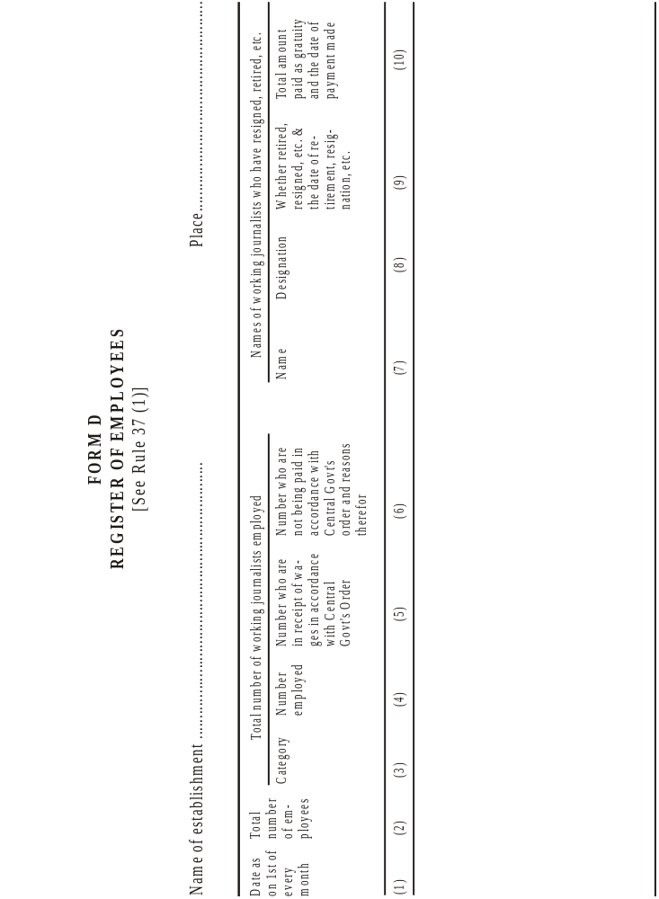
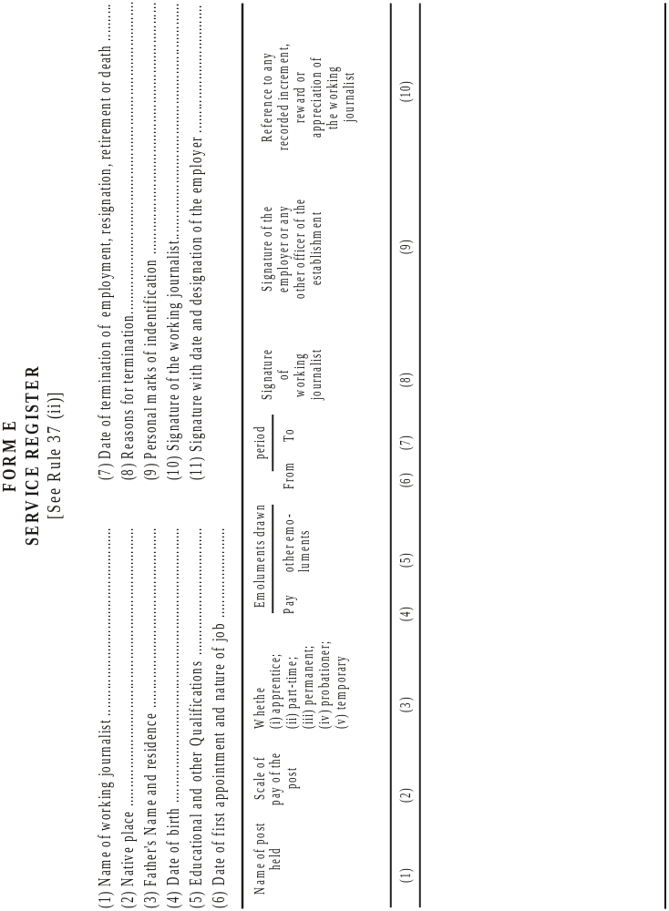
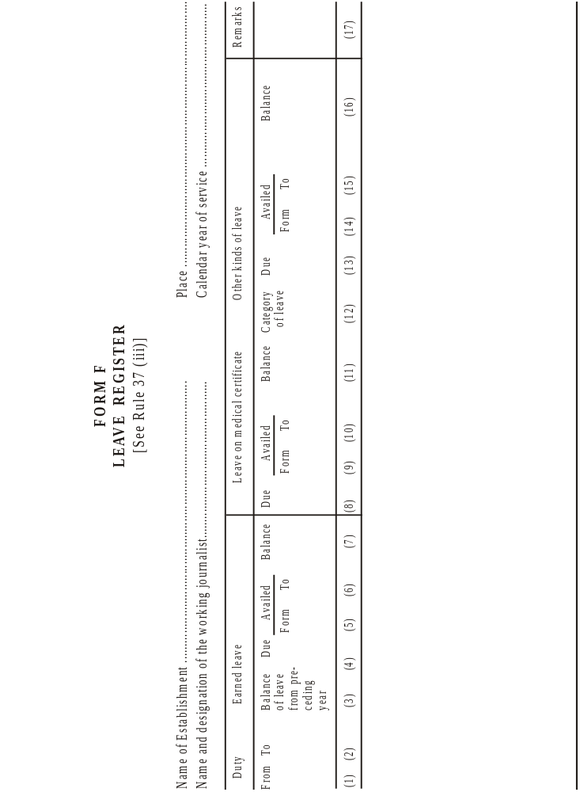
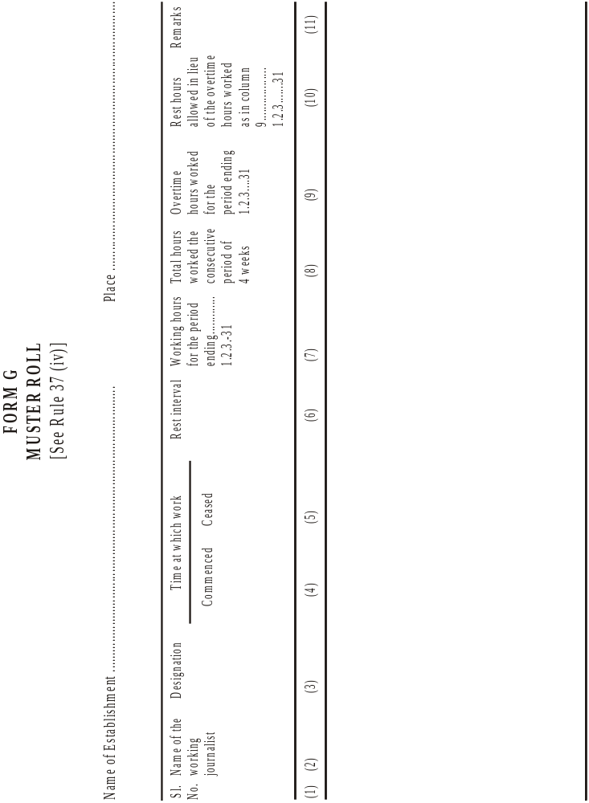
[FORM H]
FORM OF NOTICE TO BE GIVEN UNDER THE PROVISO TO CLAUSE (A) OF SUB-SECTION (2) OF SECTION 12 OF THE WORKING JOURNALISTS AND OTHER NEWSPAPER EMPLOYEES (CONDITIONS OF SERVICE) AND MISCELLANEOUS PROVISIONS ACT, 1955
(See rule 35A)
Whereas the Central Government by notification No. ............................................ dated ............................................ constituted a board/tribunal for fixing or revising rates of wages of...................................... And whereas the said board/tribunal has made its recommendations;
And whereas the Central Government proposes to make the modifications to the said recommendations;
Now, therefore, in pursuance of the proviso to clause (a) of sub-section (2) of section 12 of the working journalists and other Newspaper Employees (Conditions of Service) and Miscellaneous Provisions Act, 1955, notice is hereby given to all persons likely to be affected by the following modifications to make their representation in writing within a period of thirty days from the publication of this notice.
Proposed Modifications :]

20 (4) THE WORKING JOURNALISTS AND OTHER NEWSPAPER EMPLOYEES TRIBUNAL RULES, 1979
 | INDEX
Rules | Particulars | Page
1. | Short title | 521
2. | Calling of parties | 521
3. | Notice | 521
4. | Proceedings before die Tribunal | 521
5. | Summoning of witnesses and production of documents | 521
6. | Expenses of witnesses | 522

THE WORKING JOURNALISTS AND OTHER NEWSPAPER EMPLOYEES TRIBUNAL RULES, 1979
In exercise of the powers conferred by clause (d) of sub-section (2) of section 20 of the Working Journalists and other Newspaper Employees (Conditions of Service) and Miscellaneous Provisions Act, 1955 (45 of 1955), the Central Government hereby makes the following rules, namely:—
1. Short title.—These rules may be called the Working Journalists and Other Newspaper Employees Tribunal Rules, 1979.
2. Calling of parties.—A Tribunal constituted under section 13AA or, as the case may be, under section 13DD of the Working Journalists and Other Newspaper Employees (Conditions of Service) and Miscellaneous Provisions Act, 1955 (45 of 1955), shall subject to the provisions of rule 3 call at such date, time and place, as may be appointed by it, from time to time, the parties representing employers in a newspaper establishment and the parties representing the working journalists, or, as the case may be, the non-journalist newspaper employees in such newspaper establishment.
3. Notice.—Not less than ten days before the date fixed by the Tribunal for calling the parties, a notice containing the date, time and place of the meeting, together with a list of business to be conducted at the meeting, shall be sent to both the parties referred to in rule 2 by registered post by an officer authorised by the Tribunal in this behalf.
4. Proceedings before the Tribunal.—The proceedings before the Tribunal shall ordinarily be open to the public :
Provided that the Tribunal may, at any stage, direct that any witness shall be examined, or its proceedings shall be held, in camera.
5. Summoning of witnesses and production of documents.—(1) The Tribunal may summon any person to appear as a witness in the course of any inquiry. Such summons may require the witness to appear before it on a date specified therein and to produce any books, papers or other documents and information in his possession or under his control relating in any manner to the inquiry.
(2) A summons under sub-rule (1) may be addressed to an individual or an organisation of employers or a trade union of working journalists or, as the case may be, of non-journalist newspaper employees, or other workmen as the tribunal may think fit.
(3) A summons under this rule may be served—
(a) in the case of an individual, by being delivered or sent to him by registered post; and
(b) in the case of an organisation or, as the case may be, trade union, referred to in sub-rule (2), by being delivered or sent by registered post to the Secretary or other principal officer of the organisation or trade union, as the case may be.
6. Expenses of witnesses.—Every person who is summoned and appears before the Tribunal shall be paid by the Tribunal such sum of money as appears to the Tribunal to be sufficient to defray the travelling and other expenses incurred by the person so summoned in passing to and from the place where he is required to attend.

Vide S.R.O. 1737, dated 23rd May, 1957.
Clause (e) omitted by G.S.R. 1320, dated 1st August, 1963.
Subs. by G.S.R. 1320, dated 1st August, 1963.
Subs. by G.S.R. 1320, dated 1st August, 1963.
Ins. by G.S.R. 1320, dated 1st August, 1963.
Sub-rules (3) and (4) omitted by G.S.R. 1320, dated 1st August, 1963.
Clauses (5) and (6) renumbered as clauses (3) and (4) by G.S.R. 1320, dated 1st August, 1963.
Omitted by G.S.R. 1320, dated 1st August, 1963.
Clauses (5) and (6) renumbered as clauses (3) and (4) by G.S.R. 1320, dated 1st August, 1963.
Subs. by G.S.R. 997, dated 6th July, 1964.
Subs. by G.S.R. 997, dated 6th July, 1964.
Ins. by G.S.R. 997, dated 6th July, 1964.
Ins. by G.S.R. 899 (E), dated 11th November, 1980 (w.e.f. 12-11-1980).
Subs. by G.S.R. 1320, dated 1st August, 1963.
Subs. by G.S.R. 1320, dated 1st August, 1963.
Ins. by G.S.R. 1320, dated 1st August, 1963.
Forms C to G ins. by G.S.R. 1320, dated 1st August, 1963.
Form H ins. by G.S.R. 899(E), dated 11th November, 1980 (w.e.f. 12-11-1996).
Vide S.O. 1294, dated 4th April, 1979

